**ST. XAVIER’S COLLEGE**

**(Affiliated to Tribhuvan University)**

Maitighar, Kathmandu



**Database Management System**

**Lab Assignment #4**

**Submitted by:**

Utsav luitel  
013BSCCSIT046

**Submitted to:**

|  |  |
| --- | --- |
| **Er. Sanjay Kumar Yadav**  Lecturer  St. Xavier’s College |  |

**Date of Submission:** August 10, 2015

**1.What do you mean by Entity- Relationship Diagram? Explain**

Entity-relationship model describes data involves in real world in terms of object and their relationships. It is widely used for initial database design. It describes overall structure of database. E-R model is in fact, semantic data model which describes the meaning of data. It has a capability to map the meanings and interactions of real world objects on to the conceptual schema.

**2.Define entity and give an example.**

An entity is a “thing” or “object” in the real world that is distinguishable from another object.

For example:

Specific customer , Particular course in university

Entities can be described by a set of properties called attributes. For example: customer_id, customer_name, customer_address are attributes for entity customer. Similarly, course_id, course_name are attributes for entity course.

**4.Define attribute and its types.**

In simple, attribute is descriptive property of entity set. Set of attributes describes entity set.

For example

customer = (customer-id, customer-name, customer-city)

account=( account_number, balance)

loan = (loan_number, amount)

Types of attributes

1. Simple and Composite attribute

Attribute which can not be divide into subparts (i.e. into other attributes) called simple attribute

1. Single-valued and Multivalued attributes

Attribute that can take only one value in every entry called singled-valued attribute.

1. Stored and Derived attribute

Attribute whose values can be derived from the values of other related attributes or entities called derived attribute.

**5.What is derived attributes?**

Attribute whose values can be derived from the values of other related attributes or entities called derived attribute. For example, in customer entity set, attribute age is derived attribute if customer entity set has attribute date_of_birth. We can derive age of customer from date_of_birth and current_date. Here the attribute date_of_birth is stored attribute and the attribute age is derived attribute. The value of derived attribute is not stored, it is computed when required.

6.Define relationship and give an example.

A relationship is an association among two or more entities.

Formally, if E1, E2, . . ,En (n≥2) are entity sets then a relationship set R is a subset of

{(e1,e2, . . ,en)│e1∈E1,e2 ∈E2, . . en ∈En}

where (e1,e2, . . ,en) is relationship.

**7.Explain the difference between a relationship class and a relationship instance.**

**8.Define degree of relationship.**

* The degree of relationship (also known as cardinality) is the number of occurrences in one entity which are associated (or linked) to the number of occurrences in another.

There are three degrees of relationship, known as:

* one-to-one (1:1)
* one-to-many (1:M)
* many-to-many (M:N)

**9. List and give an example of the three types of binary relationships. Draw an E-R diagram**

for each.

* For binary relationship set between entity set A and B mapping cardinality must one of the following.

**One to one**: An entity in A is associated with at most one entity in B and entity in B is associated with at most one entity in A.

**One to many**: An entity in A is associated with zero or more entities in B but entity in B can be associated with at most one entity in A.

**Many to one**: An entity in A is associated with at most one entity in B but an entity in B can be associated with zero or more entities in A.

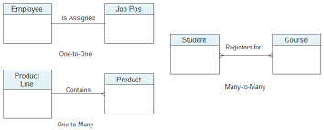

**10. Define the terms maximum cardinality and minimum cardinality.**

* **Maximum cardinality** is the **maximum** number of instances of an entity that can participate in an instance of a relationship. **Minimum** is the least number of instances of an entity that can

participate in an instance of a relationship.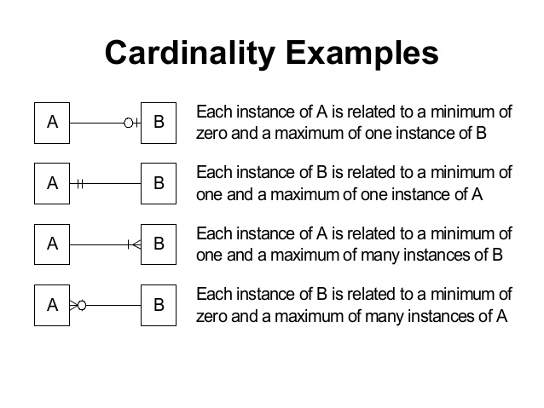

**11. Explain the distinctions among the terms primary key, candidate key and super key.**

* **Super Key:** An attribute or set of attributes that uniquely identifies a tuple within a relation  
    
  **Candidate key:** A super key such that no proper subset is a super key within the relation  
    
  **Primary key:** The candidate key that is selected to identify tuples uniquely within the relation, the candidate keys which are not selected as PKs are called "Alternate keys"

**12. What are the main building modules of the entity relationship model? Discuss each one.**

* The main building modules of the Entity-Relationship model are:  
    a. Entities  
    b. Relationships  
    c. Attributes   
  Entities  
  An Entity is a basic object of ER-model which is an object in real world that can be distinguishable and can exists independently.  
  Relationships  
  Relationship defines the association among two entities. Suppose, consider student and a class are the two entities. These entities are associated as “student studies in class”. Hence studies is a relationship between the two entities, student and class.  
  Attributes  
  The properties of the entities are called attributes.  
  For example if we consider a mobile phone as an entity then each mobile well have its own color, design, model company. All these are the attributes of the mobile entity.

**29. Write short notes on:**

**· Specialization**

Specialization follows top down design approach. Entity sets are subgroups in distinct entity sets. For example entity set person with attributes name, street and city can further subgroup into two entities sets customer and employee. Each of these person types can describes by set of attributes that includes all the attributes of entity set person plus all possible attributes of itself. For example, customer entity set can further described by set of attributes: customer_id, enroll_date etc. Similarly entity attributes can further describes by set of attributes: emplouee_id, salary etc. The process of sub groupings within an entity set is called specialization. We can apply specialization repeatedly to refine a design schema. For instance bank employees may be further classified into officer, teller or secretary.

In E-R diagram, specialization can be represented by a triangle component labeled ISA. The label ISA stands for “is a “. For example customer is a person, officer is an employee etc. The ISA relationship also called super class-subclass relationship.

· **Generalization**

* Generalization follows bottom-up approach in which multiple entity sets are synthesized into higher-level entity set on the basis of common features. For example, the database designer may have first identified a customer entity set with the attributes: name,street, city and customer_id and employee entity set with the attributes name, street, city, employee_id and salary. In both entities some attributes are common. These similarities between these two entities can be express by generalization.

During the course of database design or E-R schema for enterprise database designer may use both specialization and generalization process. Specialization and generalization in E-R diagram represent by a same way. The terms specialization and generalization are used interchangeably.



Figure: Specialization and generalization.

**· Aggregation**

* E-R model can not express relationship among relationship. To illustrate this, let us consider quaternary relationship manages among employee, branch, job and manager. Its main job is to record managers who manages particular job/task perform by particular employee at particular branch.
* 

E-R diagram with redundant relationships.

This quaternary relationship is required since binary relationship between manager and employee can not represent required information. This E-R diagram is able to represent the required information but information are redundant since every employee, branch and job exist both relationship set “work-on” and “manages”. Here aggregation is better to represent such information.

Aggregation is in fact an abstraction it treats relationships as higher level entities. In our example, it treats relationship set work-on (including entity set employee, branch and job) as entity set. So now we can create binary relationship set “manages” between work-on and manager. This removes redundant information.



E-R Diagram with aggregation