ST. XAVIER’S COLLEGE

**(Affiliated to Tribhuvan University)**

**Maitighar, Kathmandu**



**Database Management System**

**Theory Assignment (#5)**

**SUBMITTED BY**

**Pratik Gautam**

**013BSCCSIT029**

**4th sem/ 2nd year**

**SUBMITTED TO**

**Er. Sanjay K Yadav**

**Lecturer**

**Department of Computer Science**

**St. Xavier’s College**

# What do you mean by entity-relationship diagram? Explain.

An entity relationship model, also called an entity-relationship (ER) diagram, is a graphical representation of entities and their relationships to each other, typically used in computing in regard to the organization of data within databases or information systems. An entity is a piece of data-an object or concept about which data is stored.

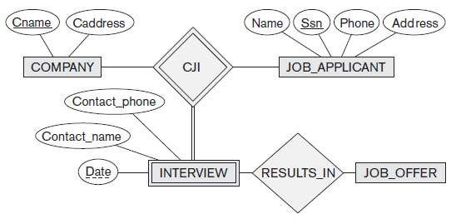

Fig: ER diagram

While useful for organizing data that can be represented by a relational structure, an entity-relationship diagram can't sufficiently represent semi-structured or unstructured data, and an ERD is unlikely to be helpful on its own in integrating data into a pre-existing information system.

Three main components of an ERD are the entities, which are objects or concepts that can have data stored about them, the relationship between those entities, and the cardinality, which defines that relationship in terms of numbers.

**2. Define entity and give an example.**

Entity is defined as the real world object that can be seen and are around us. It is generally an existing or real thing. In relation to a database, an entity is a single person, place, or thing about which data can be stored. In data modeling, an entity is some unit of data that can be classified and have stated relationships to other entities.

A member of the entity group is called an entity instance. For example, if a family had 2 children, Sarah and Peter, Sarah would be one instance of "the child" entity and Peter would be another instance of "the child" entity. By creating an entity to represent "the child", information such as the child's age can be collected for each child.

**4. Define attribute and its types.**

In general, an attribute is a characteristic property of an entity. In a database management system (DBMS), an attribute refers to a database component, such a table. It also may refer to a database field. Attributes describe the instances in the row of a database.

**Single and Composite Attributes:**

Attributes can be classified as having many parts to them or just a single unbreakable attribute. The composite attribute is an attribute that can be subdivided into other single attributes with meanings of their own. A single attribute is just an attribute that cannot be subdivided into parts.

Example: Imagine from the entity Student that instead of having the three attributes: stu_LastName, stu_MiddleName, stu_FirstName it had one attribute called stu_Name. The attribute stu_Name would be considered a composite attribute since it can be subdivided into the other three attributes: stu_LastName, stu_MiddleName, stu_FirstName. The rest of attributes would be consider single attributes since they can't be subdivided into parts.

**Single-valued and multi-valued Attributes:**

Attributes can be classified as single or multi-value. The single-value attribute can only have one value, while the multi-valued attributes usually can store multiple data in them.

Example: In the entity Student, stu_Address could be considered a multi-value attribute since a student could have multiple addresses where he lives at. An example of a single-value attribute would be stu_LastName since a student usually has one last name that uniquely identifies him/her.

**Derived Attributes:**

Derived attribute, where one attribute is calculated from another attribute. The derived attribute may not be stored in the database but rather calculated using algorithm.

Example: In the entity Student, stu_Age would be considered a derived attribute since it could be calculated using the student's date of birth with the current date to find their age.﻿﻿

**5. What is derived attributes?**

Derived attribute, where one attribute is calculated from another attribute. The derived attribute may not be stored in the database but rather calculated using algorithm.

Example: In the entity Student, stu_Age would be considered a derived attribute since it could be calculated using the student's date of birth with the current date to find their age.﻿﻿

**6. Define relationship and give an example.**

Relationship, in the context of databases, is a situation that exists between two relational database tables when one table has a foreign key that references the primary key of the other table. Relationships allow relational databases to split and store data in different tables, while linking disparate data items.

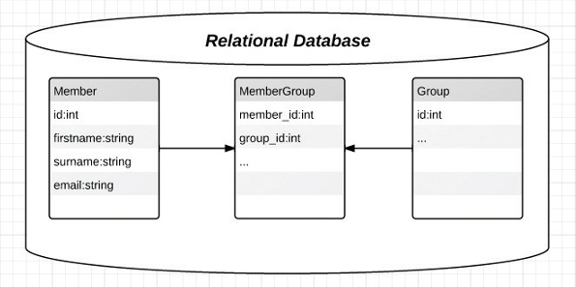

**7. Explain the difference between a relationship class and a relationship instance.**

**8. Define degree of relationship.**

A relationship's degree indicates the number of associated entities or participants.

* Unary Relationship
* Binary Relationship
* Ternary Relationship

A unary relationship exists when an association is maintained with in a single entity. A binary relationship exists when two entities are associated. A ternary relationship exists when three entities are associated.

9. List and give an example of the three types of binary relationships. Draw an E-R diagram for each.

1:1 - a single entity instance of one type is related to a single-entity instance of another type.

1:N - a single entity instance of one type is related to many-entity instances of another type.

M:N - many-entity instances of one type relate to many-entity instances of another type.

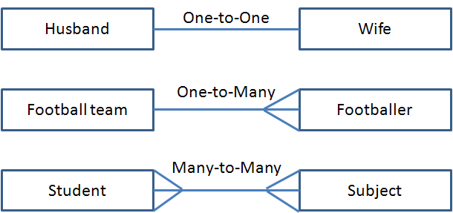

11. Explain the distinctions among the terms; primary key, candidate key and super key.

* Primary Key is a key that is selected as the identifier for an entity type, and hence, cannot be repeated.
* A Candidate Key is an attribute, or a group of attributes, that uniquely identifies each instance of an entity type.
* A superkey is a combination of columns that uniquely identifies any row within a relational database management system (RDBMS) table.

12. What are the main building modules of the entity relationship model? Discuss each one.

13. What is composite attributes, when it is used?

Attributes that can be further divided into factions that do hold a meaning on their own are known as composite attributes.

14. Explain the difference between single-value attributes and simple attributes.

A single -valued attribute is one that can have only one value. For example, a person has only one first name and only one social security number.

A simple attribute is one that cannot be decomposed into its component pieces. For example, a person's sex is classified as either M or F and there is no reasonable way to decompose M or F. Similarly, a person's first name cannot be decomposed into meaningful components. (In contrast, if a phone number includes the area code, it can be decomposed into the area code and the phone number. And a person's