class HomeOwnerUser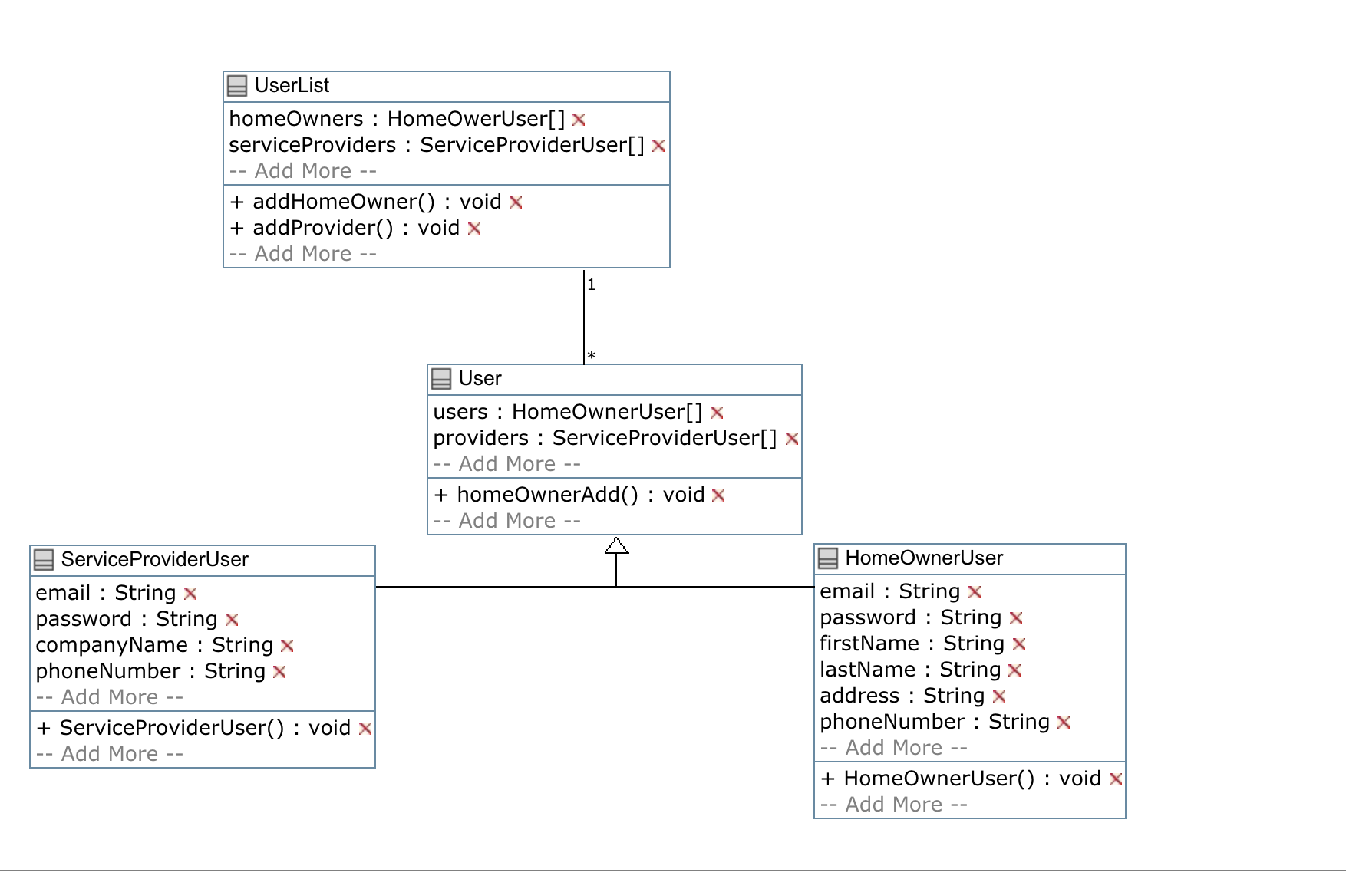

{

isA User;

String email;

String password;

String firstName;

String lastName;

String address;

String phoneNumber;

public HomeOwnerUser (){

}

}

class ServiceProviderUser

{

isA User;

String email;

String password;

String companyName;

String phoneNumber;

public ServiceProviderUser(){

}

}

class UserList

{

HomeOwerUser[] homeOwners;

ServiceProviderUser[] serviceProviders;

public void addHomeOwner(){

}

public void addProvider(){

}

}

class User

{

HomeOwnerUser[] users;

ServiceProviderUser[]providers;

\* -- 1 UserList;

public void homeOwnerAdd(){

}

}