Computer Vision Final Assignment

# Checkpoint 1: Extracting Filter Responses

Below are 3 example filter responses produced by our code for a sample image. In order to view the last two as non-dark images, a value of 0.5 was added to each pixel

|  |  |
| --- | --- |
|  |  |
|  |  |

## Checkpoint 2: Mapping pixels to visual words

Here we take 3 random images and display the overlayed word map that resulted from using Random-chosen points and Harris algorithm-chosen points. In order to get these images, the labels with the image were converted into RGB, and then it was converted to BGR.

|  |  |  |
| --- | --- | --- |
|  |  |  |
|  |  |  |
|  |  |  |

Checkpoint 3: Confusion Matrices

Below are the resulting confusion matrices that show the accuracy of our overall program (which images were correctly labeled). Based on this data, our system performed best wit randomly chosen points and using a chi-squared distance function.

Using Harris + Chi Squared for kNN our best accuracy 60.625 with k = 7.

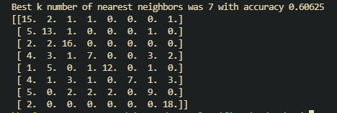

**Program requirements:**

* CV2
* Numpy
* Skipy
* Skimage

**Execution instructions:**

…

**Known issues:**

…

**Final comments:**

…