CS 150 Lecture 23 Exercises

Complete each of the exercises below and upload to Canvas before the deadline.

A. The Command Line

Write the program **frp** (in **frp.cpp**, of course), that can be called from the command-line like this:

**./frp somefile frog grenouille**

The program should open the file (**somefile**) and print it on the screen, replacing all instances of the *searched-for* word (**frog**) with the *replace-with* word (**grenouille**). If there is no third argument, then the searched-for word (**frog**) is simply not printed.

Here are the specifications:

* Less than 2 arguments supplied? Print an error message on standard error and exit
* Two arguments? Open the input file for reading read the file line by line, displaying the entire file on the console with all instances of the second argument removed
  + Cannot open file? Print error message (standard error) and exit
* Three arguments? Open the input file for reading read the file line by line, displaying the entire file on the console with all instances of the second argument replaced by the third.

As you read the file, line-by-line, use **find()** to see if the desired string exists in the line, and then use **substr()** to display all but the line. Here are some sample runs, with the command-line in blue, error messages shown in green and normal output appearing in green.

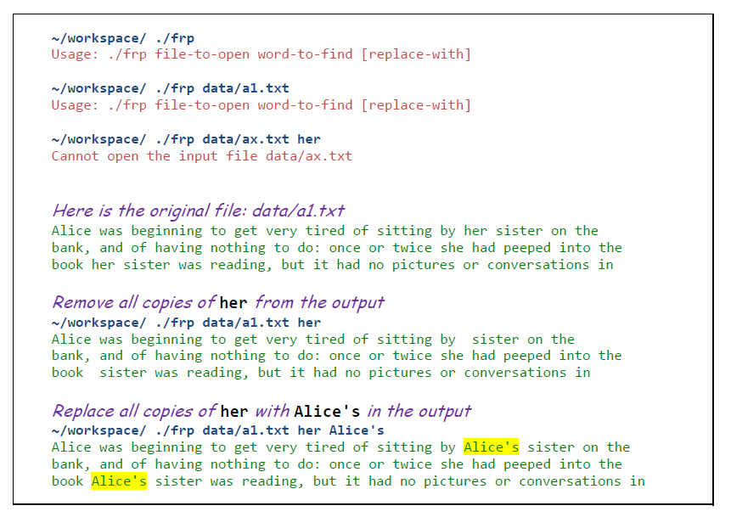

| *Copy and paste a screenshot of the source code for frp.cpp here.* |
| --- |

| *Copy and paste a screenshot running the program with make test* |
| --- |

B. Dynamic Memory Basics

Inside **dynamic.cpp** change the program to use **dynamic variables**. When you're done, make sure you get rid of the error messages as well. Copy your completed code into the text areas below.

| *Copy and paste a screenshot of the source code for dynamic.cpp here.* |
| --- |

| *Copy and paste a screenshot running the program.* |
| --- |

| *Copy and paste a screenshot running the program with make check* |
| --- |

# 