CS 150 Lecture 0 Exercises

Complete each of the exercises below. Upload them to Canvas before the deadline. For the screenshots, do NOT take a picture of the whole screen, just the section of interest.

# Exercise 1 - Introduce Yourself

Go to **Canvas Discussions**. Follow the instructions to introduce yourself. When you have finished and posted your introduction, shoot a screenshot of your introduction and paste it here.

|  |
| --- |
|  |

Then, shoot a screenshot of your modified Canvas profile (with your picture and bio.)

# 

# Exercise 2 - IDE, Github & the CS 150 Console

To make sure you can complete and submit the homework, complete the following steps in exactly this order to configure all of the tools for your homework assignments. Follow the instructions in the handout provided on Canvas to complete this assignment and **provide screenshots that show**:

|  |
| --- |
| 1. https://github.com/anguyen798 |

2. Screenshot of your repo before opening codespaces

|  |
| --- |
|  |

3. Screenshot running 150config.py (want to see name, email, ID)

|  |
| --- |
|  |

4. Screenshot of file tree with cs150/hw expanded

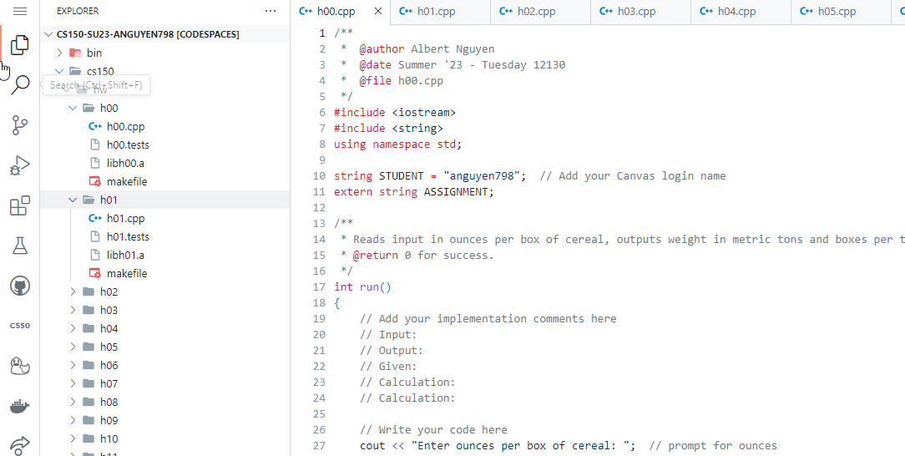

5. Log into the CS150 Homework console. Show me your account.

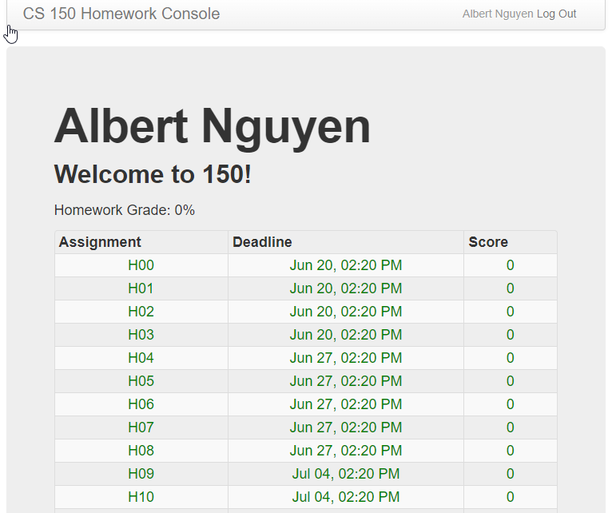

# Exercise 3 - Getting Started with the Homework

To make sure you understand how to complete the homework assignments, follow along with your instructor as we complete and submit H00.

Show me the following screenshots.

A screenshot of make test passing at least one test

|  |
| --- |
|  |

A screenshot of make submit with your submission updated

|  |
| --- |
|  |

The CS 150 Homework Console with h00 updated appropriately

|  |
| --- |
|  |

Your GitHub repository with the code from CS 150 updated

|  |
| --- |
|  |

**Be sure to check Canvas and the CS150 Homework Console for the rest homework deadlines.**