在 CentOS7 上安装 kafka 服务

1. 下载 kafka_2.12-2.0.0.tgz

下载地址：[http://kafka.apache.org/downloads.html](http://kafka.apache.org/downloads.html" \t "https://blog.csdn.net/lilinoscar/article/details/_blank)

1. 安装

2.1解压缩 kafka_2.12-2.0.0.tgz

tar zxvf kafka_2.12-2.0.0.tgz

mv kafka_2.12-2.0.0 /usr/local

cd /usr/local/kafka_2.12-2.0.0

2.2修改server.properties

vi config/server.properties

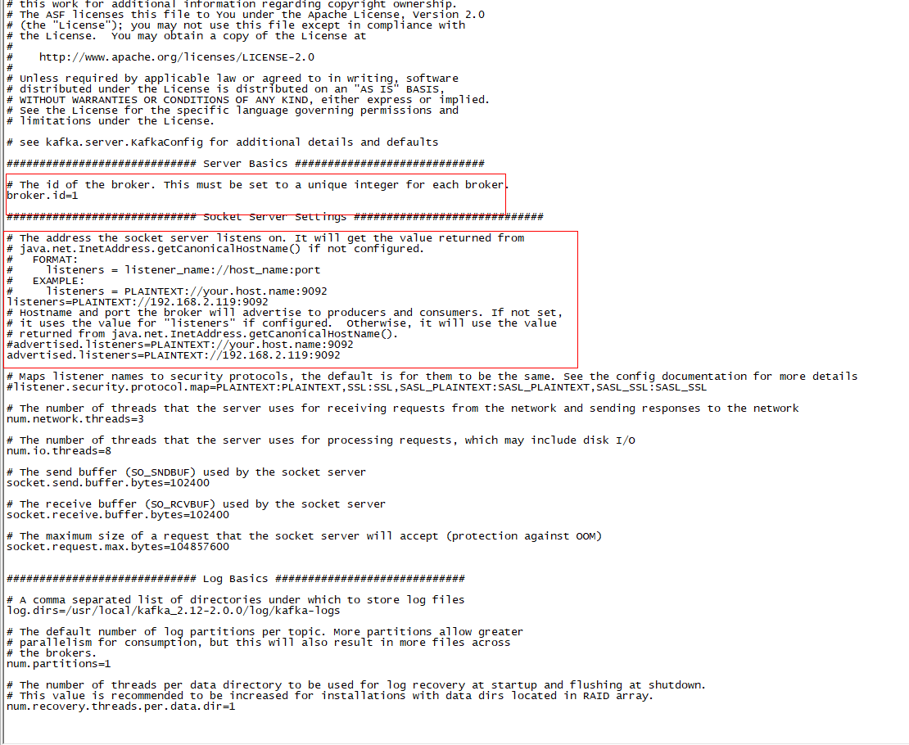

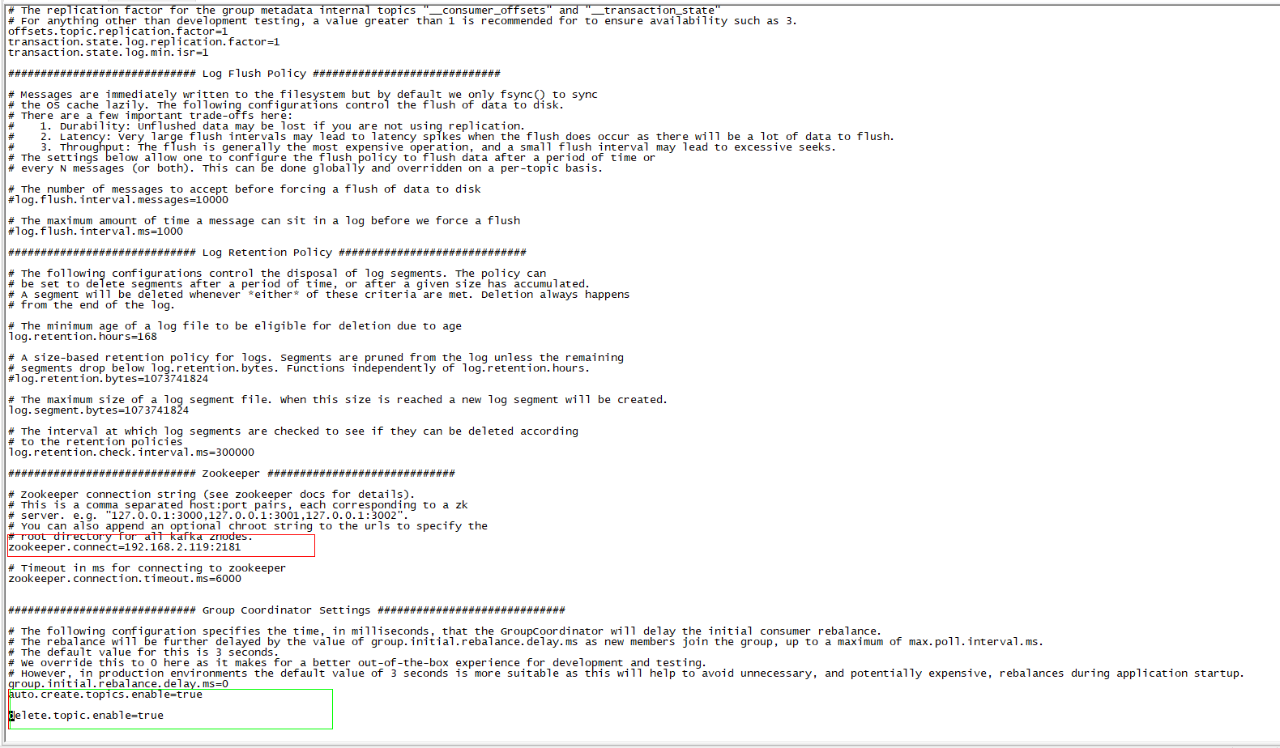

修改标红的部分，将其该kafka和zookeeper地址

新增以下参数

#tipic不存在，自动创建topic

auto.create.topics.enable=true

delete.topic.enable=true

2.3启动kafka

nohup ./bin/kafka-server-start.sh ./config/server.properties &

检测是否启动成功

Jps

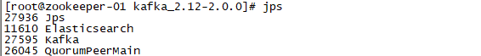

出现kafka，则启动成功

2.4 开机启动

cd /etc/init.d/

vi kafka

#!/bin/bash

export JAVA_HOME=/usr/local/java/jdk1.8.0_171

export PATH=$JAVA_HOME/bin:$PATH

#chkconfig:2345 20 90

#description:kafka

#processname:kafka

case $1 in

start)

/usr/local/kafka_2.12-2.0.0/bin/kafka-server-start.sh -daemon /usr/local/kafka_2.12-2.0.0/config/server.properties

;;

stop)

/usr/local/kafka_2.12-2.0.0/bin/kafka-server-stop.sh

;;

status)

jps

;;

restart)

/usr/local/kafka_2.12-2.0.0/bin/kafka-server-stop.sh

/usr/local/kafka_2.12-2.0.0/bin/kafka-server-start.sh -daemon /usr/local/kafka_2.12-2.0.0/config/server.properties

;;

*)

echo "require start|stop|status|restart"

;;

esac

修改权限

chmod 755 kafka

修改/etc/rc.d/rc.local

新增以下内容

/etc/init.d/kafka start

2.5、开放端口：

#centos查询端口是不是开放的

firewall-cmd --permanent --query-port=9092/tcp

#添加对外开放端口

firewall-cmd --permanent --add-port=9092/tcp

#重启firewall

firewall-cmd --reload