在 CentOS7 上安装 zookeeper-3.4.10 服务

1、下载 zookeeper-3.4.10.tar.gz：

wget https://mirrors.tuna.tsinghua.edu.cn/apache/zookeeper/zookeeper-3.4.10/zookeeper-3.4.10.tar.gz

2、安装

2.1解压缩 zookeeper-3.4.10.tar.gz：

tar -zxvf zookeeper-3.4.10.tar.gz

mv zookeeper-3.4.10 /usr/local

cd /usr/local/zookeeper-3.4.10/conf

2.1复制 zoo_sample.cfg 文件的并命名为为 zoo.cfg：

cp zoo_sample.cfg zoo.cfg

vi zoo.cfg

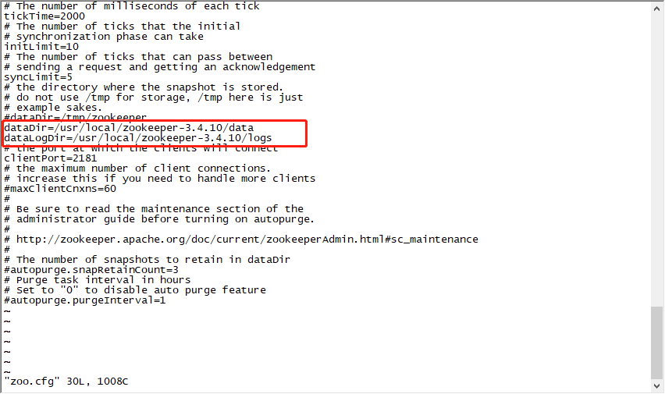

标红部分修改为本地zookeeper路径

2.3新增zookeeper环境配置

vi /etc/profile

# zookeeper-3.4.10 config

export ZOOKEEPER_HOME=/usr/local/zookeeper-3.4.10/

export PATH=$ZOOKEEPER_HOME/bin:$PATH

export PATH

新增以上内容到/etc/profile中

使profile 文件即可生效：

source /etc/profile

2.4启动zookeeper

cd /usr/local/zookeeper-3.4.10/

zkServer.sh start

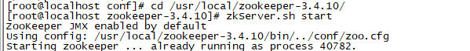

检测是否启动成功

ps -ef|grep zookeeper

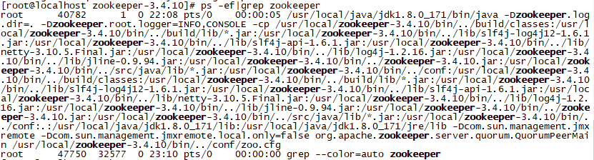

zookeeper命令如下

zkServer.sh start

zkServer.sh status

zkServer.sh stop

zkServer.sh restart

2.5、开放端口：

#centos查询端口是不是开放的

firewall-cmd --permanent --query-port=2181/tcp

#添加对外开放端口

firewall-cmd --permanent --add-port=2181/tcp

#重启firewall

firewall-cmd --reload

3、zookeeper设置开机启动

进入/etc/rc.d/init.d目录

cd /etc/rc.d/init.d

新建zookeeper文件

touch zookeeper

使用vim命令修改文件内容，文件内容是：

vi zookeeper

#!/bin/bash

#chkconfig: 2345 10 90

#description: service zookeeper

export JAVA_HOME=/usr/local/java/jdk1.8.0_171

export ZOO_LOG_DIR=/usr/local/zookeeper-3.4.10/logs

ZOOKEEPER_HOME=/usr/local/zookeeper-3.4.10

case "$1" in

start) su root ${ZOOKEEPER_HOME}/bin/zkServer.sh start;;

start-foreground) su root ${ZOOKEEPER_HOME}/bin/zkServer.sh start-foreground;;

stop) su root ${ZOOKEEPER_HOME}/bin/zkServer.sh stop;;

status) su root ${ZOOKEEPER_HOME}/bin/zkServer.sh status;;

restart) su root ${ZOOKEEPER_HOME}/bin/zkServer.sh restart;;

upgrade)su root ${ZOOKEEPER_HOME}/bin/zkServer.sh upgrade;;

print-cmd)su root ${ZOOKEEPER_HOME}/bin/zkServer.sh print-cmd;;

*) echo "requirestart|start-foreground|stop|status|restart|print-cmd";;

esac

为新建的/etc/rc.d/init.d/zookeeper文件添加可执行权限，命令是：

chmod +x /etc/rc.d/init.d/zookeeper

把zookeeper这个脚本添加到开机启动项里面，命令是：

chkconfig --add zookeeper