CST2550 Coursework 1

Report

Case Diagram

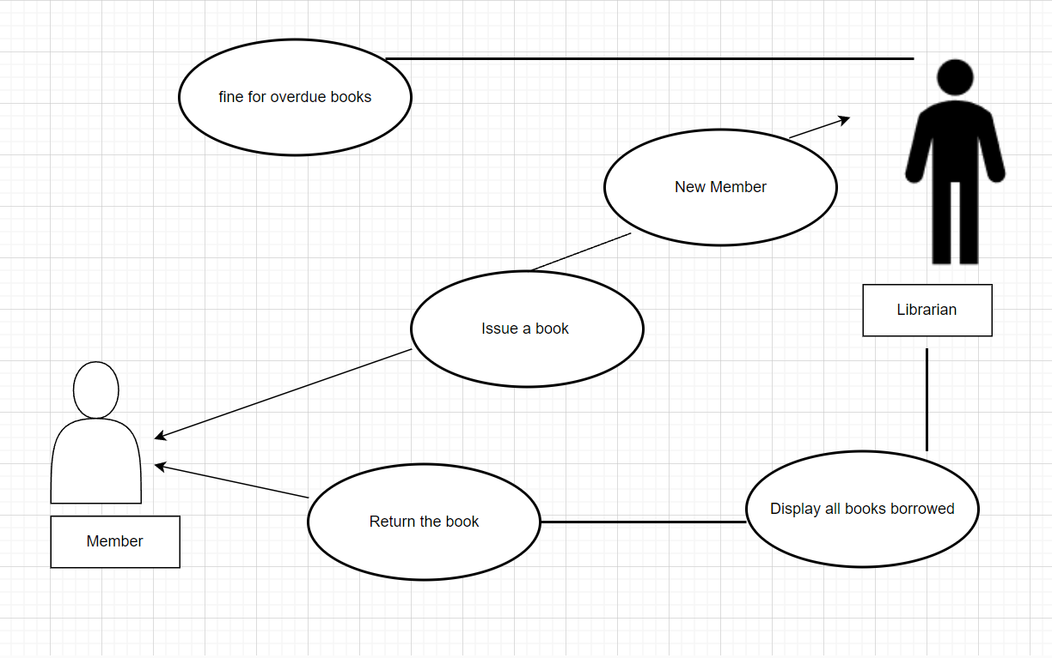

Activity Diagram

I would like to know about the testing code I know that I have to link makefile to catch2 but why at the moment to compile it is not working also the code although it is correct I count not find the error in make.