# HOW TO CREATE A THIRD PERSON CONTROLLER IN UNITY

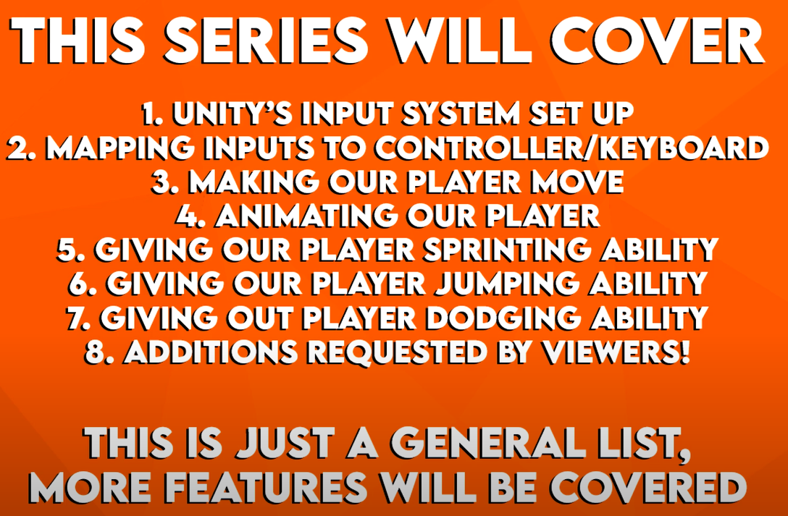

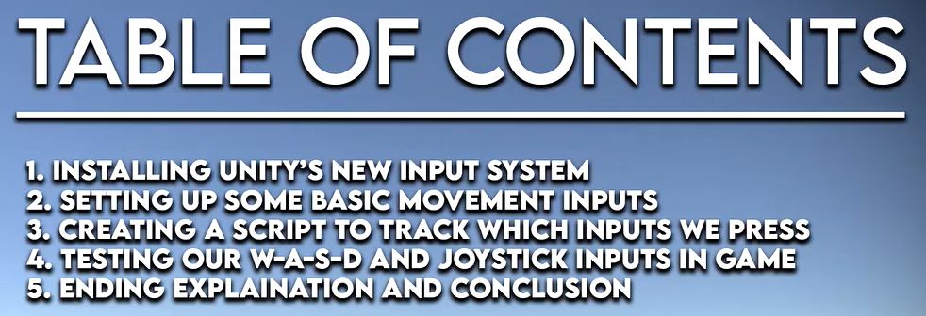

Step1: Create PlayerControl

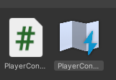 --> 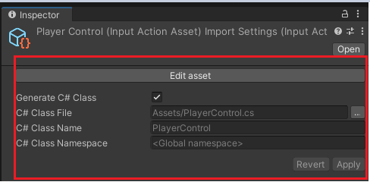

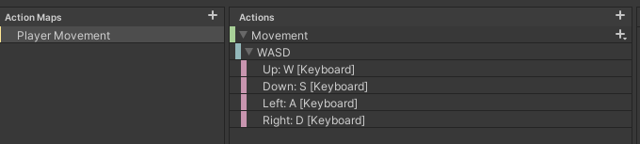

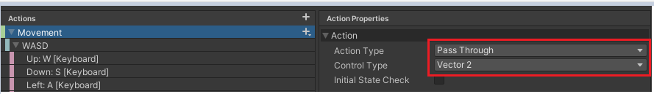

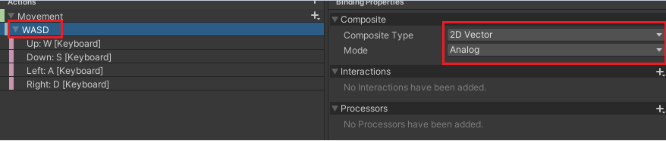

Step2: Create script “InputManager”.

