

**REQUIREMENTS MANAGEMENT**

Course: **COMP1787**

Learner’s name: TRAN QUANG ANH THUAN

Banner ID: **001392791**

Student ID: GCS210834

Assessor name: NGO QUOC ANH

Table of Contents

Table Of Figure 2

**Section A- Management Summary** 3

1. Business goals 3

2. Methodologies 3

3. Chosen method for the scenario. 5

4. Summary 6

**Section B – High level requirements analysis and MoSCoW prioritization** 7

1. List of requirements for the project 7

B.1.1 Identify requirements are not appropriate to be considered at high level requirements 8

B.1.2 List of high-level functional requirements needed to build the system 9

B.2 Use the Moscow/Timebox rules to prioritize the requirements in your updated ‘high level requirements list. 10

B.2.1 Timebox 10

B.2.2 MoSCoW 12

**Section C – Legal, Social, Ethical and Professional issues** 13

C.1 Legal, Social, Ethical and Professional issues (LSEPI) 13

C.2 Guiding Principles of the British Computer Society (BCS) in Making Professional 14

REFERENCE 16

# Table Of Figure

Figure 1: Scrum methodology 4

Figure 2: Rapid Application Development (RAD) 4

Figure 3: Dynamic Systems Development Method (DSDM) 5

# **Section A- Management Summary**

1. Business goals

* **Introduction:** In just three months, Green Groceries, a thriving medium-sized business that specializes in providing organic and locally sourced grocery items, will establish an online platform in an effort to increase its market share. Green Groceries, a company well-known for its strong ties to local farmers and eco-aware suppliers, aims to make sustainable products more widely accessible. Because it does not have an internal development team, it has chosen to outsource its software development efforts to System Concepts (SC) in keeping with this aim. The web platform is being created by SC, which is well-known for its proficiency with SCRUM and Agile approaches. Throughout the development process, flexibility and collaboration are being encouraged.
* **Goals:** Within three months, Green Groceries has an aim to develop an online platform in an effort to increase market share and increase accessibility to sustainable products. They have chosen to employ System Concepts (SC) in order to develop the platform utilizing SCRUM and Agile methods, overcoming previous issues with traditional project management, as they do not have an in-house software team.
* **Issues:** Green Groceries faces some troubles in the shortage of in-house software development department, which led to important difficulties in project control and agreement with company values Previous problems related to traditional 'waterfall' projects show a possible conflict between project management techniques Actively choosing Agile and SCRUM concepts using System Concepts (SC) is one thing, but effective communication between the insiders and the external team of developers is different.
* **Interviews to Gather Requirements:** There are variety of option. Offering delivery options, cart modifications, pet-friendly policies, managing addresses, marketing preferences, encryption of information, marketing consistency, handling increased traffic, team-building events, offers/discounts, VAT compliance, and a variety of payment methods are just a few of the requirements that are covered. Additional needs include enabling online order processing, maintaining a green workspace, updating customer accounts, planning virtual events, providing data protection, and enabling account registration and management.

1. Methodologies

* **Scrum**

This study from (Hron & Obwegeser, 2022) looks into how Scrum, a popular agile development model, could possibly be implemented outside of traditional software environments. It presents nine typical modification objectives and seven general modification strategies after reviewing the literature to understand why and how Scrum has been adjusted for different purposes. Through the discovery of research gaps and interesting areas for additional investigation, the study seeks to inform future research and practice.

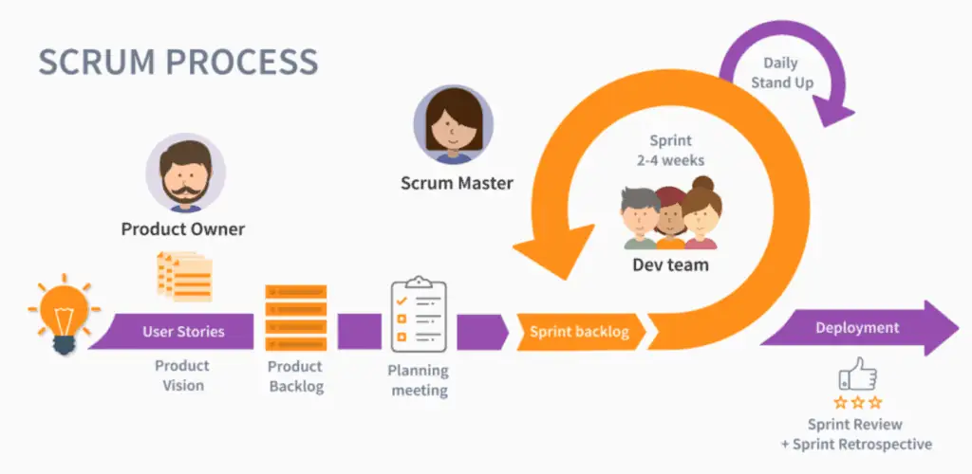

Figure 1: Scrum methodology.

* **Rapid Application Development (RAD)**

Rapid Application Development, or RAD, is a methodology which makes rapid system development achievable by efficiently using high-performance computation and technology. It facilitates the quick testing, retargeting is and reuse of existing software by both novice and expert programmers. If necessary, it also makes hardware-specific optimization possible. Unlike waterfall and agile development techniques, RAD (rapid application development) places an emphasis on producing high-quality products quickly.

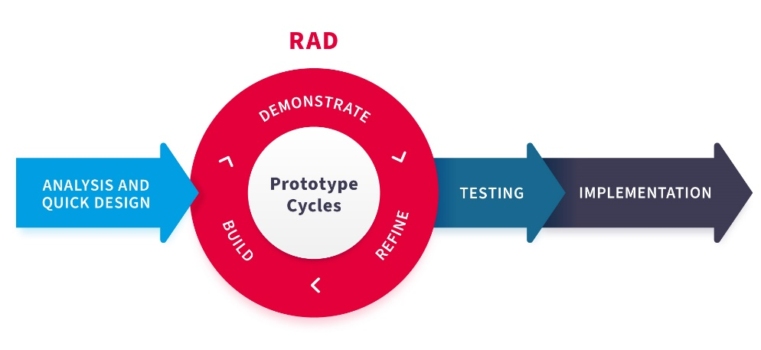

Figure 2: Rapid Application Development (RAD)

* **Dynamic Systems Development Method (DSDM)**

A project management methodology called the Dynamic System Development Method (DSDM) makes system design and development more effective from . Practicality, business studies, functional model the next iteration design and build iteration, and implementation are its five phases. The system design process has been simplified by DSDM, which provides an organized approach and saves time. It also makes post-development system maintenance quick and easy (Farouq, 2020).

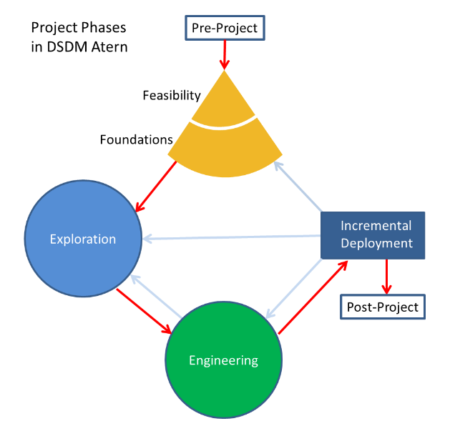

Figure 3: Dynamic Systems Development Method (DSDM)

1. Chosen method for the scenario.

Scrum implementation is advised in order to effectively meet Green Groceries' needs. Scrum ensures that the web platform will be delivered on schedule in three months, allowing for continuous improvement through teamwork. Its transparency ensures data security compliance by allowing quick issue resolution. Using Scrum to mitigate risks early on is essential for peak traffic management. All things considered, Scrum helps Green Grocery reach their goals and launch their platform on time.

**Strengths**

* **Flexibility and Adaptability:** The iterative approach of Scrum makes it feasible to react quickly to changing market conditions and needs. This is beneficial for Green Groceries because they want to reach a wider audience and can run into changing consumer tastes or technology improvements.
* **Collaborative Approach:** Scrum places an enormous value on teamwork and collaboration, which is beneficial for a project like Green Groceries where many kinds of interested parties need to be included in the course of development, including farmers, suppliers, and customers. In along with ensuring alignment with the business's values and objectives, this collaborative approach produces improved communication.
* **Early and Continuous Delivery:** Because Scrum promotes ongoing delivery of software that works in short repetitions, Green Groceries is able to get feedback at the beginning of the development process. This makes it easy for them to quickly check features and make the required changes, confirming that the finished product meets their needs and objectives.

**Drawback and Challenges**

* **Dependence on External Teams:** Green Groceries may experience difficulty adopting outside developers into the Scrum framework because they favor outsourcing their software campaigns. This could cause misunderstandings, obstacles, or misunderstanding if the development team is inexperienced with the goals and values of the company in question.
* **Limited Predictability:** Scrum's focus on quick iterations and adaptation to change may make program timetables and results more unpredictable. Green Groceries might discover this hard, especially when they have strict time frames or budgetary constraints to meet.
* **Risk of Scope Creep:** Scrum projects are susceptible to feature creep, which occurs when extra features or changes are added while the undertaking remains in development. Such can happen when suitable oversight systems aren't in place. This can have an effect on the timeline and cost of the project, which could make Green Groceries and its stakeholders dissatisfied or dissatisfied.

## Summary

Although having green with groceries offers numerous opportunities to broaden your audience, boost sales, enhance customer service, and use based on data tactics, you need also be mindful of the risks associated. Customer availability, appropriate scope management, overcoming communication challenges, and resource allocation are merely a few of the potential problems that could develop.

**Cost/Benefit:**

* **Cost:** It costs a lot of money to start building an online platform and facilities including marketing, web design, and technology. Buying locally and healthily produced goods may also be more expensive than purchasing economically produced goods. Moreover, it could be essential to invest more money and resources in training employees about environmentally friendly procedures and product knowledge.
* **Benefits:** Investing in a website has multiple benefits for Green Groceries, beyond the initial costs. First off, it gives the business the opportunity to reach more people by reaching out to customers beyond its current area of operation. Easy online shopping alternatives can also result in higher revenue growth and sales. In addition, offering a perfect online store and customized customer support can improve customer engagement, happiness, and devotion. Last but not least, emphasizing sustainability and eco-consciousness can improve the company's reputation as a brand and draw in customers who care about the environment.

**Risks:**

* **Market Competition:** Local stores offering similar goods and renowned online supermarkets fight with Green Grocery. The current competitive environment could make it difficult to draw in and keep clients.
* **Supply Chain Disruptions:** Reliance on nearby producers and vendors for organic goods risks the company to potential delays brought on by things like bad weather, failing crops, or shortage of supplies. Both availability of goods and efficiency in operation may be affected by these interruptions.
* **Regulatory Compliance:** Precise records, inspections, and regulatory charges are necessary to maintain organic product certifications and laws. Sanctions and damage to reputation may result from breaking legal regulations.
* **Consumer Perception:** Although many consumers place a high value on long-term viability some might think organic items are more costly. This view might restrict market acceptance and impede the expansion of sales.
* **Technology Risks:** Dependence on technology for online sales includes risks like attacks by hackers, website interruptions, or technical issues that negatively affect the user experience. Investing in strong cybersecurity defenses and continuous infrastructure and technology maintenance are necessary for reducing these risks.

**Feasibility of the project:**

* **Technical Feasibility:**

Working out if the technology needed for the building of the online platform is scalable, readily available, and will work with the systems currently in place at the business.   
Examining the vendor's or developer team's capacity to deliver the necessary features within the allocated budget and time frame.

* **Operational Feasibility:**

Examining how the online platform has affected order processing, inventory control, and customer service at Green Grocery on a daily basis.

Knowing potential operational obstacles or bottlenecks brought about by the online platform's implementation and creating plans to overcome them.

* **Financial Feasibility:** Determining the price of developing, launching, and supporting a web platform, including the upfront expenditure for marketing, technology, and staff training.
* **Market Feasibility:** Performing market research in order to assess the target audience's need for locally sourced and natural foods as well as the competitiveness of the online grocery business.

**Conclusion:** In conclusion, adopting Scrum holds significant promise for Green Groceries in launching their online platform within the specified timeframe and meeting various requirements. Scrum's strengths in flexibility, collaboration, transparency, iterative development, and faster time-to-market align well with the company's objectives. However, potential weaknesses such as complexity and dependency on team collaboration should be noted. Despite challenges, Scrum offers a structured and efficient approach to achieve Green Groceries' goals effectively, ensuring customer satisfaction and business success.

# **Section B – High level requirements analysis and MoSCoW prioritization**

## 1. List of requirements for the project

|  |  |  |  |
| --- | --- | --- | --- |
| ID | Requirements Details | FR/NFR | Role |
| RQ-1 | I wish to replace the paper-based strategy for completing telephone purchases as an Order Handling Clerk with the website. | Functional Requirement | Order Handling Clerk |
| RQ-2 | As part of the company's dedication to a green and healthy workspace, keep at least twenty office plants. | Non-Functional Requirement |  |
| RQ-3 | I want to be able to update my account information as a customer so that my most recent information is captured. | Functional Requirement | Customer |
| RQ-4 | Celebrate the CEO's birthday remotely on the company website to point out the light and welcoming culture of the organization. | Non-Functional Requirement |  |
| RQ-5 | As the Managing Director, I would like to ensure that the website conforms with the Data Protection Act in order in order to prevent fines that might amount to hundreds of hundreds of thousands of pounds. | Functional Requirement | Managing Director |
| RQ-6 | Create Account | Functional Requirement | Customer |
| RQ-7 | I would prefer to have a selection of delivery times so that I can properly organise my diary. | Functional Requirement | Customer |
| RQ-8 | To be able to change my mind about what to buy, I would like to be able to make changes to my shopping cart. | Functional Requirement | Customer |
| RQ-9 | It is recommended that the organization develop pet-friendly policies in order to create a happy and welcoming workplace. | Non-Functional Requirement |  |
| RQ-10 | During peak times, the system needs to be able cope with a 30% increase in traffic without experiencing any performance decrease. | Non-Functional Requirement |  |
| RQ-11 | In order for me as a client to receive my luggage when visiting a friend's house, I would want to submit different delivery and invoice addresses. | Functional Requirement | Customer |
| RQ-12 | I want to be able to update my account information as a consumer so that my most recent data is kept on file. | Functional Requirement | Customer |
| RQ-13 | I want to be able to process phone orders through the website instead of the paper-based system as an Orders Handling Clerk. | Functional Requirement | Order Handling Clerk |
| RQ-14 | In order to avoid getting too much junk mail, I, as a customer, want to decide whether or not I receive marketing information. | Functional Requirement | Customer |
| RQ-15 | For maximum security, any user data, including payment and personal information, needs to be protected. | Non-Functional Requirement |  |
| RQ-16 | To strengthen their brand identification, keep the logo and website design consistent. | Non-Functional Requirement |  |
| RQ-17 | Every three months, the development team needs to take advantage of an activity that builds relationships to promote collaboration and an enjoyable work environment. | Non-Functional Requirement |  |
| RQ-18 | I would need an incentives or discount page in order that we can let our customers aware about the above. | Functional Requirement | Marketing Director |
| RQ-19 | In my position, I want the site adhere to by VAT rules in order to prevent paying a large penalties. | Functional Requirement | Chief Accountant |
| RQ-20 | In order to assist as many customers as I can in my occupation, I wish to accept every payment option. | Functional Requirement | Operations Director |

## B.1.1 Identify requirements are not appropriate to be considered at high level requirements

|  |  |  |  |
| --- | --- | --- | --- |
| ID | Requirement details | FR/N-FR | Reason |
| RQ-2 | As part of the company's dedication to a green and healthy workspace, keep at least twenty office plants. | Non-  Functional  Requirement | To promote staff well-being and conservation efforts, make sure your workspace is green and has twenty or more office plants. |
| RQ-4 | Celebrate the CEO's birthday remotely on the company website to point out the light and welcoming culture of the organization. | Functional Requirement | Celebrate the CEO's birthday virtually on the business website to showcase the company's friendly and laid-back attitude. This policy encourages inclusivity among staff members, highlights the company's ideals, and improves the spirits of workers. |
| RQ-9 | It is recommended that the organization develop pet-friendly policies in order to create a happy and welcoming workplace. | Non-  Functional  Requirement | This requirement creates rules for creating a positive, welcoming, and pet-friendly work atmosphere that also complies with current workplace practices. |
| RQ-10 | During peak times, the system needs to be able cope with a 30% increase in traffic without experiencing any performance decrease. | Non-  Functional  Requirement | In order to offer an outstanding user experience even during instances of high demand, make sure the system is capable of handling a 30% increase in traffic at peak hours without seeing a decline in performance. |
| RQ-14 | In order to avoid getting too much junk mail, I, as a customer, want to decide whether or not I receive marketing information. | Functional Requirement | By giving customers a way to control their marketing tastes, you may increase customer happiness and privacy while lowering unsolicited communications and enhancing user experience overall. |
| RQ-16 | To strengthen their brand identification, keep the logo and website design consistent. | Non-Functional Requirement | For a stronger the identity of the brand, consistency in the mark and website design is important. It ensures uniformity throughout all aspects of the brand, increasing customer rapport and trust. Greater connections and greater commitment result from a consistent design, which also improves brand recall and promotes interaction with consumers. |
| RQ-17 | Every three months, the development team needs to take advantage of an activity that builds relationships to promote collaboration and an enjoyable work environment. | Non-Functional Requirement | By planning scheduled events every three months, you may encourage collaboration and a healthy work environment among the growth of team members while also encouraging teamwork and innovation. |
| RQ-18 | I would need an incentives or discount page in order that we can let our customers aware about the above as a Marketting Director. | Functional  Requirement | Create a website page with incentive or reductions, offer offers and benefits details to increase customer happiness and loyalty, and use these tactics to engage customers and increase sales. |

## B.1.2 List of high-level functional requirements needed to build the system

|  |  |  |  |
| --- | --- | --- | --- |
| ID | Requirement details | FR/N-FR | Reason |
| RQ-1 | As a role of Order Handling Clerk, I wish to replace the paper-based strategy for completing telephone purchases as an Order Handling Clerk with the website. | Functional Requirement | This requirement give order handling clerks the ability to handle phone orders via the website, doing away with the need for paper records and increasing productivity. |
| RQ-3 | I want to be able to update my account information as a customer so that my most recent information is captured. | Functional  Requirement | This requirement Allow customers to change their account information on the site, while making sure that the most recent information is recorded for better accuracy and user experience. |
| RQ-5 | As the Managing Director, I would like to ensure that the website conforms with the Data Protection Act in order in order to prevent fines that might amount to hundreds of hundreds of thousands of pounds. | Functional  Requirement | This requirement Makes sure the website conforms with the laws governing data protection in order to avoid any fines, protect user information, and reduce legal issues for the managing director. |
| RQ-6 | Create Account in role of customer | Functional  Requirement | This requirement gives customer ability in registering the account on the website. |
| RQ-7 | As a customer, I would prefer to have a selection of delivery times so that I can properly organise my diary. | Functional  Requirement | This requirement allows consumers to have a variety of delivery times to organize their diary more effective, giving convenience and fulfilled customer requirement. |
| RQ-8 | To be able to change my mind about what to buy, I would like to be able to make changes to my shopping cart. | Functional  Requirement | This requirement gives customers more option about changing their shopping carts, giving flexibility and comfortable use during the purchasing process with this requirement. |
| RQ-11 | In order for me as a client to receive my luggage when visiting a friend's house, I would want to submit different delivery and invoice addresses. | Functional  Requirement | This requirement gives customers ability to submit different delivery and different address, having different shipping location needs and giving convenience with this feature |
| RQ-13 | I want to be able to process phone orders through the website instead of the paper-based system as an Orders Handling Clerk. | Functional  Requirement | This requirement from Orders Handling Clerk to process phone orders from the web platform, replacing the outdated paper systems to improve productivity and excellent accuracy. |
| RQ-15 | For maximum security, any user data, including payment and personal information, needs to be protected. | Non-  Functional  Requirement | This requirement shows performs high security systems to protect user personal information, providing powerful and full security efficiency and high accuracy. |
| RQ-19 | In my position as Chief Accountant, I want the site adhere to by VAT rules in order to prevent paying a large penalties. | Functional  Requirement | In order to prevent fines for the Chief accountant, preserve compliance with taxes, and decrease costs, make sure the website conforms with VAT laws. |
| RQ-20 | In order to assist as many customers as I can in my occupation, I wish to accept every payment option. | Functional  Requirement | This requirement focus on giving help for multiple payment choices to accommodate customer preferences and full accessibility, fulfilling consumers requirements and sales chance. |

## B.2 Use the Moscow/Timebox rules to prioritize the requirements in your updated ‘high level requirements list.

Understanding that there are 5 individuals on the project team of developers, each different member role works for 3 months, 6 days per week, 8 hours per day in my calculations:

**Total effort:** 5 (members) * 8 (work hours/day) * 6 (days/week) * 4 (weeks) * 3 (months) = 2880 hours.

## B.2.1 Timebox

|  |  |  |  |
| --- | --- | --- | --- |
| ID | High-level Requirement | Estimation | Reason for prioritization |
| RQ-1 | As a role of Order Handling Clerk, I wish to replace the paper-based strategy for completing telephone purchases as an Order Handling Clerk with the website. | 16% | Making the switch from a paper-based method to a digital one speeds up the purchasing procedure, boosting productivity and reducing accidents. This is in line with the business's objectives of improving customer experience and completing a digital transformation. |
| RQ-3 | I want to be able to update my account information as a customer so that my most recent information is captured. | 14,7% | Providing buyers have a simple way of changing their account information is indicative of an effort to deliver precise and current services. By giving customers control over their personal information and preferences, it improves customer happiness and loyalty. |
| RQ-5 | As the Managing Director, I would like to ensure that the website conforms with the Data Protection Act in order in order to prevent fines that might amount to hundreds of hundreds of thousands of pounds. | 13,6% | Compliance to data protection laws is crucial for protecting the privacy of clients and preventing severe consequences. Making this need the primary concern shows a commitment to social and legal principles, protecting the business and its clients. |
| RQ-6 | Create Account in role of customer | 12,3% | Providing users the chance to register for an account enhances the user experiences by enabling personalized features like order tracking and tailored recommendations. In the end, this promotes client loyalty and engagement, which fuels business expansion. |
| RQ-7 | As a customer, I would prefer to have a selection of delivery times so that I can properly organise my diary. | 11,8% | Giving a range of delivery choices fulfills customers' need for convenience and customization. It increases overall shopping enjoyment and satisfaction by meeting a variety of timetable needs and improving the overall shopping experience. |
| RQ-8 | To be able to change my mind about what to buy, I would like to be able to make changes to my shopping cart. | 8,6% | Making it easy for customers to make changes to their shopping carts improves flexibility and lowers aggravation throughout the process of making a payment. This makes it easier for users to make modifications, which raises conversion rates and increases customer satisfaction. |
| RQ-11 | In order for me as a client to receive my luggage when visiting a friend's house, I would want to submit different delivery and invoice addresses. | 7,4% | Allowing users to provide different delivery and payment locations fulfills a variety of shipping conditions, including the exchange and receipt of offers at different places. Customers will benefit from increased flexibility and convenience as a result, making their shopping experience more enjoyable. |
| RQ-13 | I want to be able to process phone orders through the website instead of the paper-based system as an Orders Handling Clerk. | 5,1% | The website's capability to accept calls expedites the sales process and increases access for clients who would rather communicate over the phone. This boosts customer service effectiveness and creates greater revenue chances. |
| RQ-15 | For maximum security, any user data, including payment and personal information, needs to be protected. | 4,9% | Safeguarding user data security is of the utmost importance in order to keep consumer trust and confidence. It enhances the company's commitment to security and privacy through decreasing the chance of data breaches and protecting sensitive information. |
| RQ-19 | In my position as Chief Accountant, I want the site adhere to by VAT rules in order to prevent paying a large penalties. | 3,2% | Making sure VAT rules are followed reduces the risk of fines and legal problems. The company's reputation and economic health are safeguarded by its display of competent financial management and compliance with regulations. |
| RQ-20 | In order to assist as many customers as I can in my occupation, I wish to accept every payment option. | 2,4% | Providing a wide range of payment methods makes an organization more readily available and easy for clients, which increases customer satisfaction and conversion rates. It supports a wide range of tastes and improves the entire buying experience, leading to business expansion. |

## B.2.2 MoSCoW

|  |  |  |  |
| --- | --- | --- | --- |
| ID | High-level Requirement | MoSCoW | Reason for prioritization |
| RQ-1 | As a role of Order Handling Clerk, I wish to replace the paper-based strategy for completing telephone purchases as an Order Handling Clerk with the website. | Must have | Making the transition from paper-based to digital purchasing is essential for productivity and client happiness. By providing a more simple purchasing process, it improves customer experience and has a direct impact on fundamental business processes. |
| RQ-3 | I want to be able to update my account information as a customer so that my most recent information is captured. | Must have | Providing customers have the capacity to modify their account information is essential for maintaining accurate records and offering customized services. Since it impacts customer loyalty and satisfaction, it is an important requirement. |
| RQ-5 | As the Managing Director, I would like to ensure that the website conforms with the Data Protection Act in order in order to prevent fines that might amount to hundreds of hundreds of thousands of pounds. | Must have | It is essential that you conform to requirements for data protection in order to safeguard customer confidentiality and avoid legal consequences. It is essential to give meeting these standards the highest priority because disobedience can have severe consequences for the business. |
| RQ-6 | Create Account in role of customer | Should have | Promotes engagement and individualized services, which strengthens client connections and encourages recurring business. |
| RQ-7 | As a customer, I would prefer to have a selection of delivery times so that I can properly organize my diary. | Should have | Increases client satisfaction and experience, increasing competitiveness in the market. |
| RQ-8 | To be able to change my mind about what to buy, I would like to be able to make changes to my shopping cart. | Could have | Improves the buying experience through improved versatility and usability, while it is not immediately necessary. |
| RQ-11 | In order for me as a client to receive my luggage when visiting a friend's house, I would want to submit different delivery and invoice addresses. | Could have | Improves flexibility but is not equally significant as essential characteristics like data security and processing transactions. |
| RQ-13 | I want to be able to process phone orders through the website instead of the paper-based system as an Orders Handling Clerk. | Could have | In contrast with critical e-commerce functions, enabling telephone purchases through the website may not be immediately important, but it does enhance accessibility. Although essential to offering customers a variety of channels, it can be handled later to give priority to the elements that are most significant. |
| RQ-15 | For maximum security, any user data, including payment and personal information, needs to be protected. | Must have | Important for maintaining trust, following to rules, and protecting client data. |
| RQ-19 | In my position as Chief Accountant, I want the site to adhere to by VAT rules in order to prevent paying a large penalties. | Could have | While following VAT laws is necessary for financial conformity, safeguarding information and other essential transactional activities may take primacy. But it's also essential to maintain financial stability and compliance with laws, so it deserves consideration in the following phases. |
| RQ-20 | In order to assist as many customers as I can in my occupation, I wish to accept every payment option. | Could have | In contrast with critical transaction activities, offering a variety of ways to pay may not be immediately essential, even though it can be helpful for customers. Even so, it should be taken into consideration in subsequent phases of development in order to meet an extensive variety of client preferences and boost conversion rates. |

• Must have: 48.2%

• Should have: 24.1%

• Could have: 26.7%

# **Section C – Legal, Social, Ethical and Professional issues**

## C.1 Legal, Social, Ethical and Professional issues (LSEPI)

In order to guarantee the project's achievement and compatibility with the values of the business, the system developer has to take into consideration a number of Legal, Social, Ethical, & Professional Issues (LSEPI) when creating a website for Green Groceries. Following is an organizational summary that includes each aspects:

**Legal Issues:**

* **Data Protection Compliance:** Green Grocery must keep up with privacy legislation such as GDPR and look for consent from users for data treatment. As proven by previous instances of processing information gone wrong, failure carries a risk of legal proceedings and harms image.
* **Intellectual Property Rights:** Respect your intellectual property rights by getting suitable software as well as licenses. Piracy can damage content creators' names and give rise to legal measures that undermine their trust in them.

**Social Issues:**

* **Digital Inclusion:** To avoid being excluded, ensure that the platform is available to a wide range of demographic. Overlooking inclusiveness frustrates the company's objective through restricting customer reach and maintaining injustices in society.
* **Community Impact:** Think about the way program regulations impact farming along with other neighborhood participants. Ignoring the impact compromises image, generates negative reactions from members of the community, and weakens existing bonds.

**Ethical Issues:**

* **Fair Trade Practices:** Maintain equal treatment of workers and customers at all phases throughout the supply chain. Making money at the cost of injustice creates ethical issues, damages a company's reputation, and creates obstacles for moral business practices.
* **Transparency and Honesty:** To promote trust, keep advertising and supplier relationships honest and forthright. Deceptive tactics damage long-term relationships by diminishing customer loyalty and damaging reliability.

**Professional Issues:**

* **Adherence to Standards:** To assure platform reliability and safety, comply to established guidelines. The importance of quality control is highlighted by the failure risks of damage to reputation and compromises.
* **Client Relationship Management:** Maintaining customer satisfaction requires promptness and effective communication. Wasteful management of projects causes delays and dissatisfaction which highlights the significance of proactive client engagement.

## C.2 Guiding Principles of the British Computer Society (BCS) in Making Professional

Professional organizations such as the British Computer Society (BCS) has an important impact on the decisions and actions of individuals who work on the online platform creation for Green Grocery (MacLure, K. M. A. L. S. a. D., 2022). Specifically intended for this particular case research, the BCS is an outline for expertise, moral behavior, and industry standards in the software development space. An outline regarding the BCS's objectives and how they may affect members' choices is provided below:

**Public Interest:** Developers give system access first priority, improving every person's user experience. ensuring accessibility reliability, for example, complies with including values of BCS. In addition, the integration of user feedback tools indicates a dedication to fulfilling every need of Green Groceries' clientele. Developers checking the platform's usability with people with disabilities to make sure it complies with BCS inclusion rules and is usable by all users is one example of this.

**Professional Competence and Integrity:** Developers and Green Groceries can build trust through open project estimates. One approach to show honesty is to provide precise timelines that reflect realistic evaluations. Furthermore, keeping up with advances in technology and market trends demonstrates professional competence. To ensure they can integrate cutting-edge technology into Green Groceries' platform, developers who are members of BCS often attend industry conferences and seminars to stay up to date on the newest developments in software development.

**Duty to Relevant Authority:** For Green Groceries, complying with privacy regulations like the GDPR ensures platform safety and compliance with law. For instance, putting robust encryption of information into practice complies with BCS data protection rules and regulations. Getting the authorizations and licenses required for using software additionally demonstrates that you follow the law. An example of this would be if developers followed GDPR rules and implemented encryption mechanisms to secure consumer data on Green Groceries' platform, ensuring legal compliance and safeguarding user privacy.

**Duty to the Profession:** Members of Green Groceries benefit from the expansion of the software development community, which is facilitated by knowledge sharing in industry forums. This means taking part in discussions about environmentally friendly technology methods that match the principles of Green Grocery. Moreover, the BCS's mentorship programs support the growth of upcoming generations of software professionals. A good example of this would be when experienced programmers act as teachers to young software engineers, teaching knowledge and helping them adopt best practices in the field. In the end, this benefits Green Groceries by ensuring a pool of qualified professionals for projects in the future.

System Concepts personnel plays important roles to the BCS Code of Conduct for the Green Groceries project:

* System Concepts' Millie, Peter, Anita, Cheryl, and Pat combine their internet development expertise with the BCS Rules of Conduct's principles to create a solid website that meets Green Groceries' environmental and accessible objectives.
* Respecting the power of the Green Grocery staff, every member of the team concentrates on their professional competence, updating their abilities to provide the best web design solutions; • They work effectively together to support the objectives of the project.
* Employees at System Concepts maintain the respect of their field through delivering outstanding work, speaking logically, and resolving disputes in a professional way.

The staff of Green Grocery and the System Concept team are dedicated to upholding ethical standards and making certain that their decisions and actions follow the rules given in the BCS Code of Conduct. By doing this, they ensure the successful execution of an online platform that embodies the essence of the company's objectives and core values.

**Conclusion and Assumptions**

Together with System Concepts, Green Groceries appears to have an excellent opportunity of developing and launching an online platform together. Green Grocery, a business known for its reliability and commitment to sustainability, intends to employ System Concepts' experience and Agile approach to build a dependable and user-friendly platform. The software development project will be given to System Concepts, allowing Green Groceries to take advantage of the particular knowledge and experience of important staff members Pat, Millie, Anita, and Cheryl. Each of these people has a wealth of technological experience. Because it has the support of other key team members, including the Financial Controller, the CEO, and the Founder, the connection between Green Groceries and System Concepts is expected to be efficient and in line with the core principles and goals of the business. This joint venture seeks to overcome previous obstacles and produce an online platform that not only satisfies the needs of Green Grocers' consumers but also encourages sustainability in the food service sector through the use of Agile principles and responsive development tactics.

# REFERENCE

Hron, M. & Obwegeser, N., 2018. *Scrum in Practice: an Overview of Scrum Adaptations.*   
Available at: https://scholarspace.manoa.hawaii.edu/handle/10125/50568  
(Accessed 15 April 2024).

Farouq, Z. (2020) Projectmanagement.com - DSDM (Dynamic Systems Development Method). Available at: <https://www.projectmanagement.com/wikis/483410/DSDM--Dynamic-> Systems-Development-Method- (Accessed: 15 April 2024)

MacLure, K. M. A. L. S. a. D., 2022. *Characterising the health and social care segment of the BCS (The Chartered Institute for IT) membership and their continuing professional development needs.* [Online]   
Available at: https://www.ncbi.nlm.nih.gov/pmc/articles/PMC8921867/  
(Accessed: 15 April 2024).