EROS Manual and Parameters Description

Setup
- Install dependencies
  - sudo apt-get install libqglviewer-dev
  - sudo apt-get install libgsl0-dev
  - sudo apt-get install libncurses5-dev
  - sudo apt-get install libx264-dev
  - sudo apt install ros-kinetic-g2o
  - sudo apt install ros-kinetic-opencv3
  - sudo apt install ros-kinetic-yaml-cpp-0-3
- Clone this repository to a local folder.
  - git clone -b <branch> <repo>
  - cd erojaya
  - git init
  - git config –install
- Setup Camera
  - run the set_camera.py script to set the camera port to the /dev/eyeRight
sudo python src/nimbro/scripts/set_camera.py and follows the prompt.
  - Run the set_usb2dyna.py script to set the usb2dynamixel port to the /dev/usb2dyna
sudo python src/nimbro/script/set_usb2dyna.py and follows the prompt.

Ball
NOTE: if one of the asymmetric scale ratio parameters is zero, then there is no scale for the desired direction, it will use middle rect.
- HSV
User needs to define histogram of ball by activating it in vision-gui-saveHistogram. Then define a circle region of a ball by clicking in rqt_vision_module and save it. This region will be compared with each of ball candidate circle and return the histogram different as defined in the following:
  - HistogramH: Max histogram different using H channel of candidate ball circles. (0-1)
  - HistogramS: Max histogram different using S channel of candidate ball circles. (0-1)
  - HistogramV: Max histogram different using V channel of candidate ball circles. (0-1)
- Hough
  - kernelBlur: Gaussian kernel size for Gaussian Blur. Implemented as kernelBlur * 2 + 1 both for the kernel width and height.
  - sigmaBlur: Gaussian kernel standard deviation in X and Y direction.
  - PyrDown: Downsampled field binary image to half after blurring.
  - MaxDist: minimum distance between the centers of the detected circles. If the parameter is too small, multiple neighbor circles may be falsely detected in addition to a true one. If it is too large, some circles may be missed. In pixel.
  - minR: minimum circle radius, in pixel.
  - MaxR: maximum circle radius, in pixel.
  - houghCandWRatio: x left and right asymmetric scale ratio of contour rectangle after blurring.
  - HoughCandHTopRatio: y top asymmetric scale ratio of contour rectangle after blurring.
  - HoughCandHDownRatio: y down asymmetric scale ratio of contour rectangle after blurring.
Based on hough circle detector opencv:
A circle is represented mathematically as (x−xcenter)2+(y−ycenter)2=r2 where (xcenter,ycenter) is the center of the circle, and r is the radius of the circle. From equation, we can see we have 3 parameters, so we need a 3D accumulator for hough transform, which would be highly ineffective. OpenCV uses more trickier method, Hough Gradient Method which uses the gradient information of edges.

  - Canny: first method-specific parameter. In case of HOUGH_GRADIENT , it is the higher threshold of the two passed to the Canny edge detector (the lower one is twice smaller).
  - Circle: second method-specific parameter. In case of HOUGH_GRADIENT , it is the accumulator threshold for the circle centers at the detection stage. The smaller it is, the more false circles may be detected. Circles, corresponding to the larger accumulator values, will be returned first.
  - Dp: inverse ratio of the accumulator resolution to the image resolution. For example, if dp = 1 , the accumulator has the same resolution as the input image. If dp = 2 , the accumulator has half as big width and height.
- Cascade
  - dist2cascade: Max distance of detector using cascade classifier, indicated by yellow circle when showinput is enabled.
  - Enable: enable cascade classifier.
BiggerRect determines maxSize – Maximum possible object size of detectMultiScale. Objects larger than that are ignored. And also minSize using certain formula.
  - BiggerRectHB: y down asymmetric scale ratio of candidate ball circle rectangle before using cascade classifier.
  - BiggerRectHT: y top asymmetric scale ratio of candidate ball circle rectangle before using cascade classifier.
  - BiggerRectW: x left and right asymmetric scale ratio of candidate ball circle rectangle before using cascade classifier.
  - CascadeScale: Parameter specifying how much the image size is reduced at each image scale.
  - cascadeNinNeighbors: Parameter specifying how many neighbors each candidate rectangle should have to retain it.
  - histogramH_C: Max histogram different using H channel of result ball circles after cascade classifier. (0-1)
  - histogramS_C: Max histogram different using H channel of result ball circles after cascade classifier. (0-1)
  - histogramV_C: Max histogram different using H channel of result ball circles after cascade classifier. (0-1)
- Reject
  - btnGCheckBoxW: x left and right asymmetric scale ratio of candidate ball circle rectangle.
  - BtnGCheckBoxDown: y down asymmetric scale ratio of candidate ball circle rectangle.
  - BtnGCheckBoxTop: y top asymmetric scale ratio of candidate ball circle rectangle.
  - btnGCheckPercent: Min green pixel of ball rectangle in percent (0-100). The green pixel includes pixel outside of ball region but still within ball rectangle, and color pattern of the ball.
  - notGPercent: Min not green pixel of ball in percent (0-100).
  - whitePercent: Min white pixel of ball in percent (0-100).
- gui
  - RectRotationMax: Maximum rotation in degree for saving an image sample for training cascade classifier. The image sample will be rotated +-RectRotationMax with mirroring.
  - RectRotationStep: Step to rotate an image sample for training cascade classifier.
For example, setting RectRotationMax=20 and RectRotationStep=10 will produce 5 rotated positive and 5 mirrored rotated positive image samples.
  - RectResizeHeight: Height of image training sample.
  - RectResizeWidth: Width of image training sample.

Goal
In the first stage, the image is binarized using color segmentation of the color white, defined as a particular region of the HSV color space by the user. Horizontal and vertical lines are then extracted from the binarized image using probabilistic Hough line detection. Using a similar approach as for field line detection, the detected vertical and horizontal line segments are merged together to produce fewer, bigger lines.
We calculate 5 equally spaced points on the line, and search locally around each of these points for large changes in the H channel of the HSV color space. If many changes in the H channel are observed, the candidate is rejected. Currently, large change in H channel is not implemented yet.
- Shape
  - DistanceToMerge: Max distance to merge two line segments. In pixel.
  - MinLineLength: (Hough parameter) The minimum number of points that can form a line. Lines with less than this number of points are disregarded.
  - MaxOutField: Distance between bottom goal line to the nearest field contour, in pixel. Below this value, the candidate goal line is discarded.
  - FarMaxLen: Max length of goal line for the farest distance, in pixel.
  - FarMinLen: Min length of goal line for the farest distance, in pixel.
  - FarestDistance: Max distance between robot to the goal line, in metre.
  - NearMaxLen: Max length of goal line for the nearest distance, in pixel.
  - NearMinLen: Min length of goal line for the nearest distance, in pixel.
  - NearestDistance: Min distance between robot to the goal line, in metre.
- Vote
For each candidate vertical goal line, we calculate 5 equally spaced points. Each equally spaced point then is constructed a horizontal line which contains mid, left, and right points. The horizontal line is used for checking condition by traversing along its line pixels. The condition of high response canny edge is currently implemented.
  - minDoubleLength: Minimum length of the horizontal line starting from mid to left/right point for checking high response of canny edge.
  - VoteDouble: Minimum threshold of canny edge voter either for left and right checking. (0-100). Left checking is traversing the horizontal line from the mid to left point. And vice versa for right checking.
  - JumpDouble: Max length of the horizontal line from mid to left/right point, in pixel.
  - MinContinuesColor: Currently not used.

Line
Our approach is to detect spatial changes in brightness in the image using a canny edge detector on the V channel of the HSV color space of field detector. The V channel encodes brightness information, and the result of the canny edge detector on this V channel input is quite robust to changes in lighting conditions, so there is no need to tune parameters for changing lighting conditions.
- Hough
  - MinLineLength: The minimum number of points that can form a line. Lines with less than this number of points are disregarded.
  - MaxLineGapHough: The maximum gap between two points to be considered in the same line.
  - rhoHough: The resolution of the parameter r in pixels. We use 1 pixel.
  - thetaHough: The resolution of the parameter theta in radians. We use 1 degree (CV_PI/180). This value will change 180. Default is 180.
  - thresholdHough: The minimum number of intersections to “detect” a line.
- Canny
  - blurSize: Blur canny result.
  - cannyThreshold: First threshold for the hysteresis procedure. Second threshold is this value multiplied by 3.
  - cannyaperture: Aperture size for the Sobel() operator.
- Shape
  - AngleToMerge: Max different angle to merge two line segments. In degree. Default 15 degree.
  - DistanceToMerge: Max distance to merge two line segments. In metre. Default 0.25m.
- Vote
In an ideal scenario, will produce a pair of high responses in the edge detector, one on each border of the line. Ten equally spaced points are chosen on each line segment under review, and two normals to the line are constructed at each of these points, of approximate 5 cm length in each of the two directions. The pixels in the captured image underneath these normals are checked for white color and green color, and the output of the canny edge detector is checked for high response. The number of instances where these three checks succeed are independently totaled, and if all three counts—V_W (vote white), V_G (vote green) and V_E (vote edge) respectively—exceed the configured thresholds, the line segment is accepted, otherwise the line segment is rejected.
For example,
---|---|---|---|---|---|---|---|---|---
In the above line segment, 9 mid points are constructed from the line segment. The vertical line (normal to the line segment) contains mid, up, and down points. The vertical line is employed for checking several condition on each pixel. Those conditions are color, double, and green. Color is from HSV image, green is from field image, and double is from canny edge binary image. These 3 conditions (each can be disabled) must be passed to be said as a valid line.
  - aprxDist: Enable approximate distance.
  - colorVEnd: Specify the end pixel of mid-to-up/down line for color checking. Zero value means mid pixel, and 1 value means end of up/down line pixel.
  - colorVStart: Specify the start pixel of mid-to-up/down line for color checking. Zero value means mid pixel, and 1 value means end of up/down line pixel.
  - ColorVote: Minimum threshold of color voter (0 – 100).
  - colorVoteUse: Enable this if color condition is used to check the validity of a line.
  - doubleVEnd:
  - doubleVStart:
  - doubleVote:
  - doubleVoteUse:
  - greenVEnd:
  - greenVStart:
  - greenVote:
  - greenVoteUse:
  - jumpMax: Max length in pixel of the normal to the line segment.
jumpMax is the max length of the vertical line from mid to up/down point, in pixel.
  - JumpMin: Min length of vertical line from mid to up/down point, in pixel.
  - widthCheck: Width of vertical line from mid to up/down point, in metre. From paper, the value is 5 cm.
Probability value of each line is computed as follow:

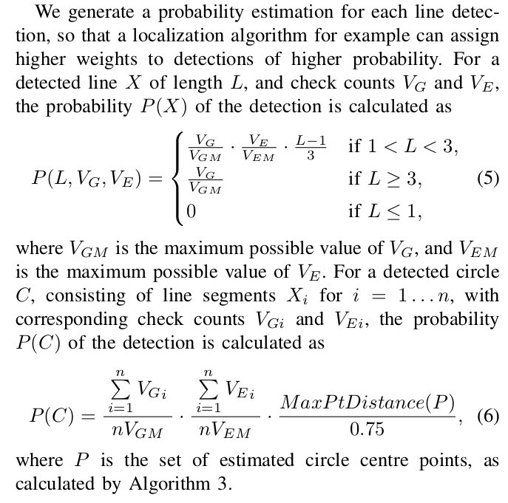
Field
More care needs to be taken in our case due to the significant image distortion. It shows how the convex hull may include parts of the image that are not the field. To exclude these unwanted areas, the vertices of the connected regions are first undistorted before calculating the convex hull. The convex hull points and intermediate points on each edge are then distorted back into the raw captured image, and the resulting polygon is taken as the field boundary.
- Shape
An island can be represented as a contour.
  - MaxAcceptDistance: Max acceptable distance of undistorted field points to the robot.
  - maxContourCount: Max contour on the field. Simply speaking how many islands in the field are. Small island that satisfy the conditions can be merged to a bigger island.
  - MaxDownDiffPixel: Max different height between camera height to the bottom of an island, in pixel.
  - MinAcceptX: Min acceptable x pos on real coordinate of undistorted field points x on unrotated camera yaw.
  - minArea: Min area of an island, in pixel.

Circle
- MaxLineLength: Max length of line to form a circle in metre.
- MinLineLength: Min length of line to form a circle in metre.
- MinLineSegmentCount: Min number of line segments to be said as a circle.
- maxDistBetween2LS: Max distance between two line segments, in metre.
- ConfiusedDist: Min distance of a circle point to another circle point to be said as “confiused”. If it is “confiused”, it shows yellow circle in rviz, otherwise gray. I am not sure why must be said “confiused”. It shows as an input argument to localization but the variable is not used.
- Coef
  - RadiusMaxCoef: Max radius coefficient, which is multiplied by radius of field circle, of the distance between a line segment to the intersection point. More specifically, pls1 and pls2 contain perpendicular lines of line-segment1 and 2, respectively. The intersection point is computed from the intersection of pls1 and pls2.
  - RadiusMinCoef: Min radius coefficient, which is multiplied by radius of field circle, of the distance between a line segment to the intersection point. More specifically, pls1 and pls2 contain perpendicular lines of line-segment1 and 2, respectively. The intersection point is computed from the intersection of pls1 and pls2.

Localization
Basically, localization is computed using 5 field lines, that are center, left, right, front, back lines.
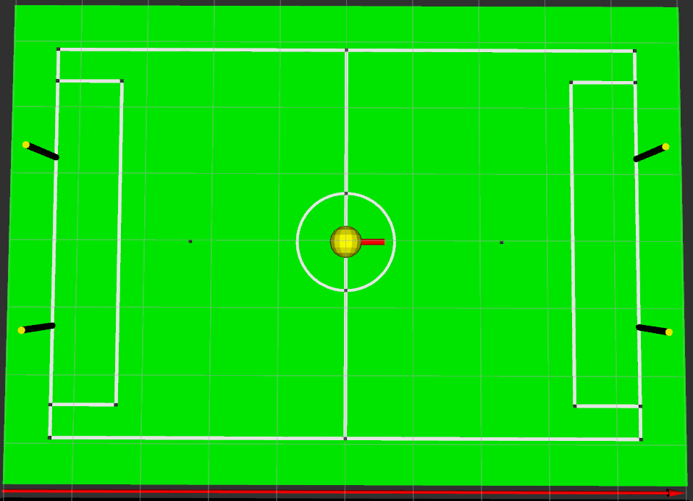
BACK
FRONT
LEFT
RIGHT
CENTER
Left and Right lines are called vertical lines, while back, center, and front are called horizontal lines.
- Coef
This is the implementation of coefficient
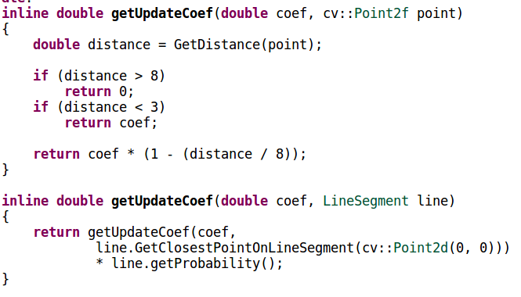
  - TOTALGAIN: Each below coefficient is multiplied with this value.
  - UPDATENORMAL: Coefficient for center, left, and right field lines. And when single goal line is detected.
  - UPDATESTRONG: Coefficient for front and back field lines. And when the two goal lines are detected.
  - UPDATEWEAK: Coefficient for detected center circle.
- Coefs
  - VerLineMinDistanceToUpdate: Min distance between a line to the robot, for the line to be considered as vertical line (left or right side boundary field line, robot facing to away goal / zero heading). In metre.
- MinLineLength: Min length of lines, below this value a line is ignored for localization.
- Enable: enable localization.
- UseKalman: Enable using Kalman filter for localization.
- forwardRobotTrackerXY:
- forwardRobotTrackerZ:

Training Image Sample
- Activate vision-gui-saveSample in config server.
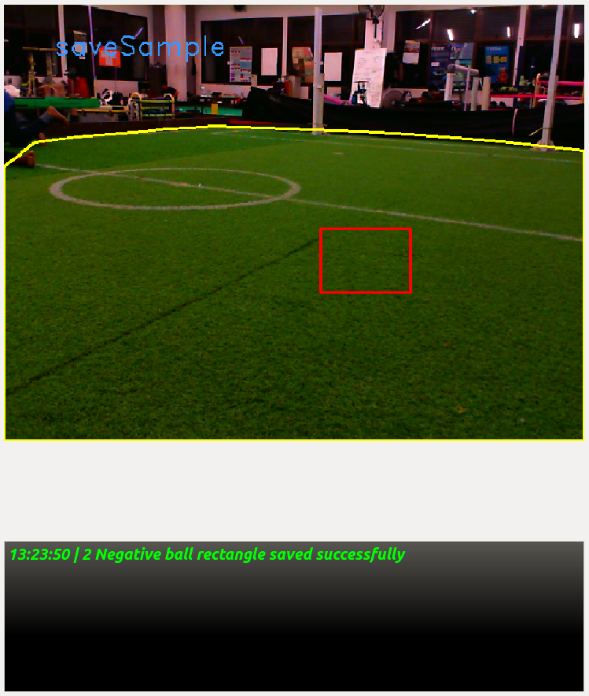
- In rqt_vision_module view, draw a rectangle indicating a ball using click and hold left click mouse button. It is desirable to draw a rectangle as tight as possible to a ball.
- Press shift+right click to save rectangle image sample as positive and ctrl+right click as negative. ctrl+alt+right click to save the whole image as negative.

Setup Camera Configuration
In the folder ./install/share/launch/config/vision there are 3 files for camera configuration, namely, logitechConfig.txt, logitechConfig_default.txt, and logitechConfig_off.txt.
To generate those files use this command:
v4l2ctrl -d /dev/video0 -s logitechConfig.txt
In the program flow, at first logitechConfig_default.txt is used as camera config for certain milliseconds, then logitechConfig.txt is applied. This is to let camera to use auto exposure enabled to adjust the camera for certain milliseconds, then the desired camera config uses logitechConfig.txt.
- Generate default camera config by running guvcview
- In the image control tab, make sure auto exposure is enabled and adjust to the desired value.
- Open terminal, type v4l2ctrl -d /dev/video0 -s logitechConfig_default.txt
- Place the file logitechConfig_default.txt to ./install/share/launch/config/vision folder.
- Set to the desired config, run guvcview again
- Set to the desired config and make sure auto exposure is disabled.
- In terminal, type v4l2ctrl -d /dev/video0 -s logitechConfig.txt.
- Place the file logitechConfig.txt to ./install/share/launch/config/vision folder.
- And do the same for logitechConfig_off.txt, but set what the camera config looks like when it is in off state.

Camera Calibration
- Open terminal and run roscore
- Open a new terminal and type roslaunch launch camera_calib.launch
- Open a new terminal and run rqt. Make sure rqt_vision_module and paremeter_tuner plugins are loaded.
- Set the parameter in vision->camera in parameter_tuner. Delay=200ms and framecount=60 should be best.
- Place checkerboard in front of the camera to calibrate.
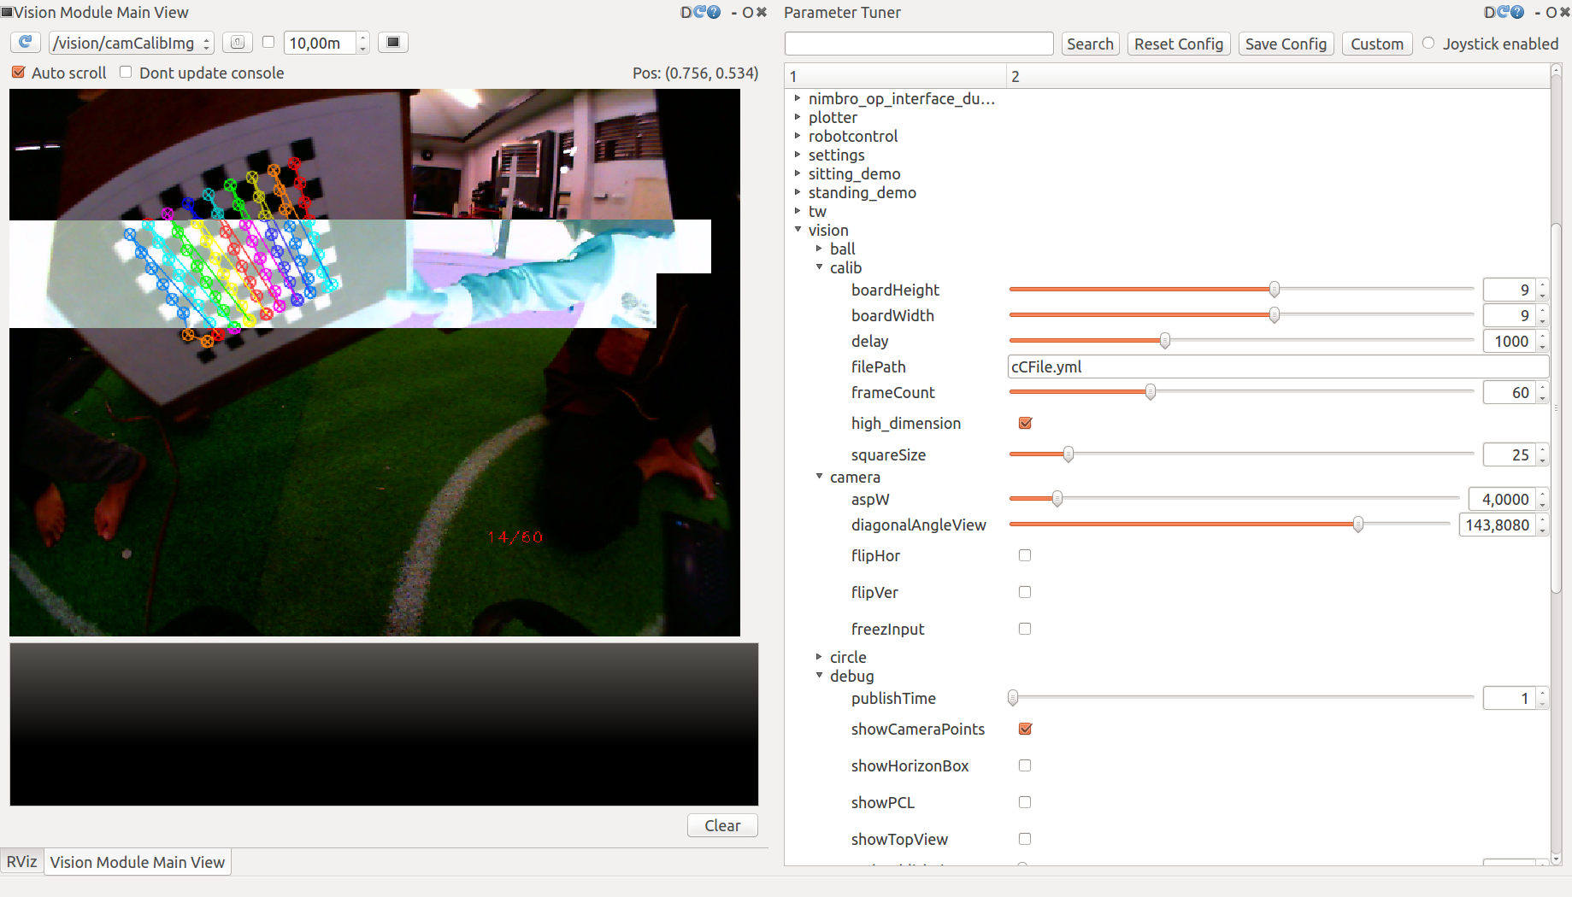
- We found that placing checkerboard around center with few rotation should give best result. Calibration will fail when running vision_module and encounter this error “Calculated Boundry if symetrical => ( width = -639 , height = -477)”, this value should be positive. This value is negative due to overflow of integer value, the real value is infinite due to error.

Camera Kinematic Calibration
- Open rqt_vision_module, parameter_tuner, and rviz.
- Disable localization in parameter_tuner.
- In rviz set LocDisplay reference frame to ego_floor first to precisely set robot location.
- Activate set location in vision→gui→rviz→setLoc.
- In rviz use publish point tool and click on the desired robot position in the field.
- Activate back localization.
- Activate tf kinematic calibration in parameter_tuner. Set aspect ratio width vision→camera→aspW to 4.0 since internally aspect ratio height is set to 3.0
- Set vision→camera→diagonalAngleView to the suggested value while running vision_module “Suggested Diagonal Camera Angle = 133.211”.
- Set vision→tf→orientation to zero
- Actiavate calibration in vision→gui→rviz→setCalibTF and vision→gui->tfCalib.
- Before doing auto calibration, increase the value vision→tf→orientation.y so that camera view is pointing to the field.
- Place real robot to the middle of field. In rqt_vision_module, click several points to match with the real distance in the field. For example, click penalty point and the two goal.

