

cake shop project

* **Faculty: Ho Hoan Kiem**
* **Batch:**
* **Team Member:**
  + - * **Nguyen Vu Tuan Anh**

**Ho Chi Minh City, Nov 11 2020**

Table of Contents

1. Review 1

* **Problem Definition..…………………………………………………………………………………01**
* **Customer Request Specification……………………………………………………………… 02**

1. Review 2

* ***Use Case Diagram* 04**
* ***Class Diagram* 15**
* ***ERD* 18**
* ***Entity Description* 19**
* ***Table Relationship Diagram* 26**

1. Review 3

* Interface Design………………………………………………………………………………..... 27
* Tasksheet……………………………………………………………………………………………. 56

REVIEW 1

Problem Definition

1. **The Object Of The Project**

This project will aim at providing a convenient way to by cake online. This will be accessible to all customers who have a valid User Id and Password. This system provides the following facilities:

* Create new account
* Search the cake you want
* Add cake to cart
* Check out with shipping information
* View your orders history

Customer Request   
 Specification

1. **Functional Requirements**

Following is a list of functionalities of the system. More functionalities that you find appropriate can be added to this list.

* Customer must have a valid User Id and password to login to the system
* If a wrong password is given thrice in succession, that account will be locked and the customer will not be able to use it. When an invalid password is entered a warning is given to the user that his account is going to get locked.
* Customers can search cake by name.
* Customer can change the amount of cake they want to add to their cart.
* Customer can delete unwanted cake from cart.
* Customer can view the order and its order detail.

# Hardware/ Software Requirements

By adding new technologies such as ASP.NET 4.5, AJAX, Web Service and 3-tier architecture, the web site becomes more interactive with users, security and easily updated.

1. **System Requirement**

* **For Users**
  + **Hardware**
    - CPU: Intel Core i5 2.0 GHz or higher
    - RAM: 1024 MB or higher
  + **Software**
    - OS: Windows 7/XP Professional and above..
    - Browser: Internet Explorer 8.0 or higher
* **For Software Developers**
  + **Hardware**
    - CPU: Intel Core i5 2.0 GHz or higher
    - RAM: 2048 MB or higher
  + **Software**
    - OS: Windows 7 Professional and above…
    - Environment: Microsoft .NET Framework 3.5
    - Database Management System: Microsoft SQL Server 2014
    - IDE: Microsoft Visual Studio 2019

|  |  |  |
| --- | --- | --- |
| **Date: Sep 10, 2012** | **Prepared by Project**  **Team Leader:** | **Approved by**  **Mr Ho Hoan Kiem** |
| **Signature** | **Anh** |  |

REVIEW 2

**USE CASE DIAGRAM**

**Customer :**

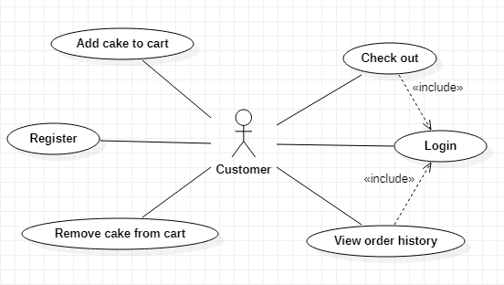

**Administrators :**

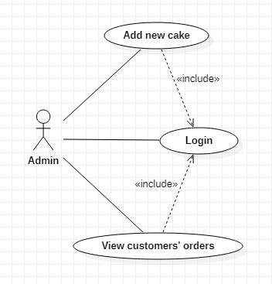

**USE CASE DESCRIPTION**

1. **Actor:**

* **Customers:** include all visitors that use this website. They are guests and members. ***Guest*** is the person that uses this website but doesn’t register. ***Member*** is the person that uses this website and register to become a member of us.
* **Website administrators:** The person(s) that manage and maintain this web site.

1. **Usecase:**

|  |  |
| --- | --- |
| **Usecase** | Register |
| **Short Description** | Register account to become a member of the web site. |
| **Pre-Conditions** |  |
| **Post-Conditions** |  |
| **Main flow** | _Guest must provide mandatory information :   * Username * Password. * Confirm Password. * Phone * Address   _Guest clicks on Register button.  _System checks the information which guest provided  _System create new account for guest that registers to this website.  _Guest becomes a member of this website. |
| **Alternative flow(s)** | _If the mandatory information that guest provided, is missed or not exactly, system notify the error. All cases are :   * Username has existed in Database. * Password is less than 6 characters or more than 30 characters. * Confirm Password and Password are not the same. * Any fields are blank.   _If the information that guest provided, is invalid form, system notify the error. All cases are :   * Phone number has any character is not a digit. |

|  |  |
| --- | --- |
| **Usecase** | Login |
| **Short Description** | Log in website to use any function of member. |
| **Pre-Conditions** |  |
| **Post-Conditions** |  |
| **Main flow** | _Guest inputs the login information :   * Username. * Password.   _Guest clicks on the Login button.  _System check the Username and Password.  _If Username and Password are valid, system will move member to Homepage.  _ If a wrong password is given thrice in succession, that account will notify and the customer will have to retry. |
| **Alternative flow(s)** | _If Username field or Password field is invalid form or blank when guest clicks on the “Login” button, system will notify the error. |

|  |  |
| --- | --- |
| **Usecase** | Check out |
| **Short Description** | Customers can checkout |
| **Pre-Conditions** |  |
| **Post-Conditions** |  |
| **Main flow** | _Guest login to this website.  _Customer click to view the cake’s information.  _Customer input the number of cake  _Customer click the checkout button. |
| **Alternative flow(s)** | _If the cake’s quantity is down to 0, the system show the “Out of stock”  Message.  _Customer can remove cake from cart  _The checkout button is invisible if there are no cake in cart. |

|  |  |
| --- | --- |
| **Usecase** | View Customer’s Orders |
| **Short Description** | Administrator view customer’s order. |
| **Pre-Conditions** |  |
| **Post-Conditions** |  |
|  |  |
|  |  |
| **Main flow** | Administrator clicks on the “View all orders” button.  _Administrator choose the order that administrator wants to see information.  _System shows the customer’s order to the administrator. |
| **Alternative flow(s)** | _If server notifies any error when it’s processing, system must be write report into Log file. |

|  |  |
| --- | --- |
| **Usecase** | Administrator Add new cake |
| **Short Description** | Add new cake to the system |
| **Pre-Conditions** |  |
| **Post-Conditions** |  |
| **Main flow** | _Admin can add new cake to the system by input the field.  _System check this information is valid and save it on the server.  _System show new cake on the main page. |
| **Alternative flow(s)** | _If any information input are invalid, system will notify the error. |

|  |  |
| --- | --- |
| **Usecase** | Search cakes |
| **Short Description** | Search all cake’s information in the system. |
| **Pre-Conditions** |  |
| **Post-Conditions** |  |
| **Main flow** | _Customer inputs the information that wants to see in the search field.  _Customer clicks on the “Search” button.  _System shows the result to the customer. |
| **Alternative flow(s)** |  |

**CLASS DIAGRAM**

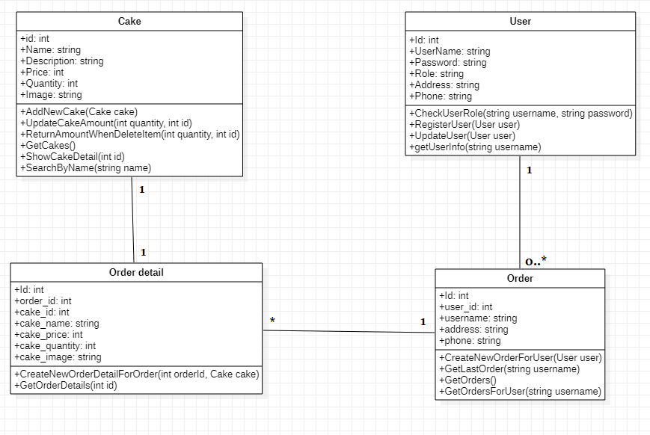

**ENTITY RELATIONSHIP DIAGRAM (ERD)  
  
  
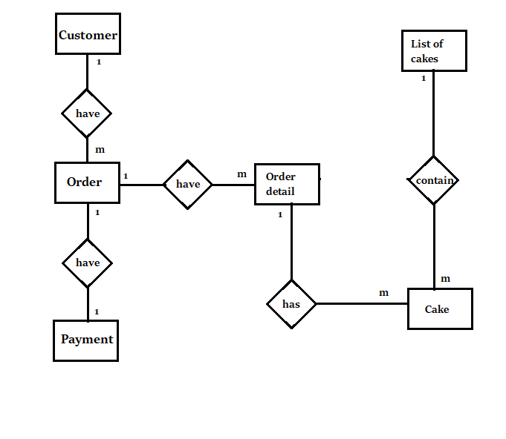  
  
ENTITY DESCRIPTION**

* 1. **Account Customer :**

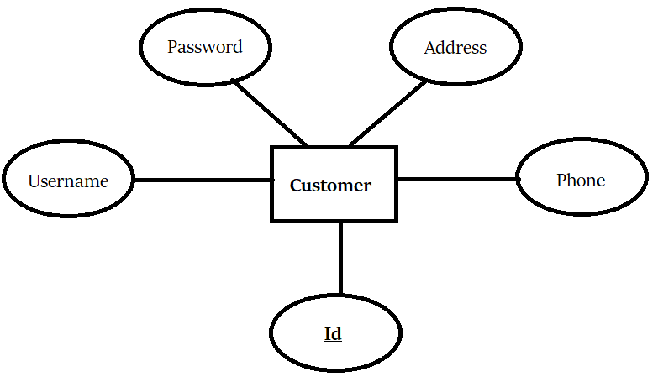

* 1. **Order:**

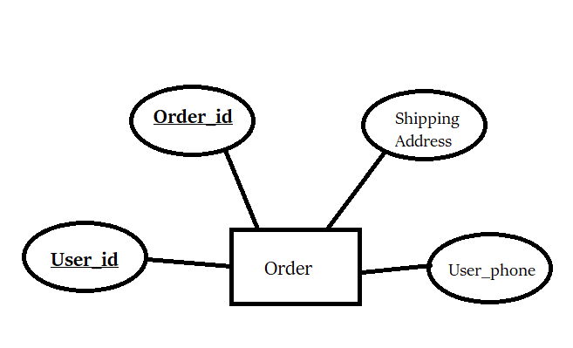

* 1. **Order detail:**

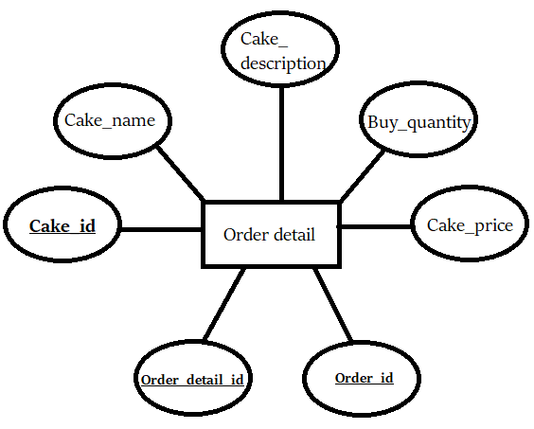

* 1. **Cake:**

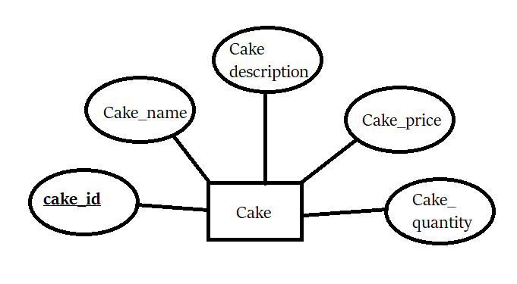

**TABLE DESIGN**

1. **Account User:**

|  |  |  |  |  |  |
| --- | --- | --- | --- | --- | --- |
| **No** | **Column Name** | **Data Type** | **Size** | **Check** | **Description** |
| 1 | **🗝**Id | int | Identity | Not Null | User ID |
| 2 | ✓Username | nvarchar | 255 | Not Null | User’s username |
| 3 | Password | nvarchar | 255 | Not Null | User’s password |
| 4 | role | nvarchar | 10 | Not Null | User’s role |
| 6 | address | nvarchar | 50 | Allow Null | User’s address |
| 7 | ✓phone | nvarchar | 50 | Allow Null | User’s contact number |

1. **Cake Information :**

|  |  |  |  |  |  |
| --- | --- | --- | --- | --- | --- |
| **No** | **Column Name** | **Data Type** | **Size** | **Check** | **Description** |
| 1 | **🗝**Id | Int | Identity | Not Null | ID |
| 2 | Cake_name | nvarchar | 255 | Not Null | Cake’s name |
| 3 | Cake_description | nvarchar | MAX | Not Null | Cake’s description |
| 4 | Cake_price | int |  | Not Null | Cake unit price |
| 5 | Cake_quantity | int |  | Not Null | Cake quantity in stock |
| 6 | Cake_image | nvarchar | MAX | Not Null | Cake_image |

1. **Order :**

|  |  |  |  |  |  |
| --- | --- | --- | --- | --- | --- |
| **No** | **Column Name** | **Data Type** | **Size** | **Check** | **Description** |
| 1 | **🗝**Order_id | int | Identity | Not Null | Order’s id |
| 2 | User_id | int | Identity | Not Null | Buyer’s id |
| 3 | username | nvarchar | 255 | Not Null | Buyer’s username |
| 4 | address | nvarchar | 255 | Not Null | Buyer’s address |
| 5 | phone | nvarchar | 255 | Not Null | Buyer’s contact number |

1. **Order detail:**

|  |  |  |  |  |  |
| --- | --- | --- | --- | --- | --- |
| **No** | **Column Name** | **Data Type** | **Size** | **Check** | **Description** |
| 1 | **🗝**Order_detail_ID | int | Identity | Not Null | Order detail’s ID |
| 2 | Order_detail | int | Identity | Not Null | Order’s id |
| 3 | Id | Int | Identity | Not Null | ID |
| 4 | Cake_name | nvarchar | 255 | Not Null | Cake’s name |
| 5 | Cake_description | nvarchar | MAX | Not Null | Cake’s description |
| 6 | Cake_price | int |  | Not Null | Cake unit price |
| 7 | Cake_quantity | int |  | Not Null | Cake quantity in stock |
| 6 | Cake_image | nvarchar | MAX | Not Null | Cake_image |

**Note**

**🗝** Primary key

✓ Unique constraint

**TABLE RELATIONSHIP DIAGRAM**

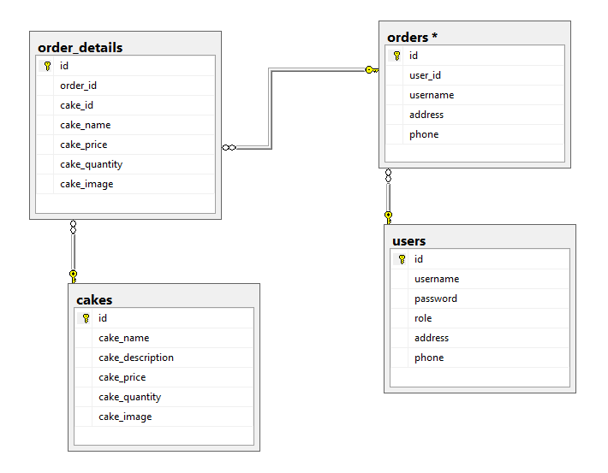

|  |  |  |
| --- | --- | --- |
| **Date: Sep 20, 2012** | **Prepared by Project Group 4**  **Team Leader:** | **Approved by**  **Mr. Ho Hoan Kiem** |
| **Signature** |  |  |

REVIEW 3

**INTERFACE DESIGN**

1. **Home Page**

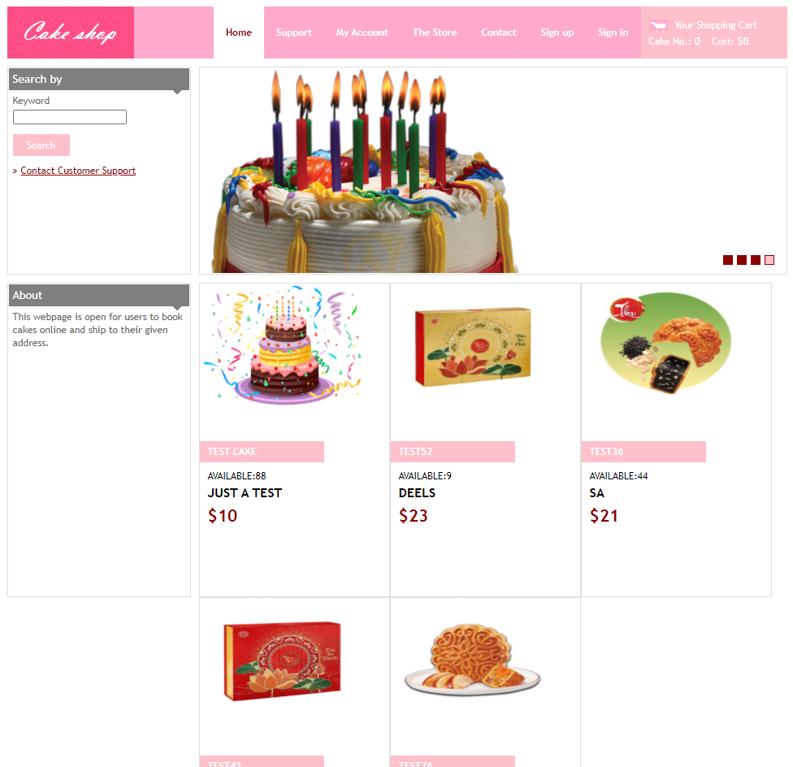

1. **Login:**

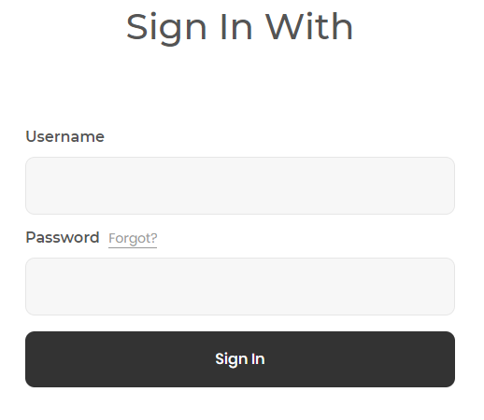

1. **Register new account:**

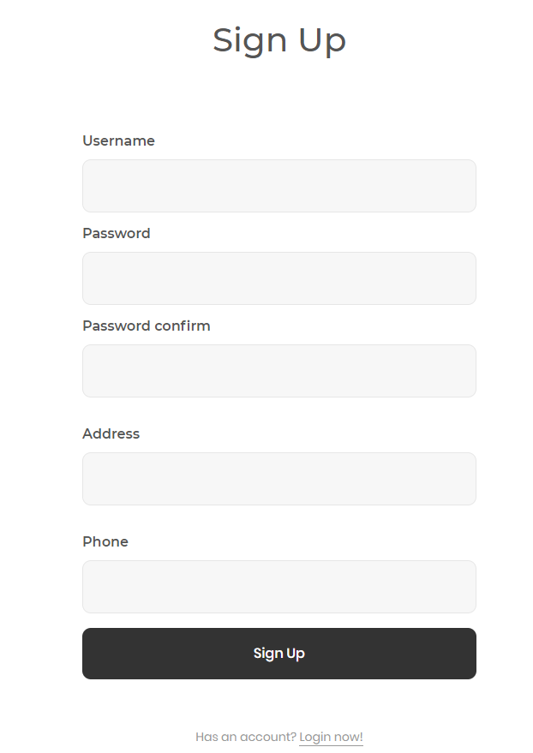

1. **Cake description page:**

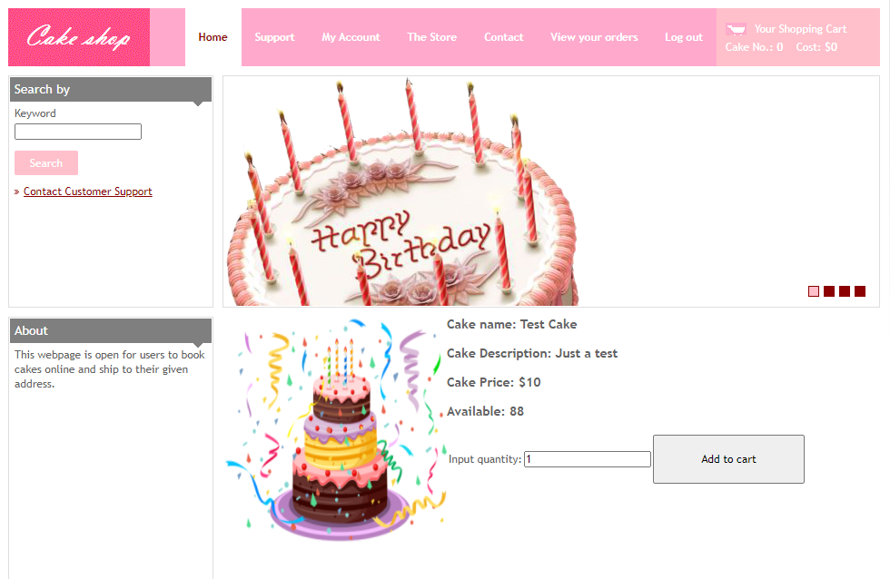

1. **Cart:**

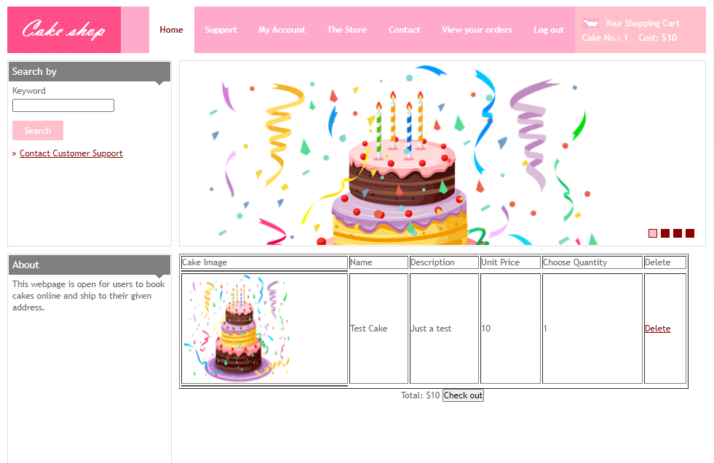

1. **Update info before check out:**

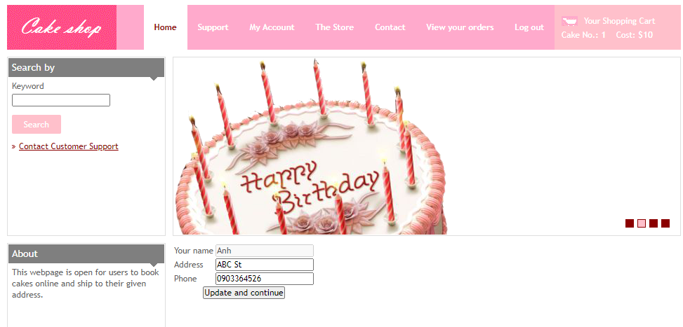

1. **User orders history:**

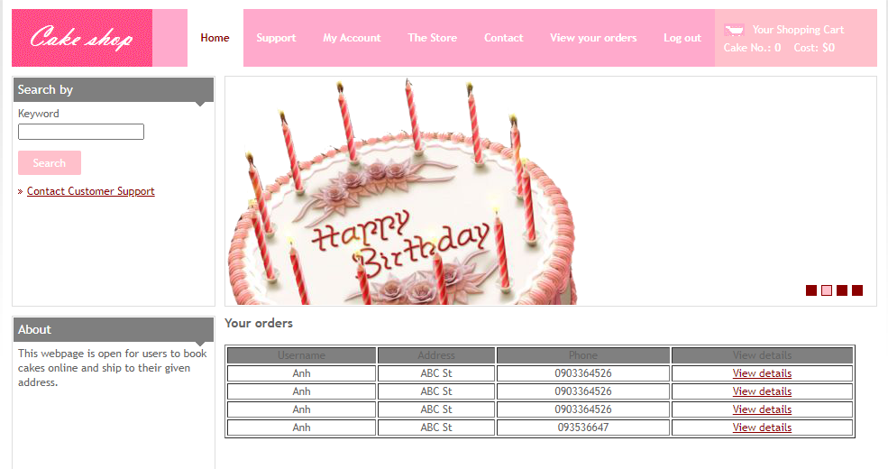

1. **User order’s detail:**

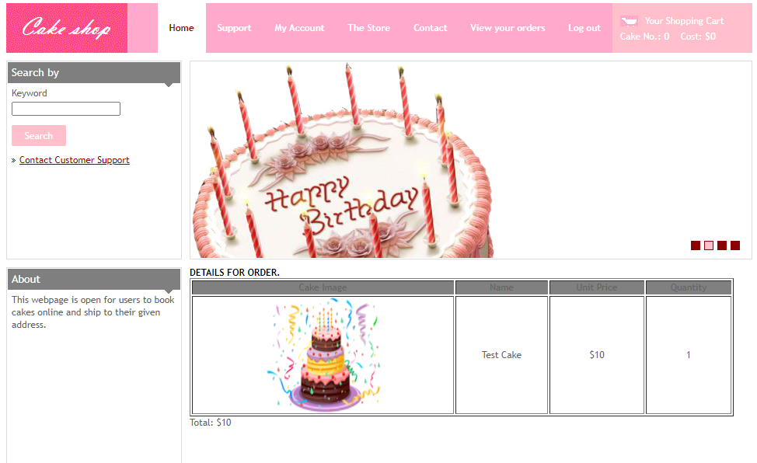

1. **Admin’s add cake:**

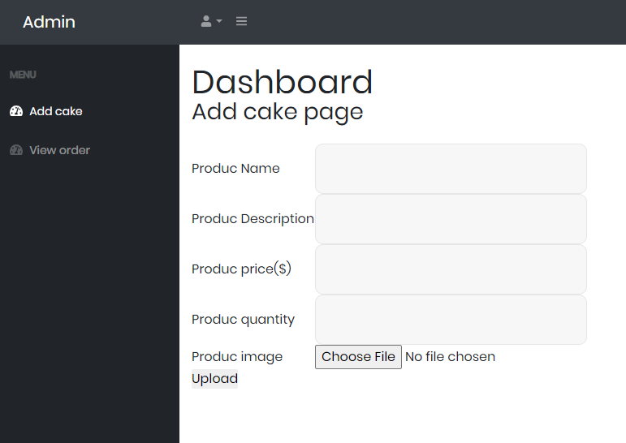

1. **Admin users’ order view:**

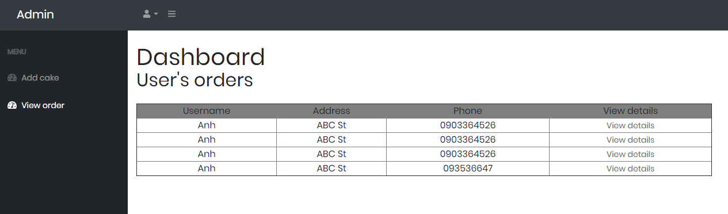

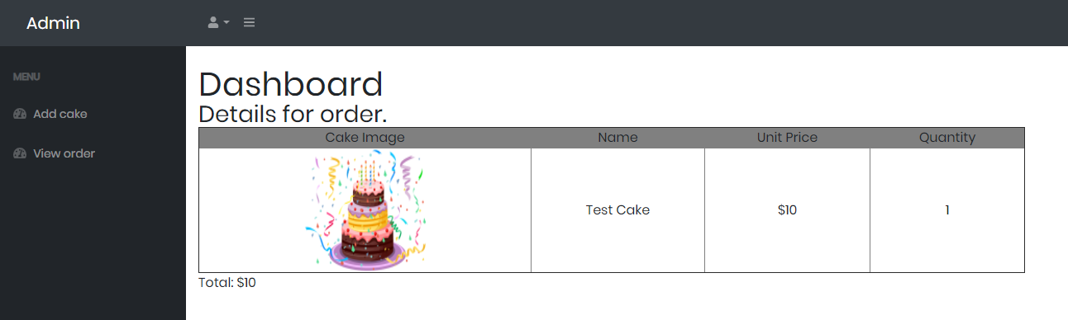

|  |  |  |
| --- | --- | --- |
| **Date: Oct 10, 2012** | **Prepared by Project Group 4**  **Team Leader:** | **Approved by**  **Mr. Ho Hoan Kiem** |
| **Signature** |  |  |