Game Design Document

Fill up the Following document

1. Write the title of your project.

Ans. Math Shooting

1. What is the goal of the game?

Ans. The goal of game is that player shoot the villain with the same pawer which given in it if power is less than the villain power so the player get next change to shoot but in 6 sec if the player is not able to shot in 6 sec so the game is over. If the power is much than the bullet is crosse through the villain and shoot the BOOM and the player is also die and game is over. The villain power should be given in simple math’s equation. And get the money (100 per kill).

1. Write a brief story of your game?

Ans. There is a agent how get the information that the villain has a BOOM

and launch into India to blast it but the player find him and shot him

And give the BOOM to Police.

1. Which are the playing characters of this game?

* Playing characters are the ones which respond to the user based on the input from the user
* Cars, monkeys, dinos, wizards etc, are the playing characters in the game.

|  |  |  |
| --- | --- | --- |
| Number | Character Name | What can this character do? |
| 1 | Player | Shoot and Select the weapon. |
| 2 | Villain | Escaped or Die. |
| 3 |  |  |
| 4 |  |  |
| 5 |  |  |
| 6 |  |  |
| 7 |  |  |
| 8 |  |  |

1. Which are the Non Playing Characters of this game?

* Non Playing characters are the ones which don't have an action or a behaviour when the user interacts with the game.
* Hurdles, stones, bananas, coins, etc are non playing characters in the game.

|  |  |  |
| --- | --- | --- |
| Number | Character Name | What can this character do? |
| 1 | BOOM | Blast |
| 2 | Weapon | Shoot |
| 3 | Bullet | fire |
| 4 |  |  |
| 5 |  |  |
| 6 |  |  |
| 7 |  |  |
| 8 |  |  |

Draw your imagination of this game. What does this game look like?

* Draw the game either on your computer or on paper,
* Add images of scenes of the game to show each of the playing and non-playing characters at least once.

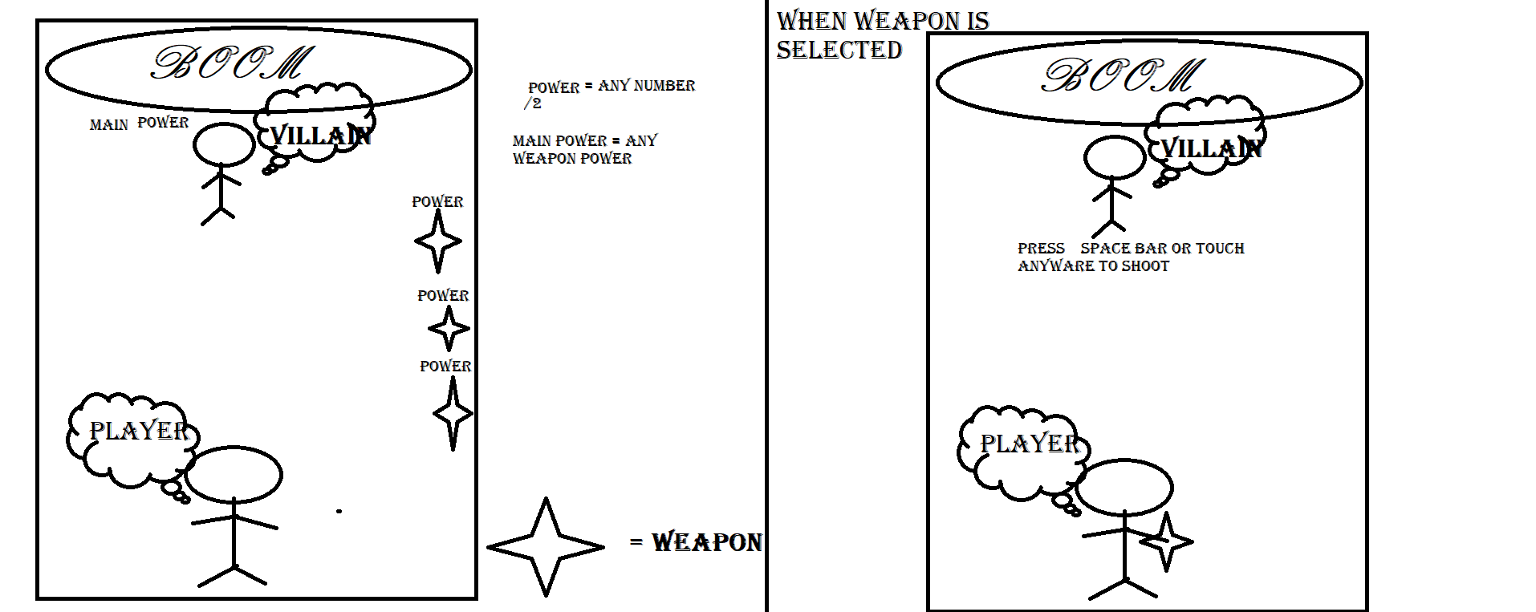

How do you plan to make your game engaging?

Ans. By playing other game and take ideas to make my game engaging.