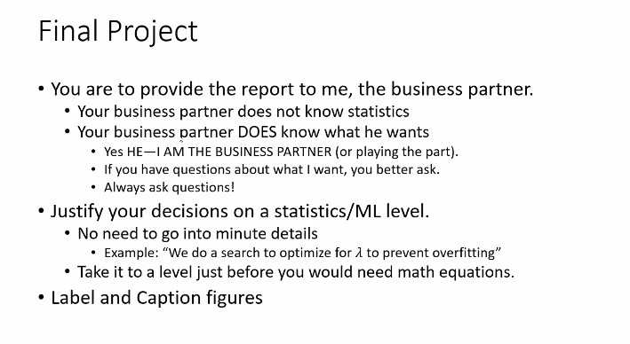

1. Explore Data
2. Impute Data
   1. Remove Highly Correlated Features
   2. Categorical Features
      1. Remove
      2. One-Hot Encode
      3. Assign numeric value
   3. Correct misspellings
   4. Normalize data
3. Basic ML models
   1. Logistic Regression
   2. Random Forest
   3. Cluster : K-means
4. Advanced ML Models
   1. Ensemble
   2. Neural Net
5. Dimension Reduction/ Feature Engineer
   1. PCA