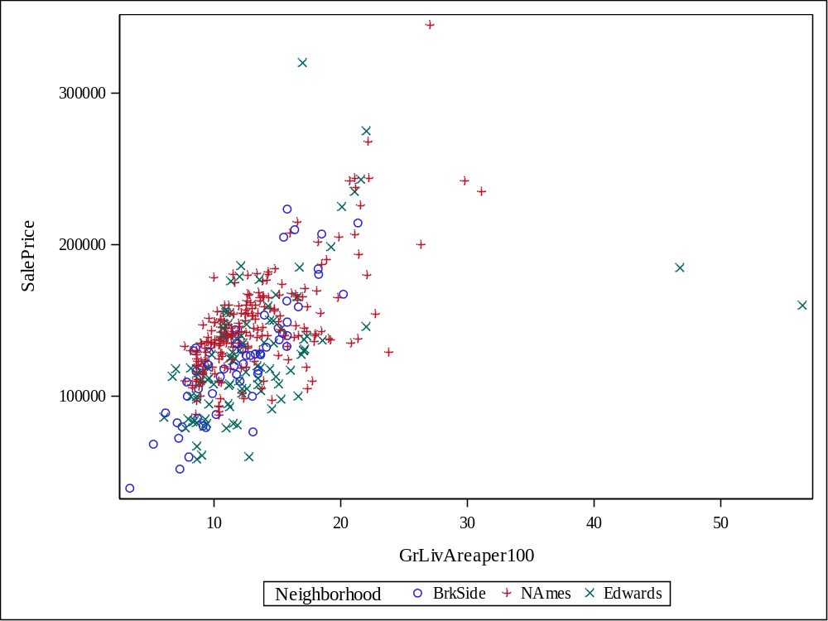

Class Level Information
Class | Levels | Values
Neighborhood | 3 | BrkSide Edwards NAmes

Number of Observations Read | 383
Number of Observations Used | 383

Source | DF | Sum of Squares | Mean Square | F Value | Pr > F
Model | 5 | 248809044707 | 49761808941 | 61.04 | <.0001
Error | 377 | 307343083951 | 815233644.43
Corrected Total | 382 | 556152128658

R-Square | Coeff Var | Root MSE | SalePrice Mean
0.447376 | 20.68070 | 28552.30 | 138062.5

Source | DF | Type I SS | Mean Square | F Value | Pr > F
GrLivAreaper100 | 1 | 190367576250 | 190367576250 | 233.51 | <.0001
Neighborhood | 2 | 30140030207 | 15070015103 | 18.49 | <.0001
GrLivArea*Neighborho | 2 | 28301438250 | 14150719125 | 17.36 | <.0001

Source | DF | Type III SS | Mean Square | F Value | Pr > F
GrLivAreaper100 | 1 | 175551611085 | 175551611085 | 215.34 | <.0001
Neighborhood | 2 | 19551639383 | 9775819691.3 | 11.99 | <.0001
GrLivArea*Neighborho | 2 | 28301438250 | 14150719125 | 17.36 | <.0001

Observation |  | Observed | Predicted | Residual | 95% Confidence Limits for Mean Predicted Value
1 |  | 118000.0000 | 113845.5614 | 4154.4386 | 106085.2342 | 121605.8886
2 |  | 157000.0000 | 142734.1776 | 14265.8224 | 138955.4595 | 146512.8956
3 |  | 132000.0000 | 94408.3166 | 37591.6834 | 84437.3186 | 104379.3147
4 |  | 149000.0000 | 129209.5277 | 19790.4723 | 124547.9937 | 133871.0618
5 |  | 139000.0000 | 147405.3418 | -8405.3418 | 143653.5237 | 151157.1598
6 |  | 134800.0000 | 123560.6780 | 11239.3220 | 118282.1106 | 128839.2454
7 |  | 207500.0000 | 161581.7819 | 45918.2181 | 157008.5324 | 166155.0315
8 |  | 68500.0000 | 65296.0307 | 3203.9693 | 50231.0219 | 80361.0396
9 |  | 165500.0000 | 167013.3682 | -1513.3682 | 161865.0110 | 172161.7254
10 |  | 153000.0000 | 145124.0755 | 7875.9245 | 141379.3476 | 148868.8034
11 |  | 109000.0000 | 132088.2685 | -23088.2685 | 127696.3420 | 136480.1950
12 |  | 82000.0000 | 122625.4531 | -40625.4531 | 116782.4084 | 128468.4978
13 |  | 160000.0000 | 146590.6038 | 13409.3962 | 142845.7638 | 150335.4438
14 |  | 141000.0000 | 137139.6437 | 3860.3563 | 133124.2520 | 141155.0353
15 |  | 114500.0000 | 122474.6521 | -7974.6521 | 115084.5220 | 129864.7823
16 |  | 130000.0000 | 148545.9749 | -18545.9749 | 144776.1484 | 152315.8014
17 |  | 180500.0000 | 152076.5059 | 28423.4941 | 148191.8075 | 155961.2044
18 |  | 180000.0000 | 194551.5106 | -14551.5106 | 185597.2856 | 203505.7356
19 |  | 244000.0000 | 195420.5644 | 48579.4356 | 186334.2779 | 204506.8509
20 |  | 144900.0000 | 133663.4285 | 11236.5715 | 129403.2477 | 137923.6093
21 |  | 135750.0000 | 126385.1029 | 9364.8971 | 121427.8799 | 131342.3259
22 |  | 127000.0000 | 131975.3682 | -4975.3682 | 124437.0461 | 139513.6903
23 |  | 193500.0000 | 191020.9795 | 2479.0205 | 182598.8243 | 199443.1348
24 |  | 126500.0000 | 132522.7954 | -6022.7954 | 128168.4018 | 136877.1890
25 |  | 109900.0000 | 131164.8988 | -21264.8988 | 126690.3510 | 135639.4466
26 |  | 98600.0000 | 141756.4920 | -43156.4920 | 137951.8678 | 145561.1163
27 |  | 94750.0000 | 116913.3951 | -22163.3951 | 110414.9334 | 123411.8567
28 |  | 83000.0000 | 113194.6073 | -30194.6073 | 106092.8612 | 120296.3533
29 |  | 128950.0000 | 141213.3334 | -12263.3334 | 137391.3770 | 145035.2898
30 |  | 136900.0000 | 143539.9157 | -6639.9157 | 136385.5334 | 150694.2981
31 |  | 155000.0000 | 121822.1950 | 33177.8050 | 115910.4882 | 127733.9017
32 |  | 136000.0000 | 133337.5333 | 2662.4667 | 129051.0872 | 137623.9794
33 |  | 155000.0000 | 147894.1845 | 7105.8155 | 144135.8202 | 151652.5488
34 |  | 150000.0000 | 131871.0050 | 18128.9950 | 127459.9840 | 136282.0260
35 |  | 226000.0000 | 191835.7175 | 34164.2825 | 183291.4480 | 200379.9870
36 |  | 150750.0000 | 146753.5514 | 3996.4486 | 143007.7102 | 150499.3926
37 |  | 143000.0000 | 140615.8589 | 2384.1411 | 136772.4536 | 144459.2642
38 |  | 115000.0000 | 121605.3069 | -6605.3069 | 116091.5846 | 127119.0293
39 |  | 166000.0000 | 149903.8714 | 16096.1286 | 146100.2567 | 153707.4862
40 |  | 130000.0000 | 139196.3716 | -9196.3716 | 132745.4377 | 145647.3055
41 |  | 105000.0000 | 96238.7298 | 8761.2702 | 86535.1130 | 105942.3466
42 |  | 115000.0000 | 137117.9576 | -22117.9576 | 129263.6151 | 144972.3001
43 |  | 79000.0000 | 120959.4362 | -41959.4362 | 114964.8049 | 126954.0675
44 |  | 109500.0000 | 131164.8988 | -21664.8988 | 126690.3510 | 135639.4466
45 |  | 127500.0000 | 128664.7645 | -1164.7645 | 123049.1159 | 134280.4132
46 |  | 215000.0000 | 164623.4702 | 50376.5298 | 159740.5634 | 169506.3770
47 |  | 163000.0000 | 148654.6066 | 14345.3934 | 144882.5677 | 152426.6455
48 |  | 243000.0000 | 152554.2573 | 90445.7427 | 143546.6545 | 161561.8602
49 |  | 120000.0000 | 128218.5100 | -8218.5100 | 122604.3393 | 133832.6807
50 |  | 127000.0000 | 129099.0046 | -2099.0046 | 121667.4032 | 136530.6060
51 |  | 184000.0000 | 155009.5625 | 28990.4375 | 150966.0245 | 159053.1006
52 |  | 130000.0000 | 139196.3716 | -9196.3716 | 132745.4377 | 145647.3055
53 |  | 235000.0000 | 243707.3664 | -8707.3664 | 226939.9495 | 260474.7833
54 |  | 140000.0000 | 121703.1938 | 18296.8062 | 115780.6062 | 127625.7813
55 |  | 141000.0000 | 134423.8506 | 6576.1494 | 130222.8511 | 138624.8500
56 |  | 145000.0000 | 133989.3237 | 11010.6763 | 129754.8714 | 138223.7759
57 |  | 98000.0000 | 114057.3660 | -16057.3660 | 107105.7604 | 121008.9717
58 |  | 186000.0000 | 124410.4713 | 61589.5287 | 118689.0445 | 130131.8981
59 |  | 134450.0000 | 141810.8079 | -7360.8079 | 138007.8022 | 145613.8136
60 |  | 97000.0000 | 121605.3069 | -24605.3069 | 116091.5846 | 127119.0293
61 |  | 148000.0000 | 139529.5417 | 8470.4583 | 135640.8759 | 143418.2074
62 |  | 113000.0000 | 132591.8044 | -19591.8044 | 126836.7559 | 138346.8530
63 |  | 140000.0000 | 149360.7128 | -9360.7128 | 145572.2061 | 153149.2196
64 |  | 76500.0000 | 133805.7814 | -57305.7814 | 126172.7953 | 141438.7675
65 |  | 158000.0000 | 145395.6548 | 12604.3452 | 141652.1151 | 149139.1946
66 |  | 145000.0000 | 146047.4452 | -1047.4452 | 142304.5151 | 149790.3752
67 |  | 176000.0000 | 149740.9238 | 26259.0762 | 145942.0627 | 153539.7850
68 |  | 148000.0000 | 121465.1913 | 26534.8087 | 115520.3030 | 127410.0797
69 |  | 139000.0000 | 163319.8895 | -24319.8895 | 158573.8757 | 168065.9033
70 |  | 205000.0000 | 154899.1143 | 50100.8857 | 144981.5332 | 164816.6953
71 |  | 159000.0000 | 168860.1075 | -9860.1075 | 163495.2730 | 174224.9421
72 |  | 88000.0000 | 121279.4118 | -33279.4118 | 115725.5978 | 126833.2257
73 |  | 153575.0000 | 141650.4093 | 11924.5907 | 133397.3311 | 149903.4875
74 |  | 131000.0000 | 139404.6237 | -8404.6237 | 132923.7861 | 145885.4613
75 |  | 167000.0000 | 163971.6799 | 3028.3201 | 159157.9638 | 168785.3960
76 |  | 82500.0000 | 113968.1151 | -31468.1151 | 107001.2428 | 120934.9874
77 |  | 132000.0000 | 127471.4201 | 4528.5799 | 122631.2256 | 132311.6146
78 |  | 242000.0000 | 236429.0408 | 5570.9592 | 220844.1959 | 252013.8857
79 |  | 145250.0000 | 149795.2397 | -4545.2397 | 145994.8150 | 153595.6644
80 |  | 214500.0000 | 205976.3584 | 8523.6416 | 186612.6818 | 225340.0349
81 |  | 119000.0000 | 168534.2124 | -49534.2124 | 163208.2382 | 173860.1865
82 |  | 139000.0000 | 132033.9526 | 6966.0474 | 127637.2728 | 136430.6324
83 |  | 155000.0000 | 140670.1748 | 14329.8252 | 136828.8216 | 144511.5280
84 |  | 87500.0000 | 131164.8988 | -43664.8988 | 126690.3510 | 135639.4466
85 |  | 140200.0000 | 157426.8277 | -17226.8277 | 147127.7637 | 167725.8917
86 |  | 151500.0000 | 126710.9980 | 24789.0020 | 121789.2937 | 131632.7024
87 |  | 157500.0000 | 154955.2467 | 2544.7533 | 150915.1331 | 158995.3603
88 |  | 95000.0000 | 121405.6907 | -26405.6907 | 115455.1157 | 127356.2658
89 |  | 145000.0000 | 151151.1254 | -6151.1254 | 141766.6550 | 160535.5957
90 |  | 198500.0000 | 145533.1860 | 52966.8140 | 138007.5270 | 153058.8449
91 |  | 159000.0000 | 150392.7142 | 8607.2858 | 146573.7106 | 154211.7179
92 |  | 165000.0000 | 152402.4011 | 12597.5989 | 148502.7723 | 156302.0300
93 |  | 132000.0000 | 143548.9155 | -11548.9155 | 139786.5049 | 147311.3261
94 |  | 162000.0000 | 144580.9169 | 17419.0831 | 140832.1670 | 148329.6667
95 |  | 123000.0000 | 146319.0245 | -23319.0245 | 142575.4141 | 150062.6349
96 |  | 61000.0000 | 115247.3781 | -54247.3781 | 108493.1800 | 122001.5763
97 |  | 81000.0000 | 123577.4628 | -42577.4628 | 117804.7149 | 129350.2107
98 |  | 125000.0000 | 121822.1950 | 3177.8050 | 115910.4882 | 127733.9017
99 |  | 119000.0000 | 129021.7682 | -10021.7682 | 123402.7989 | 134640.7374
100 |  | 106500.0000 | 122582.9925 | -16082.9925 | 117188.0374 | 127977.9475
101 |  | 100000.0000 | 88655.5895 | 11344.4105 | 77789.1996 | 99521.9794
102 |  | 129000.0000 | 122387.4507 | 6612.5493 | 116524.9392 | 128249.9622
103 |  | 169500.0000 | 173096.7448 | -3596.7448 | 167204.2503 | 178989.2394
104 |  | 60000.0000 | 126314.4906 | -66314.4906 | 120673.2979 | 131955.6834
105 |  | 126000.0000 | 122089.9477 | 3910.0523 | 116202.0595 | 127977.8359
106 |  | 142000.0000 | 132033.9526 | 9966.0474 | 127637.2728 | 136430.6324
107 |  | 139000.0000 | 139638.1734 | -638.1734 | 135754.3914 | 143521.9554
108 |  | 109008.0000 | 123940.8890 | -14932.8890 | 118706.9066 | 129174.8715
109 |  | 119000.0000 | 98766.4433 | 20233.5567 | 89415.9387 | 108116.9478
110 |  | 110000.0000 | 123934.4664 | -13934.4664 | 118184.8954 | 129684.0375
111 |  | 118000.0000 | 131193.5402 | -13193.5402 | 125513.7578 | 136873.3226
112 |  | 162900.0000 | 157078.1776 | 5821.8224 | 146832.6928 | 167323.6624
113 |  | 127500.0000 | 138601.3655 | -11101.3655 | 132233.4996 | 144969.2314
114 |  | 190000.0000 | 177224.7504 | 12775.2496 | 170784.8427 | 183664.6581
115 |  | 110000.0000 | 124828.0405 | -14828.0405 | 117456.2732 | 132199.8079
116 |  | 167000.0000 | 144037.7583 | 22962.2417 | 140282.7985 | 147792.7180
117 |  | 146500.0000 | 163971.6799 | -17471.6799 | 159157.9638 | 168785.3960
118 |  | 148000.0000 | 120245.4289 | 27754.5711 | 114175.2530 | 126315.6049
119 |  | 147000.0000 | 135129.9568 | 11870.0432 | 130981.1852 | 139278.7283
120 |  | 156000.0000 | 132957.3223 | 23042.6777 | 128639.5679 | 137275.0766
121 |  | 133000.0000 | 160386.8329 | -27386.8329 | 155925.2773 | 164848.3886
122 |  | 155000.0000 | 143603.2314 | 11396.7686 | 139841.7354 | 147364.7273
123 |  | 184000.0000 | 178607.3231 | 5392.6769 | 164637.8344 | 192576.8118
124 |  | 120000.0000 | 124212.4684 | -4212.4684 | 119010.0917 | 129414.8450
125 |  | 140000.0000 | 124469.9719 | 15530.0281 | 118751.8394 | 130188.1043
126 |  | 124500.0000 | 131219.2147 | -6719.2147 | 126749.6320 | 135688.7973
127 |  | 164900.0000 | 148708.9225 | 16191.0775 | 144935.7451 | 152482.0998
128 |  | 129900.0000 | 121605.3069 | 8294.6931 | 116091.5846 | 127119.0293
129 |  | 150000.0000 | 142245.3348 | 7754.6652 | 138454.5206 | 146036.1490
130 |  | 159000.0000 | 165009.9680 | -6009.9680 | 153479.9570 | 176539.9791
131 |  | 184750.0000 | 227465.5188 | -42715.5188 | 198193.8897 | 256737.1479
132 |  | 132000.0000 | 125081.5222 | 6918.4778 | 119978.8899 | 130184.1544
133 |  | 86000.0000 | 106352.0377 | -20352.0377 | 97891.1362 | 114812.9393
134 |  | 128000.0000 | 138686.8832 | -10686.8832 | 130706.4385 | 146667.3278
135 |  | 107500.0000 | 119595.6200 | -12095.6200 | 113830.9197 | 125360.3204
136 |  | 39300.0000 | 49083.7997 | -9783.7997 | 30814.7653 | 67352.8341
137 |  | 107500.0000 | 128426.7621 | -20926.7621 | 122812.2715 | 134041.2527
138 |  | 111250.0000 | 121605.3069 | -10355.3069 | 116091.5846 | 127119.0293
139 |  | 133000.0000 | 116336.6683 | 16663.3317 | 110147.8921 | 122525.4445
140 |  | 210000.0000 | 162482.2546 | 47517.7454 | 151375.4058 | 173589.1034
141 |  | 108000.0000 | 121851.9453 | -13851.9453 | 115942.9305 | 127760.9600
142 |  | 113000.0000 | 111317.8480 | 1682.1520 | 103365.5612 | 119270.1347
143 |  | 141000.0000 | 133989.3237 | 7010.6763 | 129754.8714 | 138223.7759
144 |  | 108000.0000 | 117984.4060 | -9984.4060 | 111636.4252 | 124332.3867
145 |  | 185000.0000 | 138155.1110 | 46844.8890 | 131847.1774 | 144463.0446
146 |  | 135960.0000 | 125896.2601 | 10063.7399 | 120885.1227 | 130907.3976
147 |  | 142600.0000 | 168534.2124 | -25934.2124 | 163208.2382 | 173860.1865
148 |  | 120000.0000 | 121605.3069 | -1605.3069 | 116091.5846 | 127119.0293
149 |  | 139000.0000 | 134912.6933 | 4087.3067 | 130748.1376 | 139077.2491
150 |  | 118500.0000 | 140724.4906 | -22224.4906 | 136885.1691 | 144563.8121
151 |  | 181900.0000 | 152293.7694 | 29606.2306 | 148399.1955 | 156188.3433
152 |  | 118500.0000 | 112629.3515 | 5870.6485 | 105426.2390 | 119832.4640
153 |  | 133000.0000 | 157078.1776 | -24078.1776 | 146832.6928 | 167323.6624
154 |  | 130000.0000 | 93013.7161 | 36986.2839 | 82832.9546 | 103194.4776
155 |  | 79500.0000 | 101468.4818 | -21968.4818 | 92472.4951 | 110464.4685
156 |  | 205000.0000 | 182547.7049 | 22452.2951 | 175365.7243 | 189729.6856
157 |  | 225000.0000 | 148091.7120 | 76908.2880 | 140053.8434 | 156129.5805
158 |  | 137500.0000 | 131925.3209 | 5574.6791 | 127519.0938 | 136331.5480
159 |  | 105500.0000 | 119867.1993 | -14367.1993 | 114136.9215 | 125597.4772
160 |  | 67000.0000 | 114057.3660 | -47057.3660 | 107105.7604 | 121008.9717
161 |  | 160000.0000 | 135292.9044 | 24707.0956 | 131155.8016 | 139430.0071
162 |  | 139900.0000 | 151913.5584 | -12013.5584 | 148036.0601 | 155791.0566
163 |  | 153000.0000 | 157236.5129 | -4236.5129 | 153038.0739 | 161434.9519
164 |  | 135000.0000 | 187653.3960 | -52653.3960 | 179731.1514 | 195575.6407
165 |  | 168500.0000 | 148002.8162 | 20497.1838 | 144242.7580 | 151762.8745
166 |  | 139400.0000 | 132033.9526 | 7366.0474 | 127637.2728 | 136430.6324
167 |  | 60000.0000 | 89701.5399 | -29701.5399 | 79003.5771 | 100399.5026
168 |  | 85000.0000 | 112034.3455 | -27034.3455 | 104722.0937 | 119346.5972
169 |  | 345000.0000 | 221546.4944 | 123453.5056 | 208361.0281 | 234731.9607
170 |  | 143250.0000 | 127960.2629 | 15289.7371 | 123171.4214 | 132749.1043
171 |  | 98300.0000 | 131599.4257 | -33299.4257 | 127164.2348 | 136034.6166
172 |  | 155000.0000 | 120899.9356 | 34100.0644 | 114899.2445 | 126900.6267
173 |  | 155000.0000 | 174563.2731 | -19563.2731 | 168479.6091 | 180646.9371
174 |  | 108000.0000 | 133276.0614 | -25276.0614 | 127474.2380 | 139077.8848
175 |  | 145500.0000 | 131871.0050 | 13628.9950 | 127459.9840 | 136282.0260
176 |  | 97500.0000 | 153868.9294 | -56368.9294 | 149893.5760 | 157844.2828
177 |  | 167000.0000 | 132562.0541 | 34437.9459 | 126808.8932 | 138315.2150
178 |  | 110000.0000 | 150284.0825 | -40284.0825 | 146468.6442 | 154099.5207
179 |  | 137500.0000 | 123488.2119 | 14011.7881 | 117709.3956 | 129267.0282
180 |  | 129000.0000 | 203948.1549 | -74948.1549 | 193547.4968 | 214348.8130
181 |  | 103600.0000 | 129081.2688 | -25481.2688 | 123461.5615 | 134700.9760
182 |  | 140000.0000 | 136379.2216 | 3620.7784 | 132316.1070 | 140442.3362
183 |  | 141500.0000 | 154114.6515 | -12614.6515 | 144312.0262 | 163917.2767
184 |  | 89000.0000 | 73663.6339 | 15336.3661 | 60178.6226 | 87148.6451
185 |  | 123500.0000 | 122506.4519 | 993.5481 | 116653.7671 | 128359.1368
186 |  | 52000.0000 | 83513.0001 | -31513.0001 | 71787.5754 | 95238.4247
187 |  | 129000.0000 | 103647.5451 | 25352.4549 | 94918.2602 | 112376.8300
188 |  | 124500.0000 | 121605.3069 | 2894.6931 | 116091.5846 | 127119.0293
189 |  | 135000.0000 | 132086.0493 | 2913.9507 | 126361.4130 | 137810.6856
190 |  | 320000.0000 | 138869.1182 | 181130.8818 | 132464.3116 | 145273.9249
191 |  | 120500.0000 | 121605.3069 | -1105.3069 | 116091.5846 | 127119.0293
192 |  | 110000.0000 | 171141.3738 | -61141.3738 | 165497.3058 | 176785.4417
193 |  | 93500.0000 | 131164.8988 | -37664.8988 | 126690.3510 | 135639.4466
194 |  | 179000.0000 | 124053.4677 | 54946.5323 | 118311.2297 | 129795.7056
195 |  | 98000.0000 | 133841.3171 | -35841.3171 | 127996.0718 | 139686.5625
196 |  | 156000.0000 | 130404.4767 | 25595.5233 | 125859.0858 | 134949.8676
197 |  | 127500.0000 | 121605.3069 | 5894.6931 | 116091.5846 | 127119.0293
198 |  | 100000.0000 | 133369.9687 | -33369.9687 | 125761.3595 | 140978.5779
199 |  | 102000.0000 | 124648.4737 | -22648.4737 | 118939.9238 | 130357.0236
200 |  | 107000.0000 | 121584.1926 | -14584.1926 | 115650.5441 | 127517.8410
201 |  | 114500.0000 | 124212.4684 | -9712.4684 | 119010.0917 | 129414.8450
202 |  | 110000.0000 | 116662.5634 | -6662.5634 | 110517.0473 | 122808.0796
203 |  | 118000.0000 | 135944.6947 | -17944.6947 | 131852.7896 | 140036.5998
204 |  | 135500.0000 | 127905.9470 | 7594.0530 | 123111.4412 | 132700.4529
205 |  | 223500.0000 | 157339.6652 | 66160.3348 | 147054.0237 | 167625.3066
206 |  | 159950.0000 | 133663.4285 | 26286.5715 | 129403.2477 | 137923.6093
207 |  | 157900.0000 | 152999.8756 | 4900.1244 | 149071.0628 | 156928.6884
208 |  | 116000.0000 | 125540.9828 | -9540.9828 | 119873.5186 | 131208.4469
209 |  | 137000.0000 | 129426.7912 | 7573.2088 | 124786.7963 | 134066.7860
210 |  | 109500.0000 | 88306.9394 | 21193.0606 | 77383.9004 | 99229.9783
211 |  | 166000.0000 | 150284.0825 | 15715.9175 | 146468.6442 | 154099.5207
212 |  | 167000.0000 | 157019.2495 | 9980.7505 | 152837.1262 | 161201.3727
213 |  | 139950.0000 | 136813.7485 | 3136.2515 | 132778.3245 | 140849.1726
214 |  | 130500.0000 | 124053.4677 | 6446.5323 | 118311.2297 | 129795.7056
215 |  | 174900.0000 | 137954.3816 | 36945.6184 | 133986.2460 | 141922.5172
216 |  | 141000.0000 | 172444.9545 | -31444.9545 | 166636.1283 | 178253.7806
217 |  | 158000.0000 | 153162.8232 | 4837.1768 | 149225.6497 | 157099.9967
218 |  | 132500.0000 | 137031.0120 | -4531.0120 | 133009.0136 | 141053.0103
219 |  | 148500.0000 | 129100.8960 | 19399.1040 | 124428.5239 | 133773.2681
220 |  | 109500.0000 | 123234.7828 | -13734.7828 | 117917.6937 | 128551.8720
221 |  | 116000.0000 | 124103.8366 | -8103.8366 | 118888.8420 | 129318.8312
222 |  | 133000.0000 | 143548.9155 | -10548.9155 | 139786.5049 | 147311.3261
223 |  | 157000.0000 | 120780.9344 | 36219.0656 | 114767.9939 | 126793.8749
224 |  | 100000.0000 | 123126.1511 | -23126.1511 | 117796.1597 | 128456.1425
225 |  | 145000.0000 | 167665.1586 | -22665.1586 | 162441.4527 | 172888.8644
226 |  | 135500.0000 | 129795.2760 | 5704.7240 | 124162.6109 | 135427.9411
227 |  | 268000.0000 | 195094.6692 | 72905.3308 | 186057.9529 | 204131.3856
228 |  | 149500.0000 | 156421.7750 | -6921.7750 | 152283.2109 | 160560.3391
229 |  | 122900.0000 | 124864.2587 | -1964.2587 | 119736.8936 | 129991.6238
230 |  | 140000.0000 | 172227.6910 | -32227.6910 | 166446.5679 | 178008.8141
231 |  | 110000.0000 | 121279.4118 | -11279.4118 | 115725.5978 | 126833.2257
232 |  | 153000.0000 | 145612.9183 | 7387.0817 | 141869.9335 | 149355.9031
233 |  | 128000.0000 | 132414.1636 | -4414.1636 | 128050.4697 | 136777.8576
234 |  | 154300.0000 | 198190.6734 | -43890.6734 | 188680.8949 | 207700.4519
235 |  | 88000.0000 | 108441.4844 | -20441.4844 | 100230.0296 | 116652.9392
236 |  | 135000.0000 | 124916.2264 | 10083.7736 | 119221.2016 | 130611.2512
237 |  | 176500.0000 | 151479.0315 | 25020.9685 | 147619.8611 | 155338.2018
238 |  | 145900.0000 | 153803.7700 | -7903.7700 | 144510.5884 | 163096.9517
239 |  | 117500.0000 | 124918.5746 | -7418.5746 | 119797.4056 | 130039.7435
240 |  | 242000.0000 | 187055.9216 | 54944.0784 | 179221.4850 | 194890.3581
241 |  | 79900.0000 | 85081.9256 | -5181.9256 | 73623.6651 | 96540.1862
242 |  | 150000.0000 | 131193.5402 | 18806.4598 | 125513.7578 | 136873.3226
243 |  | 143000.0000 | 136813.7485 | 6186.2515 | 132778.3245 | 140849.1726
244 |  | 129000.0000 | 121605.3069 | 7394.6931 | 116091.5846 | 127119.0293
245 |  | 127500.0000 | 117508.4011 | 9991.5989 | 111094.9541 | 123921.8482
246 |  | 116500.0000 | 94756.9668 | 21743.0332 | 84837.6108 | 104676.3227
247 |  | 135000.0000 | 134315.2188 | 684.7812 | 130105.9486 | 138524.4891
248 |  | 140000.0000 | 134152.2712 | 5847.7288 | 129930.4790 | 138374.0635
249 |  | 135000.0000 | 139420.9099 | -4420.9099 | 135527.2821 | 143314.5378
250 |  | 167500.0000 | 195952.6671 | -28452.6671 | 178613.8832 | 213291.4511
251 |  | 85500.0000 | 95715.7546 | -10215.7546 | 85936.6995 | 105494.8098
252 |  | 110000.0000 | 114949.8751 | -4949.8751 | 108147.4232 | 121752.3270
253 |  | 178400.0000 | 128937.9484 | 49462.0516 | 124249.2346 | 133626.6622
254 |  | 125000.0000 | 122982.4568 | 2017.5432 | 117167.2040 | 128797.7096
255 |  | 187000.0000 | 175215.0635 | 11784.9365 | 169045.2153 | 181384.9117
256 |  | 121600.0000 | 127181.4289 | -5581.4289 | 119791.4852 | 134571.3726
257 |  | 136500.0000 | 131708.0574 | 4791.9426 | 127282.5744 | 136133.5404
258 |  | 82000.0000 | 116437.3902 | -34437.3902 | 109868.4573 | 123006.3232
259 |  | 163500.0000 | 164677.7861 | -1177.7861 | 159789.0482 | 169566.5240
260 |  | 100000.0000 | 137857.6080 | -37857.6080 | 131588.4687 | 144126.7472
261 |  | 119200.0000 | 133446.1650 | -14246.1650 | 129168.5330 | 137723.7970
262 |  | 176000.0000 | 122030.4471 | 53969.5529 | 116137.3457 | 127923.5485
263 |  | 167500.0000 | 143331.6520 | 24168.3480 | 139565.3666 | 147097.9375
264 |  | 105000.0000 | 149415.0287 | -44415.0287 | 145625.1061 | 153204.9512
265 |  | 84000.0000 | 113492.1103 | -29492.1103 | 106442.7750 | 120541.4456
266 |  | 139600.0000 | 139910.3788 | -310.3788 | 133355.1778 | 146465.5799
267 |  | 84900.0000 | 116020.8860 | -31120.8860 | 109388.5564 | 122653.2156
268 |  | 165000.0000 | 182058.8622 | -17058.8622 | 174946.4363 | 189171.2880
269 |  | 144500.0000 | 133752.0662 | 10747.9338 | 127913.9604 | 139590.1721
270 |  | 154000.0000 | 137356.9071 | 16643.0929 | 133354.5149 | 141359.2994
271 |  | 167900.0000 | 162179.2564 | 5720.7436 | 157547.9444 | 166810.5684
272 |  | 135000.0000 | 123180.4670 | 11819.5330 | 117856.9305 | 128504.0034
273 |  | 135000.0000 | 131599.4257 | 3400.5743 | 127164.2348 | 136034.6166
274 |  | 91500.0000 | 131669.5451 | -40169.5451 | 125967.2531 | 137371.8370
275 |  | 159500.0000 | 130777.0360 | 28722.9640 | 125114.2720 | 136439.8000
276 |  | 138800.0000 | 134206.5871 | 4593.4129 | 129988.9842 | 138424.1900
277 |  | 160000.0000 | 142625.5458 | 17374.4542 | 138844.2888 | 146406.8029
278 |  | 137500.0000 | 139196.3716 | -1696.3716 | 132745.4377 | 145647.3055
279 |  | 92900.0000 | 131164.8988 | -38264.8988 | 126690.3510 | 135639.4466
280 |  | 146000.0000 | 139855.4368 | 6144.5632 | 135981.1858 | 143729.6879
281 |  | 129000.0000 | 125516.0491 | 3483.9509 | 120462.4639 | 130569.6343
282 |  | 128000.0000 | 135374.7070 | -7374.7070 | 127644.6883 | 143104.7256
283 |  | 119500.0000 | 126276.4711 | -6776.4711 | 121307.3325 | 131245.6098
284 |  | 135000.0000 | 136270.5899 | -1270.5899 | 132200.3799 | 140340.7999
285 |  | 159500.0000 | 139529.5417 | 19970.4583 | 135640.8759 | 143418.2074
286 |  | 129900.0000 | 118998.1455 | 10901.8545 | 113157.1899 | 124839.1012
287 |  | 134500.0000 | 129426.7912 | 5073.2088 | 124786.7963 | 134066.7860
288 |  | 133700.0000 | 131164.8988 | 2535.1012 | 126690.3510 | 135639.4466
289 |  | 112000.0000 | 116913.3951 | -4913.3951 | 110414.9334 | 123411.8567
290 |  | 118000.0000 | 109118.8159 | 8881.1841 | 101239.1469 | 116998.4848
291 |  | 115000.0000 | 129263.8436 | -14263.8436 | 124607.7115 | 133919.9757
292 |  | 102000.0000 | 105913.7709 | -3913.7709 | 97441.7871 | 114385.7547
293 |  | 119000.0000 | 142679.8617 | -23679.8617 | 138899.8848 | 146459.8386
294 |  | 144000.0000 | 121690.1893 | 22309.8107 | 114285.8498 | 129094.5289
295 |  | 139000.0000 | 126385.1029 | 12614.8971 | 121427.8799 | 131342.3259
296 |  | 80000.0000 | 115842.3842 | -35842.3842 | 109182.4013 | 122502.3671
297 |  | 149000.0000 | 157339.6652 | -8339.6652 | 147054.0237 | 167625.3066
298 |  | 124000.0000 | 125298.7856 | -1298.7856 | 120220.7473 | 130376.8239
299 |  | 149900.0000 | 131967.0481 | 17932.9519 | 126249.0464 | 137685.0498
300 |  | 201800.0000 | 173531.2717 | 28268.7283 | 167582.5453 | 179479.9982
301 |  | 179900.0000 | 143385.9679 | 36514.0321 | 139620.6836 | 147151.2522
302 |  | 235000.0000 | 151066.7422 | 83933.2578 | 142391.7065 | 159741.7780
303 |  | 163000.0000 | 143168.7045 | 19831.2955 | 139399.2862 | 146938.1227
304 |  | 93000.0000 | 121792.4447 | -28792.4447 | 115878.0347 | 127706.8547
305 |  | 104900.0000 | 124678.2240 | -19778.2240 | 118971.2273 | 130385.2207
306 |  | 116050.0000 | 121605.3069 | -5555.3069 | 116091.5846 | 127119.0293
307 |  | 117000.0000 | 137466.6077 | -20466.6077 | 129585.3824 | 145347.8331
308 |  | 140000.0000 | 144363.6534 | -4363.6534 | 140612.6816 | 148114.6252
309 |  | 113000.0000 | 108345.3080 | 4654.6920 | 100306.9464 | 116383.6696
310 |  | 134500.0000 | 128937.9484 | 5562.0516 | 124249.2346 | 133626.6622
311 |  | 80500.0000 | 99463.7435 | -18963.7435 | 90207.1042 | 108720.3829
312 |  | 115000.0000 | 124212.4684 | -9212.4684 | 119010.0917 | 129414.8450
313 |  | 143000.0000 | 174943.4842 | -31943.4842 | 168809.6337 | 181077.3347
314 |  | 137900.0000 | 190695.0844 | -52795.0844 | 182321.6543 | 199068.5144
315 |  | 145000.0000 | 136487.8533 | 8512.1467 | 132431.7654 | 140543.9413
316 |  | 147000.0000 | 124212.4684 | 22787.5316 | 119010.0917 | 129414.8450
317 |  | 127000.0000 | 156530.4067 | -29530.4067 | 152384.0673 | 160676.7461
318 |  | 132500.0000 | 139312.2782 | -6812.2782 | 135413.6101 | 143210.9463
319 |  | 101800.0000 | 141159.0175 | -39359.0175 | 137335.2139 | 144982.8212
320 |  | 142000.0000 | 139203.6465 | 2796.3535 | 135299.8603 | 143107.4326
321 |  | 119000.0000 | 128340.4739 | -9340.4739 | 123590.9873 | 133089.9606
322 |  | 244000.0000 | 189282.8719 | 54717.1281 | 181119.7512 | 197445.9926
323 |  | 165400.0000 | 137619.6055 | 27780.3945 | 131380.8196 | 143858.3915
324 |  | 127500.0000 | 139122.6959 | -11622.6959 | 131104.9214 | 147140.4703
325 |  | 99900.0000 | 114057.3660 | -14157.3660 | 107105.7604 | 121008.9717
326 |  | 151000.0000 | 131925.3209 | 19074.6791 | 127519.0938 | 136331.5480
327 |  | 128900.0000 | 131708.0574 | -2808.0574 | 127282.5744 | 136133.5404
328 |  | 180500.0000 | 178955.9733 | 1544.0267 | 164921.0741 | 192990.8724
329 |  | 181000.0000 | 147296.7100 | 33703.2900 | 143546.1068 | 151047.3132
330 |  | 144000.0000 | 157453.7764 | -13453.7764 | 153238.7724 | 161668.7803
331 |  | 177000.0000 | 128724.2651 | 48275.7349 | 123108.1950 | 134340.3353
332 |  | 137000.0000 | 178962.8580 | -41962.8580 | 172284.5860 | 185641.1300
333 |  | 132500.0000 | 143045.0098 | -10545.0098 | 134649.0591 | 151440.9606
334 |  | 180500.0000 | 137248.2754 | 43251.7246 | 133239.4193 | 141257.1316
335 |  | 115000.0000 | 114057.3660 | 942.6340 | 107105.7604 | 121008.9717
336 |  | 138500.0000 | 131816.6891 | 6683.3109 | 127400.8609 | 136232.5174
337 |  | 155000.0000 | 135944.6947 | 19055.3053 | 131852.7896 | 140036.5998
338 |  | 140000.0000 | 120245.4289 | 19754.5711 | 114175.2530 | 126315.6049
339 |  | 160000.0000 | 256204.3109 | -96204.3109 | 218734.2610 | 293674.3608
340 |  | 154000.0000 | 142353.9665 | 11646.0335 | 138565.9891 | 146141.9439
341 |  | 130000.0000 | 139166.6213 | -9166.6213 | 132719.9246 | 145613.3179
342 |  | 119000.0000 | 116556.3914 | 2443.6086 | 110005.2769 | 123107.5060
343 |  | 206900.0000 | 189391.5037 | 17508.4963 | 181212.2548 | 197570.7525
344 |  | 111000.0000 | 116556.3914 | -5556.3914 | 110005.2769 | 123107.5060
345 |  | 156500.0000 | 154955.2467 | 1544.7533 | 150915.1331 | 158995.3603
346 |  | 72500.0000 | 82728.5373 | -10228.5373 | 70867.9974 | 94589.0771
347 |  | 82500.0000 | 81682.5869 | 817.4131 | 69640.3808 | 93724.7930
348 |  | 79000.0000 | 111379.8388 | -32379.8388 | 103944.7756 | 118814.9021
349 |  | 100000.0000 | 112629.3515 | -12629.3515 | 105426.2390 | 119832.4640
350 |  | 123000.0000 | 122039.8338 | 960.1662 | 116579.1809 | 127500.4868
351 |  | 200000.0000 | 217744.3840 | -17744.3840 | 205166.5236 | 230322.2444
352 |  | 171000.0000 | 167882.4220 | 3117.5780 | 162633.3385 | 173131.5055
353 |  | 134900.0000 | 122474.6521 | 12425.3479 | 115084.5220 | 129864.7823
354 |  | 110000.0000 | 123126.1511 | -13126.1511 | 117796.1597 | 128456.1425
355 |  | 149900.0000 | 133228.9016 | 16671.0984 | 128933.5828 | 137524.2204
356 |  | 104900.0000 | 169077.3710 | -64177.3710 | 163686.4798 | 174468.2622
357 |  | 165500.0000 | 164895.0496 | 604.9504 | 159982.8889 | 169807.2102
358 |  | 117000.0000 | 136072.5898 | -19072.5898 | 130015.6875 | 142129.4921
359 |  | 58500.0000 | 114057.3660 | -55557.3660 | 107105.7604 | 121008.9717
360 |  | 237500.0000 | 189663.0830 | 47836.9170 | 181443.4770 | 197882.6890
361 |  | 105000.0000 | 125778.9852 | -20778.9852 | 120120.5351 | 131437.4352
362 |  | 131000.0000 | 126135.4785 | 4864.5215 | 118758.1194 | 133512.8376
363 |  | 124000.0000 | 160712.7281 | -36712.7281 | 156221.3145 | 165204.1418
364 |  | 123000.0000 | 123560.6780 | -560.6780 | 118282.1106 | 128839.2454
365 |  | 137500.0000 | 151848.4256 | -14348.4256 | 142367.9646 | 161328.8866
366 |  | 138000.0000 | 178093.8042 | -40093.8042 | 171535.2376 | 184652.3708
367 |  | 120000.0000 | 120905.7265 | -905.7265 | 113483.1667 | 128328.2864
368 |  | 140000.0000 | 165275.2606 | -25275.2606 | 160321.7370 | 170228.7842
369 |  | 90000.0000 | 131164.8988 | -41164.8988 | 126690.3510 | 135639.4466
370 |  | 207000.0000 | 181047.8740 | 25952.1260 | 166618.1246 | 195477.6235
371 |  | 124000.0000 | 136813.7485 | -12813.7485 | 132778.3245 | 140849.1726
372 |  | 274970.0000 | 153833.5203 | 121136.4797 | 144533.4746 | 163133.5661
373 |  | 144000.0000 | 147676.9211 | -3676.9211 | 143921.6839 | 151432.1582
374 |  | 142000.0000 | 142679.8617 | -679.8617 | 138899.8848 | 146459.8386
375 |  | 140000.0000 | 159300.5157 | -19300.5157 | 154935.0588 | 163665.9726
376 |  | 174000.0000 | 158159.8826 | 15840.1174 | 153889.3566 | 162430.4086
377 |  | 120500.0000 | 121605.3069 | -1105.3069 | 116091.5846 | 127119.0293
378 |  | 121000.0000 | 102950.2448 | 18049.7552 | 94137.5916 | 111762.8981
379 |  | 112000.0000 | 128397.0118 | -16397.0118 | 122782.6065 | 134011.4171
380 |  | 136000.0000 | 172010.4276 | -36010.4276 | 166256.9120 | 177763.9431
381 |  | 145000.0000 | 120245.4289 | 24754.5711 | 114175.2530 | 126315.6049
382 |  | 142125.0000 | 133228.9016 | 8896.0984 | 128933.5828 | 137524.2204
383 |  | 147500.0000 | 125719.4846 | 21780.5154 | 120058.8583 | 131380.1109

Sum of Residuals | 7.2323019E-9
Sum of Squared Residuals | 307343083951
Sum of Squared Residuals - Error SS | 0.0026855469
PRESS Statistic | 340967460744
First Order Autocorrelation | -0.028648008
Durbin-Watson D | 2.0556963375

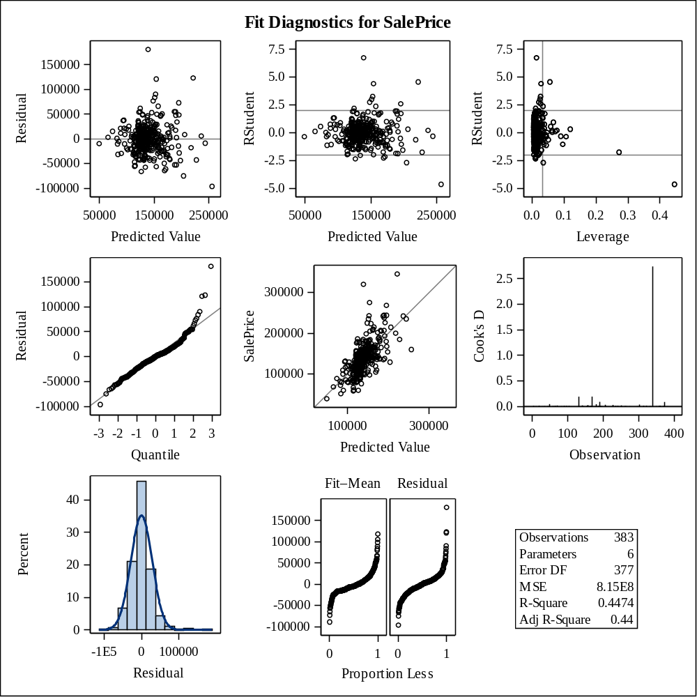

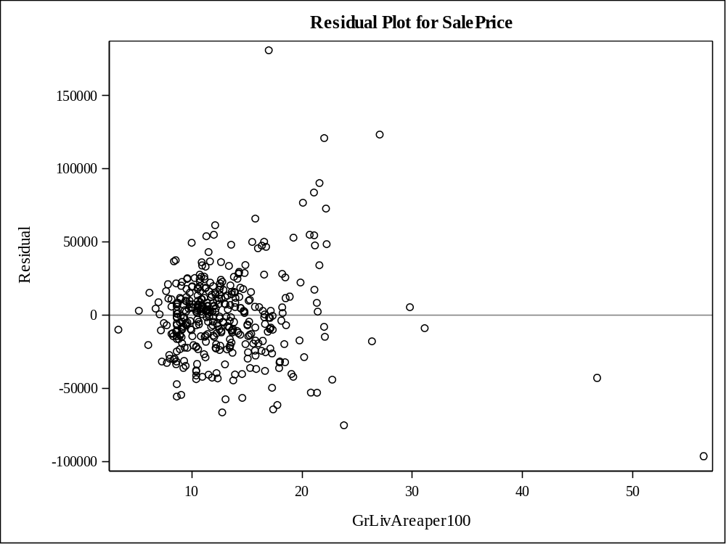

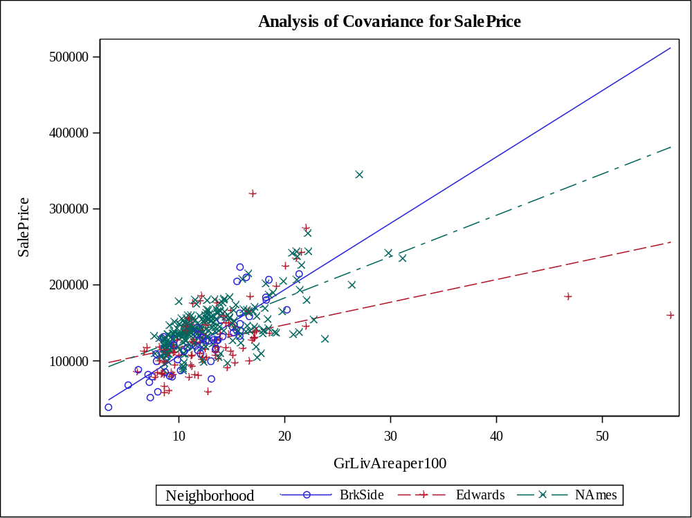

Class Level Information
Class | Levels | Values
Neighborhood | 3 | BrkSide Edwards NAmes

Number of Observations Read | 381
Number of Observations Used | 381

Source | DF | Sum of Squares | Mean Square | F Value | Pr > F
Model | 5 | 283631588727 | 56726317745 | 78.83 | <.0001
Error | 375 | 269847202943 | 719592541.18
Corrected Total | 380 | 553478791670

R-Square | Coeff Var | Root MSE | SalePrice Mean
0.512452 | 19.45515 | 26825.22 | 137882.4

Source | DF | Type I SS | Mean Square | F Value | Pr > F
GrLivAreaper100 | 1 | 253099925462 | 253099925462 | 351.73 | <.0001
Neighborhood | 2 | 20620955996 | 10310477998 | 14.33 | <.0001
GrLivArea*Neighborho | 2 | 9910707269.1 | 4955353634.6 | 6.89 | 0.0012

Source | DF | Type III SS | Mean Square | F Value | Pr > F
GrLivAreaper100 | 1 | 210178319563 | 210178319563 | 292.08 | <.0001
Neighborhood | 2 | 18323983921 | 9161991960.5 | 12.73 | <.0001
GrLivArea*Neighborho | 2 | 9910707269.1 | 4955353634.6 | 6.89 | 0.0012

Observation |  | Observed | Predicted | Residual | 95% Confidence Limits for Mean Predicted Value
1 |  | 118000.0000 | 113845.5614 | 4154.4386 | 106554.5165 | 121136.6063
2 |  | 157000.0000 | 142734.1776 | 14265.8224 | 139183.9660 | 146284.3891
3 |  | 132000.0000 | 94408.3166 | 37591.6834 | 85040.2845 | 103776.3487
4 |  | 149000.0000 | 129209.5277 | 19790.4723 | 124829.8859 | 133589.1696
5 |  | 139000.0000 | 147405.3418 | -8405.3418 | 143880.4035 | 150930.2800
6 |  | 134800.0000 | 123560.6780 | 11239.3220 | 118601.3160 | 128520.0400
7 |  | 207500.0000 | 161581.7819 | 45918.2181 | 157285.0858 | 165878.4780
8 |  | 68500.0000 | 65296.0307 | 3203.9693 | 51142.0328 | 79450.0287
9 |  | 165500.0000 | 167013.3682 | -1513.3682 | 162176.3423 | 171850.3941
10 |  | 153000.0000 | 145124.0755 | 7875.9245 | 141605.7987 | 148642.3523
11 |  | 109000.0000 | 132088.2685 | -23088.2685 | 127961.9304 | 136214.6065
12 |  | 82000.0000 | 118953.4106 | -36953.4106 | 113373.2022 | 124533.6190
13 |  | 160000.0000 | 146590.6038 | 13409.3962 | 143072.2217 | 150108.9859
14 |  | 141000.0000 | 137139.6437 | 3860.3563 | 133367.0707 | 140912.2167
15 |  | 114500.0000 | 122474.6521 | -7974.6521 | 115531.4177 | 129417.8865
16 |  | 130000.0000 | 148545.9749 | -18545.9749 | 145004.1172 | 152087.8325
17 |  | 180500.0000 | 152076.5059 | 28423.4941 | 148426.7229 | 155726.2890
18 |  | 180000.0000 | 194551.5106 | -14551.5106 | 186138.7653 | 202964.2559
19 |  | 244000.0000 | 195420.5644 | 48579.4356 | 186883.7436 | 203957.3852
20 |  | 144900.0000 | 133663.4285 | 11236.5715 | 129660.8692 | 137665.9877
21 |  | 135750.0000 | 126385.1029 | 9364.8971 | 121727.6529 | 131042.5528
22 |  | 127000.0000 | 131975.3682 | -4975.3682 | 124892.9033 | 139057.8331
23 |  | 193500.0000 | 191020.9795 | 2479.0205 | 183108.1287 | 198933.8304
24 |  | 126500.0000 | 132522.7954 | -6022.7954 | 128431.7205 | 136613.8702
25 |  | 109900.0000 | 131164.8988 | -21264.8988 | 126960.9358 | 135368.8618
26 |  | 98600.0000 | 141756.4920 | -43156.4920 | 138181.9409 | 145331.0431
27 |  | 94750.0000 | 104365.9346 | -9615.9346 | 97359.9018 | 111371.9674
28 |  | 83000.0000 | 94868.8799 | -11868.8799 | 86517.0577 | 103220.7022
29 |  | 128950.0000 | 141213.3334 | -12263.3334 | 137622.4983 | 144804.1685
30 |  | 136900.0000 | 172364.8462 | -35464.8462 | 161967.7717 | 182761.9206
31 |  | 155000.0000 | 116902.0468 | 38097.9532 | 111187.8386 | 122616.2550
32 |  | 136000.0000 | 133337.5333 | 2662.4667 | 129310.2970 | 137364.7696
33 |  | 155000.0000 | 147894.1845 | 7105.8155 | 144363.0959 | 151425.2731
34 |  | 150000.0000 | 131871.0050 | 18128.9950 | 127726.7272 | 136015.2828
35 |  | 226000.0000 | 191835.7175 | 34164.2825 | 183808.1368 | 199863.2981
36 |  | 150750.0000 | 146753.5514 | 3996.4486 | 143234.2286 | 150272.8742
37 |  | 143000.0000 | 140615.8589 | 2384.1411 | 137004.8719 | 144226.8459
38 |  | 115000.0000 | 121605.3069 | -6605.3069 | 116425.0103 | 126785.6036
39 |  | 166000.0000 | 149903.8714 | 16096.1286 | 146330.2688 | 153477.4741
40 |  | 130000.0000 | 161272.2863 | -31272.2863 | 152688.8085 | 169855.7641
41 |  | 105000.0000 | 96238.7298 | 8761.2702 | 87121.9099 | 105355.5498
42 |  | 115000.0000 | 137117.9576 | -22117.9576 | 129738.5827 | 144497.3325
43 |  | 79000.0000 | 114698.7301 | -35698.7301 | 108812.6469 | 120584.8133
44 |  | 109500.0000 | 131164.8988 | -21664.8988 | 126960.9358 | 135368.8618
45 |  | 127500.0000 | 134376.6274 | -6876.6274 | 128867.8331 | 139885.4218
46 |  | 215000.0000 | 164623.4702 | 50376.5298 | 160035.8425 | 169211.0980
47 |  | 163000.0000 | 148654.6066 | 14345.3934 | 145110.6703 | 152198.5429
48 |  | 243000.0000 | 195385.7067 | 47614.2933 | 180880.9642 | 209890.4493
49 |  | 120000.0000 | 133236.9809 | -13236.9809 | 127781.1680 | 138692.7937
50 |  | 127000.0000 | 129099.0046 | -2099.0046 | 122116.8069 | 136081.2024
51 |  | 184000.0000 | 155009.5625 | 28990.4375 | 151210.5452 | 158808.5799
52 |  | 130000.0000 | 161272.2863 | -31272.2863 | 152688.8085 | 169855.7641
53 |  | 235000.0000 | 243707.3664 | -8707.3664 | 227953.9083 | 259460.8245
54 |  | 140000.0000 | 116598.1410 | 23401.8590 | 110861.8960 | 122334.3861
55 |  | 141000.0000 | 134423.8506 | 6576.1494 | 130476.8939 | 138370.8073
56 |  | 145000.0000 | 133989.3237 | 11010.6763 | 130010.9371 | 137967.7102
57 |  | 98000.0000 | 97072.1966 | 927.8034 | 89051.8111 | 105092.5821
58 |  | 186000.0000 | 123511.9969 | 62488.0031 | 118130.6269 | 128893.3668
59 |  | 134450.0000 | 141810.8079 | -7360.8079 | 138237.7774 | 145383.8384
60 |  | 97000.0000 | 121605.3069 | -24605.3069 | 116425.0103 | 126785.6036
61 |  | 148000.0000 | 139529.5417 | 8470.4583 | 135876.0312 | 143183.0521
62 |  | 113000.0000 | 144405.5172 | -31405.5172 | 138092.1351 | 150718.8992
63 |  | 140000.0000 | 149360.7128 | -9360.7128 | 145801.3046 | 152920.1211
64 |  | 76500.0000 | 133805.7814 | -57305.7814 | 126634.3770 | 140977.1857
65 |  | 158000.0000 | 145395.6548 | 12604.3452 | 141878.4943 | 148912.8154
66 |  | 145000.0000 | 146047.4452 | -1047.4452 | 142530.8575 | 149564.0329
67 |  | 176000.0000 | 149740.9238 | 26259.0762 | 146171.7873 | 153310.0604
68 |  | 148000.0000 | 115990.3295 | 32009.6705 | 110208.3801 | 121772.2789
69 |  | 139000.0000 | 163319.8895 | -24319.8895 | 158860.8766 | 167778.9025
70 |  | 205000.0000 | 154899.1143 | 50100.8857 | 145581.2690 | 164216.9596
71 |  | 159000.0000 | 168860.1075 | -9860.1075 | 163819.6951 | 173900.5199
72 |  | 88000.0000 | 121279.4118 | -33279.4118 | 116061.4479 | 126497.3756
73 |  | 153575.0000 | 141650.4093 | 11924.5907 | 133896.4110 | 149404.4076
74 |  | 131000.0000 | 161804.1214 | -30804.1214 | 153137.7562 | 170470.4865
75 |  | 167000.0000 | 163971.6799 | 3028.3201 | 159449.0587 | 168494.3010
76 |  | 82500.0000 | 96844.2673 | -14344.2673 | 88790.0607 | 104898.4738
77 |  | 132000.0000 | 127471.4201 | 4528.5799 | 122923.9217 | 132018.9185
78 |  | 242000.0000 | 236429.0408 | 5570.9592 | 221786.6423 | 251071.4393
79 |  | 145250.0000 | 149795.2397 | -4545.2397 | 146224.6342 | 153365.8452
80 |  | 214500.0000 | 205976.3584 | 8523.6416 | 187783.6416 | 224169.0751
81 |  | 119000.0000 | 168534.2124 | -49534.2124 | 163530.3104 | 173538.1143
82 |  | 139000.0000 | 132033.9526 | 6966.0474 | 127903.1487 | 136164.7565
83 |  | 155000.0000 | 140670.1748 | 14329.8252 | 137061.1158 | 144279.2338
84 |  | 87500.0000 | 131164.8988 | -43664.8988 | 126960.9358 | 135368.8618
85 |  | 140200.0000 | 157426.8277 | -17226.8277 | 147750.5684 | 167103.0870
86 |  | 151500.0000 | 126710.9980 | 24789.0020 | 122086.9189 | 131335.0772
87 |  | 157500.0000 | 154955.2467 | 2544.7533 | 151159.4467 | 158751.0466
88 |  | 95000.0000 | 115838.3767 | -20838.3767 | 110044.6661 | 121632.0872
89 |  | 145000.0000 | 151151.1254 | -6151.1254 | 142334.1525 | 159968.0982
90 |  | 198500.0000 | 177455.2675 | 21044.7325 | 166179.9847 | 188730.5503
91 |  | 159000.0000 | 150392.7142 | 8607.2858 | 146804.6532 | 153980.7752
92 |  | 165000.0000 | 152402.4011 | 12597.5989 | 148738.5905 | 156066.2117
93 |  | 132000.0000 | 143548.9155 | -11548.9155 | 140014.0253 | 147083.8057
94 |  | 162000.0000 | 144580.9169 | 17419.0831 | 141058.8613 | 148102.9724
95 |  | 123000.0000 | 146319.0245 | -23319.0245 | 142801.7977 | 149836.2513
96 |  | 61000.0000 | 100111.2541 | -39111.2541 | 92530.5027 | 107692.0055
97 |  | 81000.0000 | 121384.6566 | -40384.6566 | 115928.1822 | 126841.1310
98 |  | 125000.0000 | 116902.0468 | 8097.9532 | 111187.8386 | 122616.2550
99 |  | 119000.0000 | 135288.3447 | -16288.3447 | 129730.9155 | 140845.7739
100 |  | 106500.0000 | 122582.9925 | -16082.9925 | 117514.2810 | 127651.7040
101 |  | 100000.0000 | 88655.5895 | 11344.4105 | 78446.3117 | 98864.8673
102 |  | 129000.0000 | 118345.5991 | 10654.4009 | 112728.4211 | 123962.7771
103 |  | 169500.0000 | 173096.7448 | -3596.7448 | 167560.5811 | 178632.9086
104 |  | 60000.0000 | 128374.4889 | -68374.4889 | 123042.1585 | 133706.8192
105 |  | 126000.0000 | 117585.8347 | 8414.1653 | 111919.1815 | 123252.4879
106 |  | 142000.0000 | 132033.9526 | 9966.0474 | 127903.1487 | 136164.7565
107 |  | 139000.0000 | 139638.1734 | -638.1734 | 135989.2513 | 143287.0954
108 |  | 109008.0000 | 123940.8890 | -14932.8890 | 119023.4159 | 128858.3622
109 |  | 119000.0000 | 98766.4433 | 20233.5567 | 89981.3822 | 107551.5043
110 |  | 110000.0000 | 122296.3739 | -12296.3739 | 116875.9742 | 127716.7735
111 |  | 118000.0000 | 140834.6246 | -22834.6246 | 134870.8940 | 146798.3553
112 |  | 162900.0000 | 157078.1776 | 5821.8224 | 147452.2575 | 166704.0977
113 |  | 127500.0000 | 159752.7575 | -32252.7575 | 151403.3015 | 168102.2135
114 |  | 190000.0000 | 177224.7504 | 12775.2496 | 171174.2767 | 183275.2241
115 |  | 110000.0000 | 124828.0405 | -14828.0405 | 117902.0585 | 131754.0225
116 |  | 167000.0000 | 144037.7583 | 22962.2417 | 140509.8683 | 147565.6482
117 |  | 146500.0000 | 163971.6799 | -17471.6799 | 159449.0587 | 168494.3010
118 |  | 148000.0000 | 112875.2956 | 35124.7044 | 106826.7880 | 118923.8032
119 |  | 147000.0000 | 135129.9568 | 11870.0432 | 131232.0696 | 139027.8439
120 |  | 156000.0000 | 132957.3223 | 23042.6777 | 128900.6710 | 137013.9735
121 |  | 133000.0000 | 160386.8329 | -27386.8329 | 156195.0764 | 164578.5895
122 |  | 155000.0000 | 143603.2314 | 11396.7686 | 140069.2005 | 147137.2622
123 |  | 184000.0000 | 178607.3231 | 5392.6769 | 165482.5970 | 191732.0492
124 |  | 120000.0000 | 124212.4684 | -4212.4684 | 119324.6897 | 129100.2470
125 |  | 140000.0000 | 123663.9497 | 16336.0503 | 118286.7193 | 129041.1801
126 |  | 124500.0000 | 131219.2147 | -6719.2147 | 127019.9165 | 135418.5128
127 |  | 164900.0000 | 148708.9225 | 16191.0775 | 145163.9166 | 152253.9283
128 |  | 129900.0000 | 121605.3069 | 8294.6931 | 116425.0103 | 126785.6036
129 |  | 150000.0000 | 142245.3348 | 7754.6652 | 138683.7586 | 145806.9109
130 |  | 159000.0000 | 165009.9680 | -6009.9680 | 154177.1995 | 175842.7366
131 |  | 132000.0000 | 125081.5222 | 6918.4778 | 120287.4562 | 129875.5882
132 |  | 86000.0000 | 77394.2993 | 8605.7007 | 66156.1030 | 88632.4956
133 |  | 128000.0000 | 138686.8832 | -10686.8832 | 131189.0318 | 146184.7346
134 |  | 107500.0000 | 119595.6200 | -12095.6200 | 114179.5225 | 125011.7176
135 |  | 39300.0000 | 49083.7997 | -9783.7997 | 31919.5299 | 66248.0695
136 |  | 107500.0000 | 133768.8159 | -26268.8159 | 128289.3732 | 139248.2586
137 |  | 111250.0000 | 121605.3069 | -10355.3069 | 116425.0103 | 126785.6036
138 |  | 133000.0000 | 116336.6683 | 16663.3317 | 110522.1396 | 122151.1969
139 |  | 210000.0000 | 162482.2546 | 47517.7454 | 152047.0589 | 172917.4503
140 |  | 108000.0000 | 116978.0232 | -8978.0232 | 111269.2382 | 122686.8082
141 |  | 113000.0000 | 111317.8480 | 1682.1520 | 103846.4517 | 118789.2442
142 |  | 141000.0000 | 133989.3237 | 7010.6763 | 130010.9371 | 137967.7102
143 |  | 108000.0000 | 107101.0864 | 898.9136 | 100434.2856 | 113767.8871
144 |  | 185000.0000 | 158613.1110 | 26386.8890 | 150436.2869 | 166789.9351
145 |  | 135960.0000 | 125896.2601 | 10063.7399 | 121188.1560 | 130604.3642
146 |  | 142600.0000 | 168534.2124 | -25934.2124 | 163530.3104 | 173538.1143
147 |  | 120000.0000 | 121605.3069 | -1605.3069 | 116425.0103 | 126785.6036
148 |  | 139000.0000 | 134912.6933 | 4087.3067 | 130999.9765 | 138825.4101
149 |  | 118500.0000 | 140724.4906 | -22224.4906 | 137117.3405 | 144331.6408
150 |  | 181900.0000 | 152293.7694 | 29606.2306 | 148634.7081 | 155952.8307
151 |  | 118500.0000 | 93425.3276 | 25074.6724 | 84851.2430 | 101999.4122
152 |  | 133000.0000 | 157078.1776 | -24078.1776 | 147452.2575 | 166704.0977
153 |  | 130000.0000 | 93013.7161 | 36986.2839 | 83448.6054 | 102578.8269
154 |  | 79500.0000 | 101468.4818 | -21968.4818 | 93016.5002 | 109920.4634
155 |  | 205000.0000 | 182547.7049 | 22452.2951 | 175800.0329 | 189295.3770
156 |  | 225000.0000 | 183989.2411 | 41010.7589 | 171557.5957 | 196420.8865
157 |  | 137500.0000 | 131925.3209 | 5574.6791 | 127785.5470 | 136065.0947
158 |  | 105500.0000 | 119867.1993 | -14367.1993 | 114483.4427 | 125250.9560
159 |  | 67000.0000 | 97072.1966 | -30072.1966 | 89051.8111 | 105092.5821
160 |  | 160000.0000 | 135292.9044 | 24707.0956 | 131405.9804 | 139179.8283
161 |  | 139900.0000 | 151913.5584 | -12013.5584 | 148270.5401 | 155556.5766
162 |  | 153000.0000 | 157236.5129 | -4236.5129 | 153291.9618 | 161181.0640
163 |  | 135000.0000 | 187653.3960 | -52653.3960 | 180210.2252 | 195096.5669
164 |  | 168500.0000 | 148002.8162 | 20497.1838 | 144470.1362 | 151535.4963
165 |  | 139400.0000 | 132033.9526 | 7366.0474 | 127903.1487 | 136164.7565
166 |  | 60000.0000 | 89701.5399 | -29701.5399 | 79650.5041 | 99752.5757
167 |  | 85000.0000 | 91905.7989 | -6905.7989 | 83093.7738 | 100717.8239
168 |  | 345000.0000 | 221546.4944 | 123453.5056 | 209158.3793 | 233934.6095
169 |  | 143250.0000 | 127960.2629 | 15289.7371 | 123461.0121 | 132459.5136
170 |  | 98300.0000 | 131599.4257 | -33299.4257 | 127432.4395 | 135766.4119
171 |  | 155000.0000 | 114546.7772 | 40453.2228 | 108647.8335 | 120445.7210
172 |  | 155000.0000 | 174563.2731 | -19563.2731 | 168847.5003 | 180279.0459
173 |  | 108000.0000 | 146152.9752 | -38152.9752 | 139647.2432 | 152658.7072
174 |  | 145500.0000 | 131871.0050 | 13628.9950 | 127726.7272 | 136015.2828
175 |  | 97500.0000 | 153868.9294 | -56368.9294 | 150133.9735 | 157603.8853
176 |  | 167000.0000 | 144329.5407 | 22670.4593 | 138024.2233 | 150634.8582
177 |  | 110000.0000 | 150284.0825 | -40284.0825 | 146699.3713 | 153868.7937
178 |  | 137500.0000 | 121156.7273 | 16343.2727 | 115690.3380 | 126623.1166
179 |  | 129000.0000 | 203948.1549 | -74948.1549 | 194176.4451 | 213719.8646
180 |  | 103600.0000 | 135440.2975 | -31840.2975 | 129874.2335 | 141006.3616
181 |  | 140000.0000 | 136379.2216 | 3620.7784 | 132561.8116 | 140196.6317
182 |  | 141500.0000 | 154114.6515 | -12614.6515 | 144904.8104 | 163324.4926
183 |  | 89000.0000 | 73663.6339 | 15336.3661 | 60994.0879 | 86333.1799
184 |  | 123500.0000 | 118649.5049 | 4850.4951 | 113051.1051 | 124247.9046
185 |  | 52000.0000 | 83513.0001 | -31513.0001 | 72496.6350 | 94529.3651
186 |  | 129000.0000 | 103647.5451 | 25352.4549 | 95446.1373 | 111848.9529
187 |  | 124500.0000 | 121605.3069 | 2894.6931 | 116425.0103 | 126785.6036
188 |  | 135000.0000 | 143113.9177 | -8113.9177 | 136934.0741 | 149293.7614
189 |  | 320000.0000 | 160436.5455 | 159563.4545 | 151982.3056 | 168890.7853
190 |  | 120500.0000 | 121605.3069 | -1105.3069 | 116425.0103 | 126785.6036
191 |  | 110000.0000 | 171141.3738 | -61141.3738 | 165838.6138 | 176444.1338
192 |  | 93500.0000 | 131164.8988 | -37664.8988 | 126960.9358 | 135368.8618
193 |  | 179000.0000 | 122600.2796 | 56399.7204 | 117190.6169 | 128009.9423
194 |  | 98000.0000 | 147596.5275 | -49596.5275 | 140922.5164 | 154270.5387
195 |  | 156000.0000 | 130404.4767 | 25595.5233 | 126133.9546 | 134674.9988
196 |  | 127500.0000 | 121605.3069 | 5894.6931 | 116425.0103 | 126785.6036
197 |  | 100000.0000 | 133369.9687 | -33369.9687 | 126221.4671 | 140518.4703
198 |  | 102000.0000 | 124119.8084 | -22119.8084 | 118754.0014 | 129485.6153
199 |  | 107000.0000 | 116294.2353 | -9294.2353 | 110535.4077 | 122053.0629
200 |  | 114500.0000 | 124212.4684 | -9712.4684 | 119324.6897 | 129100.2470
201 |  | 110000.0000 | 116662.5634 | -6662.5634 | 110888.6788 | 122436.4481
202 |  | 118000.0000 | 135944.6947 | -17944.6947 | 132100.2352 | 139789.1543
203 |  | 135500.0000 | 127905.9470 | 7594.0530 | 123401.3744 | 132410.5196
204 |  | 223500.0000 | 157339.6652 | 66160.3348 | 147676.0168 | 167003.3136
205 |  | 159950.0000 | 133663.4285 | 26286.5715 | 129660.8692 | 137665.9877
206 |  | 157900.0000 | 152999.8756 | 4900.1244 | 149308.6459 | 156691.1054
207 |  | 116000.0000 | 126399.1015 | -10399.1015 | 121067.7640 | 131730.4390
208 |  | 137000.0000 | 129426.7912 | 7573.2088 | 125067.3860 | 133786.1964
209 |  | 109500.0000 | 88306.9394 | 21193.0606 | 78044.4381 | 98569.4406
210 |  | 166000.0000 | 150284.0825 | 15715.9175 | 146699.3713 | 153868.7937
211 |  | 167000.0000 | 157019.2495 | 9980.7505 | 153090.0275 | 160948.4715
212 |  | 139950.0000 | 136813.7485 | 3136.2515 | 133022.3545 | 140605.1425
213 |  | 130500.0000 | 122600.2796 | 7899.7204 | 117190.6169 | 128009.9423
214 |  | 174900.0000 | 137954.3816 | 36945.6184 | 134226.2070 | 141682.5562
215 |  | 141000.0000 | 172444.9545 | -31444.9545 | 166987.3995 | 177902.5094
216 |  | 158000.0000 | 153162.8232 | 4837.1768 | 149463.7383 | 156861.9081
217 |  | 132500.0000 | 137031.0120 | -4531.0120 | 133252.2318 | 140809.7921
218 |  | 148500.0000 | 129100.8960 | 19399.1040 | 124711.0715 | 133490.7205
219 |  | 109500.0000 | 123234.7828 | -13734.7828 | 118239.2285 | 128230.3371
220 |  | 116000.0000 | 124103.8366 | -8103.8366 | 119204.2031 | 129003.4702
221 |  | 133000.0000 | 143548.9155 | -10548.9155 | 140014.0253 | 147083.8057
222 |  | 157000.0000 | 114242.8715 | 42757.1285 | 108317.8311 | 120167.9118
223 |  | 100000.0000 | 123126.1511 | -23126.1511 | 118118.4748 | 128133.8274
224 |  | 145000.0000 | 167665.1586 | -22665.1586 | 162757.3405 | 172572.9766
225 |  | 135500.0000 | 137263.7320 | -1763.7320 | 131582.6091 | 142944.8550
226 |  | 268000.0000 | 195094.6692 | 72905.3308 | 186604.4210 | 203584.9175
227 |  | 149500.0000 | 156421.7750 | -6921.7750 | 152533.4780 | 160310.0719
228 |  | 122900.0000 | 124864.2587 | -1964.2587 | 120046.9555 | 129681.5619
229 |  | 140000.0000 | 172227.6910 | -32227.6910 | 166796.1638 | 177659.2182
230 |  | 110000.0000 | 121279.4118 | -11279.4118 | 116061.4479 | 126497.3756
231 |  | 153000.0000 | 145612.9183 | 7387.0817 | 142096.2792 | 149129.5574
232 |  | 128000.0000 | 132414.1636 | -4414.1636 | 128314.3509 | 136513.9764
233 |  | 154300.0000 | 198190.6734 | -43890.6734 | 189255.9700 | 207125.3768
234 |  | 88000.0000 | 108441.4844 | -20441.4844 | 100726.5925 | 116156.3763
235 |  | 135000.0000 | 124803.5963 | 10196.4037 | 119452.1095 | 130155.0831
236 |  | 176500.0000 | 151479.0315 | 25020.9685 | 147853.2328 | 155104.8301
237 |  | 145900.0000 | 198576.7171 | -52676.7171 | 183481.9577 | 213671.4766
238 |  | 117500.0000 | 124918.5746 | -7418.5746 | 120107.0928 | 129730.0563
239 |  | 242000.0000 | 187055.9216 | 54944.0784 | 179695.2489 | 194416.5942
240 |  | 79900.0000 | 85081.9256 | -5181.9256 | 74316.5687 | 95847.2826
241 |  | 150000.0000 | 140834.6246 | 9165.3754 | 134870.8940 | 146798.3553
242 |  | 143000.0000 | 136813.7485 | 6186.2515 | 133022.3545 | 140605.1425
243 |  | 129000.0000 | 121605.3069 | 7394.6931 | 116425.0103 | 126785.6036
244 |  | 127500.0000 | 105885.4634 | 21614.5366 | 99071.1312 | 112699.7955
245 |  | 116500.0000 | 94756.9668 | 21743.0332 | 85437.4539 | 104076.4797
246 |  | 135000.0000 | 134315.2188 | 684.7812 | 130360.4915 | 138269.9462
247 |  | 140000.0000 | 134152.2712 | 5847.7288 | 130185.7791 | 138118.7634
248 |  | 135000.0000 | 139420.9099 | -4420.9099 | 135762.7375 | 143079.0824
249 |  | 167500.0000 | 195952.6671 | -28452.6671 | 179662.3937 | 212242.9405
250 |  | 85500.0000 | 95715.7546 | -10215.7546 | 86528.0583 | 104903.4510
251 |  | 110000.0000 | 99351.4897 | 10648.5103 | 91662.8966 | 107040.0829
252 |  | 178400.0000 | 128937.9484 | 49462.0516 | 124532.7704 | 133343.1264
253 |  | 125000.0000 | 119865.1279 | 5134.8721 | 114335.9145 | 125394.3412
254 |  | 187000.0000 | 175215.0635 | 11784.9365 | 169418.3182 | 181011.8088
255 |  | 121600.0000 | 127181.4289 | -5581.4289 | 120238.3697 | 134124.4881
256 |  | 136500.0000 | 131708.0574 | 4791.9426 | 127550.1921 | 135865.9227
257 |  | 82000.0000 | 103150.3116 | -21150.3116 | 95985.4946 | 110315.1286
258 |  | 163500.0000 | 164677.7861 | -1177.7861 | 160084.6798 | 169270.8924
259 |  | 100000.0000 | 157853.3466 | -57853.3466 | 149790.1484 | 165916.5448
260 |  | 119200.0000 | 133446.1650 | -14246.1650 | 129427.2099 | 137465.1201
261 |  | 176000.0000 | 117433.8819 | 58566.1181 | 111756.9060 | 123110.8577
262 |  | 167500.0000 | 143331.6520 | 24168.3480 | 139793.1213 | 146870.1828
263 |  | 105000.0000 | 149415.0287 | -44415.0287 | 145854.2902 | 152975.7671
264 |  | 84000.0000 | 95628.6443 | -11628.6443 | 87392.2193 | 103865.0693
265 |  | 139600.0000 | 163095.7208 | -23495.7208 | 154226.0674 | 171965.3742
266 |  | 84900.0000 | 102086.6415 | -17186.6415 | 94779.2013 | 109394.0816
267 |  | 165000.0000 | 182058.8622 | -17058.8622 | 175376.5388 | 188741.1856
268 |  | 144500.0000 | 147368.5982 | -2868.5982 | 140721.6929 | 154015.5035
269 |  | 154000.0000 | 137356.9071 | 16643.0929 | 133596.5475 | 141117.2668
270 |  | 167900.0000 | 162179.2564 | 5720.7436 | 157828.0090 | 166530.5038
271 |  | 135000.0000 | 123180.4670 | 11819.5330 | 118178.8553 | 128182.0787
272 |  | 135000.0000 | 131599.4257 | 3400.5743 | 127432.4395 | 135766.4119
273 |  | 91500.0000 | 142050.2476 | -50550.2476 | 135974.4791 | 148126.0161
274 |  | 159500.0000 | 139770.9545 | 19729.0455 | 133898.8979 | 145643.0111
275 |  | 138800.0000 | 134206.5871 | 4593.4129 | 130244.0310 | 138169.1432
276 |  | 160000.0000 | 142625.5458 | 17374.4542 | 139072.9488 | 146178.1428
277 |  | 137500.0000 | 161272.2863 | -23772.2863 | 152688.8085 | 169855.7641
278 |  | 92900.0000 | 131164.8988 | -38264.8988 | 126960.9358 | 135368.8618
279 |  | 146000.0000 | 139855.4368 | 6144.5632 | 136215.4694 | 143495.4043
280 |  | 129000.0000 | 125516.0491 | 3483.9509 | 120768.0641 | 130264.0340
281 |  | 128000.0000 | 135374.7070 | -7374.7070 | 128112.1378 | 142637.2761
282 |  | 119500.0000 | 126276.4711 | -6776.4711 | 121607.8262 | 130945.1161
283 |  | 135000.0000 | 136270.5899 | -1270.5899 | 132446.5135 | 140094.6663
284 |  | 159500.0000 | 139529.5417 | 19970.4583 | 135876.0312 | 143183.0521
285 |  | 129900.0000 | 118998.1455 | 10901.8545 | 113510.4040 | 124485.8870
286 |  | 134500.0000 | 129426.7912 | 5073.2088 | 125067.3860 | 133786.1964
287 |  | 133700.0000 | 131164.8988 | 2535.1012 | 126960.9358 | 135368.8618
288 |  | 112000.0000 | 104365.9346 | 7634.0654 | 97359.9018 | 111371.9674
289 |  | 118000.0000 | 84460.1080 | 33539.8920 | 74432.9183 | 94487.2977
290 |  | 115000.0000 | 129263.8436 | -14263.8436 | 124889.2770 | 133638.4102
291 |  | 102000.0000 | 105913.7709 | -3913.7709 | 97954.1047 | 113873.4371
292 |  | 119000.0000 | 142679.8617 | -23679.8617 | 139128.4675 | 146231.2559
293 |  | 144000.0000 | 121690.1893 | 22309.8107 | 114733.6049 | 128646.7738
294 |  | 139000.0000 | 126385.1029 | 12614.8971 | 121727.6529 | 131042.5528
295 |  | 80000.0000 | 101630.7829 | -21630.7829 | 94261.2173 | 109000.3484
296 |  | 149000.0000 | 157339.6652 | -8339.6652 | 147676.0168 | 167003.3136
297 |  | 124000.0000 | 125298.7856 | -1298.7856 | 120527.8263 | 130069.7449
298 |  | 149900.0000 | 142810.0120 | 7089.9880 | 136660.4618 | 148959.5622
299 |  | 201800.0000 | 173531.2717 | 28268.7283 | 167942.2765 | 179120.2669
300 |  | 179900.0000 | 143385.9679 | 36514.0321 | 139848.3778 | 146923.5580
301 |  | 235000.0000 | 191586.8849 | 43413.1151 | 177779.6445 | 205394.1252
302 |  | 163000.0000 | 143168.7045 | 19831.2955 | 139627.2304 | 146710.1785
303 |  | 93000.0000 | 116826.0704 | -23826.0704 | 111106.4045 | 122545.7362
304 |  | 104900.0000 | 124195.7848 | -19295.7848 | 118831.7362 | 129559.8334
305 |  | 116050.0000 | 121605.3069 | -5555.3069 | 116425.0103 | 126785.6036
306 |  | 117000.0000 | 137466.6077 | -20466.6077 | 130061.9757 | 144871.2398
307 |  | 140000.0000 | 144363.6534 | -4363.6534 | 140839.5103 | 147887.7966
308 |  | 113000.0000 | 82484.7206 | 30515.2794 | 72123.7765 | 92845.6647
309 |  | 134500.0000 | 128937.9484 | 5562.0516 | 124532.7704 | 133343.1264
310 |  | 80500.0000 | 99463.7435 | -18963.7435 | 90766.8715 | 108160.6156
311 |  | 115000.0000 | 124212.4684 | -9212.4684 | 119324.6897 | 129100.2470
312 |  | 143000.0000 | 174943.4842 | -31943.4842 | 169180.5597 | 180706.4086
313 |  | 137900.0000 | 190695.0844 | -52795.0844 | 182828.0122 | 198562.1565
314 |  | 145000.0000 | 136487.8533 | 8512.1467 | 132677.0450 | 140298.6617
315 |  | 147000.0000 | 124212.4684 | 22787.5316 | 119324.6897 | 129100.2470
316 |  | 127000.0000 | 156530.4067 | -29530.4067 | 152634.8047 | 160426.0087
317 |  | 132500.0000 | 139312.2782 | -6812.2782 | 135649.3703 | 142975.1861
318 |  | 101800.0000 | 141159.0175 | -39359.0175 | 137566.4468 | 144751.5882
319 |  | 142000.0000 | 139203.6465 | 2796.3535 | 135535.9300 | 142871.3629
320 |  | 119000.0000 | 128340.4739 | -9340.4739 | 123878.1981 | 132802.7498
321 |  | 244000.0000 | 189282.8719 | 54717.1281 | 181613.3913 | 196952.3526
322 |  | 165400.0000 | 157245.5351 | 8154.4649 | 149272.3559 | 165218.7143
323 |  | 127500.0000 | 139122.6959 | -11622.6959 | 131589.7720 | 146655.6197
324 |  | 99900.0000 | 97072.1966 | 2827.8034 | 89051.8111 | 105092.5821
325 |  | 151000.0000 | 131925.3209 | 19074.6791 | 127785.5470 | 136065.0947
326 |  | 128900.0000 | 131708.0574 | -2808.0574 | 127550.1921 | 135865.9227
327 |  | 180500.0000 | 178955.9733 | 1544.0267 | 165769.7922 | 192142.1543
328 |  | 181000.0000 | 147296.7100 | 33703.2900 | 143772.9132 | 150820.5068
329 |  | 144000.0000 | 157453.7764 | -13453.7764 | 153493.6621 | 161413.8907
330 |  | 177000.0000 | 134528.5803 | 42471.4197 | 129012.0614 | 140045.0992
331 |  | 137000.0000 | 178962.8580 | -41962.8580 | 172688.4343 | 185237.2817
332 |  | 132500.0000 | 143045.0098 | -10545.0098 | 135156.7788 | 150933.2409
333 |  | 180500.0000 | 137248.2754 | 43251.7246 | 133481.8427 | 141014.7081
334 |  | 115000.0000 | 97072.1966 | 17927.8034 | 89051.8111 | 105092.5821
335 |  | 138500.0000 | 131816.6891 | 6683.3109 | 127667.8947 | 135965.4835
336 |  | 155000.0000 | 135944.6947 | 19055.3053 | 132100.2352 | 139789.1543
337 |  | 140000.0000 | 112875.2956 | 27124.7044 | 106826.7880 | 118923.8032
338 |  | 154000.0000 | 142353.9665 | 11646.0335 | 138795.0556 | 145912.8774
339 |  | 130000.0000 | 161196.3099 | -31196.3099 | 152624.6327 | 169767.9870
340 |  | 119000.0000 | 103454.2174 | 15545.7826 | 96329.5285 | 110578.9062
341 |  | 206900.0000 | 189391.5037 | 17508.4963 | 181706.8701 | 197076.1372
342 |  | 111000.0000 | 103454.2174 | 7545.7826 | 96329.5285 | 110578.9062
343 |  | 156500.0000 | 154955.2467 | 1544.7533 | 151159.4467 | 158751.0466
344 |  | 72500.0000 | 82728.5373 | -10228.5373 | 71585.2277 | 93871.8468
345 |  | 82500.0000 | 81682.5869 | 817.4131 | 70368.5968 | 92996.5770
346 |  | 79000.0000 | 90234.3172 | -11234.3172 | 81156.2202 | 99312.4143
347 |  | 100000.0000 | 93425.3276 | 6574.6724 | 84851.2430 | 101999.4122
348 |  | 123000.0000 | 122039.8338 | 960.1662 | 116909.3974 | 127170.2703
349 |  | 200000.0000 | 217744.3840 | -17744.3840 | 205927.1316 | 229561.6364
350 |  | 171000.0000 | 167882.4220 | 3117.5780 | 162950.7610 | 172814.0830
351 |  | 134900.0000 | 122474.6521 | 12425.3479 | 115531.4177 | 129417.8865
352 |  | 110000.0000 | 123126.1511 | -13126.1511 | 118118.4748 | 128133.8274
353 |  | 149900.0000 | 133228.9016 | 16671.0984 | 129193.3292 | 137264.4740
354 |  | 104900.0000 | 169077.3710 | -64177.3710 | 164012.4776 | 174142.2643
355 |  | 165500.0000 | 164895.0496 | 604.9504 | 160279.9369 | 169510.1622
356 |  | 117000.0000 | 153294.7604 | -36294.7604 | 145885.5910 | 160703.9298
357 |  | 58500.0000 | 97072.1966 | -38572.1966 | 89051.8111 | 105092.5821
358 |  | 237500.0000 | 189663.0830 | 47836.9170 | 181940.5328 | 197385.6331
359 |  | 105000.0000 | 127006.9130 | -22006.9130 | 121678.3329 | 132335.4930
360 |  | 131000.0000 | 126135.4785 | 4864.5215 | 119204.2429 | 133066.7141
361 |  | 124000.0000 | 160712.7281 | -36712.7281 | 156492.9191 | 164932.5371
362 |  | 123000.0000 | 123560.6780 | -560.6780 | 118601.3160 | 128520.0400
363 |  | 137500.0000 | 151848.4256 | -14348.4256 | 142941.2668 | 160755.5844
364 |  | 138000.0000 | 178093.8042 | -40093.8042 | 171931.8471 | 184255.7613
365 |  | 120000.0000 | 120905.7265 | -905.7265 | 113932.0235 | 127879.4296
366 |  | 140000.0000 | 165275.2606 | -25275.2606 | 160621.2863 | 169929.2349
367 |  | 90000.0000 | 131164.8988 | -41164.8988 | 126960.9358 | 135368.8618
368 |  | 207000.0000 | 181047.8740 | 25952.1260 | 167490.7201 | 194605.0280
369 |  | 124000.0000 | 136813.7485 | -12813.7485 | 133022.3545 | 140605.1425
370 |  | 274970.0000 | 198652.6935 | 76317.3065 | 183543.8442 | 213761.5429
371 |  | 144000.0000 | 147676.9211 | -3676.9211 | 144148.7705 | 151205.0716
372 |  | 142000.0000 | 142679.8617 | -679.8617 | 139128.4675 | 146231.2559
373 |  | 140000.0000 | 159300.5157 | -19300.5157 | 155199.0466 | 163401.9848
374 |  | 174000.0000 | 158159.8826 | 15840.1174 | 154147.6037 | 162172.1614
375 |  | 120500.0000 | 121605.3069 | -1105.3069 | 116425.0103 | 126785.6036
376 |  | 121000.0000 | 102950.2448 | 18049.7552 | 94670.5101 | 111229.9795
377 |  | 112000.0000 | 133692.8395 | -21692.8395 | 128216.8905 | 139168.7885
378 |  | 136000.0000 | 172010.4276 | -36010.4276 | 166604.8385 | 177416.0167
379 |  | 145000.0000 | 112875.2956 | 32124.7044 | 106826.7880 | 118923.8032
380 |  | 142125.0000 | 133228.9016 | 8896.0984 | 129193.3292 | 137264.4740
381 |  | 147500.0000 | 126854.9601 | 20645.0399 | 121525.9459 | 132183.9744

Sum of Residuals | 9.2841219E-9
Sum of Squared Residuals | 269847202943
Sum of Squared Residuals - Error SS | 0.0020141602
PRESS Statistic | 282791737788
First Order Autocorrelation | -0.042598395
Durbin-Watson D | 2.083553353

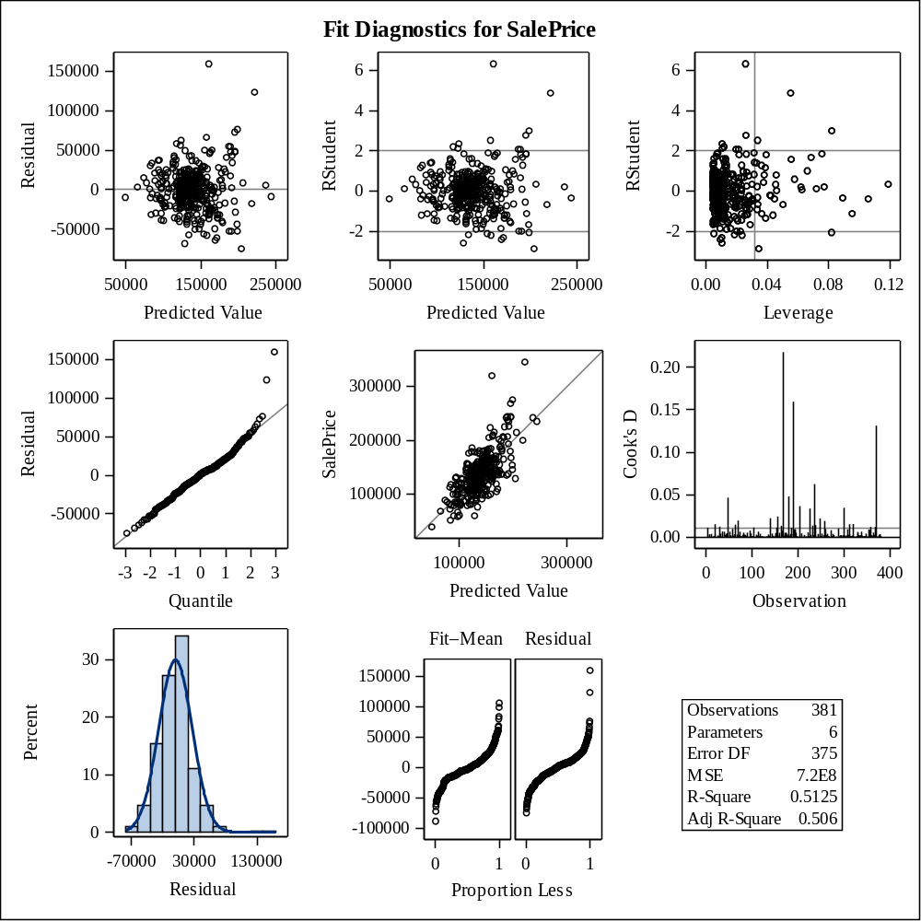

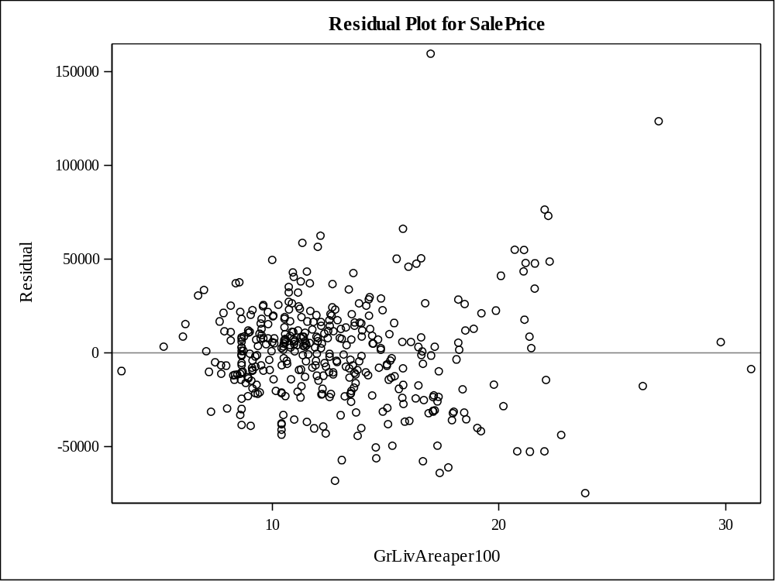

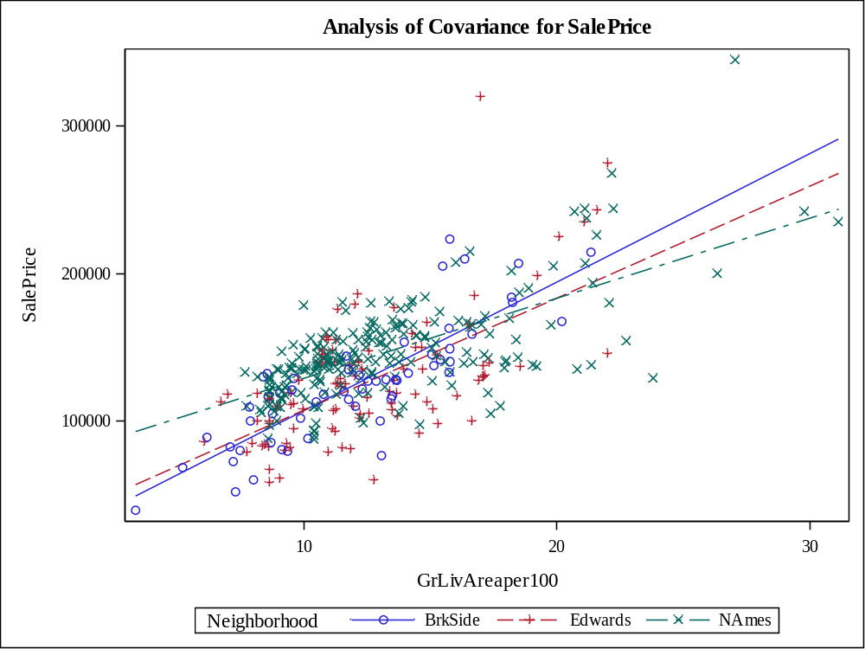

Class Level Information
Class | Levels | Values
Neighborhood | 3 | BrkSide Edwards NAmes

Number of Observations Read | 381
Number of Observations Used | 381

Source | DF | Sum of Squares | Mean Square | F Value | Pr > F
Model | 5 | 221859293303 | 44371858661 | 64.50 | <.0001
Error | 375 | 257971540792 | 687924108.78
Corrected Total | 380 | 479830834095

R-Square | Coeff Var | Root MSE | SalePrice Mean
0.462370 | 19.13891 | 26228.31 | 137041.8

Source | DF | Type I SS | Mean Square | F Value | Pr > F
GrLivAreaper100 | 1 | 162199455504 | 162199455504 | 235.78 | <.0001
Neighborhood | 2 | 32205052684 | 16102526342 | 23.41 | <.0001
GrLivArea*Neighborho | 2 | 27454785115 | 13727392558 | 19.95 | <.0001

Source | DF | Type III SS | Mean Square | F Value | Pr > F
GrLivAreaper100 | 1 | 161446328276 | 161446328276 | 234.69 | <.0001
Neighborhood | 2 | 20158862707 | 10079431353 | 14.65 | <.0001
GrLivArea*Neighborho | 2 | 27454785115 | 13727392558 | 19.95 | <.0001

Observation |  | Observed | Predicted | Residual | 95% Confidence Limits for Mean Predicted Value
1 |  | 118000.0000 | 113845.5614 | 4154.4386 | 106716.7568 | 120974.3660
2 |  | 157000.0000 | 142425.9557 | 14574.0443 | 138952.4879 | 145899.4236
3 |  | 132000.0000 | 94408.3166 | 37591.6834 | 85248.7419 | 103567.8913
4 |  | 149000.0000 | 130085.2050 | 18914.7950 | 125788.2808 | 134382.1293
5 |  | 139000.0000 | 146688.2230 | -7688.2230 | 143229.4417 | 150147.0043
6 |  | 134800.0000 | 124930.8353 | 9869.1647 | 120050.0140 | 129811.6566
7 |  | 207500.0000 | 159623.7087 | 47876.2913 | 155348.0423 | 163899.3751
8 |  | 68500.0000 | 65296.0307 | 3203.9693 | 51456.9875 | 79135.0740
9 |  | 165500.0000 | 164579.8335 | 920.1665 | 159748.3068 | 169411.3602
10 |  | 153000.0000 | 144606.6506 | 8393.3494 | 141160.2519 | 148053.0494
11 |  | 109000.0000 | 132711.9512 | -23711.9512 | 128669.4914 | 136754.4109
12 |  | 82000.0000 | 121080.9096 | -39080.9096 | 115695.6102 | 126466.2089
13 |  | 160000.0000 | 145944.8043 | 14055.1957 | 142494.7325 | 149394.8761
14 |  | 141000.0000 | 137321.1472 | 3678.8528 | 133631.7852 | 141010.5092
15 |  | 114500.0000 | 122474.6521 | -7974.6521 | 115685.9186 | 129263.3857
16 |  | 130000.0000 | 147729.0092 | -17729.0092 | 144250.1116 | 151207.9069
17 |  | 180500.0000 | 150950.4903 | 29549.5097 | 147352.7486 | 154548.2320
18 |  | 180000.0000 | 189707.3861 | -9707.3861 | 181249.9136 | 198164.8585
19 |  | 244000.0000 | 190500.3660 | 53499.6340 | 181917.7210 | 199083.0111
20 |  | 144900.0000 | 134149.2273 | 10750.7727 | 130230.7644 | 138067.6903
21 |  | 135750.0000 | 127508.0201 | 8241.9799 | 122931.4357 | 132084.6046
22 |  | 127000.0000 | 131975.3682 | -4975.3682 | 125050.5023 | 138900.2341
23 |  | 193500.0000 | 186485.9050 | 7014.0950 | 178532.9831 | 194438.8268
24 |  | 126500.0000 | 133108.4411 | -6608.4411 | 129101.3379 | 137115.5444
25 |  | 109900.0000 | 131869.4099 | -21969.4099 | 127749.0502 | 135989.7697
26 |  | 98600.0000 | 141533.8533 | -42933.8533 | 138037.6739 | 145030.0326
27 |  | 94750.0000 | 115665.6226 | -20915.6226 | 109685.5698 | 121645.6753
28 |  | 83000.0000 | 112140.0451 | -29140.0451 | 105609.4110 | 118670.6792
29 |  | 128950.0000 | 141038.2408 | -12088.2408 | 137526.5891 | 144549.8925
30 |  | 136900.0000 | 140908.7574 | -4008.7574 | 134294.5782 | 147522.9366
31 |  | 155000.0000 | 120319.3849 | 34680.6151 | 114872.1505 | 125766.6192
32 |  | 136000.0000 | 133851.8599 | 2148.1401 | 129908.7028 | 137795.0169
33 |  | 155000.0000 | 147134.2743 | 7865.7257 | 143667.9971 | 150600.5514
34 |  | 150000.0000 | 132513.7062 | 17486.2938 | 128453.2511 | 136574.1613
35 |  | 226000.0000 | 187229.3237 | 38770.6763 | 179160.5675 | 195298.0798
36 |  | 150750.0000 | 146093.4881 | 4656.5119 | 142642.0542 | 149544.9219
37 |  | 143000.0000 | 140493.0671 | 2506.9329 | 136962.0797 | 144024.0544
38 |  | 115000.0000 | 123146.6303 | -8146.6303 | 118043.0823 | 128250.1784
39 |  | 166000.0000 | 148968.0404 | 17031.9596 | 145453.3537 | 152482.7271
40 |  | 130000.0000 | 136790.8829 | -6790.8829 | 130825.9783 | 142755.7875
41 |  | 105000.0000 | 96238.7298 | 8761.2702 | 87324.7773 | 105152.6823
42 |  | 115000.0000 | 137117.9576 | -22117.9576 | 129902.7885 | 144333.1267
43 |  | 79000.0000 | 119501.4509 | -40501.4509 | 113979.2308 | 125023.6709
44 |  | 109500.0000 | 131869.4099 | -22369.4099 | 127749.0502 | 135989.7697
45 |  | 127500.0000 | 126806.4474 | 693.5526 | 121621.0782 | 131991.8167
46 |  | 215000.0000 | 162399.1386 | 52600.8614 | 157823.5593 | 166974.7179
47 |  | 163000.0000 | 147828.1317 | 15171.8683 | 144346.8408 | 151309.4226
48 |  | 243000.0000 | 149454.7572 | 93545.2428 | 141133.8587 | 157775.6558
49 |  | 120000.0000 | 126383.3781 | -6383.3781 | 121200.0205 | 131566.7358
50 |  | 127000.0000 | 129099.0046 | -2099.0046 | 122272.1747 | 135925.8345
51 |  | 184000.0000 | 153626.7977 | 30373.2023 | 149870.1168 | 157383.4786
52 |  | 130000.0000 | 136790.8829 | -6790.8829 | 130825.9783 | 142755.7875
53 |  | 235000.0000 | 234560.3153 | 439.6847 | 218715.8881 | 250404.7424
54 |  | 140000.0000 | 120206.5664 | 19793.4336 | 114749.5031 | 125663.6297
55 |  | 141000.0000 | 134843.0848 | 6156.9152 | 130980.2028 | 138705.9669
56 |  | 145000.0000 | 134446.5948 | 10553.4052 | 130552.3061 | 138340.8836
57 |  | 98000.0000 | 112957.9791 | -14957.9791 | 106564.5159 | 119351.4422
58 |  | 186000.0000 | 122773.1868 | 63226.8132 | 117496.9942 | 128049.3793
59 |  | 134450.0000 | 141583.4145 | -7133.4145 | 138088.6710 | 145078.1580
60 |  | 97000.0000 | 123146.6303 | -26146.6303 | 118043.0823 | 128250.1784
61 |  | 148000.0000 | 139501.8421 | 8498.1579 | 135929.6119 | 143074.0723
62 |  | 113000.0000 | 130529.4573 | -17529.4573 | 125210.6556 | 135848.2589
63 |  | 140000.0000 | 148472.4279 | -8472.4279 | 144973.5811 | 151971.2748
64 |  | 76500.0000 | 133805.7814 | -57305.7814 | 126793.9551 | 140817.6077
65 |  | 158000.0000 | 144854.4569 | 13145.5431 | 141408.5453 | 148300.3684
66 |  | 145000.0000 | 145449.1918 | -449.1918 | 142002.2839 | 148896.0997
67 |  | 176000.0000 | 148819.3567 | 27180.6433 | 145309.6333 | 152329.0800
68 |  | 148000.0000 | 119980.9294 | 28019.0706 | 114503.7109 | 125458.1479
69 |  | 139000.0000 | 161209.6686 | -22209.6686 | 156766.4669 | 165652.8703
70 |  | 205000.0000 | 154899.1143 | 50100.8857 | 145788.6096 | 164009.6189
71 |  | 159000.0000 | 166264.9159 | -7264.9159 | 161225.2510 | 171304.5807
72 |  | 88000.0000 | 122849.2629 | -34849.2629 | 117707.7384 | 127990.7873
73 |  | 153575.0000 | 141650.4093 | 11924.5907 | 134068.9530 | 149231.8656
74 |  | 131000.0000 | 136988.3152 | -5988.3152 | 130995.7706 | 142980.8598
75 |  | 167000.0000 | 161804.4036 | 5195.5964 | 157295.6957 | 166313.1115
76 |  | 82500.0000 | 112873.3652 | -30373.3652 | 106465.9579 | 119280.7725
77 |  | 132000.0000 | 128499.2451 | 3500.7549 | 124033.3919 | 132965.0983
78 |  | 242000.0000 | 227919.1081 | 14080.8919 | 213191.3940 | 242646.8221
79 |  | 145250.0000 | 148868.9179 | -3618.9179 | 145357.5602 | 152380.2757
80 |  | 214500.0000 | 205976.3584 | 8523.6416 | 188188.4659 | 223764.2509
81 |  | 119000.0000 | 165967.5484 | -46967.5484 | 160965.2132 | 170969.8836
82 |  | 139000.0000 | 132662.3899 | 6337.6101 | 128615.4509 | 136709.3289
83 |  | 155000.0000 | 140542.6283 | 14457.3717 | 137013.4980 | 144071.7586
84 |  | 87500.0000 | 131869.4099 | -44369.4099 | 127749.0502 | 135989.7697
85 |  | 140200.0000 | 157426.8277 | -17226.8277 | 147965.8845 | 166887.7709
86 |  | 151500.0000 | 127805.3876 | 23694.6124 | 123262.4157 | 132348.3596
87 |  | 157500.0000 | 153577.2365 | 3922.7635 | 149823.9544 | 157330.5186
88 |  | 95000.0000 | 119924.5202 | -24924.5202 | 114442.1599 | 125406.8804
89 |  | 145000.0000 | 151151.1254 | -6151.1254 | 142530.3477 | 159771.9030
90 |  | 198500.0000 | 142798.4669 | 55701.5331 | 135842.0886 | 149754.8453
91 |  | 159000.0000 | 149414.0916 | 9585.9084 | 145883.4373 | 152944.7460
92 |  | 165000.0000 | 151247.8578 | 13752.1422 | 147635.0266 | 154860.6891
93 |  | 132000.0000 | 143169.3744 | -11169.3744 | 139709.7081 | 146629.0408
94 |  | 162000.0000 | 144111.0381 | 17888.9619 | 140662.0736 | 147560.0027
95 |  | 123000.0000 | 145696.9981 | -22696.9981 | 142248.7731 | 149145.2230
96 |  | 61000.0000 | 114086.1638 | -53086.1638 | 107872.9225 | 120299.4052
97 |  | 81000.0000 | 121983.4574 | -40983.4574 | 116661.3517 | 127305.5631
98 |  | 125000.0000 | 120319.3849 | 4680.6151 | 114872.1505 | 125766.6192
99 |  | 119000.0000 | 127144.9029 | -8144.9029 | 121955.9647 | 132333.8410
100 |  | 106500.0000 | 124038.7328 | -17538.7328 | 119047.6807 | 129029.7849
101 |  | 100000.0000 | 88655.5895 | 11344.4105 | 78673.4885 | 98637.6905
102 |  | 129000.0000 | 120855.2726 | 8144.7274 | 115452.4311 | 126258.1142
103 |  | 169500.0000 | 170130.6932 | -630.6932 | 164585.3441 | 175676.0424
104 |  | 60000.0000 | 124578.2825 | -64578.2825 | 119372.9406 | 129783.6243
105 |  | 126000.0000 | 120573.2264 | 5426.7736 | 115147.4956 | 125998.9572
106 |  | 142000.0000 | 132662.3899 | 9337.6101 | 128615.4509 | 136709.3289
107 |  | 139000.0000 | 139600.9646 | -600.9646 | 136033.2064 | 143168.7228
108 |  | 109008.0000 | 125277.7640 | -16269.7640 | 120439.1651 | 130116.3629
109 |  | 119000.0000 | 98766.4433 | 20233.5567 | 90176.8674 | 107356.0192
110 |  | 110000.0000 | 122321.9129 | -12321.9129 | 117020.5721 | 127623.2536
111 |  | 118000.0000 | 129203.8401 | -11203.8401 | 123956.0006 | 134451.6796
112 |  | 162900.0000 | 157078.1776 | 5821.8224 | 147666.4534 | 166489.9017
113 |  | 127500.0000 | 136226.7905 | -8726.7905 | 130338.6934 | 142114.8876
114 |  | 190000.0000 | 173897.3480 | 16102.6520 | 167829.1727 | 179965.5234
115 |  | 110000.0000 | 124828.0405 | -14828.0405 | 118056.1754 | 131599.9056
116 |  | 167000.0000 | 143615.4257 | 23384.5743 | 140161.7778 | 147069.0736
117 |  | 146500.0000 | 161804.4036 | -15304.4036 | 157295.6957 | 166313.1115
118 |  | 148000.0000 | 118824.5400 | 29175.4600 | 113233.8786 | 124415.2014
119 |  | 147000.0000 | 135487.3810 | 11512.6190 | 131673.4670 | 139301.2950
120 |  | 156000.0000 | 133504.9311 | 22495.0689 | 129532.3202 | 137477.5421
121 |  | 133000.0000 | 158533.3612 | -25533.3612 | 154366.3467 | 162700.3758
122 |  | 155000.0000 | 143218.9357 | 11781.0643 | 139760.0222 | 146677.8492
123 |  | 184000.0000 | 178607.3231 | 5392.6769 | 165774.6484 | 191439.9979
124 |  | 120000.0000 | 125525.5702 | -5525.5702 | 120716.9007 | 130334.2398
125 |  | 140000.0000 | 122829.5960 | 17170.4040 | 117556.3411 | 128102.8509
126 |  | 124500.0000 | 131918.9712 | -7418.9712 | 127803.2952 | 136034.6472
127 |  | 164900.0000 | 147877.6930 | 17022.3070 | 144395.1745 | 151360.2114
128 |  | 129900.0000 | 123146.6303 | 6753.3697 | 118043.0823 | 128250.1784
129 |  | 150000.0000 | 141979.9045 | 8020.0955 | 138495.9129 | 145463.8961
130 |  | 159000.0000 | 165009.9680 | -6009.9680 | 154418.2502 | 175601.6858
131 |  | 184750.0000 | 220473.9902 | -35723.9902 | 193511.8082 | 247436.1722
132 |  | 132000.0000 | 126318.5502 | 5681.4498 | 121604.3236 | 131032.7768
133 |  | 86000.0000 | 105652.9825 | -19652.9825 | 97878.1001 | 113427.8649
134 |  | 128000.0000 | 138686.8832 | -10686.8832 | 131355.8740 | 146017.8924
135 |  | 107500.0000 | 121312.8642 | -13812.8642 | 115971.5719 | 126654.1565
136 |  | 39300.0000 | 49083.7997 | -9783.7997 | 32301.4691 | 65866.1302
137 |  | 107500.0000 | 126580.8105 | -19080.8105 | 121396.8530 | 131764.7680
138 |  | 111250.0000 | 123146.6303 | -11896.6303 | 118043.0823 | 128250.1784
139 |  | 133000.0000 | 118339.1893 | 14660.8107 | 112596.1860 | 124082.1926
140 |  | 210000.0000 | 162482.2546 | 47517.7454 | 152279.2628 | 172685.2464
141 |  | 108000.0000 | 120347.5895 | -12347.5895 | 114902.7864 | 125792.3926
142 |  | 113000.0000 | 111317.8480 | 1682.1520 | 104012.7052 | 118622.9908
143 |  | 141000.0000 | 134446.5948 | 6553.4052 | 130552.3061 | 138340.8836
144 |  | 108000.0000 | 116680.9889 | -8680.9889 | 110837.9523 | 122524.0254
145 |  | 185000.0000 | 135803.7212 | 49196.2788 | 129971.0679 | 141636.3745
146 |  | 135960.0000 | 127061.9689 | 8898.0311 | 122434.3562 | 131689.5816
147 |  | 142600.0000 | 165967.5484 | -23367.5484 | 160965.2132 | 170969.8836
148 |  | 120000.0000 | 123146.6303 | -3146.6303 | 118043.0823 | 128250.1784
149 |  | 139000.0000 | 135289.1360 | 3710.8640 | 131460.4323 | 139117.8398
150 |  | 118500.0000 | 140592.1896 | -22092.1896 | 137064.8966 | 144119.4825
151 |  | 181900.0000 | 151148.7353 | 30751.2647 | 147541.0081 | 154756.4626
152 |  | 118500.0000 | 111604.1573 | 6895.8427 | 104980.8705 | 118227.4441
153 |  | 133000.0000 | 157078.1776 | -24078.1776 | 147666.4534 | 166489.9017
154 |  | 130000.0000 | 93013.7161 | 36986.2839 | 83661.4482 | 102365.9841
155 |  | 79500.0000 | 101468.4818 | -21968.4818 | 93204.5736 | 109732.3899
156 |  | 205000.0000 | 178754.3503 | 26245.6497 | 171979.3957 | 185529.3049
157 |  | 225000.0000 | 145224.0642 | 79775.9358 | 137795.8810 | 152652.2475
158 |  | 137500.0000 | 132563.2674 | 4936.7326 | 128507.3307 | 136619.2041
159 |  | 105500.0000 | 121560.6704 | -16060.6704 | 116251.9862 | 126869.3546
160 |  | 67000.0000 | 112957.9791 | -45957.9791 | 106564.5159 | 119351.4422
161 |  | 160000.0000 | 135636.0648 | 24363.9352 | 131833.0789 | 139439.0507
162 |  | 139900.0000 | 150801.8066 | -10901.8066 | 147211.3583 | 154392.2548
163 |  | 153000.0000 | 155658.8089 | -2658.8089 | 151749.1841 | 159568.4337
164 |  | 135000.0000 | 183413.1076 | -48413.1076 | 175934.6445 | 190891.5707
165 |  | 168500.0000 | 147233.3967 | 21266.6033 | 143765.2240 | 150701.5695
166 |  | 139400.0000 | 132662.3899 | 6737.6101 | 128615.4509 | 136709.3289
167 |  | 60000.0000 | 89701.5399 | -29701.5399 | 79874.1597 | 99528.9201
168 |  | 85000.0000 | 111040.0649 | -26040.0649 | 104316.9867 | 117763.1431
169 |  | 143250.0000 | 128945.2963 | 14304.7037 | 124528.0158 | 133362.5768
170 |  | 98300.0000 | 132265.8999 | -33965.8999 | 128182.6590 | 136349.1409
171 |  | 155000.0000 | 119445.0416 | 35554.9584 | 113917.3356 | 124972.7477
172 |  | 155000.0000 | 171468.8469 | -16468.8469 | 165740.7412 | 177196.9526
173 |  | 108000.0000 | 131178.1635 | -23178.1635 | 125815.5472 | 136540.7799
174 |  | 145500.0000 | 132513.7062 | 12986.2938 | 128453.2511 | 136574.1613
175 |  | 97500.0000 | 152586.0115 | -55086.0115 | 148897.1950 | 156274.8280
176 |  | 167000.0000 | 130501.2526 | 36498.7474 | 125184.2225 | 135818.2828
177 |  | 110000.0000 | 149314.9692 | -39314.9692 | 145788.0022 | 152841.9361
178 |  | 137500.0000 | 121898.8436 | 15601.1564 | 116571.2941 | 127226.3930
179 |  | 129000.0000 | 198281.4819 | -69281.4819 | 188454.0252 | 208108.9387
180 |  | 103600.0000 | 127201.3121 | -23601.3121 | 122011.6100 | 132391.0142
181 |  | 140000.0000 | 136627.2897 | 3372.7103 | 132893.4656 | 140361.1138
182 |  | 141500.0000 | 154114.6515 | -12614.6515 | 145109.7477 | 163119.5552
183 |  | 89000.0000 | 73663.6339 | 15336.3661 | 61276.0106 | 86051.2572
184 |  | 123500.0000 | 120968.0911 | 2531.9089 | 115574.1066 | 126362.0756
185 |  | 52000.0000 | 83513.0001 | -31513.0001 | 72741.7711 | 94284.2290
186 |  | 129000.0000 | 103647.5451 | 25352.4549 | 95628.6350 | 111666.4552
187 |  | 124500.0000 | 123146.6303 | 1353.3697 | 118043.0823 | 128250.1784
188 |  | 135000.0000 | 130049.9787 | 4950.0213 | 124759.7594 | 135340.1981
189 |  | 120500.0000 | 123146.6303 | -2646.6303 | 118043.0823 | 128250.1784
190 |  | 110000.0000 | 168346.4883 | -58346.4883 | 163038.9660 | 173654.0106
191 |  | 93500.0000 | 131869.4099 | -38369.4099 | 127749.0502 | 135989.7697
192 |  | 179000.0000 | 122434.7313 | 56565.2687 | 117139.9510 | 127729.5117
193 |  | 98000.0000 | 131714.0513 | -33714.0513 | 126310.8709 | 137117.2317
194 |  | 156000.0000 | 131175.5525 | 24824.4475 | 126988.3349 | 135362.7701
195 |  | 127500.0000 | 123146.6303 | 4353.3697 | 118043.0823 | 128250.1784
196 |  | 100000.0000 | 133369.9687 | -33369.9687 | 126380.5355 | 140359.4019
197 |  | 102000.0000 | 122998.8237 | -20998.8237 | 117734.1056 | 128263.5419
198 |  | 107000.0000 | 120093.7479 | -13093.7479 | 114626.6896 | 125560.8062
199 |  | 114500.0000 | 125525.5702 | -11025.5702 | 120716.9007 | 130334.2398
200 |  | 110000.0000 | 118636.5568 | -8636.5568 | 112934.5300 | 124338.5836
201 |  | 118000.0000 | 136230.7998 | -18230.7998 | 132470.0922 | 139991.5073
202 |  | 135500.0000 | 128895.7351 | 6604.2649 | 124473.0974 | 133318.3727
203 |  | 223500.0000 | 157339.6652 | 66160.3348 | 147891.0523 | 166788.2781
204 |  | 159950.0000 | 134149.2273 | 25800.7727 | 130230.7644 | 138067.6903
205 |  | 157900.0000 | 151793.0315 | 6106.9685 | 148150.8196 | 155435.2435
206 |  | 116000.0000 | 123844.9623 | -7844.9623 | 118616.6495 | 129073.2752
207 |  | 137000.0000 | 130283.4500 | 6716.5500 | 126006.8791 | 134560.0210
208 |  | 109500.0000 | 88306.9394 | 21193.0606 | 78272.7993 | 98341.0794
209 |  | 166000.0000 | 149314.9692 | 16685.0308 | 145788.0022 | 152841.9361
210 |  | 167000.0000 | 155460.5639 | 11539.4361 | 151566.9865 | 159354.1412
211 |  | 139950.0000 | 137023.7797 | 2926.2203 | 133315.7709 | 140731.7886
212 |  | 130500.0000 | 122434.7313 | 8065.2687 | 117139.9510 | 127729.5117
213 |  | 174900.0000 | 138064.5659 | 36835.4341 | 134419.0760 | 141710.0558
214 |  | 141000.0000 | 169535.9582 | -28535.9582 | 164070.6627 | 175001.2537
215 |  | 158000.0000 | 151941.7153 | 6058.2847 | 148291.1105 | 155592.3200
216 |  | 132500.0000 | 137222.0247 | -4722.0247 | 133526.5159 | 140917.5335
217 |  | 148500.0000 | 129986.0825 | 18513.9175 | 125678.9158 | 134293.2493
218 |  | 109500.0000 | 124633.4678 | -15133.4678 | 119716.1640 | 129550.7715
219 |  | 116000.0000 | 125426.4477 | -9426.4477 | 120605.8297 | 130247.0658
220 |  | 133000.0000 | 143169.3744 | -10169.3744 | 139709.7081 | 146629.0408
221 |  | 157000.0000 | 119332.2232 | 37667.7768 | 113793.4254 | 124871.0209
222 |  | 100000.0000 | 124534.3453 | -24534.3453 | 119604.8219 | 129463.8686
223 |  | 145000.0000 | 165174.5684 | -20174.5684 | 160270.5420 | 170078.5949
224 |  | 135500.0000 | 127878.2230 | 7621.7770 | 122675.5968 | 133080.8492
225 |  | 268000.0000 | 190202.9985 | 77797.0015 | 181667.3353 | 198738.6618
226 |  | 149500.0000 | 154915.3901 | -5415.3901 | 151064.7202 | 158766.0601
227 |  | 122900.0000 | 126120.3052 | -3220.3052 | 121382.6620 | 130857.9484
228 |  | 140000.0000 | 169337.7132 | -29337.7132 | 163898.9336 | 174776.4929
229 |  | 110000.0000 | 122849.2629 | -12849.2629 | 117707.7384 | 127990.7873
230 |  | 153000.0000 | 145052.7018 | 7947.2982 | 141606.7979 | 148498.6058
231 |  | 128000.0000 | 133009.3186 | -5009.3186 | 128993.4564 | 137025.1809
232 |  | 154300.0000 | 193027.9897 | -38727.9897 | 184044.0802 | 202011.8992
233 |  | 88000.0000 | 108441.4844 | -20441.4844 | 100898.2642 | 115984.7046
234 |  | 135000.0000 | 123252.6653 | 11747.3347 | 117999.9715 | 128505.3592
235 |  | 176500.0000 | 150405.3166 | 26094.6834 | 146833.4888 | 153977.1444
236 |  | 145900.0000 | 150639.3513 | -4739.3513 | 142055.6342 | 159223.0683
237 |  | 117500.0000 | 126169.8665 | -8669.8665 | 121438.0897 | 130901.6432
238 |  | 242000.0000 | 182867.9339 | 59132.0661 | 175472.8555 | 190263.0122
239 |  | 79900.0000 | 85081.9256 | -5181.9256 | 74556.1194 | 95607.7319
240 |  | 150000.0000 | 129203.8401 | 20796.1599 | 123956.0006 | 134451.6796
241 |  | 143000.0000 | 137023.7797 | 5976.2203 | 133315.7709 | 140731.7886
242 |  | 129000.0000 | 123146.6303 | 5853.3697 | 118043.0823 | 128250.1784
243 |  | 127500.0000 | 116229.7150 | 11270.2850 | 110327.0911 | 122132.3388
244 |  | 116500.0000 | 94756.9668 | 21743.0332 | 85644.8316 | 103869.1019
245 |  | 135000.0000 | 134743.9623 | 256.0377 | 130873.3181 | 138614.6065
246 |  | 140000.0000 | 134595.2786 | 5404.7214 | 130712.8789 | 138477.6782
247 |  | 135000.0000 | 139402.7196 | -4402.7196 | 135825.9412 | 142979.4981
248 |  | 167500.0000 | 195952.6671 | -28452.6671 | 180024.8848 | 211880.4495
249 |  | 85500.0000 | 95715.7546 | -10215.7546 | 86732.5029 | 104699.0064
250 |  | 110000.0000 | 113804.1177 | -3804.1177 | 107546.8390 | 120061.3963
251 |  | 178400.0000 | 129837.3988 | 48562.6012 | 125514.7868 | 134160.0108
252 |  | 125000.0000 | 121419.3650 | 3580.6350 | 116059.0811 | 126779.6489
253 |  | 187000.0000 | 172063.5819 | 14936.4181 | 166253.1492 | 177874.0145
254 |  | 121600.0000 | 127181.4289 | -5581.4289 | 120392.8666 | 133969.9912
255 |  | 136500.0000 | 132365.0224 | 4134.9776 | 128290.9344 | 136439.1104
256 |  | 82000.0000 | 115214.3486 | -33214.3486 | 109170.0755 | 121258.6218
257 |  | 163500.0000 | 162448.6998 | 1051.3002 | 157867.4881 | 167029.9115
258 |  | 100000.0000 | 135521.6750 | -35521.6750 | 129724.9252 | 141318.4248
259 |  | 119200.0000 | 133950.9824 | -14750.9824 | 130016.1138 | 137885.8509
260 |  | 176000.0000 | 120516.8172 | 55483.1828 | 115086.3814 | 125947.2530
261 |  | 167500.0000 | 142971.1294 | 24528.8706 | 139508.2422 | 146434.0167
262 |  | 105000.0000 | 148521.9892 | -43521.9892 | 145021.6492 | 152022.3292
263 |  | 84000.0000 | 112422.0913 | -28422.0913 | 105939.3495 | 118904.8330
264 |  | 139600.0000 | 137467.7938 | 2132.2062 | 131406.5353 | 143529.0522
265 |  | 84900.0000 | 114819.4840 | -29919.4840 | 108717.4119 | 120921.5561
266 |  | 165000.0000 | 178308.2991 | -13308.2991 | 171599.5159 | 185017.0823
267 |  | 144500.0000 | 131629.4374 | 12870.5626 | 126232.9208 | 137025.9541
268 |  | 154000.0000 | 137519.3922 | 16480.6078 | 133842.1160 | 141196.6683
269 |  | 167900.0000 | 160168.8824 | 7731.1176 | 155836.8457 | 164500.9191
270 |  | 135000.0000 | 124583.9065 | 10416.0935 | 119660.4966 | 129507.3164
271 |  | 135000.0000 | 132265.8999 | 2734.1001 | 128182.6590 | 136349.1409
272 |  | 91500.0000 | 129655.1140 | -38155.1140 | 124385.9637 | 134924.2644
273 |  | 159500.0000 | 128808.9754 | 30691.0246 | 123577.3339 | 134040.6170
274 |  | 138800.0000 | 134644.8398 | 4155.1602 | 130766.3736 | 138523.3061
275 |  | 160000.0000 | 142326.8332 | 17673.1668 | 138851.1714 | 145802.4951
276 |  | 137500.0000 | 136790.8829 | 709.1171 | 130825.9783 | 142755.7875
277 |  | 92900.0000 | 131869.4099 | -38969.4099 | 127749.0502 | 135989.7697
278 |  | 146000.0000 | 139799.2096 | 6200.7904 | 136240.1655 | 143358.2537
279 |  | 129000.0000 | 126715.0402 | 2284.9598 | 122047.2466 | 131382.8338
280 |  | 128000.0000 | 135374.7070 | -7374.7070 | 128273.7444 | 142475.6695
281 |  | 119500.0000 | 127408.8977 | -7908.8977 | 122821.0362 | 131996.7591
282 |  | 135000.0000 | 136528.1672 | -1528.1672 | 132787.7215 | 140268.6130
283 |  | 159500.0000 | 139501.8421 | 19998.1579 | 135929.6119 | 143074.0723
284 |  | 129900.0000 | 120767.6905 | 9132.3095 | 115354.1622 | 126181.2187
285 |  | 134500.0000 | 130283.4500 | 4216.5500 | 126006.8791 | 134560.0210
286 |  | 133700.0000 | 131869.4099 | 1830.5901 | 127749.0502 | 135989.7697
287 |  | 112000.0000 | 115665.6226 | -3665.6226 | 109685.5698 | 121645.6753
288 |  | 118000.0000 | 108276.0121 | 9723.9879 | 101033.6528 | 115518.3715
289 |  | 115000.0000 | 130134.7663 | -15134.7663 | 125842.9469 | 134426.5857
290 |  | 102000.0000 | 105913.7709 | -3913.7709 | 98131.2232 | 113696.3187
291 |  | 119000.0000 | 142376.3945 | -23376.3945 | 138901.8400 | 145850.9490
292 |  | 144000.0000 | 121690.1893 | 22309.8107 | 114888.4027 | 128491.9759
293 |  | 139000.0000 | 127508.0201 | 11491.9799 | 122931.4357 | 132084.6046
294 |  | 80000.0000 | 114650.2562 | -34650.2562 | 108522.9654 | 120777.5471
295 |  | 149000.0000 | 157339.6652 | -8339.6652 | 147891.0523 | 166788.2781
296 |  | 124000.0000 | 126516.7952 | -2516.7952 | 121825.8524 | 131207.7380
297 |  | 149900.0000 | 129937.1602 | 19962.8398 | 124653.1896 | 135221.1309
298 |  | 201800.0000 | 170527.1832 | 31272.8168 | 164928.0553 | 176126.3111
299 |  | 179900.0000 | 143020.6907 | 36879.3093 | 139558.6401 | 146482.7413
300 |  | 235000.0000 | 148044.5262 | 86955.4738 | 140029.7271 | 156059.3254
301 |  | 163000.0000 | 142822.4457 | 20177.5543 | 139356.9230 | 146287.9684
302 |  | 93000.0000 | 120291.1802 | -27291.1802 | 114841.5043 | 125740.8562
303 |  | 104900.0000 | 123027.0284 | -18127.0284 | 117763.6926 | 128290.3642
304 |  | 116050.0000 | 123146.6303 | -7096.6303 | 118043.0823 | 128250.1784
305 |  | 117000.0000 | 137466.6077 | -20466.6077 | 130226.7435 | 144706.4719
306 |  | 140000.0000 | 143912.7932 | -3912.7932 | 140462.2089 | 147363.3774
307 |  | 113000.0000 | 107542.6920 | 5457.3080 | 100154.9896 | 114930.3944
308 |  | 134500.0000 | 129837.3988 | 4662.6012 | 125514.7868 | 134160.0108
309 |  | 80500.0000 | 99463.7435 | -18963.7435 | 90960.3942 | 107967.0928
310 |  | 115000.0000 | 125525.5702 | -10525.5702 | 120716.9007 | 130334.2398
311 |  | 143000.0000 | 171815.7756 | -28815.7756 | 166039.7250 | 177591.8263
312 |  | 137900.0000 | 186188.5375 | -48288.5375 | 178281.8415 | 194095.2335
313 |  | 145000.0000 | 136726.4122 | 8273.5878 | 132999.1430 | 140453.6815
314 |  | 147000.0000 | 125525.5702 | 21474.4298 | 120716.9007 | 130334.2398
315 |  | 127000.0000 | 155014.5126 | -28014.5126 | 151156.1765 | 158872.8488
316 |  | 132500.0000 | 139303.5971 | -6803.5971 | 135722.1945 | 142884.9997
317 |  | 101800.0000 | 140988.6795 | -39188.6795 | 137475.3698 | 144501.9893
318 |  | 142000.0000 | 139204.4746 | 2795.5254 | 135618.3721 | 142790.5771
319 |  | 119000.0000 | 129292.2251 | -10292.2251 | 124912.1601 | 133672.2900
320 |  | 244000.0000 | 184899.9450 | 59100.0550 | 177192.8151 | 192607.0749
321 |  | 165400.0000 | 135296.0380 | 30103.9620 | 129527.3883 | 141064.6877
322 |  | 127500.0000 | 139122.6959 | -11622.6959 | 131757.3946 | 146487.9971
323 |  | 99900.0000 | 112957.9791 | -13057.9791 | 106564.5159 | 119351.4422
324 |  | 151000.0000 | 132563.2674 | 18436.7326 | 128507.3307 | 136619.2041
325 |  | 128900.0000 | 132365.0224 | -3465.0224 | 128290.9344 | 136439.1104
326 |  | 180500.0000 | 178955.9733 | 1544.0267 | 166063.2111 | 191848.7355
327 |  | 181000.0000 | 146589.1005 | 34410.8995 | 143131.7544 | 150046.4467
328 |  | 144000.0000 | 155857.0539 | -11857.0539 | 151931.1490 | 159782.9587
329 |  | 177000.0000 | 126862.8567 | 50137.1433 | 121677.0135 | 132048.6999
330 |  | 137000.0000 | 175483.3080 | -38483.3080 | 169187.8960 | 181778.7199
331 |  | 132500.0000 | 143045.0098 | -10545.0098 | 135332.3077 | 150757.7120
332 |  | 180500.0000 | 137420.2697 | 43079.7303 | 133736.9854 | 141103.5540
333 |  | 115000.0000 | 112957.9791 | 2042.0209 | 106564.5159 | 119351.4422
334 |  | 138500.0000 | 132464.1449 | 6035.8551 | 128399.1584 | 136529.1314
335 |  | 155000.0000 | 136230.7998 | 18769.2002 | 132470.0922 | 139991.5073
336 |  | 140000.0000 | 118824.5400 | 21175.4600 | 113233.8786 | 124415.2014
337 |  | 160000.0000 | 247719.6530 | -87719.6530 | 213215.2819 | 282224.0242
338 |  | 154000.0000 | 142079.0270 | 11920.9730 | 138597.5184 | 145560.5356
339 |  | 130000.0000 | 136762.6783 | -6762.6783 | 130801.6906 | 142723.6660
340 |  | 119000.0000 | 115327.1671 | 3672.8329 | 109299.1348 | 121355.1994
341 |  | 206900.0000 | 184999.0675 | 21900.9325 | 177276.6307 | 192721.5044
342 |  | 111000.0000 | 115327.1671 | -4327.1671 | 109299.1348 | 121355.1994
343 |  | 156500.0000 | 153577.2365 | 2922.7635 | 149823.9544 | 157330.5186
344 |  | 72500.0000 | 82728.5373 | -10228.5373 | 71833.1886 | 93623.8860
345 |  | 82500.0000 | 81682.5869 | 817.4131 | 70620.3556 | 92744.8181
346 |  | 79000.0000 | 110419.5633 | -31419.5633 | 103584.1539 | 117254.9727
347 |  | 100000.0000 | 111604.1573 | -11604.1573 | 104980.8705 | 118227.4441
348 |  | 123000.0000 | 123543.1203 | -543.1203 | 118489.8405 | 128596.4002
349 |  | 200000.0000 | 210870.0388 | -10870.0388 | 198983.3274 | 222756.7503
350 |  | 171000.0000 | 165372.8134 | 5627.1866 | 160444.3823 | 170301.2445
351 |  | 134900.0000 | 122474.6521 | 12425.3479 | 115685.9186 | 129263.3857
352 |  | 110000.0000 | 124534.3453 | -14534.3453 | 119604.8219 | 129463.8686
353 |  | 149900.0000 | 133752.7374 | 16147.2626 | 129801.2351 | 137704.2396
354 |  | 104900.0000 | 166463.1609 | -61563.1609 | 161398.4735 | 171527.8483
355 |  | 165500.0000 | 162646.9448 | 2853.0552 | 158043.1136 | 167250.7760
356 |  | 117000.0000 | 133829.3978 | -16829.3978 | 128229.3316 | 139429.4640
357 |  | 58500.0000 | 112957.9791 | -54457.9791 | 106564.5159 | 119351.4422
358 |  | 237500.0000 | 185246.8738 | 52253.1262 | 177486.1367 | 193007.6108
359 |  | 105000.0000 | 124070.5993 | -19070.5993 | 118850.2094 | 129290.9892
360 |  | 131000.0000 | 126135.4785 | 4864.5215 | 119358.4767 | 132912.4803
361 |  | 124000.0000 | 158830.7287 | -34830.7287 | 154634.6398 | 163026.8176
362 |  | 123000.0000 | 124930.8353 | -1930.8353 | 120050.0140 | 129811.6566
363 |  | 137500.0000 | 151848.4256 | -14348.4256 | 143139.4689 | 160557.3824
364 |  | 138000.0000 | 174690.3280 | -36690.3280 | 168509.0054 | 180871.6506
365 |  | 120000.0000 | 120905.7265 | -905.7265 | 114087.2023 | 127724.2508
366 |  | 140000.0000 | 162993.8735 | -22993.8735 | 158350.1165 | 167637.6306
367 |  | 90000.0000 | 131869.4099 | -41869.4099 | 127749.0502 | 135989.7697
368 |  | 207000.0000 | 181047.8740 | 25952.1260 | 167792.3938 | 194303.3543
369 |  | 124000.0000 | 137023.7797 | -13023.7797 | 133315.7709 | 140731.7886
370 |  | 274970.0000 | 150667.5559 | 124302.4441 | 142077.5221 | 159257.5896
371 |  | 144000.0000 | 146936.0293 | -2936.0293 | 143473.2929 | 150398.7656
372 |  | 142000.0000 | 142376.3945 | -376.3945 | 138901.8400 | 145850.9490
373 |  | 140000.0000 | 157542.1363 | -17542.1363 | 153468.8630 | 161615.4096
374 |  | 174000.0000 | 156501.3501 | 17498.6499 | 152520.9631 | 160481.7370
375 |  | 120500.0000 | 123146.6303 | -2646.6303 | 118043.0823 | 128250.1784
376 |  | 121000.0000 | 102950.2448 | 18049.7552 | 94854.7507 | 111045.7389
377 |  | 112000.0000 | 126552.6059 | -14552.6059 | 121368.7704 | 131736.4413
378 |  | 136000.0000 | 169139.4683 | -33139.4683 | 163727.1181 | 174551.8184
379 |  | 145000.0000 | 118824.5400 | 26175.4600 | 113233.8786 | 124415.2014
380 |  | 142125.0000 | 133752.7374 | 8372.2626 | 129801.2351 | 137704.2396
381 |  | 147500.0000 | 124014.1901 | 23485.8099 | 118791.8904 | 129236.4897

Sum of Residuals | 1.0288204E-8
Sum of Squared Residuals | 257971540792
Sum of Squared Residuals - Error SS | 0.0019226074
PRESS Statistic | 285344082029
First Order Autocorrelation | -0.028829395
Durbin-Watson D | 2.0554537299

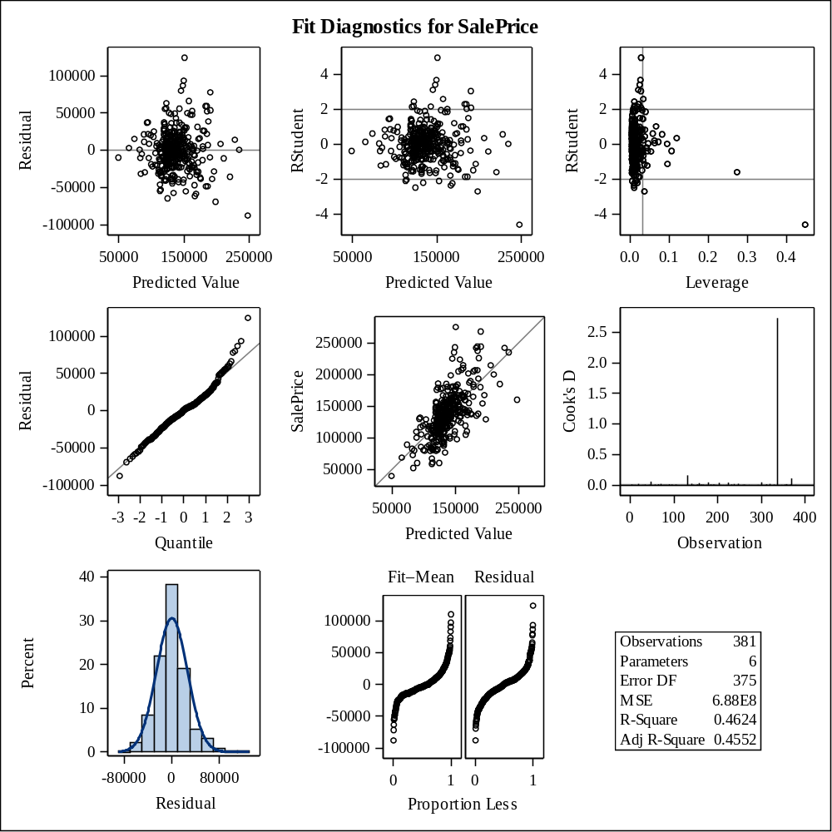

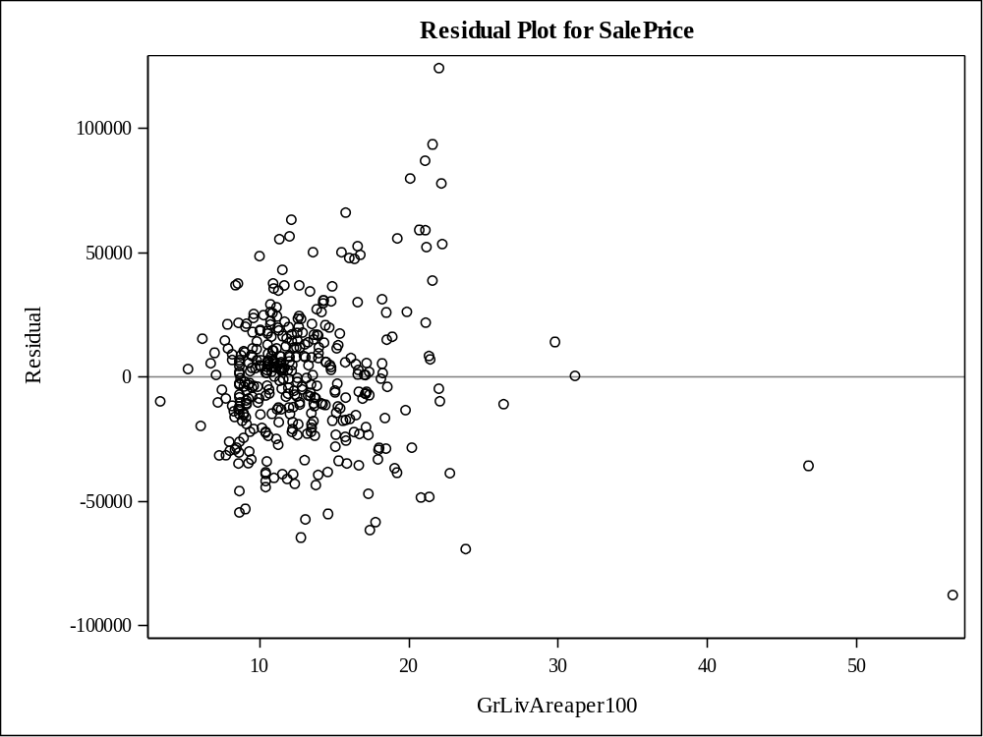

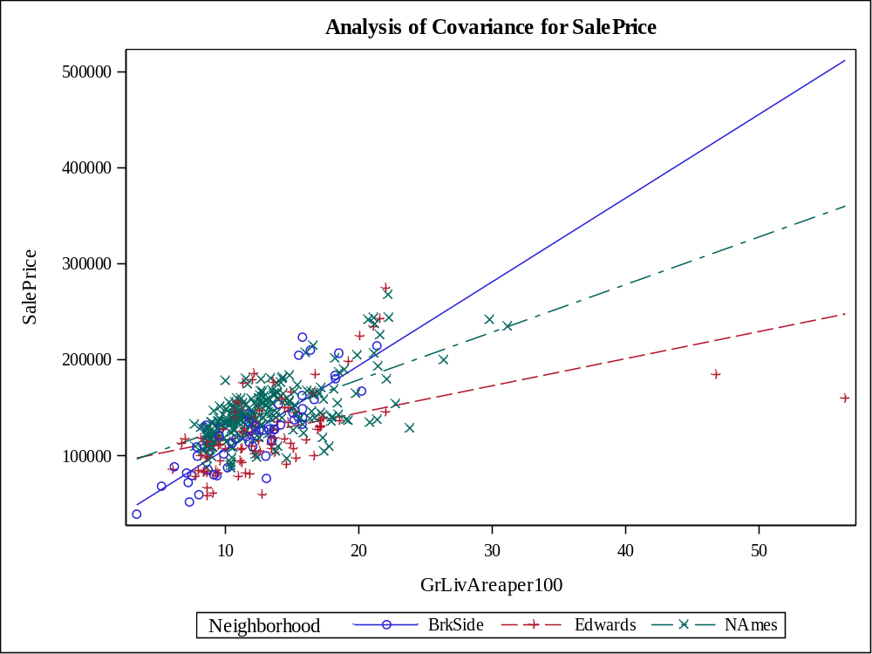

Class Level Information
Class | Levels | Values
Neighborhood | 3 | BrkSide Edwards NAmes

Number of Observations Read | 379
Number of Observations Used | 379

Source | DF | Sum of Squares | Mean Square | F Value | Pr > F
Model | 5 | 249429640074 | 49885928015 | 81.76 | <.0001
Error | 373 | 227584871181 | 610147107.72
Corrected Total | 378 | 477014511255

R-Square | Coeff Var | Root MSE | SalePrice Mean
0.522897 | 18.04909 | 24701.16 | 136855.4

Source | DF | Type I SS | Mean Square | F Value | Pr > F
GrLivAreaper100 | 1 | 214866815955 | 214866815955 | 352.16 | <.0001
Neighborhood | 2 | 23080953286 | 11540476643 | 18.91 | <.0001
GrLivArea*Neighborho | 2 | 11481870833 | 5740935416.3 | 9.41 | 0.0001

Source | DF | Type III SS | Mean Square | F Value | Pr > F
GrLivAreaper100 | 1 | 187984048744 | 187984048744 | 308.10 | <.0001
Neighborhood | 2 | 20322662167 | 10161331083 | 16.65 | <.0001
GrLivArea*Neighborho | 2 | 11481870833 | 5740935416.3 | 9.41 | 0.0001

Observation |  | Observed | Predicted | Residual | 95% Confidence Limits for Mean Predicted Value
1 |  | 118000.0000 | 113845.5614 | 4154.4386 | 107131.7171 | 120559.4057
2 |  | 157000.0000 | 142425.9557 | 14574.0443 | 139154.6748 | 145697.2366
3 |  | 132000.0000 | 94408.3166 | 37591.6834 | 85781.9113 | 103034.7220
4 |  | 149000.0000 | 130085.2050 | 18914.7950 | 126038.4003 | 134132.0098
5 |  | 139000.0000 | 146688.2230 | -7688.2230 | 143430.7738 | 149945.6722
6 |  | 134800.0000 | 124930.8353 | 9869.1647 | 120334.1215 | 129527.5490
7 |  | 207500.0000 | 159623.7087 | 47876.2913 | 155596.9244 | 163650.4930
8 |  | 68500.0000 | 65296.0307 | 3203.9693 | 52262.5438 | 78329.5177
9 |  | 165500.0000 | 164579.8335 | 920.1665 | 160029.5449 | 169130.1220
10 |  | 153000.0000 | 144606.6506 | 8393.3494 | 141360.8632 | 147852.4381
11 |  | 109000.0000 | 132711.9512 | -23711.9512 | 128904.7988 | 136519.1035
12 |  | 82000.0000 | 117922.8626 | -35922.8626 | 112775.0942 | 123070.6309
13 |  | 160000.0000 | 145944.8043 | 14055.1957 | 142695.5576 | 149194.0510
14 |  | 141000.0000 | 137321.1472 | 3678.8528 | 133846.5392 | 140795.7552
15 |  | 114500.0000 | 122474.6521 | -7974.6521 | 116081.0837 | 128868.2206
16 |  | 130000.0000 | 147729.0092 | -17729.0092 | 144452.6146 | 151005.4039
17 |  | 180500.0000 | 150950.4903 | 29549.5097 | 147562.1695 | 154338.8112
18 |  | 180000.0000 | 189707.3861 | -9707.3861 | 181742.2143 | 197672.5578
19 |  | 244000.0000 | 190500.3660 | 53499.6340 | 182417.3078 | 198583.4242
20 |  | 144900.0000 | 134149.2273 | 10750.7727 | 130458.8540 | 137839.6006
21 |  | 135750.0000 | 127508.0201 | 8241.9799 | 123197.8340 | 131818.2063
22 |  | 127000.0000 | 131975.3682 | -4975.3682 | 125453.5915 | 138497.1448
23 |  | 193500.0000 | 186485.9050 | 7014.0950 | 178995.9145 | 193975.8955
24 |  | 126500.0000 | 133108.4411 | -6608.4411 | 129334.5872 | 136882.2950
25 |  | 109900.0000 | 131869.4099 | -21969.4099 | 127988.8920 | 135749.9279
26 |  | 98600.0000 | 141533.8533 | -42933.8533 | 138241.1829 | 144826.5236
27 |  | 94750.0000 | 104452.4557 | -9702.4557 | 98001.0080 | 110903.9035
28 |  | 83000.0000 | 95682.6596 | -12682.6596 | 87988.1292 | 103377.1900
29 |  | 128950.0000 | 141038.2408 | -12088.2408 | 137730.9987 | 144345.4829
30 |  | 136900.0000 | 167244.1959 | -30344.1959 | 157547.3746 | 176941.0173
31 |  | 155000.0000 | 116028.5866 | 38971.4134 | 110760.2068 | 121296.9664
32 |  | 136000.0000 | 133851.8599 | 2148.1401 | 130138.2299 | 137565.4898
33 |  | 155000.0000 | 147134.2743 | 7865.7257 | 143869.7655 | 150398.7830
34 |  | 150000.0000 | 132513.7062 | 17486.2938 | 128689.6060 | 136337.8064
35 |  | 226000.0000 | 187229.3237 | 38770.6763 | 179630.2415 | 194828.4059
36 |  | 150750.0000 | 146093.4881 | 4656.5119 | 142842.9586 | 149344.0175
37 |  | 143000.0000 | 140493.0671 | 2506.9329 | 137167.6148 | 143818.5193
38 |  | 115000.0000 | 123146.6303 | -8146.6303 | 118340.1545 | 127953.1062
39 |  | 166000.0000 | 148968.0404 | 17031.9596 | 145657.9400 | 152278.1409
40 |  | 130000.0000 | 157001.0741 | -27001.0741 | 148993.6044 | 165008.5437
41 |  | 105000.0000 | 96238.7298 | 8761.2702 | 87843.6492 | 104633.8104
42 |  | 115000.0000 | 137117.9576 | -22117.9576 | 130322.7761 | 143913.1392
43 |  | 79000.0000 | 113993.9939 | -34993.9939 | 108569.7520 | 119418.2359
44 |  | 109500.0000 | 131869.4099 | -22369.4099 | 127988.8920 | 135749.9279
45 |  | 127500.0000 | 132165.0115 | -4665.0115 | 127048.9851 | 137281.0378
46 |  | 215000.0000 | 162399.1386 | 52600.8614 | 158089.8990 | 166708.3781
47 |  | 163000.0000 | 147828.1317 | 15171.8683 | 144549.4831 | 151106.7803
48 |  | 243000.0000 | 188502.1817 | 54497.8183 | 174986.5315 | 202017.8319
49 |  | 120000.0000 | 131112.6359 | -11112.6359 | 126048.3512 | 136176.9207
50 |  | 127000.0000 | 129099.0046 | -2099.0046 | 122669.5574 | 135528.4518
51 |  | 184000.0000 | 153626.7977 | 30373.2023 | 150088.7893 | 157164.8061
52 |  | 130000.0000 | 157001.0741 | -27001.0741 | 148993.6044 | 165008.5437
53 |  | 235000.0000 | 234560.3153 | 439.6847 | 219638.1758 | 249482.4547
54 |  | 140000.0000 | 115747.9531 | 24252.0469 | 110459.6486 | 121036.2577
55 |  | 141000.0000 | 134843.0848 | 6156.9152 | 131205.0571 | 138481.1125
56 |  | 145000.0000 | 134446.5948 | 10553.4052 | 130778.9886 | 138114.2011
57 |  | 98000.0000 | 97717.2523 | 282.7477 | 90329.2635 | 105105.2411
58 |  | 186000.0000 | 122132.3647 | 63867.6353 | 117159.7066 | 127105.0228
59 |  | 134450.0000 | 141583.4145 | -7133.4145 | 138292.0964 | 144874.7326
60 |  | 97000.0000 | 123146.6303 | -26146.6303 | 118340.1545 | 127953.1062
61 |  | 148000.0000 | 139501.8421 | 8498.1579 | 136137.5477 | 142866.1365
62 |  | 113000.0000 | 141425.9162 | -28425.9162 | 135543.8083 | 147308.0240
63 |  | 140000.0000 | 148472.4279 | -8472.4279 | 145177.2454 | 151767.6105
64 |  | 76500.0000 | 133805.7814 | -57305.7814 | 127202.1062 | 140409.4565
65 |  | 158000.0000 | 144854.4569 | 13145.5431 | 141609.1283 | 148099.7854
66 |  | 145000.0000 | 145449.1918 | -449.1918 | 142202.9249 | 148695.4588
67 |  | 176000.0000 | 148819.3567 | 27180.6433 | 145513.9307 | 152124.7827
68 |  | 148000.0000 | 115186.6862 | 32813.3138 | 109856.9961 | 120516.3763
69 |  | 139000.0000 | 161209.6686 | -22209.6686 | 157025.1010 | 165394.2362
70 |  | 205000.0000 | 154899.1143 | 50100.8857 | 146318.9226 | 163479.3059
71 |  | 159000.0000 | 166264.9159 | -7264.9159 | 161518.6047 | 171011.2271
72 |  | 88000.0000 | 122849.2629 | -34849.2629 | 118007.0212 | 127691.5045
73 |  | 153575.0000 | 141650.4093 | 11924.5907 | 134510.2617 | 148790.5569
74 |  | 131000.0000 | 157492.1826 | -26492.1826 | 149407.4130 | 165576.9523
75 |  | 167000.0000 | 161804.4036 | 5195.5964 | 157558.1429 | 166050.6643
76 |  | 82500.0000 | 97506.7772 | -15006.7772 | 90087.5166 | 104926.0378
77 |  | 132000.0000 | 128499.2451 | 3500.7549 | 124293.3446 | 132705.1456
78 |  | 242000.0000 | 227919.1081 | 14080.8919 | 214048.6790 | 241789.5372
79 |  | 145250.0000 | 148868.9179 | -3618.9179 | 145561.9527 | 152175.8832
80 |  | 214500.0000 | 205976.3584 | 8523.6416 | 189223.8806 | 222728.8361
81 |  | 119000.0000 | 165967.5484 | -46967.5484 | 161256.3940 | 170678.7028
82 |  | 139000.0000 | 132662.3899 | 6337.6101 | 128851.0191 | 136473.7608
83 |  | 155000.0000 | 140542.6283 | 14457.3717 | 137218.9250 | 143866.3316
84 |  | 87500.0000 | 131869.4099 | -44369.4099 | 127988.8920 | 135749.9279
85 |  | 140200.0000 | 157426.8277 | -17226.8277 | 148516.5962 | 166337.0592
86 |  | 151500.0000 | 127805.3876 | 23694.6124 | 123526.8573 | 132083.9179
87 |  | 157500.0000 | 153577.2365 | 3922.7635 | 150042.4290 | 157112.0439
88 |  | 95000.0000 | 115046.3694 | -20046.3694 | 109706.0173 | 120386.7215
89 |  | 145000.0000 | 151151.1254 | -6151.1254 | 143032.1542 | 159270.0965
90 |  | 198500.0000 | 171944.8066 | 26555.1934 | 161430.9538 | 182458.6594
91 |  | 159000.0000 | 149414.0916 | 9585.9084 | 146088.9531 | 152739.2302
92 |  | 165000.0000 | 151247.8578 | 13752.1422 | 147845.3257 | 154650.3899
93 |  | 132000.0000 | 143169.3744 | -11169.3744 | 139911.0917 | 146427.6572
94 |  | 162000.0000 | 144111.0381 | 17888.9619 | 140862.8342 | 147359.2421
95 |  | 123000.0000 | 145696.9981 | -22696.9981 | 142449.4907 | 148944.5054
96 |  | 61000.0000 | 100523.5871 | -39523.5871 | 93541.8718 | 107505.3024
97 |  | 81000.0000 | 120167.9304 | -39167.9304 | 115130.1393 | 125205.7215
98 |  | 125000.0000 | 116028.5866 | 8971.4134 | 110760.2068 | 121296.9664
99 |  | 119000.0000 | 133006.9119 | -14006.9119 | 127843.7338 | 138170.0900
100 |  | 106500.0000 | 124038.7328 | -17538.7328 | 119338.2047 | 128739.2610
101 |  | 100000.0000 | 88655.5895 | 11344.4105 | 79254.5362 | 98056.6428
102 |  | 129000.0000 | 117361.5956 | 11638.4044 | 112180.6624 | 122542.5288
103 |  | 169500.0000 | 170130.6932 | -630.6932 | 164908.1331 | 175353.2533
104 |  | 60000.0000 | 126622.5003 | -66622.5003 | 121684.1707 | 131560.8299
105 |  | 126000.0000 | 116660.0119 | 9339.9881 | 111434.5537 | 121885.4702
106 |  | 142000.0000 | 132662.3899 | 9337.6101 | 128851.0191 | 136473.7608
107 |  | 139000.0000 | 139600.9646 | -600.9646 | 136240.8819 | 142961.0473
108 |  | 109008.0000 | 125277.7640 | -16269.7640 | 120720.8149 | 129834.7131
109 |  | 119000.0000 | 98766.4433 | 20233.5567 | 90676.8577 | 106856.0289
110 |  | 110000.0000 | 121009.8308 | -11009.8308 | 116003.5943 | 126016.0673
111 |  | 118000.0000 | 138128.4728 | -20128.4728 | 132576.9966 | 143679.9491
112 |  | 162900.0000 | 157078.1776 | 5821.8224 | 148214.3001 | 165942.0550
113 |  | 127500.0000 | 155597.9067 | -28097.9067 | 147808.7501 | 163387.0632
114 |  | 190000.0000 | 173897.3480 | 16102.6520 | 168182.3949 | 179612.3012
115 |  | 110000.0000 | 124828.0405 | -14828.0405 | 118450.3587 | 131205.7224
116 |  | 167000.0000 | 143615.4257 | 23384.5743 | 140362.8110 | 146868.0403
117 |  | 146500.0000 | 161804.4036 | -15304.4036 | 157558.1429 | 166050.6643
118 |  | 148000.0000 | 112310.1931 | 35689.8069 | 106737.9323 | 117882.4538
119 |  | 147000.0000 | 135487.3810 | 11512.6190 | 131895.4710 | 139079.2910
120 |  | 156000.0000 | 133504.9311 | 22495.0689 | 129763.5617 | 137246.3005
121 |  | 133000.0000 | 158533.3612 | -25533.3612 | 154608.9043 | 162457.8182
122 |  | 155000.0000 | 143218.9357 | 11781.0643 | 139961.3619 | 146476.5094
123 |  | 184000.0000 | 178607.3231 | 5392.6769 | 166521.6250 | 190693.0212
124 |  | 120000.0000 | 125525.5702 | -5525.5702 | 120996.8084 | 130054.3321
125 |  | 140000.0000 | 122272.6814 | 17727.3186 | 117303.5289 | 127241.8339
126 |  | 124500.0000 | 131918.9712 | -7418.9712 | 128042.8644 | 135795.0780
127 |  | 164900.0000 | 147877.6930 | 17022.3070 | 144597.8883 | 151157.4976
128 |  | 129900.0000 | 123146.6303 | 6753.3697 | 118340.1545 | 127953.1062
129 |  | 150000.0000 | 141979.9045 | 8020.0955 | 138698.7124 | 145261.0965
130 |  | 159000.0000 | 165009.9680 | -6009.9680 | 155034.7832 | 174985.1529
131 |  | 132000.0000 | 126318.5502 | 5681.4498 | 121878.7338 | 130758.3666
132 |  | 86000.0000 | 79546.2348 | 6453.7652 | 69177.5385 | 89914.9310
133 |  | 128000.0000 | 138686.8832 | -10686.8832 | 131782.6044 | 145591.1620
134 |  | 107500.0000 | 121312.8642 | -13812.8642 | 116282.4830 | 126343.2454
135 |  | 39300.0000 | 49083.7997 | -9783.7997 | 33278.3512 | 64889.2482
136 |  | 107500.0000 | 131603.7445 | -24103.7445 | 126516.3231 | 136691.1659
137 |  | 111250.0000 | 123146.6303 | -11896.6303 | 118340.1545 | 127953.1062
138 |  | 133000.0000 | 118339.1893 | 14660.8107 | 112930.4803 | 123747.8983
139 |  | 210000.0000 | 162482.2546 | 47517.7454 | 152873.1684 | 172091.3408
140 |  | 108000.0000 | 116098.7450 | -8098.7450 | 110835.2654 | 121362.2245
141 |  | 113000.0000 | 111317.8480 | 1682.1520 | 104437.9300 | 118197.7660
142 |  | 141000.0000 | 134446.5948 | 6553.4052 | 130778.9886 | 138114.2011
143 |  | 108000.0000 | 106978.1570 | 1021.8430 | 100839.0271 | 113117.2870
144 |  | 185000.0000 | 154545.5311 | 30454.4689 | 146917.4876 | 162173.5747
145 |  | 135960.0000 | 127061.9689 | 8898.0311 | 122703.7247 | 131420.2131
146 |  | 142600.0000 | 165967.5484 | -23367.5484 | 161256.3940 | 170678.7028
147 |  | 120000.0000 | 123146.6303 | -3146.6303 | 118340.1545 | 127953.1062
148 |  | 139000.0000 | 135289.1360 | 3710.8640 | 131683.2971 | 138894.9749
149 |  | 118500.0000 | 140592.1896 | -22092.1896 | 137270.2166 | 143914.1625
150 |  | 181900.0000 | 151148.7353 | 30751.2647 | 147751.0101 | 154546.4605
151 |  | 118500.0000 | 94349.6506 | 24150.3494 | 86449.4562 | 102249.8450
152 |  | 133000.0000 | 157078.1776 | -24078.1776 | 148214.3001 | 165942.0550
153 |  | 130000.0000 | 93013.7161 | 36986.2839 | 84205.8340 | 101821.5982
154 |  | 79500.0000 | 101468.4818 | -21968.4818 | 93685.6072 | 109251.3564
155 |  | 205000.0000 | 178754.3503 | 26245.6497 | 172373.7588 | 185134.9419
156 |  | 225000.0000 | 177978.4264 | 47021.5736 | 166389.3506 | 189567.5021
157 |  | 137500.0000 | 132563.2674 | 4936.7326 | 128743.4226 | 136383.1122
158 |  | 105500.0000 | 121560.6704 | -16060.6704 | 116560.9992 | 126560.3416
159 |  | 67000.0000 | 97717.2523 | -30717.2523 | 90329.2635 | 105105.2411
160 |  | 160000.0000 | 135636.0648 | 24363.9352 | 132054.4467 | 139217.6828
161 |  | 139900.0000 | 150801.8066 | -10901.8066 | 147420.3546 | 154183.2586
162 |  | 153000.0000 | 155658.8089 | -2658.8089 | 151976.7593 | 159340.8585
163 |  | 135000.0000 | 183413.1076 | -48413.1076 | 176369.9581 | 190456.2571
164 |  | 168500.0000 | 147233.3967 | 21266.6033 | 143967.1027 | 150499.6908
165 |  | 139400.0000 | 132662.3899 | 6737.6101 | 128851.0191 | 136473.7608
166 |  | 60000.0000 | 89701.5399 | -29701.5399 | 80446.2013 | 98956.8785
167 |  | 85000.0000 | 92946.4832 | -7946.4832 | 84826.0458 | 101066.9207
168 |  | 143250.0000 | 128945.2963 | 14304.7037 | 124785.1411 | 133105.4515
169 |  | 98300.0000 | 132265.8999 | -33965.8999 | 128420.3402 | 136111.4597
170 |  | 155000.0000 | 113853.6772 | 41146.3228 | 108417.7369 | 119289.6175
171 |  | 155000.0000 | 171468.8469 | -16468.8469 | 166074.1683 | 176863.5255
172 |  | 108000.0000 | 143039.5586 | -35039.5586 | 136976.2589 | 149102.8583
173 |  | 145500.0000 | 132513.7062 | 12986.2938 | 128689.6060 | 136337.8064
174 |  | 97500.0000 | 152586.0115 | -55086.0115 | 149111.9172 | 156060.1058
175 |  | 167000.0000 | 141355.7578 | 25644.2422 | 135481.2556 | 147230.2599
176 |  | 110000.0000 | 149314.9692 | -39314.9692 | 145993.3033 | 152636.6350
177 |  | 137500.0000 | 119957.4553 | 17542.5447 | 114910.9354 | 125003.9751
178 |  | 129000.0000 | 198281.4819 | -69281.4819 | 189026.0712 | 207536.8926
179 |  | 103600.0000 | 133147.2286 | -29547.2286 | 127975.7049 | 138318.7523
180 |  | 140000.0000 | 136627.2897 | 3372.7103 | 133110.8076 | 140143.7718
181 |  | 141500.0000 | 154114.6515 | -12614.6515 | 145633.9138 | 162595.3891
182 |  | 89000.0000 | 73663.6339 | 15336.3661 | 61997.0813 | 85330.1865
183 |  | 123500.0000 | 117642.2291 | 5857.7709 | 112478.1543 | 122806.3039
184 |  | 52000.0000 | 83513.0001 | -31513.0001 | 73368.7532 | 93657.2470
185 |  | 129000.0000 | 103647.5451 | 25352.4549 | 96095.4074 | 111199.6828
186 |  | 124500.0000 | 123146.6303 | 1353.3697 | 118340.1545 | 127953.1062
187 |  | 135000.0000 | 140233.2239 | -5233.2239 | 134477.1634 | 145989.2844
188 |  | 120500.0000 | 123146.6303 | -2646.6303 | 118340.1545 | 127953.1062
189 |  | 110000.0000 | 168346.4883 | -58346.4883 | 163347.9114 | 173345.0652
190 |  | 93500.0000 | 131869.4099 | -38369.4099 | 127988.8920 | 135749.9279
191 |  | 179000.0000 | 121290.4643 | 57709.5357 | 116293.5393 | 126287.3893
192 |  | 98000.0000 | 144372.5676 | -46372.5676 | 138151.0353 | 150594.1000
193 |  | 156000.0000 | 131175.5525 | 24824.4475 | 127232.0685 | 135119.0365
194 |  | 127500.0000 | 123146.6303 | 4353.3697 | 118340.1545 | 127953.1062
195 |  | 100000.0000 | 133369.9687 | -33369.9687 | 126787.3832 | 139952.5542
196 |  | 102000.0000 | 122693.6317 | -20693.6317 | 117734.0657 | 127653.1976
197 |  | 107000.0000 | 115467.3197 | -8467.3197 | 110158.5763 | 120776.0630
198 |  | 114500.0000 | 125525.5702 | -11025.5702 | 120996.8084 | 130054.3321
199 |  | 110000.0000 | 118636.5568 | -8636.5568 | 113266.4390 | 124006.6746
200 |  | 118000.0000 | 136230.7998 | -18230.7998 | 132688.9990 | 139772.6005
201 |  | 135500.0000 | 128895.7351 | 6604.2649 | 124730.5346 | 133060.9356
202 |  | 223500.0000 | 157339.6652 | 66160.3348 | 148441.0462 | 166238.2841
203 |  | 159950.0000 | 134149.2273 | 25800.7727 | 130458.8540 | 137839.6006
204 |  | 157900.0000 | 151793.0315 | 6106.9685 | 148362.8290 | 155223.2341
205 |  | 116000.0000 | 124798.3827 | -8798.3827 | 119865.6010 | 129731.1645
206 |  | 137000.0000 | 130283.4500 | 6716.5500 | 126255.8138 | 134311.0862
207 |  | 109500.0000 | 88306.9394 | 21193.0606 | 78856.8762 | 97757.0026
208 |  | 166000.0000 | 149314.9692 | 16685.0308 | 145993.3033 | 152636.6350
209 |  | 167000.0000 | 155460.5639 | 11539.4361 | 151793.6276 | 159127.5001
210 |  | 139950.0000 | 137023.7797 | 2926.2203 | 133531.6102 | 140515.9492
211 |  | 130500.0000 | 121290.4643 | 9209.5357 | 116293.5393 | 126287.3893
212 |  | 174900.0000 | 138064.5659 | 36835.4341 | 134631.2762 | 141497.8556
213 |  | 141000.0000 | 169535.9582 | -28535.9582 | 164388.7919 | 174683.1246
214 |  | 158000.0000 | 151941.7153 | 6058.2847 | 148503.6084 | 155379.8221
215 |  | 132500.0000 | 137222.0247 | -4722.0247 | 133741.6276 | 140702.4218
216 |  | 148500.0000 | 129986.0825 | 18513.9175 | 125929.6315 | 134042.5336
217 |  | 109500.0000 | 124633.4678 | -15133.4678 | 120002.3952 | 129264.5404
218 |  | 116000.0000 | 125426.4477 | -9426.4477 | 120886.4329 | 129966.4626
219 |  | 133000.0000 | 143169.3744 | -10169.3744 | 139911.0917 | 146427.6572
220 |  | 157000.0000 | 113573.0437 | 43426.9563 | 108113.3525 | 119032.7349
221 |  | 100000.0000 | 124534.3453 | -24534.3453 | 119891.7644 | 129176.9262
222 |  | 145000.0000 | 165174.5684 | -20174.5684 | 160556.0003 | 169793.1366
223 |  | 135500.0000 | 134831.0295 | 668.9705 | 129548.8392 | 140113.2198
224 |  | 268000.0000 | 190202.9985 | 77797.0015 | 182164.1874 | 198241.8097
225 |  | 149500.0000 | 154915.3901 | -5415.3901 | 151288.8637 | 158541.9166
226 |  | 122900.0000 | 126120.3052 | -3220.3052 | 121658.4353 | 130582.1751
227 |  | 140000.0000 | 169337.7132 | -29337.7132 | 164215.5193 | 174459.9072
228 |  | 110000.0000 | 122849.2629 | -12849.2629 | 118007.0212 | 127691.5045
229 |  | 153000.0000 | 145052.7018 | 7947.2982 | 141807.3804 | 148298.0233
230 |  | 128000.0000 | 133009.3186 | -5009.3186 | 129227.2156 | 136791.4217
231 |  | 154300.0000 | 193027.9897 | -38727.9897 | 184567.0242 | 201488.9551
232 |  | 88000.0000 | 108441.4844 | -20441.4844 | 101337.3472 | 115545.6215
233 |  | 135000.0000 | 123325.0570 | 11674.9430 | 118377.2403 | 128272.8737
234 |  | 176500.0000 | 150405.3166 | 26094.6834 | 147041.4012 | 153769.2320
235 |  | 145900.0000 | 191448.8332 | -45548.8332 | 177385.0348 | 205512.6316
236 |  | 117500.0000 | 126169.8665 | -8669.8665 | 121713.5216 | 130626.2114
237 |  | 242000.0000 | 182867.9339 | 59132.0661 | 175903.3154 | 189832.5524
238 |  | 79900.0000 | 85081.9256 | -5181.9256 | 75168.8157 | 94995.0356
239 |  | 150000.0000 | 138128.4728 | 11871.5272 | 132576.9966 | 143679.9491
240 |  | 143000.0000 | 137023.7797 | 5976.2203 | 133531.6102 | 140515.9492
241 |  | 129000.0000 | 123146.6303 | 5853.3697 | 118340.1545 | 127953.1062
242 |  | 127500.0000 | 105855.6231 | 21644.3769 | 99580.7459 | 112130.5003
243 |  | 116500.0000 | 94756.9668 | 21743.0332 | 86175.2396 | 103338.6940
244 |  | 135000.0000 | 134743.9623 | 256.0377 | 131098.6243 | 138389.3003
245 |  | 140000.0000 | 134595.2786 | 5404.7214 | 130938.8694 | 138251.6878
246 |  | 135000.0000 | 139402.7196 | -4402.7196 | 136034.1417 | 142771.2975
247 |  | 167500.0000 | 195952.6671 | -28452.6671 | 180952.0245 | 210953.3098
248 |  | 85500.0000 | 95715.7546 | -10215.7546 | 87255.4086 | 104176.1006
249 |  | 110000.0000 | 99822.0034 | 10177.9966 | 92740.6717 | 106903.3350
250 |  | 178400.0000 | 129837.3988 | 48562.6012 | 125766.4016 | 133908.3960
251 |  | 125000.0000 | 118764.7630 | 6235.2370 | 113662.5504 | 123866.9756
252 |  | 187000.0000 | 172063.5819 | 14936.4181 | 166591.3685 | 177535.7953
253 |  | 121600.0000 | 127181.4289 | -5581.4289 | 120788.0217 | 133574.8360
254 |  | 136500.0000 | 132365.0224 | 4134.9776 | 128528.0828 | 136201.9620
255 |  | 82000.0000 | 103329.9218 | -21329.9218 | 96732.0918 | 109927.7518
256 |  | 163500.0000 | 162448.6998 | 1051.3002 | 158134.1557 | 166763.2439
257 |  | 100000.0000 | 153843.9475 | -53843.9475 | 146321.9837 | 161365.9112
258 |  | 119200.0000 | 133950.9824 | -14750.9824 | 130245.1584 | 137656.8063
259 |  | 176000.0000 | 116519.6952 | 59480.3048 | 111284.9296 | 121754.4608
260 |  | 167500.0000 | 142971.1294 | 24528.8706 | 139709.8133 | 146232.4456
261 |  | 105000.0000 | 148521.9892 | -43521.9892 | 145225.4004 | 151818.5780
262 |  | 84000.0000 | 96384.2433 | -12384.2433 | 88796.4634 | 103972.0232
263 |  | 139600.0000 | 158684.8749 | -19084.8749 | 150410.5673 | 166959.1825
264 |  | 84900.0000 | 102347.7047 | -17447.7047 | 95618.3059 | 109077.1034
265 |  | 165000.0000 | 178308.2991 | -13308.2991 | 171990.0272 | 184626.5710
266 |  | 144500.0000 | 144162.0925 | 337.9075 | 137966.0322 | 150358.1529
267 |  | 154000.0000 | 137519.3922 | 16480.6078 | 134056.1665 | 140982.6179
268 |  | 167900.0000 | 160168.8824 | 7731.1176 | 156089.0091 | 164248.7558
269 |  | 135000.0000 | 124583.9065 | 10416.0935 | 119947.0832 | 129220.7299
270 |  | 135000.0000 | 132265.8999 | 2734.1001 | 128420.3402 | 136111.4597
271 |  | 91500.0000 | 139251.0067 | -47751.0067 | 133593.3642 | 144908.6492
272 |  | 159500.0000 | 137146.2556 | 22353.7444 | 131681.8573 | 142610.6540
273 |  | 138800.0000 | 134644.8398 | 4155.1602 | 130992.1351 | 138297.5446
274 |  | 160000.0000 | 142326.8332 | 17673.1668 | 139053.4860 | 145600.1804
275 |  | 137500.0000 | 157001.0741 | -19501.0741 | 148993.6044 | 165008.5437
276 |  | 92900.0000 | 131869.4099 | -38969.4099 | 127988.8920 | 135749.9279
277 |  | 146000.0000 | 139799.2096 | 6200.7904 | 136447.3337 | 143151.0854
278 |  | 129000.0000 | 126715.0402 | 2284.9598 | 122318.9540 | 131111.1264
279 |  | 128000.0000 | 135374.7070 | -7374.7070 | 128687.0841 | 142062.3298
280 |  | 119500.0000 | 127408.8977 | -7908.8977 | 123088.0909 | 131729.7044
281 |  | 135000.0000 | 136528.1672 | -1528.1672 | 133005.4490 | 140050.8855
282 |  | 159500.0000 | 139501.8421 | 19998.1579 | 136137.5477 | 142866.1365
283 |  | 129900.0000 | 120767.6905 | 9132.3095 | 115669.2781 | 125866.1028
284 |  | 134500.0000 | 130283.4500 | 4216.5500 | 126255.8138 | 134311.0862
285 |  | 133700.0000 | 131869.4099 | 1830.5901 | 127988.8920 | 135749.9279
286 |  | 112000.0000 | 104452.4557 | 7547.5443 | 98001.0080 | 110903.9035
287 |  | 118000.0000 | 86070.9631 | 31929.0369 | 76824.9060 | 95317.0201
288 |  | 115000.0000 | 130134.7663 | -15134.7663 | 126092.7693 | 134176.7633
289 |  | 102000.0000 | 105913.7709 | -3913.7709 | 98584.2372 | 113243.3047
290 |  | 119000.0000 | 142376.3945 | -23376.3945 | 139104.0902 | 145648.6988
291 |  | 144000.0000 | 121690.1893 | 22309.8107 | 115284.3277 | 128096.0510
292 |  | 139000.0000 | 127508.0201 | 11491.9799 | 123197.8340 | 131818.2063
293 |  | 80000.0000 | 101926.7544 | -21926.7544 | 95140.0230 | 108713.4859
294 |  | 149000.0000 | 157339.6652 | -8339.6652 | 148441.0462 | 166238.2841
295 |  | 124000.0000 | 126516.7952 | -2516.7952 | 122098.9073 | 130934.6831
296 |  | 149900.0000 | 139952.5904 | 9947.4096 | 134225.1588 | 145680.0220
297 |  | 201800.0000 | 170527.1832 | 31272.8168 | 165253.9747 | 175800.3917
298 |  | 179900.0000 | 143020.6907 | 36879.3093 | 139760.1625 | 146281.2189
299 |  | 235000.0000 | 184994.2633 | 50005.7367 | 172126.7021 | 197861.8244
300 |  | 163000.0000 | 142822.4457 | 20177.5543 | 139558.6475 | 146086.2439
301 |  | 93000.0000 | 115958.4282 | -22958.4282 | 110685.1158 | 121231.7407
302 |  | 104900.0000 | 122763.7900 | -17863.7900 | 117805.6858 | 127721.8943
303 |  | 116050.0000 | 123146.6303 | -7096.6303 | 118340.1545 | 127953.1062
304 |  | 117000.0000 | 137466.6077 | -20466.6077 | 130648.1685 | 144285.0470
305 |  | 140000.0000 | 143912.7932 | -3912.7932 | 140663.0639 | 147162.5224
306 |  | 113000.0000 | 84246.8455 | 28753.1545 | 74691.4531 | 93802.2378
307 |  | 134500.0000 | 129837.3988 | 4662.6012 | 125766.4016 | 133908.3960
308 |  | 80500.0000 | 99463.7435 | -18963.7435 | 91455.3654 | 107472.1217
309 |  | 115000.0000 | 125525.5702 | -10525.5702 | 120996.8084 | 130054.3321
310 |  | 143000.0000 | 171815.7756 | -28815.7756 | 166375.9429 | 177255.6084
311 |  | 137900.0000 | 186188.5375 | -48288.5375 | 178742.0820 | 193634.9929
312 |  | 145000.0000 | 136726.4122 | 8273.5878 | 133216.1034 | 140236.7210
313 |  | 147000.0000 | 125525.5702 | 21474.4298 | 120996.8084 | 130054.3321
314 |  | 127000.0000 | 155014.5126 | -28014.5126 | 151380.7663 | 158648.2590
315 |  | 132500.0000 | 139303.5971 | -6803.5971 | 135930.6642 | 142676.5300
316 |  | 101800.0000 | 140988.6795 | -39188.6795 | 137679.8759 | 144297.4832
317 |  | 142000.0000 | 139204.4746 | 2795.5254 | 135827.1154 | 142581.8338
318 |  | 119000.0000 | 129292.2251 | -10292.2251 | 125167.1192 | 133417.3310
319 |  | 244000.0000 | 184899.9450 | 59100.0550 | 177641.4392 | 192158.4509
320 |  | 165400.0000 | 153282.6805 | 12117.3195 | 145844.7790 | 160720.5820
321 |  | 127500.0000 | 139122.6959 | -11622.6959 | 132186.1212 | 146059.2706
322 |  | 99900.0000 | 97717.2523 | 2182.7477 | 90329.2635 | 105105.2411
323 |  | 151000.0000 | 132563.2674 | 18436.7326 | 128743.4226 | 136383.1122
324 |  | 128900.0000 | 132365.0224 | -3465.0224 | 128528.0828 | 136201.9620
325 |  | 180500.0000 | 178955.9733 | 1544.0267 | 166813.6854 | 191098.2611
326 |  | 181000.0000 | 146589.1005 | 34410.8995 | 143333.0029 | 149845.1982
327 |  | 144000.0000 | 155857.0539 | -11857.0539 | 152159.6718 | 159554.4359
328 |  | 177000.0000 | 132305.3282 | 44694.6718 | 127181.7943 | 137428.8621
329 |  | 137000.0000 | 175483.3080 | -38483.3080 | 169554.3454 | 181412.2705
330 |  | 132500.0000 | 143045.0098 | -10545.0098 | 135781.2561 | 150308.7636
331 |  | 180500.0000 | 137420.2697 | 43079.7303 | 133951.3856 | 140889.1538
332 |  | 115000.0000 | 97717.2523 | 17282.7477 | 90329.2635 | 105105.2411
333 |  | 138500.0000 | 132464.1449 | 6035.8551 | 128635.7771 | 136292.5128
334 |  | 155000.0000 | 136230.7998 | 18769.2002 | 132688.9990 | 139772.6005
335 |  | 140000.0000 | 112310.1931 | 27689.8069 | 106737.9323 | 117882.4538
336 |  | 154000.0000 | 142079.0270 | 11920.9730 | 138800.1734 | 145357.8806
337 |  | 130000.0000 | 156930.9157 | -26930.9157 | 148934.4522 | 164927.3792
338 |  | 119000.0000 | 103610.5553 | 15389.4447 | 97049.7292 | 110171.3814
339 |  | 206900.0000 | 184999.0675 | 21900.9325 | 177726.1457 | 192271.9893
340 |  | 111000.0000 | 103610.5553 | 7389.4447 | 97049.7292 | 110171.3814
341 |  | 156500.0000 | 153577.2365 | 2922.7635 | 150042.4290 | 157112.0439
342 |  | 72500.0000 | 82728.5373 | -10228.5373 | 72467.3955 | 92989.6790
343 |  | 82500.0000 | 81682.5869 | 817.4131 | 71264.2766 | 92100.8971
344 |  | 79000.0000 | 91402.9991 | -12402.9991 | 83036.2040 | 99769.7942
345 |  | 100000.0000 | 94349.6506 | 5650.3494 | 86449.4562 | 102249.8450
346 |  | 123000.0000 | 123543.1203 | -543.1203 | 118783.9867 | 128302.2540
347 |  | 200000.0000 | 210870.0388 | -10870.0388 | 199675.2405 | 222064.8372
348 |  | 171000.0000 | 165372.8134 | 5627.1866 | 160731.2612 | 170014.3657
349 |  | 134900.0000 | 122474.6521 | 12425.3479 | 116081.0837 | 128868.2206
350 |  | 110000.0000 | 124534.3453 | -14534.3453 | 119891.7644 | 129176.9262
351 |  | 149900.0000 | 133752.7374 | 16147.2626 | 130031.2479 | 137474.2268
352 |  | 104900.0000 | 166463.1609 | -61563.1609 | 161693.2837 | 171233.0381
353 |  | 165500.0000 | 162646.9448 | 2853.0552 | 158311.0978 | 166982.7918
354 |  | 117000.0000 | 149634.4453 | -32634.4453 | 142723.7543 | 156545.1363
355 |  | 58500.0000 | 97717.2523 | -39217.2523 | 90329.2635 | 105105.2411
356 |  | 237500.0000 | 185246.8738 | 52253.1262 | 177937.8812 | 192555.8664
357 |  | 105000.0000 | 125359.6497 | -20359.6497 | 120428.0111 | 130291.2883
358 |  | 131000.0000 | 126135.4785 | 4864.5215 | 119752.9590 | 132517.9980
359 |  | 124000.0000 | 158830.7287 | -34830.7287 | 154878.8898 | 162782.5676
360 |  | 123000.0000 | 124930.8353 | -1930.8353 | 120334.1215 | 129527.5490
361 |  | 137500.0000 | 151848.4256 | -14348.4256 | 143646.4082 | 160050.4430
362 |  | 138000.0000 | 174690.3280 | -36690.3280 | 168868.8138 | 180511.8422
363 |  | 120000.0000 | 120905.7265 | -905.7265 | 114484.1016 | 127327.3515
364 |  | 140000.0000 | 162993.8735 | -22993.8735 | 158620.4248 | 167367.3223
365 |  | 90000.0000 | 131869.4099 | -41869.4099 | 127988.8920 | 135749.9279
366 |  | 207000.0000 | 181047.8740 | 25952.1260 | 168563.9815 | 193531.7666
367 |  | 124000.0000 | 137023.7797 | -13023.7797 | 133531.6102 | 140515.9492
368 |  | 274970.0000 | 191518.9916 | 83451.0084 | 177442.1039 | 205595.8793
369 |  | 144000.0000 | 146936.0293 | -2936.0293 | 143674.8552 | 150197.2033
370 |  | 142000.0000 | 142376.3945 | -376.3945 | 139104.0902 | 145648.6988
371 |  | 140000.0000 | 157542.1363 | -17542.1363 | 153705.9640 | 161378.3086
372 |  | 174000.0000 | 156501.3501 | 17498.6499 | 152752.6573 | 160250.0428
373 |  | 120500.0000 | 123146.6303 | -2646.6303 | 118340.1545 | 127953.1062
374 |  | 121000.0000 | 102950.2448 | 18049.7552 | 95325.9811 | 110574.5086
375 |  | 112000.0000 | 131533.5861 | -19533.5861 | 126449.5788 | 136617.5935
376 |  | 136000.0000 | 169139.4683 | -33139.4683 | 164042.1653 | 174236.7712
377 |  | 145000.0000 | 112310.1931 | 32689.8069 | 106737.9323 | 117882.4538
378 |  | 142125.0000 | 133752.7374 | 8372.2626 | 130031.2479 | 137474.2268
379 |  | 147500.0000 | 125219.3329 | 22280.6671 | 120287.6462 | 130151.0197

Sum of Residuals | -1.018634E-9
Sum of Squared Residuals | 227584871181
Sum of Squared Residuals - Error SS | 0.0021362305
PRESS Statistic | 237769407660
First Order Autocorrelation | -0.046536661
Durbin-Watson D | 2.0908161961

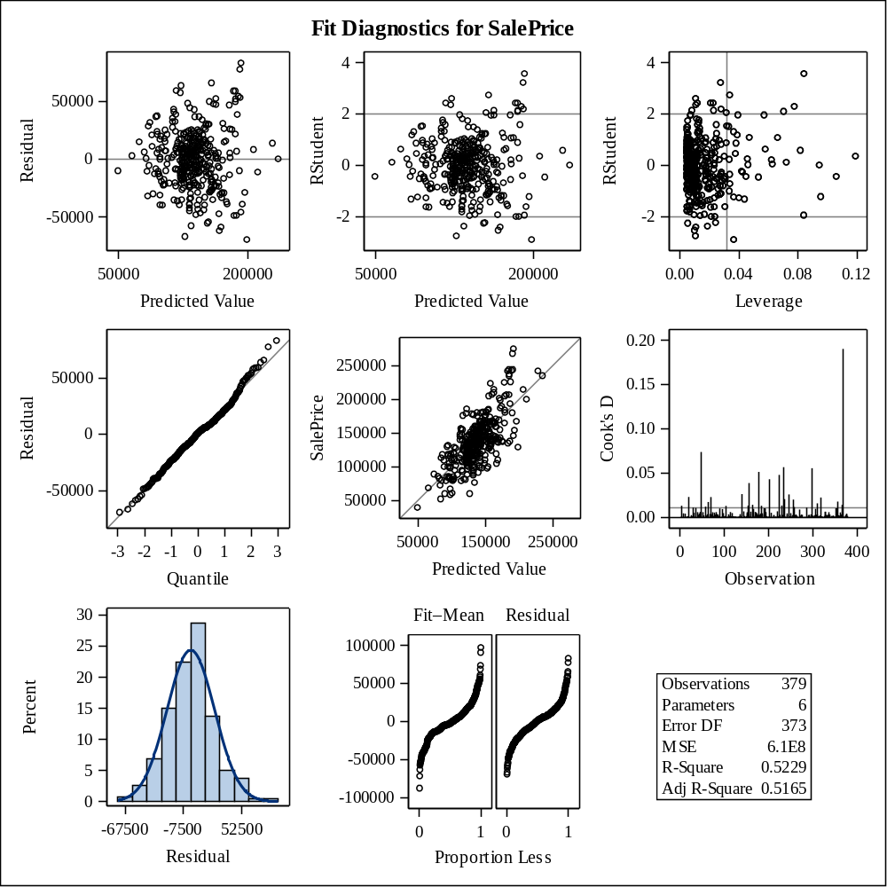

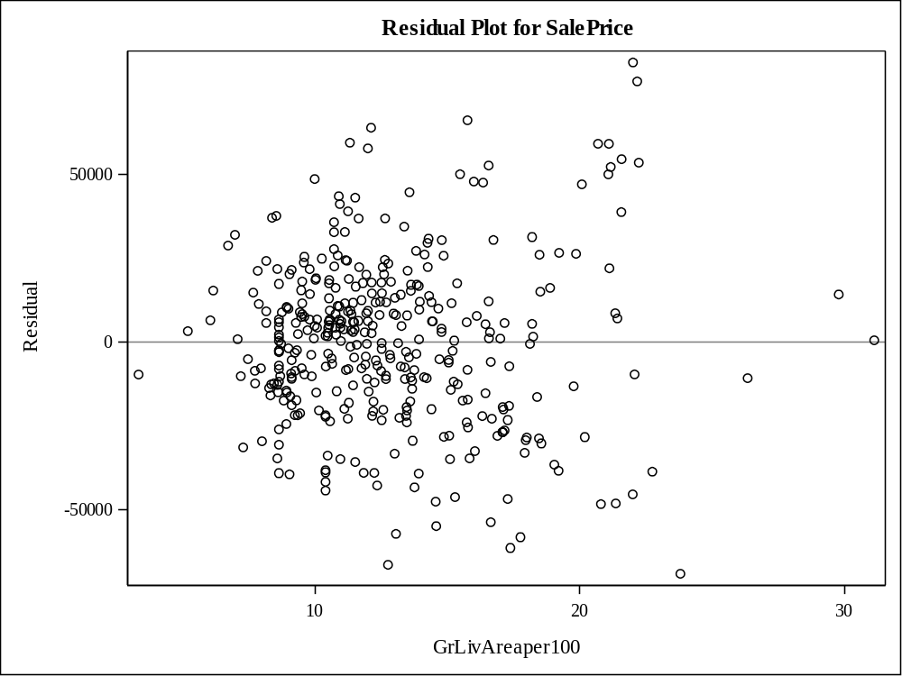

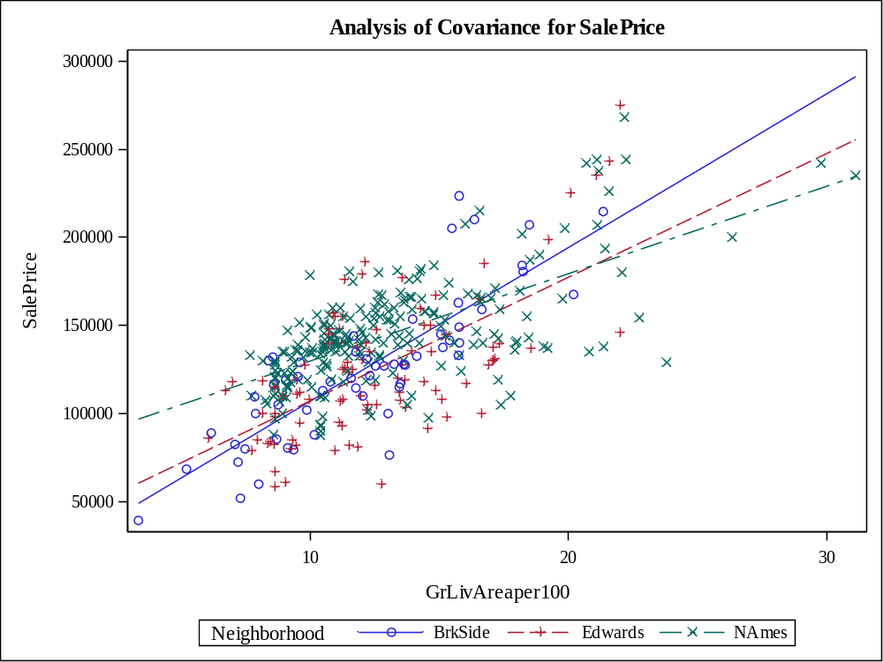

Class Level Information
Class | Levels | Values
Neighborhood | 3 | BrkSide Edwards NAmes

Number of Observations Read | 383
Number of Observations Used | 383

Source | DF | Sum of Squares | Mean Square | F Value | Pr > F
Model | 5 | 13.31148241 | 2.66229648 | 65.79 | <.0001
Error | 377 | 15.25484353 | 0.04046378
Corrected Total | 382 | 28.56632594

R-Square | Coeff Var | Root MSE | logSalePrice Mean
0.465985 | 1.704877 | 0.201156 | 11.79887

Source | DF | Type I SS | Mean Square | F Value | Pr > F
GrLivAreaper100 | 1 | 8.95480608 | 8.95480608 | 221.30 | <.0001
Neighborhood | 2 | 2.41721851 | 1.20860925 | 29.87 | <.0001
GrLivArea*Neighborho | 2 | 1.93945783 | 0.96972891 | 23.97 | <.0001

Source | DF | Type III SS | Mean Square | F Value | Pr > F
GrLivAreaper100 | 1 | 9.79528439 | 9.79528439 | 242.08 | <.0001
Neighborhood | 2 | 1.94039293 | 0.97019647 | 23.98 | <.0001
GrLivArea*Neighborho | 2 | 1.93945783 | 0.96972891 | 23.97 | <.0001

Observation |  | Observed | Predicted | Residual | 95% Confidence Limits for Mean Predicted Value
1 |  | 11.67843990 | 11.58665992 | 0.09177998 | 11.53198701 | 11.64133283
2 |  | 11.96400108 | 11.84946874 | 0.11453234 | 11.82284699 | 11.87609049
3 |  | 11.79055720 | 11.42203624 | 0.36852096 | 11.35178875 | 11.49228372
4 |  | 11.91170158 | 11.76876173 | 0.14293985 | 11.73592038 | 11.80160308
5 |  | 11.84222921 | 11.87734345 | -0.03511424 | 11.85091121 | 11.90377569
6 |  | 11.81154748 | 11.73505278 | 0.07649470 | 11.69786432 | 11.77224124
7 |  | 12.24288662 | 11.96193995 | 0.28094667 | 11.92972058 | 11.99415932
8 |  | 11.13458902 | 11.17546982 | -0.04088080 | 11.06933411 | 11.28160554
9 |  | 12.01672647 | 11.99435240 | 0.02237407 | 11.95808130 | 12.03062351
10 |  | 11.93819320 | 11.86373022 | 0.07446298 | 11.83734793 | 11.89011250
11 |  | 11.59910316 | 11.78594033 | -0.18683717 | 11.75499841 | 11.81688225
12 |  | 11.31447453 | 11.67156596 | -0.35709143 | 11.63040065 | 11.71273126
13 |  | 11.98292909 | 11.87248158 | 0.11044751 | 11.84609851 | 11.89886466
14 |  | 11.85651517 | 11.81608391 | 0.04043126 | 11.78779475 | 11.84437307
15 |  | 11.64833010 | 11.65974398 | -0.01141388 | 11.60767917 | 11.71180878
16 |  | 11.77528973 | 11.88415006 | -0.10886033 | 11.85759095 | 11.91070917
17 |  | 12.10348606 | 11.90521816 | 0.19826790 | 11.87784975 | 11.93258656
18 |  | 12.10071213 | 12.15868354 | -0.05797141 | 12.09559941 | 12.22176768
19 |  | 12.40492350 | 12.16386953 | 0.24105397 | 12.09985500 | 12.22788407
20 |  | 11.88379913 | 11.79533994 | 0.08845919 | 11.76532620 | 11.82535369
21 |  | 11.81857024 | 11.75190726 | 0.06666298 | 11.71698272 | 11.78683179
22 |  | 11.75194237 | 11.74021026 | 0.01173210 | 11.68710142 | 11.79331911
23 |  | 12.17303279 | 12.13761545 | 0.03541734 | 12.07827984 | 12.19695105
24 |  | 11.74799759 | 11.78853333 | -0.04053574 | 11.75785584 | 11.81921082
25 |  | 11.60732614 | 11.78043021 | -0.17310407 | 11.74890622 | 11.81195421
26 |  | 11.49882654 | 11.84363450 | -0.34480796 | 11.81683023 | 11.87043876
27 |  | 11.45899712 | 11.62996179 | -0.17096466 | 11.58417895 | 11.67574462
28 |  | 11.32659589 | 11.60287574 | -0.27627985 | 11.55284265 | 11.65290882
29 |  | 11.76718001 | 11.84039325 | -0.07321324 | 11.81346688 | 11.86731963
30 |  | 11.82700601 | 11.82389789 | 0.00310812 | 11.77349397 | 11.87430181
31 |  | 11.95118040 | 11.66571537 | 0.28546503 | 11.62406632 | 11.70736441
32 |  | 11.82041016 | 11.79339520 | 0.02701497 | 11.76319641 | 11.82359398
33 |  | 11.95118040 | 11.88026057 | 0.07091983 | 11.85378221 | 11.90673893
34 |  | 11.91839057 | 11.78464383 | 0.13374674 | 11.75356739 | 11.81572027
35 |  | 12.32829028 | 12.14247731 | 0.18581296 | 12.08228139 | 12.20267324
36 |  | 11.92337811 | 11.87345395 | 0.04992416 | 11.84706383 | 11.89984408
37 |  | 11.87059991 | 11.83682788 | 0.03377203 | 11.80975040 | 11.86390537
38 |  | 11.65268741 | 11.72338430 | -0.07069689 | 11.68453913 | 11.76222947
39 |  | 12.01974307 | 11.89225318 | 0.12748989 | 11.86545602 | 11.91905033
40 |  | 11.77528973 | 11.79226138 | -0.01697165 | 11.74681339 | 11.83770938
41 |  | 11.56171563 | 11.43753892 | 0.12417671 | 11.36917518 | 11.50590265
42 |  | 11.65268741 | 11.78376541 | -0.13107800 | 11.72843014 | 11.83910067
43 |  | 11.27720313 | 11.65943141 | -0.38222827 | 11.61719814 | 11.70166467
44 |  | 11.60367983 | 11.78043021 | -0.17675039 | 11.74890622 | 11.81195421
45 |  | 11.75587164 | 11.71555370 | 0.04031795 | 11.67599044 | 11.75511696
46 |  | 12.27839331 | 11.98009093 | 0.29830238 | 11.94568996 | 12.01449189
47 |  | 12.00150548 | 11.88479831 | 0.11670717 | 11.85822362 | 11.91137301
48 |  | 12.40081672 | 11.88955447 | 0.51126226 | 11.82609427 | 11.95301466
49 |  | 11.69524702 | 11.71230337 | -0.01705635 | 11.67275052 | 11.75185622
50 |  | 11.75194237 | 11.71584891 | 0.03609346 | 11.66349193 | 11.76820589
51 |  | 12.12269104 | 11.92272088 | 0.19997015 | 11.89423343 | 11.95120834
52 |  | 11.77528973 | 11.79226138 | -0.01697165 | 11.74681339 | 11.83770938
53 |  | 12.36734079 | 12.45201624 | -0.08467545 | 12.33388675 | 12.57014573
54 |  | 11.84939770 | 11.66484862 | 0.18454909 | 11.62312291 | 11.70657432
55 |  | 11.85651517 | 11.79987769 | 0.05663748 | 11.77028088 | 11.82947449
56 |  | 11.88448902 | 11.79728469 | 0.08720433 | 11.76745221 | 11.82711717
57 |  | 11.49272276 | 11.60915970 | -0.11643694 | 11.56018438 | 11.65813502
58 |  | 12.13350195 | 11.68456726 | 0.44893469 | 11.64425877 | 11.72487575
59 |  | 11.80894766 | 11.84395862 | -0.03501096 | 11.81716576 | 11.87075149
60 |  | 11.48246626 | 11.72338430 | -0.24091804 | 11.68453913 | 11.76222947
61 |  | 11.90496755 | 11.83034539 | 0.07462216 | 11.80294904 | 11.85774175
62 |  | 11.63514310 | 11.74415656 | -0.10901347 | 11.70361120 | 11.78470192
63 |  | 11.84939770 | 11.88901193 | -0.03961423 | 11.86232122 | 11.91570265
64 |  | 11.24504602 | 11.75571294 | -0.51066692 | 11.70193717 | 11.80948871
65 |  | 11.97035031 | 11.86535084 | 0.10499947 | 11.83897693 | 11.89172476
66 |  | 11.88448902 | 11.86924034 | 0.01524869 | 11.84287072 | 11.89560996
67 |  | 12.07823927 | 11.89128080 | 0.18695847 | 11.86451714 | 11.91804447
68 |  | 11.90496755 | 11.66311511 | 0.24185244 | 11.62123229 | 11.70499792
69 |  | 11.84222921 | 11.97231194 | -0.13008272 | 11.93887541 | 12.00574846
70 |  | 12.23076526 | 11.93436286 | 0.29640240 | 11.86449170 | 12.00423401
71 |  | 11.97665948 | 12.00537264 | -0.02871316 | 11.96757641 | 12.04316887
72 |  | 11.38509209 | 11.72143955 | -0.33634746 | 11.68231193 | 11.76056717
73 |  | 11.94194433 | 11.82215299 | 0.11979133 | 11.76400856 | 11.88029742
74 |  | 11.78295260 | 11.79377820 | -0.01082560 | 11.74811953 | 11.83943688
75 |  | 12.02574909 | 11.97620143 | 0.04954766 | 11.94228793 | 12.01011493
76 |  | 11.32055357 | 11.60850964 | -0.28795606 | 11.55942676 | 11.65759251
77 |  | 11.79055720 | 11.75838975 | 0.03216746 | 11.72428970 | 11.79248979
78 |  | 12.39669301 | 12.40858355 | -0.01189055 | 12.29878550 | 12.51838161
79 |  | 11.88621167 | 11.89160493 | -0.00539325 | 11.86483025 | 11.91837961
80 |  | 12.27606502 | 12.36696142 | -0.09089640 | 12.23054081 | 12.50338202
81 |  | 11.68687877 | 12.00342789 | -0.31654912 | 11.96590544 | 12.04095034
82 |  | 11.84222921 | 11.78561621 | 0.05661301 | 11.75464080 | 11.81659161
83 |  | 11.95118040 | 11.83715201 | 0.11402839 | 11.81008898 | 11.86421504
84 |  | 11.37939407 | 11.78043021 | -0.40103614 | 11.74890622 | 11.81195421
85 |  | 11.85082525 | 11.95577132 | -0.10494607 | 11.88321255 | 12.02833009
86 |  | 11.92834090 | 11.75385200 | 0.17448890 | 11.71917770 | 11.78852630
87 |  | 11.96718074 | 11.92239676 | 0.04478398 | 11.89393343 | 11.95086009
88 |  | 11.46163217 | 11.66268173 | -0.20104956 | 11.62075885 | 11.70460461
89 |  | 11.88448902 | 11.90261928 | -0.01813026 | 11.83650399 | 11.96873457
90 |  | 12.19854438 | 11.83841601 | 0.36012837 | 11.78539638 | 11.89143564
91 |  | 11.97665948 | 11.89517030 | 0.08148918 | 11.86826473 | 11.92207587
92 |  | 12.01370075 | 11.90716291 | 0.10653785 | 11.87968931 | 11.93463650
93 |  | 11.79055720 | 11.85433061 | -0.06377341 | 11.82782374 | 11.88083747
94 |  | 11.99535161 | 11.86048897 | 0.13486264 | 11.83407835 | 11.88689959
95 |  | 11.71993963 | 11.87086096 | -0.15092132 | 11.84448655 | 11.89723537
96 |  | 11.01862914 | 11.61782724 | -0.59919809 | 11.57024269 | 11.66541179
97 |  | 11.30220443 | 11.67849998 | -0.37629555 | 11.63782993 | 11.71917004
98 |  | 11.73606902 | 11.66571537 | 0.07035365 | 11.62406632 | 11.70736441
99 |  | 11.68687877 | 11.71815396 | -0.03127519 | 11.67856730 | 11.75774061
100 |  | 11.57590026 | 11.72921854 | -0.15331827 | 11.69121010 | 11.76722697
101 |  | 11.51292546 | 11.37331353 | 0.13961193 | 11.29675785 | 11.44986922
102 |  | 11.76756768 | 11.66983245 | 0.09773524 | 11.62852999 | 11.71113490
103 |  | 12.04060821 | 12.03065435 | 0.00995385 | 11.98914066 | 12.07216804
104 |  | 11.00209984 | 11.69843531 | -0.69633547 | 11.65869209 | 11.73817854
105 |  | 11.74403719 | 11.66766556 | 0.07637162 | 11.62618433 | 11.70914680
106 |  | 11.86358234 | 11.78561621 | 0.07796613 | 11.75464080 | 11.81659161
107 |  | 11.84222921 | 11.83099364 | 0.01123557 | 11.80363169 | 11.85835559
108 |  | 11.59917655 | 11.73732165 | -0.13814510 | 11.70044730 | 11.77419601
109 |  | 11.68687877 | 11.45894738 | 0.22793139 | 11.39307138 | 11.52482337
110 |  | 11.60823564 | 11.68110024 | -0.07286460 | 11.64059347 | 11.72160701
111 |  | 11.67843990 | 11.73397221 | -0.05553231 | 11.69395711 | 11.77398730
112 |  | 12.00089179 | 11.95281843 | 0.04807337 | 11.88063713 | 12.02499972
113 |  | 11.75587164 | 11.78792762 | -0.03205597 | 11.74306485 | 11.83279038
114 |  | 12.15477935 | 12.05528782 | 0.09949154 | 12.00991750 | 12.10065813
115 |  | 11.60823564 | 11.67967599 | -0.07144035 | 11.62774056 | 11.73161143
116 |  | 12.02574909 | 11.85724773 | 0.16850136 | 11.83079336 | 11.88370210
117 |  | 11.89478071 | 11.97620143 | -0.08142072 | 11.94228793 | 12.01011493
118 |  | 11.90496755 | 11.65423088 | 0.25073667 | 11.61146540 | 11.69699637
119 |  | 11.89818787 | 11.80409131 | 0.09409656 | 11.77486246 | 11.83332015
120 |  | 11.95761129 | 11.79112632 | 0.16648496 | 11.76070696 | 11.82154569
121 |  | 11.79810441 | 11.95480921 | -0.15670480 | 11.92337674 | 11.98624168
122 |  | 11.95118040 | 11.85465473 | 0.09652566 | 11.82815431 | 11.88115515
123 |  | 12.12269104 | 12.13515946 | -0.01246842 | 12.03674188 | 12.23357703
124 |  | 11.69524702 | 11.73894227 | -0.04369525 | 11.70229059 | 11.77559396
125 |  | 11.84939770 | 11.68500063 | 0.16439707 | 11.64471536 | 11.72528591
126 |  | 11.73206099 | 11.78075434 | -0.04869334 | 11.74926532 | 11.81224336
127 |  | 12.01309451 | 11.88512244 | 0.12797207 | 11.85853972 | 11.91170516
128 |  | 11.77452020 | 11.72338430 | 0.05113591 | 11.68453913 | 11.76222947
129 |  | 11.91839057 | 11.84655162 | 0.07183895 | 11.81984465 | 11.87325859
130 |  | 11.97665948 | 12.01999670 | -0.04333722 | 11.93876569 | 12.10122772
131 |  | 12.12675884 | 12.43517581 | -0.30841697 | 12.22895189 | 12.64139974
132 |  | 11.79055720 | 11.74412827 | 0.04642893 | 11.70817930 | 11.78007724
133 |  | 11.36210258 | 11.55303741 | -0.19093484 | 11.49342883 | 11.61264599
134 |  | 11.75978554 | 11.79705342 | -0.03726787 | 11.74082974 | 11.85327710
135 |  | 11.58524613 | 11.71139169 | -0.12614556 | 11.67077833 | 11.75200505
136 |  | 10.57897980 | 11.03816038 | -0.45918059 | 10.90945173 | 11.16686904
137 |  | 11.58524613 | 11.71382019 | -0.12857406 | 11.67426509 | 11.75337529
138 |  | 11.61953520 | 11.72338430 | -0.10384910 | 11.68453913 | 11.76222947
139 |  | 11.79810441 | 11.69194422 | 0.10616019 | 11.64834317 | 11.73554527
140 |  | 12.25486281 | 11.99858824 | 0.25627457 | 11.92033848 | 12.07683800
141 |  | 11.58988651 | 11.66593206 | -0.07604555 | 11.62430198 | 11.70756214
142 |  | 11.63514310 | 11.56525146 | 0.06989164 | 11.50922616 | 11.62127676
143 |  | 11.85651517 | 11.79728469 | 0.05923048 | 11.76745221 | 11.82711717
144 |  | 11.58988651 | 11.63776257 | -0.04787606 | 11.59303989 | 11.68248524
145 |  | 12.12811110 | 11.78467729 | 0.34343381 | 11.74023676 | 11.82911782
146 |  | 11.82011600 | 11.74899014 | 0.07112587 | 11.71368576 | 11.78429451
147 |  | 11.86779879 | 12.00342789 | -0.13562910 | 11.96590544 | 12.04095034
148 |  | 11.69524702 | 11.72338430 | -0.02813728 | 11.68453913 | 11.76222947
149 |  | 11.84222921 | 11.80279481 | 0.03943441 | 11.77345476 | 11.83213486
150 |  | 11.68266824 | 11.83747613 | -0.15480789 | 11.81042742 | 11.86452485
151 |  | 12.11121236 | 11.90651466 | 0.20469771 | 11.87907668 | 11.93395263
152 |  | 11.68266824 | 11.59875866 | 0.08390958 | 11.54801143 | 11.64950589
153 |  | 11.79810441 | 11.95281843 | -0.15471402 | 11.88063713 | 12.02499972
154 |  | 11.77528973 | 11.41022467 | 0.36506506 | 11.33849937 | 11.48194998
155 |  | 11.28351230 | 11.48183228 | -0.19831998 | 11.41845393 | 11.54521064
156 |  | 12.23076526 | 12.08705202 | 0.14371324 | 12.03645367 | 12.13765037
157 |  | 12.32385568 | 11.85705121 | 0.46680447 | 11.80042297 | 11.91367945
158 |  | 11.83137920 | 11.78496796 | 0.04641124 | 11.75392529 | 11.81601063
159 |  | 11.56646623 | 11.71301231 | -0.14654608 | 11.67264147 | 11.75338316
160 |  | 11.11244790 | 11.60915970 | -0.49671180 | 11.56018438 | 11.65813502
161 |  | 11.98292909 | 11.80506368 | 0.17786542 | 11.77591704 | 11.83421032
162 |  | 11.84868316 | 11.90424578 | -0.05556262 | 11.87692811 | 11.93156346
163 |  | 11.93819320 | 11.93600999 | 0.00218321 | 11.90643123 | 11.96558875
164 |  | 11.81303006 | 12.11751973 | -0.30448967 | 12.06170608 | 12.17333337
165 |  | 12.03469103 | 11.88090882 | 0.15378221 | 11.85441853 | 11.90739911
166 |  | 11.84510278 | 11.78561621 | 0.05948657 | 11.75464080 | 11.81659161
167 |  | 11.00209984 | 11.38217221 | -0.38007237 | 11.30680312 | 11.45754129
168 |  | 11.35040654 | 11.59442489 | -0.24401836 | 11.54290875 | 11.64594103
169 |  | 12.75129970 | 12.31977343 | 0.43152626 | 12.22687944 | 12.41266743
170 |  | 11.87234663 | 11.76130687 | 0.11103977 | 11.72756861 | 11.79504512
171 |  | 11.49577931 | 11.78302321 | -0.28724390 | 11.75177649 | 11.81426993
172 |  | 11.95118040 | 11.65899803 | 0.29218237 | 11.61672207 | 11.70127398
173 |  | 11.95118040 | 12.03940571 | -0.08822532 | 11.99654520 | 12.08226623
174 |  | 11.58988651 | 11.74914040 | -0.15925389 | 11.70826550 | 11.79001529
175 |  | 11.88793137 | 11.78464383 | 0.10328753 | 11.75356739 | 11.81572027
176 |  | 11.48760766 | 11.91591427 | -0.42830661 | 11.88790718 | 11.94392135
177 |  | 12.02574909 | 11.74393987 | 0.28180922 | 11.70340781 | 11.78447193
178 |  | 11.60823564 | 11.89452205 | -0.28628640 | 11.86764160 | 11.92140250
179 |  | 11.83137920 | 11.67784992 | 0.15352928 | 11.63713711 | 11.71856273
180 |  | 11.76756768 | 12.21475708 | -0.44718940 | 12.14148257 | 12.28803160
181 |  | 11.54829261 | 11.71858733 | -0.17029473 | 11.67899548 | 11.75817919
182 |  | 11.84939770 | 11.81154617 | 0.03785153 | 11.78292079 | 11.84017155
183 |  | 11.86005500 | 11.92771885 | -0.06766386 | 11.85865758 | 11.99678012
184 |  | 11.39639165 | 11.24633921 | 0.15005244 | 11.15133487 | 11.34134356
185 |  | 11.72399644 | 11.67069920 | 0.05329723 | 11.62946598 | 11.71193243
186 |  | 10.85899900 | 11.32975839 | -0.47075939 | 11.24715065 | 11.41236613
187 |  | 11.76756768 | 11.50028785 | 0.26727983 | 11.43878846 | 11.56178725
188 |  | 11.73206099 | 11.72338430 | 0.00867670 | 11.68453913 | 11.76222947
189 |  | 11.81303006 | 11.74047286 | 0.07255720 | 11.70014176 | 11.78080396
190 |  | 12.67607627 | 11.78987781 | 0.88619846 | 11.74475479 | 11.83500083
191 |  | 11.69940503 | 11.72338430 | -0.02397927 | 11.68453913 | 11.76222947
192 |  | 11.60823564 | 12.01898587 | -0.41075022 | 11.97922239 | 12.05874935
193 |  | 11.44571672 | 11.78043021 | -0.33471350 | 11.74890622 | 11.81195421
194 |  | 12.09514108 | 11.68196700 | 0.41317409 | 11.64151189 | 11.72242210
195 |  | 11.49272276 | 11.75325747 | -0.26053472 | 11.71207666 | 11.79443829
196 |  | 11.95761129 | 11.77589247 | 0.18171882 | 11.74386937 | 11.80791557
197 |  | 11.75587164 | 11.72338430 | 0.03248735 | 11.68453913 | 11.76222947
198 |  | 11.51292546 | 11.75202183 | -0.23909636 | 11.69841780 | 11.80562586
199 |  | 11.53272809 | 11.68630077 | -0.15357267 | 11.64608300 | 11.72651853
200 |  | 11.58058411 | 11.66398186 | -0.08339775 | 11.62217823 | 11.70578549
201 |  | 11.64833010 | 11.73894227 | -0.09061217 | 11.70229059 | 11.77559396
202 |  | 11.60823564 | 11.69388896 | -0.08565332 | 11.65059269 | 11.73718524
203 |  | 11.67843990 | 11.80895317 | -0.13051327 | 11.78012496 | 11.83778139
204 |  | 11.81672692 | 11.76098274 | 0.05574418 | 11.72720458 | 11.79476090
205 |  | 12.31716669 | 11.95503310 | 0.36213360 | 11.88256889 | 12.02749730
206 |  | 11.98261655 | 11.79533994 | 0.18727660 | 11.76532620 | 11.82535369
207 |  | 11.96971720 | 11.91072828 | 0.05898892 | 11.88304908 | 11.93840747
208 |  | 11.66134547 | 11.69280142 | -0.03145595 | 11.65287311 | 11.73272973
209 |  | 11.82773620 | 11.77005823 | 0.05767798 | 11.73736863 | 11.80274783
210 |  | 11.60367983 | 11.37036064 | 0.23331919 | 11.29340586 | 11.44731543
211 |  | 12.01974307 | 11.89452205 | 0.12522102 | 11.86764160 | 11.92140250
212 |  | 12.02574909 | 11.93471349 | 0.09103560 | 11.90524968 | 11.96417731
213 |  | 11.84904049 | 11.81413917 | 0.03490133 | 11.78570887 | 11.84256946
214 |  | 11.77912851 | 11.68196700 | 0.09716151 | 11.64151189 | 11.72242210
215 |  | 12.07196966 | 11.82094578 | 0.25102388 | 11.79298955 | 11.84890201
216 |  | 11.85651517 | 12.02676486 | -0.17024969 | 11.98584063 | 12.06768909
217 |  | 11.97035031 | 11.91170065 | 0.05864966 | 11.88396255 | 11.93943875
218 |  | 11.79433792 | 11.81543566 | -0.02109774 | 11.78709996 | 11.84377137
219 |  | 11.90834024 | 11.76811348 | 0.14022675 | 11.73519578 | 11.80103119
220 |  | 11.60367983 | 11.73310803 | -0.12942820 | 11.69564818 | 11.77056789
221 |  | 11.66134547 | 11.73829403 | -0.07694856 | 11.70155344 | 11.77503461
222 |  | 11.79810441 | 11.85433061 | -0.05622620 | 11.82782374 | 11.88083747
223 |  | 11.96400108 | 11.65813128 | 0.30586981 | 11.61576902 | 11.70049353
224 |  | 11.51292546 | 11.73245978 | -0.21953432 | 11.69490903 | 11.77001054
225 |  | 11.88448902 | 11.99824190 | -0.11375288 | 11.96143995 | 12.03504385
226 |  | 11.81672692 | 11.72378786 | 0.09293906 | 11.68410471 | 11.76347100
227 |  | 12.49874226 | 12.16192479 | 0.33681747 | 12.09825948 | 12.22559009
228 |  | 11.91505167 | 11.93114812 | -0.01609645 | 11.90199119 | 11.96030505
229 |  | 11.71912630 | 11.74283177 | -0.02370547 | 11.70670855 | 11.77895498
230 |  | 11.84939770 | 12.02546836 | -0.17607066 | 11.98473930 | 12.06619742
231 |  | 11.60823564 | 11.72143955 | -0.11320391 | 11.68231193 | 11.76056717
232 |  | 11.93819320 | 11.86664734 | 0.07154586 | 11.84027733 | 11.89301734
233 |  | 11.75978554 | 11.78788508 | -0.02809954 | 11.75714207 | 11.81862809
234 |  | 11.94665404 | 12.18039988 | -0.23374585 | 12.11340177 | 12.24739800
235 |  | 11.38509209 | 11.54089011 | -0.15579801 | 11.48303892 | 11.59874129
236 |  | 11.81303006 | 11.68825096 | 0.12477910 | 11.64812848 | 11.72837344
237 |  | 12.08107616 | 11.90165279 | 0.17942337 | 11.87446424 | 11.92884134
238 |  | 11.89067673 | 11.89865538 | -0.00797864 | 11.83318323 | 11.96412753
239 |  | 11.67419361 | 11.74315589 | -0.06896228 | 11.70707633 | 11.77923546
240 |  | 12.39669301 | 12.11395436 | 0.28273865 | 12.05875933 | 12.16914938
241 |  | 11.28853113 | 11.34304640 | -0.05451527 | 11.26232088 | 11.42377192
242 |  | 11.91839057 | 11.73397221 | 0.18441836 | 11.69395711 | 11.77398730
243 |  | 11.87059991 | 11.81413917 | 0.05646074 | 11.78570887 | 11.84256946
244 |  | 11.76756768 | 11.72338430 | 0.04418339 | 11.68453913 | 11.76222947
245 |  | 11.75587164 | 11.63429555 | 0.12157609 | 11.58911166 | 11.67947945
246 |  | 11.66564655 | 11.42498913 | 0.24065742 | 11.35510547 | 11.49487279
247 |  | 11.81303006 | 11.79922944 | 0.01380062 | 11.76957437 | 11.82888451
248 |  | 11.84939770 | 11.79825706 | 0.05114064 | 11.76851377 | 11.82800035
249 |  | 11.81303006 | 11.82969714 | -0.01666709 | 11.80226583 | 11.85712846
250 |  | 12.02873863 | 12.28206579 | -0.25332716 | 12.15991092 | 12.40422067
251 |  | 11.35627165 | 11.43310958 | -0.07683792 | 11.36421437 | 11.50200479
252 |  | 11.60823564 | 11.61566035 | -0.00742471 | 11.56773585 | 11.66358486
253 |  | 12.09178350 | 11.76714111 | 0.32464239 | 11.73410827 | 11.80017395
254 |  | 11.73606902 | 11.67416622 | 0.06190280 | 11.63319671 | 11.71513572
255 |  | 12.13886390 | 12.04329521 | 0.09556869 | 11.99982751 | 12.08676291
256 |  | 11.70849225 | 11.69960801 | 0.00888424 | 11.64754452 | 11.75167150
257 |  | 11.82407989 | 11.78367146 | 0.04040843 | 11.75249313 | 11.81484979
258 |  | 11.31447453 | 11.62649477 | -0.31202025 | 11.58021545 | 11.67277409
259 |  | 12.00456827 | 11.98041505 | 0.02415322 | 11.94597301 | 12.01485709
260 |  | 11.51292546 | 11.78251041 | -0.26958494 | 11.73834319 | 11.82667763
261 |  | 11.68855803 | 11.79404344 | -0.10548541 | 11.76390675 | 11.82418014
262 |  | 12.07823927 | 11.66723219 | 0.41100709 | 11.62571422 | 11.70875015
263 |  | 12.02873863 | 11.85303411 | 0.17570452 | 11.82649995 | 11.87956827
264 |  | 11.56171563 | 11.88933606 | -0.32762043 | 11.86263537 | 11.91603675
265 |  | 11.33857208 | 11.60504262 | -0.26647054 | 11.55537878 | 11.65470647
266 |  | 11.84653647 | 11.79746190 | 0.04907456 | 11.75127933 | 11.84364448
267 |  | 11.34922937 | 11.62346113 | -0.27423176 | 11.57673517 | 11.67018710
268 |  | 12.01370075 | 12.08413490 | -0.07043415 | 12.03402657 | 12.13424323
269 |  | 11.88103479 | 11.75260741 | 0.12842738 | 11.71147690 | 11.79373792
270 |  | 11.94470788 | 11.81738041 | 0.12732747 | 11.78918283 | 11.84557799
271 |  | 12.03112384 | 11.96550532 | 0.06561852 | 11.93287689 | 11.99813375
272 |  | 11.81303006 | 11.73278391 | 0.08024615 | 11.69527863 | 11.77028919
273 |  | 11.81303006 | 11.78302321 | 0.03000685 | 11.75177649 | 11.81426993
274 |  | 11.42409425 | 11.73743922 | -0.31334497 | 11.69726554 | 11.77761290
275 |  | 11.97979920 | 11.73093857 | 0.24886063 | 11.69104337 | 11.77083377
276 |  | 11.84078933 | 11.79858119 | 0.04220814 | 11.76886741 | 11.82829496
277 |  | 11.98292909 | 11.84882049 | 0.13410860 | 11.82218085 | 11.87546013
278 |  | 11.83137920 | 11.79226138 | 0.03911781 | 11.74681339 | 11.83770938
279 |  | 11.43927892 | 11.78043021 | -0.34115129 | 11.74890622 | 11.81195421
280 |  | 11.89136190 | 11.83229014 | 0.05907176 | 11.80499534 | 11.85958494
281 |  | 11.76756768 | 11.74672126 | 0.02084642 | 11.71111784 | 11.78232469
282 |  | 11.75978554 | 11.76900095 | -0.00921541 | 11.71454157 | 11.82346033
283 |  | 11.69107165 | 11.75125901 | -0.06018736 | 11.71625053 | 11.78626749
284 |  | 11.81303006 | 11.81089792 | 0.00213214 | 11.78222255 | 11.83957329
285 |  | 11.97979920 | 11.83034539 | 0.14945381 | 11.80294904 | 11.85774175
286 |  | 11.77452020 | 11.70782632 | 0.06669388 | 11.66667573 | 11.74897691
287 |  | 11.80931948 | 11.77005823 | 0.03926125 | 11.73736863 | 11.80274783
288 |  | 11.80335376 | 11.78043021 | 0.02292355 | 11.74890622 | 11.81195421
289 |  | 11.62625415 | 11.62996179 | -0.00370764 | 11.58417895 | 11.67574462
290 |  | 11.67843990 | 11.57318943 | 0.10525047 | 11.51767574 | 11.62870312
291 |  | 11.65268741 | 11.76908586 | -0.11639845 | 11.73628256 | 11.80188915
292 |  | 11.53272809 | 11.51948165 | 0.01324645 | 11.45979499 | 11.57916831
293 |  | 11.68687877 | 11.84914461 | -0.16226584 | 11.82251399 | 11.87577524
294 |  | 11.87756858 | 11.65309997 | 0.22446861 | 11.60093506 | 11.70526489
295 |  | 11.84222921 | 11.75190726 | 0.09032196 | 11.71698272 | 11.78683179
296 |  | 11.28978191 | 11.62216100 | -0.33237909 | 11.57524022 | 11.66908179
297 |  | 11.91170158 | 11.95503310 | -0.04333151 | 11.88256889 | 12.02749730
298 |  | 11.72803684 | 11.74542477 | -0.01738792 | 11.70964907 | 11.78120046
299 |  | 11.91772368 | 11.73960611 | 0.17811758 | 11.69932175 | 11.77989046
300 |  | 12.21503239 | 12.03324735 | 0.18178504 | 11.99133749 | 12.07515720
301 |  | 12.10015642 | 11.85335823 | 0.24679819 | 11.82683112 | 11.87988534
302 |  | 12.36734079 | 11.87872005 | 0.48862075 | 11.81760285 | 11.93983724
303 |  | 12.00150548 | 11.85206174 | 0.14944374 | 11.82550550 | 11.87861797
304 |  | 11.44035477 | 11.66549868 | -0.22514391 | 11.62383059 | 11.70716677
305 |  | 11.56076279 | 11.68651745 | -0.12575466 | 11.64631063 | 11.72672428
306 |  | 11.66177641 | 11.72338430 | -0.06160789 | 11.68453913 | 11.76222947
307 |  | 11.66992921 | 11.78671830 | -0.11678908 | 11.73119364 | 11.84224296
308 |  | 11.84939770 | 11.85919248 | -0.00979477 | 11.83276620 | 11.88561875
309 |  | 11.63514310 | 11.56755553 | 0.06758757 | 11.51092382 | 11.62418724
310 |  | 11.80931948 | 11.76714111 | 0.04217837 | 11.73410827 | 11.80017395
311 |  | 11.29601246 | 11.46485316 | -0.16884070 | 11.39963846 | 11.53006786
312 |  | 11.65268741 | 11.73894227 | -0.08625487 | 11.70229059 | 11.77559396
313 |  | 11.87059991 | 12.04167459 | -0.17107468 | 11.99846050 | 12.08488867
314 |  | 11.83428406 | 12.13567070 | -0.30138664 | 12.07667837 | 12.19466303
315 |  | 11.88448902 | 11.81219442 | 0.07229460 | 11.78361854 | 11.84077029
316 |  | 11.89818787 | 11.73894227 | 0.15924559 | 11.70229059 | 11.77559396
317 |  | 11.75194237 | 11.93179637 | -0.17985400 | 11.90258466 | 11.96100808
318 |  | 11.79433792 | 11.82904889 | -0.03471097 | 11.80158207 | 11.85651572
319 |  | 11.53076538 | 11.84006913 | -0.30930374 | 11.81312974 | 11.86700852
320 |  | 11.86358234 | 11.82840064 | 0.03518169 | 11.80089777 | 11.85590352
321 |  | 11.68687877 | 11.76357574 | -0.07669697 | 11.73011475 | 11.79703673
322 |  | 12.40492350 | 12.12724346 | 0.27768004 | 12.06973280 | 12.18475412
323 |  | 12.01612206 | 11.78077690 | 0.23534516 | 11.73682352 | 11.82473028
324 |  | 11.75587164 | 11.80074453 | -0.04487289 | 11.74425786 | 11.85723120
325 |  | 11.51192496 | 11.60915970 | -0.09723474 | 11.56018438 | 11.65813502
326 |  | 11.92503512 | 11.78496796 | 0.14006716 | 11.75392529 | 11.81601063
327 |  | 11.76679219 | 11.78367146 | -0.01687927 | 11.75249313 | 11.81484979
328 |  | 12.10348606 | 12.13811235 | -0.03462629 | 12.03923394 | 12.23699075
329 |  | 12.10625231 | 11.87669520 | 0.22955711 | 11.85027152 | 11.90311888
330 |  | 11.87756858 | 11.93730649 | -0.05973791 | 11.90761102 | 11.96700195
331 |  | 12.08390501 | 11.71598707 | 0.36791794 | 11.67642084 | 11.75555330
332 |  | 11.82773620 | 12.06565980 | -0.23792360 | 12.01861017 | 12.11270944
333 |  | 11.79433792 | 11.83396456 | -0.03962663 | 11.77481356 | 11.89311555
334 |  | 12.10348606 | 11.81673216 | 0.28675389 | 11.78848904 | 11.84497528
335 |  | 11.65268741 | 11.60915970 | 0.04352771 | 11.56018438 | 11.65813502
336 |  | 11.83862560 | 11.78431971 | 0.05430590 | 11.75320940 | 11.81543002
337 |  | 11.95118040 | 11.80895317 | 0.14222722 | 11.78012496 | 11.83778139
338 |  | 11.84939770 | 11.65423088 | 0.19516682 | 11.61146540 | 11.69699637
339 |  | 11.98292909 | 12.64449679 | -0.66156769 | 12.38051350 | 12.90848007
340 |  | 11.94470788 | 11.84719987 | 0.09750801 | 11.82051288 | 11.87388685
341 |  | 11.77528973 | 11.79204470 | -0.01675497 | 11.74662655 | 11.83746284
342 |  | 11.68687877 | 11.62736153 | 0.05951725 | 11.58120774 | 11.67351531
343 |  | 12.23999086 | 12.12789171 | 0.11209915 | 12.07026742 | 12.18551600
344 |  | 11.61728548 | 11.62736153 | -0.01007605 | 11.58120774 | 11.67351531
345 |  | 11.96081129 | 11.92239676 | 0.03841453 | 11.89393343 | 11.95086009
346 |  | 11.19134184 | 11.32311438 | -0.13177254 | 11.23955473 | 11.40667403
347 |  | 11.32055357 | 11.31425571 | 0.00629786 | 11.22941619 | 11.39909523
348 |  | 11.27720313 | 11.58965775 | -0.31245462 | 11.53727638 | 11.64203911
349 |  | 11.51292546 | 11.59875866 | -0.08583319 | 11.54801143 | 11.64950589
350 |  | 11.71993963 | 11.72597729 | -0.00603766 | 11.68750600 | 11.76444858
351 |  | 12.20607265 | 12.29708472 | -0.09101207 | 12.20847141 | 12.38569802
352 |  | 12.04941884 | 11.99953840 | 0.04988044 | 11.96255765 | 12.03651914
353 |  | 11.81228904 | 11.65974398 | 0.15254506 | 11.60767917 | 11.71180878
354 |  | 11.60823564 | 11.73245978 | -0.12422414 | 11.69490903 | 11.77001054
355 |  | 11.91772368 | 11.79274695 | 0.12497674 | 11.76248565 | 11.82300825
356 |  | 11.56076279 | 12.00666914 | -0.44590634 | 11.96868933 | 12.04464894
357 |  | 12.01672647 | 11.98171155 | 0.03501493 | 11.94710449 | 12.01631861
358 |  | 11.66992921 | 11.76950910 | -0.09957989 | 11.72683713 | 11.81218108
359 |  | 10.97678203 | 11.60915970 | -0.63237767 | 11.56018438 | 11.65813502
360 |  | 12.37792290 | 12.12951233 | 0.24841057 | 12.07160372 | 12.18742095
361 |  | 11.56171563 | 11.69453492 | -0.13281929 | 11.65467012 | 11.73439973
362 |  | 11.78295260 | 11.69074934 | 0.09220327 | 11.63877451 | 11.74272417
363 |  | 11.72803684 | 11.95675396 | -0.22871711 | 11.92511114 | 11.98839678
364 |  | 11.71993963 | 11.73505278 | -0.01511315 | 11.69786432 | 11.77224124
365 |  | 11.83137920 | 11.90852506 | -0.07714586 | 11.84173350 | 11.97531662
366 |  | 11.83500896 | 12.06047381 | -0.22546484 | 12.01426752 | 12.10668010
367 |  | 11.69524702 | 11.64645597 | 0.04879105 | 11.59416269 | 11.69874925
368 |  | 11.84939770 | 11.98398042 | -0.13458272 | 11.94908195 | 12.01887889
369 |  | 11.40756495 | 11.78043021 | -0.37286527 | 11.74890622 | 11.81195421
370 |  | 12.24047407 | 12.15582970 | 0.08464438 | 12.05416950 | 12.25748989
371 |  | 11.72803684 | 11.81413917 | -0.08610232 | 11.78570887 | 11.84256946
372 |  | 12.52441728 | 11.89887207 | 0.62554521 | 11.83335156 | 11.96439257
373 |  | 11.87756858 | 11.87896407 | -0.00139549 | 11.85250775 | 11.90542040
374 |  | 11.86358234 | 11.84914461 | 0.01443772 | 11.82251399 | 11.87577524
375 |  | 11.84939770 | 11.94832672 | -0.09892902 | 11.91757129 | 11.97908216
376 |  | 12.06681058 | 11.94152011 | 0.12529047 | 11.91143348 | 11.97160673
377 |  | 11.69940503 | 11.72338430 | -0.02397927 | 11.68453913 | 11.76222947
378 |  | 11.70354582 | 11.49438207 | 0.20916375 | 11.43229533 | 11.55646881
379 |  | 11.62625415 | 11.71360350 | -0.08734935 | 11.67404900 | 11.75315800
380 |  | 11.82041016 | 12.02417186 | -0.20376170 | 11.98363730 | 12.06470642
381 |  | 11.88448902 | 11.65423088 | 0.23025814 | 11.61146540 | 11.69699637
382 |  | 11.86446223 | 11.79274695 | 0.07171528 | 11.76248565 | 11.82300825
383 |  | 11.90158345 | 11.69410155 | 0.20748191 | 11.65422141 | 11.73398168

Sum of Residuals | 0.00000000
Sum of Squared Residuals | 15.25484353
Sum of Squared Residuals - Error SS | 0.00000000
PRESS Statistic | 16.86059550
First Order Autocorrelation | -0.02277524
Durbin-Watson D | 2.04217632

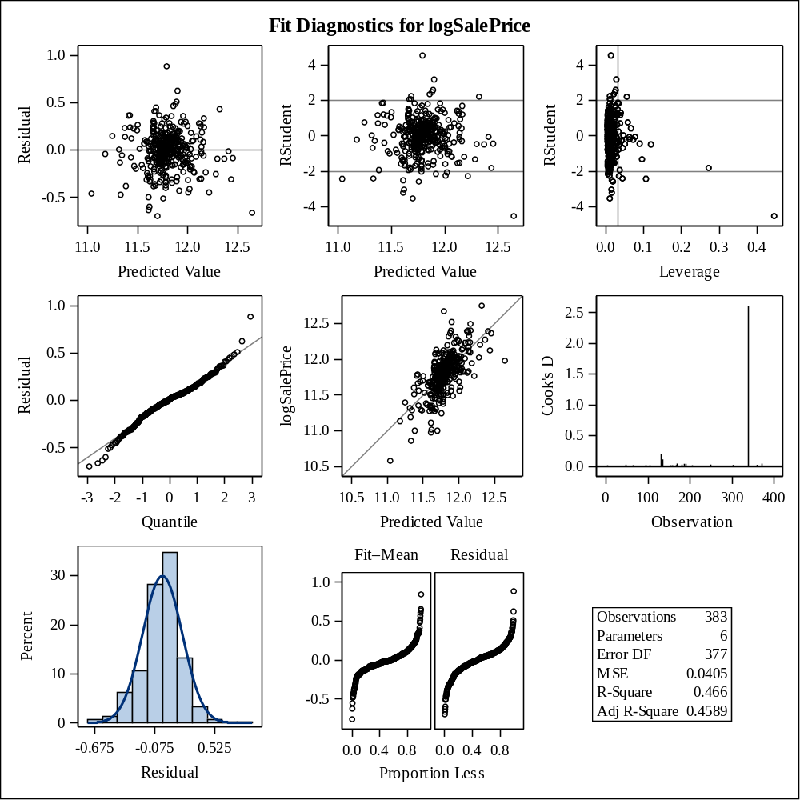

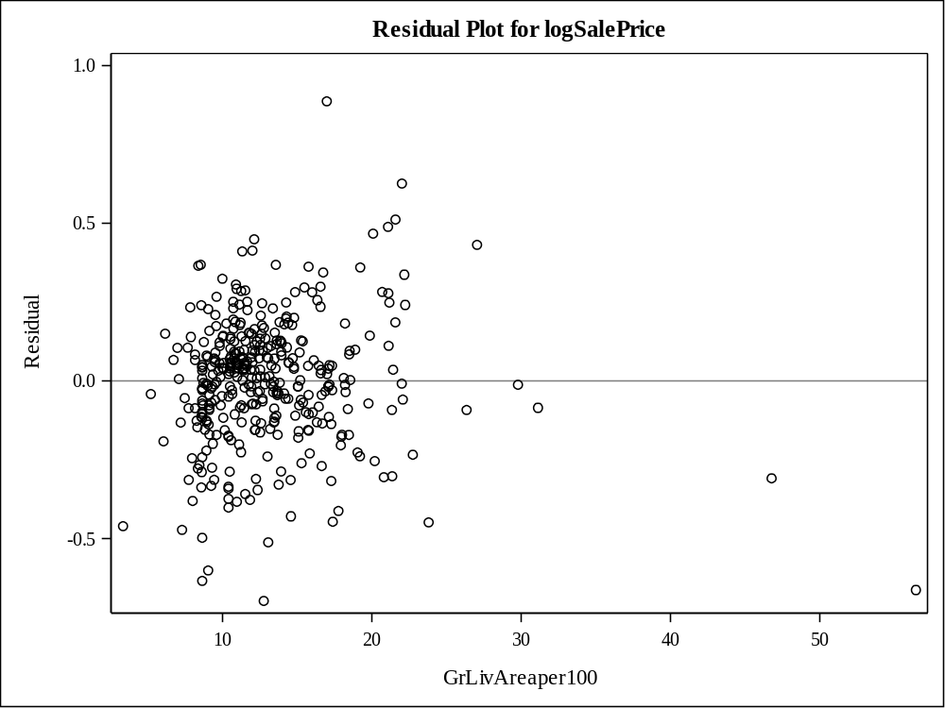

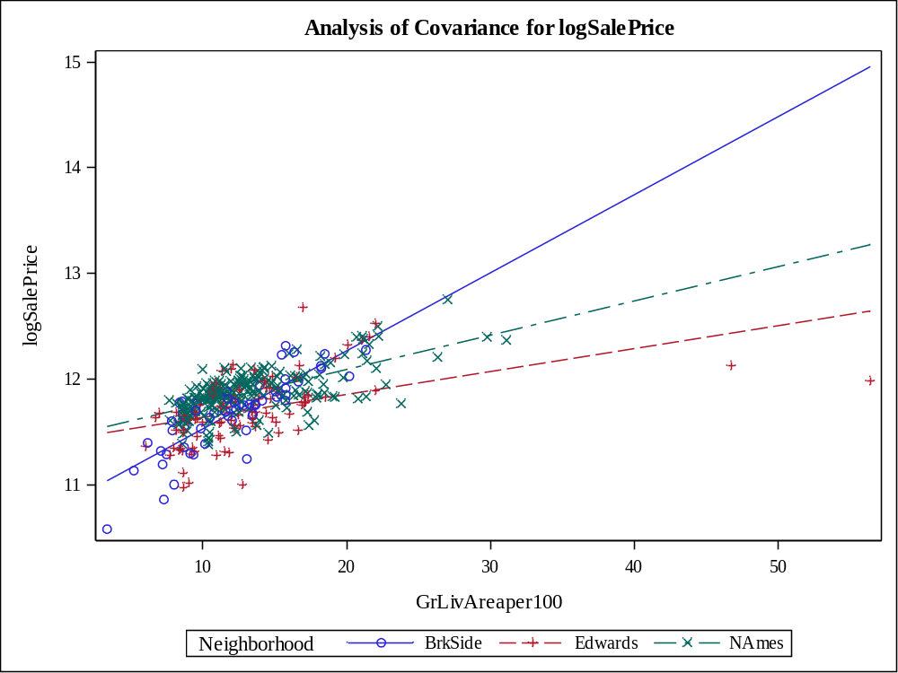

Class Level Information
Class | Levels | Values
Neighborhood | 3 | BrkSide Edwards NAmes

Number of Observations Read | 383
Number of Observations Used | 383

Source | DF | Sum of Squares | Mean Square | F Value | Pr > F
Model | 5 | 259060779993 | 51812155999 | 65.75 | <.0001
Error | 377 | 297091348665 | 788040712.64
Corrected Total | 382 | 556152128658

R-Square | Coeff Var | Root MSE | SalePrice Mean
0.465809 | 20.33287 | 28072.06 | 138062.5

Source | DF | Type I SS | Mean Square | F Value | Pr > F
logGrLivAreaper100 | 1 | 233388202131 | 233388202131 | 296.16 | <.0001
Neighborhood | 2 | 23681607510 | 11840803755 | 15.03 | <.0001
logGrLivA*Neighborho | 2 | 1990970352 | 995485176.02 | 1.26 | 0.2839

Source | DF | Type III SS | Mean Square | F Value | Pr > F
logGrLivAreaper100 | 1 | 204646998260 | 204646998260 | 259.69 | <.0001
Neighborhood | 2 | 2204373706.7 | 1102186853.3 | 1.40 | 0.2482
logGrLivA*Neighborho | 2 | 1990970352 | 995485176.02 | 1.26 | 0.2839

Observation |  | Observed | Predicted | Residual | 95% Confidence Limits for Mean Predicted Value
1 |  | 118000.0000 | 119899.0337 | -1899.0337 | 112567.3891 | 127230.6783
2 |  | 157000.0000 | 145667.4578 | 11332.5422 | 141987.5040 | 149347.4117
3 |  | 132000.0000 | 98607.8998 | 33392.1002 | 89277.1899 | 107938.6097
4 |  | 149000.0000 | 128549.8824 | 20450.1176 | 123852.4992 | 133247.2655
5 |  | 139000.0000 | 150796.3790 | -11796.3790 | 147022.9137 | 154569.8444
6 |  | 134800.0000 | 120100.9468 | 14699.0532 | 114406.5031 | 125795.3905
7 |  | 207500.0000 | 164555.4672 | 42944.5328 | 159706.4416 | 169404.4928
8 |  | 68500.0000 | 53080.2115 | 15419.7885 | 35444.4888 | 70715.9341
9 |  | 165500.0000 | 169239.5243 | -3739.5243 | 163842.1616 | 174636.8869
10 |  | 153000.0000 | 148334.0631 | 4665.9369 | 144630.3677 | 152037.7585
11 |  | 109000.0000 | 132524.5129 | -23524.5129 | 128211.9723 | 136837.0535
12 |  | 82000.0000 | 122431.0994 | -40431.0994 | 116754.0555 | 128108.1433
13 |  | 160000.0000 | 149925.9611 | 10074.0389 | 146182.2796 | 153669.6426
14 |  | 141000.0000 | 139039.9116 | 1960.0884 | 135184.8711 | 142894.9522
15 |  | 114500.0000 | 127969.3032 | -13469.3032 | 120687.5590 | 135251.0474
16 |  | 130000.0000 | 151998.7218 | -21998.7218 | 148175.2009 | 155822.2427
17 |  | 180500.0000 | 155605.9213 | 24894.0787 | 151574.2383 | 159637.6043
18 |  | 180000.0000 | 189405.6941 | -9405.6941 | 181183.8722 | 197627.5160
19 |  | 244000.0000 | 189963.8059 | 54036.1941 | 181657.6342 | 198269.9777
20 |  | 144900.0000 | 134615.7606 | 10284.2394 | 130476.3101 | 138755.2111
21 |  | 135750.0000 | 124440.8462 | 11309.1538 | 119283.6746 | 129598.0177
22 |  | 127000.0000 | 136103.8506 | -9103.8506 | 128428.7740 | 143778.9271
23 |  | 193500.0000 | 187095.9736 | 6404.0264 | 179220.8533 | 194971.0939
24 |  | 126500.0000 | 133107.0852 | -6607.0852 | 128844.9941 | 137369.1763
25 |  | 109900.0000 | 131271.7666 | -21371.7666 | 126845.2858 | 135698.2474
26 |  | 98600.0000 | 144549.4809 | -45949.4809 | 140863.1395 | 148235.8223
27 |  | 94750.0000 | 109537.9319 | -14787.9319 | 102551.3494 | 116524.5144
28 |  | 83000.0000 | 99672.8507 | -16672.8507 | 91111.1942 | 108234.5071
29 |  | 128950.0000 | 143921.3207 | -14971.3207 | 140227.1631 | 147615.4784
30 |  | 136900.0000 | 156119.4542 | -19219.4542 | 147670.6647 | 164568.2438
31 |  | 155000.0000 | 120753.9463 | 34246.0537 | 114974.9092 | 126532.9835
32 |  | 136000.0000 | 134187.7081 | 1812.2919 | 130014.6737 | 138360.7425
33 |  | 155000.0000 | 151313.9615 | 3686.0385 | 147520.1980 | 155107.7251
34 |  | 150000.0000 | 132231.5712 | 17768.4288 | 127893.0420 | 136570.1005
35 |  | 226000.0000 | 187635.1473 | 38364.8527 | 179679.4517 | 195590.8430
36 |  | 150750.0000 | 150100.8309 | 649.1691 | 146351.6089 | 153850.0530
37 |  | 143000.0000 | 143224.3943 | -224.3943 | 139518.0328 | 146930.7557
38 |  | 115000.0000 | 116946.9057 | -1946.9057 | 110836.4818 | 123057.3295
39 |  | 166000.0000 | 153406.1064 | 12593.8936 | 149511.3565 | 157300.8564
40 |  | 130000.0000 | 150322.3665 | -20322.3665 | 142829.3145 | 157815.4185
41 |  | 105000.0000 | 100837.2584 | 4162.7416 | 91812.7974 | 109861.7194
42 |  | 115000.0000 | 140223.5794 | -25223.5794 | 132197.3210 | 148249.8378
43 |  | 79000.0000 | 118907.1214 | -39907.1214 | 112988.8441 | 124825.3988
44 |  | 109500.0000 | 131271.7666 | -21771.7666 | 126845.2858 | 135698.2474
45 |  | 127500.0000 | 133908.5435 | -6408.5435 | 128236.8025 | 139580.2844
46 |  | 215000.0000 | 167213.4342 | 47786.5658 | 162060.9766 | 172365.8918
47 |  | 163000.0000 | 152112.2608 | 10887.7392 | 148283.4910 | 155941.0306
48 |  | 243000.0000 | 166818.6814 | 76181.3186 | 156388.9403 | 177248.4226
49 |  | 120000.0000 | 133121.3371 | -13121.3371 | 127488.3595 | 138754.3148
50 |  | 127000.0000 | 133716.3018 | -6716.3018 | 126200.2380 | 141232.3656
51 |  | 184000.0000 | 158479.6803 | 25520.3197 | 154226.7065 | 162732.6541
52 |  | 130000.0000 | 150322.3665 | -20322.3665 | 142829.3145 | 157815.4185
53 |  | 235000.0000 | 215955.7889 | 19044.2111 | 203563.0370 | 228348.5408
54 |  | 140000.0000 | 120502.0613 | 19497.9387 | 114705.6578 | 126298.4649
55 |  | 141000.0000 | 135605.4227 | 5394.5773 | 131539.7627 | 139671.0827
56 |  | 145000.0000 | 135041.4547 | 9958.5453 | 130934.4146 | 139148.4947
57 |  | 98000.0000 | 102087.1905 | -4087.1905 | 93940.8452 | 110233.5358
58 |  | 186000.0000 | 126021.5475 | 59978.4525 | 120478.8457 | 131564.2493
59 |  | 134450.0000 | 144612.0170 | -10162.0170 | 140926.2877 | 148297.7463
60 |  | 97000.0000 | 116946.9057 | -19946.9057 | 110836.4818 | 123057.3295
61 |  | 148000.0000 | 141940.9216 | 6059.0784 | 138202.4919 | 145679.3513
62 |  | 113000.0000 | 140482.3064 | -27482.3064 | 134287.8351 | 146676.7778
63 |  | 140000.0000 | 152846.2251 | -12846.2251 | 148981.4027 | 156711.0476
64 |  | 76500.0000 | 137591.4831 | -61091.4831 | 129800.3774 | 145382.5888
65 |  | 158000.0000 | 148631.3443 | 9368.6557 | 144921.6265 | 152341.0621
66 |  | 145000.0000 | 149340.1867 | -4340.1867 | 145613.4212 | 153066.9521
67 |  | 176000.0000 | 153238.5676 | 22761.4324 | 149352.9900 | 157124.1452
68 |  | 148000.0000 | 119995.5837 | 28004.4163 | 114162.6864 | 125828.4811
69 |  | 139000.0000 | 166085.4831 | -27085.4831 | 161064.4477 | 171106.5185
70 |  | 205000.0000 | 153192.0285 | 51807.9715 | 143553.3438 | 162830.7132
71 |  | 159000.0000 | 170769.5402 | -11769.5402 | 165180.4758 | 176358.6046
72 |  | 88000.0000 | 116408.4834 | -28408.4834 | 110225.2640 | 122591.7028
73 |  | 153575.0000 | 143707.2671 | 9867.7329 | 135315.9990 | 152098.5352
74 |  | 131000.0000 | 150611.4276 | -19611.4276 | 143073.3996 | 158149.4556
75 |  | 167000.0000 | 166651.5170 | 348.4830 | 161564.9969 | 171738.0370
76 |  | 82500.0000 | 101841.2193 | -19341.2193 | 93653.3106 | 110029.1281
77 |  | 132000.0000 | 126047.2092 | 5952.7908 | 121076.2383 | 131018.1801
78 |  | 242000.0000 | 212555.1482 | 29444.8518 | 200709.2836 | 224401.0129
79 |  | 145250.0000 | 153294.4543 | -8044.4543 | 149405.8375 | 157183.0711
80 |  | 214500.0000 | 182653.5945 | 31846.4055 | 167808.6600 | 197498.5290
81 |  | 119000.0000 | 170501.7296 | -51501.7296 | 164946.6094 | 176056.8497
82 |  | 139000.0000 | 132451.3816 | 6548.6184 | 128132.3914 | 136770.3717
83 |  | 155000.0000 | 143288.0116 | 11711.9884 | 139582.9174 | 146993.1058
84 |  | 87500.0000 | 131271.7666 | -43771.7666 | 126845.2858 | 135698.2474
85 |  | 140200.0000 | 154895.3425 | -14695.3425 | 145000.8995 | 164789.7856
86 |  | 151500.0000 | 124926.2715 | 26573.7285 | 119826.1708 | 130026.3722
87 |  | 157500.0000 | 158427.4224 | -927.4224 | 154178.8641 | 162675.9807
88 |  | 95000.0000 | 119868.3955 | -24868.3955 | 114026.0070 | 125710.7840
89 |  | 145000.0000 | 150606.7660 | -5606.7660 | 141339.7065 | 159873.8254
90 |  | 198500.0000 | 158628.5947 | 39871.4053 | 149736.3405 | 167520.8489
91 |  | 159000.0000 | 153906.5540 | 5093.4460 | 149983.3196 | 157829.7885
92 |  | 165000.0000 | 155930.5574 | 9069.4426 | 151876.1780 | 159984.9369
93 |  | 132000.0000 | 146586.9048 | -14586.9048 | 142904.9576 | 150268.8520
94 |  | 162000.0000 | 147736.0471 | 14263.9529 | 144042.4307 | 151429.6635
95 |  | 123000.0000 | 149633.6290 | -26633.6290 | 145898.7071 | 153368.5510
96 |  | 61000.0000 | 105287.5845 | -44287.5845 | 97664.6420 | 112910.5269
97 |  | 81000.0000 | 124368.6627 | -43368.6627 | 118778.7525 | 129958.5728
98 |  | 125000.0000 | 120753.9463 | 4246.0537 | 114974.9092 | 126532.9835
99 |  | 119000.0000 | 134532.0594 | -15532.0594 | 128825.7499 | 140238.3688
100 |  | 106500.0000 | 118540.0194 | -12040.0194 | 112642.0470 | 124437.9918
101 |  | 100000.0000 | 91226.4934 | 8773.5066 | 80774.9036 | 101678.0832
102 |  | 129000.0000 | 121938.2985 | 7061.7015 | 116233.7849 | 127642.8121
103 |  | 169500.0000 | 174169.1499 | -4669.1499 | 168136.3405 | 180201.9593
104 |  | 60000.0000 | 129660.5053 | -69660.5053 | 124130.8865 | 135190.1240
105 |  | 126000.0000 | 121317.4285 | 4682.5715 | 115575.3281 | 127059.5290
106 |  | 142000.0000 | 132451.3816 | 9548.6184 | 128132.3914 | 136770.3717
107 |  | 139000.0000 | 142070.2325 | -3070.2325 | 138335.5905 | 145804.8746
108 |  | 109008.0000 | 120699.5585 | -11691.5585 | 115081.8455 | 126317.2715
109 |  | 119000.0000 | 103829.4873 | 15170.5127 | 95187.6984 | 112471.2761
110 |  | 110000.0000 | 125081.7777 | -15081.7777 | 119515.3491 | 130648.2063
111 |  | 118000.0000 | 138211.0610 | -20211.0610 | 132234.8797 | 144187.2423
112 |  | 162900.0000 | 154662.2738 | 8237.7262 | 144803.3075 | 164521.2402
113 |  | 127500.0000 | 149489.9068 | -21989.9068 | 142124.5829 | 156855.2307
114 |  | 190000.0000 | 177343.6554 | 12656.3446 | 170877.9729 | 183809.3379
115 |  | 110000.0000 | 130052.4614 | -20052.4614 | 122710.9715 | 137393.9513
116 |  | 167000.0000 | 147133.3664 | 19866.6336 | 143447.1379 | 150819.5949
117 |  | 146500.0000 | 166651.5170 | -20151.5170 | 161564.9969 | 171738.0370
118 |  | 148000.0000 | 117341.3755 | 30658.6245 | 111284.3375 | 123398.4135
119 |  | 147000.0000 | 136513.1807 | 10486.8193 | 132510.2677 | 140516.0937
120 |  | 156000.0000 | 133685.2976 | 22314.7024 | 129471.6063 | 137898.9889
121 |  | 133000.0000 | 163485.7257 | -30485.7257 | 158752.3052 | 168219.1461
122 |  | 155000.0000 | 146647.8140 | 8352.1860 | 142965.5037 | 150330.1242
123 |  | 184000.0000 | 168047.2102 | 15952.7898 | 155952.4683 | 180141.9520
124 |  | 120000.0000 | 121124.3165 | -1124.3165 | 115560.5782 | 126688.0547
125 |  | 140000.0000 | 126138.1454 | 13861.8546 | 120597.8102 | 131678.4806
126 |  | 124500.0000 | 131346.0225 | -6846.0225 | 126926.4956 | 135765.5494
127 |  | 164900.0000 | 152168.9678 | 12731.0322 | 148337.5432 | 156000.3924
128 |  | 129900.0000 | 116946.9057 | 12953.0943 | 110836.4818 | 123057.3295
129 |  | 150000.0000 | 145110.4915 | 4889.5085 | 141428.5627 | 148792.4202
130 |  | 159000.0000 | 159823.4350 | -823.4350 | 149146.6073 | 170500.2628
131 |  | 184750.0000 | 221501.1119 | -36751.1119 | 199414.0952 | 243588.1285
132 |  | 132000.0000 | 122468.0595 | 9531.9405 | 117072.3543 | 127863.7648
133 |  | 86000.0000 | 76887.7190 | 9112.2810 | 63888.9354 | 89886.5026
134 |  | 128000.0000 | 141444.4943 | -13444.4943 | 133296.9602 | 149592.0285
135 |  | 107500.0000 | 113565.2408 | -6065.2408 | 106990.1397 | 120140.3419
136 |  | 39300.0000 | 12454.4178 | 26845.5822 | -13748.3295 | 38657.1652
137 |  | 107500.0000 | 133489.7909 | -25989.7909 | 127839.3544 | 139140.2273
138 |  | 111250.0000 | 116946.9057 | -5696.9057 | 110836.4818 | 123057.3295
139 |  | 133000.0000 | 107745.9333 | 25254.0667 | 100336.3957 | 115155.4709
140 |  | 210000.0000 | 158209.9641 | 51790.0359 | 147795.7085 | 168624.2196
141 |  | 108000.0000 | 120816.7777 | -12816.7777 | 115041.9906 | 126591.5647
142 |  | 113000.0000 | 117394.0765 | -4394.0765 | 109957.0528 | 124831.1003
143 |  | 141000.0000 | 135041.4547 | 5958.5453 | 130934.4146 | 139148.4947
144 |  | 108000.0000 | 112141.2923 | -4141.2923 | 105503.8395 | 118778.7451
145 |  | 185000.0000 | 148859.0673 | 36140.9327 | 141588.6934 | 156129.4412
146 |  | 135960.0000 | 123706.9414 | 12253.0586 | 118462.2342 | 128951.6487
147 |  | 142600.0000 | 170501.7296 | -27901.7296 | 164946.6094 | 176056.8497
148 |  | 120000.0000 | 116946.9057 | 3053.0943 | 110836.4818 | 123057.3295
149 |  | 139000.0000 | 136235.0047 | 2764.9953 | 132213.3797 | 140256.6298
150 |  | 118500.0000 | 143351.5766 | -24851.5766 | 139647.7180 | 147055.4353
151 |  | 181900.0000 | 155822.4969 | 26077.5031 | 151775.7406 | 159869.2532
152 |  | 118500.0000 | 98045.1397 | 20454.8603 | 89194.9439 | 106895.3354
153 |  | 133000.0000 | 154662.2738 | -21662.2738 | 144803.3075 | 164521.2402
154 |  | 130000.0000 | 96872.2310 | 33127.7690 | 87291.8297 | 106452.6322
155 |  | 79500.0000 | 106923.7372 | -27423.7372 | 98639.1033 | 115208.3711
156 |  | 205000.0000 | 181253.5248 | 23746.4752 | 174235.1384 | 188271.9113
157 |  | 225000.0000 | 161724.0664 | 63275.9336 | 152265.1424 | 171182.9905
158 |  | 137500.0000 | 132304.9108 | 5195.0892 | 127972.9263 | 136636.8954
159 |  | 105500.0000 | 114030.9642 | -8530.9642 | 107520.8607 | 120541.0677
160 |  | 67000.0000 | 102087.1905 | -35087.1905 | 93940.8452 | 110233.5358
161 |  | 160000.0000 | 136721.1573 | 23278.8427 | 132731.9306 | 140710.3841
162 |  | 139900.0000 | 155443.0903 | -15543.0903 | 151422.5584 | 159463.6222
163 |  | 153000.0000 | 160592.3791 | -7592.3791 | 156149.8873 | 165034.8709
164 |  | 135000.0000 | 184826.5905 | -49826.5905 | 177288.0086 | 192365.1724
165 |  | 168500.0000 | 151428.5105 | 17071.4895 | 147629.9978 | 155227.0232
166 |  | 139400.0000 | 132451.3816 | 6948.6184 | 128132.3914 | 136770.3717
167 |  | 60000.0000 | 92613.4833 | -32613.4833 | 82383.5359 | 102843.4307
168 |  | 85000.0000 | 96290.2943 | -11290.2943 | 87122.1767 | 105458.4119
169 |  | 345000.0000 | 205097.7139 | 139902.2861 | 194441.1560 | 215754.2717
170 |  | 143250.0000 | 126759.3182 | 16490.6818 | 121868.3493 | 131650.2871
171 |  | 98300.0000 | 131863.8253 | -33563.8253 | 127492.0980 | 136235.5525
172 |  | 155000.0000 | 118777.9586 | 36222.0414 | 112848.9341 | 124706.9831
173 |  | 155000.0000 | 175311.9308 | -20311.9308 | 169125.1495 | 181498.7121
174 |  | 108000.0000 | 141567.7349 | -33567.7349 | 135256.4248 | 147879.0450
175 |  | 145500.0000 | 132231.5712 | 13268.4288 | 127893.0420 | 136570.1005
176 |  | 97500.0000 | 157374.7729 | -59874.7729 | 153212.1744 | 161537.3714
177 |  | 167000.0000 | 140434.7339 | 26565.2661 | 134245.2050 | 146624.2627
178 |  | 110000.0000 | 153795.6232 | -43795.6232 | 149878.8421 | 157712.4044
179 |  | 137500.0000 | 124189.2546 | 13310.7454 | 118592.7004 | 129785.8088
180 |  | 129000.0000 | 195236.4725 | -66236.4725 | 186123.8856 | 204349.0594
181 |  | 103600.0000 | 134635.4463 | -31035.4463 | 128923.0793 | 140347.8132
182 |  | 140000.0000 | 138093.5429 | 1906.4571 | 134187.9142 | 141999.1717
183 |  | 141500.0000 | 152656.9206 | -11156.9206 | 143096.8512 | 162216.9899
184 |  | 89000.0000 | 68627.8426 | 20372.1574 | 54097.3158 | 83158.3693
185 |  | 123500.0000 | 122185.1282 | 1314.8718 | 116494.6372 | 127875.6192
186 |  | 52000.0000 | 84084.4936 | -32084.4936 | 72426.9743 | 95742.0129
187 |  | 129000.0000 | 109345.2695 | 19654.7305 | 101309.4314 | 117381.1076
188 |  | 124500.0000 | 116946.9057 | 7553.0943 | 110836.4818 | 123057.3295
189 |  | 135000.0000 | 139669.1877 | -4669.1877 | 133557.0661 | 145781.3092
190 |  | 320000.0000 | 149865.7268 | 170134.2732 | 142443.0746 | 157288.3790
191 |  | 120500.0000 | 116946.9057 | 3553.0943 | 110836.4818 | 123057.3295
192 |  | 110000.0000 | 172618.6642 | -62618.6642 | 166791.0536 | 178446.2747
193 |  | 93500.0000 | 131271.7666 | -37771.7666 | 126845.2858 | 135698.2474
194 |  | 179000.0000 | 125317.8936 | 53682.1064 | 119758.2021 | 130877.5850
195 |  | 98000.0000 | 142451.9953 | -44451.9953 | 136039.9332 | 148864.0574
196 |  | 156000.0000 | 130224.6200 | 25775.3800 | 125697.5176 | 134751.7224
197 |  | 127500.0000 | 116946.9057 | 10553.0943 | 110836.4818 | 123057.3295
198 |  | 100000.0000 | 137239.4660 | -37239.4660 | 129476.9522 | 145001.9798
199 |  | 102000.0000 | 126486.7902 | -24486.7902 | 120952.7671 | 132020.8133
200 |  | 107000.0000 | 120249.2760 | -13249.2760 | 114434.9194 | 126063.6325
201 |  | 114500.0000 | 121124.3165 | -6624.3165 | 115560.5782 | 126688.0547
202 |  | 110000.0000 | 108347.9879 | 1652.0121 | 101026.4804 | 115669.4954
203 |  | 118000.0000 | 137547.5104 | -19547.5104 | 133610.0401 | 141484.9808
204 |  | 135500.0000 | 126680.5183 | 8819.4817 | 121780.7774 | 131580.2591
205 |  | 223500.0000 | 154837.1308 | 68662.8692 | 144951.5624 | 164722.6993
206 |  | 159950.0000 | 134615.7606 | 25334.2394 | 130476.3101 | 138755.2111
207 |  | 157900.0000 | 156522.2039 | 1377.7961 | 152424.8987 | 160619.5092
208 |  | 116000.0000 | 128204.6878 | -12204.6878 | 122684.9432 | 133724.4323
209 |  | 137000.0000 | 128857.0926 | 8142.9074 | 124191.7627 | 133522.4225
210 |  | 109500.0000 | 90759.4657 | 18740.5343 | 80232.2298 | 101286.7015
211 |  | 166000.0000 | 153795.6232 | 12204.3768 | 149878.8421 | 157712.4044
212 |  | 167000.0000 | 160388.7867 | 6611.2133 | 155965.4561 | 164812.1172
213 |  | 139950.0000 | 138635.7436 | 1314.2564 | 134759.8228 | 142511.6644
214 |  | 130500.0000 | 125317.8936 | 5182.1064 | 119758.2021 | 130877.5850
215 |  | 174900.0000 | 140041.1776 | 34858.8224 | 136233.0908 | 143849.2645
216 |  | 141000.0000 | 173655.7707 | -32655.7707 | 167691.3943 | 179620.1472
217 |  | 158000.0000 | 156682.7789 | 1317.2211 | 152573.4820 | 160792.0757
218 |  | 132500.0000 | 138905.4237 | -6405.4237 | 135043.5565 | 142767.2910
219 |  | 148500.0000 | 128395.8179 | 20104.1821 | 123682.2276 | 133109.4083
220 |  | 109500.0000 | 119584.1336 | -10084.1336 | 113822.8409 | 125345.4264
221 |  | 116000.0000 | 120954.6934 | -4954.6934 | 115369.4487 | 126539.9381
222 |  | 133000.0000 | 146586.9048 | -13586.9048 | 142904.9576 | 150268.8520
223 |  | 157000.0000 | 118518.9230 | 38481.0770 | 112567.9594 | 124469.8867
224 |  | 100000.0000 | 119411.0915 | -19411.0915 | 113627.2947 | 125194.8883
225 |  | 145000.0000 | 169782.9962 | -24782.9962 | 164318.1673 | 175247.8251
226 |  | 135500.0000 | 135864.4412 | -364.4412 | 130073.1175 | 141655.7649
227 |  | 268000.0000 | 189754.9861 | 78245.0139 | 181480.3992 | 198029.5731
228 |  | 149500.0000 | 159826.1254 | -10326.1254 | 155454.7817 | 164197.4691
229 |  | 122900.0000 | 122134.3083 | 765.6917 | 116697.2664 | 127571.3502
230 |  | 140000.0000 | 173483.8835 | -33483.8835 | 167542.3132 | 179425.4538
231 |  | 110000.0000 | 116408.4834 | -6408.4834 | 110225.2640 | 122591.7028
232 |  | 153000.0000 | 148868.3484 | 4131.6516 | 145153.3507 | 152583.3460
233 |  | 128000.0000 | 132961.8534 | -4961.8534 | 128687.3415 | 137236.3653
234 |  | 154300.0000 | 191716.3504 | -37416.3504 | 183143.9747 | 200288.7260
235 |  | 88000.0000 | 114457.8738 | -26457.8738 | 106846.3259 | 122069.4217
236 |  | 135000.0000 | 127006.5555 | 7993.4445 | 121479.8092 | 132533.3018
237 |  | 176500.0000 | 155007.1891 | 21492.8109 | 151015.7307 | 158998.6476
238 |  | 145900.0000 | 168181.7795 | -22281.7795 | 157485.6010 | 178877.9580
239 |  | 117500.0000 | 122217.8814 | -4717.8814 | 116791.2157 | 127644.5470
240 |  | 242000.0000 | 184416.9024 | 57583.0976 | 176938.5982 | 191895.2065
241 |  | 79900.0000 | 86322.9156 | -6422.9156 | 75053.9155 | 97591.9157
242 |  | 150000.0000 | 138211.0610 | 11788.9390 | 132234.8797 | 144187.2423
243 |  | 143000.0000 | 138635.7436 | 4364.2564 | 134759.8228 | 142511.6644
244 |  | 129000.0000 | 116946.9057 | 12053.0943 | 110836.4818 | 123057.3295
245 |  | 127500.0000 | 110996.0586 | 16503.9414 | 104209.2741 | 117782.8430
246 |  | 116500.0000 | 99036.7358 | 17463.2642 | 89766.2403 | 108307.2313
247 |  | 135000.0000 | 135464.8162 | -464.8162 | 131389.0082 | 139540.6242
248 |  | 140000.0000 | 135253.4254 | 4746.5746 | 131162.1490 | 139344.7018
249 |  | 135000.0000 | 141811.3938 | -6811.3938 | 138069.0463 | 145553.7414
250 |  | 167500.0000 | 177569.8791 | -10069.8791 | 163707.8802 | 191431.8780
251 |  | 85500.0000 | 100205.8058 | -14705.8058 | 91096.3368 | 109315.2748
252 |  | 110000.0000 | 104500.9619 | 5499.0381 | 96752.5351 | 112249.3888
253 |  | 178400.0000 | 128164.1438 | 50235.8562 | 123426.0175 | 132902.2701
254 |  | 125000.0000 | 123163.9208 | 1836.0792 | 117523.7867 | 128804.0550
255 |  | 187000.0000 | 175814.4580 | 11185.5420 | 169559.2857 | 182069.6302
256 |  | 121600.0000 | 132089.3805 | -10489.3805 | 124661.5212 | 139517.2397
257 |  | 136500.0000 | 132011.1338 | 4488.8662 | 127652.7805 | 136369.4871
258 |  | 82000.0000 | 108349.3890 | -26349.3890 | 101192.5187 | 115506.2593
259 |  | 163500.0000 | 167260.0767 | -3760.0767 | 162102.1054 | 172418.0480
260 |  | 100000.0000 | 148435.3594 | -48435.3594 | 141227.8322 | 155642.8866
261 |  | 119200.0000 | 134330.6559 | -15130.6559 | 130168.9462 | 138492.3656
262 |  | 176000.0000 | 121192.5977 | 54807.4023 | 115442.5443 | 126942.6511
263 |  | 167500.0000 | 146342.7868 | 21157.2132 | 142662.0067 | 150023.5669
264 |  | 105000.0000 | 152902.3962 | -47902.3962 | 149034.6650 | 156770.1274
265 |  | 84000.0000 | 100514.7253 | -16514.7253 | 92099.6937 | 108929.7570
266 |  | 139600.0000 | 151308.5529 | -11708.5529 | 143660.7823 | 158956.3236
267 |  | 84900.0000 | 107292.7707 | -22392.7707 | 99979.3166 | 114606.2248
268 |  | 165000.0000 | 180902.5934 | -15902.5934 | 173934.5775 | 187870.6093
269 |  | 144500.0000 | 142313.1082 | 2186.8918 | 135917.1911 | 148709.0253
270 |  | 154000.0000 | 139308.1872 | 14691.8128 | 135466.4001 | 143149.9743
271 |  | 167900.0000 | 165084.8346 | 2815.1654 | 160177.1511 | 169992.5181
272 |  | 135000.0000 | 119497.6610 | 15502.3390 | 113725.1301 | 125270.1920
273 |  | 135000.0000 | 131863.8253 | 3136.1747 | 127492.0980 | 136235.5525
274 |  | 91500.0000 | 138992.4683 | -47492.4683 | 132945.3547 | 145039.5818
275 |  | 159500.0000 | 137520.1742 | 21979.8258 | 131602.8974 | 143437.4510
276 |  | 138800.0000 | 135323.9533 | 3476.0467 | 131237.8658 | 139410.0407
277 |  | 160000.0000 | 145544.0341 | 14455.9659 | 141863.8496 | 149224.2185
278 |  | 137500.0000 | 150322.3665 | -12822.3665 | 142829.3145 | 157815.4185
279 |  | 92900.0000 | 131271.7666 | -38371.7666 | 126845.2858 | 135698.2474
280 |  | 146000.0000 | 142328.2070 | 3671.7930 | 138600.7510 | 146055.6630
281 |  | 129000.0000 | 123131.2677 | 5868.7323 | 117816.8857 | 128445.6497
282 |  | 128000.0000 | 138847.6803 | -10847.6803 | 130948.9638 | 146746.3969
283 |  | 119500.0000 | 124278.3576 | -4778.3576 | 119101.9334 | 129454.7818
284 |  | 135000.0000 | 137957.3962 | -2957.3962 | 134044.0070 | 141870.7853
285 |  | 159500.0000 | 141940.9216 | 17559.0784 | 138202.4919 | 145679.3513
286 |  | 129900.0000 | 112530.6592 | 17369.3408 | 105810.1282 | 119251.1902
287 |  | 134500.0000 | 128857.0926 | 5642.9074 | 124191.7627 | 133522.4225
288 |  | 133700.0000 | 131271.7666 | 2428.2334 | 126845.2858 | 135698.2474
289 |  | 112000.0000 | 109537.9319 | 2462.0681 | 102551.3494 | 116524.5144
290 |  | 118000.0000 | 86999.5366 | 31000.4634 | 76055.2843 | 97943.7890
291 |  | 115000.0000 | 128626.7995 | -13626.7995 | 123937.4749 | 133316.1241
292 |  | 102000.0000 | 111797.6657 | -9797.6657 | 103983.4114 | 119611.9201
293 |  | 119000.0000 | 145605.7706 | -26605.7706 | 141925.7162 | 149285.8250
294 |  | 144000.0000 | 127264.2748 | 16735.7252 | 119996.0699 | 134532.4796
295 |  | 139000.0000 | 124440.8462 | 14559.1538 | 119283.6746 | 129598.0177
296 |  | 80000.0000 | 106835.0562 | -26835.0562 | 99452.3352 | 114217.7772
297 |  | 149000.0000 | 154837.1308 | -5837.1308 | 144951.5624 | 164722.6993
298 |  | 124000.0000 | 122800.3752 | 1199.6248 | 117445.5570 | 128155.1935
299 |  | 149900.0000 | 139476.4992 | 10423.5008 | 133383.2196 | 145569.7788
300 |  | 201800.0000 | 174509.5173 | 27290.4827 | 168431.0809 | 180587.9536
301 |  | 179900.0000 | 146403.8886 | 33496.1114 | 142722.8597 | 150084.9176
302 |  | 235000.0000 | 165160.9253 | 69839.0747 | 155051.6603 | 175270.1904
303 |  | 163000.0000 | 146159.1908 | 16840.8092 | 142478.9848 | 149839.3968
304 |  | 93000.0000 | 120691.0592 | -27691.0592 | 114907.7353 | 126474.3830
305 |  | 104900.0000 | 126544.7309 | -21644.7309 | 121011.6456 | 132077.8162
306 |  | 116050.0000 | 116946.9057 | -896.9057 | 110836.4818 | 123057.3295
307 |  | 117000.0000 | 140496.3010 | -23496.3010 | 132443.6004 | 148549.0017
308 |  | 140000.0000 | 147495.5387 | -7495.5387 | 143805.2050 | 151185.8724
309 |  | 113000.0000 | 84315.0791 | 28684.9209 | 72835.1869 | 95794.9714
310 |  | 134500.0000 | 128164.1438 | 6335.8562 | 123426.0175 | 132902.2701
311 |  | 80500.0000 | 104638.0454 | -24138.0454 | 96093.5724 | 113182.5183
312 |  | 115000.0000 | 121124.3165 | -6124.3165 | 115560.5782 | 126688.0547
313 |  | 143000.0000 | 175605.4687 | -32605.4687 | 169378.7878 | 181832.1496
314 |  | 137900.0000 | 186879.2462 | -48979.2462 | 179036.4499 | 194722.0425
315 |  | 145000.0000 | 138229.4502 | 6770.5498 | 134331.4486 | 142127.4519
316 |  | 147000.0000 | 121124.3165 | 25875.6835 | 115560.5782 | 126688.0547
317 |  | 127000.0000 | 159928.7327 | -32928.7327 | 155548.0161 | 164309.4493
318 |  | 132500.0000 | 141681.6486 | -9181.6486 | 137935.2529 | 145428.0443
319 |  | 101800.0000 | 143858.2229 | -42058.2229 | 140163.1129 | 147553.3330
320 |  | 142000.0000 | 141551.6851 | 448.3149 | 137801.1106 | 145302.2596
321 |  | 119000.0000 | 127308.6785 | -8308.6785 | 122478.2891 | 132139.0678
322 |  | 244000.0000 | 185933.0048 | 58066.9952 | 178230.8900 | 193635.1197
323 |  | 165400.0000 | 148094.5557 | 17305.4443 | 140937.0221 | 155252.0892
324 |  | 127500.0000 | 141780.7745 | -14280.7745 | 133598.5461 | 149963.0029
325 |  | 99900.0000 | 102087.1905 | -2187.1905 | 93940.8452 | 110233.5358
326 |  | 151000.0000 | 132304.9108 | 18695.0892 | 127972.9263 | 136636.8954
327 |  | 128900.0000 | 132011.1338 | -3111.1338 | 127652.7805 | 136369.4871
328 |  | 180500.0000 | 168248.6828 | 12251.3172 | 156117.7709 | 180379.5947
329 |  | 181000.0000 | 150680.8883 | 30319.1117 | 146911.6908 | 154450.0858
330 |  | 144000.0000 | 160795.4364 | -16795.4364 | 156333.6521 | 165257.2208
331 |  | 177000.0000 | 134012.8453 | 42987.1547 | 128335.5577 | 139690.1329
332 |  | 137000.0000 | 178642.2285 | -41642.2285 | 171995.1479 | 185289.3091
333 |  | 132500.0000 | 144753.0989 | -12253.0989 | 136241.3292 | 153264.8687
334 |  | 180500.0000 | 139174.1658 | 41325.8342 | 135325.8187 | 143022.5130
335 |  | 115000.0000 | 102087.1905 | 12912.8095 | 93940.8452 | 110233.5358
336 |  | 138500.0000 | 132158.1619 | 6341.8381 | 127813.0563 | 136503.2676
337 |  | 155000.0000 | 137547.5104 | 17452.4896 | 133610.0401 | 141484.9808
338 |  | 140000.0000 | 117341.3755 | 22658.6245 | 111284.3375 | 123398.4135
339 |  | 160000.0000 | 234781.3831 | -74781.3831 | 209734.7125 | 259828.0537
340 |  | 154000.0000 | 145234.6092 | 8765.3908 | 141553.3284 | 148915.8901
341 |  | 130000.0000 | 150280.9754 | -20280.9754 | 142794.3377 | 157767.6131
342 |  | 119000.0000 | 108648.4027 | 10351.5973 | 101534.9724 | 115761.8331
343 |  | 206900.0000 | 186006.2055 | 20893.7945 | 178293.2341 | 193719.1769
344 |  | 111000.0000 | 108648.4027 | 2351.5973 | 101534.9724 | 115761.8331
345 |  | 156500.0000 | 158427.4224 | -1927.4224 | 154178.8641 | 162675.9807
346 |  | 72500.0000 | 82944.4696 | -10444.4696 | 71085.8170 | 94803.1222
347 |  | 82500.0000 | 81402.0677 | 1097.9323 | 69268.0377 | 93536.0978
348 |  | 79000.0000 | 94308.2970 | -15308.2970 | 84773.4349 | 103843.1592
349 |  | 100000.0000 | 98045.1397 | 1954.8603 | 89194.9439 | 106895.3354
350 |  | 123000.0000 | 117659.0146 | 5340.9854 | 111644.1132 | 123673.9161
351 |  | 200000.0000 | 203071.2097 | -3071.2097 | 192734.9948 | 213407.4247
352 |  | 171000.0000 | 169963.3073 | 1036.6927 | 164475.9392 | 175450.6755
353 |  | 134900.0000 | 127969.3032 | 6930.6968 | 120687.5590 | 135251.0474
354 |  | 110000.0000 | 119411.0915 | -9411.0915 | 113627.2947 | 125194.8883
355 |  | 149900.0000 | 134044.4953 | 15855.5047 | 129860.0065 | 138228.9841
356 |  | 104900.0000 | 170947.5662 | -66047.5662 | 165335.8496 | 176559.2828
357 |  | 165500.0000 | 167446.3656 | -1946.3656 | 162266.3118 | 172626.4194
358 |  | 117000.0000 | 145838.3734 | -28838.3734 | 138998.4973 | 152678.2495
359 |  | 58500.0000 | 102087.1905 | -43587.1905 | 93940.8452 | 110233.5358
360 |  | 237500.0000 | 186188.9043 | 51311.0957 | 178448.8167 | 193928.9918
361 |  | 105000.0000 | 128655.8321 | -23655.8321 | 123135.1831 | 134176.4811
362 |  | 131000.0000 | 131189.6600 | -189.6600 | 123803.3026 | 138576.0174
363 |  | 124000.0000 | 163778.9453 | -39778.9453 | 159014.2388 | 168543.6518
364 |  | 123000.0000 | 120100.9468 | 2899.0532 | 114406.5031 | 125795.3905
365 |  | 137500.0000 | 151093.2920 | -13593.2920 | 141757.9111 | 160428.6729
366 |  | 138000.0000 | 177995.6701 | -39995.6701 | 171439.1960 | 184552.1441
367 |  | 120000.0000 | 126553.7880 | -6553.7880 | 119295.7737 | 133811.8023
368 |  | 140000.0000 | 167771.2942 | -27771.2942 | 162552.4940 | 172990.0945
369 |  | 90000.0000 | 131271.7666 | -41271.7666 | 126845.2858 | 135698.2474
370 |  | 207000.0000 | 169448.3176 | 37551.6824 | 157100.8140 | 181795.8211
371 |  | 124000.0000 | 138635.7436 | -14635.7436 | 134759.8228 | 142511.6644
372 |  | 274970.0000 | 168213.9162 | 106756.0838 | 157511.4260 | 178916.4063
373 |  | 144000.0000 | 151084.3528 | -7084.3528 | 147299.8294 | 154868.8763
374 |  | 142000.0000 | 145605.7706 | -3605.7706 | 141925.7162 | 149285.8250
375 |  | 140000.0000 | 162500.2113 | -22500.2113 | 157869.6153 | 167130.8073
376 |  | 174000.0000 | 161451.7113 | 12548.2887 | 156926.3611 | 165977.0615
377 |  | 120500.0000 | 116946.9057 | 3553.0943 | 110836.4818 | 123057.3295
378 |  | 121000.0000 | 108577.3090 | 12422.6910 | 100465.6711 | 116688.9468
379 |  | 112000.0000 | 133437.2720 | -21437.2720 | 127789.3980 | 139085.1460
380 |  | 136000.0000 | 173311.6130 | -37311.6130 | 167392.8451 | 179230.3809
381 |  | 145000.0000 | 117341.3755 | 27658.6245 | 111284.3375 | 123398.4135
382 |  | 142125.0000 | 134044.4953 | 8080.5047 | 129860.0065 | 138228.9841
383 |  | 147500.0000 | 128543.3156 | 18956.6844 | 123023.0735 | 134063.5576

Sum of Residuals | 2.9831426E-8
Sum of Squared Residuals | 297091348665
Sum of Squared Residuals - Error SS | 0.0159301758
PRESS Statistic | 312931798515
First Order Autocorrelation | -0.03997231
Durbin-Watson D | 2.0787229014

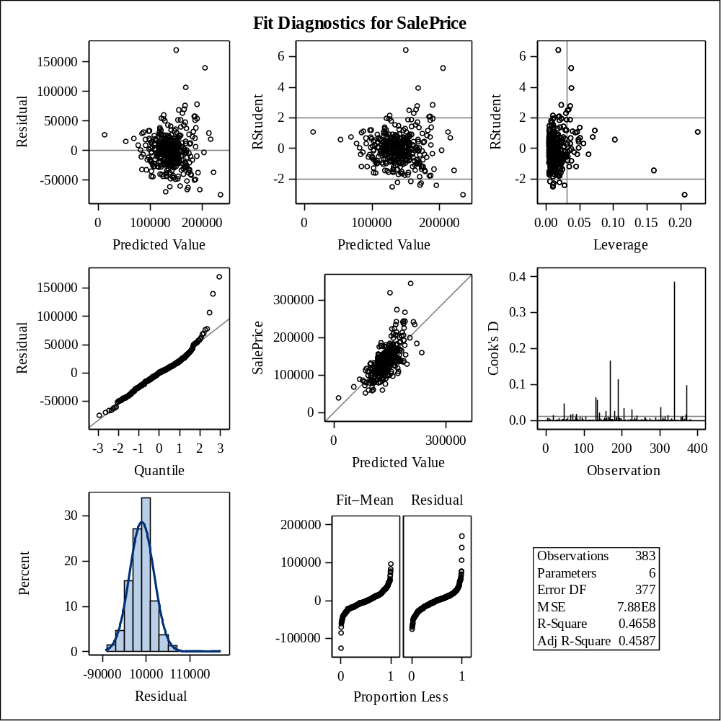

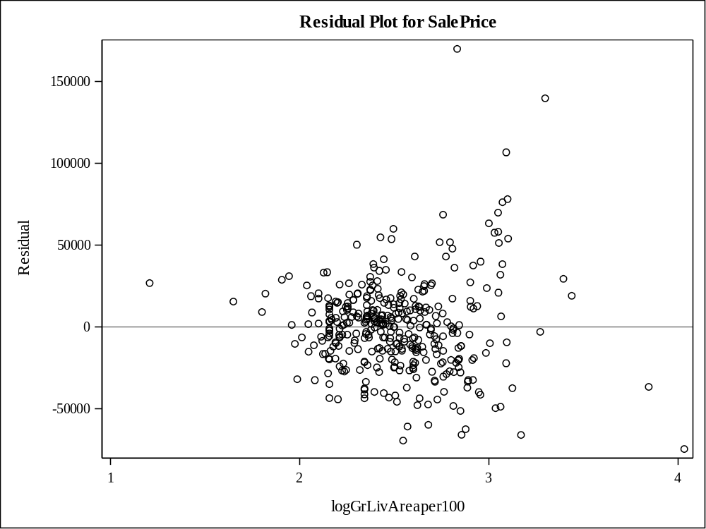

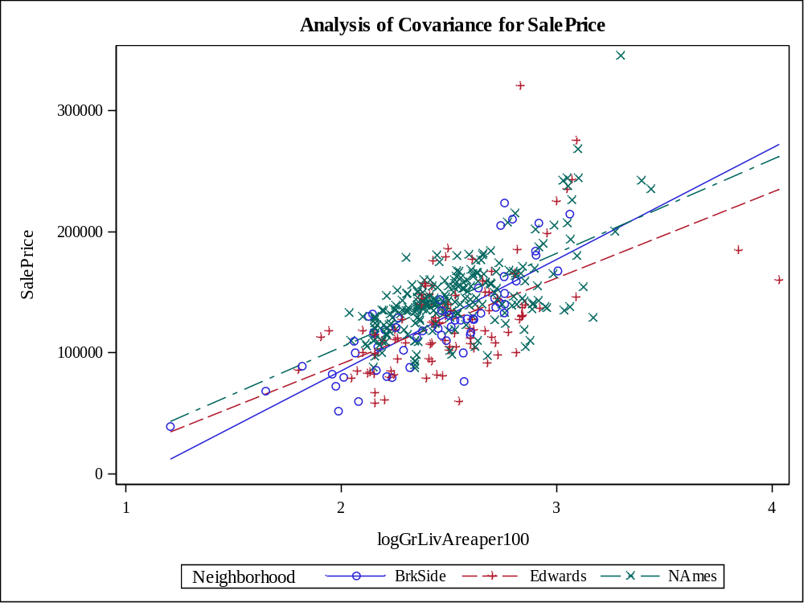

Class Level Information
Class | Levels | Values
Neighborhood | 3 | BrkSide Edwards NAmes

Number of Observations Read | 383
Number of Observations Used | 383

Source | DF | Sum of Squares | Mean Square | F Value | Pr > F
Model | 5 | 14.62857557 | 2.92571511 | 79.14 | <.0001
Error | 377 | 13.93775037 | 0.03697016
Corrected Total | 382 | 28.56632594

R-Square | Coeff Var | Root MSE | logSalePrice Mean
0.512092 | 1.629617 | 0.192276 | 11.79887

Source | DF | Type I SS | Mean Square | F Value | Pr > F
logGrLivAreaper100 | 1 | 12.00843049 | 12.00843049 | 324.81 | <.0001
Neighborhood | 2 | 1.98063548 | 0.99031774 | 26.79 | <.0001
logGrLivA*Neighborho | 2 | 0.63950960 | 0.31975480 | 8.65 | 0.0002

Source | DF | Type III SS | Mean Square | F Value | Pr > F
logGrLivAreaper100 | 1 | 11.69403942 | 11.69403942 | 316.31 | <.0001
Neighborhood | 2 | 0.80762020 | 0.40381010 | 10.92 | <.0001
logGrLivA*Neighborho | 2 | 0.63950960 | 0.31975480 | 8.65 | 0.0002

Observation |  | Observed | Predicted | Residual | 95% Confidence Limits for Mean Predicted Value
1 |  | 11.67843990 | 11.63564992 | 0.04278998 | 11.58543269 | 11.68586715
2 |  | 11.96400108 | 11.86694499 | 0.09705610 | 11.84173958 | 11.89215039
3 |  | 11.79055720 | 11.44548872 | 0.34506848 | 11.38157913 | 11.50939831
4 |  | 11.91170158 | 11.76214725 | 0.14955434 | 11.72997308 | 11.79432141
5 |  | 11.84222921 | 11.89834543 | -0.05611621 | 11.87249952 | 11.92419133
6 |  | 11.81154748 | 11.71042091 | 0.10112656 | 11.67141750 | 11.74942433
7 |  | 12.24288662 | 11.98258173 | 0.26030488 | 11.94936891 | 12.01579456
8 |  | 11.13458902 | 11.03885936 | 0.09572966 | 10.91806558 | 11.15965315
9 |  | 12.01672647 | 12.01125861 | 0.00546786 | 11.97429002 | 12.04822721
10 |  | 11.93819320 | 11.88327056 | 0.05492264 | 11.85790254 | 11.90863858
11 |  | 11.59910316 | 11.78648085 | -0.18737769 | 11.75694262 | 11.81601908
12 |  | 11.31447453 | 11.66977401 | -0.35529949 | 11.63088977 | 11.70865825
13 |  | 11.98292909 | 11.89301653 | 0.08991257 | 11.86737462 | 11.91865843
14 |  | 11.85651517 | 11.82636962 | 0.03014555 | 11.79996498 | 11.85277426
15 |  | 11.64833010 | 11.70772932 | -0.05939922 | 11.65785388 | 11.75760476
16 |  | 11.77528973 | 11.90570645 | -0.13041672 | 11.87951769 | 11.93189520
17 |  | 12.10348606 | 11.92779055 | 0.17569550 | 11.90017602 | 11.95540509
18 |  | 12.10071213 | 12.13472055 | -0.03400842 | 12.07840616 | 12.19103494
19 |  | 12.40492350 | 12.13813744 | 0.26678606 | 12.08124530 | 12.19502958
20 |  | 11.88379913 | 11.79928395 | 0.08451518 | 11.77093128 | 11.82763662
21 |  | 11.81857024 | 11.73699078 | 0.08157946 | 11.70166735 | 11.77231421
22 |  | 11.75194237 | 11.78038282 | -0.02844045 | 11.72781329 | 11.83295234
23 |  | 12.17303279 | 12.12057991 | 0.05245288 | 12.06664021 | 12.17451961
24 |  | 11.74799759 | 11.79004749 | -0.04204990 | 11.76085480 | 11.81924018
25 |  | 11.60732614 | 11.77881125 | -0.17148511 | 11.74849259 | 11.80912990
26 |  | 11.49882654 | 11.86010048 | -0.36127394 | 11.83485132 | 11.88534963
27 |  | 11.45899712 | 11.57502747 | -0.11603035 | 11.52717371 | 11.62288124
28 |  | 11.32659589 | 11.50253308 | -0.17593719 | 11.44389103 | 11.56117513
29 |  | 11.76718001 | 11.85625473 | -0.08907472 | 11.83095204 | 11.88155743
30 |  | 11.82700601 | 11.91733576 | -0.09032975 | 11.85946678 | 11.97520474
31 |  | 11.95118040 | 11.65744931 | 0.29373109 | 11.61786648 | 11.69703214
32 |  | 11.82041016 | 11.79666331 | 0.02374685 | 11.76808061 | 11.82524602
33 |  | 11.95118040 | 11.90151419 | 0.04966621 | 11.87552925 | 11.92749912
34 |  | 11.91839057 | 11.78468739 | 0.13370318 | 11.75497115 | 11.81440363
35 |  | 12.32829028 | 12.12388086 | 0.20440942 | 12.06938926 | 12.17837245
36 |  | 11.92337811 | 11.89408712 | 0.02929099 | 11.86840727 | 11.91976697
37 |  | 11.87059991 | 11.85198799 | 0.01861192 | 11.82660171 | 11.87737427
38 |  | 11.65268741 | 11.69111115 | -0.03842374 | 11.64925853 | 11.73296377
39 |  | 12.01974307 | 11.91432278 | 0.10542029 | 11.88764615 | 11.94099941
40 |  | 11.77528973 | 11.87473537 | -0.09944564 | 11.82341260 | 11.92605814
41 |  | 11.56171563 | 11.46540018 | 0.09631545 | 11.40358820 | 11.52721215
42 |  | 11.65268741 | 11.81717807 | -0.16449066 | 11.76220316 | 11.87215297
43 |  | 11.27720313 | 11.64387776 | -0.36667463 | 11.60334122 | 11.68441430
44 |  | 11.60367983 | 11.77881125 | -0.17513142 | 11.74849259 | 11.80912990
45 |  | 11.75587164 | 11.75411699 | 0.00175465 | 11.71526907 | 11.79296491
46 |  | 12.27839331 | 11.99885442 | 0.27953889 | 11.96356328 | 12.03414557
47 |  | 12.00150548 | 11.90640156 | 0.09510392 | 11.88017685 | 11.93262626
48 |  | 12.40081672 | 11.99595995 | 0.40485678 | 11.92452267 | 12.06739722
49 |  | 11.69524702 | 11.74833214 | -0.05308512 | 11.70974973 | 11.78691455
50 |  | 11.75194237 | 11.75905849 | -0.00711612 | 11.70757810 | 11.81053888
51 |  | 12.12269104 | 11.94538437 | 0.17730667 | 11.91625413 | 11.97451461
52 |  | 11.77528973 | 11.87473537 | -0.09944564 | 11.82341260 | 11.92605814
53 |  | 12.36734079 | 12.29726635 | 0.07007444 | 12.21238367 | 12.38214903
54 |  | 11.84939770 | 11.65559831 | 0.19379939 | 11.61589653 | 11.69530009
55 |  | 11.85651517 | 11.80534289 | 0.05117228 | 11.77749563 | 11.83319015
56 |  | 11.88448902 | 11.80189015 | 0.08259887 | 11.77375946 | 11.83002083
57 |  | 11.49272276 | 11.52027506 | -0.02755231 | 11.46447764 | 11.57607249
58 |  | 12.13350195 | 11.69615873 | 0.43734323 | 11.65819465 | 11.73412280
59 |  | 11.80894766 | 11.86048334 | -0.05153567 | 11.83523837 | 11.88572830
60 |  | 11.48246626 | 11.69111115 | -0.20864489 | 11.64925853 | 11.73296377
61 |  | 11.90496755 | 11.84413027 | 0.06083728 | 11.81852434 | 11.86973620
62 |  | 11.63514310 | 11.80242485 | -0.16728175 | 11.75999655 | 11.84485314
63 |  | 11.84939770 | 11.91089506 | -0.06149735 | 11.88442341 | 11.93736670
64 |  | 11.24504602 | 11.79366957 | -0.54862355 | 11.74030532 | 11.84703382
65 |  | 11.97035031 | 11.88509058 | 0.08525973 | 11.85968131 | 11.91049986
66 |  | 11.88448902 | 11.88943028 | -0.00494126 | 11.86390424 | 11.91495632
67 |  | 12.07823927 | 11.91329707 | 0.16494221 | 11.88668327 | 11.93991087
68 |  | 11.90496755 | 11.65187642 | 0.25309113 | 11.61192468 | 11.69182816
69 |  | 11.84222921 | 11.99194884 | -0.14971963 | 11.95755786 | 12.02633983
70 |  | 12.23076526 | 11.93300543 | 0.29775983 | 11.86698640 | 11.99902446
71 |  | 11.97665948 | 12.02062572 | -0.04396624 | 11.98234409 | 12.05890735
72 |  | 11.38509209 | 11.68781480 | -0.30272271 | 11.64546358 | 11.73016603
73 |  | 11.94194433 | 11.84829253 | 0.09365179 | 11.79081754 | 11.90576753
74 |  | 11.78295260 | 11.87685956 | -0.09390696 | 11.82522873 | 11.92849039
75 |  | 12.02574909 | 11.99541423 | 0.03033486 | 11.96057472 | 12.03025375
76 |  | 11.32055357 | 11.51846752 | -0.19791395 | 11.46238541 | 11.57454963
77 |  | 11.79055720 | 11.74682530 | 0.04373190 | 11.71277723 | 11.78087338
78 |  | 12.39669301 | 12.27644685 | 0.12024616 | 12.19531000 | 12.35758369
79 |  | 11.88621167 | 11.91363922 | -0.02742754 | 11.88700460 | 11.94027384
80 |  | 12.27606502 | 12.19614063 | 0.07992438 | 12.09446202 | 12.29781925
81 |  | 11.68687877 | 12.01898612 | -0.33210735 | 11.98093699 | 12.05703526
82 |  | 11.84222921 | 11.78603312 | 0.05619609 | 11.75645071 | 11.81561553
83 |  | 11.95118040 | 11.85237747 | 0.09880293 | 11.82699987 | 11.87775507
84 |  | 11.37939407 | 11.77881125 | -0.39941718 | 11.74849259 | 11.80912990
85 |  | 11.85082525 | 11.94821854 | -0.09739328 | 11.88044772 | 12.01598935
86 |  | 11.92834090 | 11.73996266 | 0.18837824 | 11.70503013 | 11.77489520
87 |  | 11.96718074 | 11.94506443 | 0.02211630 | 11.91596444 | 11.97416443
88 |  | 11.46163217 | 11.65094176 | -0.18930959 | 11.61092502 | 11.69095851
89 |  | 11.88448902 | 11.90991523 | -0.02542620 | 11.84644160 | 11.97338885
90 |  | 12.19854438 | 11.93577439 | 0.26276998 | 11.87486796 | 11.99668083
91 |  | 11.97665948 | 11.91738663 | 0.05927285 | 11.89051491 | 11.94425836
92 |  | 12.01370075 | 11.92977805 | 0.08392270 | 11.90200806 | 11.95754804
93 |  | 11.79055720 | 11.87257405 | -0.08201685 | 11.84735499 | 11.89779311
94 |  | 11.99535161 | 11.87960937 | 0.11574225 | 11.85431038 | 11.90490836
95 |  | 11.71993963 | 11.89122680 | -0.17128717 | 11.86564490 | 11.91680871
96 |  | 11.01862914 | 11.54379343 | -0.52516429 | 11.49158099 | 11.59600587
97 |  | 11.30220443 | 11.68401236 | -0.38180793 | 11.64572494 | 11.72229979
98 |  | 11.73606902 | 11.65744931 | 0.07861971 | 11.61786648 | 11.69703214
99 |  | 11.68687877 | 11.75869895 | -0.07182018 | 11.71961426 | 11.79778364
100 |  | 11.57590026 | 11.70086456 | -0.12496429 | 11.66046710 | 11.74126202
101 |  | 11.51292546 | 11.37956188 | 0.13336358 | 11.30797496 | 11.45114880
102 |  | 11.76756768 | 11.66615262 | 0.10141506 | 11.62708024 | 11.70522501
103 |  | 12.04060821 | 12.04143892 | -0.00083071 | 12.00011790 | 12.08275993
104 |  | 11.00209984 | 11.72289992 | -0.72080008 | 11.68502545 | 11.76077439
105 |  | 11.74403719 | 11.66159011 | 0.08244708 | 11.62226027 | 11.70091994
106 |  | 11.86358234 | 11.78603312 | 0.07754921 | 11.75645071 | 11.81561553
107 |  | 11.84222921 | 11.84492195 | -0.00269273 | 11.81934196 | 11.87050193
108 |  | 11.59917655 | 11.71408575 | -0.11490920 | 11.67560790 | 11.75256361
109 |  | 11.68687877 | 11.49212519 | 0.19475358 | 11.43293428 | 11.55131610
110 |  | 11.60823564 | 11.68925275 | -0.08101710 | 11.65112616 | 11.72737934
111 |  | 11.67843990 | 11.78573441 | -0.10729450 | 11.74480126 | 11.82666755
112 |  | 12.00089179 | 11.94613689 | 0.05475491 | 11.87860907 | 12.01366471
113 |  | 11.75587164 | 11.86861797 | -0.11274632 | 11.81817006 | 11.91906588
114 |  | 12.15477935 | 12.06087397 | 0.09390538 | 12.01658805 | 12.10515990
115 |  | 11.60823564 | 11.72633499 | -0.11809935 | 11.67605033 | 11.77661966
116 |  | 12.02574909 | 11.87591962 | 0.14982947 | 11.85067123 | 11.90116800
117 |  | 11.89478071 | 11.99541423 | -0.10063353 | 11.96057472 | 12.03025375
118 |  | 11.90496755 | 11.63237174 | 0.27259581 | 11.59088478 | 11.67385870
119 |  | 11.89818787 | 11.81090039 | 0.08728747 | 11.78348292 | 11.83831787
120 |  | 11.95761129 | 11.79358744 | 0.16402384 | 11.76472626 | 11.82244862
121 |  | 11.79810441 | 11.97603253 | -0.17792812 | 11.94361153 | 12.00845353
122 |  | 11.95118040 | 11.87294695 | 0.07823344 | 11.84772541 | 11.89816850
123 |  | 12.12269104 | 12.06568410 | 0.05700694 | 11.98284260 | 12.14852559
124 |  | 11.69524702 | 11.71668622 | -0.02143920 | 11.67857806 | 11.75479438
125 |  | 11.84939770 | 11.69701556 | 0.15238214 | 11.65906769 | 11.73496342
126 |  | 11.73206099 | 11.77926586 | -0.04720487 | 11.74899484 | 11.80953688
127 |  | 12.01309451 | 11.90674873 | 0.10634578 | 11.88050584 | 11.93299162
128 |  | 11.77452020 | 11.69111115 | 0.08340905 | 11.64925853 | 11.73296377
129 |  | 11.91839057 | 11.86353511 | 0.05485546 | 11.83831618 | 11.88875405
130 |  | 11.97665948 | 11.99223366 | -0.01557418 | 11.91910400 | 12.06536333
131 |  | 12.12675884 | 12.39779845 | -0.27103961 | 12.24651605 | 12.54908085
132 |  | 11.79055720 | 11.72491292 | 0.06564428 | 11.68795568 | 11.76187017
133 |  | 11.36210258 | 11.33509460 | 0.02700798 | 11.24606097 | 11.42412822
134 |  | 11.75978554 | 11.82808264 | -0.06829709 | 11.77227707 | 11.88388820
135 |  | 11.58524613 | 11.67040782 | -0.08516169 | 11.62537244 | 11.71544319
136 |  | 10.57897980 | 10.67601115 | -0.09703136 | 10.49653855 | 10.85548376
137 |  | 11.58524613 | 11.75103975 | -0.16579362 | 11.71233776 | 11.78974174
138 |  | 11.61953520 | 11.69111115 | -0.07157595 | 11.64925853 | 11.73296377
139 |  | 11.79810441 | 11.63478067 | 0.16332373 | 11.58402993 | 11.68553142
140 |  | 12.25486281 | 11.97782299 | 0.27703982 | 11.90649178 | 12.04915420
141 |  | 11.58988651 | 11.65791103 | -0.06802453 | 11.61835731 | 11.69746475
142 |  | 11.63514310 | 11.61327696 | 0.02186614 | 11.56233795 | 11.66421597
143 |  | 11.85651517 | 11.80189015 | 0.05462502 | 11.77375946 | 11.83002083
144 |  | 11.58988651 | 11.59415849 | -0.00427198 | 11.54869604 | 11.63962093
145 |  | 12.12811110 | 11.86398219 | 0.26412891 | 11.81418463 | 11.91377975
146 |  | 11.82011600 | 11.73249764 | 0.08761836 | 11.69657465 | 11.76842064
147 |  | 11.86779879 | 12.01898612 | -0.15118734 | 11.98093699 | 12.05703526
148 |  | 11.69524702 | 11.69111115 | 0.00413587 | 11.64925853 | 11.73296377
149 |  | 11.84222921 | 11.80919734 | 0.03303188 | 11.78165169 | 11.83674298
150 |  | 11.68266824 | 11.85276663 | -0.17009839 | 11.82739749 | 11.87813577
151 |  | 12.11121236 | 11.92911648 | 0.18209589 | 11.90139870 | 11.95683425
152 |  | 11.68266824 | 11.49057171 | 0.19209653 | 11.42995334 | 11.55119007
153 |  | 11.79810441 | 11.94613689 | -0.14803248 | 11.87860907 | 12.01366471
154 |  | 11.77528973 | 11.42998664 | 0.34530309 | 11.36436682 | 11.49560646
155 |  | 11.28351230 | 11.51976140 | -0.23624910 | 11.46301679 | 11.57650602
156 |  | 12.23076526 | 12.08481109 | 0.14595417 | 12.03673949 | 12.13288270
157 |  | 12.32385568 | 11.95852173 | 0.36533395 | 11.89373396 | 12.02330951
158 |  | 11.83137920 | 11.78513640 | 0.04624280 | 11.75546498 | 11.81480781
159 |  | 11.56646623 | 11.67325908 | -0.10679285 | 11.62866890 | 11.71784926
160 |  | 11.11244790 | 11.52027506 | -0.40782716 | 11.46447764 | 11.57607249
161 |  | 11.98292909 | 11.81217367 | 0.17075542 | 11.78484994 | 11.83949741
162 |  | 11.84868316 | 11.92679366 | -0.07811050 | 11.89925551 | 11.95433182
163 |  | 11.93819320 | 11.95831880 | -0.02012560 | 11.92789048 | 11.98874712
164 |  | 11.81303006 | 12.10668622 | -0.29365617 | 12.05505160 | 12.15832085
165 |  | 12.03469103 | 11.90221548 | 0.13247555 | 11.87619802 | 11.92823294
166 |  | 11.84510278 | 11.78603312 | 0.05906965 | 11.75645071 | 11.81561553
167 |  | 11.00209984 | 11.39194974 | -0.38984990 | 11.32188093 | 11.46201855
168 |  | 11.35040654 | 11.47767608 | -0.12726954 | 11.41488014 | 11.54047201
169 |  | 12.75129970 | 12.23079071 | 0.52050898 | 12.15779989 | 12.30378154
170 |  | 11.87234663 | 11.75118500 | 0.12116164 | 11.71768489 | 11.78468511
171 |  | 11.49577931 | 11.78243597 | -0.28665666 | 11.75249234 | 11.81237959
172 |  | 11.95118040 | 11.64292860 | 0.30825180 | 11.60231845 | 11.68353875
173 |  | 11.95118040 | 12.04843528 | -0.09725489 | 12.00605966 | 12.09081091
174 |  | 11.58988651 | 11.81040121 | -0.22051471 | 11.76717264 | 11.85362978
175 |  | 11.88793137 | 11.78468739 | 0.10324397 | 11.75497115 | 11.81440363
176 |  | 11.48760766 | 11.93861987 | -0.45101221 | 11.91010865 | 11.96713109
177 |  | 12.02574909 | 11.80207526 | 0.22367383 | 11.75968081 | 11.84446970
178 |  | 11.60823564 | 11.91670749 | -0.30847185 | 11.88987996 | 11.94353502
179 |  | 11.83137920 | 11.68269397 | 0.14868523 | 11.64436103 | 11.72102690
180 |  | 11.76756768 | 12.17041792 | -0.40285024 | 12.10800234 | 12.23283350
181 |  | 11.54829261 | 11.75945870 | -0.21116609 | 11.72033252 | 11.79858488
182 |  | 11.84939770 | 11.82057574 | 0.02882197 | 11.79382460 | 11.84732688
183 |  | 11.86005500 | 11.92822613 | -0.06817113 | 11.86274557 | 11.99370669
184 |  | 11.39639165 | 11.17772262 | 0.21866903 | 11.07819751 | 11.27724774
185 |  | 11.72399644 | 11.66796647 | 0.05602996 | 11.62899013 | 11.70694281
186 |  | 10.85899900 | 11.31577330 | -0.45677430 | 11.23592650 | 11.39562009
187 |  | 11.76756768 | 11.54138925 | 0.22617843 | 11.48634874 | 11.59642977
188 |  | 11.73206099 | 11.69111115 | 0.04094985 | 11.64925853 | 11.73296377
189 |  | 11.81303006 | 11.79644958 | 0.01658048 | 11.75458532 | 11.83831383
190 |  | 12.67607627 | 11.87137971 | 0.80469656 | 11.82053914 | 11.92222029
191 |  | 11.69940503 | 11.69111115 | 0.00829388 | 11.64925853 | 11.73296377
192 |  | 11.60823564 | 12.03194649 | -0.42371084 | 11.99203096 | 12.07186201
193 |  | 11.44571672 | 11.77881125 | -0.33309453 | 11.74849259 | 11.80912990
194 |  | 12.09514108 | 11.69098787 | 0.40415322 | 11.65290742 | 11.72906831
195 |  | 11.49272276 | 11.81689927 | -0.32417652 | 11.77298062 | 11.86081793
196 |  | 11.95761129 | 11.77240038 | 0.18521091 | 11.74139253 | 11.80340823
197 |  | 11.75587164 | 11.69111115 | 0.06476050 | 11.64925853 | 11.73296377
198 |  | 11.51292546 | 11.79052554 | -0.27760007 | 11.73735712 | 11.84369395
199 |  | 11.53272809 | 11.69957760 | -0.16684951 | 11.66167297 | 11.73748224
200 |  | 11.58058411 | 11.65374070 | -0.07315658 | 11.61391595 | 11.69356544
201 |  | 11.64833010 | 11.71668622 | -0.06835612 | 11.67857806 | 11.75479438
202 |  | 11.60823564 | 11.63846659 | -0.03023095 | 11.58831880 | 11.68861439
203 |  | 11.67843990 | 11.81723280 | -0.13879289 | 11.79026356 | 11.84420203
204 |  | 11.81672692 | 11.75070257 | 0.06602435 | 11.71714237 | 11.78426276
205 |  | 12.31716669 | 11.94769862 | 0.36946807 | 11.87998859 | 12.01540865
206 |  | 11.98261655 | 11.79928395 | 0.18333260 | 11.77093128 | 11.82763662
207 |  | 11.96971720 | 11.93340025 | 0.03631695 | 11.90533624 | 11.96146425
208 |  | 11.66134547 | 11.71220172 | -0.05085625 | 11.67439489 | 11.75000855
209 |  | 11.82773620 | 11.76402806 | 0.06370815 | 11.73207343 | 11.79598268
210 |  | 11.60367983 | 11.37539063 | 0.22828919 | 11.30328558 | 11.44749569
211 |  | 12.01974307 | 11.91670749 | 0.10303558 | 11.88987996 | 11.94353502
212 |  | 12.02574909 | 11.95707236 | 0.06867674 | 11.92677528 | 11.98736943
213 |  | 11.84904049 | 11.82389521 | 0.02514528 | 11.79734755 | 11.85044287
214 |  | 11.77912851 | 11.69098787 | 0.08814064 | 11.65290742 | 11.72906831
215 |  | 12.07196966 | 11.83249960 | 0.23947006 | 11.80641657 | 11.85858264
216 |  | 11.85651517 | 12.03829589 | -0.18178072 | 11.99744360 | 12.07914818
217 |  | 11.97035031 | 11.93438332 | 0.03596699 | 11.90623718 | 11.96252946
218 |  | 11.79433792 | 11.82554626 | -0.03120833 | 11.79909486 | 11.85199766
219 |  | 11.90834024 | 11.76120403 | 0.14713621 | 11.72891885 | 11.79348920
220 |  | 11.60367983 | 11.70725687 | -0.10357704 | 11.66779558 | 11.74671816
221 |  | 11.66134547 | 11.71564775 | -0.05430228 | 11.67739228 | 11.75390322
222 |  | 11.79810441 | 11.87257405 | -0.07446965 | 11.84735499 | 11.89779311
223 |  | 11.96400108 | 11.64102505 | 0.32297603 | 11.60026463 | 11.68178547
224 |  | 11.51292546 | 11.70619746 | -0.19327200 | 11.66658203 | 11.74581289
225 |  | 11.88448902 | 12.01458587 | -0.13009685 | 11.97715518 | 12.05201657
226 |  | 11.81672692 | 11.76849007 | 0.04823685 | 11.72882309 | 11.80815706
227 |  | 12.49874226 | 12.13685900 | 0.36188326 | 12.08018320 | 12.19353480
228 |  | 11.91505167 | 11.95362761 | -0.03857594 | 11.92368661 | 11.98356861
229 |  | 11.71912630 | 11.72286962 | -0.00374333 | 11.68562925 | 11.76011000
230 |  | 11.84939770 | 12.03724356 | -0.18784586 | 11.99654748 | 12.07793964
231 |  | 11.60823564 | 11.68781480 | -0.07957916 | 11.64546358 | 11.73016603
232 |  | 11.93819320 | 11.88654158 | 0.05165162 | 11.86109614 | 11.91198701
233 |  | 11.75978554 | 11.78915835 | -0.02937281 | 11.75988059 | 11.81843611
234 |  | 11.94665404 | 12.14886692 | -0.20221288 | 12.09015145 | 12.20758239
235 |  | 11.38509209 | 11.58705234 | -0.20196025 | 11.53491795 | 11.63918674
236 |  | 11.81303006 | 11.70339714 | 0.10963291 | 11.66554235 | 11.74125193
237 |  | 12.08107616 | 11.92412498 | 0.15695118 | 11.89678596 | 11.95146400
238 |  | 11.89067673 | 12.00597679 | -0.11530005 | 11.93271458 | 12.07923899
239 |  | 11.67419361 | 11.72338128 | -0.04918766 | 11.68621197 | 11.76055058
240 |  | 12.39669301 | 12.10417802 | 0.29251499 | 12.05295626 | 12.15539978
241 |  | 11.28853113 | 11.33576570 | -0.04723457 | 11.25858003 | 11.41295138
242 |  | 11.91839057 | 11.78573441 | 0.13265617 | 11.74480126 | 11.82666755
243 |  | 11.87059991 | 11.82389521 | 0.04670470 | 11.79734755 | 11.85044287
244 |  | 11.76756768 | 11.69111115 | 0.07645654 | 11.64925853 | 11.73296377
245 |  | 11.75587164 | 11.58574264 | 0.17012900 | 11.53925737 | 11.63222791
246 |  | 11.66564655 | 11.44931886 | 0.21632770 | 11.38582170 | 11.51281601
247 |  | 11.81303006 | 11.80448206 | 0.00854799 | 11.77656530 | 11.83239883
248 |  | 11.84939770 | 11.80318788 | 0.04620982 | 11.77516517 | 11.83121059
249 |  | 11.81303006 | 11.84333728 | -0.03030722 | 11.81770451 | 11.86897004
250 |  | 12.02873863 | 12.15073556 | -0.12199693 | 12.05578945 | 12.24568168
251 |  | 11.35627165 | 11.45976037 | -0.10348872 | 11.39736615 | 11.52215460
252 |  | 11.60823564 | 11.53801287 | 0.07022278 | 11.48494094 | 11.59108480
253 |  | 12.09178350 | 11.75978566 | 0.33199783 | 11.72733243 | 11.79223890
254 |  | 11.73606902 | 11.67515921 | 0.06090980 | 11.63652778 | 11.71379064
255 |  | 12.13886390 | 12.05151187 | 0.08735202 | 12.00866781 | 12.09435593
256 |  | 11.70849225 | 11.74452768 | -0.03603543 | 11.69365144 | 11.79540392
257 |  | 11.82407989 | 11.78333782 | 0.04074207 | 11.75348580 | 11.81318985
258 |  | 11.31447453 | 11.56629336 | -0.25181884 | 11.51727323 | 11.61531350
259 |  | 12.00456827 | 11.99913998 | 0.00542829 | 11.96381107 | 12.03446889
260 |  | 11.51292546 | 11.86086854 | -0.34794307 | 11.81150143 | 11.91023564
261 |  | 11.68855803 | 11.79753847 | -0.10898044 | 11.76903334 | 11.82604361
262 |  | 12.07823927 | 11.66067278 | 0.41756650 | 11.62128847 | 11.70005709
263 |  | 12.02873863 | 11.87107951 | 0.15765912 | 11.84586844 | 11.89629057
264 |  | 11.56171563 | 11.91123895 | -0.34952332 | 11.88474738 | 11.93773051
265 |  | 11.33857208 | 11.50871967 | -0.17014759 | 11.45108191 | 11.56635743
266 |  | 11.84653647 | 11.88198244 | -0.03544597 | 11.82959995 | 11.93436494
267 |  | 11.34922937 | 11.55852871 | -0.20929934 | 11.50843608 | 11.60862135
268 |  | 12.01370075 | 12.08266261 | -0.06896186 | 12.03493601 | 12.13038921
269 |  | 11.88103479 | 11.81587865 | 0.06515614 | 11.77207058 | 11.85968673
270 |  | 11.94470788 | 11.82801207 | 0.11669581 | 11.80169820 | 11.85432593
271 |  | 12.03112384 | 11.98582264 | 0.04530120 | 11.95220805 | 12.01943724
272 |  | 11.81303006 | 11.70672746 | 0.10630260 | 11.66718919 | 11.74626573
273 |  | 11.81303006 | 11.78243597 | 0.03059409 | 11.75249234 | 11.81237959
274 |  | 11.42409425 | 11.79147664 | -0.36738239 | 11.75005766 | 11.83289563
275 |  | 11.97979920 | 11.78065737 | 0.19914183 | 11.74012768 | 11.82118705
276 |  | 11.84078933 | 11.80361967 | 0.03716966 | 11.77563250 | 11.83160684
277 |  | 11.98292909 | 11.86618936 | 0.11673973 | 11.84098237 | 11.89139635
278 |  | 11.83137920 | 11.87473537 | -0.04335617 | 11.82341260 | 11.92605814
279 |  | 11.43927892 | 11.77881125 | -0.33953232 | 11.74849259 | 11.80912990
280 |  | 11.89136190 | 11.84650132 | 0.04486058 | 11.82097056 | 11.87203209
281 |  | 11.76756768 | 11.72897324 | 0.03859445 | 11.69257301 | 11.76537347
282 |  | 11.75978554 | 11.80488926 | -0.04510372 | 11.75078794 | 11.85899058
283 |  | 11.69107165 | 11.73599599 | -0.04492434 | 11.70054068 | 11.77145129
284 |  | 11.81303006 | 11.81974221 | -0.00671216 | 11.79293792 | 11.84654651
285 |  | 11.97979920 | 11.84413027 | 0.13566893 | 11.81852434 | 11.86973620
286 |  | 11.77452020 | 11.66407387 | 0.11044633 | 11.61804239 | 11.71010535
287 |  | 11.80931948 | 11.76402806 | 0.04529142 | 11.73207343 | 11.79598268
288 |  | 11.80335376 | 11.77881125 | 0.02454251 | 11.74849259 | 11.80912990
289 |  | 11.62625415 | 11.57502747 | 0.05122668 | 11.52717371 | 11.62288124
290 |  | 11.67843990 | 11.40940215 | 0.26903775 | 11.33444080 | 11.48436351
291 |  | 11.65268741 | 11.76261815 | -0.10993074 | 11.73049918 | 11.79473712
292 |  | 11.53272809 | 11.56329277 | -0.03056467 | 11.50976996 | 11.61681557
293 |  | 11.68687877 | 11.86656732 | -0.17968855 | 11.84136123 | 11.89177342
294 |  | 11.87756858 | 11.70143238 | 0.17613620 | 11.65164967 | 11.75121508
295 |  | 11.84222921 | 11.73699078 | 0.10523843 | 11.70166735 | 11.77231421
296 |  | 11.28978191 | 11.55516516 | -0.26538325 | 11.50459809 | 11.60573223
297 |  | 11.91170158 | 11.94769862 | -0.03599703 | 11.87998859 | 12.01540865
298 |  | 11.72803684 | 11.72694744 | 0.00108941 | 11.69027025 | 11.76362463
299 |  | 11.91772368 | 11.79503359 | 0.12269010 | 11.75329839 | 11.83676878
300 |  | 12.21503239 | 12.04352272 | 0.17150966 | 12.00188920 | 12.08515625
301 |  | 12.10015642 | 11.87145359 | 0.22870283 | 11.84624082 | 11.89666636
302 |  | 12.36734079 | 11.98377778 | 0.38356301 | 11.91453557 | 12.05301999
303 |  | 12.00150548 | 11.86995549 | 0.13154999 | 11.84474836 | 11.89516262
304 |  | 11.44035477 | 11.65698718 | -0.21663241 | 11.61737499 | 11.69659937
305 |  | 11.56076279 | 11.70000339 | -0.13924059 | 11.66210517 | 11.73790160
306 |  | 11.66177641 | 11.69111115 | -0.02933474 | 11.64925853 | 11.73296377
307 |  | 11.66992921 | 11.81961387 | -0.14968466 | 11.76445786 | 11.87476989
308 |  | 11.84939770 | 11.87813692 | -0.02873922 | 11.85286042 | 11.90341342
309 |  | 11.63514310 | 11.38967519 | 0.24546791 | 11.31104503 | 11.46830535
310 |  | 11.80931948 | 11.75978566 | 0.04953381 | 11.72733243 | 11.79223890
311 |  | 11.29601246 | 11.49934680 | -0.20333434 | 11.44082245 | 11.55787116
312 |  | 11.65268741 | 11.71668622 | -0.06399881 | 11.67857806 | 11.75479438
313 |  | 11.87059991 | 12.05023239 | -0.17963248 | 12.00758348 | 12.09288130
314 |  | 11.83428406 | 12.11925306 | -0.28496899 | 12.06553475 | 12.17297136
315 |  | 11.88448902 | 11.82140779 | 0.06308123 | 11.79470889 | 11.84810669
316 |  | 11.89818787 | 11.71668622 | 0.18150165 | 11.67857806 | 11.75479438
317 |  | 11.75194237 | 11.95425580 | -0.20231343 | 11.92425060 | 11.98426100
318 |  | 11.79433792 | 11.84254295 | -0.04820502 | 11.81688245 | 11.86820344
319 |  | 11.53076538 | 11.85586843 | -0.32510305 | 11.83055922 | 11.88117765
320 |  | 11.86358234 | 11.84174728 | 0.02183506 | 11.81605816 | 11.86743639
321 |  | 11.68687877 | 11.75454831 | -0.06766954 | 11.72146313 | 11.78763349
322 |  | 12.40492350 | 12.11345995 | 0.29146356 | 12.06070523 | 12.16621467
323 |  | 12.01612206 | 11.85836411 | 0.15775795 | 11.80933943 | 11.90738879
324 |  | 11.75587164 | 11.83108612 | -0.07521447 | 11.77504291 | 11.88712932
325 |  | 11.51192496 | 11.52027506 | -0.00835010 | 11.46447764 | 11.57607249
326 |  | 11.92503512 | 11.78513640 | 0.13989872 | 11.75546498 | 11.81480781
327 |  | 11.76679219 | 11.78333782 | -0.01654564 | 11.75348580 | 11.81318985
328 |  | 12.10348606 | 12.06748354 | 0.03600251 | 11.98439430 | 12.15057278
329 |  | 12.10625231 | 11.89763836 | 0.20861395 | 11.87182169 | 11.92345504
330 |  | 11.87756858 | 11.95956196 | -0.08199338 | 11.92900150 | 11.99012242
331 |  | 12.08390501 | 11.75488346 | 0.32902155 | 11.71599755 | 11.79376937
332 |  | 11.82773620 | 12.06882413 | -0.24108793 | 12.02329575 | 12.11435252
333 |  | 11.79433792 | 11.85763335 | -0.06329543 | 11.79933300 | 11.91593371
334 |  | 12.10348606 | 11.82719156 | 0.27629450 | 11.80083276 | 11.85355035
335 |  | 11.65268741 | 11.52027506 | 0.13241234 | 11.46447764 | 11.57607249
336 |  | 11.83862560 | 11.78423796 | 0.05438764 | 11.75447668 | 11.81399925
337 |  | 11.95118040 | 11.81723280 | 0.13394760 | 11.79026356 | 11.84420203
338 |  | 11.84939770 | 11.63237174 | 0.21702596 | 11.59088478 | 11.67385870
339 |  | 11.98292909 | 12.49538966 | -0.51246056 | 12.32383546 | 12.66694385
340 |  | 11.94470788 | 11.86429499 | 0.08041289 | 11.83908049 | 11.88950948
341 |  | 11.77528973 | 11.87443120 | -0.09914147 | 11.82315237 | 11.92571004
342 |  | 11.68687877 | 11.56849069 | 0.11838808 | 11.51976809 | 11.61721329
343 |  | 12.23999086 | 12.11390810 | 0.12608276 | 12.06107902 | 12.16673718
344 |  | 11.61728548 | 11.56849069 | 0.04879479 | 11.51976809 | 11.61721329
345 |  | 11.96081129 | 11.94506443 | 0.01574686 | 11.91596444 | 11.97416443
346 |  | 11.19134184 | 11.30559120 | -0.11424936 | 11.22436677 | 11.38681563
347 |  | 11.32055357 | 11.29181528 | 0.02873829 | 11.20870468 | 11.37492588
348 |  | 11.27720313 | 11.46311120 | -0.18590807 | 11.39780330 | 11.52841911
349 |  | 11.51292546 | 11.49057171 | 0.02235376 | 11.42995334 | 11.55119007
350 |  | 11.71993963 | 11.69547084 | 0.02446879 | 11.65427249 | 11.73666920
351 |  | 12.20607265 | 12.21838399 | -0.01231134 | 12.14758731 | 12.28918066
352 |  | 12.04941884 | 12.01568978 | 0.03372906 | 11.97810470 | 12.05327486
353 |  | 11.81228904 | 11.70772932 | 0.10455972 | 11.65785388 | 11.75760476
354 |  | 11.60823564 | 11.70619746 | -0.09796182 | 11.66658203 | 11.74581289
355 |  | 11.91772368 | 11.79578653 | 0.12193715 | 11.76712537 | 11.82444769
356 |  | 11.56076279 | 12.02171564 | -0.46095284 | 11.98327885 | 12.06015242
357 |  | 12.01672647 | 12.00028048 | 0.01644599 | 11.96480032 | 12.03576064
358 |  | 11.66992921 | 11.84178436 | -0.17185515 | 11.79493544 | 11.88863328
359 |  | 10.97678203 | 11.52027506 | -0.54349303 | 11.46447764 | 11.57607249
360 |  | 12.37792290 | 12.11502662 | 0.26289628 | 12.06201181 | 12.16804143
361 |  | 11.56171563 | 11.71551699 | -0.15380136 | 11.67770396 | 11.75333002
362 |  | 11.78295260 | 11.73649185 | 0.04646075 | 11.68589988 | 11.78708383
363 |  | 11.72803684 | 11.97782769 | -0.24979084 | 11.94519240 | 12.01046298
364 |  | 11.71993963 | 11.71042091 | 0.00951872 | 11.67141750 | 11.74942433
365 |  | 11.83137920 | 11.91426062 | -0.08288142 | 11.85031904 | 11.97820220
366 |  | 11.83500896 | 12.06486575 | -0.22985679 | 12.01995796 | 12.10977354
367 |  | 11.69524702 | 11.69508668 | 0.00016034 | 11.64537378 | 11.74479959
368 |  | 11.84939770 | 12.00226977 | -0.15287207 | 11.96652422 | 12.03801532
369 |  | 11.40756495 | 11.77881125 | -0.37124630 | 11.74849259 | 11.80912990
370 |  | 12.24047407 | 12.07819805 | 0.16227602 | 11.99362529 | 12.16277081
371 |  | 11.72803684 | 11.82389521 | -0.09585837 | 11.79734755 | 11.85044287
372 |  | 12.52441728 | 12.00621295 | 0.51820433 | 11.93290751 | 12.07951838
373 |  | 11.87756858 | 11.90010847 | -0.02253989 | 11.87418682 | 11.92603011
374 |  | 11.86358234 | 11.86656732 | -0.00298499 | 11.84136123 | 11.89177342
375 |  | 11.84939770 | 11.96999898 | -0.12060128 | 11.93828227 | 12.00171570
376 |  | 12.06681058 | 11.96357983 | 0.10323075 | 11.93258398 | 11.99457567
377 |  | 11.69940503 | 11.69111115 | 0.00829388 | 11.64925853 | 11.73296377
378 |  | 11.70354582 | 11.53453023 | 0.16901559 | 11.47897053 | 11.59008993
379 |  | 11.62625415 | 11.75065381 | -0.12439966 | 11.71196937 | 11.78933825
380 |  | 11.82041016 | 12.03618888 | -0.21577871 | 11.99564898 | 12.07672878
381 |  | 11.88448902 | 11.63237174 | 0.25211728 | 11.59088478 | 11.67385870
382 |  | 11.86446223 | 11.79578653 | 0.06867570 | 11.76712537 | 11.82444769
383 |  | 11.90158345 | 11.71469015 | 0.18689330 | 11.67687991 | 11.75250040

Sum of Residuals | 0.00000000
Sum of Squared Residuals | 13.93775037
Sum of Squared Residuals - Error SS | 0.00000000
PRESS Statistic | 14.60907700
First Order Autocorrelation | -0.03661491
Durbin-Watson D | 2.07059238

