Login Flow & Code Explanation
This report explains the authentication flow and the corresponding code implementation, following the requested test scenarios.

1. Access Application
Step: Access http://localhost:8080/StudentManagement/
Result: Redirected to login (AuthFilter)

Code Explanation
- AuthFilter.java: This filter intercepts requests to protected resources (like /dashboard, /student).
- It checks if a session exists and if a user attribute is present.
- If not authenticated, it redirects the user to the login page:
response.sendRedirect(request.getContextPath() + "/login");
- LoginController.java (doGet): Receives the request for /login and forwards it to login.jsp.
request.getRequestDispatcher("/views/login.jsp").forward(request, response);

2. Admin Login

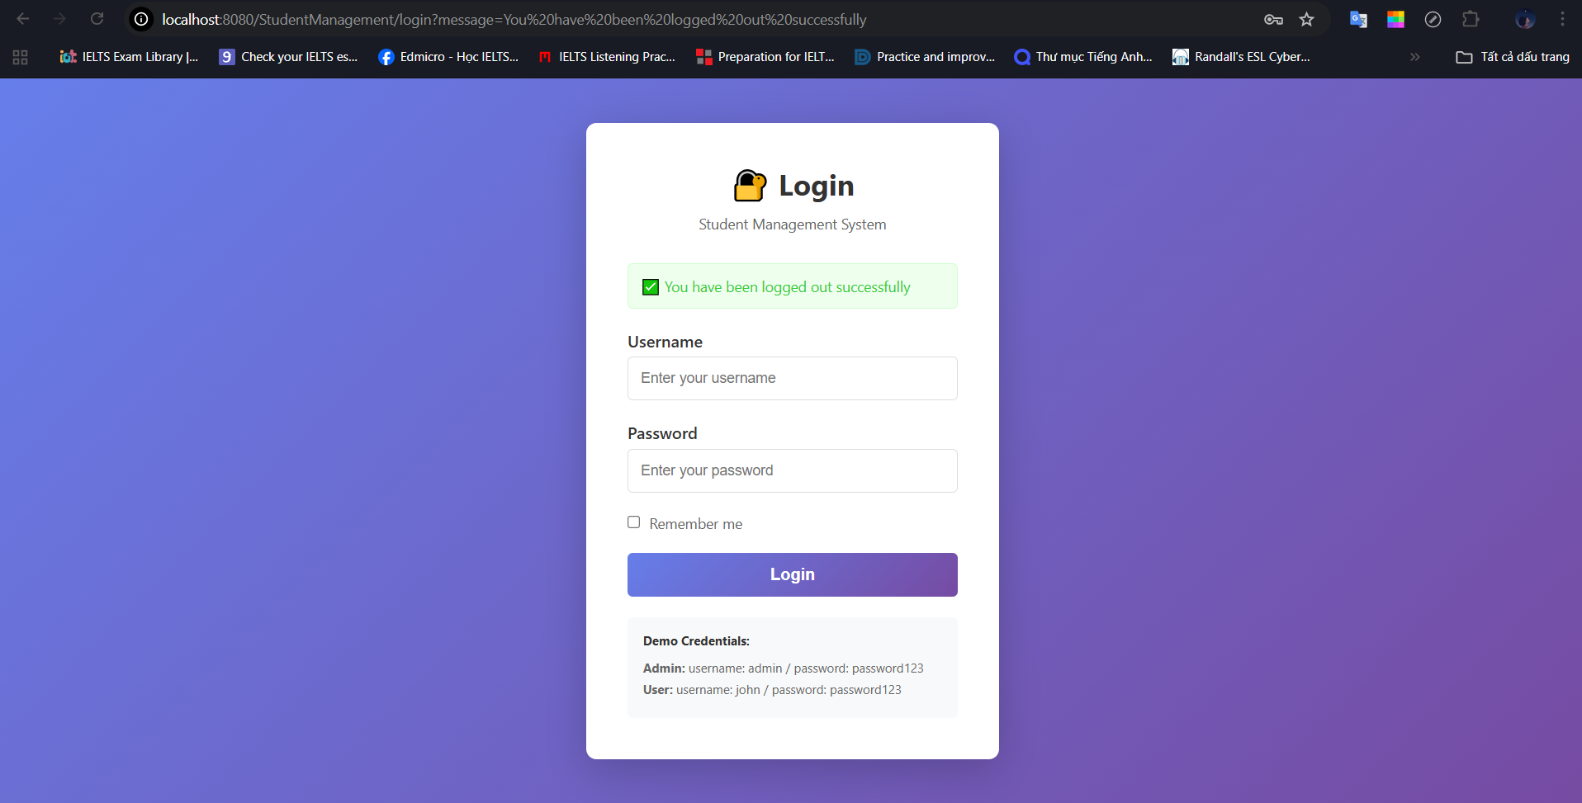

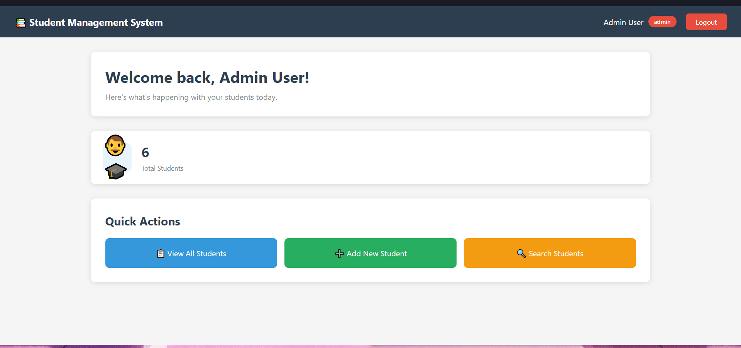
Step: Login with admin / password123
Result: Creates session -> Redirected to dashboard

Code Explanation
- login.jsp: The form submits data via POST to the login servlet.
<form action="${pageContext.request.contextPath}/login" method="post">
- LoginController.java (doPost):
  - Authentication: Calls userDAO.authenticate("admin", "password123").
  - Session Creation: If valid, creates a new session and stores user details.
HttpSession session = request.getSession(true);
session.setAttribute("user", user);
session.setAttribute("role", user.getRole()); // role = "admin"
- Redirect: Redirects to the dashboard.
response.sendRedirect("dashboard");

3. View Students (Admin)

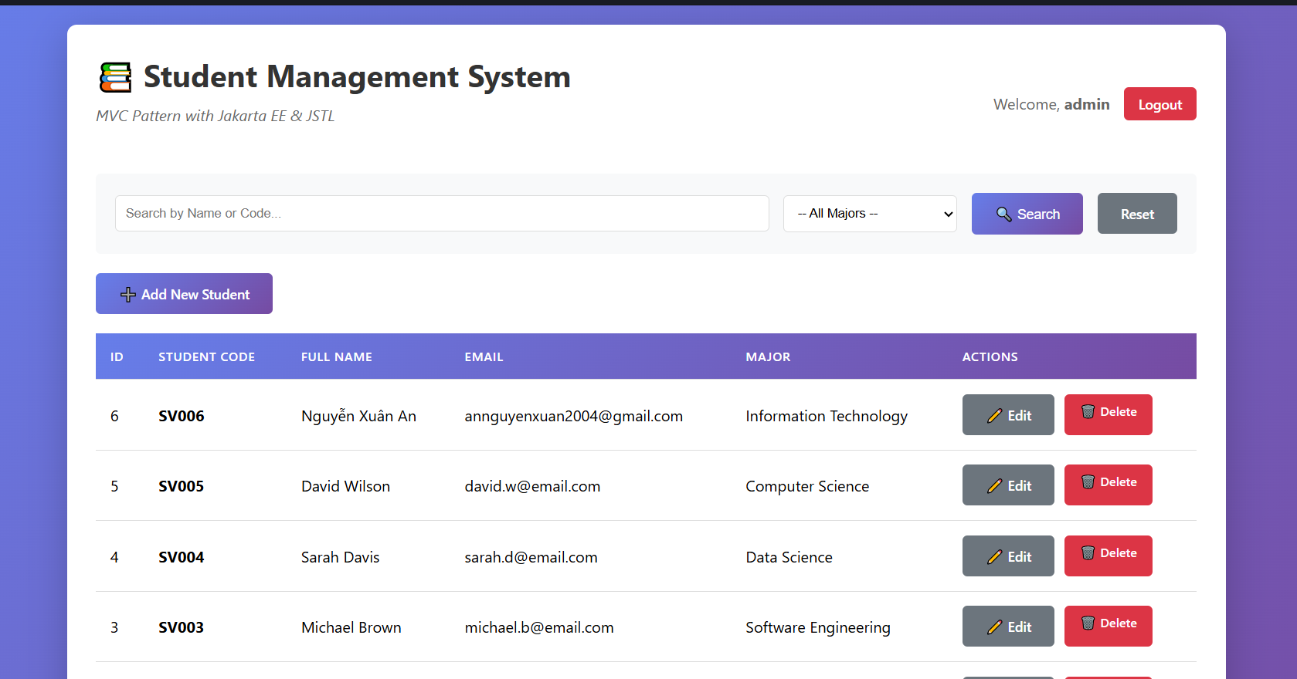
Step: Click "View All Students"
Result: Shows student list -> Edit/Delete buttons visible (admin)

Code Explanation
- student-list.jsp (or similar view): Uses JSTL to check the user's role stored in the session.
- Since sessionScope.role is "admin", the Edit/Delete buttons are rendered.
<c:if test="${sessionScope.role == 'admin'}">
<a href="student?action=edit&id=...">Edit</a>
<a href="student?action=delete&id=...">Delete</a>
</c:if>

4. Logout
Step: Logout
Result: Session invalidated -> Redirected to login

Code Explanation
- LogoutController.java:
  - Invalidate: Destroys the current session.
session.invalidate();
- Redirect: Redirects back to login with a success message.
response.sendRedirect("login?message=Logged out successfully");
- login.jsp: Displays the success message from the URL parameter.
<c:if test="${not empty param.message}">
<div class="alert alert-success">✅ ${param.message}</div>
</c:if>

5. User Login

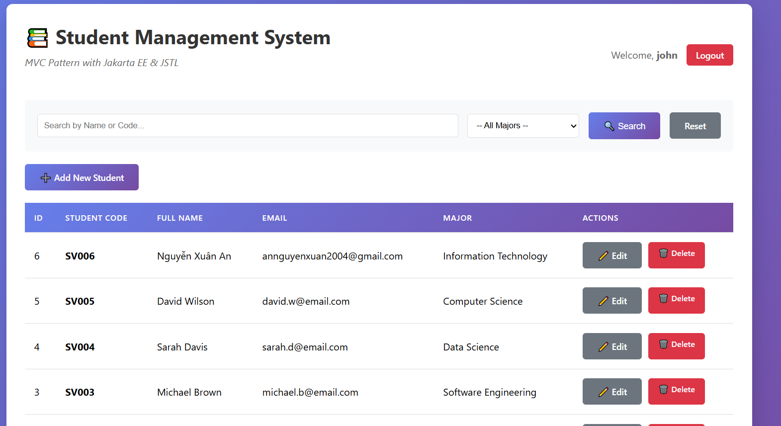
Step: Login with john / password123
Result: Regular user view -> No Edit/Delete buttons

Code Explanation
- LoginController.java: Authenticates "john" and sets sessionScope.role to "user".
- View: The same JSTL check <c:if test="${sessionScope.role == 'admin'}"> now evaluates to false, so the Edit/Delete buttons are not rendered, preventing unauthorized actions in the UI.

6. Access Restricted Resource

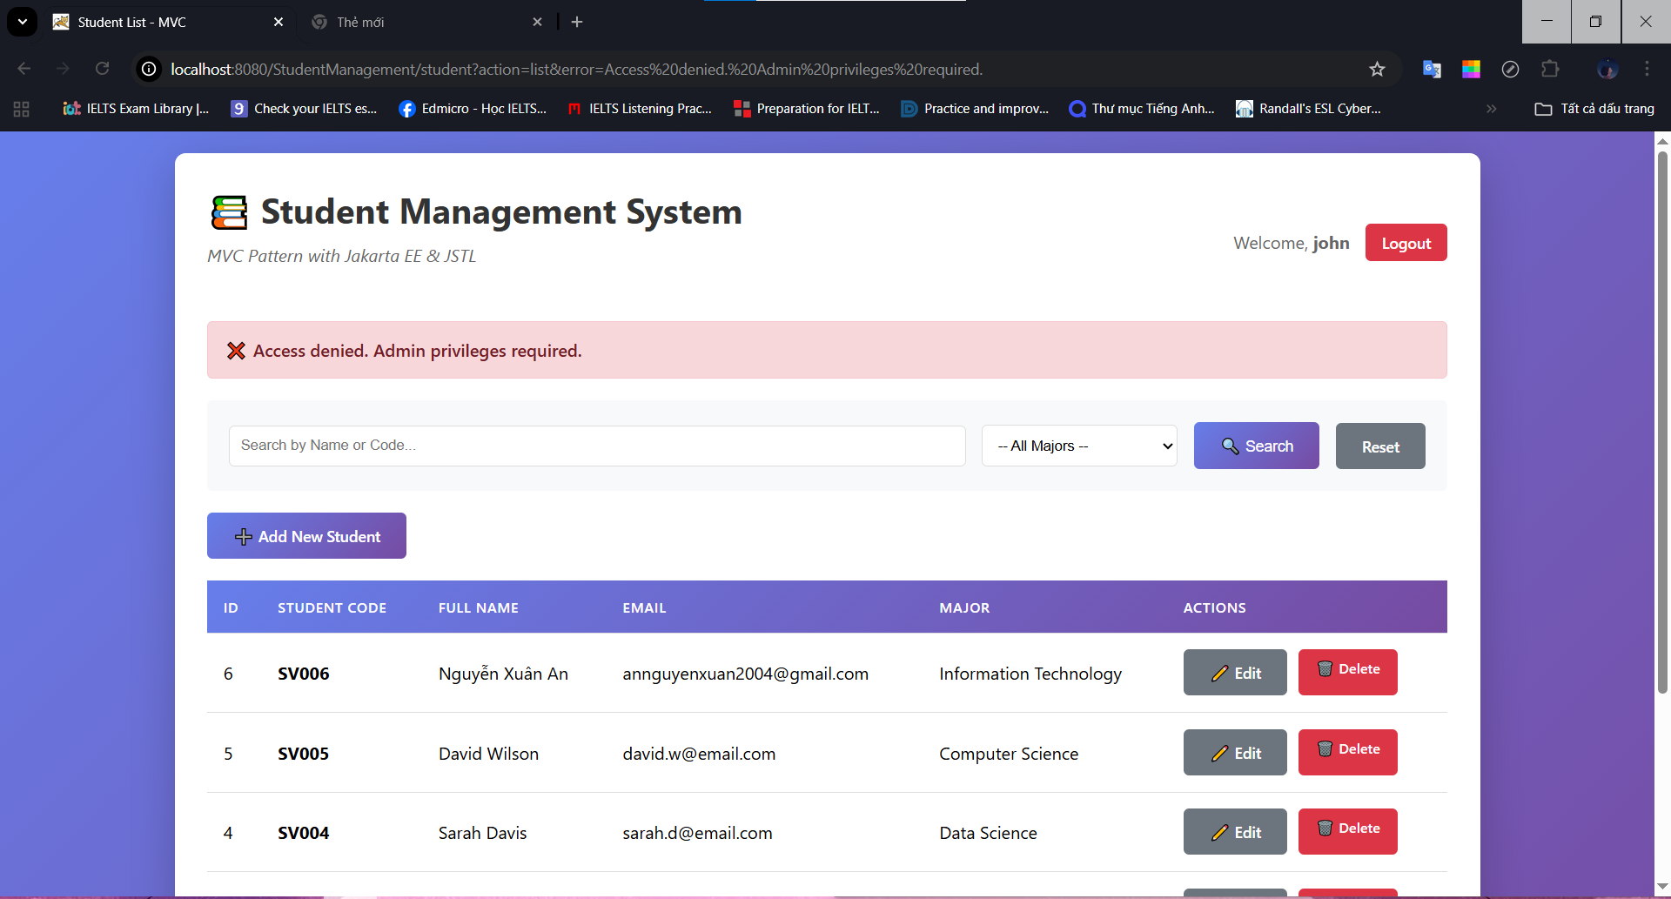
Step: Try to access /student?action=new
Result: AdminFilter blocks access -> Error message displayed

Code Explanation
- AdminFilter.java: Intercepts requests to administrative actions (like action=new, action=delete).
- It checks the user's role:
User user = (User) session.getAttribute("user");
if (user == null || !user.isAdmin()) {
// Block access
}
- Blocking: If the user is not an admin (like "john"), the filter blocks the request and displays an error page or redirects with an error message.

