State
通过3个方法来赋值
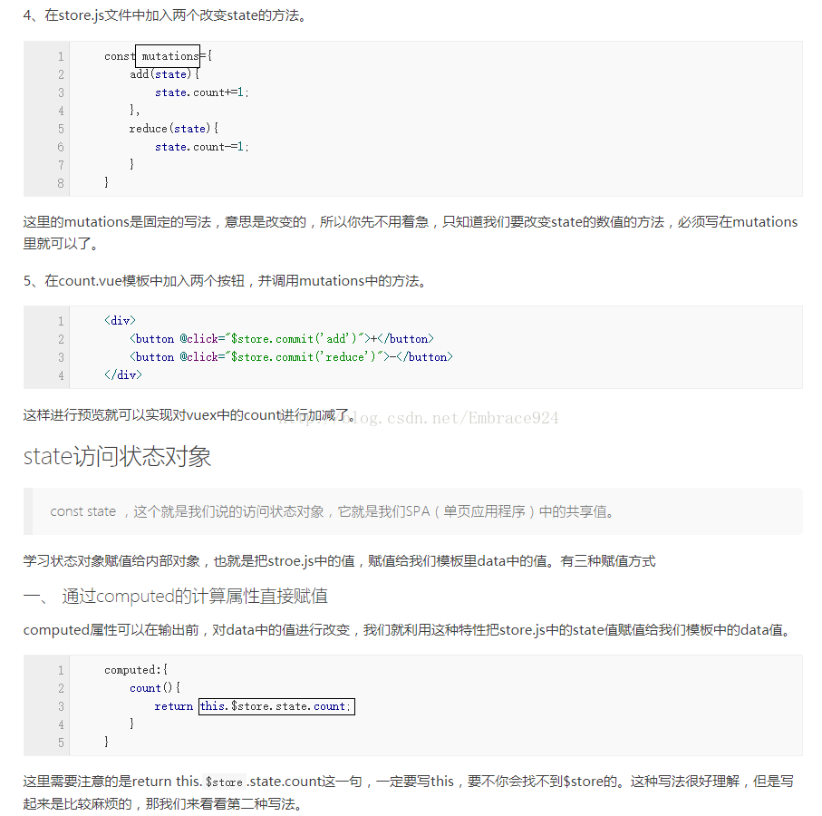

Mutations
- 改变state的值
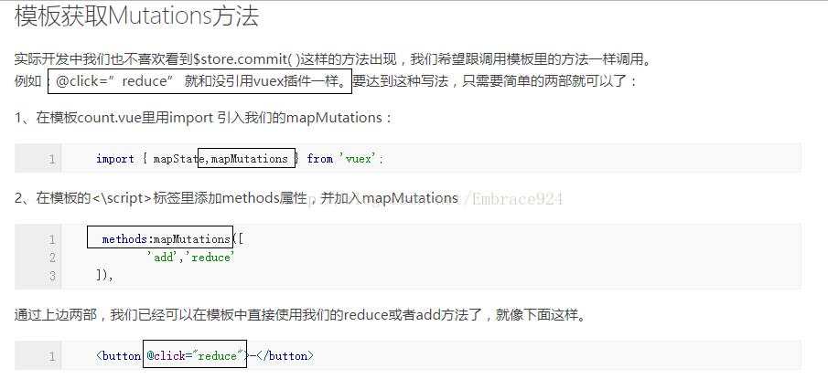

getters计算过滤操作
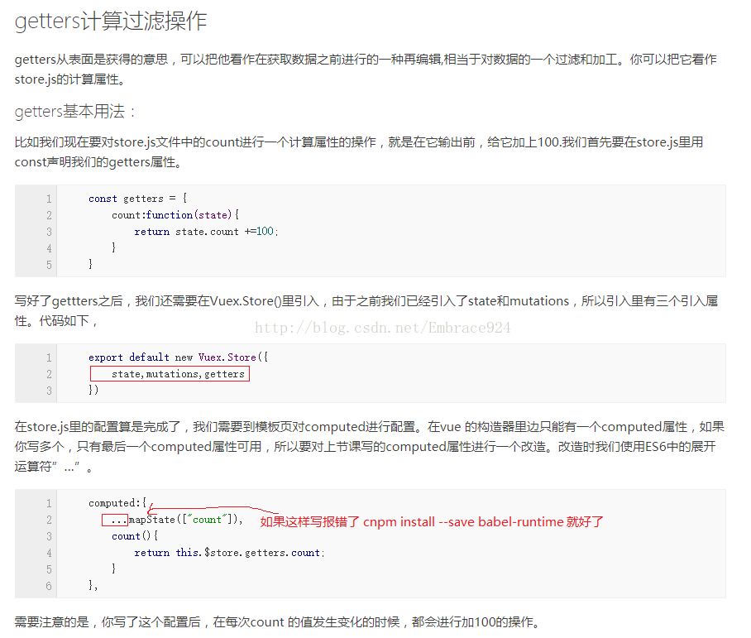

4.actions异步修改状态
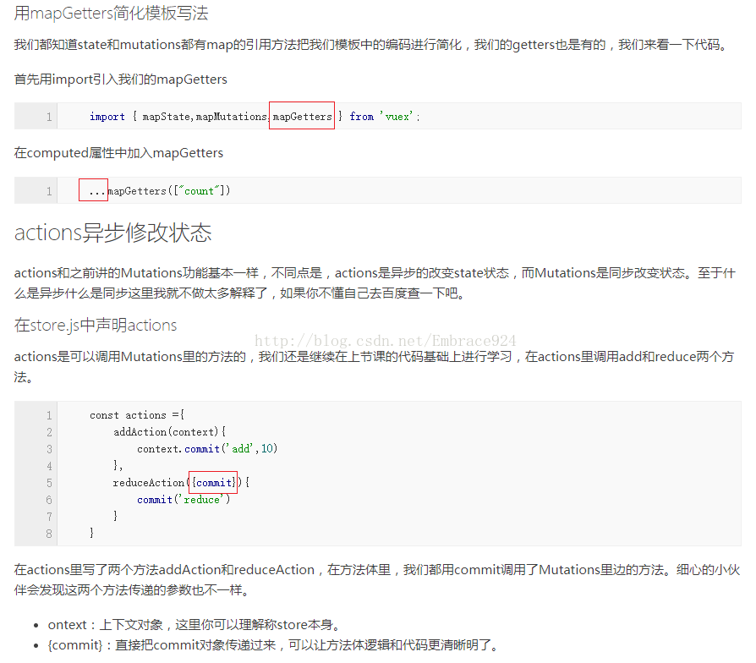

5.选择框
<el-col :xs="12" :sm="8" :lg="6" class="card-panel-col20">
<div class="a-col-title">项目类型：</div>
<div class="lucencyInput">
<el-select size="medium" style="width: 80%;" v-model="projectSelect.val" filterable
placeholder="请选择项目类型" default-first-option>
<el-option v-for="item in projectSelectData" :key="item.val" :label="item.name"
:value="item.val"></el-option>
</el-select>
</div>
</el-col>

