using maximum likelihood assuming that the data are drawn independently from the model. The solution is obtained by fitting the model for each class separately using the correspondingly labelled data. As an example, suppose that the probability density within each class is chosen to be Gaussian. In this case, the naive Bayes assumption then implies that the covariance matrix for each Gaussian is diagonal, and the contours of constant density within each class will be axis-aligned ellipsoids. The marginal density, however, is given by a superposition of diagonal Gaussians (with weighting coefficients given by the class priors) and so will no longer factorize with respect to its components.
The naive Bayes assumption is helpful when the dimensionality D of the input space is high, making density estimation in the full D-dimensional space more challenging. It is also useful if the input vector contains both discrete and continuous variables, since each can be represented separately using appropriate models (e.g., Bernoulli distributions for binary observations or Gaussians for real-valued variables). The conditional independence assumption of this model is clearly a strong one that may lead to rather poor representations of the class-conditional densities. Nevertheless, even if this assumption is not precisely satisfied, the model may still give good classification performance in practice because the decision boundaries can be insensitive to some of the details in the class-conditional densities, as illustrated in Figure 1.27.
We have seen that a particular directed graph represents a specific decomposition of a joint probability distribution into a product of conditional probabilities. The graph also expresses a set of conditional independence statements obtained through the d-separation criterion, and the d-separation theorem is really an expression of the equivalence of these two properties. In order to make this clear, it is helpful to think of a directed graph as a filter. Suppose we consider a particular joint probability distribution $p(x)$ over the variables x corresponding to the (nonobserved) nodes of the graph. The filter will allow this distribution to pass through if, and only if, it can be expressed in terms of the factorization (8.5) implied by the graph. If we present to the filter the set of all possible distributions $p(x)$ over the set of variables x, then the subset of distributions that are passed by the filter will be denoted $DF$ , for directed factorization. This is illustrated in Figure 8.25. Alternatively, we can use the graph as a different kind of filter by first listing all of the conditional independence properties obtained by applying the d-separation criterion to the graph, and then allowing a distribution to pass only if it satisfies all of these properties. If we present all possible distributions $p(x)$ to this second kind of filter, then the d-separation theorem tells us that the set of distributions that will be allowed through is precisely the set $DF$
It should be emphasized that the conditional independence properties obtained from d-separation apply to any probabilistic model described by that particular directed graph. This will be true, for instance, whether the variables are discrete or continuous or a combination of these. Again, we see that a particular graph is describing a whole family of probability distributions.
At one extreme we have a fully connected graph that exhibits no conditional independence properties at all, and which can represent any possible joint probability distribution over the given variables. The set $DF$ will contain all possible distributions $p(x)$ . At the other extreme, we have the fully disconnected graph, i.e., one having no links at all. This corresponds to joint distributions which factorize into the product of the marginal distributions over the variables comprising the nodes of the graph.
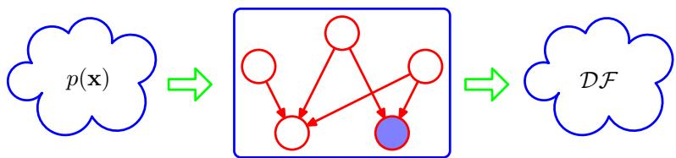
Figure 8.25 We can view a graphical model (in this case a directed graph) as a filter in which a probability distribution $p(x)$ is allowed through the filter if, and only if, it satisfies the directed factorization property (8.5). The set of all possible probability distributions $p(x)$ that pass through the filter is denoted . We can alternatively use the graph to filter distributions according to whether they respect all of the conditional independencies implied by the d-separation properties of the graph. The d-separation theorem says that it is the same set of distributions $DF$ that will be allowed through this second kind of filter.
Note that for any given graph, the set of distributions $DF$ will include any distributions that have additional independence properties beyond those described by the graph. For instance, a fully factorized distribution will always be passed through the filter implied by any graph over the corresponding set of variables.
We end our discussion of conditional independence properties by exploring the concept of a Markov blanket or Markov boundary. Consider a joint distribution $p(x_{1},…,x_{D})$ represented by a directed graph having D nodes, and consider the conditional distribution of a particular node with variables $x_{i}$ conditioned on all of the remaining variables $x_{j≠i}$ . Using the factorization property (8.5), we can express this conditional distribution in the form
p(xi|x{j≠i})=p(x1,…,xD)∫p(x1,…,xD)dxi=k​p(xk|pak)∫k​p(xk|pak)dxi
in which the integral is replaced by a summation in the case of discrete variables. We now observe that any factor $p(x_{k}|{pa}_{k})$ that does not have any functional dependence on $x_{i}$ can be taken outside the integral over $x_{i}.$ , and will therefore cancel between numerator and denominator. The only factors that remain will be the conditional distribution $p(x_{i}|{pa}_{i})$ for node $x_{i}$ itself, together with the conditional distributions for any nodes $x_{k}$ such that node $x_{i}$ is in the conditioning set of $p(x_{k}|{pa}_{k})$ , in other words for which $x_{i}$ is a parent of $x_{k}$ . The conditional $p(x_{i}|{pa}_{i})$ will depend on the parents of node $x_{i}.$ , whereas the conditionals $p(x_{k}|{pa}_{k})$ will depend on the children
Figure 8.26
The Markov blanket of a node $x_{i}$ comprises the set of parents, children and co-parents of the node. It has the property that the conditional distribution of $x_{i},$ , conditioned on all the remaining variables in the graph, is dependent only on the variables in the Markov blanket.
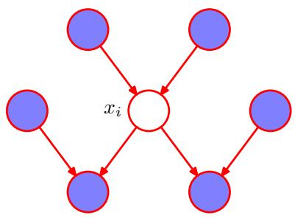
of $x_{i}$ as well as on the co-parents, in other words variables corresponding to parents of node $x_{k}$ other than node $x_{i}$ . The set of nodes comprising the parents, the children and the co-parents is called the Markov blanket and is illustrated in Figure 8.26. We can think of the Markov blanket of a node $x_{i}$ as being the minimal set of nodes that isolates $x_{i}$ from the rest of the graph. Note that it is not sufficient to include only the parents and children of node $x_{i}$ because the phenomenon of explaining away means that observations of the child nodes will not block paths to the co-parents. We must therefore observe the co-parent nodes also.

8.3. Markov Random Fields
We have seen that directed graphical models specify a factorization of the joint distribution over a set of variables into a product of local conditional distributions. They also define a set of conditional independence properties that must be satisfied by any distribution that factorizes according to the graph. We turn now to the second major class of graphical models that are described by undirected graphs and that again specify both a factorization and a set of conditional independence relations.
A Markov random field, also known as a Markov network or an undirected graphical model (Kindermann and Snell, 1980), has a set of nodes each of which corresponds to a variable or group of variables, as well as a set of links each of which connects a pair of nodes. The links are undirected, that is they do not carry arrows. In the case of undirected graphs, it is convenient to begin with a discussion of conditional independence properties.

8.3.1 Conditional independence properties
In the case of directed graphs, we saw that it was possible to test whether a particular conditional independence property holds by applying a graphical test called d-separation. This involved testing whether or not the paths connecting two sets of nodes were ‘blocked’. The definition of blocked, however, was somewhat subtle due to the presence of paths having head-to-head nodes. We might ask whether it is possible to define an alternative graphical semantics for probability distributions such that conditional independence is determined by simple graph separation. This is indeed the case and corresponds to undirected graphical models. By removing the
An example of an undirected graph in which every path from any node in set A to any node in set B passes through at least one node in set C. Consequently the conditional independence property A B C holds for any probability distribution described by this graph.
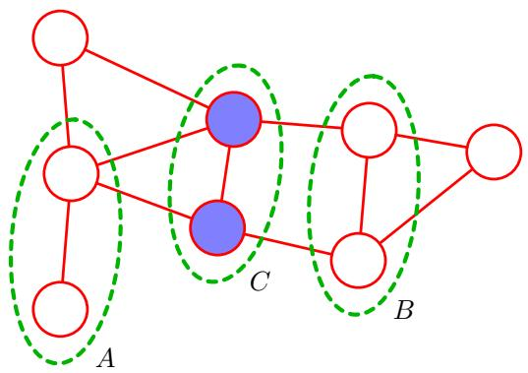
directionality from the links of the graph, the asymmetry between parent and child nodes is removed, and so the subtleties associated with head-to-head nodes no longer arise.
Suppose that in an undirected graph we identify three sets of nodes, denoted A, $B,$ and $C,$ , and that we consider the conditional independence property
$$A⟂⟂B∣C.$$
To test whether this property is satisfied by a probability distribution defined by a graph we consider all possible paths that connect nodes in set A to nodes in set B. If all such paths pass through one or more nodes in set C, then all such paths are ‘blocked’ and so the conditional independence property holds. However, if there is at least one such path that is not blocked, then the property does not necessarily hold, or more precisely there will exist at least some distributions corresponding to the graph that do not satisfy this conditional independence relation. This is illustrated with an example in Figure 8.27. Note that this is exactly the same as the d-separation criterion except that there is no ‘explaining away’ phenomenon. Testing for conditional independence in undirected graphs is therefore simpler than in directed graphs.
An alternative way to view the conditional independence test is to imagine removing all nodes in set C from the graph together with any links that connect to those nodes. We then ask if there exists a path that connects any node in A to any node in B. If there are no such paths, then the conditional independence property must hold.
The Markov blanket for an undirected graph takes a particularly simple form, because a node will be conditionally independent of all other nodes conditioned only on the neighbouring nodes, as illustrated in Figure 8.28.

8.3.2 Factorization properties
We now seek a factorization rule for undirected graphs that will correspond to the above conditional independence test. Again, this will involve expressing the joint distribution $p(x)$ as a product of functions defined over sets of variables that are local to the graph. We therefore need to decide what is the appropriate notion of locality in this case.
Figure 8.28 For an undirected graph, the Markov blanket of a node $x_{i}$ consists of the set of neighbouring nodes. It has the property that the conditional distribution of $x_{i},$ , conditioned on all the remaining variables in the graph, is dependent only on the variables in the Markov blanket.
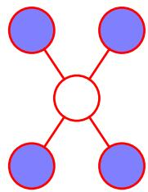
If we consider two nodes $x_{i}$ and $x_{j}$ that are not connected by a link, then these variables must be conditionally independent given all other nodes in the graph. This follows from the fact that there is no direct path between the two nodes, and all other paths pass through nodes that are observed, and hence those paths are blocked. This conditional independence property can be expressed as
$$p(x_{i},x_{j}|x_{∖\{i,j\}})=p(x_{i}|x_{∖\{i,j\}})p(x_{j}|x_{∖\{i,j\}})$$
where $ _ i , j } $ denotes the set x of all variables with $x_{i}$ and $x_{j}$ removed. The factorization of the joint distribution must therefore be such that $x_{i}$ and $x_{j}$ do not appear in the same factor in order for the conditional independence property to hold for all possible distributions belonging to the graph.
This leads us to consider a graphical concept called a clique, which is defined as a subset of the nodes in a graph such that there exists a link between all pairs of nodes in the subset. In other words, the set of nodes in a clique is fully connected. Furthermore, a maximal clique is a clique such that it is not possible to include any other nodes from the graph in the set without it ceasing to be a clique. These concepts are illustrated by the undirected graph over four variables shown in Figure 8.29. This graph has five cliques of two nodes given by $\{x_{1},x_{2}\},\{x_{2},x_{3}\},\{x_{3},x_{4}\},\{x_{4},x_{2}\}$ and $\{x_{1},x_{3}\}$ , as well as two maximal cliques given by $\{x_{1},x_{2},x_{3}\}$ and $\{x_{2},x_{3},x_{4}\}$ The set $\{x_{1},x_{2},x_{3},x_{4}\}$ is not a clique because of the missing link from $x_{1} to x_{4}$
We can therefore define the factors in the decomposition of the joint distribution to be functions of the variables in the cliques. In fact, we can consider functions of the maximal cliques, without loss of generality, because other cliques must be subsets of maximal cliques. Thus, if $\{x_{1},x_{2},x_{3}\}$ is a maximal clique and we define an arbitrary function over this clique, then including another factor defined over a subset of these variables would be redundant.
Let us denote a clique by $C$ and the set of variables in that clique by $x_{C}$ . Then
Figure 8.29
A four-node undirected graph showing a clique (outlined in green) and a maximal clique (outlined in blue).
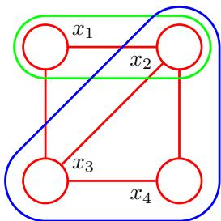
the joint distribution is written as a product of potential functions $ψ_{C}(x_{C})$ over the maximal cliques of the graph
p(x)=1ZC​ψC(xC).
Here the quantity $Z,$ sometimes called the partitionfunction, is a normalization constant and is given by
Z=x​C​ψC(xC)
which ensures that the distribution $p(x)$ given by (8.39) is correctly normalized. By considering only potential functions which satisfy $ψ_{C}(x_{C})≥0$ we ensure that $p(x)≥0$ . In (8.40) we have assumed that x comprises discrete variables, but the framework is equally applicable to continuous variables, or a combination of the two, in which the summation is replaced by the appropriate combination of summation and integration.
Note that we do not restrict the choice of potential functions to those that have a specific probabilistic interpretation as marginal or conditional distributions. This is in contrast to directed graphs in which each factor represents the conditional distribution of the corresponding variable, conditioned on the state of its parents. However, in special cases, for instance where the undirected graph is constructed by starting with a directed graph, the potential functions may indeed have such an interpretation, as we shall see shortly.
One consequence of the generality of the potential functions $ψ_{C}(x_{C})$ is that their product will in general not be correctly normalized. We therefore have to introduce an explicit normalization factor given by (8.40). Recall that for directed graphs, the joint distribution was automatically normalized as a consequence of the normalization of each of the conditional distributions in the factorization.
The presence of this normalization constant is one of the major limitations of undirected graphs. If we have a model with M discrete nodes each having K states, then the evaluation of the normalization term involves summing over $K^{M}$ states and so (in the worst case) is exponential in the size of the model. The partition function is needed for parameter learning because it will be a function of any parameters that govern the potential functions $ψ_{C}(x_{C})$ . However, for evaluation of local conditional distributions, the partition function is not needed because a conditional is the ratio of two marginals, and the partition function cancels between numerator and denominator when evaluating this ratio. Similarly, for evaluating local marginal probabilities we can work with the unnormalized joint distribution and then normalize the marginals explicitly at the end. Provided the marginals only involves a small number of variables, the evaluation of their normalization coefficient will be feasible.
So far, we have discussed the notion of conditional independence based on simple graph separation and we have proposed a factorization of the joint distribution that is intended to correspond to this conditional independence structure. However, we have not made any formal connection between conditional independence and factorization for undirected graphs. To do so we need to restrict attention to potential functions $ψ_{C}(x_{C})$ that are strictly positive (i.e., never zero or negative for any choice of $x_{C})$ . Given this restriction, we can make a precise relationship between factorization and conditional independence.
To do this we again return to the concept of a graphical model as a filter, corresponding to Figure 8.25. Consider the set of all possible distributions defined over a fixed set of variables corresponding to the nodes of a particular undirected graph. We can define to be the set of such distributions that are consistent with the set of conditional independence statements that can be read from the graph using graph separation. Similarly, we can define $UF$ to be the set of such distributions that can be expressed as a factorization of the form (8.39) with respect to the maximal cliques of the graph. The Hammersley-Clifford theorem (Clifford, 1990) states that the sets and $UF$ are identical.
Because we are restricted to potential functions which are strictly positive it is convenient to express them as exponentials, so that
$$ψ_{C}(x_{C})=exp\left\{−E(x_{C})\right\}$$
where $E(x_{C})$ is called an energy function, and the exponential representation is called the Boltzmann distribution. The joint distribution is defined as the product of potentials, and so the total energy is obtained by adding the energies of each of the maximal cliques.
In contrast to the factors in the joint distribution for a directed graph, the potentials in an undirected graph do not have a specific probabilistic interpretation. Although this gives greater flexibility in choosing the potential functions, because there is no normalization constraint, it does raise the question of how to motivate a choice of potential function for a particular application. This can be done by viewing the potential function as expressing which configurations of the local variables are preferred to others. Global configurations that have a relatively high probability are those that find a good balance in satisfying the (possibly conflicting) influences of the clique potentials. We turn now to a specific example to illustrate the use of undirected graphs.

8.3.3 Illustration: Image de-noising
We can illustrate the application of undirected graphs using an example of noise removal from a binary image (Besag, 1974; Geman and Geman, 1984; Besag, 1986). Although a very simple example, this is typical of more sophisticated applications. Let the observed noisy image be described by an array of binary pixel values $y_{i}∈$ $\{−1,+1\}$ , where the index $i=1,…,D$ runs over all pixels. We shall suppose that the image is obtained by taking an unknown noise-free image, described by binary pixel values $x_{i}∈\{−1,+1\}$ and randomly flipping the sign of pixels with some small probability. An example binary image, together with a noise corrupted image obtained by flipping the sign of the pixels with probability 10%, is shown in Figure 8.30. Given the noisy image, our goal is to recover the original noise-free image.
Because the noise level is small, we know that there will be a strong correlation between $x_{i}$ and $y_{i}$ . We also know that neighbouring pixels $x_{i}$ and $x_{j}$ in an image are strongly correlated. This prior knowledge can be captured using the Markov random field model whose undirected graph is shown in Figure 8.31. This graph has two types of cliques, each of which contains two variables. The cliques of the form $\{x_{i},y_{i}\}$ have an associated energy function that expresses the correlation between these variables. We choose a very simple energy function for these cliques of the form $−ηx_{i}y_{i}$ where $η$ is a positive constant. This has the desired effect of giving a lower energy (thus encouraging a higher probability) when $x_{i}$ and $y_{i}$ have the same sign and a higher energy when they have the opposite sign.
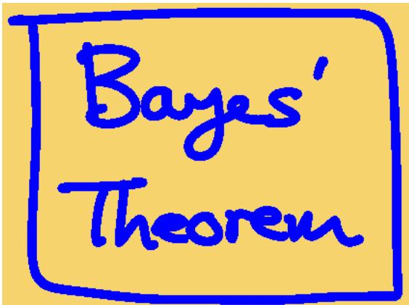
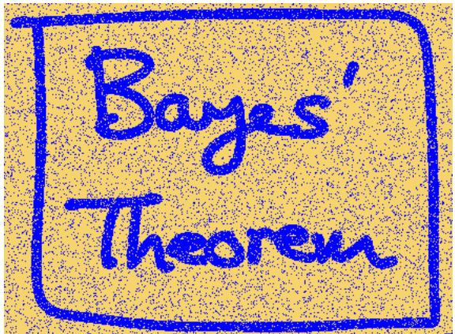
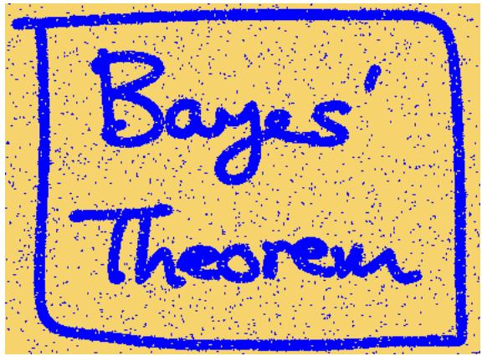
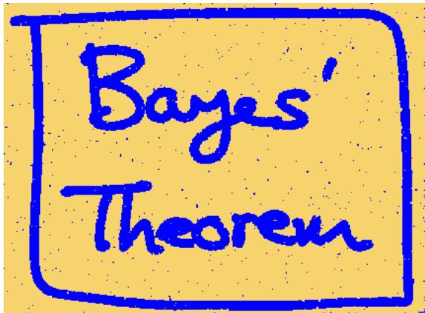
Figure 8.30 Illustration of image de-noising using a Markov random field. The top row shows the original binary image on the left and the corrupted image after randomly changing 10% of the pixels on the right. The bottom row shows the restored images obtained using iterated conditional models (ICM) on the left and using the graph-cut algorithm on the right. ICM produces an image where 96% of the pixels agree with the original image, whereas the corresponding number for graph-cut is 99%.
The remaining cliques comprise pairs of variables $\{x_{i},x_{j}\}$ where $i$ and $j$ are indices of neighbouring pixels. Again, we want the energy to be lower when the pixels have the same sign than when they have the opposite sign, and so we choose an energy given by $−βx_{i}x_{j}$ where $β$ is a positive constant.
Because a potential function is an arbitrary, nonnegative function over a maximal clique, we can multiply it by any nonnegative functions of subsets of the clique, or
An undirected graphical model representing a Markov random field for image de-noising, in which $x_{i}$ is a binary variable denoting the state of pixel i in the unknown noise-free image, and $y_{i}$ denotes the corresponding value of pixel i in the observed noisy image.
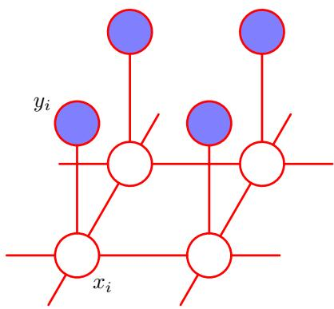
equivalently we can add the corresponding energies. In this example, this allows us to add an extra term $hx_{i}$ for each pixel i in the noise-free image. Such a term has the effect of biasing the model towards pixel values that have one particular sign in preference to the other.
The complete energy function for the model then takes the form
E(x,y)=hi​xi−β{i,j}​xixj−ηi​xiyi
which defines a joint distribution over x and y given by
$$p(x,y)=\frac{1}{Z}exp\{−E(x,y)\}.$$
We now fix the elements of $y$ to the observed values given by the pixels of the noisy image, which implicitly defines a conditional distribution $p(x|y)$ over noisefree images. This is an example of the Ising model, which has been widely studied in statistical physics. For the purposes of image restoration, we wish to find an image x having a high probability (ideally the maximum probability). To do this we shall use a simple iterative technique called iterated conditional modes, or ICM (Kittler and Foglein, 1984), which is simply an application of coordinate-wise gradient ascent.¨ The idea is first to initialize the variables $\{x_{i}\}$ , which we do by simply setting $x_{i}=$ $y_{i}$ for all i. Then we take one node $x_{j}$ at a time and we evaluate the total energy for the two possible states $x_{j}=+1$ and $x_{j}=−1$ , keeping all other node variables fixed, and set $x_{j}$ to whichever state has the lower energy. This will either leave the probability unchanged, if $x_{j}$ is unchanged, or will increase it. Because only one variable is changed, this is a simple local computation that can be performed efficiently. We then repeat the update for another site, and so on, until some suitable stopping criterion is satisfied. The nodes may be updated in a systematic way, for instance by repeatedly raster scanning through the image, or by choosing nodes at random.
If we have a sequence of updates in which every site is visited at least once, and in which no changes to the variables are made, then by definition the algorithm
Figure 8.32 graph. (b) graph.
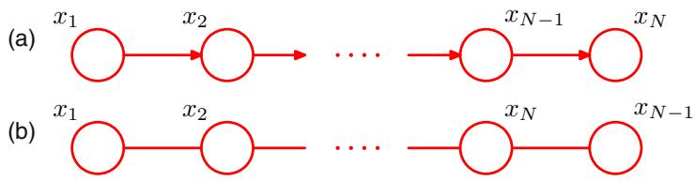
will have converged to a local maximum of the probability. This need not, however, correspond to the global maximum.
For the purposes of this simple illustration, we have fixed the parameters to be $β=1.0,η=2.1$ and $h=0$ . Note that leaving $h=0$ simply means that the prior probabilities of the two states of $x_{i}$ are equal. Starting with the observed noisy image as the initial configuration, we run ICM until convergence, leading to the de-noised image shown in the lower left panel of Figure 8.30. Note that if we set $β=0$ which effectively removes the links between neighbouring pixels, then the global most probable solution is given by $x_{i}=y_{i}$ for all i, corresponding to the observed noisy image.
Later we shall discuss a more effective algorithm for finding high probability solutions called the max-product algorithm, which typically leads to better solutions, although this is still not guaranteed to find the global maximum of the posterior distribution. However, for certain classes of model, including the one given by (8.42), there exist efficient algorithms based on graph cuts that are guaranteed to find the global maximum (Greig et al., 1989; Boykov et al., 2001; Kolmogorov and Zabih, 2004). The lower right panel of Figure 8.30 shows the result of applying a graph-cut algorithm to the de-noising problem.

8.3.4 Relation to directed graphs
We have introduced two graphical frameworks for representing probability distributions, corresponding to directed and undirected graphs, and it is instructive to discuss the relation between these. Consider first the problem of taking a model that is specified using a directed graph and trying to convert it to an undirected graph. In some cases this is straightforward, as in the simple example in Figure 8.32. Here the joint distribution for the directed graph is given as a product of conditionals in the form
$$p(x)=p(x_{1})p(x_{2}|x_{1})p(x_{3}|x_{2})…p(x_{N}|x_{N−1}).$$
Now let us convert this to an undirected graph representation, as shown in Figure 8.32. In the undirected graph, the maximal cliques are simply the pairs of neighbouring nodes, and so from (8.39) we wish to write the joint distribution in the form
$$p(x)=\frac{1}{Z}ψ_{1,2}(x_{1},x_{2})ψ_{2,3}(x_{2},x_{3})…ψ_{N−1,N}(x_{N−1},x_{N}).$$
Figure 8.33 Example of a simple directed graph (a) and the corresponding moral graph (b).
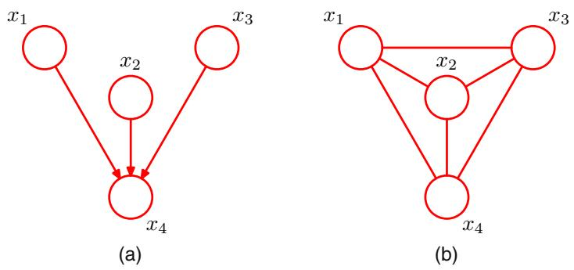
This is easily done by identifying
$$\begin{matrix}ψ_{1,2}(x_{1},x_{2}) & = & p(x_{1})p(x_{2}|x_{1}) \\ ψ_{2,3}(x_{2},x_{3}) & = & p(x_{3}|x_{2}) \\ & ⋮ \\ ψ_{N−1,N}(x_{N−1},x_{N}) & = & p(x_{N}|x_{N−1})\end{matrix}$$
where we have absorbed the marginal $p(x_{1})$ for the first node into the first potential function. Note that in this case, the partition function $Z=1$
Let us consider how to generalize this construction, so that we can convert any distribution specified by a factorization over a directed graph into one specified by a factorization over an undirected graph. This can be achieved if the clique potentials of the undirected graph are given by the conditional distributions of the directed graph. In order for this to be valid, we must ensure that the set of variables that appears in each of the conditional distributions is a member of at least one clique of the undirected graph. For nodes on the directed graph having just one parent, this is achieved simply by replacing the directed link with an undirected link. However, for nodes in the directed graph having more than one parent, this is not sufficient. These are nodes that have ‘head-to-head’ paths encountered in our discussion of conditional independence. Consider a simple directed graph over 4 nodes shown in Figure 8.33. The joint distribution for the directed graph takes the form
$$p(x)=p(x_{1})p(x_{2})p(x_{3})p(x_{4}|x_{1},x_{2},x_{3}).$$
We see that the factor $p(x_{4}|x_{1},x_{2},x_{3})$ involves the four variables $x_{1},x_{2},x_{3}$ , and $x_{4}.$ , and so these must all belong to a single clique if this conditional distribution is to be absorbed into a clique potential. To ensure this, we add extra links between all pairs of parents of the node $x_{4}$ . Anachronistically, this process of ‘marrying the parents’ has become known as moralization, and the resulting undirected graph, after dropping the arrows, is called the moral graph. It is important to observe that the moral graph in this example is fully connected and so exhibits no conditiona independence properties, in contrast to the original directed graph.
Thus in general to convert a directed graph into an undirected graph, we first add additional undirected links between all pairs of parents for each node in the graph and then drop the arrows on the original links to give the moral graph. Then we initialize all of the clique potentials of the moral graph to 1. We then take each conditional distribution factor in the original directed graph and multiply it into one of the clique potentials. There will always exist at least one maximal clique that contains all of the variables in the factor as a result of the moralization step. Note that in all cases the partition function is given by Z = 1.
The process of converting a directed graph into an undirected graph plays an important role in exact inference techniques such as the junction tree algorithm. Converting from an undirected to a directed representation is much less common and in general presents problems due to the normalization constraints.
We saw that in going from a directed to an undirected representation we had to discard some conditional independence properties from the graph. Of course, we could always trivially convert any distribution over a directed graph into one over an undirected graph by simply using a fully connected undirected graph. This would, however, discard all conditional independence properties and so would be vacuous. The process of moralization adds the fewest extra links and so retains the maximum number of independence properties.
We have seen that the procedure for determining the conditional independence properties is different between directed and undirected graphs. It turns out that the two types of graph can express different conditional independence properties, and it is worth exploring this issue in more detail. To do so, we return to the view of a specific (directed or undirected) graph as a filter, so that the set of all possible distributions over the given variables could be reduced to a subset that respects the conditional independencies implied by the graph. A graph is said to be a D map (for ‘dependency map’) of a distribution if every conditional independence statement satisfied by the distribution is reflected in the graph. Thus a completely disconnected graph (no links) will be a trivial D map for any distribution.
Alternatively, we can consider a specific distribution and ask which graphs have the appropriate conditional independence properties. If every conditional independence statement implied by a graph is satisfied by a specific distribution, then the graph is said to be an I map (for ‘independence map’) of that distribution. Clearly a fully connected graph will be a trivial I map for any distribution.
If it is the case that every conditional independence property of the distribution is reflected in the graph, and vice versa, then the graph is said to be a perfect map for
Venn diagram illustrating the set of all distributions P over a given set of variables, together with the set of distributions D that can be represented as a perfect map using a directed graph, and the set U that can be represented as a perfect map using an undirected graph.
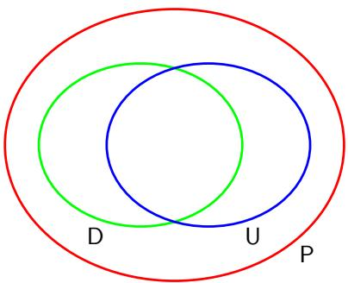
Figure 8.35 A directed graph whose conditional independence properties cannot be expressed using an undirected graph over the same three variables.
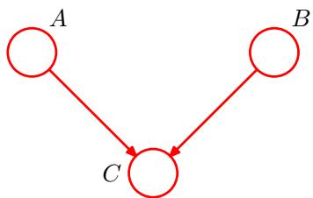
that distribution. A perfect map is therefore both an I map and a D map.
Consider the set of distributions such that for each distribution there exists a directed graph that is a perfect map. This set is distinct from the set of distributions such that for each distribution there exists an undirected graph that is a perfect map. In addition there are distributions for which neither directed nor undirected graphs offer a perfect map. This is illustrated as a Venn diagram in Figure 8.34.
Figure 8.35 shows an example of a directed graph that is a perfect map for a distribution satisfying the conditional independence properties $\hat{A}⟂⟂B∣∅$ and A B C. There is no corresponding undirected graph over the same three variables that is a perfect map.
Conversely, consider the undirected graph over four variables shown in Figure 8.36. This graph exhibits the properties $A↓χ B | ∅,C↓⊥ D | A∪B$ and $A⊥⊥B∣C∪D$ . There is no directed graph over four variables that implies the same set of conditional independence properties.
The graphical framework can be extended in a consistent way to graphs that include both directed and undirected links. These are called chain graphs (Lauritzen and Wermuth, 1989; Frydenberg, 1990), and contain the directed and undirected graphs considered so far as special cases. Although such graphs can represent a broader class of distributions than either directed or undirected alone, there remain distributions for which even a chain graph cannot provide a perfect map. Chain graphs are not discussed further in this book.
An undirected graph whose conditional independence properties cannot be expressed in terms of a directed graph over the same variables.
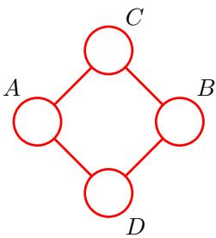

8.4. Inference in Graphical Models
We turn now to the problem of inference in graphical models, in which some of the nodes in a graph are clamped to observed values, and we wish to compute the posterior distributions of one or more subsets of other nodes. As we shall see, we can exploit the graphical structure both to find efficient algorithms for inference, and
Figure 8.37 A graphical representation of Bayes’ theorem. See the text for details.
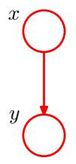
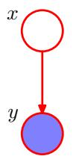
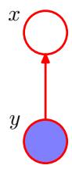
to make the structure of those algorithms transparent. Specifically, we shall see that many algorithms can be expressed in terms of the propagation of local messages around the graph. In this section, we shall focus primarily on techniques for exact inference, and in Chapter 10 we shall consider a number of approximate inference algorithms.
To start with, let us consider the graphical interpretation of Bayes’ theorem. Suppose we decompose the joint distribution $p(x,y)$ over two variables x and y into a product of factors in the form $p(x,y)=p(x)p(y|x)$ . This can be represented by the directed graph shown in Figure 8.37(a). Now suppose we observe the value of $y,$ as indicated by the shaded node in Figure 8.37(b). We can view the marginal distribution $p(x)$ as a prior over the latent variable x, and our goal is to infer the corresponding posterior distribution over x. Using the sum and product rules of probability we can evaluate
p(y)=x′​p(y|x′)p(x′)
which can then be used in Bayes’ theorem to calculate
$$p(x|y)=\frac{p(y|x)p(x)}{p(y)}.$$
Thus the joint distribution is now expressed in terms of $p(y)$ and $p(x|y)$ . From a graphical perspective, the joint distribution $p(x,y)$ is now represented by the graph shown in Figure 8.37(c), in which the direction of the arrow is reversed. This is the simplest example of an inference problem for a graphical model.

8.4.1 Inference on a chain
Now consider a more complex problem involving the chain of nodes of the form shown in Figure 8.32. This example will lay the foundation for a discussion of exact inference in more general graphs later in this section.
Specifically, we shall consider the undirected graph in Figure 8.32(b). We have already seen that the directed chain can be transformed into an equivalent undirected chain. Because the directed graph does not have any nodes with more than one parent, this does not require the addition of any extra links, and the directed and undirected versions of this graph express exactly the same set of conditional independence statements.
The joint distribution for this graph takes the form
$$p(x)=\frac{1}{Z}ψ_{1,2}(x_{1},x_{2})ψ_{2,3}(x_{2},x_{3})…ψ_{N−1,N}(x_{N−1},x_{N}).$$
We shall consider the specific case in which the N nodes represent discrete variables each having K states, in which case each potential function $ψ_{n−1,n}(x_{n−1},x_{n})$ comprises an $K×K$ table, and so the joint distribution has $(N−1)K^{2}$ parameters.
Let us consider the inference problem of finding the marginal distribution $p(x_{n})$ for a specific node $x_{n}$ that is part way along the chain. Note that, for the moment, there are no observed nodes. By definition, the required marginal is obtained by summing the joint distribution over all variables except $x_{n}$ , so that
p(xn)=x1​…xn−1​xn+1​…xN​p(x).
In a naive implementation, we would first evaluate the joint distribution and then perform the summations explicitly. The joint distribution can be represented as a set of numbers, one for each possible value for . Because there are N variables each with K states, there are $\dot{K^{N}}$ values for x and so evaluation and storage of the joint distribution, as well as marginalization to obtain $p(x_{n})$ , all involve storage and computation that scale exponentially with the length N of the chain.
We can, however, obtain a much more efficient algorithm by exploiting the conditional independence properties of the graphical model. If we substitute the factorized expression (8.49) for the joint distribution into (8.50), then we can rearrange the order of the summations and the multiplications to allow the required marginal to be evaluated much more efficiently. Consider for instance the summation over $x_{N}$ . The potential $ψ_{N−1,N}(x_{N−1},x_{N})$ is the only one that depends on $x_{N}$ , and so we can perform the summation
xN​ψN−1,N(xN−1,xN)
first to give a function of $x_{N−1}$ . We can then use this to perform the summation over $x_{N−1}$ , which will involve only this new function together with the potential $ψ_{N−2,N−1}(x_{N−2},x_{N−1})$ , because this is the only other place that $x_{N−1}$ appears. Similarly, the summation over $x_{1}$ involves only the potential $ψ_{1,2}(x_{1},x_{2})$ and so can be performed separately to give a function of $x_{2}$ , and so on. Because each summation effectively removes a variable from the distribution, this can be viewed as the removal of a node from the graph.
If we group the potentials and summations together in this way, we can express
the desired marginal in the form
p(xn)=1Zxn−1​ψn−1,n(xn−1,xn)⋯x2​ψ2,3(x2,x3)x1​ψ1,2(x1,x2)⋯⏟μα(xn)xn+1​ψn,n+1(xn,xn+1)⋯xN​ψN−1,N(xN−1,xN)⋯⏟μβ(xn).
The reader is encouraged to study this re-ordering carefully as the underlying idea forms the basis for the later discussion of the general sum-product algorithm. Here the key concept that we are exploiting is that multiplication is distributive over addition, so that
$$ab+ac=a(b+c)$$
in which the left-hand side involves three arithmetic operations whereas the righthand side reduces this to two operations.
Let us work out the computational cost of evaluating the required marginal using this re-ordered expression. We have to perform $N−1$ summations each of which is over $K$ states and each of which involves a function of two variables. For instance, the summation over $x_{1}$ involves only the function $ψ_{1,2}(x_{1},x_{2})$ , which is a table of $K×K$ numbers. We have to sum this table over $x_{1}$ for each value of $x_{2}$ and so this has $O(K^{2})$ cost. The resulting vector of K numbers is multiplied by the matrix of numbers $ψ_{2,3}(x_{2},x_{3})$ and so is again $O(K^{2})$ ). Because there are $N−1$ summations and multiplications of this kind, the total cost of evaluating the marginal $p(x_{n})$ is $O(NK^{2})$ . This is linear in the length of the chain, in contrast to the exponential cost of a naive approach. We have therefore been able to exploit the many conditional independence properties of this simple graph in order to obtain an efficient calculation. If the graph had been fully connected, there would have been no conditional independence properties, and we would have been forced to work directly with the full joint distribution.
We now give a powerful interpretation of this calculation in terms of the passing of local messages around on the graph. From (8.52) we see that the expression for the marginal $p(x_{n})$ decomposes into the product of two factors times the normalization constant
$$p(x_{n})=\frac{1}{Z}μ_{α}(x_{n})μ_{β}(x_{n}).$$
We shall interpret $μ_{α}(x_{n})$ as a message passed forwards along the chain from node $x_{n−1}$ to node $x_{n}$ . Similarly, $μ_{β}(x_{n})$ can be viewed as a message passed backwards along the chain to node $x_{n}$ from node $x_{n+1}$ . Note that each of the messages comprises a set of K values, one for each choice of $x_{n}$ , and so the product of two messages should be interpreted as the point-wise multiplication of the elements of the two messages to give another set of K values.
Figure 8.38 The marginal distribution $p(x_{n})$ for a node $x_{n}$ along the chain is obtained by multiplying the two messages $μ_{α}(x_{n})$ and $μ_{β}(x_{n})$ , and then normalizing. These messages can themselves be evaluated recursively by passing messages from both ends of the chain towards node $x_{n}$
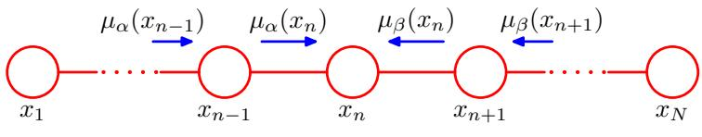
The message $μ_{α}(x_{n})$ can be evaluated recursively because
μα(xn)=xn−1​ψn−1,n(xn−1,xn)xn−2​…=xn−1​ψn−1,n(xn−1,xn)μα(xn−1).
We therefore first evaluate
μα(x2)=x1​ψ1,2(x1,x2)
and then apply (8.55) repeatedly until we reach the desired node. Note carefully the structure of the message passing equation. The outgoing message $μ_{α}(x_{n})$ in (8.55) is obtained by multiplying the incoming message $μ_{α}(x_{n−1})$ by the local potential involving the node variable and the outgoing variable and then summing over the node variable.
Similarly, the message $μ_{β}(x_{n})$ can be evaluated recursively by starting with node $x_{N}$ and using
μβ(xn)=xn+1​ψn+1,n(xn+1,xn)xn+2​…=xn+1​ψn+1,n(xn+1,xn)μβ(xn+1).
This recursive message passing is illustrated in Figure 8.38. The normalization constant $Z$ is easily evaluated by summing the right-hand side of (8.54) over all states of $x_{n}$ , an operation that requires only $O(K)$ computation.
Graphs of the form shown in Figure 8.38 are called Markov chains, and the corresponding message passing equations represent an example of the Chapman-Kolmogorov equations for Markov processes (Papoulis, 1984).
Now suppose we wish to evaluate the marginals $p(x_{n})$ for every node $n∈$ $\{1,…,N\}$ in the chain. Simply applying the above procedure separately for each node will have computational cost that is $O(N^{2}M^{2})$ . However, such an approach would be very wasteful of computation. For instance, to find $p(x_{1})$ we need to propagate a message $μ_{β}(⋅)$ from node $x_{N}$ back to node $x_{2}$ . Similarly, to evaluate $p(x_{2})$ we need to propagate a messages $μ_{β}(⋅)$ from node $x_{N}$ back to node $x_{3}$ . This will involve much duplicated computation because most of the messages will be identical in the two cases.
Suppose instead we first launch a message $μ_{β}(x_{N−1})$ starting from node $x_{N}$ and propagate corresponding messages all the way back to node $x_{1}$ , and suppose we similarly launch a message $μ_{α}(x_{2})$ starting from node $x_{1}$ and propagate the corresponding messages all the way forward to node $x_{N}$ . Provided we store all of the intermediate messages along the way, then any node can evaluate its marginal simply by applying (8.54). The computational cost is only twice that for finding the marginal of a single node, rather than N times as much. Observe that a message has passed once in each direction across each link in the graph. Note also that the normalization constant $Z$ need be evaluated only once, using any convenient node.
If some of the nodes in the graph are observed, then the corresponding variables are simply clamped to their observed values and there is no summation. To see this, note that the effect of clamping a variable $x_{n}$ to an observed value ${\hat{x}}_{n}$ can be expressed by multiplying the joint distribution by (one or more copies of) an additional function $I(x_{n},{\hat{x}}_{n})$ , which takes the value 1 when $x_{n}={\hat{x}}_{n}$ and the value 0 otherwise. One such function can then be absorbed into each of the potentials that contain $x_{n}$ . Summations over $x_{n}$ then contain only one term in which $x_{n}={\hat{x}}_{n}$
Now suppose we wish to calculate the joint distribution $p(x_{n−1},x_{n})$ for two neighbouring nodes on the chain. This is similar to the evaluation of the marginal for a single node, except that there are now two variables that are not summed out. A few moments thought will show that the required joint distribution can be written in the form
$$p(x_{n−1},x_{n})=\frac{1}{Z}μ_{α}(x_{n−1})ψ_{n−1,n}(x_{n−1},x_{n})μ_{β}(x_{n}).$$
Thus we can obtain the joint distributions over all of the sets of variables in each of the potentials directly once we have completed the message passing required to obtain the marginals.
This is a useful result because in practice we may wish to use parametric forms for the clique potentials, or equivalently for the conditional distributions if we started from a directed graph. In order to learn the parameters of these potentials in situations where not all of the variables are observed, we can employ the EM algorithm, and it turns out that the local joint distributions of the cliques, conditioned on any observed data, is precisely what is needed in the E step. We shall consider some examples of this in detail in Chapter 13.

8.4.2 Trees
We have seen that exact inference on a graph comprising a chain of nodes can be performed efficiently in time that is linear in the number of nodes, using an algorithm that can be interpreted in terms of messages passed along the chain. More generally, inference can be performed efficiently using local message passing on a broader class of graphs called trees. In particular, we shall shortly generalize the message passing formalism derived above for chains to give the sum-product algorithm, which provides an efficient framework for exact inference in tree-structured graphs.
Figure 8.39 Examples of treestructured graphs, showing (a) an undirected tree, (b) a directed tree, and (c) a directed polytree.
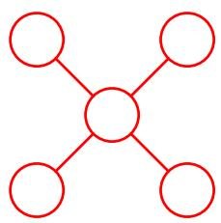
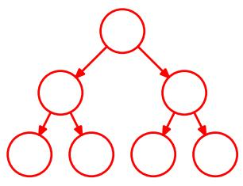
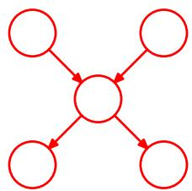
In the case of an undirected graph, a tree is defined as a graph in which there is one, and only one, path between any pair of nodes. Such graphs therefore do not have loops. In the case of directed graphs, a tree is defined such that there is a single node, called the root, which has no parents, and all other nodes have one parent. If we convert a directed tree into an undirected graph, we see that the moralization step will not add any links as all nodes have at most one parent, and as a consequence the corresponding moralized graph will be an undirected tree. Examples of undirected and directed trees are shown in Figure 8.39(a) and 8.39(b). Note that a distribution represented as a directed tree can easily be converted into one represented by an undirected tree, and vice versa.
If there are nodes in a directed graph that have more than one parent, but there is still only one path (ignoring the direction of the arrows) between any two nodes, then the graph is a called a polytree, as illustrated in Figure 8.39(c). Such a graph will have more than one node with the property of having no parents, and furthermore, the corresponding moralized undirected graph will have loops.

8.4.3 Factor graphs
The sum-product algorithm that we derive in the next section is applicable to undirected and directed trees and to polytrees. It can be cast in a particularly simple and general form if we first introduce a new graphical construction called a factor graph (Frey, 1998; Kschischnang et al., 2001).
Both directed and undirected graphs allow a global function of several variables to be expressed as a product of factors over subsets of those variables. Factor graphs make this decomposition explicit by introducing additional nodes for the factors themselves in addition to the nodes representing the variables. They also allow us to be more explicit about the details of the factorization, as we shall see.
Let us write the joint distribution over a set of variables in the form of a product of factors
p(x)=s​fs(xs)
where $x_{s}$ denotes a subset of the variables. For convenience, we shall denote the individual variables by $x_{i},$ , however, as in earlier discussions, these can comprise groups of variables (such as vectors or matrices). Each factor $f_{s}$ is a function of a corresponding set of variables $x_{s}$
Figure 8.40 Example of a factor graph, which corresponds to the factorization (8.60).
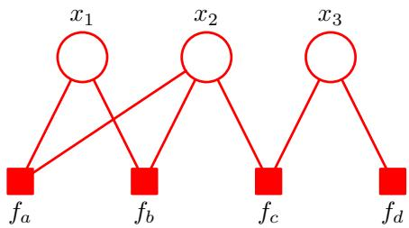
Directed graphs, whose factorization is defined by (8.5), represent special cases of (8.59) in which the factors $f_{s}(x_{s})$ are local conditional distributions. Similarly, undirected graphs, given by (8.39), are a special case in which the factors are potential functions over the maximal cliques (the normalizing coefficient $1/Z$ can be viewed as a factor defined over the empty set of variables).
In a factor graph, there is a node (depicted as usual by a circle) for every variable in the distribution, as was the case for directed and undirected graphs. There are also additional nodes (depicted by small squares) for each factor $f_{s}(x_{s})$ in the joint distribution. Finally, there are undirected links connecting each factor node to all of the variables nodes on which that factor depends. Consider, for example, a distribution that is expressed in terms of the factorization
$$p(x)=f_{a}(x_{1},x_{2})f_{b}(x_{1},x_{2})f_{c}(x_{2},x_{3})f_{d}(x_{3}).$$
This can be expressed by the factor graph shown in Figure 8.40. Note that there are two factors $f_{a}(x_{1},x_{2})$ and $f_{b}(x_{1},x_{2})$ that are defined over the same set of variables. In an undirected graph, the product of two such factors would simply be lumped together into the same clique potential. Similarly, $f_{c}(x_{2},x_{3})$ and $f_{d}(x_{3})$ could be combined into a single potential over $x_{2}$ and $x_{3}$ . The factor graph, however, keeps such factors explicit and so is able to convey more detailed information about the underlying factorization.
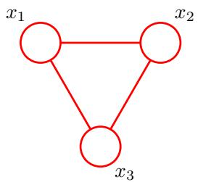
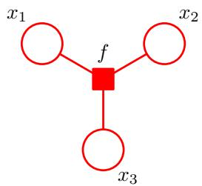
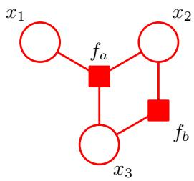
Figure 8.41 (a) An undirected graph with a single clique potential $ψ(x_{1},x_{2},x_{3})$ . (b) A factor graph with factor $f(x_{1},x_{2},x_{3})=ψ(x_{1},x_{2},x_{3})$ representing the same distribution as the undirected graph. (c) A different factor graph representing the same distribution, whose factors satisfy $f_{a}(x_{1},x_{2},x_{3})f_{b}(x_{1},x_{2})=ψ(x_{1},x_{2},x_{3})$
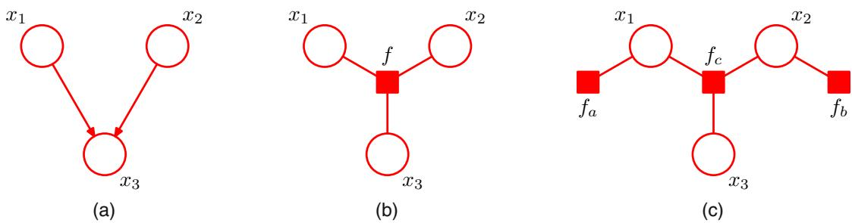
Figure 8.42 (a) A directed graph with the factorization $p(x_{1})p(x_{2})p(x_{3}|x_{1},x_{2})$ . (b) A factor graph representing the same distribution as the directed graph, whose factor satisfies $f(x_{1},x_{2},x_{3})=p(x_{1})p(x_{2})p(x_{3}|x_{1},x_{2})$ . (c) A different factor graph representing the same distribution with factors $f_{a}(x_{1}) := :p(x_{1}), :f_{b}(x_{2}) := :p(x_{2})$ and $f_{c}(x_{1},x_{2},x_{3})=p(x_{3}|x_{1},x_{2})$
Factor graphs are said to be bipartite because they consist of two distinct kinds of nodes, and all links go between nodes of opposite type. In general, factor graphs can therefore always be drawn as two rows of nodes (variable nodes at the top and factor nodes at the bottom) with links between the rows, as shown in the example in Figure 8.40. In some situations, however, other ways of laying out the graph may be more intuitive, for example when the factor graph is derived from a directed or undirected graph, as we shall see.
If we are given a distribution that is expressed in terms of an undirected graph, then we can readily convert it to a factor graph. To do this, we create variable nodes corresponding to the nodes in the original undirected graph, and then create additional factor nodes corresponding to the maximal cliques $x_{s}$ . The factors $f_{s}(x_{s})$ are then set equal to the clique potentials. Note that there may be several different factor graphs that correspond to the same undirected graph. These concepts are illustrated in Figure 8.41.
Similarly, to convert a directed graph to a factor graph, we simply create variable nodes in the factor graph corresponding to the nodes of the directed graph, and then create factor nodes corresponding to the conditional distributions, and then finally add the appropriate links. Again, there can be multiple factor graphs all of which correspond to the same directed graph. The conversion of a directed graph to a factor graph is illustrated in Figure 8.42.
We have already noted the importance of tree-structured graphs for performing efficient inference. If we take a directed or undirected tree and convert it into a factor graph, then the result will again be a tree (in other words, the factor graph will have no loops, and there will be one and only one path connecting any two nodes). In the case of a directed polytree, conversion to an undirected graph results in loops due to the moralization step, whereas conversion to a factor graph again results in a tree, as illustrated in Figure 8.43. In fact, local cycles in a directed graph due to links connecting parents of a node can be removed on conversion to a factor graph by defining the appropriate factor function, as shown in Figure 8.44.
We have seen that multiple different factor graphs can represent the same directed or undirected graph. This allows factor graphs to be more specific about the precise form of the factorization. Figure 8.45 shows an example of a fully connected undirected graph along with two different factor graphs. In (b), the joint distribution is given by a general form $p(x)=f(x_{1},x_{2},x_{3})$ , whereas in (c), it is given by the more specific factorization $p ( { \bf x } ) = f _ { a } ( x _ { 1 } , x _ { 2 } ) f _ { b } ( x _ { 1 } , x _ { 3 } ) f _ { c } ( x _ { 2 } , x _ { 3 } )$ . It should be emphasized that the factorization in (c) does not correspond to any conditional independence properties.
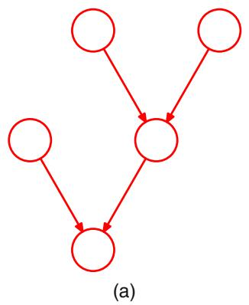
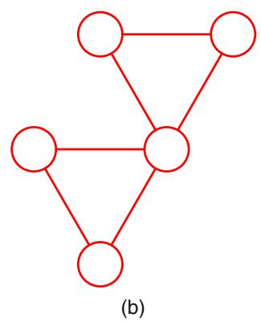
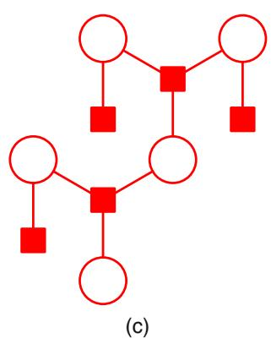
Figure 8.43 (a) A directed polytree. (b) The result of converting the polytree into an undirected graph showing the creation of loops. (c) The result of converting the polytree into a factor graph, which retains the tree structure.

8.4.4 The sum-product algorithm
We shall now make use of the factor graph framework to derive a powerful class of efficient, exact inference algorithms that are applicable to tree-structured graphs. Here we shall focus on the problem of evaluating local marginals over nodes or subsets of nodes, which will lead us to the sum-product algorithm. Later we shall modify the technique to allow the most probable state to be found, giving rise to the max-sum algorithm.
Also we shall suppose that all of the variables in the model are discrete, and so marginalization corresponds to performing sums. The framework, however, is equally applicable to linear-Gaussian models in which case marginalization involves integration, and we shall consider an example of this in detail when we discuss linear dynamical systems.
Figure 8.44
- A fragment of a directed graph having a local cycle. (b) Conversion to a fragment of a factor graph having a tree structure, in which $f(x_{1},x_{2},x_{3})=$ $p(x_{1})p(x_{2}|x_{1})p(x_{3}|x_{1},x_{2})$
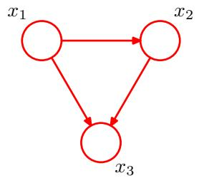
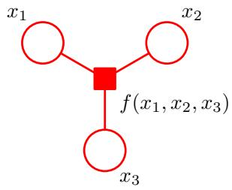
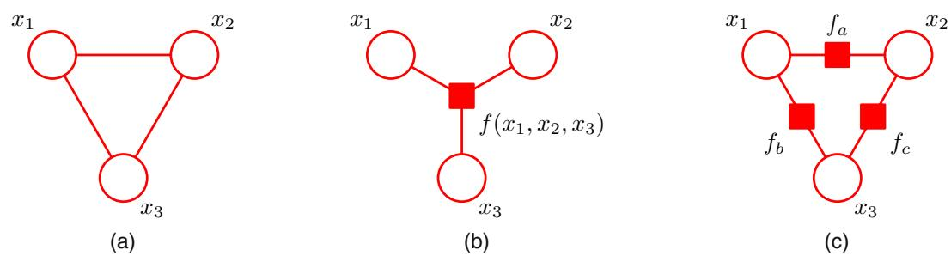
Figure 8.45 (a) A fully connected undirected graph. (b) and (c) Two factor graphs each of which corresponds to the undirected graph in (a).
There is an algorithm for exact inference on directed graphs without loops known as belief propagation (Pearl, 1988; Lauritzen and Spiegelhalter, 1988), and is equivalent to a special case of the sum-product algorithm. Here we shall consider only the sum-product algorithm because it is simpler to derive and to apply, as well as being more general.
We shall assume that the original graph is an undirected tree or a directed tree or polytree, so that the corresponding factor graph has a tree structure. We first convert the original graph into a factor graph so that we can deal with both directed and undirected models using the same framework. Our goal is to exploit the structure of the graph to achieve two things: (i) to obtain an efficient, exact inference algorithm for finding marginals; (ii) in situations where several marginals are required to allow computations to be shared efficiently.
We begin by considering the problem of finding the marginal $p(x)$ for particular variable node x. For the moment, we shall suppose that all of the variables are hidden. Later we shall see how to modify the algorithm to incorporate evidence corresponding to observed variables. By definition, the marginal is obtained by summing the joint distribution over all variables except x so that
p(x)=x∖x​p(x)
where $\text{ x }∖x$ denotes the set of variables in x with variable x omitted. The idea is to substitute for $p(x)$ using the factor graph expression (8.59) and then interchange summations and products in order to obtain an efficient algorithm. Consider the fragment of graph shown in Figure 8.46 in which we see that the tree structure of the graph allows us to partition the factors in the joint distribution into groups, with one group associated with each of the factor nodes that is a neighbour of the variable node x. We see that the joint distribution can be written as a product of the form
p(x)=s∈ne(x)​Fs(x,Xs)
ne $(x)$ denotes the set of factor nodes that are neighbours of $x,$ and $X_{s}$ denotes the set of all variables in the subtree connected to the variable node x via the factor node
Figure 8.46 A fragment of a factor graph illustrating the evaluation of the marginal $p(x)$
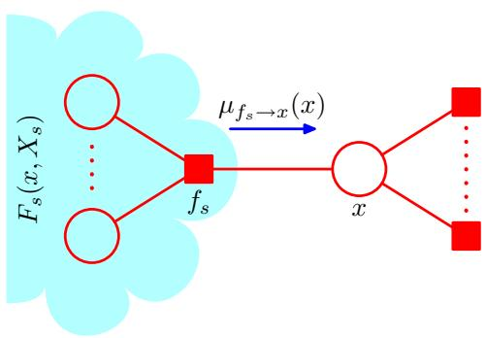
$f_{s},$ and $F_{s}(x,X_{s})$ represents the product of all the factors in the group associated with factor $f_{s}$
Substituting (8.62) into (8.61) and interchanging the sums and products, we obtain
p(x)=s∈ne(x)​Xs​Fs(x,Xs)=s∈ne(x)​μfs→x(x).
Here we have introduced a set of functions $μ_{f_{s}→x}(x)$ , defined by
μfs→x(x)≡Xs​Fs(x,Xs)
which can be viewed as messages from the factor nodes $f_{s}$ to the variable node x. We see that the required marginal $p(x)$ is given by the product of all the incoming messages arriving at node x.
In order to evaluate these messages, we again turn to Figure 8.46 and note that each factor $F_{s}(x,X_{s})$ is described by a factor (sub-)graph and so can itself be factorized. In particular, we can write
$$F_{s}(x,X_{s})=f_{s}(x,x_{1},…,x_{M})G_{1}\left(x_{1},X_{s1}\right)…G_{M}\left(x_{M},X_{sM}\right)$$
where, for convenience, we have denoted the variables associated with factor $f_{x},$ , in addition to x, by $x_{1},…,x_{M}$ . This factorization is illustrated in Figure 8.47. Note that the set of variables $\{x,x_{1},…,x_{M}\}$ is the set of variables on which the factor $f_{s}$ depends, and so it can also be denoted $x_{s}$ , using the notation of (8.59).
Substituting (8.65) into (8.64) we obtain
μfs→x(x)=x1​…xM​fs(x,x1,…,xM)m∈ne(fs)∖x​Xxm​Gm(xm,Xsm)=x1​…xM​fs(x,x1,…,xM)m∈ne(fs)∖x​μxm→fs(xm)
Figure 8.47 Illustration of the factorization of the subgraph associated with factor node $f_{s}$
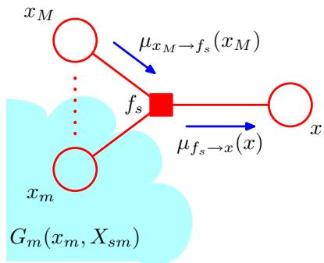
where $ne(f_{s})$ denotes the set of variable nodes that are neighbours of the factor node $f_{s},$ and ne $(f_{s})\backslash x$ denotes the same set but with node x removed. Here we have defined the following messages from variable nodes to factor nodes
μxm→fs(xm)≡Xsm​Gm(xm,Xsm).
We have therefore introduced two distinct kinds of message, those that go from factor nodes to variable nodes denoted $μ_{fx}(x)$ , and those that go from variable nodes to factor nodes denoted $μ_{xf}(x)$ . In each case, we see that messages passed along a link are always a function of the variable associated with the variable node that link connects to.
The result (8.66) says that to evaluate the message sent by a factor node to a variable node along the link connecting them, take the product of the incoming messages along all other links coming into the factor node, multiply by the factor associated with that node, and then marginalize over all of the variables associated with the incoming messages. This is illustrated in Figure 8.47. It is important to note that a factor node can send a message to a variable node once it has received incoming messages from all other neighbouring variable nodes.
Finally, we derive an expression for evaluating the messages from variable nodes to factor nodes, again by making use of the (sub-)graph factorization. From Figure 8.48, we see that term $G_{m}({\overset{‾}{x}}_{m},X_{sm})$ associated with node $x_{m}$ is given by a product of terms $F_{l}(x_{m},X_{ml})$ each associated with one of the factor nodes $f_{l}$ that is linked to node $x_{m}$ (excluding node $f_{s})$ , so that
Gm(xm,Xsm)=l∈ne(xm)\fs​Fl(xm,Xml)
where the product is taken over all neighbours of node $x_{m}$ except for node $f_{s}$ . Note that each of the factors $F_{l}(x_{m},X_{ml})$ represents a subtree of the original graph of precisely the same kind as introduced in (8.62). Substituting (8.68) into (8.67), we
Figure 8.48 Illustration of the evaluation of the message sent by a variable node to an adjacent factor node.
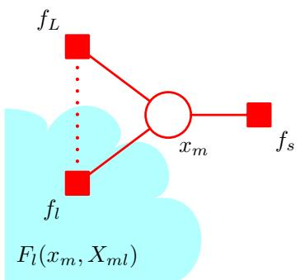
then obtain
μxm→fs(xm)=l∈ne(xm)\fs​Xml​Fl(xm,Xml)=l∈ne(xm)\fs​μfl→xm(xm)
where we have used the definition (8.64) of the messages passed from factor nodes to variable nodes. Thus to evaluate the message sent by a variable node to an adjacent factor node along the connecting link, we simply take the product of the incoming messages along all of the other links. Note that any variable node that has only two neighbours performs no computation but simply passes messages through unchanged. Also, we note that a variable node can send a message to a factor node once it has received incoming messages from all other neighbouring factor nodes.
Recall that our goal is to calculate the marginal for variable node x, and that this marginal is given by the product of incoming messages along all of the links arriving at that node. Each of these messages can be computed recursively in terms of other messages. In order to start this recursion, we can view the node x as the root of the tree and begin at the leaf nodes. From the definition (8.69), we see that if a leaf node is a variable node, then the message that it sends along its one and only link is given by
$$μ_{x→f}(x)=1$$
as illustrated in Figure 8.49(a). Similarly, if the leaf node is a factor node, we see from (8.66) that the message sent should take the form
$$μ_{f→x}(x)=f(x)$$
The sum-product algorithm begins with messages sent by the leaf nodes, which depend on whether the leaf node is (a) a variable node, or (b) a factor node.
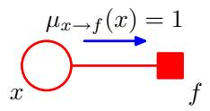
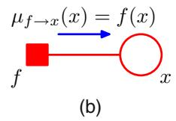
as illustrated in Figure 8.49(b).
At this point, it is worth pausing to summarize the particular version of the sumproduct algorithm obtained so far for evaluating the marginal $p(x)$ We start by viewing the variable node x as the root of the factor graph and initiating messages at the leaves of the graph using (8.70) and (8.71). The message passing steps (8.66) and (8.69) are then applied recursively until messages have been propagated along every link, and the root node has received messages from all of its neighbours. Each node can send a message towards the root once it has received messages from all of its other neighbours. Once the root node has received messages from all of its neighbours, the required marginal can be evaluated using (8.63). We shall illustrate this process shortly.
To see that each node will always receive enough messages to be able to send out a message, we can use a simple inductive argument as follows. Clearly, for a graph comprising a variable root node connected directly to several factor leaf nodes, the algorithm trivially involves sending messages of the form (8.71) directly from the leaves to the root. Now imagine building up a general graph by adding nodes one at a time, and suppose that for some particular graph we have a valid algorithm. When one more (variable or factor) node is added, it can be connected only by a single link because the overall graph must remain a tree, and so the new node will be a leaf node. It therefore sends a message to the node to which it is linked, which in turn will therefore receive all the messages it requires in order to send its own message towards the root, and so again we have a valid algorithm, thereby completing the proof.
Now suppose we wish to find the marginals for every variable node in the graph. This could be done by simply running the above algorithm afresh for each such node. However, this would be very wasteful as many of the required computations would be repeated. We can obtain a much more efficient procedure by ‘overlaying’ these multiple message passing algorithms to obtain the general sum-product algorithm as follows. Arbitrarily pick any (variable or factor) node and designate it as the root. Propagate messages from the leaves to the root as before. At this point, the root node will have received messages from all of its neighbours. It can therefore send out messages to all of its neighbours. These in turn will then have received messages from all of their neighbours and so can send out messages along the links going away from the root, and so on. In this way, messages are passed outwards from the root all the way to the leaves. By now, a message will have passed in both directions across every link in the graph, and every node will have received a message from all of its neighbours. Again a simple inductive argument can be used to verify the validity of this message passing protocol. Because every variable node will have received messages from all of its neighbours, we can readily calculate the marginal distribution for every variable in the graph. The number of messages that have to be computed is given by twice the number of links in the graph and so involves only twice the computation involved in finding a single marginal. By comparison, if we had run the sum-product algorithm separately for each node, the amount of computation would grow quadratically with the size of the graph. Note that this algorithm is in fact independent of which node was designated as the root,
The sum-product algorithm can be viewed purely in terms of messages sent out by factor nodes to other factor nodes. In this example, the outgoing message shown by the blue arrow is obtained by taking the product of all the incoming messages shown by green arrows, multiplying by the factor $f_{s}$ , and marginalizing over the variables $x_{1}$ and $x_{2}$
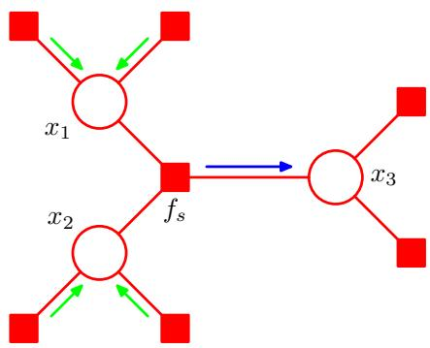
and indeed the notion of one node having a special status was introduced only as a convenient way to explain the message passing protocol.
Next suppose we wish to find the marginal distributions $p(x_{s})$ associated with the sets of variables belonging to each of the factors. By a similar argument to that used above, it is easy to see that the marginal associated with a factor is given by the product of messages arriving at the factor node and the local factor at that node
p(xs)=fs(xs)i∈ne(fs)​μxi→fs(xi)
in complete analogy with the marginals at the variable nodes. If the factors are parameterized functions and we wish to learn the values of the parameters using the EM algorithm, then these marginals are precisely the quantities we will need to calculate in the E step, as we shall see in detail when we discuss the hidden Markov model in Chapter 13.
The message sent by a variable node to a factor node, as we have seen, is simply the product of the incoming messages on other links. We can if we wish view the sum-product algorithm in a slightly different form by eliminating messages from variable nodes to factor nodes and simply considering messages that are sent out by factor nodes. This is most easily seen by considering the example in Figure 8.50.
So far, we have rather neglected the issue of normalization. If the factor graph was derived from a directed graph, then the joint distribution is already correctly normalized, and so the marginals obtained by the sum-product algorithm will similarly be normalized correctly. However, if we started from an undirected graph, then in general there will be an unknown normalization coefficient $1/Z$ . As with the simple chain example of Figure 8.38, this is easily handled by working with an unnormalized version $\tilde{p}(x)$ of the joint distribution, where $p(x)=\tilde{p}(x)/Z$ . We first run the sum-product algorithm to find the corresponding unnormalized marginals $\tilde{p}(x_{i})$ . The coefficient $1/Z$ is then easily obtained by normalizing any one of these marginals, and this is computationally efficient because the normalization is done over a single variable rather than over the entire set of variables as would be required to normalize $\tilde{p}(x)$ directly.
At this point, it may be helpful to consider a simple example to illustrate the operation of the sum-product algorithm. Figure 8.51 shows a simple 4-node factor
Figure 8.51 A simple factor graph used to illustrate the sum-product algorithm.
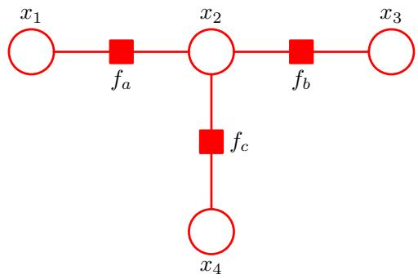
graph whose unnormalized joint distribution is given by
$$\tilde{p}(x)=f_{a}(x_{1},x_{2})f_{b}(x_{2},x_{3})f_{c}(x_{2},x_{4}).$$
In order to apply the sum-product algorithm to this graph, let us designate node $x_{3}$ as the root, in which case there are two leaf nodes $x_{1}$ and $x_{4}$ . Starting with the leaf nodes, we then have the following sequence of six messages
$$μ_{x_{1}→f_{a}}(x_{1})=1$$
μfa→x2(x2)=x1​fa(x1,x2)
$$μ_{x_{4}→f_{c}}(x_{4})=1$$
μfc→x2(x2)=x4​fc(x2,x4)
$$μ_{x_{2}→f_{b}}(x_{2})=μ_{f_{a}→x_{2}}(x_{2})μ_{f_{c}→x_{2}}(x_{2})$$
μfb→x3(x3)=x2​fb(x2,x3)μx2→fb.
The direction of flow of these messages is illustrated in Figure 8.52. Once this message propagation is complete, we can then propagate messages from the root node out to the leaf nodes, and these are given by
$$μ_{x_{3}→f_{b}}(x_{3})=1$$
μfb→x2(x2)=x3​fb(x2,x3)
$$μ_{x_{2}→f_{a}}(x_{2})=μ_{f_{b}→x_{2}}(x_{2})μ_{f_{c}→x_{2}}(x_{2})$$
μfa→x1(x1)=x2​fa(x1,x2)μx2→fa(x2)
$$μ_{x_{2}→f_{c}}(x_{2})=μ_{f_{a}→x_{2}}(x_{2})μ_{f_{b}→x_{2}}(x_{2})$$
$$μ_{f_{c}→x_{4}}(x_{4})=∑f_{c}(x_{2},x_{4})μ_{x_{2}→f_{c}}(x_{2}).$$
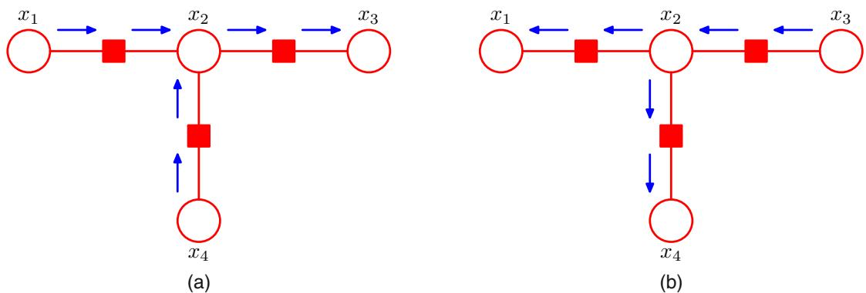
Figure 8.52 Flow of messages for the sum-product algorithm applied to the example graph in Figure 8.51. (a) From the leaf nodes $x_{1}$ and $x_{4}$ towards the root node $x_{3}$ . (b) From the root node towards the leaf nodes.
One message has now passed in each direction across each link, and we can now evaluate the marginals. As a simple check, let us verify that the marginal $p(x_{2})$ is given by the correct expression. Using (8.63) and substituting for the messages using the above results, we have
p(x2)=μfa→x2(x2)μfb→x2(x2)μfc→x2(x2)=x1​fa(x1,x2)x3​fb(x2,x3)x4​fc(x2,x4)=x1​x2​x4​fa(x1,x2)fb(x2,x3)fc(x2,x4)=x1​x3​x4​p(x)
as required.
So far, we have assumed that all of the variables in the graph are hidden. In most practical applications, a subset of the variables will be observed, and we wish to calculate posterior distributions conditioned on these observations. Observed nodes are easily handled within the sum-product algorithm as follows. Suppose we partition x into hidden variables h and observed variables v, and that the observed value of v is denoted $\hat{v}.$ . Then we simply multiply the joint distribution $p(x)$ by i​I(vi,vi) where $I(v,\hat{v})=1$ if $v=\hat{\hat{v}}$ and $I(v,\hat{v})=0$ otherwise. This product corresponds to $p(h,v=\hat{v})$ and hence is an unnormalized version of $p(h|v=\hat{v})$ . By run- ning the sum-product algorithm, we can efficiently calculate the posterior marginals $p(h_{i}|v=\hat{v})$ up to a normalization coefficient whose value can be found efficiently using a local computation. Any summations over variables in v then collapse into a single term.
We have assumed throughout this section that we are dealing with discrete variables. However, there is nothing specific to discrete variables either in the graphical framework or in the probabilistic construction of the sum-product algorithm. For
Table 8.1 Example of a joint distribution over two binary variables for which the maximum of the joint distribution occurs for different variable values compared to the maxima of the two marginals.
 | x=0 | x=1
y=0 | 0.3 | 0.4
y=1 | 0.3 | 0.0
continuous variables the summations are simply replaced by integrations. We shall give an example of the sum-product algorithm applied to a graph of linear-Gaussian variables when we consider linear dynamical systems.

8.4.5 The max-sum algorithm
The sum-product algorithm allows us to take a joint distribution $p(x)$ expressed as a factor graph and efficiently find marginals over the component variables. Two other common tasks are to find a setting of the variables that has the largest probability and to find the value of that probability. These can be addressed through a closely related algorithm called max-sum, which can be viewed as an application of dynamic programming in the context of graphical models (Cormen et al., 2001).
A simple approach to finding latent variable values having high probability would be to run the sum-product algorithm to obtain the marginals $p(x_{i})$ for every variable, and then, for each marginal in turn, to find the value $x_{i}^{⋆}$ that maximizes that marginal. However, this would give the set of values that are individually the most probable. In practice, we typically wish to find the set of values that jointly have the largest probability, in other words the vector $x^{max}$ that maximizes the joint distribution, so that
$$x^{max}=\underset{x}{argmax}p(x)$$
for which the corresponding value of the joint probability will be given by
$$p(x^{max})=\max_{x}p(x).$$
In general, $x^{max}$ is not the same as the set of $x_{i}^{⋆}$ values, as we can easily show using a simple example. Consider the joint distribution $p(x,y)$ over two binary variables $x,y∈\{0,1\}$ given in Table 8.1. The joint distribution is maximized by setting $x=$ 1 and $y=0$ , corresponding the value 0.4. However, the marginal for $p(x)$ , obtained by summing over both values of $y,$ is given by $p(x=0)=0.6$ and $p(x=1)=0.4$ and similarly the marginal for $y$ is given by $p(y=0)=0.7$ and $p(y=1)=0.3$ and so the marginals are maximized by $x=0$ and $y=0$ , which corresponds to a value of 0.3 for the joint distribution. In fact, it is not difficult to construct examples for which the set of individually most probable values has probability zero under the joint distribution.
We therefore seek an efficient algorithm for finding the value of x that maximizes the joint distribution $p(x)$ and that will allow us to obtain the value of the joint distribution at its maximum. To address the second of these problems, we shall simply write out the max operator in terms of its components
$$\max_{x}p(x)=\max_{x_{1}}…\max_{x_{M}}p(x)$$
where M is the total number of variables, and then substitute for $p(x)$ using its expansion in terms of a product of factors. In deriving the sum-product algorithm, we made use of the distributive law (8.53) for multiplication. Here we make use of the analogous law for the max operator
$$max(ab,ac)=amax(b,c)$$
which holds if $a≥0$ (as will always be the case for the factors in a graphical model). This allows us to exchange products with maximizations.
Consider first the simple example of a chain of nodes described by (8.49). The evaluation of the probability maximum can be written as
$$\begin{matrix}\max_{x}p(x)=\frac{1}{Z}\max_{x_{1}}…\max_{x_{N}}\left[ψ_{1,2}(x_{1},x_{2})…ψ_{N−1,N}(x_{N−1},x_{N})\right] \\ =\frac{1}{Z}\max_{x_{1}}\left[ψ_{1,2}(x_{1},x_{2})\left[…\max_{x_{N}}ψ_{N−1,N}(x_{N−1},x_{N})\right]\right].\end{matrix}$$
As with the calculation of marginals, we see that exchanging the max and product operators results in a much more efficient computation, and one that is easily interpreted in terms of messages passed from node $x_{N}$ backwards along the chain to node $x_{1}$
We can readily generalize this result to arbitrary tree-structured factor graphs by substituting the expression (8.59) for the factor graph expansion into (8.89) and again exchanging maximizations with products. The structure of this calculation is identical to that of the sum-product algorithm, and so we can simply translate those results into the present context. In particular, suppose that we designate a particular variable node as the ‘root’ of the graph. Then we start a set of messages propagating inwards from the leaves of the tree towards the root, with each node sending its message towards the root once it has received all incoming messages from its other neighbours. The final maximization is performed over the product of all messages arriving at the root node, and gives the maximum value for $p(x)$ . This could be called the max-product algorithm and is identical to the sum-product algorithm except that summations are replaced by maximizations. Note that at this stage, messages have been sent from leaves to the root, but not in the other direction.
In practice, products of many small probabilities can lead to numerical underflow problems, and so it is convenient to work with the logarithm of the joint distribution. The logarithm is a monotonic function, so that if $a>b$ then ln $a>lnb,$ and hence the max operator and the logarithm function can be interchanged, so that
$$ln\left(\max_{x}p(x)\right)=\max_{x}lnp(x).$$
The distributive property is preserved because
$$max(a+b,a+c)=a+max(b,c).$$
Thus taking the logarithm simply has the effect of replacing the products in the max-product algorithm with sums, and so we obtain the max-sum algorithm. From the results (8.66) and (8.69) derived earlier for the sum-product algorithm, we can readily write down the max-sum algorithm in terms of message passing simply by replacing ‘sum’ with ‘max’ and replacing products with sums of logarithms to give
μf→x(x)=maxx1,…,xMlnf(x,x1,…,xM)+m∈ne(fs)∖x​μxm→f(xm)
μx→f(x)=l∈ne(x)\f​μfl→x(x).
The initial messages sent by the leaf nodes are obtained by analogy with (8.70) and (8.71) and are given by
$$μ_{x→f}(x)=0$$
$$μ_{f→x}(x)=lnf(x)$$
while at the root node the maximum probability can then be computed, by analogy with (8.63), using
pmax=maxxs∈ne(x)​μfs→x(x).
So far, we have seen how to find the maximum of the joint distribution by propagating messages from the leaves to an arbitrarily chosen root node. The result will be the same irrespective of which node is chosen as the root. Now we turn to the second problem of finding the configuration of the variables for which the joint distribution attains this maximum value. So far, we have sent messages from the leaves to the root. The process of evaluating (8.97) will also give the value $x^{max}$ for the most probable value of the root node variable, defined by
xmax=argmaxxs∈ne(x)​μfs→x(x).
At this point, we might be tempted simply to continue with the message passing algorithm and send messages from the root back out to the leaves, using (8.93) and (8.94), then apply (8.98) to all of the remaining variable nodes. However, because we are now maximizing rather than summing, it is possible that there may be multiple configurations of x all of which give rise to the maximum value for $p(x)$ . In such cases, this strategy can fail because it is possible for the individual variable values obtained by maximizing the product of messages at each node to belong to different maximizing configurations, giving an overall configuration that no longer corresponds to a maximum.
The problem can be resolved by adopting a rather different kind of message passing from the root node to the leaves. To see how this works, let us return once again to the simple chain example of N variables $x_{1},…,x_{N}$ each having K states,
Figure 8.53 A lattice, or trellis, diagram showing explicitly the K possible states (one per row of the diagram) for each of the variables $x_{n}$ in the chain model. In this illustration $K=3$ The arrow shows the direction of message passing in the max-product algorithm. For every state k of each variable $x_{n}$ (corresponding to column n of the diagram) the function $ϕ(x_{n})$ defines a unique state at the previous variable, indicated by the black lines. The two paths through the lattice correspond to configurations that give the global maximum of the joint probability distribution, and either of these can be found by tracing back along the black lines in the opposite direction to the arrow.
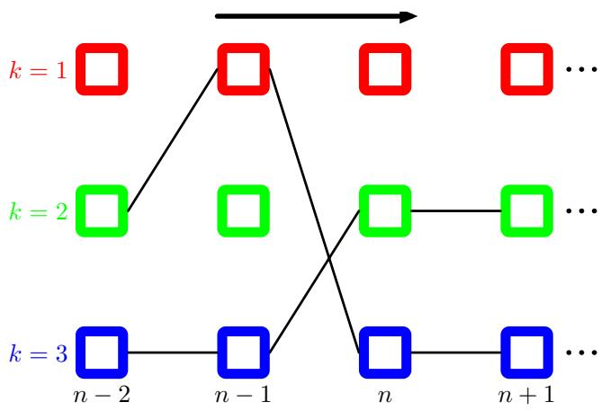
corresponding to the graph shown in Figure 8.38. Suppose we take node $x_{N}$ to be the root node. Then in the first phase, we propagate messages from the leaf node $x_{1}$ to the root node using
$$\begin{matrix}μ_{x_{n}→f_{n,n+1}}(x_{n}) & = & μ_{f_{n−1,n}→x_{n}}(x_{n}) \\ μ_{f_{n−1,n}→x_{n}}(x_{n}) & = & \max_{x_{n−1}}\left[lnf_{n−1,n}(x_{n−1},x_{n})+μ_{x_{n−1}→fn−1,n}(x_{n})\right]\end{matrix}$$
which follow from applying (8.94) and (8.93) to this particular graph. The initial message sent from the leaf node is simply
$$μ_{x_{1}→f_{1,2}}(x_{1})=0.$$
The most probable value for $x_{N}$ is then given by
$$x_{N}^{max}=\underset{x_{N}}{argmax}\left[μ_{f_{N−1,N}→x_{N}}(x_{N})\right].$$
Now we need to determine the states of the previous variables that correspond to the same maximizing configuration. This can be done by keeping track of which values of the variables gave rise to the maximum state of each variable, in other words by storing quantities given by
$$ϕ(x_{n})=\underset{x_{n−1}}{argmax}\left[lnf_{n−1,n}(x_{n−1},x_{n})+μ_{x_{n−1}→fn−1,n}(x_{n})\right].$$
To understand better what is happening, it is helpful to represent the chain of variables in terms of a lattice or trellis diagram as shown in Figure 8.53. Note that this is not a probabilistic graphical model because the nodes represent individual states of variables, while each variable corresponds to a column of such states in the diagram. For each state of a given variable, there is a unique state of the previous variable that maximizes the probability (ties are broken either systematically or at random), corresponding to the function $ϕ(x_{n})$ given by (8.101), and this is indicated by the lines connecting the nodes. Once we know the most probable value of the final node $x_{N}$ , we can then simply follow the link back to find the most probable state of node $x_{N−1}$ and so on back to the initial node $x_{1}$ . This corresponds to propagating a message back down the chain using
$$x_{n−1}^{max}=ϕ(x_{n}^{max})$$
and is known as back-tracking. Note that there could be several values of $x_{n−1}$ all of which give the maximum value in (8.101). Provided we chose one of these values when we do the back-tracking, we are assured of a globally consistent maximizing configuration.
In Figure 8.53, we have indicated two paths, each of which we shall suppose corresponds to a global maximum of the joint probability distribution. If $k=2$ and $k=3$ each represent possible values of $x_{N}^{max}$ , then starting from either state and tracing back along the black lines, which corresponds to iterating (8.102), we obtain a valid global maximum configuration. Note that if we had run a forward pass of max-sum message passing followed by a backward pass and then applied (8.98) at each node separately, we could end up selecting some states from one path and some from the other path, giving an overall configuration that is not a global maximizer. We see that it is necessary instead to keep track of the maximizing states during the forward pass using the functions $ϕ(x_{n})$ and then use back-tracking to find a consistent solution.
The extension to a general tree-structured factor graph should now be clear. If a message is sent from a factor node $f$ to a variable node $x,$ a maximization is performed over all other variable nodes $x_{1},…,x_{M}$ that are neighbours of that factor node, using (8.93). When we perform this maximization, we keep a record of which values of the variables $x_{1},…,x_{M}$ gave rise to the maximum. Then in the back-tracking step, having found $x^{max}$ , we can then use these stored values to assign consistent maximizing states $x_{1}^{max},…,x_{M}^{max}$ . The max-sum algorithm, with back-tracking, gives an exact maximizing configuration for the variables provided the factor graph is a tree. An important application of this technique is for finding the most probable sequence of hidden states in a hidden Markov model, in which case it is known as the Viterbi algorithm.
As with the sum-product algorithm, the inclusion of evidence in the form of observed variables is straightforward. The observed variables are clamped to their observed values, and the maximization is performed over the remaining hidden variables. This can be shown formally by including identity functions for the observed variables into the factor functions, as we did for the sum-product algorithm.
It is interesting to compare max-sum with the iterated conditional modes (ICM) algorithm described on page 389. Each step in ICM is computationally simpler because the ‘messages’ that are passed from one node to the next comprise a single value consisting of the new state of the node for which the conditional distribution is maximized. The max-sum algorithm is more complex because the messages are functions of node variables x and hence comprise a set of K values for each possible state of x. Unlike max-sum, however, ICM is not guaranteed to find a global maximum even for tree-structured graphs.

8.4.6 Exact inference in general graphs
The sum-product and max-sum algorithms provide efficient and exact solutions to inference problems in tree-structured graphs. For many practical applications, however, we have to deal with graphs having loops.
The message passing framework can be generalized to arbitrary graph topologies, giving an exact inference procedure known as the junction tree algorithm (Lauritzen and Spiegelhalter, 1988; Jordan, 2007). Here we give a brief outline of the key steps involved. This is not intended to convey a detailed understanding of the algorithm, but rather to give a flavour of the various stages involved. If the starting point is a directed graph, it is first converted to an undirected graph by moralization, whereas if starting from an undirected graph this step is not required. Next the graph is triangulated, which involves finding chord-less cycles containing four or more nodes and adding extra links to eliminate such chord-less cycles. For instance, in the graph in Figure 8.36, the cycle $A−C−B−D−A$ is chord-less a link could be added between A and B or alternatively between C and D. Note that the joint distribution for the resulting triangulated graph is still defined by a product of the same potential functions, but these are now considered to be functions over expanded sets of variables. Next the triangulated graph is used to construct a new tree-structured undirected graph called a join tree, whose nodes correspond to the maximal cliques of the triangulated graph, and whose links connect pairs of cliques that have variables in common. The selection of which pairs of cliques to connect in this way is important and is done so as to give a maximal spanning tree defined as follows. Of all possible trees that link up the cliques, the one that is chosen is one for which the weight of the tree is largest, where the weight for a link is the number of nodes shared by the two cliques it connects, and the weight for the tree is the sum of the weights for the links. If the tree is condensed, so that any clique that is a subset of another clique is absorbed into the larger clique, this gives ajunction tree. As a consequence of the triangulation step, the resulting tree satisfies the running intersection property, which means that if a variable is contained in two cliques, then it must also be contained in every clique on the path that connects them. This ensures that inference about variables will be consistent across the graph. Finally, a two-stage message passing algorithm, essentially equivalent to the sum-product algorithm, can now be applied to this junction tree in order to find marginals and conditionals. Although the junction tree algorithm sounds complicated, at its heart is the simple idea that we have used already of exploiting the factorization properties of the distribution to allow sums and products to be interchanged so that partial summations can be performed, thereby avoiding having to work directly with the joint distribution. The role of the junction tree is to provide a precise and efficient way to organize these computations. It is worth emphasizing that this is achieved using purely graphical operations!
The junction tree is exact for arbitrary graphs and is efficient in the sense that for a given graph there does not in general exist a computationally cheaper approach. Unfortunately, the algorithm must work with the joint distributions within each node (each of which corresponds to a clique of the triangulated graph) and so the computational cost of the algorithm is determined by the number of variables in the largest clique and will grow exponentially with this number in the case of discrete variables. An important concept is the treewidth of a graph (Bodlaender, 1993), which is defined in terms of the number of variables in the largest clique. In fact, it is defined to be as one less than the size of the largest clique, to ensure that a tree has a treewidth of 1. Because there in general there can be multiple different junction trees that can be constructed from a given starting graph, the treewidth is defined by the junction tree for which the largest clique has the fewest variables. If the treewidth of the original graph is high, the junction tree algorithm becomes impractical.

8.4.7 Loopy belief propagation
For many problems of practical interest, it will not be feasible to use exact inference, and so we need to exploit effective approximation methods. An important class of such approximations, that can broadly be called variational methods, will be discussed in detail in Chapter 10. Complementing these deterministic approaches is a wide range of sampling methods, also called Monte Carlo methods, that are based on stochastic numerical sampling from distributions and that will be discussed at length in Chapter 11.
Here we consider one simple approach to approximate inference in graphs with loops, which builds directly on the previous discussion of exact inference in trees. The idea is simply to apply the sum-product algorithm even though there is no guarantee that it will yield good results. This approach is known as loopy belief propagation (Frey and MacKay, 1998) and is possible because the message passing rules (8.66) and (8.69) for the sum-product algorithm are purely local. However, because the graph now has cycles, information can flow many times around the graph. For some models, the algorithm will converge, whereas for others it will not.
In order to apply this approach, we need to define a message passing schedule. Let us assume that one message is passed at a time on any given link and in any given direction. Each message sent from a node replaces any previous message sent in the same direction across the same link and will itself be a function only of the most recent messages received by that node at previous steps of the algorithm.
We have seen that a message can only be sent across a link from a node when all other messages have been received by that node across its other links. Because there are loops in the graph, this raises the problem of how to initiate the message passing algorithm. To resolve this, we suppose that an initial message given by the unit function has been passed across every link in each direction. Every node is then in a position to send a message.
There are now many possible ways to organize the message passing schedule. For example, the flooding schedule simultaneously passes a message across every link in both directions at each time step, whereas schedules that pass one message at a time are called serial schedules.
Following Kschischnang et al. (2001), we will say that a (variable or factor) node a has a message pending on its link to a node b if node a has received any message on any of its other links since the last time it send a message to b. Thus, when a node receives a message on one of its links, this creates pending messages on all of its other links. Only pending messages need to be transmitted because other messages would simply duplicate the previous message on the same link. For graphs that have a tree structure, any schedule that sends only pending messages will eventually terminate once a message has passed in each direction across every link. At this point, there are no pending messages, and the product of the received messages at every variable give the exact marginal. In graphs having loops, however, the algorithm may never terminate because there might always be pending messages, although in practice it is generally found to converge within a reasonable time for most applications. Once the algorithm has converged, or once it has been stopped if convergence is not observed, the (approximate) local marginals can be computed using the product of the most recently received incoming messages to each variable node or factor node on every link.
In some applications, the loopy belief propagation algorithm can give poor results, whereas in other applications it has proven to be very effective. In particular, state-of-the-art algorithms for decoding certain kinds of error-correcting codes are equivalent to loopy belief propagation (Gallager, 1963; Berrou et al., 1993; McEliece et al., 1998; MacKay and Neal, 1999; Frey, 1998).

8.4.8 Learning the graph structure
In our discussion of inference in graphical models, we have assumed that the structure of the graph is known and fixed. However, there is also interest in going beyond the inference problem and learning the graph structure itself from data (Friedman and Koller, 2003). This requires that we define a space of possible structures as well as a measure that can be used to score each structure.
From a Bayesian viewpoint, we would ideally like to compute a posterior distribution over graph structures and to make predictions by averaging with respect to this distribution. If we have a prior $p(m)$ over graphs indexed by m, then the posterior distribution is given by
$$p(m|D)∝p(m)p(D|m)$$
where is the observed data set. The model evidence $p(D|m)$ then provides the score for each model. However, evaluation of the evidence involves marginalization over the latent variables and presents a challenging computational problem for many models.
Exploring the space of structures can also be problematic. Because the number of different graph structures grows exponentially with the number of nodes, it is often necessary to resort to heuristics to find good candidates.

Exercises
8.1 () www By marginalizing out the variables in order, show that the representation (8.5) for the joint distribution of a directed graph is correctly normalized, provided each of the conditional distributions is normalized.
8.2 () www Show that the property of there being no directed cycles in a directed graph follows from the statement that there exists an ordered numbering of the nodes such that for each node there are no links going to a lower-numbered node.
Table 8.2 The joint distribution over three binary variables.
a | b | c | p(a,b,c)
0 | 0 | 0 | 0.192
0 | 0 | 1 | 0.144
0 | 1 | 0 | 0.048
0 | 1 | 1 | 0.216
1 | 0 | 0 | 0.192
1 | 0 | 1 | 0.064
1 | 1 | 0 | 0.048
1 | 1 | 1 | 0.096
8.3 ( ) Consider three binary variables $a,b,c∈\{0,1\}$ having the joint distribution given in Table 8.2. Show by direct evaluation that this distribution has the property that a and b are marginally dependent, so that $p(a,b)≠p(a)p(b)$ , but that they become independent when conditioned on $c,$ so that $p(a,b|c) := :p(a|c)p(b|c)$ for both $c=0$ and $c=1$
8.4 ( ) Evaluate the distributions $p(a),p(b|c)$ , and $p(c|a)$ corresponding to the joint distribution given in Table 8.2. Hence show by direct evaluation that $p(a,b,c)=$ $p(a)p(c|a)p(b|c)$ . Draw the corresponding directed graph.
8.5 () www Draw a directed probabilistic graphical model corresponding to the relevance vector machine described by (7.79) and (7.80).
8.6 () For the model shown in Figure 8.13, we have seen that the number of parameters required to specify the conditional distribution $p(y|x_{1},…,x_{M})$ , where $x_{i}∈\{0,1\}$ , could be reduced from $2^{M}$ to $M+1$ by making use of the logistic sigmoid representation (8.10). An alternative representation (Pearl, 1988) is given by
$$p(y=1∣x_{1},…,x_{M})=1−(1−μ_{0})\prod_{i=1}^{M}{(}1−μ_{i})^{x_{i}}$$
where the parameters $μ_{i}$ represent the probabilities $p(x_{i}=1)$ , and $μ_{0}$ is an additional parameters satisfying $0≤μ_{0}≤1$ . The conditional distribution $​_{(8.104)}$ is known as the noisy-OR. Show that this can be interpreted as a ‘soft’ (probabilistic) form of the logical OR function (i.e., the function that gives $y=1$ whenever at least one of the $x_{i}=1)$ . Discuss the interpretation of $μ_{0}$
8.7 ( ) Using the recursion relations (8.15) and (8.16), show that the mean and covariance of the joint distribution for the graph shown in Figure 8.14 are given by (8.17) and (8.18), respectively.
8.8 () www Show that $a⟂⟂b,c∥$ d implies $a⟂⟂b∣d.$
8.9 () www Using the d-separation criterion, show that the conditional distribution for a node x in a directed graph, conditioned on all of the nodes in the Markov blanket, is independent of the remaining variables in the graph.
Figure 8.54 Example of a graphical model used to explore the conditional independence properties of the head-to-head path $a−c−b$ when a descendant of $​^{c,}$ namely the node $d,$ is observed.
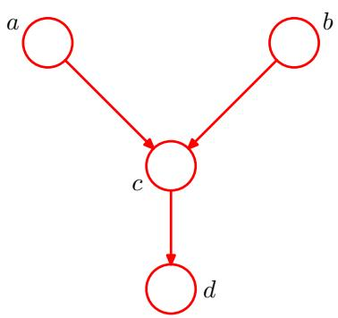
8.10 () Consider the directed graph shown in Figure 8.54 in which none of the variables is observed. Show that $a⟂⟂b∣∅$ . Suppose we now observe the variable d. Show that in general $a⟂̸b∣d.$
8.11 ( ) Consider the example of the car fuel system shown in Figure 8.21, and suppose that instead of observing the state of the fuel gauge G directly, the gauge is seen by the driver D who reports to us the reading on the gauge. This report is either that the gauge shows full $D=1$ or that it shows empty $D=0$ . Our driver is a bit unreliable, as expressed through the following probabilities
$$p(D=1|G=1)=0.9$$
$$p(D=0|G=0)=0.9.$$
Suppose that the driver tells us that the fuel gauge shows empty, in other words that we observe $D=0$ . Evaluate the probability that the tank is empty given only this observation. Similarly, evaluate the corresponding probability given also the observation that the battery is flat, and note that this second probability is lower. Discuss the intuition behind this result, and relate the result to Figure 8.54.
8.12 () www Show that there are $2^{M(M−1)/2}$ distinct undirected graphs over a set of M distinct random variables. Draw the 8 possibilities for the case of $M=3$
8.13 () Consider the use of iterated conditional modes (ICM) to minimize the energy function given by (8.42). Write down an expression for the difference in the values of the energy associated with the two states of a particular variable $x_{j}$ , with all other variables held fixed, and show that it depends only on quantities that are local to $x_{j}$ in the graph.
8.14 () Consider a particular case of the energy function given by (8.42) in which the coefficients $β=h=0$ . Show that the most probable configuration of the latent variables is given by $x_{i}=y_{i}$ for all i.
8.15 ( ) www Show that the joint distribution $p(x_{n−1},x_{n})$ for two neighbouring nodes in the graph shown in Figure 8.38 is given by an expression of the form (8.58).
8.16 ( ) Consider the inference problem of evaluating $p(x_{n}|x_{N})$ for the graph shown in Figure 8.38, for all nodes $n∈\{1,…,N−1\}$ . Show that the message passing algorithm discussed in Section 8.4.1 can be used to solve this efficiently, and discuss which messages are modified and in what way.
8.17 ( ) Consider a graph of the form shown in Figure 8.38 having $N=5$ nodes, in which nodes $x_{3}$ and $x_{5}$ are observed. Use d-separation to show that $x_{2}⟂⟂x_{5}∣x_{3}$ Show that if the message passing algorithm of Section 8.4.1 is applied to the evaluation of $p(x_{2}|x_{3},x_{5})$ , the result will be independent of the value of $x_{5}$
8.18 ( ) www Show that a distribution represented by a directed tree can trivially be written as an equivalent distribution over the corresponding undirected tree. Also show that a distribution expressed as an undirected tree can, by suitable normalization of the clique potentials, be written as a directed tree. Calculate the number of distinct directed trees that can be constructed from a given undirected tree.
8.19 ( ) Apply the sum-product algorithm derived in Section 8.4.4 to the chain-ofnodes model discussed in Section 8.4.1 and show that the results (8.54), (8.55), and (8.57) are recovered as a special case.
8.20 () www Consider the message passing protocol for the sum-product algorithm on a tree-structured factor graph in which messages are first propagated from the leaves to an arbitrarily chosen root node and then from the root node out to the leaves. Use proof by induction to show that the messages can be passed in such an order that at every step, each node that must send a message has received all of the incoming messages necessary to construct its outgoing messages.
8.21 ( ) www Show that the marginal distributions $p(x_{s})$ over the sets of variables $x_{s}$ associated with each of the factors $f_{x}(x_{s})$ in a factor graph can be found by first running the sum-product message passing algorithm and then evaluating the required marginals using (8.72).
8.22 () Consider a tree-structured factor graph, in which a given subset of the variable nodes form a connected subgraph (i.e., any variable node of the subset is connected to at least one of the other variable nodes via a single factor node). Show how the sum-product algorithm can be used to compute the marginal distribution over that subset.
8.23 ( ) www In Section 8.4.4, we showed that the marginal distribution $p(x_{i})$ for a variable node $x_{i}$ in a factor graph is given by the product of the messages arriving at this node from neighbouring factor nodes in the form (8.63). Show that the marginal $p(x_{i})$ can also be written as the product of the incoming message along any one of the links with the outgoing message along the same link.
8.24 ( ) Show that the marginal distribution for the variables $x_{s}$ in a factor $f_{s}(x_{s})$ in a tree-structured factor graph, after running the sum-product message passing algorithm, can be written as the product of the message arriving at the factor node along all its links, times the local factor $f(x_{s})$ , in the form (8.72).
8.25 $(⋆⋆)$ In (8.86), we verified that the sum-product algorithm run on the graph in Figure 8.51 with node $x_{3}$ designated as the root node gives the correct marginal for $x_{2}$ . Show that the correct marginals are obtained also for $x_{1}$ and $x_{3}$ . Similarly, show that the use of the result (8.72) after running the sum-product algorithm on this graph gives the correct joint distribution for $x_{1},x_{2}$
8.26 () Consider a tree-structured factor graph over discrete variables, and suppose we wish to evaluate the joint distribution $p(x_{a},x_{b})$ associated with two variables $x_{a}$ and $x_{b}$ that do not belong to a common factor. Define a procedure for using the sumproduct algorithm to evaluate this joint distribution in which one of the variables is successively clamped to each of its allowed values.
8.27 ( ) Consider two discrete variables x and y each having three possible states, for example $x,y∈\{0,1,2\}$ . Construct a joint distribution $p(x,y)$ over these variables having the property that the value $\hat{x}$ that maximizes the marginal $p(x)$ , along with the value $\hat{y}$ that maximizes the marginal $p(y)$ , together have probability zero under the joint distribution, so that $p(\hat{x},\hat{y})=0$
8.28 ( ) www The concept of a pending message in the sum-product algorithm for a factor graph was defined in Section 8.4.7. Show that if the graph has one or more cycles, there will always be at least one pending message irrespective of how long the algorithm runs.
8.29 ( ) www Show that if the sum-product algorithm is run on a factor graph with a tree structure (no loops), then after a finite number of messages have been sent, there will be no pending messages.

Mixture Models and EM

If we define a joint distribution over observed and latent variables, the corresponding distribution of the observed variables alone is obtained by marginalization. This allows relatively complex marginal distributions over observed variables to be expressed in terms of more tractable joint distributions over the expanded space of observed and latent variables. The introduction of latent variables thereby allows complicated distributions to be formed from simpler components. In this chapter, we shall see that mixture distributions, such as the Gaussian mixture discussed in Section 2.3.9, can be interpreted in terms of discrete latent variables. Continuous latent variables will form the subject of Chapter 12.
As well as providing a framework for building more complex probability distributions, mixture models can also be used to cluster data. We therefore begin our discussion of mixture distributions by considering the problem of finding clusters in a set of data points, which we approach first using a nonprobabilistic technique called the K-means algorithm (Lloyd, 1982). Then we introduce the latent variable view of mixture distributions in which the discrete latent variables can be interpreted as defining assignments of data points to specific components of the mixture. A general technique for finding maximum likelihood estimators in latent variable models is the expectation-maximization (EM) algorithm. We first of all use the Gaussian mixture distribution to motivate the EM algorithm in a fairly informal way, and then we give a more careful treatment based on the latent variable viewpoint. We shall see that the K-means algorithm corresponds to a particular nonprobabilistic limit of EM applied to mixtures of Gaussians. Finally, we discuss EM in some generality.
Gaussian mixture models are widely used in data mining, pattern recognition, machine learning, and statistical analysis. In many applications, their parameters are determined by maximum likelihood, typically using the EM algorithm. However, as we shall see there are some significant limitations to the maximum likelihood approach, and in Chapter 10 we shall show that an elegant Bayesian treatment can be given using the framework of variational inference. This requires little additional computation compared with EM, and it resolves the principal difficulties of maximum likelihood while also allowing the number of components in the mixture to be inferred automatically from the data.

9.1. K-means Clustering
We begin by considering the problem of identifying groups, or clusters, of data points in a multidimensional space. Suppose we have a data set $\left\{x_{1},…,x_{N}\right\}$ consisting of N observations of a random D-dimensional Euclidean variable x. Our goal is to partition the data set into some number K of clusters, where we shall suppose for the moment that the value of K is given. Intuitively, we might think of a cluster as comprising a group of data points whose inter-point distances are small compared with the distances to points outside of the cluster. We can formalize this notion by first introducing a set of D-dimensional vectors $μ_{k}$ , where $k=1,…,K$ , in which $μ_{k}$ is a prototype associated with the $k^{th}$ cluster. As we shall see shortly, we can think of the $μ_{k}$ as representing the centres of the clusters. Our goal is then to find an assignment of data points to clusters, as well as a set of vectors $\{μ_{k}\}$ , such that the sum of the squares of the distances of each data point to its closest vector $μ_{k}$ , is a minimum.
It is convenient at this point to define some notation to describe the assignment of data points to clusters. For each data point $x_{n}.$ , we introduce a corresponding set of binary indicator variables $r_{nk}∈\{0,1\}$ , where $k=1,…,K$ describing which of the K clusters the data point ${ \bf x } _ { n }$ is assigned to, so that if data point ${ \bf x } _ { n }$ is assigned to cluster k then $r_{nk}=1$ , and $r_{nj}=0$ for $j≠k$ . This is known as the 1-of-K coding scheme. We can then define an objective function, sometimes called a distortion measure, given by
$$J=\sum_{n=1}^{N}{\sum_{k=1}^{K}{r_{nk}}}∥x_{n}−μ_{k}∥^{2}$$
which represents the sum of the squares of the distances of each data point to its assigned vector $μ_{k}$ . Our goal is to find values for the $\{r_{nk}\}$ and the $\{μ_{k}\}$ so as to minimize J. We can do this through an iterative procedure in which each iteration involves two successive steps corresponding to successive optimizations with respect to the $r_{nk}$ and the $μ_{k}$ . First we choose some initial values for the $μ_{k}$ . Then in the first phase we minimize J with respect to the $r_{nk}$ , keeping the $μ_{k}$ fixed. In the second phase we minimize J with respect to the $μ_{k}$ , keeping $r_{nk}$ fixed. This two-stage optimization is then repeated until convergence. We shall see that these two stages of updating $r_{nk}$ and updating $μ_{k}$ correspond respectively to the E (expectation) and M (maximization) steps of the EM algorithm, and to emphasize this we shall use the terms E step and M step in the context of the K-means algorithm.
Consider first the determination of the $r_{nk}$ . Because J in (9.1) is a linear function of $r_{nk}$ , this optimization can be performed easily to give a closed form solution. The terms involving different n are independent and so we can optimize for each n separately by choosing $r_{nk}$ to be 1 for whichever value of k gives the minimum value of $∥x_{n}−μ_{k}∥^{2}$ . In other words, we simply assign the $n^{th}$ data point to the closest cluster centre. More formally, this can be expressed as
$$r_{nk}=\left\{\begin{matrix}1 & \text{ if }k=arg\min_{j}∥x_{n}−μ_{j}∥^{2} \\ 0 & \text{ otherwise. }\end{matrix}\right.$$
Now consider the optimization of the $μ_{k}$ with the $r_{nk}$ held fixed. The objective function J is a quadratic function of $μ_{k}$ , and it can be minimized by setting its derivative with respect to $μ_{k}$ to zero giving
$$2\sum_{n=1}^{N}{r_{nk}}(x_{n}−μ_{k})=0$$
which we can easily solve for $μ_{k}$ to give
μk=n​rnkxnn​rnk.
The denominator in this expression is equal to the number of points assigned to cluster $k,$ and so this result has a simple interpretation, namely set $μ_{k}$ equal to the mean of all of the data points ${ \bf x } _ { n }$ assigned to cluster k. For this reason, the procedure is known as the K-means algorithm.
The two phases of re-assigning data points to clusters and re-computing the cluster means are repeated in turn until there is no further change in the assignments (or until some maximum number of iterations is exceeded). Because each phase reduces the value of the objective function J, convergence of the algorithm is assured. However, it may converge to a local rather than global minimum of J. The convergence properties of the K-means algorithm were studied by MacQueen (1967).
The K-means algorithm is illustrated using the Old Faithful data set in Figure 9.1. For the purposes of this example, we have made a linear re-scaling of the data, known as standardizing, such that each of the variables has zero mean and unit standard deviation. For this example, we have chosen $K=2$ , and so in this case, the assignment of each data point to the nearest cluster centre is equivalent to a classification of the data points according to which side they lie of the perpendicular bisector of the two cluster centres. A plot of the cost function J given by (9.1) for the Old Faithful example is shown in Figure 9.2.
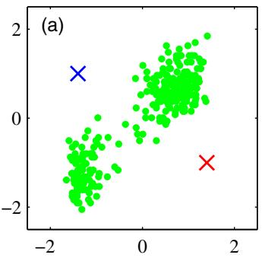
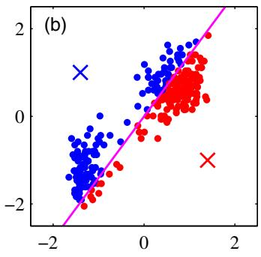
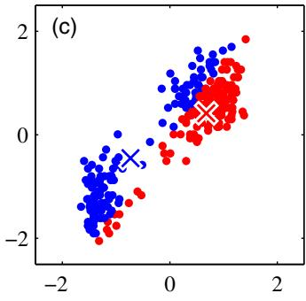
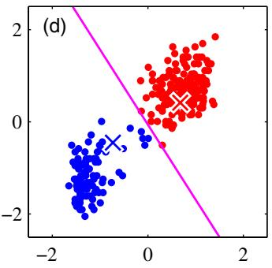
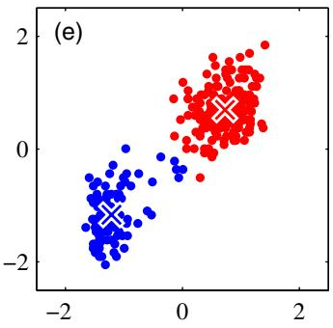
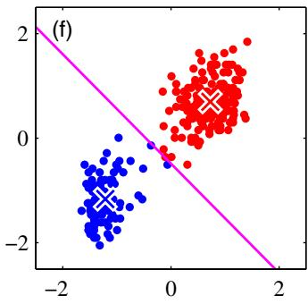
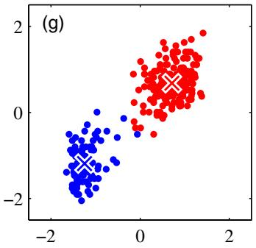
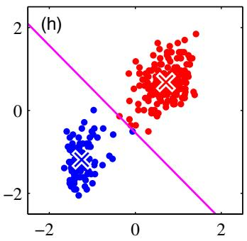
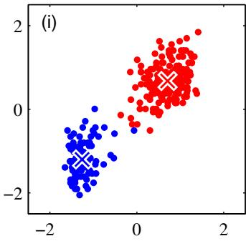
Figure 9.1 Illustration of the K-means algorithm using the re-scaled Old Faithful data set. (a) Green points denote the data set in a two-dimensional Euclidean space. The initial choices for centres $μ_{1}$ and $μ_{2}$ are shown by the red and blue crosses, respectively. (b) In the initial E step, each data point is assigned either to the red cluster or to the blue cluster, according to which cluster centre is nearer. This is equivalent to classifying the points according to which side of the perpendicular bisector of the two cluster centres, shown by the magenta line, they lie on. (c) In the subsequent M step, each cluster centre is re-computed to be the mean of the points assigned to the corresponding cluster. (d)–(i) show successive E and M steps through to final convergence of the algorithm.
Plot of the cost function J given by (9.1) after each E step (blue points) and M step (red points) of the Kmeans algorithm for the example shown in Figure 9.1. The algorithm has converged after the third M step, and the final EM cycle produces no changes in either the assignments or the prototype vectors.
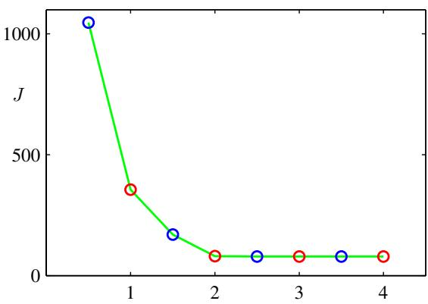
Note that we have deliberately chosen poor initial values for the cluster centres so that the algorithm takes several steps before convergence. In practice, a better initialization procedure would be to choose the cluster centres $μ_{k}$ to be equal to a random subset of K data points. It is also worth noting that the K-means algorithm itself is often used to initialize the parameters in a Gaussian mixture model before applying the EM algorithm.
A direct implementation of the K-means algorithm as discussed here can be relatively slow, because in each E step it is necessary to compute the Euclidean distance between every prototype vector and every data point. Various schemes have been proposed for speeding up the K-means algorithm, some of which are based on precomputing a data structure such as a tree such that nearby points are in the same subtree (Ramasubramanian and Paliwal, 1990; Moore, 2000). Other approaches make use of the triangle inequality for distances, thereby avoiding unnecessary distance calculations (Hodgson, 1998; Elkan, 2003).
So far, we have considered a batch version of K-means in which the whole data set is used together to update the prototype vectors. We can also derive an on-line stochastic algorithm (MacQueen, 1967) by applying the Robbins-Monro procedure to the problem of finding the roots of the regression function given by the derivatives of J in (9.1) with respect to $μ_{k}$ . This leads to a sequential update in which, for each data point ${ \bf x } _ { n }$ in turn, we update the nearest prototype $μ_{k}$ using
$$μ_{k}^{new}=μ_{k}^{old}+η_{n}(x_{n}−μ_{k}^{old})$$
where $η_{n}$ is the learning rate parameter, which is typically made to decrease monotonically as more data points are considered.
The K-means algorithm is based on the use of squared Euclidean distance as the measure of dissimilarity between a data point and a prototype vector. Not only does this limit the type of data variables that can be considered (it would be inappropriate for cases where some or all of the variables represent categorical labels for instance), but it can also make the determination of the cluster means nonrobust to outliers. We can generalize the K-means algorithm by introducing a more general dissimilarity measure $V(x,x^{′})$ between two vectors x and $x^{′}$ and then minimizing the following distortion measure
$$\tilde{J}=\sum_{n=1}^{N}{\sum_{k=1}^{K}{r_{nk}}}V(x_{n},μ_{k})$$
which gives the K-medoids algorithm. The E step again involves, for given cluster prototypes $μ_{k}$ , assigning each data point to the cluster for which the dissimilarity to the corresponding prototype is smallest. The computational cost of this is $O(KN)$ as is the case for the standard K-means algorithm. For a general choice of dissimilarity measure, the M step is potentially more complex than for K-means, and so it is common to restrict each cluster prototype to be equal to one of the data vectors assigned to that cluster, as this allows the algorithm to be implemented for any choice of dissimilarity measure $V(⋅,⋅)$ so long as it can be readily evaluated. Thus the M step involves, for each cluster k, a discrete search over the $N_{k}$ points assigned to that cluster, which requires $O(N_{k}^{2})$ evaluations of $V(⋅,⋅)$
One notable feature of the K-means algorithm is that at each iteration, every data point is assigned uniquely to one, and only one, of the clusters. Whereas some data points will be much closer to a particular centre $μ_{k}$ than to any other centre, there may be other data points that lie roughly midway between cluster centres. In the latter case, it is not clear that the hard assignment to the nearest cluster is the most appropriate. We shall see in the next section that by adopting a probabilistic approach, we obtain ‘soft’ assignments of data points to clusters in a way that reflects the level of uncertainty over the most appropriate assignment. This probabilistic formulation brings with it numerous benefits.

9.1.1 Image segmentation and compression
As an illustration of the application of the K-means algorithm, we consider the related problems of image segmentation and image compression. The goal of segmentation is to partition an image into regions each of which has a reasonably homogeneous visual appearance or which corresponds to objects or parts of objects (Forsyth and Ponce, 2003). Each pixel in an image is a point in a 3-dimensional space comprising the intensities of the red, blue, and green channels, and our segmentation algorithm simply treats each pixel in the image as a separate data point. Note that strictly this space is not Euclidean because the channel intensities are bounded by the interval [0, 1]. Nevertheless, we can apply the K-means algorithm without difficulty. We illustrate the result of running K-means to convergence, for any particular value of K, by re-drawing the image replacing each pixel vector with the $\{R,G,B\}$ intensity triplet given by the centre $μ_{k}$ to which that pixel has been assigned. Results for various values of K are shown in Figure 9.3. We see that for a given value of K, the algorithm is representing the image using a palette of only K colours. It should be emphasized that this use of K-means is not a particularly sophisticated approach to image segmentation, not least because it takes no account of the spatial proximity of different pixels. The image segmentation problem is in general extremely difficult and remains the subject of active research and is introduced here simply to illustrate the behaviour of the K-means algorithm.
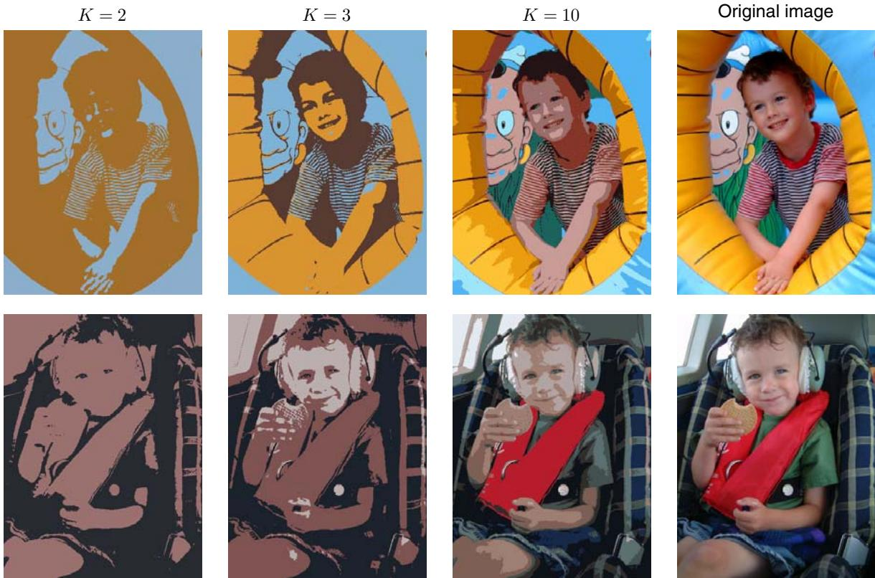
Figure 9.3 Two examples of the application of the K-means clustering algorithm to image segmentation showing the initial images together with their K-means segmentations obtained using various values of K. This also illustrates of the use of vector quantization for data compression, in which smaller values of K give higher compression at the expense of poorer image quality.
We can also use the result of a clustering algorithm to perform data compression. It is important to distinguish between lossless data compression, in which the goal is to be able to reconstruct the original data exactly from the compressed representation, and lossy data compression, in which we accept some errors in the reconstruction in return for higher levels of compression than can be achieved in the lossless case. We can apply the K-means algorithm to the problem of lossy data compression as follows. For each of the N data points, we store only the identity k of the cluster to which it is assigned. We also store the values of the K cluster centres $μ_{k}$ , which typically requires significantly less data, provided we choose $K≪N$ . Each data point is then approximated by its nearest centre $μ_{k}$ . New data points can similarly be compressed by first finding the nearest $μ_{k}$ and then storing the label k instead of the original data vector. This framework is often called vector quantization, and the vectors $μ_{k}$ are called code-book vectors.
The image segmentation problem discussed above also provides an illustration of the use of clustering for data compression. Suppose the original image has N pixels comprising $\{ R , { \cal G } , B \}$ values each of which is stored with 8 bits of precision. Then to transmit the whole image directly would cost 24N bits. Now suppose we first run K-means on the image data, and then instead of transmitting the original pixel intensity vectors we transmit the identity of the nearest vector $μ_{k}$ . Because there are K such vectors, this requires log K bits per pixel. We must also transmit the K code book vectors $μ_{k}$ , which requires 24K bits, and so the total number of bits required to transmit the image is $2\overset{‾}{4}K+N\log_{2}K$ (rounding up to the nearest integer). The original image shown in Figure 9.3 has $240×180=43$ , 200 pixels and so requires $24×43,200=1,036$ , 800 bits to transmit directly. By comparison, the compressed images require 43, 248 bits $(K=2)$ , 86, 472 bits $(K=3)$ , and 173, 040 bits $(K=10)$ , respectively, to transmit. These represent compression ratios compared to the original image of 4.2%, 8.3%, and 16.7%, respectively. We see that there is a trade-off between degree of compression and image quality. Note that our aim in this example is to illustrate the K-means algorithm. If we had been aiming to produce a good image compressor, then it would be more fruitful to consider small blocks of adjacent pixels, for instance $5×5$ , and thereby exploit the correlations that exist in natural images between nearby pixels.

9.2. Mixtures of Gaussians
In Section 2.3.9 we motivated the Gaussian mixture model as a simple linear superposition of Gaussian components, aimed at providing a richer class of density models than the single Gaussian. We now turn to a formulation of Gaussian mixtures in terms of discrete latent variables. This will provide us with a deeper insight into this important distribution, and will also serve to motivate the expectation-maximization algorithm.
Recall from (2.188) that the Gaussian mixture distribution can be written as a linear superposition of Gaussians in the form
$$p(x)=\sum_{k=1}^{K}{π_{k}}N(x|μ_{k},Σ_{k}).$$
Let us introduce a K-dimensional binary random variable z having a 1-of-K representation in which a particular element $z_{k}$ is equal to 1 and all other elements are equal to 0. The values of $z_{k}$ therefore satisfy $z_{k}∈\{0,1\}$ and k​zk=1 , and we see that there are K possible states for the vector z according to which element is nonzero. We shall define the joint distribution $p(x,z)$ in terms of a marginal distribution $p(z)$ and a conditional distribution $p(x|z)$ , corresponding to the graphical model in Figure 9.4. The marginal distribution over z is specified in terms of the mixing coefficients $π_{k}$ , such that
$$p(z_{k}=1)=π_{k}$$
Figure 9.4 Graphical representation of a mixture model, in which the joint distribution is expressed in the form $p(x,z) =$ $p(z)p(x|z)$
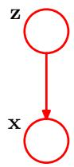
where the parameters $\left\{π_{k}\right\}$ must satisfy
$$0≤π_{k}≤1$$
together with
$$\sum_{k=1}^{K}{π_{k}}=1$$
in order to be valid probabilities. Because z uses a 1-of-K representation, we can also write this distribution in the form
$$p(z)=\prod_{k=1}^{K}{π_{k}^{z_{k}}}.$$
Similarly, the conditional distribution of x given a particular value for z is a Gaussian
$$p(x|z_{k}=1)=N(x|μ_{k},Σ_{k})$$
which can also be written in the form
$$p(x|z)=\prod_{k=1}^{K}{N}(x|μ_{k},Σ_{k})^{z_{k}}.$$
Exercise 9.3
The joint distribution is given by $p(z)p(x|z)$ , and the marginal distribution of x is then obtained by summing the joint distribution over all possible states of z to give
p(x)=z​p(z)p(x|z)=k=1KπkN(x|μk,Σk)
where we have made use of (9.10) and (9.11). Thus the marginal distribution of x is a Gaussian mixture of the form (9.7). If we have several observations $x_{1},…,x_{N}$ then, because we have represented the marginal distribution in the form $p(x)α=α$ z​p(x,z) , it follows that for every observed data point ${ \bf x } _ { n }$ there is a corresponding latent variable $z_{n}$
We have therefore found an equivalent formulation of the Gaussian mixture involving an explicit latent variable. It might seem that we have not gained much by doing so. However, we are now able to work with the joint distribution $p(x,z)$
instead of the marginal distribution $p(x)$ , and this will lead to significant simplifications, most notably through the introduction of the expectation-maximization (EM) algorithm.
Another quantity that will play an important role is the conditional probability of z given x. We shall use $γ(z_{k})$ to denote $p(z_{k}=1|x)$ , whose value can be found using Bayes’ theorem
$$\begin{matrix}γ(z_{k})≡p(z_{k}=1|x) & = & \frac{p(z_{k}=1)p(x|z_{k}=1)}{K} \\ & & \sum_{j=1}^{K}{p}(z_{j}=1)p(x|z_{j}=1) \\ & = & \frac{π_{k}N(x|μ_{k},Σ_{k})}{K}. \\ & & \sum_{j=1}^{K}{π_{j}}N(x|μ_{j},Σ_{j})\end{matrix}$$
We shall view $π_{k}$ as the prior probability of $z_{k}=1$ , and the quantity $γ(z_{k})$ as the corresponding posterior probability once we have observed x. As we shall see later, $γ(z_{k})$ can also be viewed as the responsibility that component k takes for ‘explaining’ the observation x.
We can use the technique of ancestral sampling to generate random samples distributed according to the Gaussian mixture model. To do this, we first generate a value for $z,$ which we denote $\hat{z},$ , from the marginal distribution $p(z)$ and then generate a value for x from the conditional distribution $p(x|\hat{z})$ . Techniques for sampling from standard distributions are discussed in Chapter 11. We can depict samples from the joint distribution $p(x,z)$ by plotting points at the corresponding values of x and then colouring them according to the value of $z,$ in other words according to which Gaussian component was responsible for generating them, as shown in Figure 9.5(a). Similarly samples from the marginal distribution $p(x)$ are obtained by taking the samples from the joint distribution and ignoring the values of $z.$ . These are illustrated in Figure 9.5(b) by plotting the x values without any coloured labels.
We can also use this synthetic data set to illustrate the ‘responsibilities’ by evaluating, for every data point, the posterior probability for each component in the mixture distribution from which this data set was generated. In particular, we can represent the value of the responsibilities $γ(z_{nk})$ associated with data point ${ \bf x } _ { n }$ by plotting the corresponding point using proportions of red, blue, and green ink given by $γ(z_{nk})$ for $k=1,2,3$ , respectively, as shown in Figure 9.5(c). So, for instance, a data point for which $γ(z_{n1})=1$ will be coloured red, whereas one for which $γ(z_{n2})=γ(z_{n3})=0.5$ will be coloured with equal proportions of blue and green ink and so will appear cyan. This should be compared with Figure 9.5(a) in which the data points were labelled using the true identity of the component from which they were generated.

9.2.1 Maximum likelihood
Suppose we have a data set of observations $\left\{x_{1},…,x_{N}\right\}$ , and we wish to model this data using a mixture of Gaussians. We can represent this data set as an $N×D$ matrix X in which the $n^{th}$ row is given by ${ \bf x } _ { n } ^ { \mathrm { T } }$ . Similarly, the corresponding latent variables will be denoted by an $N×K$ matrix Z with rows ${ \bf z } _ { n } ^ { \mathrm { T } }$ . If we assume that the data points are drawn independently from the distribution, then we can express the Gaussian mixture model for this i.i.d. data set using the graphical representation shown in Figure 9.6. From (9.7) the log of the likelihood function is given by
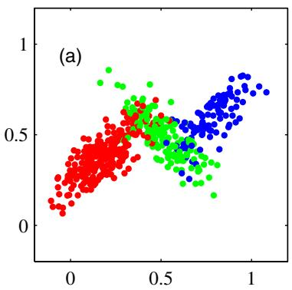
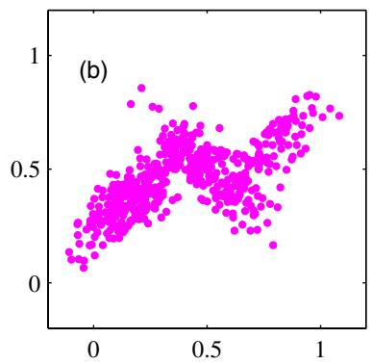
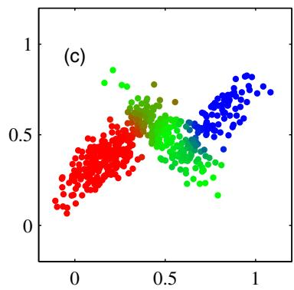
Figure 9.5 Example of 500 points drawn from the mixture of 3 Gaussians shown in Figure 2.23. (a) Samples from the joint distribution $p(z)p(x|z)$ in which the three states of z, corresponding to the three components of the mixture, are depicted in red, green, and blue, and (b) the corresponding samples from the marginal distribution $p(x)$ , which is obtained by simply ignoring the values of z and just plotting the x values. The data set in (a) is said to be complete, whereas that in (b) is incomplete. (c) The same samples in which the colours represent the value of the responsibilities $γ(z_{nk})$ associated with data point $x_{n},$ obtained by plotting the corresponding point using proportions of red, blue, and green ink given by $γ(z_{nk})$ for $k=1$ , 2, 3, respectively
$$lnp(X|π,μ,Σ)=\sum_{n=1}^{N}{ln}\left\{\sum_{k=1}^{K}{π_{k}}N(x_{n}|μ_{k},Σ_{k})\right\}.$$
Before discussing how to maximize this function, it is worth emphasizing that there is a significant problem associated with the maximum likelihood framework applied to Gaussian mixture models, due to the presence of singularities. For simplicity, consider a Gaussian mixture whose components have covariance matrices given by $Σ_{k}=σ_{k}^{2}I$ , where I is the unit matrix, although the conclusions will hold for general covariance matrices. Suppose that one of the components of the mixture model, let us say the $j^{th}$ component, has its mean $μ_{j}$ exactly equal to one of the data points so that $μ_{j}=x_{n}$ for some value of n. This data point will then contribute a term in the likelihood function of the form
Figure 9.6 Graphical representation of a Gaussian mixture model for a set of N i.i.d. data points $\left\{x_{n}\right\}$ , with corresponding latent points $\left\{z_{n}\right\}$ , where $n=1,…,N$
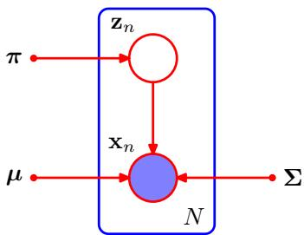
Illustration of how singularities in the likelihood function arise with mixtures of Gaussians. This should be compared with the case of a single Gaussian shown in Figure 1.14 for which no singularities arise.
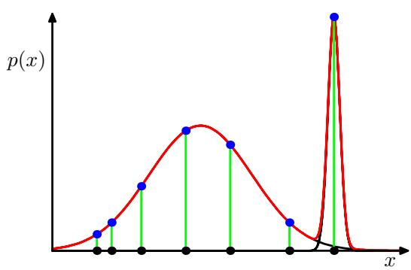
$$N(x_{n}|x_{n},σ_{j}^{2}I)=\frac{1}{(2π)^{1/2}}\frac{1}{σ_{j}}.$$
If we consider the limit $σ_{j} → 0$ , then we see that this term goes to infinity and so the log likelihood function will also go to infinity. Thus the maximization of the log likelihood function is not a well posed problem because such singularities will always be present and will occur whenever one of the Gaussian components ‘collapses’ onto a specific data point. Recall that this problem did not arise in the case of a single Gaussian distribution. To understand the difference, note that if a single Gaussian collapses onto a data point it will contribute multiplicative factors to the likelihood function arising from the other data points and these factors will go to zero exponentially fast, giving an overall likelihood that goes to zero rather than infinity. However, once we have (at least) two components in the mixture, one of the components can have a finite variance and therefore assign finite probability to all of the data points while the other component can shrink onto one specific data point and thereby contribute an ever increasing additive value to the log likelihood. This is illustrated in Figure 9.7. These singularities provide another example of the severe over-fitting that can occur in a maximum likelihood approach. We shall see that this difficulty does not occur if we adopt a Bayesian approach. For the moment, however, we simply note that in applying maximum likelihood to Gaussian mixture models we must take steps to avoid finding such pathological solutions and instead seek local maxima of the likelihood function that are well behaved. We can hope to avoid the singularities by using suitable heuristics, for instance by detecting when a Gaussian component is collapsing and resetting its mean to a randomly chosen value while also resetting its covariance to some large value, and then continuing with the optimization.
A further issue in finding maximum likelihood solutions arises from the fact that for any given maximum likelihood solution, a K-component mixture will have a total of K! equivalent solutions corresponding to the K! ways of assigning K sets of parameters to K components. In other words, for any given (nondegenerate) point in the space of parameter values there will be a further $K!−1$ additional points all of which give rise to exactly the same distribution. This problem is known as identifiability (Casella and Berger, 2002) and is an important issue when we wish to interpret the parameter values discovered by a model. Identifiability will also arise when we discuss models having continuous latent variables in Chapter 12. However, for the purposes of finding a good density model, it is irrelevant because any of the equivalent solutions is as good as any other.
Maximizing the log likelihood function (9.14) for a Gaussian mixture model turns out to be a more complex problem than for the case of a single Gaussian. The difficulty arises from the presence of the summation over k that appears inside the logarithm in (9.14), so that the logarithm function no longer acts directly on the Gaussian. If we set the derivatives of the log likelihood to zero, we will no longer obtain a closed form solution, as we shall see shortly.
One approach is to apply gradient-based optimization techniques (Fletcher, 1987; Nocedal and Wright, 1999; Bishop and Nabney, 2008). Although gradient-based techniques are feasible, and indeed will play an important role when we discuss mixture density networks in Chapter 5, we now consider an alternative approach known as the EM algorithm which has broad applicability and which will lay the foundations for a discussion of variational inference techniques in Chapter 10.

9.2.2 EM for Gaussian mixtures
An elegant and powerful method for finding maximum likelihood solutions for models with latent variables is called the expectation-maximization algorithm, or EM algorithm (Dempster et al., 1977; McLachlan and Krishnan, 1997). Later we shall give a general treatment of EM, and we shall also show how EM can be generalized to obtain the variational inference framework. Initially, we shall motivate the EM algorithm by giving a relatively informal treatment in the context of the Gaussian mixture model. We emphasize, however, that EM has broad applicability, and indeed it will be encountered in the context of a variety of different models in this book.
Let us begin by writing down the conditions that must be satisfied at a maximum of the likelihood function. Setting the derivatives of ln $p ( { \bf X } | \pi , \mu , \Sigma )$ in (9.14) with respect to the means $μ_{k}$ of the Gaussian components to zero, we obtain
0=−n=1NπkN(xn|μk,Σk)j​πjN(xn|μj,Σj)⏟γ(znk)Σk(xn−μk)
where we have made use of the form (2.43) for the Gaussian distribution. Note that the posterior probabilities, or responsibilities, given by (9.13) appear naturally on the right-hand side. Multiplying by $Σ_{k}^{−1}$ (which we assume to be nonsingular) and rearranging we obtain
$$μ_{k}=\frac{1}{N_{k}}\sum_{n=1}^{N}{γ}(z_{nk})x_{n}$$
where we have defined
$$N_{k}=\sum_{n=1}^{N}{γ}(z_{nk}).$$
We can interpret $N_{k}$ as the effective number of points assigned to cluster k. Note carefully the form of this solution. We see that the mean $μ_{k}$ for the $k^{th}$ Gaussian component is obtained by taking a weighted mean of all of the points in the data set, in which the weighting factor for data point ${ \bf x } _ { n }$ is given by the posterior probability $γ(z_{nk})$ that component k was responsible for generating ${ \bf x } _ { n }$
If we set the derivative of ln $p ( { \bf X } | \pi , \mu , \Sigma )$ with respect to $Σ_{k}$ to zero, and follow a similar line of reasoning, making use of the result for the maximum likelihood solution for the covariance matrix of a single Gaussian, we obtain
$$Σ_{k}=\frac{1}{N_{k}}\sum_{n=1}^{N}{γ}(z_{nk})(x_{n}−μ_{k})(x_{n}−μ_{k})^{T}$$
which has the same form as the corresponding result for a single Gaussian fitted to the data set, but again with each data point weighted by the corresponding posterior probability and with the denominator given by the effective number of points associated with the corresponding component.
Finally, we maximize ln $p ( { \bf X } | \pi , \mu , \Sigma )$ with respect to the mixing coefficients $π_{k}$ . Here we must take account of the constraint (9.9), which requires the mixing coefficients to sum to one. This can be achieved using a Lagrange multiplier and maximizing the following quantity
$$lnp(X|π,μ,Σ)+λ\left(\sum_{k=1}^{K}{π_{k}}−1\right)$$
which gives
0=n=1NN(xn|μk,Σk)j​πjN(xn|μj,Σj)+λ
where again we see the appearance of the responsibilities. If we now multiply both sides by $π_{k}$ and sum over k making use of the constraint (9.9), we find $λ=−N$ Using this to eliminate λ and rearranging we obtain
$$π_{k}=\frac{N_{k}}{N}$$
so that the mixing coefficient for the $k^{th}$ component is given by the average responsibility which that component takes for explaining the data points.
It is worth emphasizing that the results (9.17), (9.19), and (9.22) do not constitute a closed-form solution for the parameters of the mixture model because the responsibilities $γ(z_{nk})$ depend on those parameters in a complex way through (9.13). However, these results do suggest a simple iterative scheme for finding a solution to the maximum likelihood problem, which as we shall see turns out to be an instance of the EM algorithm for the particular case of the Gaussian mixture model. We first choose some initial values for the means, covariances, and mixing coefficients. Then we alternate between the following two updates that we shall call the E step and the M step, for reasons that will become apparent shortly. In the expectation step, or E step, we use the current values for the parameters to evaluate the posterior probabilities, or responsibilities, given by (9.13). We then use these probabilities in the maximization step, or M step, to re-estimate the means, covariances, and mixing coefficients using the results (9.17), (9.19), and (9.22). Note that in so doing we first evaluate the new means using (9.17) and then use these new values to find the covariances using (9.19), in keeping with the corresponding result for a single Gaussian distribution. We shall show that each update to the parameters resulting from an E step followed by an M step is guaranteed to increase the log likelihood function. In practice, the algorithm is deemed to have converged when the change in the log likelihood function, or alternatively in the parameters, falls below some threshold. We illustrate the EM algorithm for a mixture of two Gaussians applied to the rescaled Old Faithful data set in Figure 9.8. Here a mixture of two Gaussians is used, with centres initialized using the same values as for the K-means algorithm in Figure 9.1, and with precision matrices initialized to be proportional to the unit matrix. Plot (a) shows the data points in green, together with the initial configuration of the mixture model in which the one standard-deviation contours for the two
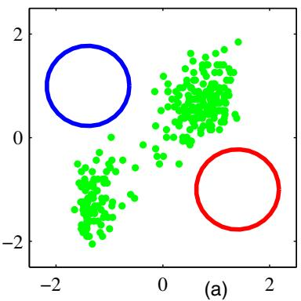
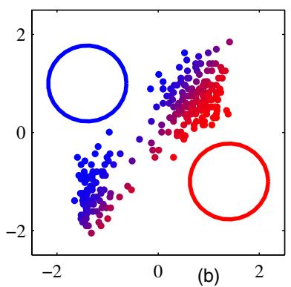
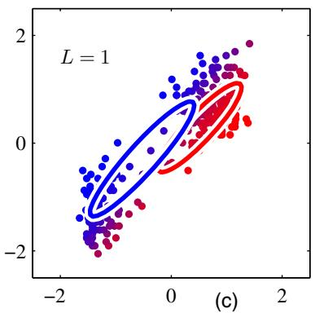
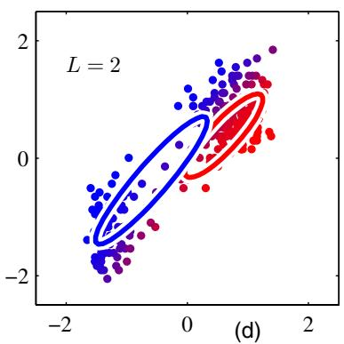
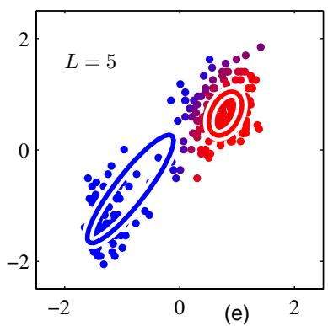
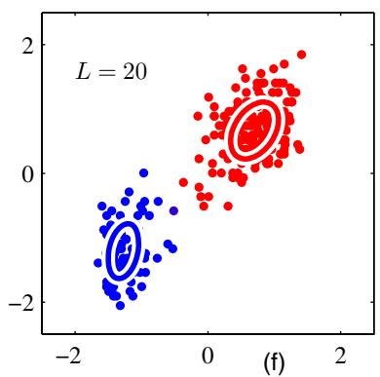
Figure 9.8 Illustration of the EM algorithm using the Old Faithful set as used for the illustration of the K-means algorithm in Figure 9.1. See the text for details.
Gaussian components are shown as blue and red circles. Plot (b) shows the result of the initial E step, in which each data point is depicted using a proportion of blue ink equal to the posterior probability of having been generated from the blue component, and a corresponding proportion of red ink given by the posterior probability of having been generated by the red component. Thus, points that have a significant probability for belonging to either cluster appear purple. The situation after the first M step is shown in plot (c), in which the mean of the blue Gaussian has moved to the mean of the data set, weighted by the probabilities of each data point belonging to the blue cluster, in other words it has moved to the centre of mass of the blue ink. Similarly, the covariance of the blue Gaussian is set equal to the covariance of the blue ink. Analogous results hold for the red component. Plots (d), (e), and (f) show the results after 2, 5, and 20 complete cycles of EM, respectively. In plot (f) the algorithm is close to convergence.
Note that the EM algorithm takes many more iterations to reach (approximate) convergence compared with the K-means algorithm, and that each cycle requires significantly more computation. It is therefore common to run the K-means algorithm in order to find a suitable initialization for a Gaussian mixture model that is subsequently adapted using EM. The covariance matrices can conveniently be initialized to the sample covariances of the clusters found by the K-means algorithm, and the mixing coefficients can be set to the fractions of data points assigned to the respective clusters. As with gradient-based approaches for maximizing the log likelihood, techniques must be employed to avoid singularities of the likelihood function in which a Gaussian component collapses onto a particular data point. It should be emphasized that there will generally be multiple local maxima of the log likelihood function, and that EM is not guaranteed to find the largest of these maxima. Because the EM algorithm for Gaussian mixtures plays such an important role, we summarize it below.

EM for Gaussian Mixtures
Given a Gaussian mixture model, the goal is to maximize the likelihood function with respect to the parameters (comprising the means and covariances of the components and the mixing coefficients).
- Initialize the means $μ_{k}$ , covariances $Σ_{k}$ and mixing coefficients $π_{k}$ , and evaluate the initial value of the log likelihood.
- E step. Evaluate the responsibilities using the current parameter values
$$γ(z_{nk})=\frac{π_{k}N(x_{n}|μ_{k},Σ_{k})}{\sum_{j=1}^{K}{π_{j}}N(x_{n}|μ_{j},Σ_{j})}.$$
- M step. Re-estimate the parameters using the current responsibilities
$$μ_{k}^{new}=\frac{1}{N_{k}}\sum_{n=1}^{N}{γ}(z_{nk})x_{n}$$
$$Σ_{k}^{new}=\frac{1}{N_{k}}\sum_{n=1}^{N}{γ}(z_{nk})(x_{n}−μ_{k}^{new})(x_{n}−μ_{k}^{new})^{T}$$
$$π_{k}^{new}=\frac{N_{k}}{N}$$
where
$$N_{k}=\sum_{n=1}^{N}{γ}(z_{nk}).$$
- Evaluate the log likelihood
$$lnp(X|μ,Σ,π)=\sum_{n=1}^{N}{ln}\left\{\sum_{k=1}^{K}{π_{k}}N(x_{n}|μ_{k},Σ_{k})\right\}$$
and check for convergence of either the parameters or the log likelihood. If the convergence criterion is not satisfied return to step 2.

9.3. An Alternative View of EM
In this section, we present a complementary view of the EM algorithm that recognizes the key role played by latent variables. We discuss this approach first of all in an abstract setting, and then for illustration we consider once again the case of Gaussian mixtures.
The goal of the EM algorithm is to find maximum likelihood solutions for models having latent variables. We denote the set of all observed data by X, in which the $n^{th}$ row represents $x_{n}^{T}.$ , and similarly we denote the set of all latent variables by Z, with a corresponding row $z_{n}^{T}$ . The set of all model parameters is denoted by θ, and so the log likelihood function is given by
lnp(X|θ)=lnZ​p(X,Z|θ).
Note that our discussion will apply equally well to continuous latent variables simply by replacing the sum over Z with an integral.
A key observation is that the summation over the latent variables appears inside the logarithm. Even if the joint distribution $p(X,Z|θ)$ belongs to the exponential family, the marginal distribution $p(X|θ)$ typically does not as a result of this summation. The presence of the sum prevents the logarithm from acting directly on the joint distribution, resulting in complicated expressions for the maximum likelihood solution.
Now suppose that, for each observation in X, we were told the corresponding value of the latent variable Z. We shall call $\{X,Z\}$ the complete data set, and we shall refer to the actual observed data X as incomplete, as illustrated in Figure 9.5. The likelihood function for the complete data set simply takes the form ln $p(X,Z|θ)$ and we shall suppose that maximization of this complete-data log likelihood function is straightforward.
In practice, however, we are not given the complete data set $\{X,Z\}$ , but only the incomplete data X. Our state of knowledge of the values of the latent variables in Z is given only by the posterior distribution $p(Z|X,θ)$ . Because we cannot use the complete-data log likelihood, we consider instead its expected value under the posterior distribution of the latent variable, which corresponds (as we shall see) to the E step of the EM algorithm. In the subsequent M step, we maximize this expectation. If the current estimate for the parameters is denoted $θ^{old}$ , then a pair of successive E and M steps gives rise to a revised estimate $θ^{new}$ . The algorithm is initialized by choosing some starting value for the parameters $θ_{0}$ . The use of the expectation may seem somewhat arbitrary. However, we shall see the motivation for this choice when we give a deeper treatment of EM in Section 9.4.
In the E step, we use the current parameter values $θ^{old}$ to find the posterior distribution of the latent variables given by $p ( { \bf Z } | { \bf X } , \boldsymbol { \theta } ^ { \mathrm { o l d } } )$ . We then use this posterior distribution to find the expectation of the complete-data log likelihood evaluated for some general parameter value θ. This expectation, denoted $Q(θ,θ^{old})$ , is given by
Q(θ,θold)=Z​p(Z|X,θold)lnp(X,Z|θ).
In the M step, we determine the revised parameter estimate $θ^{new}$ by maximizing this function
$$θ^{\text{ new }}=\underset{θ}{argmax}Q(θ,θ^{\text{ old }}).$$
Note that in the definition of $Q(θ,θ^{old})$ , the logarithm acts directly on the joint distribution $p(X,Z|θ)$ , and so the corresponding M-step maximization will, by supposition, be tractable.
The general EM algorithm is summarized below. It has the property, as we shall show later, that each cycle of EM will increase the incomplete-data log likelihood (unless it is already at a local maximum).

The General EM Algorithm
Given a joint distribution $p(X,Z|θ)$ over observed variables X and latent variables Z, governed by parameters θ, the goal is to maximize the likelihood function $p(X|θ)$ with respect to $θ.$
- Choose an initial setting for the parameters $θ^{old}$
- E step Evaluate $p ( { \bf Z } | { \bf X } , \boldsymbol { \theta } ^ { \mathrm { o l d } } )$
- M step Evaluate $θ^{new}$ given by
$$θ^{\text{ new }}=\underset{θ}{argmax}Q(θ,θ^{\text{ old }})$$
where
Q(θ,θold)=Z​p(Z|X,θold)lnp(X,Z|θ).
- Check for convergence of either the log likelihood or the parameter values. If the convergence criterion is not satisfied, then let
$$θ^{old}←θ^{new}$$
and return to step 2.
The EM algorithm can also be used to find MAP (maximum posterior) solutions for models in which a prior $p(θ)$ is defined over the parameters. In this case the E step remains the same as in the maximum likelihood case, whereas in the M step the quantity to be maximized is given by $Q(θ,θ^{old})+lnp(θ)$ . Suitable choices for the prior will remove the singularities of the kind illustrated in Figure 9.7.
Here we have considered the use of the EM algorithm to maximize a likelihood function when there are discrete latent variables. However, it can also be applied when the unobserved variables correspond to missing values in the data set. The distribution of the observed values is obtained by taking the joint distribution of all the variables and then marginalizing over the missing ones. EM can then be used to maximize the corresponding likelihood function. We shall show an example of the application of this technique in the context of principal component analysis in Figure 12.11. This will be a valid procedure if the data values are missing at random, meaning that the mechanism causing values to be missing does not depend on the unobserved values. In many situations this will not be the case, for instance if a sensor fails to return a value whenever the quantity it is measuring exceeds some threshold.

9.3.1 Gaussian mixtures revisited
We now consider the application of this latent variable view of EM to the specific case of a Gaussian mixture model. Recall that our goal is to maximize the log likelihood function (9.14), which is computed using the observed data set X, and we saw that this was more difficult than for the case of a single Gaussian distribution due to the presence of the summation over k that occurs inside the logarithm. Suppose then that in addition to the observed data set X, we were also given the values of the corresponding discrete variables Z. Recall that Figure 9.5(a) shows a ‘complete’ data set (i.e., one that includes labels showing which component generated each data point) while Figure 9.5(b) shows the corresponding ‘incomplete’ data set. The graphical model for the complete data is shown in Figure 9.9.
Figure 9.9 This shows the same graph as in Figure 9.6 except that we now suppose that the discrete variables $z_{n}$ are observed, as well as the data variables ${ \bf x } _ { n }$
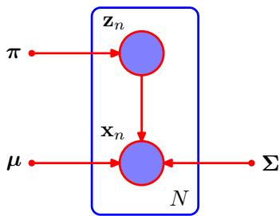
Now consider the problem of maximizing the likelihood for the complete data set X, Z . From (9.10) and (9.11), this likelihood function takes the form
$$p(X,Z|μ,Σ,π)=\prod_{n=1}^{N}{\prod_{k=1}^{K}{π_{k}^{z_{nk}}}}N(x_{n}|μ_{k},Σ_{k})^{z_{nk}}$$
where $z_{nk}$ denotes the $k^{th}$ component of $z_{n}$ . Taking the logarithm, we obtain
$$lnp(X,Z|μ,Σ,π)=\sum_{n=1}^{N}{\sum_{k=1}^{K}{z_{nk}}}\left\{lnπ_{k}+lnN(x_{n}|μ_{k},Σ_{k})\right\}.$$
Comparison with the log likelihood function (9.14) for the incomplete data shows that the summation over k and the logarithm have been interchanged. The logarithm now acts directly on the Gaussian distribution, which itself is a member of the exponential family. Not surprisingly, this leads to a much simpler solution to the maximum likelihood problem, as we now show. Consider first the maximization with respect to the means and covariances. Because $z_{n}$ is a $K⋅$ -dimensional vector with all elements equal to 0 except for a single element having the value 1, the complete-data log likelihood function is simply a sum of K independent contributions, one for each mixture component. Thus the maximization with respect to a mean or a covariance is exactly as for a single Gaussian, except that it involves only the subset of data points that are ‘assigned’ to that component. For the maximization with respect to the mixing coefficients, we note that these are coupled for different values of k by virtue of the summation constraint (9.9). Again, this can be enforced using a Lagrange multiplier as before, and leads to the result
$$π_{k}=\frac{1}{N}\sum_{n=1}^{N}{z_{nk}}$$
so that the mixing coefficients are equal to the fractions of data points assigned to the corresponding components.
Thus we see that the complete-data log likelihood function can be maximized trivially in closed form. In practice, however, we do not have values for the latent variables so, as discussed earlier, we consider the expectation, with respect to the posterior distribution of the latent variables, of the complete-data log likelihood.
Using (9.10) and (9.11) together with Bayes’ theorem, we see that this posterior distribution takes the form
$$p(Z|X,μ,Σ,π)∝\prod_{n=1}^{N}{\prod_{k=1}^{K}{[}}π_{k}N(x_{n}|μ_{k},Σ_{k})]^{z_{nk}}.$$
and hence factorizes over n so that under the posterior distribution the $\left\{ { { \bf { z } } _ { n } } \right\}$ are independent. This is easily verified by inspection of the directed graph in Figure 9.6 and making use of the d-separation criterion. The expected value of the indicator variable $z_{nk}$ under this posterior distribution is then given by
E[znk]=znk​znkπkN(xn|μk,Σk)znkznj​πjN(xn|μj,Σj)znj=πkN(xn|μk,Σk)j=1KπjN(xn|μj,Σj)=γ(znk)
which is just the responsibility of component k for data point ${ \bf x } _ { n }$ . The expected value of the complete-data log likelihood function is therefore given by
$$E_{Z}[lnp(X,Z|μ,Σ,π)]=\sum_{n=1}^{N}{\sum_{k=1}^{K}{γ}}(z_{nk})\left\{lnπ_{k}+lnN(x_{n}|μ_{k},Σ_{k})\right\}.$$
We can now proceed as follows. First we choose some initial values for the parameters $μ^{old},Σ^{old}$ and $π^{old}$ , and use these to evaluate the responsibilities (the E step). We then keep the responsibilities fixed and maximize (9.40) with respect to $μ_{k},Σ_{k}$ and $π_{k}$ (the M step). This leads to closed form solutions for $μ^{new},{\overset{‾}{Σ}}^{new}$ and $π^{new}$ given by (9.17), (9.19), and (9.22) as before. This is precisely the EM algorithm for Gaussian mixtures as derived earlier. We shall gain more insight into the role of the expected complete-data log likelihood function when we give a proof of convergence of the EM algorithm in Section 9.4.

9.3.2 Relation to K-means
Comparison of the K-means algorithm with the EM algorithm for Gaussian mixtures shows that there is a close similarity. Whereas the K-means algorithm performs a hard assignment of data points to clusters, in which each data point is associated uniquely with one cluster, the EM algorithm makes a soft assignment based on the posterior probabilities. In fact, we can derive the K-means algorithm as a particular limit of EM for Gaussian mixtures as follows.
Consider a Gaussian mixture model in which the covariance matrices of the mixture components are given by I, where is a variance parameter that is shared by all of the components, and I is the identity matrix, so that
$$p(x|μ_{k},Σ_{k})=\frac{1}{(2πϵ)^{1/2}}exp\left\{−\frac{1}{2ϵ}∥x−μ_{k}∥^{2}\right\}.$$
We now consider the EM algorithm for a mixture of K Gaussians of this form in which we treat as a fixed constant, instead of a parameter to be re-estimated. From (9.13) the posterior probabilities, or responsibilities, for a particular data point ${ \bf x } _ { n }$ are given by
γ(znk)=πkexp−∥xn−μk∥2/2ϵj​πjexp−∥xn−μj∥2/2ϵ.
If we consider the limit $ϵ0$ , we see that in the denominator the term for which $∥x_{n}−μ_{i}∥^{2}$ is smallest will go to zero most slowly, and hence the responsibilities $γ(z_{nk})$ for the data point ${ \bf x } _ { n }$ all go to zero except for term $j,$ , for which the responsibility $γ(z_{nj})$ will go to unity. Note that this holds independently of the values of the $π_{k}$ so long as none of the $π_{k}$ is zero. Thus, in this limit, we obtain a hard assignment of data points to clusters, just as in the K-means algorithm, so that $γ(z_{nk})→r_{nk}$ where $r_{nk}$ is defined by (9.2). Each data point is thereby assigned to the cluster having the closest mean.
The EM re-estimation equation for the $μ_{k}$ , given by (9.17), then reduces to the K-means result (9.4). Note that the re-estimation formula for the mixing coefficients (9.22) simply re-sets the value of $π_{k}$ to be equal to the fraction of data points assigned to cluster $k,$ although these parameters no longer play an active role in the algorithm.
Finally, in the limit $ϵ0$ the expected complete-data log likelihood, given by (9.40), becomes
$$E_{Z}[lnp(X,Z|μ,Σ,π)]→−\frac{1}{2}\sum_{n=1}^{N}{\sum_{k=1}^{K}{r_{nk}}}∥x_{n}−μ_{k}∥^{2}+const.$$
Thus we see that in this limit, maximizing the expected complete-data log likelihood is equivalent to minimizing the distortion measure J for the K-means algorithm given by (9.1).
Note that the K-means algorithm does not estimate the covariances of the clusters but only the cluster means. A hard-assignment version of the Gaussian mixture model with general covariance matrices, known as the elliptical K-means algorithm, has been considered by Sung and Poggio (1994).

9.3.3 Mixtures of Bernoulli distributions
So far in this chapter, we have focussed on distributions over continuous variables described by mixtures of Gaussians. As a further example of mixture modelling, and to illustrate the EM algorithm in a different context, we now discuss mixtures of discrete binary variables described by Bernoulli distributions. This model is also known as latent class analysis (Lazarsfeld and Henry, 1968; McLachlan and Peel, 2000). As well as being of practical importance in its own right, our discussion of Bernoulli mixtures will also lay the foundation for a consideration of hidden Markov models over discrete variables.
Consider a set of D binary variables $x_{i}$ , where $i=1,…,D$ , each of which is governed by a Bernoulli distribution with parameter $μ_{i}$ , so that
$$p(x|μ)=\prod_{i=1}^{D}{μ_{i}^{x_{i}}}(1−μ_{i})^{(1−x_{i})}$$
where ${ \bf x } = ( x _ { 1 } , \dots , x _ { D } ) ^ { \mathrm { T } }$ and $μ=(μ_{1},…,μ_{D})^{T}$ . We see that the individual variables $x_{i}$ are independent, given $μ.$ . The mean and covariance of this distribution are easily seen to be
$$E[x]=μ$$
$$cov[x]=diag\{μ_{i}(1−μ_{i})\}.$$
Now let us consider a finite mixture of these distributions given by
$$p(x|μ,π)=\sum_{k=1}^{K}{π_{k}}p(x|μ_{k})$$
where $μ=\{μ_{1},…,μ_{K}\},π=\{π_{1},…,π_{K}\}$ , and
$$p(x|μ_{k})=\prod_{i=1}^{D}{μ_{ki}^{x_{i}}}(1−μ_{ki})^{(1−x_{i})}.$$
Exercise 9.12
The mean and covariance of this mixture distribution are given by
$$\begin{matrix}E[x] & = & \sum_{k=1}^{K}{π_{k}}μ_{k} \\ cov[x] & = & \sum_{k=1}^{K}{π_{k}}\left\{Σ_{k}+μ_{k}μ_{k}^{T}\right\}−E[x]E[x]^{T}\end{matrix}$$
(9.50)
where Σ = diag $\{μ_{ki}(1−μ_{ki})\}$ . Because the covariance matrix $cov[x]$ is no longer diagonal, the mixture distribution can capture correlations between the variables, unlike a single Bernoulli distribution.
If we are given a data set $X=\{x_{1},…,x_{N}\}$ then the log likelihood function for this model is given by
$$lnp(X|μ,π)=\sum_{n=1}^{N}{ln}\left\{\sum_{k=1}^{K}{π_{k}}p\left(x_{n}∣μ_{k}\right)\right\}.$$
Again we see the appearance of the summation inside the logarithm, so that the maximum likelihood solution no longer has closed form.
We now derive the EM algorithm for maximizing the likelihood function for the mixture of Bernoulli distributions. To do this, we first introduce an explicit latent
Exercise 9.14
variable z associated with each instance of x. As in the case of the Gaussian mixture, $z=(z_{1},…,z_{K})^{T}$ is a binary K-dimensional variable having a single component equal to 1, with all other components equal to 0. We can then write the conditional distribution of x, given the latent variable, as
$$p(x|z,μ)=\prod_{k=1}^{K}{p}(x|μ_{k})^{z_{k}}$$
while the prior distribution for the latent variables is the same as for the mixture of Gaussians model, so that
$$p(z|π)=\prod_{k=1}^{K}{π_{k}^{z_{k}}}.$$
If we form the product of $p(x|z,μ)$ and $p(z|π)$ and then marginalize over z, then we recover (9.47).
In order to derive the EM algorithm, we first write down the complete-data log likelihood function, which is given by
$$\begin{matrix}lnp(X,Z|μ,π)=\sum_{n=1}^{N}{\sum_{k=1}^{K}{z_{nk}}}\left\{lnπ_{k}\right. \\ \left.+\sum_{i=1}^{D}{[}x_{ni}lnμ_{ki}+(1−x_{ni})ln(1−μ_{ki})]\right\}\end{matrix}$$
where ${ \bf X } = \{ { \bf x } _ { n } \}$ and ${ \bf Z } = \{ { \bf z } _ { n } \}$ . Next we take the expectation of the complete-data log likelihood with respect to the posterior distribution of the latent variables to give
$$\begin{matrix}E_{Z}[lnp(X,Z|μ,π)]=\sum_{n=1}^{N}{\sum_{k=1}^{K}{γ}}(z_{nk})\left\{lnπ_{k}\right. \\ \left.+\sum_{i=1}^{D}{\left[x_{ni}lnμ_{ki}+(1−x_{ni})ln(1−μ_{ki})\right]}\right\}\end{matrix}$$
where $γ(z_{nk})=E[z_{nk}]$ is the posterior probability, or responsibility, of component k given data point ${ \bf x } _ { n }$ . In the E step, these responsibilities are evaluated using Bayes theorem, which takes the form
γ(znk)=E[znk]=znk​znkπkp(xn|μk)znkznj​πjp(xn|μj)znj=πkp(xn|μk)j=1Kπjp(xn|μj).
If we consider the sum over n in (9.55), we see that the responsibilities enter only through two terms, which can be written as
$$N_{k}=\sum_{n=1}^{N}{γ}(z_{nk})$$
$${\overline{x}}_{k}=\frac{1}{N_{k}}\sum_{n=1}^{N}{γ}(z_{nk})x_{n}$$
where $N_{k}$ is the effective number of data points associated with component k. In the M step, we maximize the expected complete-data log likelihood with respect to the parameters $μ_{k}$ and $π.$ . If we set the derivative of (9.55) with respect to $μ_{k}$ equal to zero and rearrange the terms, we obtain
$$μ_{k}={\overline{x}}_{k}.$$
We see that this sets the mean of component k equal to a weighted mean of the data, with weighting coefficients given by the responsibilities that component k takes for data points. For the maximization with respect to $π_{k}.$ , we need to introduce a Lagrange multiplier to enforce the constraint $\dot{\underset{k}{∑}}π_{k}=1$ . Following analogous steps to those used for the mixture of Gaussians, we then obtain
$$π_{k}=\frac{N_{k}}{N}$$
which represents the intuitively reasonable result that the mixing coefficient for component k is given by the effective fraction of points in the data set explained by that component.
Note that in contrast to the mixture of Gaussians, there are no singularities in which the likelihood function goes to infinity. This can be seen by noting that the likelihood function is bounded above because $0≤p(x_{n}|μ_{k})≤1$ There exist singularities at which the likelihood function goes to zero, but these will not be found by EM provided it is not initialized to a pathological starting point, because the EM algorithm always increases the value of the likelihood function, until a local maximum is found. We illustrate the Bernoulli mixture model in Figure 9.10 by using it to model handwritten digits. Here the digit images have been turned into binary vectors by setting all elements whose values exceed 0.5 to 1 and setting the remaining elements to 0. We now fit a data set of N = 600 such digits, comprising the digits ‘2’, ‘3’, and $⋅_{4},$ , with a mixture of K = 3 Bernoulli distributions by running 10 iterations of the EM algorithm. The mixing coefficients were initialized to $π_{k}=1/K$ , and the parameters $μ_{kj}$ were set to random values chosen uniformly in the range (0.25, 0.75) and then normalized to satisfy the constraint that j​μkj=1 We see that a mixture of 3 Bernoulli distributions is able to find the three clusters in the data set corresponding to the different digits.
The conjugate prior for the parameters of a Bernoulli distribution is given by the beta distribution, and we have seen that a beta prior is equivalent to introducing
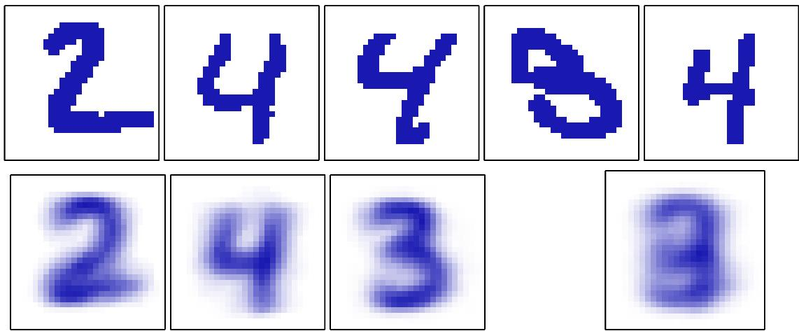
Figure 9.10 Illustration of the Bernoulli mixture model in which the top row shows examples from the digits data set after converting the pixel values from grey scale to binary using a threshold of 0.5. On the bottom row the first three images show the parameters $μ_{ki}$ for each of the three components in the mixture model. As a comparison, we also fit the same data set using a single multivariate Bernoulli distribution, again using maximum likelihood. This amounts to simply averaging the counts in each pixel and is shown by the right-most image on the bottom row.
Section 2.1.1
Exercise 9.18
additional effective observations of $x.$ We can similarly introduce priors into the Bernoulli mixture model, and use EM to maximize the posterior probability distributions.
Exercise 9.19
It is straightforward to extend the analysis of Bernoulli mixtures to the case of multinomial binary variables having $M>2$ states by making use of the discrete distribution (2.26). Again, we can introduce Dirichlet priors over the model parameters if desired.

9.3.4 EM for Bayesian linear regression
As a third example of the application of EM, we return to the evidence approximation for Bayesian linear regression. In Section 3.5.2, we obtained the reestimation equations for the hyperparameters α and $β$ by evaluation of the evidence and then setting the derivatives of the resulting expression to zero. We now turn to an alternative approach for finding α and $β$ based on the EM algorithm. Recall that our goal is to maximize the evidence function $p(t|α,β)$ given by (3.77) with respect to α and $β.$ Because the parameter vector w is marginalized out, we can regard it as a latent variable, and hence we can optimize this marginal likelihood function using EM. In the E step, we compute the posterior distribution of w given the current setting of the parameters α and $β$ and then use this to find the expected complete-data log likelihood. In the M step, we maximize this quantity with respect to α and β. We have already derived the posterior distribution of w because this is given by (3.49). The complete-data log likelihood function is then given by
$$lnp(t,w|α,β)=lnp(t|w,β)+lnp(w|α)$$
where the likelihood $p(t|w,β)$ and the prior $p(w|α)$ are given by (3.10) and (3.52), respectively, and $y(x,w)$ is given by (3.3). Taking the expectation with respect to the posterior distribution of w then gives
$$\begin{matrix}E\left[lnp(t,w|α,β)\right] & = & \frac{M}{2}ln\left(\frac{α}{2π}\right)−\frac{α}{2}E\left[w^{T}w\right]+\frac{N}{2}ln\left(\frac{β}{2π}\right) \\ & & −\frac{β}{2}\sum_{n=1}^{N}{E}\left[(t_{n}−w^{T}ϕ_{n})^{2}\right].\end{matrix}$$
Setting the derivatives with respect to α to zero, we obtain the M step re-estimation equation
$$α=\frac{M}{E\left[w^{T}w\right]}=\frac{M}{m_{N}^{T}m_{N}+Tr(S_{N})}.$$
An analogous result holds for $β.$
Note that this re-estimation equation takes a slightly different form from the corresponding result (3.92) derived by direct evaluation of the evidence function. However, they each involve computation and inversion (or eigen decomposition) of an $M×M$ matrix and hence will have comparable computational cost per iteration.
These two approaches to determining $α$ should of course converge to the same result (assuming they find the same local maximum of the evidence function). This can be verified by first noting that the quantity $γ$ is defined by
$$γ=M−α\sum_{i=1}^{M}{\frac{1}{λ_{i}+α}}=M−αTr(S_{N}).$$
At a stationary point of the evidence function, the re-estimation equation (3.92) will be self-consistently satisfied, and hence we can substitute for $γ$ to give
$$αm_{N}^{T}m_{N}=γ=M−αTr(S_{N})$$
and solving for α we obtain (9.63), which is precisely the EM re-estimation equation.
As a final example, we consider a closely related model, namely the relevance vector machine for regression discussed in Section 7.2.1. There we used direct maximization of the marginal likelihood to derive re-estimation equations for the hyperparameters α and $β$ . Here we consider an alternative approach in which we view the weight vector w as a latent variable and apply the EM algorithm. The E step involves finding the posterior distribution over the weights, and this is given by (7.81). In the M step we maximize the expected complete-data log likelihood, which is defined by
$$E_{w}\left[lnp(t|X,w,β)p(w|α)\right]$$
where the expectation is taken with respect to the posterior distribution computed using the ‘old’ parameter values. To compute the new parameter values we maximize with respect to α and $β$ to give
$$α_{i}^{new}=\frac{1}{m_{i}^{2}+Σ_{ii}}$$
(βnew)−1=∥t−ΦmN∥2+β−1i​γiN
Exercise 9.23
These re-estimation equations are formally equivalent to those obtained by direct maxmization.

9.4. The EM Algorithm in General
The expectation maximization algorithm, or EM algorithm, is a general technique for finding maximum likelihood solutions for probabilistic models having latent variables (Dempster et al., 1977; McLachlan and Krishnan, 1997). Here we give a very general treatment of the EM algorithm and in the process provide a proof that the EM algorithm derived heuristically in Sections 9.2 and 9.3 for Gaussian mixtures does indeed maximize the likelihood function (Csiszar and Tusnady, 1984; Hath- away, 1986; Neal and Hinton, 1999). Our discussion will also form the basis for the derivation of the variational inference framework.
Consider a probabilistic model in which we collectively denote all of the observed variables by X and all of the hidden variables by Z. The joint distribution $p(X,Z|θ)$ is governed by a set of parameters denoted $θ.$ Our goal is to maximize the likelihood function that is given by
p(X|θ)=Z​p(X,Z|θ).
Here we are assuming Z is discrete, although the discussion is identical if Z comprises continuous variables or a combination of discrete and continuous variables, with summation replaced by integration as appropriate.
We shall suppose that direct optimization of $p(X|θ)$ is difficult, but that opti mization of the complete-data likelihood function $p(X,Z|θ)$ is significantly easier. Next we introduce a distribution $q(Z)$ defined over the latent variables, and we observe that, for any choice of $q(Z)$ , the following decomposition holds
$$lnp(X|θ)=L(q,θ)+KL(q∥p)$$
where we have defined
L(q,θ)=Z​q(Z)lnp(X,Z|θ)q(Z)
KL(q∥p)=−Z​q(Z)lnp(Z|X,θ)q(Z).
Note that $L(q,θ)$ is a functional (see Appendix D for a discussion of functionals) of the distribution $q(Z)$ , and a function of the parameters $θ.$ It is worth studying
Illustration of the decomposition given by (9.70), which holds for any choice of distribution $q(Z)$ Because the Kullback-Leibler divergence satisfies $KL(q∥p)≥0$ , we see that the quantity $\dot{L}(q,θ)$ is a lower bound on the log likelihood function ln $p(X|θ)$
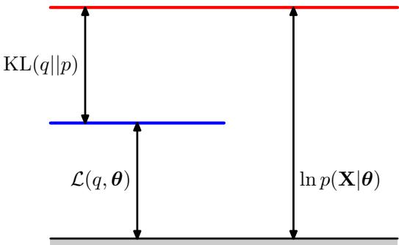
carefully the forms of the expressions (9.71) and (9.72), and in particular noting that they differ in sign and also that $L(q,θ)$ contains the joint distribution of X and Z while KL $\left(q∥p\right)$ contains the conditional distribution of $Z$ given $X$ . To verify the decomposition (9.70), we first make use of the product rule of probability to give
$$lnp(X,Z|θ)=lnp(Z|X,θ)+lnp(X|θ)$$
which we then substitute into the expression for $L(q,θ)$ . This gives rise to two terms, one of which cancels $KL(q∥p)$ while the other gives the required log likelihood ln $p(X|θ)$ after noting that $q(Z)$ is a normalized distribution that sums to 1.
From (9.72), we see that $KL(q∥p)$ is the Kullback-Leibler divergence between $q(Z)$ and the posterior distribution $p(Z|X,θ)$ . Recall that the Kullback-Leibler divergence satisfies KL $(q∥p)≥0$ , with equality if, and only if, $q(Z)=p(Z|X,θ)$ . It therefore follows from $​_{(9.70)}$ that $L(q,θ)≤lnp(X|θ)$ , in other words that $L(q,θ)$ is a lower bound on ln $p(X|θ)$ . The decomposition (9.70) is illustrated in Figure 9.11.
The EM algorithm is a two-stage iterative optimization technique for finding maximum likelihood solutions. We can use the decomposition (9.70) to define the EM algorithm and to demonstrate that it does indeed maximize the log likelihood. Suppose that the current value of the parameter vector is $θ^{old}$ . In the E step, the lower bound $L(q,θ^{old})$ is maximized with respect to $q(Z)$ while holding $θ^{old}$ fixed. The solution to this maximization problem is easily seen by noting that the value of ln $p(X|θ^{old})$ does not depend on $q(Z)$ and so the largest value of $L(q,θ^{old})$ will occur when the Kullback-Leibler divergence vanishes, in other words when $q(Z)$ is equal to the posterior distribution $p(Z|X,θ^{old})$ . In this case, the lower bound will equal the log likelihood, as illustrated in Figure 9.12.
In the subsequent M step, the distribution $q(Z)$ is held fixed and the lower bound $L(q,θ)$ is maximized with respect to $θ$ to give some new value $θ^{new}$ This will cause the lower bound $L$ to increase (unless it is already at a maximum), which will necessarily cause the corresponding log likelihood function to increase. Because the distribution $q$ is determined using the old parameter values rather than the new values and is held fixed during the M step, it will not equal the new posterior distribution $p(Z|X,θ^{new})$ , and hence there will be a nonzero KL divergence. The increase in the log likelihood function is therefore greater than the increase in the lower bound, as
Illustration of the E step of the EM algorithm. The q distribution is set equal to the posterior distribution for the current parameter values $θ^{old}$ , causing the lower bound to move up to the same value as the log likelihood function, with the KL divergence vanishing.
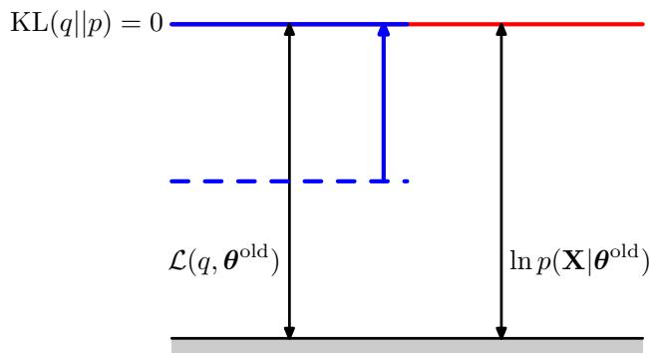
shown in Figure 9.13. If we substitute $q(Z)=p(Z|X,θ^{old})$ into (9.71), we see that, after the E step, the lower bound takes the form
L(q,θ)=Z​p(Z|X,θold)lnp(X,Z|θ)−Z​p(Z|X,θold)lnp(Z|X,θold)=Q(θ,θold)+const
where the constant is simply the negative entropy of the q distribution and is therefore independent of θ. Thus in the M step, the quantity that is being maximized is the expectation of the complete-data log likelihood, as we saw earlier in the case of mixtures of Gaussians. Note that the variable $θ$ over which we are optimizing appears only inside the logarithm. If the joint distribution $p(Z,X|θ)$ comprises a member of the exponential family, or a product of such members, then we see that the logarithm will cancel the exponential and lead to an M step that will be typically much simpler than the maximization of the corresponding incomplete-data log likelihood function $p(X|θ)$
The operation of the EM algorithm can also be viewed in the space of parameters, as illustrated schematically in Figure 9.14. Here the red curve depicts the (in
Illustration of the M step of the EM algorithm. The distribution $q(Z)$ is held fixed and the lower bound $L(q,θ)$ is maximized with respect to the parameter vector θ to give a revised value $θ^{new}$ . Because the KL divergence is nonnegative, this causes the log likelihood ln $p(X|θ)$ to increase by at least as much as the lower bound does.
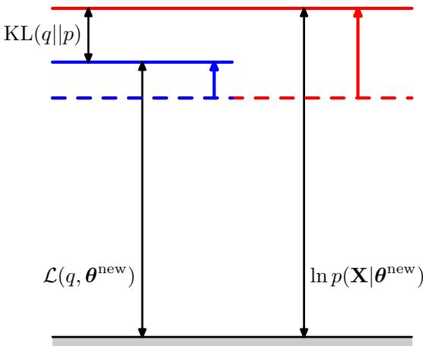
The EM algorithm involves alternately computing a lower bound on the log likelihood for the current parameter values and then maximizing this bound to obtain the new parameter values. See the text for a full discussion.
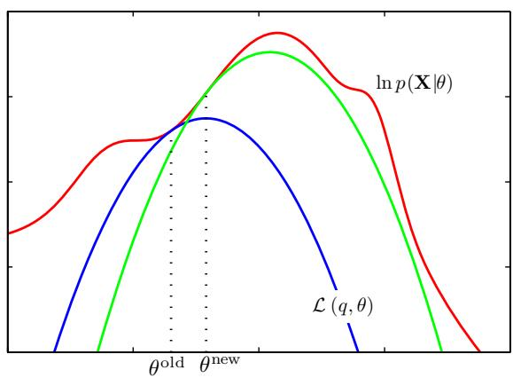
Exercise 9.25
complete data) log likelihood function whose value we wish to maximize. We start with some initial parameter value $θ^{old}$ , and in the first E step we evaluate the posterior distribution over latent variables, which gives rise to a lower bound $L(θ,{\overset{‾}{θ}}^{(old)})$ ) whose value equals the log likelihood at $θ^{(old)}$ , as shown by the blue curve. Note that the bound makes a tangential contact with the log likelihood at $θ^{(old)}$ , so that both curves have the same gradient. This bound is a convex function having a unique maximum (for mixture components from the exponential family). In the M step, the bound is maximized giving the value $θ^{(new)}$ , which gives a larger value of log likelihood than $θ^{(old)}$ . The subsequent E step then constructs a bound that is tangential at $θ^{(new)}$ as shown by the green curve.
For the particular case of an independent, identically distributed data set, X will comprise N data points $\left\{ { \bf x } _ { n } \right\}$ while Z will comprise N corresponding latent variables $\left\{ { \bf z } _ { n } \right\}$ , where $n=1,…,N$ . From the independence assumption, we have p(X,Z) = n​p(xn,zn) and, by marginalizing over the $\left\{ { { \bf { z } } _ { n } } \right\}$ we have $p(X)=$ n​p(xn) . Using the sum and product rules, we see that the posterior probability that is evaluated in the E step takes the form
p(Z|X,θ)=p(X,Z|θ)Z​p(X,Z|θ)=n=1Np(xn,zn|θ)Z​n=1Np(xn,zn|θ)=n=1Np(zn|xn,θ)
and so the posterior distribution also factorizes with respect to n. In the case of the Gaussian mixture model this simply says that the responsibility that each of the mixture components takes for a particular data point ${ \bf x } _ { n }$ depends only on the value of ${ \bf x } _ { n }$ and on the parameters θ of the mixture components, not on the values of the other data points.
We have seen that both the E and the M steps of the EM algorithm are increasing the value of a well-defined bound on the log likelihood function and that the complete EM cycle will change the model parameters in such a way as to cause the log likelihood to increase (unless it is already at a maximum, in which case the parameters remain unchanged).
We can also use the EM algorithm to maximize the posterior distribution $p(θ|X)$ for models in which we have introduced a prior $p(θ)$ over the parameters. To see this, we note that as a function of $θ_{;}$ , we have $\bar { p ( { \pmb \theta } | { \bf X } ) } = \bar { p ( { \pmb \theta } , { \bf X } ) / p ( { \bf X } ) }$ and so
$$lnp(θ|X)=lnp(θ,X)−lnp(X).$$
Making use of the decomposition (9.70), we have
$$\begin{matrix}lnp(θ|X) & = & L(q,θ)+KL(q∥p)+lnp(θ)−lnp(X) \\ & ≥ & L(q,θ)+lnp(θ)−lnp(X).\end{matrix}$$
where ln $p(X)$ is a constant. We can again optimize the right-hand side alternately with respect to $q$ and $θ.$ The optimization with respect to $q$ gives rise to the same $E−$ step equations as for the standard EM algorithm, because $q$ only appears in $L(q,θ)$ The M-step equations are modified through the introduction of the prior term ln $p(θ)$ which typically requires only a small modification to the standard maximum likelihood M-step equations.
The EM algorithm breaks down the potentially difficult problem of maximizing the likelihood function into two stages, the E step and the M step, each of which will often prove simpler to implement. Nevertheless, for complex models it may be the case that either the E step or the M step, or indeed both, remain intractable. This leads to two possible extensions of the EM algorithm, as follows.
The generalized EM, or GEM, algorithm addresses the problem of an intractable M step. Instead of aiming to maximize $L(q,θ)$ with respect to $θ,$ it seeks instead to change the parameters in such a way as to increase its value. Again, because $L(q,θ)$ is a lower bound on the log likelihood function, each complete EM cycle of the GEM algorithm is guaranteed to increase the value of the log likelihood (unless the parameters already correspond to a local maximum). One way to exploit the GEM approach would be to use one of the nonlinear optimization strategies, such as the conjugate gradients algorithm, during the M step. Another form of GEM algorithm, known as the expectation conditional maximization, or ECM, algorithm, involves making several constrained optimizations within each M step (Meng and Rubin, 1993). For instance, the parameters might be partitioned into groups, and the M step is broken down into multiple steps each of which involves optimizing one of the subset with the remainder held fixed.
We can similarly generalize the E step of the EM algorithm by performing a partial, rather than complete, optimization of $L(q,θ)$ with respect to $q(Z)$ (Neal and Hinton, 1999). As we have seen, for any given value of $θ$ there is a unique maximum of $L(q,θ)$ with respect to $q(Z)$ that corresponds to the posterior distribution $q_{θ}(Z)=$ $p(Z|X,θ)$ and that for this choice of $q(Z)$ the bound $L(q,θ)$ is equal to the log likelihood function ln $p(X|θ)$ . It follows that any algorithm that converges to the global maximum of $L(q,θ)$ will find a value of $θ$ that is also a global maximum of the log likelihood ln $p(X|θ)$ . Provided $p(X,Z|θ)$ is a continuous function of θ then, by continuity, any local maximum of $L(q,θ)$ will also be a local maximum of ln $p(X|θ)$
Consider the case of N independent data points $x_{1},…,x_{N}$ with corresponding latent variables $z_{1},…,z_{N}$ . The joint distribution $p(X,Z|θ)$ factorizes over the data points, and this structure can be exploited in an incremental form of EM in which at each EM cycle only one data point is processed at a time. In the E step, instead of recomputing the responsibilities for all of the data points, we just re-evaluate the responsibilities for one data point. It might appear that the subsequent M step would require computation involving the responsibilities for all of the data points. However, if the mixture components are members of the exponential family, then the responsibilities enter only through simple sufficient statistics, and these can be updated efficiently. Consider, for instance, the case of a Gaussian mixture, and suppose we perform an update for data point m in which the corresponding old and new values of the responsibilities are denoted $γ^{old}(z_{mk})$ and $γ^{new}(z_{mk})$ . In the M step, the required sufficient statistics can be updated incrementally. For instance, for the means the sufficient statistics are defined by (9.17) and (9.18) from which we obtain
Exercise 9.26
$$μ_{k}^{new}=μ_{k}^{old}+\left(\frac{γ^{new}(z_{mk})−γ^{old}(z_{mk})}{N_{k}^{new}}\right)(x_{m}−μ_{k}^{old})$$
together with
$$N_{k}^{new}=N_{k}^{old}+γ^{new}(z_{mk})−γ^{old}(z_{mk}).$$
The corresponding results for the covariances and the mixing coefficients are analogous.
Thus both the E step and the M step take fixed time that is independent of the total number of data points. Because the parameters are revised after each data point, rather than waiting until after the whole data set is processed, this incremental version can converge faster than the batch version. Each E or M step in this incremental algorithm is increasing the value of $L(q,θ)$ and, as we have shown above, if the algorithm converges to a local (or global) maximum of $L(q,θ)$ , this will correspond to a local (or global) maximum of the log likelihood function ln $p(X|θ)$

Exercises
9.1 () www Consider the K-means algorithm discussed in Section 9.1. Show that as a consequence of there being a finite number of possible assignments for the set of discrete indicator variables $r_{nk}$ , and that for each such assignment there is a unique optimum for the $\{μ_{k}\}$ , the K-means algorithm must converge after a finite number of iterations.
9.2 () Apply the Robbins-Monro sequential estimation procedure described in Section 2.3.5 to the problem of finding the roots of the regression function given by the derivatives of J in (9.1) with respect to $μ_{k}$ . Show that this leads to a stochastic K-means algorithm in which, for each data point ${ \bf x } _ { n }$ , the nearest prototype $μ_{k}$ is updated using (9.5).
9.3 () www Consider a Gaussian mixture model in which the marginal distribution $p(z)$ for the latent variable is given by (9.10), and the conditional distribution $p(x|z)$ for the observed variable is given by (9.11). Show that the marginal distribution $p(x)$ , obtained by summing $p(z)p(x|z)$ over all possible values of z, is a Gaussian mixture of the form (9.7).
9.4 () Suppose we wish to use the EM algorithm to maximize the posterior distribution over parameters $p(θ|X)$ for a model containing latent variables, where X is the observed data set. Show that the E step remains the same as in the maximum likelihood case, whereas in the M step the quantity to be maximized is given by $Q(θ,θ^{old})+lnp(θ)$ where $Q(θ,θ^{old})$ is defined by (9.30).
9.5 () Consider the directed graph for a Gaussian mixture model shown in Figure 9.6. By making use of the d-separation criterion discussed in Section 8.2, show that the posterior distribution of the latent variables factorizes with respect to the different data points so that
$$p(Z|X,μ,Σ,π)=\prod_{n=1}^{N}{p}(z_{n}|x_{n},μ,Σ,π).$$
9.6 ( ) Consider a special case of a Gaussian mixture model in which the covariance matrices $Σ_{k}$ of the components are all constrained to have a common value Σ. Derive the EM equations for maximizing the likelihood function under such a model.
9.7 () www Verify that maximization of the complete-data log likelihood (9.36) for a Gaussian mixture model leads to the result that the means and covariances of each component are fitted independently to the corresponding group of data points, and the mixing coefficients are given by the fractions of points in each group.
9.8 () www Show that if we maximize (9.40) with respect to $μ_{k}$ while keeping the responsibilities $γ(z_{nk})$ fixed, we obtain the closed form solution given by (9.17).
9.9 () Show that if we maximize (9.40) with respect to $Σ_{k}$ and $π_{k}$ while keeping the responsibilities $γ(z_{nk})$ fixed, we obtain the closed form solutions given by (9.19) and (9.22).
9.10 ( ) Consider a density model given by a mixture distribution
$$p(x)=\sum_{k=1}^{K}{π_{k}}p(x|k)$$
and suppose that we partition the vector x into two parts so that $x = \left(x_{a},x_{b}\right)$ Show that the conditional density $p(x_{b}|x_{a})$ is itself a mixture distribution and find expressions for the mixing coefficients and for the component densities.
9.11 () In Section 9.3.2, we obtained a relationship between K means and EM for Gaussian mixtures by considering a mixture model in which all components have covariance I. Show that in the limit $ϵ0$ , maximizing the expected completedata log likelihood for this model, given by (9.40), is equivalent to minimizing the distortion measure J for the K-means algorithm given by (9.1).
9.12 () www Consider a mixture distribution of the form
$$p(x)=\sum_{k=1}^{K}{π_{k}}p(x|k)$$
where the elements of x could be discrete or continuous or a combination of these. Denote the mean and covariance of $p(x|k)$ by $μ_{k}$ and $Σ_{k}$ , respectively. Show that the mean and covariance of the mixture distribution are given by (9.49) and (9.50).
9.13 ( ) Using the re-estimation equations for the EM algorithm, show that a mixture of Bernoulli distributions, with its parameters set to values corresponding to a maximum of the likelihood function, has the property that
$$E[x]=\frac{1}{N}\sum_{n=1}^{N}{x_{n}}≡\overline{x}.$$
Hence show that if the parameters of this model are initialized such that all components have the same mean $μ_{k}=\hat{μ}$ for $k=1,…,K$ , then the EM algorithm will converge after one iteration, for any choice of the initial mixing coefficients, and that this solution has the property $μ_{k}=\overline{x}.$ . Note that this represents a degenerate case of the mixture model in which all of the components are identical, and in practice we try to avoid such solutions by using an appropriate initialization.
9.14 () Consider the joint distribution of latent and observed variables for the Bernoulli distribution obtained by forming the product of $p(x|z,μ)$ given by (9.52) and $p(z|π)$ given by (9.53). Show that if we marginalize this joint distribution with respect to z, then we obtain (9.47).
9.15 () www Show that if we maximize the expected complete-data log likelihood function (9.55) for a mixture of Bernoulli distributions with respect to $μ_{k}$ , we obtain the M step equation (9.59).
9.16 () Show that if we maximize the expected complete-data log likelihood function (9.55) for a mixture of Bernoulli distributions with respect to the mixing coefficients πk, using a Lagrange multiplier to enforce the summation constraint, we obtain the M step equation (9.60).
9.17 () www Show that as a consequence of the constraint $0≤p(x_{n}|μ_{k})≤1$ for the discrete variable ${ \bf x } _ { n }$ , the incomplete-data log likelihood function for a mixture of Bernoulli distributions is bounded above, and hence that there are no singularities for which the likelihood goes to infinity.
9.18 ( ) Consider a Bernoulli mixture model as discussed in Section 9.3.3, together with a prior distribution $p(μ_{k}|a_{k},b_{k})$ over each of the parameter vectors $μ_{k}$ given by the beta distribution (2.13), and a Dirichlet prior $p(π|α)$ given by (2.38). Derive the EM algorithm for maximizing the posterior probability $p(μ,π|X)$
9.19 ( ) Consider a D-dimensional variable x each of whose components i is itself a multinomial variable of degree M so that x is a binary vector with components $x_{ij}$ where $i=1,…,D$ and $j=1,…,M$ , subject to the constraint that j​xij=1 for all i. Suppose that the distribution of these variables is described by a mixture of the discrete multinomial distributions considered in Section 2.2 so that
$$p(x)=\sum_{k=1}^{K}{π_{k}}p(x|μ_{k})$$
where
$$p(x|μ_{k})=\prod_{i=1}^{D}{\prod_{j=1}^{M}{μ_{kij}^{x_{ij}}}}.$$
The parameters $μ_{kij}$ represent the probabilities $p(x_{ij} = 1|μ_{k})$ and must satisfy $0≤μ_{kij}≤1$ together with the constraint j​μkij=1 for all values of k and i. Given an observed data set $\left\{x_{n}\right\}$ , where $n=1,…,N$ , derive the E and M step equations of the EM algorithm for optimizing the mixing coefficients $π_{k}$ and the component parameters $μ_{kij}$ of this distribution by maximum likelihood.
9.20 () www Show that maximization of the expected complete-data log likelihood function (9.62) for the Bayesian linear regression model leads to the M step reestimation result (9.63) for α.
9.21 ( ) Using the evidence framework of Section 3.5, derive the M-step re-estimation equations for the parameter $β$ in the Bayesian linear regression model, analogous to the result (9.63) for α.
9.22 ( ) By maximization of the expected complete-data log likelihood defined by (9.66), derive the M step equations (9.67) and (9.68) for re-estimating the hyperparameters of the relevance vector machine for regression.
9.23 ( ) www In Section 7.2.1 we used direct maximization of the marginal likelihood to derive the re-estimation equations (7.87) and (7.88) for finding values of the hyperparameters α and $β$ for the regression RVM. Similarly, in Section 9.3.4 we used the EM algorithm to maximize the same marginal likelihood, giving the re-estimation equations (9.67) and (9.68). Show that these two sets of re-estimation equations are formally equivalent.
9.24 () Verify the relation (9.70) in which $L(q,θ)$ and $KL(q∥p)$ are defined by (9.71) and (9.72), respectively.
9.25 () www Show that the lower bound $L(q,θ)$ given by (9.71), with $q(Z) =$ $p(Z|X,θ^{(old)})$ , has the same gradient with respect to $θ$ as the log likelihood function ln $p(X|θ)$ at the point $θ=θ^{(old)}$
9.26 () www Consider the incremental form of the EM algorithm for a mixture of Gaussians, in which the responsibilities are recomputed only for a specific data point $x_{m}$ . Starting from the M-step formulae (9.17) and (9.18), derive the results (9.78) and (9.79) for updating the component means.
9.27 ( ) Derive M-step formulae for updating the covariance matrices and mixing coefficients in a Gaussian mixture model when the responsibilities are updated incrementally, analogous to the result (9.78) for updating the means.

Approximate Inference
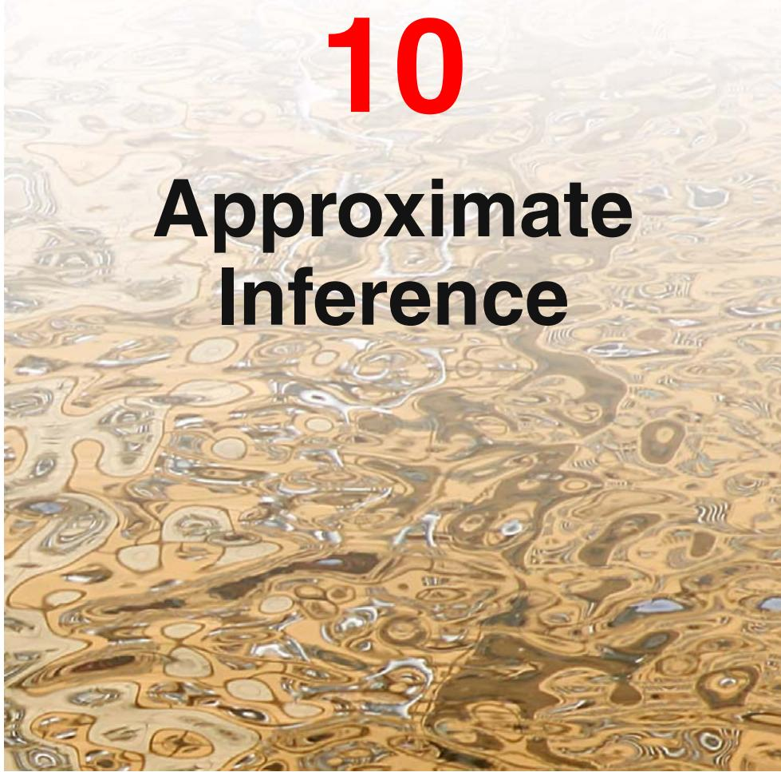
A central task in the application of probabilistic models is the evaluation of the posterior distribution p(Z X) of the latent variables Z given the observed (visible) data variables X, and the evaluation of expectations computed with respect to this distribution. The model might also contain some deterministic parameters, which we will leave implicit for the moment, or it may be a fully Bayesian model in which any unknown parameters are given prior distributions and are absorbed into the set of latent variables denoted by the vector Z. For instance, in the EM algorithm we need to evaluate the expectation of the complete-data log likelihood with respect to the posterior distribution of the latent variables. For many models of practical interest, it will be infeasible to evaluate the posterior distribution or indeed to compute expectations with respect to this distribution. This could be because the dimensionality of the latent space is too high to work with directly or because the posterior distribution has a highly complex form for which expectations are not analytically tractable. In the case of continuous variables, the required integrations may not have closed-form analytical solutions, while the dimensionality of the space and the complexity of the integrand may prohibit numerical integration. For discrete variables, the marginalizations involve summing over all possible configurations of the hidden variables, and though this is always possible in principle, we often find in practice that there may be exponentially many hidden states so that exact calculation is prohibitively expensive.
In such situations, we need to resort to approximation schemes, and these fall broadly into two classes, according to whether they rely on stochastic or deterministic approximations. Stochastic techniques such as Markov chain Monte Carlo, described in Chapter 11, have enabled the widespread use of Bayesian methods across many domains. They generally have the property that given infinite computational resource, they can generate exact results, and the approximation arises from the use of a finite amount of processor time. In practice, sampling methods can be computationally demanding, often limiting their use to small-scale problems. Also, it can be difficult to know whether a sampling scheme is generating independent samples from the required distribution.
In this chapter, we introduce a range of deterministic approximation schemes, some of which scale well to large applications. These are based on analytical approximations to the posterior distribution, for example by assuming that it factorizes in a particular way or that it has a specific parametric form such as a Gaussian. As such, they can never generate exact results, and so their strengths and weaknesses are complementary to those of sampling methods.
In Section 4.4, we discussed the Laplace approximation, which is based on a local Gaussian approximation to a mode (i.e., a maximum) of the distribution. Here we turn to a family of approximation techniques called variational inference or variational Bayes, which use more global criteria and which have been widely applied. We conclude with a brief introduction to an alternative variational framework known as expectation propagation.

10.1. Variational Inference
Variational methods have their origins in the $18^{th}$ century with the work of Euler, Lagrange, and others on the calculus of variations. Standard calculus is concerned with finding derivatives of functions. We can think of a function as a mapping that takes the value of a variable as the input and returns the value of the function as the output. The derivative of the function then describes how the output value varies as we make infinitesimal changes to the input value. Similarly, we can define a functional as a mapping that takes a function as the input and that returns the value of the functional as the output. An example would be the entropy $H[p]$ , which takes a probability distribution $p(x)$ as the input and returns the quantity
$$
\mathrm{H} [ p ] = \int p (x) \ln p (x) \mathrm{d} x\tag{10.1}
$$
as the output. We can the introduce the concept of afunctional derivative, which expresses how the value of the functional changes in response to infinitesimal changes to the input function (Feynman et al., 1964). The rules for the calculus of variations mirror those of standard calculus and are discussed in Appendix D. Many problems can be expressed in terms of an optimization problem in which the quantity being optimized is a functional. The solution is obtained by exploring all possible input functions to find the one that maximizes, or minimizes, the functional. Variational methods have broad applicability and include such areas as finite element methods (Kapur, 1989) and maximum entropy (Schwarz, 1988).
Although there is nothing intrinsically approximate about variational methods, they do naturally lend themselves to finding approximate solutions. This is done by restricting the range of functions over which the optimization is performed, for instance by considering only quadratic functions or by considering functions composed of a linear combination of fixed basis functions in which only the coefficients of the linear combination can vary. In the case of applications to probabilistic inference, the restriction may for example take the form of factorization assumptions (Jordan et al., 1999; Jaakkola, 2001).
Now let us consider in more detail how the concept of variational optimization can be applied to the inference problem. Suppose we have a fully Bayesian model in which all parameters are given prior distributions. The model may also have latent variables as well as parameters, and we shall denote the set of all latent variables and parameters by $Z.$ Similarly, we denote the set of all observed variables by X. For example, we might have a set of N independent, identically distributed data, for which $X = \{x_{1},…,x_{N}\}$ and $Z = \{z_{1},…,z_{N}\}$ Our probabilistic model specifies the joint distribution $p(X,Z)$ , and our goal is to find an approximation for the posterior distribution $p(Z|X)$ as well as for the model evidence $p(X)$ . As in our discussion of EM, we can decompose the log marginal probability using
$$lnp(X)=L(q)+KL(q∥p)$$
where we have defined
$$L(q)=∫q(Z)ln\left\{\frac{p(X,Z)}{q(Z)}\right\}dZ$$
$$KL(q∥p)=−∫q(Z)ln\left\{\frac{p(Z|X)}{q(Z)}\right\}dZ.$$
This differs from our discussion of EM only in that the parameter vector $θ$ no longer appears, because the parameters are now stochastic variables and are absorbed into Z. Since in this chapter we will mainly be interested in continuous variables we have used integrations rather than summations in formulating this decomposition. However, the analysis goes through unchanged if some or all of the variables are discrete simply by replacing the integrations with summations as required. As before, we can maximize the lower bound $L(q)$ by optimization with respect to the distribution $q(Z)$ , which is equivalent to minimizing the KL divergence. If we allow any possible choice for $q(Z)$ , then the maximum of the lower bound occurs when the KL divergence vanishes, which occurs when $q(Z)$ equals the posterior distribution $p(Z|X)$
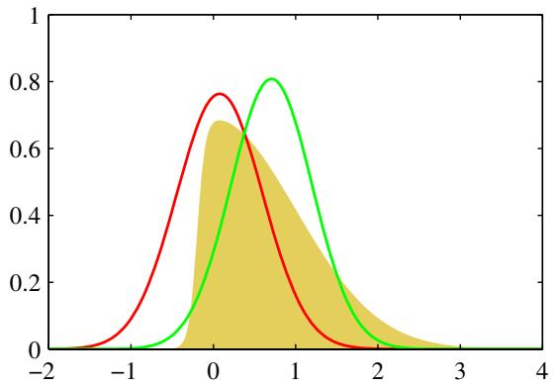
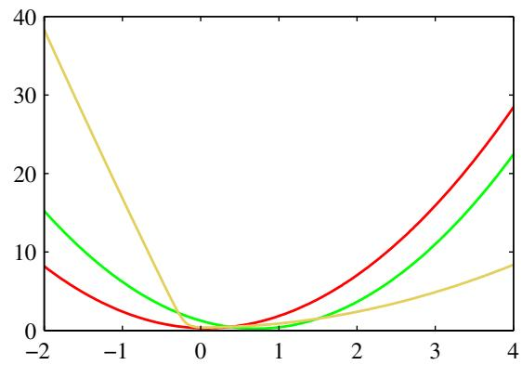
Figure 10.1 Illustration of the variational approximation for the example considered earlier in Figure 4.14. The left-hand plot shows the original distribution (yellow) along with the Laplace (red) and variational (green) approximations, and the right-hand plot shows the negative logarithms of the corresponding curves.
However, we shall suppose the model is such that working with the true posterior distribution is intractable.
We therefore consider instead a restricted family of distributions $q(Z)$ and then seek the member of this family for which the KL divergence is minimized. Our goal is to restrict the family sufficiently that they comprise only tractable distributions, while at the same time allowing the family to be sufficiently rich and flexible that it can provide a good approximation to the true posterior distribution. It is important to emphasize that the restriction is imposed purely to achieve tractability, and that subject to this requirement we should use as rich a family of approximating distributions as possible. In particular, there is no ‘over-fitting’ associated with highly flexible distributions. Using more flexible approximations simply allows us to approach the true posterior distribution more closely.
One way to restrict the family of approximating distributions is to use a parametric distribution $q(Z|ω)$ governed by a set of parameters $ω.$ . The lower bound $L(q)$ then becomes a function of $ω,$ , and we can exploit standard nonlinear optimization techniques to determine the optimal values for the parameters. An example of this approach, in which the variational distribution is a Gaussian and we have optimized with respect to its mean and variance, is shown in Figure 10.1.

10.1.1 Factorized distributions
Here we consider an alternative way in which to restrict the family of distributions $q(Z)$ . Suppose we partition the elements of $Z$ into disjoint groups that we denote by $Z_{i}$ where $i=1,…,M$ . We then assume that the $q$ distribution factorizes with respect to these groups, so that
$$q(Z)=\prod_{i=1}^{M}{q_{i}}(Z_{i}).$$
It should be emphasized that we are making no further assumptions about the distribution. In particular, we place no restriction on the functional forms of the individual factors $q_{i}(Z_{i})$ . This factorized form of variational inference corresponds to an approximation framework developed in physics called mean field theory (Parisi, 1988).
Amongst all distributions $q(Z)$ having the form (10.5), we now seek that distribution for which the lower bound $L(q)$ is largest. We therefore wish to make a free form (variational) optimization of $L(q)$ with respect to all of the distributions $q_{i}(Z_{i})$ which we do by optimizing with respect to each of the factors in turn. To achieve this, we first substitute (10.5) into (10.3) and then dissect out the dependence on one of the factors $q_{j}(Z_{j})$ . Denoting $q_{j}(Z_{j})$ by simply $q_{j}$ to keep the notation uncluttered, we then obtain
L(q)=∫i​qilnp(X,Z)−i​lnqidZ=∫qj∫lnp(X,Z)i≠j​qidZidZj−∫qjlnqjdZj+ const =∫qjlnp(X,Zj)dZj−∫qjlnqjdZj+ const
where we have defined a new distribution $\tilde{p}(X,Z_{j})$ by the relation
$$ln\tilde{p}(X,Z_{j})=E_{i≠j}[lnp(X,Z)]+\text{ const }.$$
Here the notation $E_{i≠j}[⋅⋅⋅]$ denotes an expectation with respect to the q distributions over all variables $z_{i}$ for $i≠j$ , so that
Ei≠j[lnp(X,Z)]=∫lnp(X,Z)i≠j​qidZi.
Now suppose we keep the $\{q_{i≠j}\}$ fixed and maximize $L(q)$ in (10.6) with respect to all possible forms for the distribution $q_{j}(Z_{j})$ . This is easily done by recognizing that (10.6) is a negative Kullback-Leibler divergence between $q_{j}(Z_{j})$ and $\tilde{p}(X,Z_{j})$ . Thus maximizing (10.6) is equivalent to minimizing the Kullback-Leibler


Leonhard Euler 1707–1783
Euler was a Swiss mathematician and physicist who worked in St. Petersburg and Berlin and who is widely considered to be one of the greatest mathematicians of all time. He is certainly the most prolific, and
his collected works fill 75 volumes. Amongst his many contributions, he formulated the modern theory of the function, he developed (together with Lagrange) the calculus of variations, and he discovered the formula $e^{iπ} = −1$ which relates four of the most important numbers in mathematics. During the last 17 years of his life, he was almost totally blind, and yet he produced nearly half of his results during this period.
divergence, and the minimum occurs when $q_{j}(Z_{j})=\tilde{p}(X,Z_{j})$ . Thus we obtain a general expression for the optimal solution $q_{j}^{⋆}(Z_{j})$ given by
$$lnq_{j}^{⋆}(Z_{j})=E_{i≠j}[lnp(X,Z)]+const.$$
It is worth taking a few moments to study the form of this solution as it provides the basis for applications of variational methods. It says that the log of the optimal solution for factor $q_{j}$ is obtained simply by considering the log of the joint distribution over all hidden and visible variables and then taking the expectation with respect to all of the other factors $\{q_{i}\}$ for $i≠j$
The additive constant in (10.9) is set by normalizing the distribution $q_{j}^{⋆}(Z_{j})$ Thus if we take the exponential of both sides and normalize, we have
$$q_{j}^{⋆}(Z_{j})=\frac{exp\left(E_{i≠j}[lnp(X,Z)]\right)}{∫exp\left(E_{i≠j}[lnp(X,Z)]\right)dZ_{j}}.$$
In practice, we shall find it more convenient to work with the form (10.9) and then reinstate the normalization constant (where required) by inspection. This will become clear from subsequent examples.
The set of equations given by (10.9) for $j=1,…,M$ represent a set of consistency conditions for the maximum of the lower bound subject to the factorization constraint. However, they do not represent an explicit solution because the expression on the right-hand side of (10.9) for the optimum $q_{j}^{⋆}(Z_{j})$ depends on expectations computed with respect to the other factors $q_{i}(Z_{i})$ for $i≠j$ . We will therefore seek a consistent solution by first initializing all of the factors $q_{i}(Z_{i})$ appropriately and then cycling through the factors and replacing each in turn with a revised estimate given by the right-hand side of (10.9) evaluated using the current estimates for all of the other factors. Convergence is guaranteed because bound is convex with respect to each of the factors $q_{i}(Z_{i})$ (Boyd and Vandenberghe, 2004).

10.1.2 Properties of factorized approximations
Our approach to variational inference is based on a factorized approximation to the true posterior distribution. Let us consider for a moment the problem of approximating a general distribution by a factorized distribution. To begin with, we discuss the problem of approximating a Gaussian distribution using a factorized Gaussian, which will provide useful insight into the types of inaccuracy introduced in using factorized approximations. Consider a Gaussian distribution $\dot { p } ( { \bf z } ) = \mathcal { N } ( { \bf z } | \pmb { \mu } , \pmb { \Lambda } ^ { - 1 } )$ over two correlated variables $\text{ z }= (z_{1},z_{2})$ in which the mean and precision have elements
$$μ=\left({μ_{1} \atop μ_{2}}\right), Λ=\left(\begin{matrix}Λ_{11} & Λ_{12} \\ Λ_{21} & Λ_{22}\end{matrix}\right)$$
and $Λ_{21}=Λ_{12}$ due to the symmetry of the precision matrix. Now suppose we wish to approximate this distribution using a factorized Gaussian of the form $q(z)=$ $q_{1}(z_{1})q_{2}(z_{2})$ . We first apply the general result (10.9) to find an expression for the optimal factor $q_{1}^{⋆}(z_{1})$ . In doing so it is useful to note that on the right-hand side we only need to retain those terms that have some functional dependence on $z_{1}$ because all other terms can be absorbed into the normalization constant. Thus we have
$$\begin{matrix}lnq_{1}^{⋆}(z_{1}) & = & E_{z_{2}}[lnp(z)]+\text{ const } \\ & = & E_{z_{2}}\left[−\frac{1}{2}(z_{1}−μ_{1})^{2}Λ_{11}−(z_{1}−μ_{1})Λ_{12}(z_{2}−μ_{2})\right]+\text{ const } \\ & = & −\frac{1}{2}z_{1}^{2}Λ_{11}+z_{1}μ_{1}Λ_{11}−z_{1}Λ_{12}(E[z_{2}]−μ_{2})+\text{ const }.\end{matrix}$$
Next we observe that the right-hand side of this expression is a quadratic function of $z_{1}$ , and so we can identify $q^{⋆}(z_{1})$ as a Gaussian distribution. It is worth emphasizing that we did not assume that $q(z_{i})$ is Gaussian, but rather we derived this result by variational optimization of the KL divergence over all possible distributions $q(z_{i})$ Note also that we do not need to consider the additive constant in (10.9) explicitly because it represents the normalization constant that can be found at the end by inspection if required. Using the technique of completing the square, we can identify the mean and precision of this Gaussian, giving
Section 2.3.1
$$q^{⋆}(z_{1})=N(z_{1}|m_{1},Λ_{11}^{−1})$$
where
$$m_{1}=μ_{1}−Λ_{11}^{−1}Λ_{12}\left(E[z_{2}]−μ_{2}\right).$$
By symmetry, $q_{2}^{⋆}(z_{2})$ is also Gaussian and can be written as
$$q_{2}^{⋆}(z_{2})=N(z_{2}|m_{2},Λ_{22}^{−1})$$
in which
$$m_{2}=μ_{2}−Λ_{22}^{−1}Λ_{21}\left(E[z_{1}]−μ_{1}\right).$$
Note that these solutions are coupled, so that $q^{⋆}(z_{1})$ depends on expectations computed with respect to $q^{⋆}(z_{2})$ and vice versa. In general, we address this by treating the variational solutions as re-estimation equations and cycling through the variables in turn updating them until some convergence criterion is satisfied. We shall see an example of this shortly. Here, however, we note that the problem is sufficiently simple that a closed form solution can be found. In particular, because $E[z_{1}]=m_{1}$ and $E[z_{2}]=m_{2}$ , we see that the two equations are satisfied if we take $E[z_{1}]=μ_{1}$ and $E[z_{2}]=μ_{2}$ , and it is easily shown that this is the only solution provided the distribution is nonsingular. This result is illustrated in Figure 10.2(a). We see that the mean is correctly captured but that the variance of $q(z)$ is controlled by the direction of smallest variance of $p(z)$ , and that the variance along the orthogonal direction is significantly under-estimated. It is a general result that a factorized variational approximation tends to give approximations to the posterior distribution that are too compact.
By way of comparison, suppose instead that we had been minimizing the reverse Kullback-Leibler divergence $KL(p||q)$ . As we shall see, this form of KL divergence
Figure 10.2 Comparison of the two alternative forms for the Kullback-Leibler divergence. The green contours corresponding to 1, 2, and 3 standard deviations for a correlated Gaussian distribution $p(z)$ over two variables $z_{1}$ and $z_{2}$ and the red contours represent the corresponding levels for an approximating distribution $q(z)$ over the same variables given by the product of two independent univariate Gaussian distributions whose parameters are obtained by minimization of (a) the Kullback-Leibler divergence $KL(q∥p)$ and (b) the reverse Kullback-Leibler divergence $KL(p||q)$
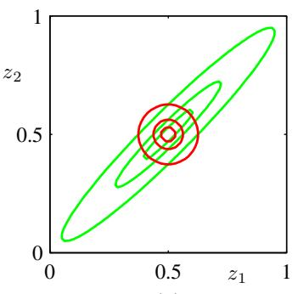
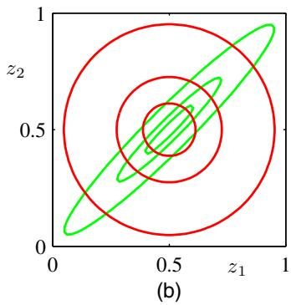
Section 10.7
is used in an alternative approximate inference framework called expectation propagation. We therefore consider the general problem of minimizing KL $(p∥q)$ when $q(Z)$ is a factorized approximation of the form (10.5). The KL divergence can then be written in the form
$$KL(p∥q)=−∫p(Z)\left[\sum_{i=1}^{M}{ln}q_{i}(Z_{i})\right]dZ+const$$
Exercise 10.3
where the constant term is simply the entropy of $p(Z)$ and so does not depend on $q(Z)$ . We can now optimize with respect to each of the factors $q_{j}(Z_{j})$ , which is easily done using a Lagrange multiplier to give
qj⋆(Zj)=∫p(Z)i≠j​dZi=p(Zj).
In this case, we find that the optimal solution for $q_{j}(Z_{j})$ is just given by the corresponding marginal distribution of $p(Z)$ . Note that this is a closed-form solution and so does not require iteration.
To apply this result to the illustrative example of a Gaussian distribution $p(z)$ over a vector z we can use (2.98), which gives the result shown in Figure 10.2(b). We see that once again the mean of the approximation is correct, but that it places significant probability mass in regions of variable space that have very low probability.
The difference between these two results can be understood by noting that there is a large positive contribution to the Kullback-Leibler divergence
$$KL(q∥p)=−∫q(Z)ln\left\{\frac{p(Z)}{q(Z)}\right\}dZ$$
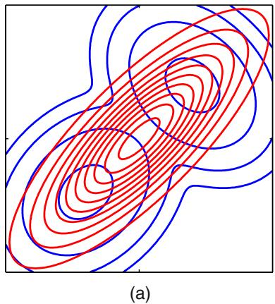
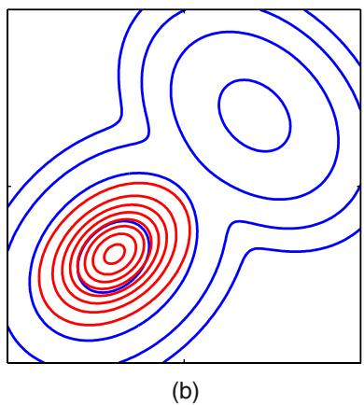
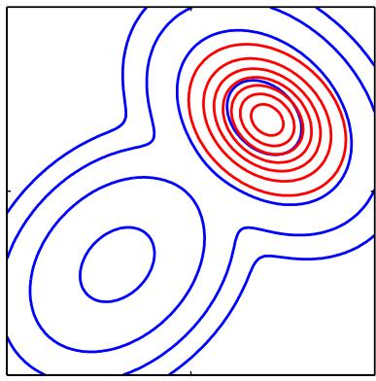
Figure 10.3 Another comparison of the two alternative forms for the Kullback-Leibler divergence. (a) The blue contours show a bimodal distribution $p(Z)$ given by a mixture of two Gaussians, and the red contours correspond to the single Gaussian distribution $q(Z)$ that best approximates $p(Z)$ in the sense of minimizing the Kullback-Leibler divergence $KL(p||q)$ . (b) $As$ in (a) but now the red contours correspond to a Gaussian distribution $q(Z)$ found by numerical minimization of the Kullback-Leibler divergence KL $(q∥p)$ . (c) As in (b) but showing a different local minimum of the Kullback-Leibler divergence.
from regions of Z space in which $p(Z)$ is near zero unless $q(Z)$ is also close to zero. Thus minimizing this form of KL divergence leads to distributions $q(Z)$ that avoid regions in which $p(Z)$ is small. Conversely, the Kullback-Leibler divergence KL $(p∥q)$ is minimized by distributions $q(Z)$ that are nonzero in regions where $p(Z)$ is nonzero.
We can gain further insight into the different behaviour of the two KL divergences if we consider approximating a multimodal distribution by a unimodal one, as illustrated in Figure 10.3. In practical applications, the true posterior distribution will often be multimodal, with most of the posterior mass concentrated in some number of relatively small regions of parameter space. These multiple modes may arise through nonidentifiability in the latent space or through complex nonlinear dependence on the parameters. Both types of multimodality were encountered in Chapter 9 in the context of Gaussian mixtures, where they manifested themselves as multiple maxima in the likelihood function, and a variational treatment based on the minimization of $KL(q∥p)$ will tend to find one of these modes. By contrast, if we were to minimize $KL(p||q)$ , the resulting approximations would average across all of the modes and, in the context of the mixture model, would lead to poor predictive distributions (because the average of two good parameter values is typically itself not a good parameter value). It is possible to make use of $KL(p||q)$ to define a useful inference procedure, but this requires a rather different approach to the one discussed here, and will be considered in detail when we discuss expectation propagation.
The two forms of Kullback-Leibler divergence are members of the alpha family
of divergences (Ali and Silvey, 1966; Amari, 1985; Minka, 2005) defined by
$$D_{α}(p∥q)=\frac{4}{1−α^{2}}\left(1−∫p(x)^{(1+α)/2}q(x)^{(1−α)/2}dx\right)$$
where $−∞<α<∞$ is a continuous parameter. The Kullback-Leibler divergence $KL(p||q)$ corresponds to the limit $α1$ , whereas $KL(q∥p)$ corresponds to the limit $α−1$ . For all values of α we have $\begin{matrix}D_{α}(p‖q)≥0\end{matrix}$ , with equality if, and only if, $p(x)=q(x)$ . Suppose $p(x)$ is a fixed distribution, and we minimize $D_{α}(p‖q)$ with respect to some set of distributions $q(x)$ . Then for $α≤−1$ the divergence is zero forcing, so that any values of x for which $p(x)=0$ will have $q(x)=0$ , and typically $q(x)$ will under-estimate the support of $p(x)$ and will tend to seek the mode with the largest mass. Conversely for $α≥1$ the divergence is zero-avoiding, so that values of $x$ for which $p(x)>0$ will have $q(x)>0$ , and typically $q(x)$ will stretch to cover all of $p(x)$ , and will over-estimate the support of $p(x)$ . When $α=0$ we obtain a symmetric divergence that is linearly related to the Hellinger distance given by
$$D_{H}(p∥q)=∫\left(p(x)^{1/2}−q(x)^{1/2}\right)dx.$$
The square root of the Hellinger distance is a valid distance metric.

10.1.3 Example: The univariate Gaussian
We now illustrate the factorized variational approximation using a Gaussian distribution over a single variable x (MacKay, 2003). Our goal is to infer the posterior distribution for the mean $μ$ and precision $τ,$ given a data set $D=\{x_{1},…,x_{N}\}$ of observed values of $x$ which are assumed to be drawn independently from the Gaussian. The likelihood function is given by
$$p(D|μ,τ)={\left(\frac{τ}{2π}\right)}^{N/2}exp\left\{−\frac{τ}{2}\sum_{n=1}^{N}{(}x_{n}−μ)^{2}\right\}.$$
We now introduce conjugate prior distributions for $μ$ and $τ$ given by
$$p(μ|τ)=N\left(μ|μ_{0},(λ_{0}τ)^{−1}\right)$$
$$p(τ)=Gam(τ|a_{0},b_{0})$$
where Gam $(τ|a_{0},b_{0})$ is the gamma distribution defined by (2.146). Together these distributions constitute a Gaussian-Gamma conjugate prior distribution.
For this simple problem the posterior distribution can be found exactly, and again takes the form of a Gaussian-gamma distribution. However, for tutorial purposes we will consider a factorized variational approximation to the posterior distribution given by
$$q(μ,τ)=q_{μ}(μ)q_{τ}(τ).$$
Note that the true posterior distribution does not factorize in this way. The optimum factors $q_{μ}(μ)$ and $q_{τ}(τ)$ can be obtained from the general result (10.9) as follows. For $q_{μ}(μ)$ we have
$$\begin{matrix}lnq_{μ}^{⋆}(μ) & = & E_{τ}\left[lnp(D|μ,τ)+lnp(μ|τ)\right]+\text{ const } \\ & = & −\frac{E[τ]}{2}\left\{λ_{0}(μ−μ_{0})^{2}+\sum_{n=1}^{N}{(}x_{n}−μ)^{2}\right\}+\text{ const }.\end{matrix}$$
Completing the square over $μ$ we see that $q_{μ}(μ)$ is a Gaussian $N\left(μ|μ_{N},λ_{N}^{−1}\right)$ with mean and precision given by
$$μ_{N}=\frac{λ_{0}μ_{0}+N\overline{x}}{λ_{0}+N}$$
$$λ_{N}=(λ_{0}+N)E[τ].$$
Note that for $N∞$ this gives the maximum likelihood result in which $μ_{N}=\overline{x}$ and the precision is infinite.
Similarly, the optimal solution for the factor $q_{τ}(τ)$ is given by
$$\begin{matrix}lnq_{τ}^{⋆}(τ) & = & E_{μ}\left[lnp(D|μ,τ)+lnp(μ|τ)\right]+lnp(τ)+\text{ const } \\ & = & (a_{0}−1)lnτ−b_{0}τ+\frac{N}{2}lnτ \\ & & −\frac{τ}{2}E_{μ}\left[\sum_{n=1}^{N}{(}x_{n}−μ)^{2}+λ_{0}(μ−μ_{0})^{2}\right]+\text{ const }\end{matrix}$$
and hence $q_{τ}(τ)$ is a gamma distribution $Gam(τ|a_{N},b_{N})$ with parameters
$$a_{N}=a_{0}+\frac{N}{2}$$
$$b_{N}=b_{0}+\frac{1}{2}E_{μ}\left[\sum_{n=1}^{N}{(}x_{n}−μ)^{2}+λ_{0}(μ−μ_{0})^{2}\right].$$
Again this exhibits the expected behaviour when $N→∞$
It should be emphasized that we did not assume these specific functional forms for the optimal distributions $q_{μ}(μ)$ and $q_{τ}(τ)$ . They arose naturally from the structure of the likelihood function and the corresponding conjugate priors.
Thus we have expressions for the optimal distributions $q_{μ}(μ)$ and $q_{τ}(τ)$ each of which depends on moments evaluated with respect to the other distribution. One approach to finding a solution is therefore to make an initial guess for, say, the moment $E[τ]$ and use this to re-compute the distribution $q_{μ}(μ)$ . Given this revised distribution we can then extract the required moments $E[μ]$ and $E[μ^{2}]$ , and use these to recompute the distribution $q_{τ}(τ)$ , and so on. Since the space of hidden variables for this example is only two dimensional, we can illustrate the variational approximation to the posterior distribution by plotting contours of both the true posterior and the factorized approximation, as illustrated in Figure 10.4.
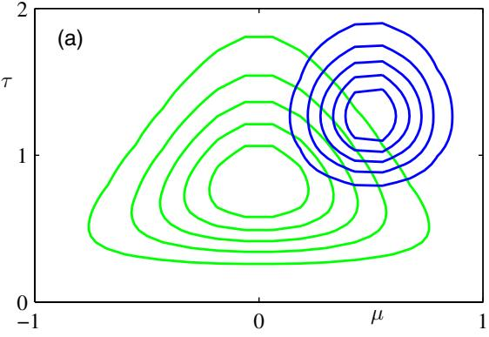
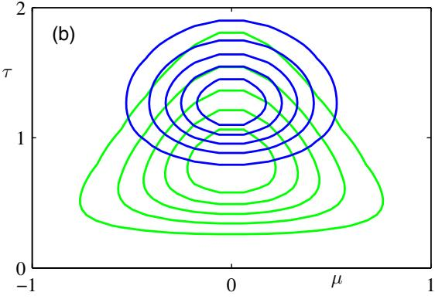
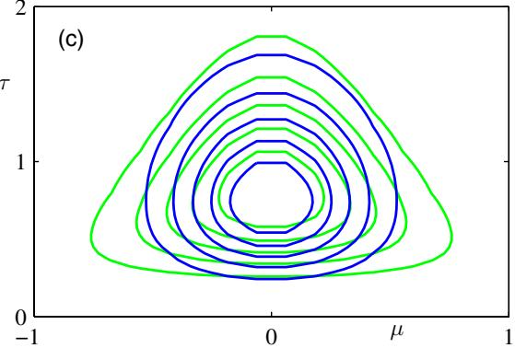
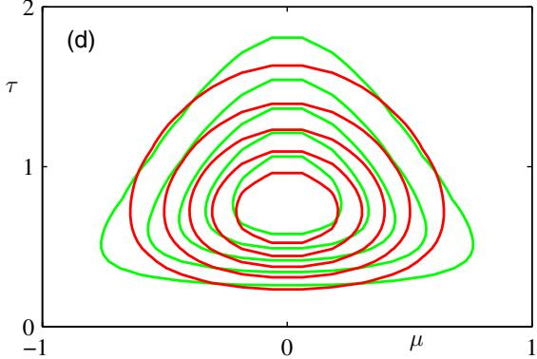
Figure 10.4 Illustration of variational inference for the mean $μ$ and precision τ of a univariate Gaussian distribu tion. Contours of the true posterior distribution $p(μ,τ|D)$ are shown in green. (a) Contours of the initial factorized approximation $q_{μ}(μ)q_{τ}(τ)$ are shown in blue. (b) After re-estimating the factor $q_{μ}(μ)$ . (c) After re-estimating the factor $q_{τ}(τ)$ . (d) Contours of the optimal factorized approximation, to which the iterative scheme converges, are shown in red.
In general, we will need to use an iterative approach such as this in order to solve for the optimal factorized posterior distribution. For the very simple example we are considering here, however, we can find an explicit solution by solving the simultaneous equations for the optimal factors $q_{μ}(μ)$ and $q_{τ}(τ)$ . Before doing this, we can simplify these expressions by considering broad, noninformative priors in which $μ_{0}=a_{0}=b_{0}=λ_{0}=0$ . Although these parameter settings correspond to improper priors, we see that the posterior distribution is still well defined. Using the standard result $E[τ]=a_{N}/b_{N}$ for the mean of a gamma distribution, together with (10.29) and (10.30), we have
$$\frac{1}{E[τ]}=E\left[\frac{1}{N}\sum_{n=1}^{N}{(}x_{n}−μ)^{2}\right]=\overline{x^{2}}−2\overline{x}E[μ]+E[μ^{2}].$$
Then, using (10.26) and (10.27), we obtain the first and second order moments of
$q_{μ}(μ)$ in the form
$$E[μ]=\overline{x}, E[μ^{2}]={\overline{x}}^{2}+\frac{1}{NE[τ]}.$$
We can now substitute these moments into (10.31) and then solve for $E[τ]$ to give
$$\begin{matrix}\frac{1}{E[τ]} & = & \frac{1}{N−1}(\overline{x^{2}}−{\overline{x}}^{2}) \\ & = & \frac{1}{N−1}\sum_{n=1}^{N}{(}x_{n}−\overline{x})^{2}.\end{matrix}$$
We recognize the right-hand side as the familiar unbiased estimator for the variance of a univariate Gaussian distribution, and so we see that the use of a Bayesian approach has avoided the bias of the maximum likelihood solution.

10.1.4 Model comparison
As well as performing inference over the hidden variables Z, we may also wish to compare a set of candidate models, labelled by the index m, and having prior probabilities $p(m)$ . Our goal is then to approximate the posterior probabilities $p(m|X)$ , where X is the observed data. This is a slightly more complex situation than that considered so far because different models may have different structure and indeed different dimensionality for the hidden variables Z. We cannot therefore simply consider a factorized approximation $q(Z)q(m)$ , but must instead recognize that the posterior over Z must be conditioned on m, and so we must consider $q(Z,m)=q(Z|m)q(m)$ . We can readily verify the following decomposition based on this variational distribution
lnp(X)=Lm−m​Z​q(Z|m)q(m)lnp(Z,m|X)q(Z|m)q(m)
where the $L_{m}$ is a lower bound on ln $p(X)$ and is given by
Lm=m​Z​q(Z|m)q(m)lnp(Z,X,m)q(Z|m)q(m).
Here we are assuming discrete Z, but the same analysis applies to continuous latent variables provided the summations are replaced with integrations. We can maximize $L_{m}$ with respect to the distribution $q(m)$ using a Lagrange multiplier, with the result
$$q(m)∝p(m)exp\{L_{m}\}.$$
However, if we maximize $L_{m}$ with respect to the $q(Z|m)$ , we find that the solutions for different m are coupled, as we expect because they are conditioned on m. We proceed instead by first optimizing each of the $q(Z|m)$ individually by optimization of (10.35), and then subsequently determining the $q(m)$ using (10.36). After normalization the resulting values for $q(m)$ can be used for model selection or model averaging in the usual way.

10.2. Illustration: Variational Mixture of Gaussians
We now return to our discussion of the Gaussian mixture model and apply the variational inference machinery developed in the previous section. This will provide a good illustration of the application of variational methods and will also demonstrate how a Bayesian treatment elegantly resolves many of the difficulties associated with the maximum likelihood approach (Attias, 1999b). The reader is encouraged to work through this example in detail as it provides many insights into the practical application of variational methods. Many Bayesian models, corresponding to much more sophisticated distributions, can be solved by straightforward extensions and generalizations of this analysis.
Our starting point is the likelihood function for the Gaussian mixture model, illustrated by the graphical model in Figure 9.6. For each observation ${ \bf x } _ { n }$ we have a corresponding latent variable $z_{n}$ comprising a 1-of-K binary vector with elements $z_{nk}$ for $k=1,…,K$ . As before we denote the observed data set by $X=$ $\{x_{1},…,x_{N}\}$ , and similarly we denote the latent variables by $Z=\{z_{1},…,z_{N}\}$ From (9.10) we can write down the conditional distribution of $Z,$ given the mixing coefficients π, in the form
$$p(Z|π)=\prod_{n=1}^{N}{\prod_{k=1}^{K}{π_{k}^{z_{nk}}}}.$$
Similarly, from (9.11), we can write down the conditional distribution of the observed data vectors, given the latent variables and the component parameters
$$p(X|Z,μ,Λ)=\prod_{n=1}^{N}{\prod_{k=1}^{K}{N}}{\left(x_{n}|μ_{k},Λ_{k}^{−1}\right)}^{z_{nk}}$$
where $μ=\{μ_{k}\}$ and $Λ=\{Λ_{k}\}$ . Note that we are working in terms of precision matrices rather than covariance matrices as this somewhat simplifies the mathematics.
Next we introduce priors over the parameters $μ,$ Λ and $π$ . The analysis is considerably simplified if we use conjugate prior distributions. We therefore choose a Dirichlet distribution over the mixing coefficients π
$$p(π)=Dir(π|α_{0})=C(α_{0})\prod_{k=1}^{K}{π_{k}^{α_{0}−1}}$$
where by symmetry we have chosen the same parameter $α_{0}$ for each of the components, and $C(α_{0})$ is the normalization constant for the Dirichlet distribution defined
Figure 10.5 Directed acyclic graph representing the Bayesian mixture of Gaussians model, in which the box (plate) denotes a set of N i.i.d. observations. Here $μ$ denotes $\{μ_{k}\}$ and Λ denotes $\{Λ_{k}\}$
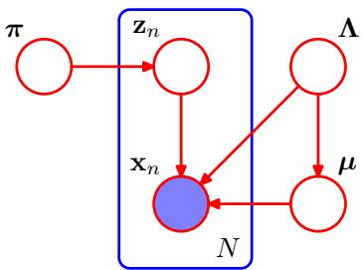
by (B.23). As we have seen, the parameter $α_{0}$ can be interpreted as the effective prior number of observations associated with each component of the mixture. If the value of $α_{0}$ is small, then the posterior distribution will be influenced primarily by the data rather than by the prior.
Similarly, we introduce an independent Gaussian-Wishart prior governing the mean and precision of each Gaussian component, given by
$$\begin{matrix}p(μ,Λ) & = & p(μ|Λ)p(Λ) \\ & = & \prod_{k=1}^{K}{N}\left(μ_{k}|m_{0},(β_{0}Λ_{k})^{−1}\right)W(Λ_{k}|W_{0},ν_{0})\end{matrix}$$
because this represents the conjugate prior distribution when both the mean and precision are unknown. Typically we would choose $m_{0}=0$ by symmetry.
The resulting model can be represented as a directed graph as shown in Figure 10.5. Note that there is a link from Λ to $μ$ since the variance of the distribution over $μ$ in (10.40) is a function of Λ.
This example provides a nice illustration of the distinction between latent variables and parameters. Variables such as $z_{n}$ that appear inside the plate are regarded as latent variables because the number of such variables grows with the size of the data set. By contrast, variables such as $μ$ that are outside the plate are fixed in number independently of the size of the data set, and so are regarded as parameters. From the perspective of graphical models, however, there is really no fundamental difference between them.

10.2.1 Variational distribution
In order to formulate a variational treatment of this model, we next write down the joint distribution of all of the random variables, which is given by
$$p(X,Z,π,μ,Λ)=p(X|Z,μ,Λ)p(Z|π)p(π)p(μ|Λ)p(Λ)$$
in which the various factors are defined above. The reader should take a moment to verify that this decomposition does indeed correspond to the probabilistic graphical model shown in Figure 10.5. Note that only the variables $X=\{x_{1},…,x_{N}\}$ are observed.
We now consider a variational distribution which factorizes between the latent variables and the parameters so that
$$q(Z,π,μ,Λ)=q(Z)q(π,μ,Λ).$$
It is remarkable that this is the only assumption that we need to make in order to obtain a tractable practical solution to our Bayesian mixture model. In particular, the functional form of the factors $q(Z)$ and $q(π,μ,Λ)$ will be determined automatically by optimization of the variational distribution. Note that we are omitting the subscripts on the $q$ distributions, much as we do with the $p$ distributions in (10.41), and are relying on the arguments to distinguish the different distributions.
The corresponding sequential update equations for these factors can be easily derived by making use of the general result (10.9). Let us consider the derivation of the update equation for the factor $q(Z)$ . The log of the optimized factor is given by
$$lnq^{⋆}(Z)=E_{π,μ,Λ}[lnp(X,Z,π,μ,Λ)]+const.$$
We now make use of the decomposition (10.41). Note that we are only interested in the functional dependence of the right-hand side on the variable Z. Thus any terms that do not depend on $Z$ can be absorbed into the additive normalization constant, giving
$$lnq^{⋆}(Z)=E_{π}[lnp(Z|π)]+E_{μ,Λ}[lnp(X|Z,μ,Λ)]+const.$$
Substituting for the two conditional distributions on the right-hand side, and again absorbing any terms that are independent of $Z$ into the additive constant, we have
$$
\ln q ^ {\star} (\mathbf {Z}) = \sum_ {n = 1} ^ {N} \sum_ {k = 1} ^ {K} z _ {n k} \ln \rho_ {n k} + \text { const }\tag{10.45}
$$
where we have defined
$$\begin{matrix}lnρ_{nk} & = & E[lnπ_{k}]+\frac{1}{2}E\left[ln|Λ_{k}|\right]−\frac{D}{2}ln(2π) \\ & & −\frac{1}{2}E_{μ_{k},Λ_{k}}\left[(x_{n}−μ_{k})^{T}Λ_{k}(x_{n}−μ_{k})\right]\end{matrix}$$
where $D$ is the dimensionality of the data variable x. Taking the exponential of both sides of (10.45) we obtain
$$q^{⋆}(Z)∝\prod_{n=1}^{N}{\prod_{k=1}^{K}{ρ_{nk}^{z_{nk}}}}.$$
Exercise 10.12
Requiring that this distribution be normalized, and noting that for each value of n the quantities $z_{nk}$ are binary and sum to 1 over all values of k, we obtain
$$q^{⋆}(Z)=\prod_{n=1}^{N}{\prod_{k=1}^{K}{r_{nk}^{z_{nk}}}}$$
where
$$r_{nk}=\frac{ρ_{nk}}{\sum_{j=1}^{K}{ρ_{nj}}}.$$
We see that the optimal solution for the factor $q(Z)$ takes the same functional form as the prior $p(Z|π)$ . Note that because $ρ_{nk}$ is given by the exponential of a real quantity, the quantities $r_{nk}$ will be nonnegative and will sum to one, as required.
For the discrete distribution $q^{⋆}(Z)$ we have the standard result
$$E[z_{nk}]=r_{nk}$$
from which we see that the quantities $r_{nk}$ are playing the role of responsibilities. Note that the optimal solution for $q^{⋆}(Z)$ depends on moments evaluated with respect to the distributions of other variables, and so again the variational update equations are coupled and must be solved iteratively.
At this point, we shall find it convenient to define three statistics of the observed data set evaluated with respect to the responsibilities, given by
$$N_{k}=\sum_{n=1}^{N}{r_{nk}}$$
$${\overline{x}}_{k}=\frac{1}{N_{k}}\sum_{n=1}^{N}{r_{nk}}x_{n}$$
$$S_{k}=\frac{1}{N_{k}}\sum_{n=1}^{N}{r_{nk}}(x_{n}−{\overline{x}}_{k})(x_{n}−{\overline{x}}_{k})^{T}.$$
Note that these are analogous to quantities evaluated in the maximum likelihood EM algorithm for the Gaussian mixture model.
Now let us consider the factor $q(π,μ,Λ)$ in the variational posterior distribution. Again using the general result (10.9) we have
$$\begin{matrix}lnq^{⋆}(π,μ,Λ)=lnp(π)+\sum_{k=1}^{K}{ln}p\left(μ_{k},Λ_{k}\right)+E_{Z}[lnp(Z|π)] \\ +\sum_{k=1}^{K}{\sum_{n=1}^{N}{E}}\left[z_{nk}\right]lnN\left(x_{n}∣μ_{k},Λ_{k}^{−1}\right)+\text{ const. }\end{matrix}$$
We observe that the right-hand side of this expression decomposes into a sum of terms involving only π together with terms only involving $μ$ and Λ, which implies that the variational posterior $q(π,μ,Λ)$ factorizes to give $q(π)q(μ,Λ)$ . Furthermore, the terms involving $μ$ and Λ themselves comprise a sum over k of terms involving $μ_{k}$ and $Λ_{Λ_{k}}$ leading to the further factorization
$$q(π,μ,Λ)=q(π)\prod_{k=1}^{K}{q}(μ_{k},Λ_{k}).$$
Identifying the terms on the right-hand side of (10.54) that depend on π, we have
$$
\ln q ^ {\star} (\boldsymbol {\pi}) = (\alpha_ {0} - 1) \sum_ {k = 1} ^ {K} \ln \pi_ {k} + \sum_ {k = 1} ^ {K} \sum_ {n = 1} ^ {N} r _ {n k} \ln \pi_ {k} + \text { const }\tag{10.56}
$$
where we have used (10.50). Taking the exponential of both sides, we recognize $q^{⋆}(π)$ as a Dirichlet distribution
$$q^{⋆}(π)=Dir(π|α)$$
where α has components $α_{k}$ given by
$$α_{k}=α_{0}+N_{k}.$$
Finally, the variational posterior distribution $q^{⋆}(μ_{k},Λ_{k})$ does not factorize into the product of the marginals, but we can always use the product rule to write it in the form $q^{⋆}(μ_{k},Λ_{k})=q^{⋆}(μ_{k}|Λ_{k})q^{⋆}(Λ_{k})$ . The two factors can be found by inspecting (10.54) and reading off those terms that involve $μ_{k}$ and $Λ_{Λ_{k}}$ . The result, as expected, is a Gaussian-Wishart distribution and is given by
Exercise 10.13
$$q^{⋆}\left(μ_{k},Λ_{k}\right)=N\left(μ_{k}∣m_{k},{\left(β_{k}Λ_{k}\right)}^{−1}\right)W\left(Λ_{k}∣W_{k},ν_{k}\right)$$
where we have defined
$$β_{k}=β_{0}+N_{k}$$
$$m_{k}=\frac{1}{β_{k}}\left(β_{0}m_{0}+N_{k}{\overline{x}}_{k}\right)$$
$$W_{k}^{−1}=W_{0}^{−1}+N_{k}S_{k}+\frac{β_{0}N_{k}}{β_{0}+N_{k}}({\overline{x}}_{k}−m_{0})({\overline{x}}_{k}−m_{0})^{T}$$
$$ν_{k}=ν_{0}+N_{k}.$$
These update equations are analogous to the M-step equations of the EM algorithm for the maximum likelihood solution of the mixture of Gaussians. We see that the computations that must be performed in order to update the variational posterior distribution over the model parameters involve evaluation of the same sums over the data set, as arose in the maximum likelihood treatment.
In order to perform this variational M step, we need the expectations $E[z_{nk}]=$ $r_{nk}$ representing the responsibilities. These are obtained by normalizing the $ρ_{nk}$ that are given by (10.46). We see that this expression involves expectations with respect to the variational distributions of the parameters, and these are easily evaluated to give
Exercise 10.14
$$\begin{aligned}&E_{μ_{k},Λ_{k}}\left[(x_{n}−μ_{k})^{T}Λ_{k}(x_{n}−μ_{k})\right] \\ & =Dβ_{k}^{−1}+ν_{k}(x_{n}−m_{k})^{T}W_{k}(x_{n}−m_{k})\end{aligned}$$
$$ln{\tilde{Λ}}_{k}≡E\left[ln|Λ_{k}|\right]=\sum_{i=1}^{D}{ψ}\left(\frac{ν_{k}+1−i}{2}\right)+Dln2+ln|W_{k}|$$
$$ln{\tilde{π}}_{k}≡E\left[lnπ_{k}\right]=ψ(α_{k})−ψ(\hat{α})$$
where we have introduced definitions of ${\tilde{Λ}}_{k}$ and ${\tilde{π}}_{k}.$ , and $ψ(⋅)$ is the digamma function defined by (B.25), with α=k​αk . The results (10.65) and (10.66) follow from the standard properties of the Wishart and Dirichlet distributions.
If we substitute (10.64), (10.65), and (10.66) into (10.46) and make use of (10.49), we obtain the following result for the responsibilities
$$r_{nk}∝{\tilde{π}}_{k}{\tilde{Λ}}_{k}^{1/2}exp\left\{−\frac{D}{2β_{k}}−\frac{ν_{k}}{2}(x_{n}−m_{k})^{T}W_{k}(x_{n}−m_{k})\right\}.$$
Notice the similarity to the corresponding result for the responsibilities in maximum likelihood EM, which from (9.13) can be written in the form
$$r_{nk}∝π_{k}|Λ_{k}|^{1/2}exp\left\{−\frac{1}{2}(x_{n}−μ_{k})^{T}Λ_{k}(x_{n}−μ_{k})\right\}$$
where we have used the precision in place of the covariance to highlight the similarity to (10.67).
Thus the optimization of the variational posterior distribution involves cycling between two stages analogous to the E and M steps of the maximum likelihood EM algorithm. In the variational equivalent of the E step, we use the current distributions over the model parameters to evaluate the moments in (10.64), (10.65), and (10.66) and hence evaluate $E[z_{nk}]=r_{nk}$ . Then in the subsequent variational equivalent of the M step, we keep these responsibilities fixed and use them to re-compute the variational distribution over the parameters using (10.57) and (10.59). In each case, we see that the variational posterior distribution has the same functional form as the corresponding factor in the joint distribution (10.41). This is a general result and is a consequence of the choice of conjugate distributions.
Figure 10.6 shows the results of applying this approach to the rescaled Old Faithful data set for a Gaussian mixture model having $K=6$ components. We see that after convergence, there are only two components for which the expected values of the mixing coefficients are numerically distinguishable from their prior values. This effect can be understood qualitatively in terms of the automatic trade-off in a Bayesian model between fitting the data and the complexity of the model, in which the complexity penalty arises from components whose parameters are pushed away from their prior values. Components that take essentially no responsibility for explaining the data points have $r_{nk}≃0$ and hence $N_{k}≃0$ . From (10.58), we see that $α_{k}≃α_{0}$ and from (10.60)–(10.63) we see that the other parameters revert to their prior values. In principle such components are fitted slightly to the data points, but for broad priors this effect is too small to be seen numerically. For the variational Gaussian mixture model the expected values of the mixing coefficients in the posterior distribution are given by
$$E[π_{k}]=\frac{α_{k}+N_{k}}{Kα_{0}+N}.$$
Consider a component for which $N_{k}≃0$ and $α_{k}≃α_{0}$ . If the prior is broad so that $α_{0}0$ , then $\overset{‾}{E[π_{k}]}→0$ and the component plays no role in the model, whereas if
Figure 10.6 Variational Bayesian mixture of $K = 6$ Gaussians applied to the Old Faithful data set, in which the ellipses denote the one standard-deviation density contours for each of the components, and the density of red ink inside each ellipse corresponds to the mean value of the mixing coefficient for each component. The number in the top left of each diagram shows the number of iterations of variational inference. Components whose expected mixing coefficient are numerically indistinguishable from zero are not plotted.
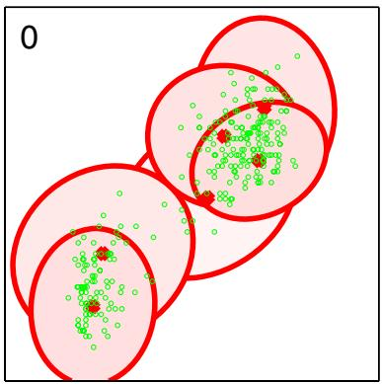
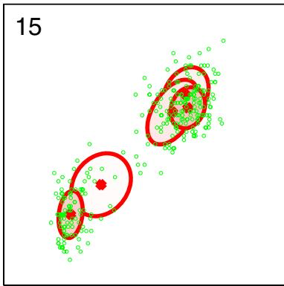
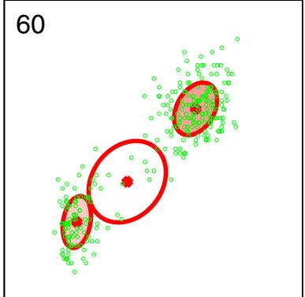
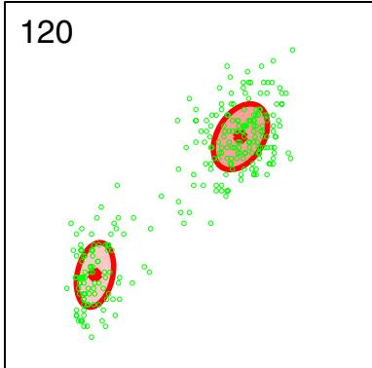
the prior tightly constrains the mixing coefficients so that $α_{0}∞,$ , then $E[π_{k}]→$ $1/K$
In Figure 10.6, the prior over the mixing coefficients is a Dirichlet of the form (10.39). Recall from Figure 2.5 that for $α_{0}<1$ the prior favours solutions in which some of the mixing coefficients are zero. Figure 10.6 was obtained using $α_{0}=10^{−3}$ and resulted in two components having nonzero mixing coefficients. If instead we choose $α_{0}=1$ we obtain three components with nonzero mixing coefficients, and for $α=10$ all six components have nonzero mixing coefficients.
As we have seen there is a close similarity between the variational solution for the Bayesian mixture of Gaussians and the EM algorithm for maximum likelihood. In fact if we consider the limit $N→∞$ then the Bayesian treatment converges to the maximum likelihood EM algorithm. For anything other than very small data sets, the dominant computational cost of the variational algorithm for Gaussian mixtures arises from the evaluation of the responsibilities, together with the evaluation and inversion of the weighted data covariance matrices. These computations mirror precisely those that arise in the maximum likelihood EM algorithm, and so there is little computational overhead in using this Bayesian approach as compared to the traditional maximum likelihood one. There are, however, some substantial advantages. First of all, the singularities that arise in maximum likelihood when a Gaussian component ‘collapses’ onto a specific data point are absent in the Bayesian treatment.
Section 10.2.4
Indeed, these singularities are removed if we simply introduce a prior and then use a MAP estimate instead of maximum likelihood. Furthermore, there is no over-fitting if we choose a large number K of components in the mixture, as we saw in Figure 10.6. Finally, the variational treatment opens up the possibility of determining the optimal number of components in the mixture without resorting to techniques such as cross validation.

10.2.2 Variational lower bound
We can also straightforwardly evaluate the lower bound (10.3) for this model. In practice, it is useful to be able to monitor the bound during the re-estimation in order to test for convergence. It can also provide a valuable check on both the mathematical expressions for the solutions and their software implementation, because at each step of the iterative re-estimation procedure the value of this bound should not decrease. We can take this a stage further to provide a deeper test of the correctness of both the mathematical derivation of the update equations and of their software implementation by using finite differences to check that each update does indeed give a (constrained) maximum of the bound (Svensen and Bishop, 2004). ´
For the variational mixture of Gaussians, the lower bound (10.3) is given by
L=Z​∭q(Z,π,μ,Λ)lnp(X,Z,π,μ,Λ)q(Z,π,μ,Λ)dπdμdΛ=E[lnp(X,Z,π,μ,Λ)]−E[lnq(Z,π,μ,Λ)]=E[lnp(X|Z,μ,Λ)]+E[lnp(Z|π)]+E[lnp(π)]+E[lnp(μ,Λ)]−E[lnq(Z)]−E[lnq(π)]−E[lnq(μ,Λ)]
where, to keep the notation uncluttered, we have omitted the superscript on the $q$ distributions, along with the subscripts on the expectation operators because each expectation is taken with respect to all of the random variables in its argument. The various terms in the bound are easily evaluated to give the following results
$$\begin{matrix}E[lnp(X|Z,μ,Λ)]=\frac{1}{2}\sum_{k=1}^{K}{N_{k}}\left\{ln{\tilde{Λ}}_{k}−Dβ_{k}^{−1}−ν_{k}Tr(S_{k}W_{k})\right. \\ \left.−ν_{k}({\overline{x}}_{k}−m_{k})^{T}W_{k}({\overline{x}}_{k}−m_{k})−Dln(2π)\right\}\end{matrix}$$
$$E[lnp(Z|π)]=\sum_{n=1}^{N}{\sum_{k=1}^{K}{r_{nk}}}ln{\tilde{π}}_{k}$$
$$E[lnp(π)]=lnC(α_{0})+(α_{0}−1)\sum_{k=1}^{K}{ln}{\tilde{π}}_{k}$$
$$\begin{matrix}E[lnp(μ,Λ)]=\frac{1}{2}\sum_{k=1}^{K}{\{}Dln(β_{0}/2π)+ln{\tilde{Λ}}_{k}−\frac{Dβ_{0}}{β_{k}} \\ −β_{0}ν_{k}(m_{k}−m_{0})^{T}W_{k}(m_{k}−m_{0})\}+KlnB(W_{0},ν_{0}) \\ +\frac{(ν_{0}−D−1)}{2}\sum_{k=1}^{K}{ln}{\tilde{Λ}}_{k}−\frac{1}{2}\sum_{k=1}^{K}{ν_{k}}Tr(W_{0}^{−1}W_{k})\end{matrix}$$
$$E[lnq(Z)]=\sum_{n=1}^{N}{\sum_{k=1}^{K}{r_{nk}}}lnr_{nk}$$
$$E[lnq(π)]=\sum_{k=1}^{K}{\left(α_{k}−1\right)}ln{\tilde{π}}_{k}+lnC(α)$$
$$E[lnq(μ,Λ)]=\sum_{k=1}^{K}{\left\{\frac{1}{2}ln{\tilde{Λ}}_{k}+\frac{D}{2}ln\left(\frac{β_{k}}{2π}\right)−\frac{D}{2}−H[q(Λ_{k})]\right\}}$$
where $D$ is the dimensionality of $x,H[q(Λ_{k})]$ is the entropy of the Wishart distribution given by (B.82), and the coefficients $C(α)$ and $B(W,ν)$ are defined by (B.23) and (B.79), respectively. Note that the terms involving expectations of the logs of the $q$ distributions simply represent the negative entropies of those distributions. Some simplifications and combination of terms can be performed when these expressions are summed to give the lower bound. However, we have kept the expressions separate for ease of understanding.
Finally, it is worth noting that the lower bound provides an alternative approach for deriving the variational re-estimation equations obtained in Section 10.2.1. To do this we use the fact that, since the model has conjugate priors, the functional form of the factors in the variational posterior distribution is known, namely discrete for $Z,$ Dirichlet for $π,$ , and Gaussian-Wishart for $(μ_{k},Λ_{k})$ . By taking general parametric forms for these distributions we can derive the form of the lower bound as a function of the parameters of the distributions. Maximizing the bound with respect to these parameters then gives the required re-estimation equations.

10.2.3 Predictive density
In applications of the Bayesian mixture of Gaussians model we will often be interested in the predictive density for a new value $\hat{x}$ of the observed variable. $As−$ sociated with this observation will be a corresponding latent variable $\hat{z},$ and the predictive density is then given by
p(x|X)=z​∭p(x|z,μ,Λ)p(z|π)p(π,μ,Λ|X)dπdμdΛ
where $p(π,μ,A|X)$ is the (unknown) true posterior distribution of the parameters. Using (10.37) and (10.38) we can first perform the summation over $\hat{z}$ to give
$$p(\hat{x}|X)=\sum_{k=1}^{K}{∭}π_{k}N\left(\hat{x}|μ_{k},Λ_{k}^{−1}\right)p(π,μ,Λ|X)dπdμdΛ.$$
Because the remaining integrations are intractable, we approximate the predictive density by replacing the true posterior distribution $p(π,μ,ΔΔΔ)$ with its variational approximation $q(π)q(μ,Λ)$ to give
$$p(\hat{x}|X)=\sum_{k=1}^{K}{∭}π_{k}N\left(\hat{x}|μ_{k},Λ_{k}^{−1}\right)q(π)q(μ_{k},Λ_{k})dπdμ_{k}dΛ_{k}$$
where we have made use of the factorization (10.55) and in each term we have implicitly integrated out all variables $\{μ_{j},Λ_{j}\}$ for $j≠k$ The remaining integrations can now be evaluated analytically giving a mixture of Student’s t-distributions
$$p(\hat{x}|X)=\frac{1}{\hat{α}}\sum_{k=1}^{K}{α_{k}}St(\hat{x}|m_{k},L_{k},ν_{k}+1−D)$$
in which the $k^{th}$ component has mean $m_{k}$ , and the precision is given by
$$L_{k}=\frac{(ν_{k}+1−D)β_{k}}{(1+β_{k})}W_{k}$$
in which $ν_{k}$ is given by (10.63). When the size N of the data set is large the predictive distribution (10.81) reduces to a mixture of Gaussians.

10.2.4 Determining the number of components
We have seen that the variational lower bound can be used to determine a posterior distribution over the number K of components in the mixture model. There is, however, one subtlety that needs to be addressed. For any given setting of the parameters in a Gaussian mixture model (except for specific degenerate settings), there will exist other parameter settings for which the density over the observed variables will be identical. These parameter values differ only through a re-labelling of the components. For instance, consider a mixture of two Gaussians and a single observed variable x, in which the parameters have the values $π_{1}=a,π_{2}=b,μ_{1}=c.$ $μ_{2}=d,σ_{1}=e,σ_{2}=f$ . Then the parameter values $π_{1}=b,π_{2}=a,μ_{1}=d.$ $μ_{2}=c,σ_{1}=f,σ_{2}=e.$ , in which the two components have been exchanged, will by symmetry give rise to the same value of $p(x)$ . If we have a mixture model comprising K components, then each parameter setting will be a member of a family of K! equivalent settings.
In the context of maximum likelihood, this redundancy is irrelevant because the parameter optimization algorithm (for example EM) will, depending on the initialization of the parameters, find one specific solution, and the other equivalent solutions play no role. In a Bayesian setting, however, we marginalize over all possible
Plot of the variational lower bound versus the number K of components in the Gaussian mixture model, for the Old Faithful data, showing a distinct peak at $K=$ 2 components. For each value of $K$ , the model is trained from 100 different random starts, and the results shown as $" + "$ symbols plotted with small random horizontal perturbations so that they can be distinguished. Note that some solutions find suboptimal local maxima, but that this happens infrequently.
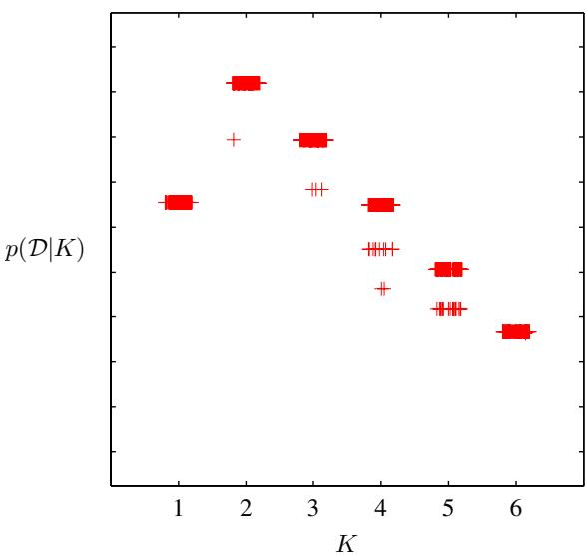
parameter values. We have seen in Figure 10.2 that if the true posterior distribution is multimodal, variational inference based on the minimization of KL $(q∥p)$ will tend to approximate the distribution in the neighbourhood of one of the modes and ignore the others. Again, because equivalent modes have equivalent predictive densities, this is of no concern provided we are considering a model having a specific number K of components. If, however, we wish to compare different values of K, then we need to take account of this multimodality. A simple approximate solution is to add a term ln K! onto the lower bound when used for model comparison and averaging.
Figure 10.7 shows a plot of the lower bound, including the multimodality factor, versus the number K of components for the Old Faithful data set. It is worth emphasizing once again that maximum likelihood would lead to values of the likelihood function that increase monotonically with K (assuming the singular solutions have been avoided, and discounting the effects of local maxima) and so cannot be used to determine an appropriate model complexity. By contrast, Bayesian inference automatically makes the trade-off between model complexity and fitting the data.
This approach to the determination of K requires that a range of models having different K values be trained and compared. An alternative approach to determining a suitable value for K is to treat the mixing coefficients π as parameters and make point estimates of their values by maximizing the lower bound (Corduneanu and Bishop, 2001) with respect to $π$ instead of maintaining a probability distribution over them as in the fully Bayesian approach. This leads to the re-estimation equation
$$π_{k}=\frac{1}{N}\sum_{n=1}^{N}{r_{nk}}$$
and this maximization is interleaved with the variational updates for the $q$ distribution over the remaining parameters. Components that provide insufficient contribution to explaining the data will have their mixing coefficients driven to zero during the optimization, and so they are effectively removed from the model through automatic relevance determination. This allows us to make a single training run in which we start with a relatively large initial value of K, and allow surplus components to be pruned out of the model. The origins of the sparsity when optimizing with respect to hyperparameters is discussed in detail in the context of the relevance vector machine.

10.2.5 Induced factorizations
In deriving these variational update equations for the Gaussian mixture model, we assumed a particular factorization of the variational posterior distribution given by (10.42). However, the optimal solutions for the various factors exhibit additional factorizations. In particular, the solution for $q^{⋆}(μ,Λ)$ is given by the product of an independent distribution $q^{⋆}(μ_{k},Λ_{k})$ over each of the components k of the mixture, whereas the variational posterior distribution $q^{⋆}(Z)$ over the latent variables, given by (10.48), factorizes into an independent distribution ${ { q } ^ { \star } } ( { \bf { z } } _ { n } )$ for each observation n (note that it does not further factorize with respect to k because, for each value of $n_{:}$ the $z_{nk}$ are constrained to sum to one over k). These additional factorizations are a consequence of the interaction between the assumed factorization and the conditional independence properties of the true distribution, as characterized by the directed graph in Figure 10.5.
We shall refer to these additional factorizations as induced factorizations because they arise from an interaction between the factorization assumed in the variational posterior distribution and the conditional independence properties of the true joint distribution. In a numerical implementation of the variational approach it is important to take account of such additional factorizations. For instance, it would be very inefficient to maintain a full precision matrix for the Gaussian distribution over a set of variables if the optimal form for that distribution always had a diagonal precision matrix (corresponding to a factorization with respect to the individual variables described by that Gaussian).
Such induced factorizations can easily be detected using a simple graphical test based on d-separation as follows. We partition the latent variables into three disjoint groups A, B, C and then let us suppose that we are assuming a factorization between C and the remaining latent variables, so that
$$q(A,B,C)=q(A,B)q(C).$$
Using the general result (10.9), together with the product rule for probabilities, we see that the optimal solution for $q(A,B)$ is given by
$$\begin{matrix}lnq^{⋆}(A,B) & = & E_{C}[lnp(X,A,B,C)]+const \\ & = & E_{C}[lnp(A,B|X,C)]+const.\end{matrix}$$
We now ask whether this resulting solution will factorize between A and B, in other words whether $q ^ { \star } ( { \bf A } , { \bf B } ) = q ^ { \star } ( { \bf A } ) q ^ { \star } ( { \bf B } )$ . This will happen if, and only if, ln $p(A,B|X,C)=lnp(A|X,C)+lnp(B|X,C)$ , that is, if the conditional independence relation
$$A⟂⟂B|X,C$$
is satisfied. We can test to see if this relation does hold, for any choice of A and B by making use of the d-separation criterion.
To illustrate this, consider again the Bayesian mixture of Gaussians represented by the directed graph in Figure 10.5, in which we are assuming a variational factorization given by (10.42). We can see immediately that the variational posterior distribution over the parameters must factorize between $π$ and the remaining parameters $μ$ and Λ because all paths connecting $π$ to either $μ$ or Λ must pass through one of the nodes $z_{n}$ all of which are in the conditioning set for our conditional independence test and all of which are head-to-tail with respect to such paths.

10.3. Variational Linear Regression
As a second illustration of variational inference, we return to the Bayesian linear regression model of Section 3.3. In the evidence framework, we approximated the integration over $α$ and $β$ by making point estimates obtained by maximizing the log marginal likelihood. A fully Bayesian approach would integrate over the hyperparameters as well as over the parameters. Although exact integration is intractable, we can use variational methods to find a tractable approximation. In order to simplify the discussion, we shall suppose that the noise precision parameter $β$ is known, and is fixed to its true value, although the framework is easily extended to include the distribution over $β.$ For the linear regression model, the variational treatment will turn out to be equivalent to the evidence framework. Nevertheless, it provides a good exercise in the use of variational methods and will also lay the foundation for variational treatment of Bayesian logistic regression in Section 10.6.
Recall that the likelihood function for w, and the prior over w, are given by
$$p(t|w)=\prod_{n=1}^{N}{N}(t_{n}|w^{T}ϕ_{n},β^{−1})$$
$$p(w|α)=N(w|0,α^{−1}I)$$
where $ϕ_{n}=ϕ(x_{n})$ . We now introduce a prior distribution over α. From our discussion in Section 2.3.6, we know that the conjugate prior for the precision of a Gaussian is given by a gamma distribution, and so we choose
$$p(α)=Gam(α|a_{0},b_{0})$$
where $Gam(⋅|⋅,⋅)$ is defined by (B.26). Thus the joint distribution of all the variables is given by
$$p(t,w,α)=p(t|w)p(w|α)p(α).$$
This can be represented as a directed graphical model as shown in Figure 10.8.

10.3.1 Variational distribution
Our first goal is to find an approximation to the posterior distribution $p(w,α|t)$ To do this, we employ the variational framework of Section 10.1, with a variational
Figure 10.8 Probabilistic graphical model representing the joint distribution (10.90) for the Bayesian linear regression model.
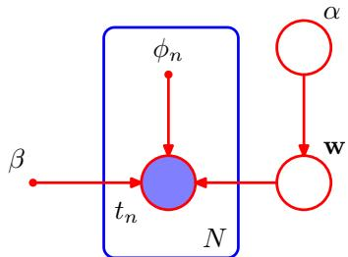
posterior distribution given by the factorized expression
$$q(w,α)=q(w)q(α).$$
We can find re-estimation equations for the factors in this distribution by making use of the general result (10.9). Recall that for each factor, we take the log of the joint distribution over all variables and then average with respect to those variables not in that factor. Consider first the distribution over α. Keeping only terms that have a functional dependence on α, we have
$$\begin{aligned}&lnq^{⋆}(α)=lnp(α)+E_{w}[lnp(w|α)]+const \\ & =(a_{0}−1)lnα−b_{0}α+\frac{M}{2}lnα−\frac{α}{2}E[w^{T}w]+const.\end{aligned}$$
We recognize this as the log of a gamma distribution, and so identifying the coefficients of α and ln α we obtain
$$q^{⋆}(α)=Gam(α|a_{N},b_{N})$$
where
$$a_{N}=a_{0}+\frac{M}{2}$$
$$b_{N}=b_{0}+\frac{1}{2}E[w^{T}w].$$
Similarly, we can find the variational re-estimation equation for the posterior distribution over w. Again, using the general result (10.9), and keeping only those terms that have a functional dependence on w, we have
$$lnq^{⋆}(w)=lnp(t|w)+E_{α}[lnp(w|α)]+const$$
$$=−\frac{β}{2}\sum_{n=1}^{N}{\{}w^{T}ϕ_{n}−t_{n}\}^{2}−\frac{1}{2}E[α]w^{T}w+const$$
$$=−\frac{1}{2}w^{T}\left(E[α]I+βΦ^{T}Φ\right)w+βw^{T}Φ^{T}t+const.$$
Because this is a quadratic form, the distribution $q^{⋆}(w)$ is Gaussian, and so we can complete the square in the usual way to identify the mean and covariance, giving
$$q^{⋆}(w)=N(w|m_{N},S_{N})$$
where
$$m_{N}=βS_{N}Φ^{T}t$$
$$S_{N}={\left(E[α]I+βΦ^{T}Φ\right)}^{−1}.$$
Note the close similarity to the posterior distribution (3.52) obtained when α was treated as a fixed parameter. The difference is that here α is replaced by its expectation $E[α]$ under the variational distribution. Indeed, we have chosen to use the same notation for the covariance matrix $S_{N}$ in both cases.
Using the standard results (B.27), (B.38), and (B.39), we can obtain the required moments as follows
$$E[α]=a_{N}/b_{N}$$
$$E[{ww}^{T}]=m_{N}m_{N}^{T}+S_{N}.$$
The evaluation of the variational posterior distribution begins by initializing the parameters of one of the distributions $q(w)$ or $q(α)$ , and then alternately re-estimates these factors in turn until a suitable convergence criterion is satisfied (usually specified in terms of the lower bound to be discussed shortly).
It is instructive to relate the variational solution to that found using the evidence framework in Section 3.5. To do this consider the case $a_{0}=b_{0}=0$ , corresponding to the limit of an infinitely broad prior over α. The mean of the variational posterior distribution $q(α)$ is then given by
$$E[α]=\frac{a_{N}}{b_{N}}=\frac{M/2}{E[w^{T}w]/2}=\frac{M}{m_{N}^{T}m_{N}+Tr(S_{N})}.$$
Comparison with (9.63) shows that in the case of this particularly simple model, the variational approach gives precisely the same expression as that obtained by maximizing the evidence function using EM except that the point estimate for α is replaced by its expected value. Because the distribution $q(w)$ depends on $q(α)$ only through the expectation $E[α]$ , we see that the two approaches will give identical results for the case of an infinitely broad prior.

10.3.2 Predictive distribution
The predictive distribution over t, given a new input x, is easily evaluated for this model using the Gaussian variational posterior for the parameters
$$\begin{matrix}p(t|x,t) & = & ∫p(t|x,w)p(w|t)dw \\ & ≃ & ∫p(t|x,w)q(w)dw \\ & = & ∫N(t|w^{T}ϕ(x),β^{−1})N(w|m_{N},S_{N})dw \\ & = & N(t|m_{N}^{T}ϕ(x),σ^{2}(x))\end{matrix}$$
where we have evaluated the integral by making use of the result (2.115) for the linear-Gaussian model. Here the input-dependent variance is given by
$$σ^{2}(x)=\frac{1}{β}+ϕ(x)^{T}S_{N}ϕ(x).$$
Note that this takes the same form as the result (3.59) obtained with fixed α except that now the expected value $E[α]$ appears in the definition of $S_{N}$

10.3.3 Lower bound
Another quantity of importance is the lower bound defined by
$$\begin{matrix}L(q) & = & E[lnp(w,α,t)]−E[lnq(w,α)] \\ & = & E_{w}[lnp(t|w)]+E_{w,α}[lnp(w|α)]+E_{α}[lnp(α)] \\ & & −E_{α}[lnq(w)]_{w}−E[lnq(α)].\end{matrix}$$
Exercise 10.27
Evaluation of the various terms is straightforward, making use of results obtained in previous chapters, and gives
$$\begin{matrix}E[lnp(t|w)]_{w} & = & \frac{N}{2}ln\left(\frac{β}{2π}\right)−\frac{β}{2}t^{T}t+βm_{N}^{T}Φ^{T}t \\ & & −\frac{β}{2}Tr\left[Φ^{T}Φ(m_{N}m_{N}^{T}+S_{N})\right]\end{matrix}$$
$$\begin{matrix}E[lnp(w|α)]_{w,α} & = & −\frac{M}{2}ln(2π)+\frac{M}{2}(ψ(a_{N})−lnb_{N}) \\ & & −\frac{a_{N}}{2b_{N}}\left[m_{N}^{T}m_{N}+Tr(S_{N})\right]\end{matrix}$$
$$\begin{matrix}E[lnp(α)]_{α} & = & a_{0}lnb_{0}+(a_{0}−1)[ψ(a_{N})−lnb_{N}] \\ & & −b_{0}\frac{a_{N}}{b_{N}}−lnΓ(a_{N})\end{matrix}$$
$$−E[lnq(w)]_{w}=\frac{1}{2}ln|S_{N}|+\frac{M}{2}[1+ln(2π)]$$
$$−E[lnq(α)]_{α}=lnΓ(a_{N})−(a_{N}−1)ψ(a_{N})−lnb_{N}+a_{N}.$$
Figure 10.9 shows a plot of the lower bound $L(q)$ versus the degree of a polynomial model for a synthetic data set generated from a degree three polynomial. Here the prior parameters have been set to $a_{0}=b_{0}=0.$ , corresponding to the noninformative prior $p(α)∝1/α$ , which is uniform over ln α as discussed in Section 2.3.6. As we saw in Section 10.1, the quantity $L$ represents lower bound on the log marginal likelihood $p(t|M)$ for the model. If we assign equal prior probabilities $p(M)$ to the different values of $M.$ , then we can interpret $L$ as an approximation to the posterior model probability $p(M|t)$ . Thus the variational framework assigns the highest probability to the model with $M=3$ . This should be contrasted with the maximum likelihood result, which assigns ever smaller residual error to models of increasing complexity until the residual error is driven to zero, causing maximum likelihood to favour severely over-fitted models.
Plot of the lower bound versus the order M of the polynomial, for a polynomial model, in which a set of 10 data points is generated from a polynomial with $M = 3$ sampled over the interval ( 5, 5) with additive Gaussian noise of variance 0.09. The value of the bound gives the log probability of the model, and we see that the value of the bound peaks at $M=3$ , corresponding to the true model from which the data set was generated.
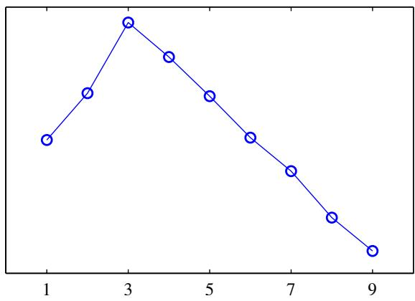

10.4. Exponential Family Distributions
In Chapter 2, we discussed the important role played by the exponential family of distributions and their conjugate priors. For many of the models discussed in this book, the complete-data likelihood is drawn from the exponential family. However, in general this will not be the case for the marginal likelihood function for the observed data. For example, in a mixture of Gaussians, the joint distribution of observations ${ \bf x } _ { n }$ and corresponding hidden variables $z_{n}$ is a member of the exponential family, whereas the marginal distribution of ${ \bf x } _ { n }$ is a mixture of Gaussians and hence is not.
Up to now we have grouped the variables in the model into observed variables and hidden variables. We now make a further distinction between latent variables, denoted Z, and parameters, denoted $θ,$ where parameters are intensive (fixed in number independent of the size of the data set), whereas latent variables are extensive (scale in number with the size of the data set). For example, in a Gaussian mixture model, the indicator variables $z_{kn}$ (which specify which component k is responsible for generating data point $x_{n})$ represent the latent variables, whereas the means $μ_{k}$ precisions $Λ_{Λ_{k}}$ and mixing proportions $π_{k}$ represent the parameters.
Consider the case of independent identically distributed data. We denote the data values by ${ \bf X } = \{ { \bf x } _ { n } \}$ , where $n=1,…N$ , with corresponding latent variables ${ \bf Z } = \{ { \bf z } _ { n } \}$ . Now suppose that the joint distribution of observed and latent variables is a member of the exponential family, parameterized by natural parameters η so that
$$p(X,Z|η)=\prod_{n=1}^{N}{h}(x_{n},z_{n})g(η)exp\left\{η^{T}u(x_{n},z_{n})\right\}.$$
We shall also use a conjugate prior for η, which can be written as
$$p(η|ν_{0},v_{0})=f(ν_{0},χ_{0})g(η)^{ν_{0}}exp\left\{ν_{o}η^{T}χ_{0}\right\}.$$
Recall that the conjugate prior distribution can be interpreted as a prior number $ν_{0}$ of observations all having the value $x_{0}$ for the u vector. Now consider a variational distribution that factorizes between the latent variables and the parameters, so that $q ( { \bf Z } , \eta ) = q ( { \bf Z } ) q ( \eta )$ . Using the general result (10.9), we can solve for the two factors as follows
$$\begin{matrix}lnq^{⋆}(Z) & = & E_{η}[lnp(X,Z|η)]+\text{ const } \\ & = & \sum_{n=1}^{N}{\left\{lnh(x_{n},z_{n})+E[η^{T}]u(x_{n},z_{n})\right\}}+\text{ const }.\end{matrix}$$
Thus we see that this decomposes into a sum of independent terms, one for each value of $n,$ and hence the solution for $q^{⋆}(Z)$ will factorize over $n$ so that $q^{⋆}(Z)=$ n​q⋆(zn) . This is an example of an induced factorization. Taking the exponential of both sides, we have
$$q^{⋆}(z_{n})=h(x_{n},z_{n})g\left(E[η]\right)exp\left\{E[η^{T}]u(x_{n},z_{n})\right\}$$
where the normalization coefficient has been re-instated by comparison with the standard form for the exponential family.
Similarly, for the variational distribution over the parameters, we have
$$lnq^{⋆}(η)=lnp(η|ν_{0},χ_{0})+E_{Z}[lnp(X,Z|η)]+const$$
$$
= \nu_ {0} \ln g (\boldsymbol {\eta}) + \boldsymbol {\eta} ^ {\mathrm{T}} \boldsymbol {\chi} _ {0} + \sum_ {n = 1} ^ {N} \left\{\ln g (\boldsymbol {\eta}) + \boldsymbol {\eta} ^ {\mathrm{T}} \mathbb {E} _ {\mathbf {z} _ {n}} [ \mathbf {u} (\mathbf {x} _ {n}, \mathbf {z} _ {n}) ] \right\} + \text { const. }\tag{10.118}
$$
Again, taking the exponential of both sides, and re-instating the normalization coefficient by inspection, we have
$$q^{⋆}(η)=f\left(ν_{N},χ_{N}\right)g(η)^{ν_{N}}exp\left\{η^{T}χ_{N}\right\}$$
where we have defined
$$
\nu_ {N} = \nu_ {0} + N\tag{10.120}
$$
$$χ_{N}=χ_{0}+\sum_{n=1}^{N}{E_{z_{n}}}[u(x_{n},z_{n})].$$
Note that the solutions for $q ^ { \star } ( { \bf z } _ { n } )$ and $q^{⋆}(η)$ are coupled, and so we solve them iteratively in a two-stage procedure. In the variational E step, we evaluate the expected sufficient statistics $\mathbb { E } [ { \bf u } ( { \bf x } _ { n } , { \bf z } _ { n } ) ]$ using the current posterior distribution $q(z_{n})$ over the latent variables and use this to compute a revised posterior distribution $q(η)$ over the parameters. Then in the subsequent variational M step, we use this revised parameter posterior distribution to find the expected natural parameters $E[η^{T}]$ , which gives rise to a revised variational distribution over the latent variables.

10.4.1 Variational message passing
We have illustrated the application of variational methods by considering a specific model, the Bayesian mixture of Gaussians, in some detail. This model can be described by the directed graph shown in Figure 10.5. Here we consider more generally the use of variational methods for models described by directed graphs and derive a number of widely applicable results.
The joint distribution corresponding to a directed graph can be written using the decomposition
p(x)=i​p(xi|pai)
where $x_{i}$ denotes the variable(s) associated with node $i,$ and ${pa}_{i}$ denotes the parent set corresponding to node i. Note that $x_{i}$ may be a latent variable or it may belong to the set of observed variables. Now consider a variational approximation in which the distribution $q(x)$ is assumed to factorize with respect to the $x_{i}$ so that
q(x)=i​qi(xi).
Note that for observed nodes, there is no factor $q(x_{i})$ in the variational distribution. We now substitute (10.122) into our general result (10.9) to give
$$
\ln q _ {j} ^ {\star} (\mathbf {x} _ {j}) = \mathbb {E} _ {i \neq j} \left[ \sum_ {i} \ln p (\mathbf {x} _ {i} | \mathrm{pa} _ {i}) \right] + \text { const. }\tag{10.124}
$$
Any terms on the right-hand side that do not depend on $x_{j}$ can be absorbed into the additive constant. In fact, the only terms that do depend on $x_{j}$ are the conditional distribution for $x_{j}$ given by $p(x_{j}|{pa}_{j})$ together with any other conditional distributions that have $x_{j}$ in the conditioning set. By definition, these conditional distributions correspond to the children of node $j$ , and they therefore also depend on the co-parents of the child nodes, i.e., the other parents of the child nodes besides node $x_{j}$ itself. We see that the set of all nodes on which $q^{⋆}(x_{j})$ depends corresponds to the Markov blanket of node $x_{j}$ , as illustrated in Figure 8.26. Thus the update of the factors in the variational posterior distribution represents a local calculation on the graph. This makes possible the construction of general purpose software for variational inference in which the form of the model does not need to be specified in advance (Bishop et al., 2003).
If we now specialize to the case of a model in which all of the conditional distributions have a conjugate-exponential structure, then the variational update procedure can be cast in terms of a local message passing algorithm (Winn and Bishop, 2005). In particular, the distribution associated with a particular node can be updated once that node has received messages from all of its parents and all of its children. This in turn requires that the children have already received messages from their coparents. The evaluation of the lower bound can also be simplified because many of the required quantities are already evaluated as part of the message passing scheme. This distributed message passing formulation has good scaling properties and is well suited to large networks.

10.5. Local Variational Methods
The variational framework discussed in Sections 10.1 and 10.2 can be considered a ‘global’ method in the sense that it directly seeks an approximation to the full posterior distribution over all random variables. An alternative ‘local’ approach involves finding bounds on functions over individual variables or groups of variables within a model. For instance, we might seek a bound on a conditional distribution $p(y|x)$ which is itself just one factor in a much larger probabilistic model specified by a directed graph. The purpose of introducing the bound of course is to simplify the resulting distribution. This local approximation can be applied to multiple variables in turn until a tractable approximation is obtained, and in Section 10.6.1 we shall give a practical example of this approach in the context of logistic regression. Here we focus on developing the bounds themselves.
We have already seen in our discussion of the Kullback-Leibler divergence that the convexity of the logarithm function played a key role in developing the lower bound in the global variational approach. We have defined a (strictly) convex function as one for which every chord lies above the function. Convexity also plays a central role in the local variational framework. Note that our discussion will apply equally to concave functions with ‘min’ and ‘max’ interchanged and with lower bounds replaced by upper bounds.
Let us begin by considering a simple example, namely the function $f(x)=$ $exp(−x)$ , which is a convex function of x, and which is shown in the left-hand plot of Figure 10.10. Our goal is to approximate $f(x)$ by a simpler function, in particular a linear function of $x.$ . From Figure 10.10, we see that this linear function will be a lower bound on $f(x)$ if it corresponds to a tangent. We can obtain the tangent line $y(x)$ at a specific value of x, say $x=ξ$ , by making a first order Taylor expansion
$$y(x)=f(ξ)+f^{′}(ξ)(x−ξ)$$
so that $y(x)≤f(x)$ with equality when $x=ξ$ . For our example function $f(x)=$
Figure 10.10 In the left-hand figure the red curve shows the function $exp(−x)$ and the blue line shows the tangent at $x = ξ$ defined by (10.125) with $ξ=1$ . This line has slope $\overset{⋅}{λ}=f^{′}(\overset{⋅}{ξ})=−exp(−\overset{⋅}{ξ})$ . Note that any other tangent line, for example the ones shown in green, will have a smaller value of $y$ at $x=$ $ξ.$ The right-hand figure shows the corresponding plot of the function $λξ−g(λ)$ , where $g(λ)$ is given by $​_{(10.131)}$ versus λ for $ξ = 1$ , in which the maximum corresponds to $λ=−exp(−ξ)=−1/e$
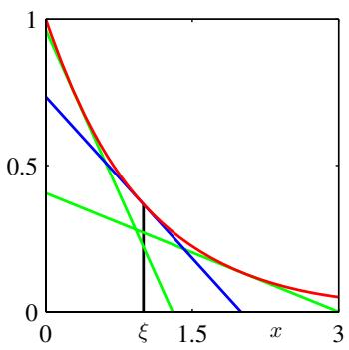
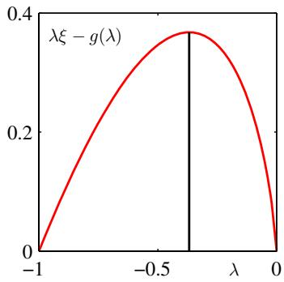
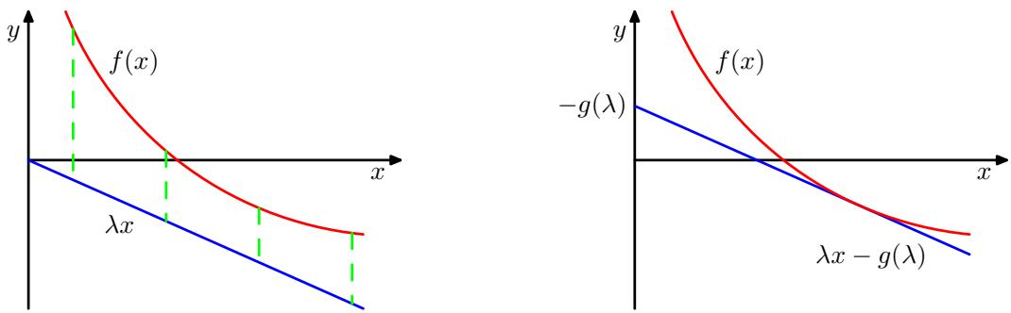
Figure 10.11 In the left-hand plot the red curve shows a convex function $f(x)$ , and the blue line represents the linear function $λx,$ which is a lower bound on $f(x)$ because $f(x)>λx$ for all x. For the given value of slope λ the contact point of the tangent line having the same slope is found by minimizing with respect to x the discrepancy (shown by the green dashed lines) given by $f(x)−λx$ . This defines the dual function $g(λ)$ , which corresponds to the (negative of the) intercept of the tangent line having slope λ.
$exp(−x)$ , we therefore obtain the tangent line in the form
$$y(x)=exp(−ξ)−exp(−ξ)(x−ξ)$$
which is a linear function parameterized by $ξ.$ For consistency with subsequent discussion, let us define $λ=−exp(−ξ)$ so that
$$y(x,λ)=λx−λ+λln(−λ).$$
Different values of λ correspond to different tangent lines, and because all such lines are lower bounds on the function, we have $f(x)≥y(x,λ)$ . Thus we can write the function in the form
$$f(x)=\max_{λ}\left\{λx−λ+λln(−λ)\right\}.$$
We have succeeded in approximating the convex function $f(x)$ by a simpler, linear function $y(x,λ)$ . The price we have paid is that we have introduced a variational parameter λ, and to obtain the tightest bound we must optimize with respect to λ.
We can formulate this approach more generally using the framework of convex duality (Rockafellar, 1972; Jordan et al., 1999). Consider the illustration of a convex function $f(x)$ shown in the left-hand plot in Figure 10.11. In this example, the function λx is a lower bound on $f(x)$ but it is not the best lower bound that can be achieved by a linear function having slope λ, because the tightest bound is given by the tangent line. Let us write the equation of the tangent line, having slope λ as $λx−g(λ)$ where the (negative) intercept $g(λ)$ clearly depends on the slope λ of the tangent. To determine the intercept, we note that the line must be moved vertically by an amount equal to the smallest vertical distance between the line and the function, as shown in Figure 10.11. Thus
$$\begin{matrix}g(λ) & = & −\min_{x}\left\{f(x)−λx\right\} \\ & = & \max_{x}\left\{λx−f(x)\right\}.\end{matrix}$$
Now, instead of fixing λ and varying x, we can consider a particular x and then adjust λ until the tangent plane is tangent at that particular x. Because the y value of the tangent line at a particular x is maximized when that value coincides with its contact point, we have
$$f(x)=\max_{λ}\left\{λx−g(λ)\right\}.$$
We see that the functions $f(x)$ and $g(λ)$ play a dual role, and are related through (10.129) and (10.130).
Let us apply these duality relations to our simple example $f(x)=exp(−x)$ From (10.129) we see that the maximizing value of x is given by $ξ=−ln(−λ)$ , and back-substituting we obtain the conjugate function $g(λ)$ in the form
$$g(λ)=λ−λln(−λ)$$
as obtained previously. The function $λξ−g(λ)$ is shown, for $ξ=1$ in the right-hand plot in Figure 10.10. As a check, we can substitute (10.131) into (10.130), which gives the maximizing value of $λ=−exp(−x)$ , and back-substituting then recovers the original function $f(x)=exp(−x)$
For concave functions, we can follow a similar argument to obtain upper bounds, in which max’ is replaced with ‘min’, so that
$$f(x)=\min_{λ}\{λx−g(λ)\}$$
$$g(λ)=\min_{x}\left\{λx−f(x)\right\}.$$
If the function of interest is not convex (or concave), then we cannot directly apply the method above to obtain a bound. However, we can first seek invertible transformations either of the function or of its argument which change it into a convex form. We then calculate the conjugate function and then transform back to the original variables.
An important example, which arises frequently in pattern recognition, is the logistic sigmoid function defined by
$$σ(x)=\frac{1}{1+e^{−x}}.$$
As it stands this function is neither convex nor concave. However, if we take the logarithm we obtain a function which is concave, as is easily verified by finding the second derivative. From (10.133) the corresponding conjugate function then takes the form
$$g(λ)=\min_{x}\left\{λx−f(x)\right\}=−λlnλ−(1−λ)ln(1−λ)$$
which we recognize as the binary entropy function for a variable whose probability of having the value 1 is λ. Using (10.132), we then obtain an upper bound on the log sigmoid
$$lnσ(x)≤λx−g(λ)$$
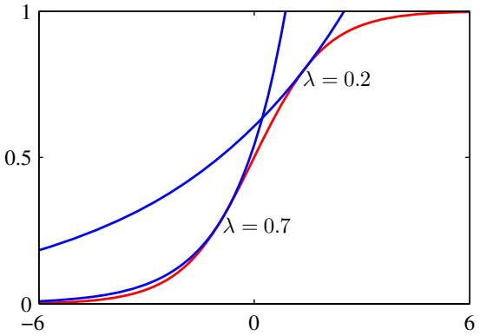
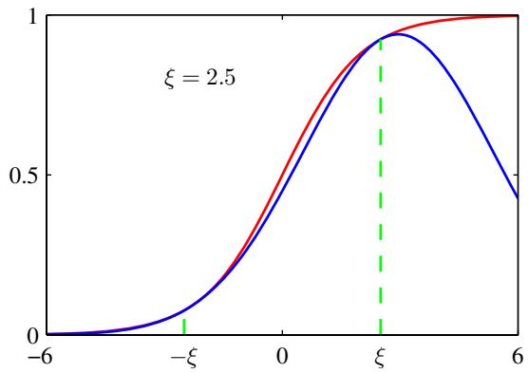
Figure 10.12 The left-hand plot shows the logistic sigmoid function $σ(x)$ defined by (10.134) in red, together with two examples of the exponential upper bound (10.137) shown in blue. The right-hand plot shows the logistic sigmoid again in red together with the Gaussian lower bound (10.144) shown in blue. Here the parameter $ξ=2.5$ , and the bound is exact at $x=ξ$ and $x=−ξ$ , denoted by the dashed green lines.
and taking the exponential, we obtain an upper bound on the logistic sigmoid itself of the form
$$σ(x)≤exp(λx−g(λ))$$
which is plotted for two values of λ on the left-hand plot in Figure 10.12.
We can also obtain a lower bound on the sigmoid having the functional form of a Gaussian. To do this, we follow Jaakkola and Jordan (2000) and make transformations both of the input variable and of the function itself. First we take the log of the logistic function and then decompose it so that
$$\begin{matrix}lnσ(x) & = & −ln(1+e^{−x})=−ln\left\{e^{−x/2}(e^{x/2}+e^{−x/2})\right\} \\ & = & x/2−ln(e^{x/2}+e^{−x/2}).\end{matrix}$$
We now note that the function $f(x)=−ln(e^{x/2}+e^{−x/2})$ is a convex function of the variable $x^{2}$ , as can again be verified by finding the second derivative. This leads to a lower bound on $f(x)$ , which is a linear function of $x^{2}$ whose conjugate function is given by
$$g(λ)=\max_{x^{2}}\left\{λx^{2}−f\left(\sqrt{x^{2}}\right)\right\}.$$
The stationarity condition leads to
$$0=λ−\frac{dx}{dx^{2}}\frac{d}{dx}f(x)=λ+\frac{1}{4x}tanh\left(\frac{x}{2}\right).$$
If we denote this value of $x,$ corresponding to the contact point of the tangent line for this particular value of λ, by $ξ,$ , then we have
$$λ(ξ)=−\frac{1}{4ξ}tanh\left(\frac{ξ}{2}\right)=−\frac{1}{2ξ}\left[σ(ξ)−\frac{1}{2}\right].$$
Instead of thinking of $λ$ as the variational parameter, we can let $ξ$ play this role as this leads to simpler expressions for the conjugate function, which is then given by
$$g(λ)=λ(ξ)ξ^{2}−f(ξ)=λ(ξ)ξ^{2}+ln(e^{ξ/2}+e^{−ξ/2}).$$
Hence the bound on $f(x)$ can be written as
$$f(x)≥λx^{2}−g(λ)=λx^{2}−λξ^{2}−ln(e^{ξ/2}+e^{−ξ/2}).$$
The bound on the sigmoid then becomes
$$σ(x)≥σ(ξ)exp\left\{(x−ξ)/2−λ(ξ)(x^{2}−ξ^{2})\right\}$$
where $λ(ξ)$ is defined by (10.141). This bound is illustrated in the right-hand plot of Figure 10.12. We see that the bound has the form of the exponential of a quadratic function of $x,$ which will prove useful when we seek Gaussian representations of posterior distributions defined through logistic sigmoid functions.
The logistic sigmoid arises frequently in probabilistic models over binary variables because it is the function that transforms a log odds ratio into a posterior probability. The corresponding transformation for a multiclass distribution is given by the softmax function. Unfortunately, the lower bound derived here for the logistic sigmoid does not directly extend to the softmax. Gibbs (1997) proposes a method for constructing a Gaussian distribution that is conjectured to be a bound (although no rigorous proof is given), which may be used to apply local variational methods to multiclass problems.
We shall see an example of the use of local variational bounds in Sections 10.6.1. For the moment, however, it is instructive to consider in general terms how these bounds can be used. Suppose we wish to evaluate an integral of the form
$$
I = \int \sigma (a) p (a) \mathrm{d} a\tag{10.145}
$$
where $σ(a)$ is the logistic sigmoid, and $p(a)$ is a Gaussian probability density. Such integrals arise in Bayesian models when, for instance, we wish to evaluate the predictive distribution, in which case $p(a)$ represents a posterior parameter distribution. Because the integral is intractable, we employ the variational bound (10.144), which we write in the form $σ(a)≥f(a,ξ)$ where $ξ$ is a variational parameter. The integral now becomes the product of two exponential-quadratic functions and so can be integrated analytically to give a bound on I
$$I≥∫f(a,ξ)p(a)da=F(ξ).$$
We now have the freedom to choose the variational parameter $ξ,$ , which we do by finding the value $ξ^{⋆}$ that maximizes the function $F(ξ)$ . The resulting value $F(ξ^{⋆})$ represents the tightest bound within this family of bounds and can be used as an approximation to I. This optimized bound, however, will in general not be exact.
Although the bound $σ(a)≥f(a,ξ)$ on the logistic sigmoid can be optimized exactly, the required choice for $ξ$ depends on the value of a, so that the bound is exact for one value of a only. Because the quantity $F(ξ)$ is obtained by integrating over all values of $a,$ the value of $ξ^{⋆}$ represents a compromise, weighted by the distribution $p(a)$

10.6. Variational Logistic Regression
We now illustrate the use of local variational methods by returning to the Bayesian logistic regression model studied in Section 4.5. There we focussed on the use of the Laplace approximation, while here we consider a variational treatment based on the approach of Jaakkola and Jordan (2000). Like the Laplace method, this also leads to a Gaussian approximation to the posterior distribution. However, the greater flexibility of the variational approximation leads to improved accuracy compared to the Laplace method. Furthermore (unlike the Laplace method), the variational approach is optimizing a well defined objective function given by a rigourous bound on the model evidence. Logistic regression has also been treated by Dybowski and Roberts (2005) from a Bayesian perspective using Monte Carlo sampling techniques.

10.6.1 Variational posterior distribution
Here we shall make use of a variational approximation based on the local bounds introduced in Section 10.5. This allows the likelihood function for logistic regression, which is governed by the logistic sigmoid, to be approximated by the exponential of a quadratic form. It is therefore again convenient to choose a conjugate Gaussian prior of the form (4.140). For the moment, we shall treat the hyperparameters $m_{0}$ and $S_{0}$ as fixed constants. In Section 10.6.3, we shall demonstrate how the variational formalism can be extended to the case where there are unknown hyperparameters whose values are to be inferred from the data.
In the variational framework, we seek to maximize a lower bound on the marginal likelihood. For the Bayesian logistic regression model, the marginal likelihood takes the form
$$p(t)=∫p(t|w)p(w)dw=∫\left[\prod_{n=1}^{N}{p}(t_{n}|w)\right]p(w)dw.$$
We first note that the conditional distribution for t can be written as
$$\begin{matrix}p(t|w) & = & σ(a)^{t}{\left\{1−σ(a)\right\}}^{1−t} \\ & = & {\left(\frac{1}{1+e^{−a}}\right)}^{t}{\left(1−\frac{1}{1+e^{−a}}\right)}^{1−t} \\ & = & e^{at}\frac{e^{−a}}{1+e^{−a}}=e^{at}σ(−a)\end{matrix}$$
where $a=w^{T}ϕ$ . In order to obtain a lower bound on $p(t)$ , we make use of the variational lower bound on the logistic sigmoid function given by (10.144), which
we reproduce here for convenience
$$σ(z)≥σ(ξ)exp\left\{(z−ξ)/2−λ(ξ)(z^{2}−ξ^{2})\right\}$$
where
$$λ(ξ)=\frac{1}{2ξ}\left[σ(ξ)−\frac{1}{2}\right].$$
We can therefore write
$$p(t|w)=e^{at}σ(−a)≥e^{at}σ(ξ)exp\left\{−(a+ξ)/2−λ(ξ)(a^{2}−ξ^{2})\right\}.$$
Note that because this bound is applied to each of the terms in the likelihood function separately, there is a variational parameter $ξ_{n}$ corresponding to each training set observation $(ϕ_{n},t_{n})$ . Using $a=w^{T}ϕ$ , and multiplying by the prior distribution, we obtain the following bound on the joint distribution of t and w
$$p(t,w)=p(t|w)p(w)≥h(w,ξ)p(w)$$
where $ξ$ denotes the set $\{ξ_{n}\}$ of variational parameters, and
$$\begin{matrix}h(w,ξ) & = & \prod_{n=1}^{N}{σ}(ξ_{n})exp\left\{w^{T}ϕ_{n}t_{n}−(w^{T}ϕ_{n}+ξ_{n})/2\right. \\ & & \left.−λ(ξ_{n})([w^{T}ϕ_{n}]^{2}−ξ_{n}^{2})\right\}.\end{matrix}$$
Evaluation of the exact posterior distribution would require normalization of the lefthand side of this inequality. Because this is intractable, we work instead with the right-hand side. Note that the function on the right-hand side cannot be interpreted as a probability density because it is not normalized. Once it is normalized to give a variational posterior distribution $q(w)$ , however, it no longer represents a bound.
Because the logarithm function is monotonically increasing, the inequality $A≥$ $B$ implies ln $A≥$ ln $B.$ . This gives a lower bound on the log of the joint distribution of t and w of the form
$$\begin{matrix}ln\left\{p(t|w)p(w)\right\}≥lnp(w)+\sum_{n=1}^{N}{\left\{lnσ(ξ_{n})+w^{T}ϕ_{n}t_{n}\right.} \\ \left.−(w^{T}ϕ_{n}+ξ_{n})/2−λ(ξ_{n})([w^{T}ϕ_{n}]^{2}−ξ_{n}^{2})\right\}.\end{matrix}$$
Substituting for the prior $p(w)$ , the right-hand side of this inequality becomes, as a function of w
$$\begin{matrix}−\frac{1}{2}(w−m_{0})^{T}S_{0}^{−1}(w−m_{0}) \\ +\sum_{n=1}^{N}{\left\{w^{T}ϕ_{n}(t_{n}−1/2)−λ(ξ_{n})w^{T}(ϕ_{n}ϕ_{n}^{T})w\right\}}+const.\end{matrix}$$
This is a quadratic function of w, and so we can obtain the corresponding variational approximation to the posterior distribution by identifying the linear and quadratic terms in w, giving a Gaussian variational posterior of the form
$$q(w)=N(w|m_{N},S_{N})$$
where
$$m_{N}=S_{N}\left(S_{0}^{−1}m_{0}+\sum_{n=1}^{N}{(}t_{n}−1/2)ϕ_{n}\right)$$
$$S_{N}^{−1}=S_{0}^{−1}+2\sum_{n=1}^{N}{λ}(ξ_{n})ϕ_{n}ϕ_{n}^{T}.$$
As with the Laplace framework, we have again obtained a Gaussian approximation to the posterior distribution. However, the additional flexibility provided by the variational parameters $\{ξ_{n}\}$ leads to improved accuracy in the approximation (Jaakkola and Jordan, 2000).
Here we have considered a batch learning context in which all of the training data is available at once. However, Bayesian methods are intrinsically well suited to sequential learning in which the data points are processed one at a time and then discarded. The formulation of this variational approach for the sequential case is straightforward.
Note that the bound given by (10.149) applies only to the two-class problem and so this approach does not directly generalize to classification problems with $K>2$ classes. An alternative bound for the multiclass case has been explored by Gibbs (1997).

10.6.2 Optimizing the variational parameters
We now have a normalized Gaussian approximation to the posterior distribution, which we shall use shortly to evaluate the predictive distribution for new data points. First, however, we need to determine the variational parameters $\{ξ_{n}\}$ by maximizing the lower bound on the marginal likelihood.
To do this, we substitute the inequality (10.152) back into the marginal likelihood to give
$$lnp(t)=ln∫p(t|w)p(w)dw≥ln∫h(w,ξ)p(w)dw=L(ξ).$$
As with the optimization of the hyperparameter α in the linear regression model of Section 3.5, there are two approaches to determining the $ξ_{n}$ . In the first approach, we recognize that the function $L(ξ)$ is defined by an integration over w and so we can view w as a latent variable and invoke the EM algorithm. In the second approach, we integrate over w analytically and then perform a direct maximization over $ξ$ . Let us begin by considering the EM approach.
The EM algorithm starts by choosing some initial values for the parameters $\{ξ_{n}\}$ , which we denote collectively by ${\dot{ξ}}^{old}$ . In the E step of the EM algorithm, we then use these parameter values to find the posterior distribution over w, which is given by (10.156). In the M step, we then maximize the expected complete-data log likelihood which is given by
$$Q(ξ,ξ^{old})=E\left[lnh(w,ξ)p(w)\right]$$
where the expectation is taken with respect to the posterior distribution $q(w)$ evaluated using $ξ^{old}$ . Noting that $p(w)$ does not depend on $ξ,$ , and substituting for $h(w,ξ)$ we obtain
$$
Q (\boldsymbol {\xi}, \boldsymbol {\xi} ^ {\text { old }}) = \sum_ {n = 1} ^ {N} \left\{\ln \sigma (\xi_ {n}) - \xi_ {n} / 2 - \lambda (\xi_ {n}) (\phi_ {n} ^ {\mathrm{T}} \mathbb {E} [ \mathbf {w w} ^ {\mathrm{T}} ] \phi_ {n} - \xi_ {n} ^ {2}) \right\} + \text { const }\tag{10.161}
$$
where ‘const’ denotes terms that are independent of ${ \bf \dot { \xi } }$ . We now set the derivative with respect to $ξ_{n}$ equal to zero. A few lines of algebra, making use of the definitions of $σ(ξ)$ and $λ(ξ)$ , then gives
$$0=λ^{′}(ξ_{n})(ϕ_{n}^{T}E[{ww}^{T}]ϕ_{n}−ξ_{n}^{2}).$$
We now note that $λ^{′}(ξ)$ is a monotonic function of $ξ$ for $ξ≥0$ , and that we can restrict attention to nonnegative values of $ξ$ without loss of generality due to the symmetry of the bound around $ξ=0$ . Thus $λ^{′}(ξ)≠0$ , and hence we obtain the following re-estimation equations
$$(ξ_{n}^{new})^{2}=ϕ_{n}^{T}E[{ww}^{T}]ϕ_{n}=ϕ_{n}^{T}(S_{N}+m_{N}m_{N}^{T})ϕ_{n}$$
where we have used (10.156).
Let us summarize the EM algorithm for finding the variational posterior distribution. We first initialize the variational parameters $ξ^{old}$ . In the E step, we evaluate the posterior distribution over w given by (10.156), in which the mean and covariance are defined by (10.157) and (10.158). In the M step, we then use this variational posterior to compute a new value for $ξ$ given by (10.163). The E and M steps are repeated until a suitable convergence criterion is satisfied, which in practice typically requires only a few iterations.
An alternative approach to obtaining re-estimation equations for $ξ$ is to note that in the integral over w in the definition (10.159) of the lower bound $L(ξ)$ , the integrand has a Gaussian-like form and so the integral can be evaluated analytically. Having evaluated the integral, we can then differentiate with respect to $ξ_{n}$ . It turns out that this gives rise to exactly the same re-estimation equations as does the EM approach given by (10.163).
As we have emphasized already, in the application of variational methods it is useful to be able to evaluate the lower bound $L(ξ)$ given by (10.159). The integration over w can be performed analytically by noting that $p(w)$ is Gaussian and $h(w,ξ)$ is the exponential of a quadratic function of $w$ . Thus, by completing the square and making use of the standard result for the normalization coefficient of a Gaussian distribution, we can obtain a closed form solution which takes the form
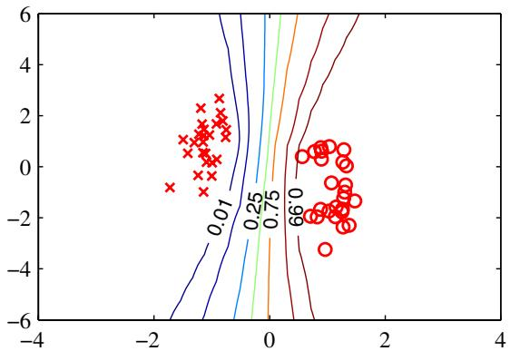
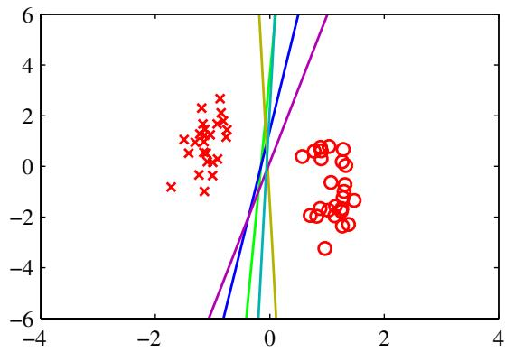
Figure 10.13 Illustration of the Bayesian approach to logistic regression for a simple linearly separable data set. The plot on the left shows the predictive distribution obtained using variational inference. We see that the decision boundary lies roughly mid way between the clusters of data points, and that the contours of the predictive distribution splay out away from the data reflecting the greater uncertainty in the classification of such regions. The plot on the right shows the decision boundaries corresponding to five samples of the parameter vector w drawn from the posterior distribution $p(w|t)$
$$\begin{matrix}L(ξ) & = & \frac{1}{2}ln\frac{|S_{N}|}{|S_{0}|}−\frac{1}{2}m_{N}^{T}S_{N}^{−1}m_{N}+\frac{1}{2}m_{0}^{T}S_{0}^{−1}m_{0} \\ & & +\sum_{n=1}^{N}{\left\{lnσ(ξ_{n})−\frac{1}{2}ξ_{n}−λ(ξ_{n})ξ_{n}^{2}\right\}}.\end{matrix}$$
This variational framework can also be applied to situations in which the data is arriving sequentially (Jaakkola and Jordan, 2000). In this case we maintain a Gaussian posterior distribution over w, which is initialized using the prior $p(w)$ . As each data point arrives, the posterior is updated by making use of the bound (10.151) and then normalized to give an updated posterior distribution.
The predictive distribution is obtained by marginalizing over the posterior distribution, and takes the same form as for the Laplace approximation discussed in Section 4.5.2. Figure 10.13 shows the variational predictive distributions for a synthetic data set. This example provides interesting insights into the concept of ‘large margin’, which was discussed in Section 7.1 and which has qualitatively similar behaviour to the Bayesian solution.

10.6.3 Inference of hyperparameters
So far, we have treated the hyperparameter α in the prior distribution as a known constant. We now extend the Bayesian logistic regression model to allow the value of this parameter to be inferred from the data set. This can be achieved by combining the global and local variational approximations into a single framework, so as to maintain a lower bound on the marginal likelihood at each stage. Such a combined approach was adopted by Bishop and Svensen (2003) in the context of a Bayesian ´ treatment of the hierarchical mixture of experts model.
Specifically, we consider once again a simple isotropic Gaussian prior distribution of the form
$$p(w|α)=N(w|0,α^{−1}I).$$
Our analysis is readily extended to more general Gaussian priors, for instance if we wish to associate a different hyperparameter with different subsets of the parameters $w_{j}$ . As usual, we consider a conjugate hyperprior over α given by a gamma distribution
$$p(α)=Gam(α|a_{0},b_{0})$$
governed by the constants $a_{0}$ and $b_{0}$ .
The marginal likelihood for this model now takes the form
$$p(t)=∬p(w,α,t)dwdα$$
where the joint distribution is given by
$$p(w,α,t)=p(t|w)p(w|α)p(α).$$
We are now faced with an analytically intractable integration over w and $α,$ which we shall tackle by using both the local and global variational approaches in the same model
To begin with, we introduce a variational distribution $q(w,α)$ , and then apply the decomposition (10.2), which in this instance takes the form
$$lnp(t)=L(q)+KL(q∥p)$$
where the lower bound $L(q)$ and the Kullback-Leibler divergence $KL(q∥p)$ are defined by
$$L(q)=∬q(w,α)ln\left\{\frac{p(w,α,t)}{q(w,α)}\right\}dwdα$$
$$KL(q∥p)=−∬q(w,α)ln\left\{\frac{p(w,α|t))}{q(w,α)}\right\}dwdα.$$
At this point, the lower bound $L(q)$ is still intractable due to the form of the likelihood factor $p(t|w)$ . We therefore apply the local variational bound to each of the logistic sigmoid factors as before. This allows us to use the inequality (10.152) and place a lower bound on $L(q)$ , which will therefore also be a lower bound on the log marginal likelihood
$$\begin{matrix}lnp(t) & ≥ & L(q)≥\tilde{L}(q,ξ) \\ & = & ∬q(w,α)ln\left\{\frac{h(w,ξ)p(w|α)p(α)}{q(w,α)}\right\}dwdα.\end{matrix}$$
Next we assume that the variational distribution factorizes between parameters and hyperparameters so that
$$q(w,α)=q(w)q(α).$$
With this factorization we can appeal to the general result (10.9) to find expressions for the optimal factors. Consider first the distribution $q(w)$ . Discarding terms that are independent of w, we have
$$\begin{matrix}lnq(w) & = & E_{α}\left[ln\left\{h(w,ξ)p(w|α)p(α)\right\}\right]+const \\ & = & lnh(w,ξ)+E_{α}\left[lnp(w|α)\right]+const.\end{matrix}$$
We now substitute for ln $h(w,ξ)$ using (10.153), and for ln $p(w|α)$ using (10.165), giving
$$lnq(w)=−\frac{E[α]}{2}w^{T}w+\sum_{n=1}^{N}{\left\{(t_{n}−1/2)w^{T}ϕ_{n}−λ(ξ_{n})w^{T}ϕ_{n}ϕ_{n}^{T}w\right\}}+const.$$
We see that this is a quadratic function of w and so the solution for $q(w)$ will be Gaussian. Completing the square in the usual way, we obtain
$$q(w)=N(w|μ_{N},Σ_{N})$$
where we have defined
$$Σ_{N}^{−1}μ_{N}=\sum_{n=1}^{N}{(}t_{n}−1/2)ϕ_{n}$$
$$Σ_{N}^{−1}=E[α]I+2\sum_{n=1}^{N}{λ}(ξ_{n})ϕ_{n}ϕ_{n}^{T}.$$
Similarly, the optimal solution for the factor $q(α)$ is obtained from
$$lnq(α)=E_{w}\left[lnp(w|α)\right]+lnp(α)+const.$$
Substituting for ln $p(w|α)$ using (10.165), and for ln $p(α)$ using (10.166), we obtain
$$lnq(α)=\frac{M}{2}lnα−\frac{α}{2}E\left[w^{T}w\right]+(a_{0}−1)lnα−b_{0}α+const.$$
We recognize this as the log of a gamma distribution, and so we obtain
$$q(α)=Gam(α|a_{N},b_{N})=\frac{1}{Γ(a_{0})}a_{0}^{b_{0}}α^{a_{0}−1}e^{−b_{0}α}$$
where
$$a_{N}=a_{0}+\frac{M}{2}$$
$$b_{N}=b_{0}+\frac{1}{2}E_{w}\left[w^{T}w\right].$$
We also need to optimize the variational parameters $ξ_{n}$ , and this is also done by maximizing the lower bound $\tilde{L}(q,ξ)$ . Omitting terms that are independent of $ξ,$ and integrating over α, we have
$$\tilde{L}(q,ξ)=∫q(w)lnh(w,ξ)dw+const.$$
Note that this has precisely the same form as (10.159), and so we can again appeal to our earlier result (10.163), which can be obtained by direct optimization of the marginal likelihood function, leading to re-estimation equations of the form
$$(ξ_{n}^{new})^{2}=ϕ_{n}^{T}(Σ_{N}+μ_{N}μ_{N}^{T})ϕ_{n}.$$
We have obtained re-estimation equations for the three quantities $q(w),q(α)$ and $ξ,$ , and so after making suitable initializations, we can cycle through these quantities, updating each in turn. The required moments are given by
Appendix B
$$E[α]=\frac{a_{N}}{b_{N}}$$
$$E\left[w^{T}w\right]=Σ_{N}+μ_{N}^{T}μ_{N}.$$

10.7. Expectation Propagation
We conclude this chapter by discussing an alternative form of deterministic approximate inference, known as expectation propagation or $EP$ (Minka, 2001a; Minka, 2001b). As with the variational Bayes methods discussed so far, this too is based on the minimization of a Kullback-Leibler divergence but now of the reverse form, which gives the approximation rather different properties.
Consider for a moment the problem of minimizing KL $(p∥q)$ with respect to $q(z)$ when $p(z)$ is a fixed distribution and $q(z)$ is a member of the exponential family and so, from (2.194), can be written in the form
$$q(z)=h(z)g(η)exp\left\{η^{T}u(z)\right\}.$$
As a function of $η,$ the Kullback-Leibler divergence then becomes
$$KL(p∥q)=−lng(η)−η^{T}E_{p(z)}[u(z)]+const$$
where the constant terms are independent of the natural parameters $η.$ . We can minimize $KL(p||q)$ within this family of distributions by setting the gradient with respect to η to zero, giving
$$−∇lng(η)=E_{p(z)}[u(z)].$$
However, we have already seen in (2.226) that the negative gradient of ln $g(η)$ is given by the expectation of $u(z)$ under the distribution $q(z)$ . Equating these two results, we obtain
$$E_{q(z)}[u(z)]=E_{p(z)}[u(z)].$$
We see that the optimum solution simply corresponds to matching the expected sufficient statistics. So, for instance, if $q(z)$ is a Gaussian $N(z|μ,Σ)$ then we minimize the Kullback-Leibler divergence by setting the mean $μ$ of $q(z)$ equal to the mean of the distribution $p(z)$ and the covariance $\overset{‾}{Σ}$ equal to the covariance of $p(z)$ . This is sometimes called moment matching. An example of this was seen in Figure 10.3(a).
Now let us exploit this result to obtain a practical algorithm for approximate inference. For many probabilistic models, the joint distribution of data $D$ and hidden variables (including parameters) $θ$ comprises a product of factors in the form
p(D,θ)=i​fi(θ).
This would arise, for example, in a model for independent, identically distributed data in which there is one factor $f_{n}(θ)=p(x_{n}|θ)$ for each data point ${ \bf x } _ { n }$ , along with a factor $f_{0}(θ)=p(θ)$ corresponding to the prior. More generally, it would also apply to any model defined by a directed probabilistic graph in which each factor is a conditional distribution corresponding to one of the nodes, or an undirected graph in which each factor is a clique potential. We are interested in evaluating the posterior distribution $p(θ|D)$ for the purpose of making predictions, as well as the model evidence $p(D)$ for the purpose of model comparison. From (10.188) the posterior is given by
p(θ|D)=1p(D)i​fi(θ)
and the model evidence is given by
p(D)=∫i​fi(θ)dθ.
Here we are considering continuous variables, but the following discussion applies equally to discrete variables with integrals replaced by summations. We shall suppose that the marginalization over $θ,$ , along with the marginalizations with respect to the posterior distribution required to make predictions, are intractable so that some form of approximation is required.
Expectation propagation is based on an approximation to the posterior distribution which is also given by a product of factors
q(θ)=1Zi​fi(θ)
in which each factor ${\tilde{f}}_{i}(θ)$ in the approximation corresponds to one of the factors $f_{i}(θ)$ in the true posterior (10.189), and the factor $1/Z$ is the normalizing constant needed to ensure that the left-hand side of (10.191) integrates to unity. In order to obtain a practical algorithm, we need to constrain the factors ${\tilde{f}}_{i}(θ)$ in some way, and in particular we shall assume that they come from the exponential family. The product of the factors will therefore also be from the exponential family and so can be described by a finite set of sufficient statistics. For example, if each of the ${\tilde{f}}_{i}(θ)$ is a Gaussian, then the overall approximation $q(θ)$ will also be Gaussian.
Ideally we would like to determine the ${\tilde{f}}_{i}(θ)$ by minimizing the Kullback-Leibler divergence between the true posterior and the approximation given by
KLp∥q=KL1p(D)i​fi(θ)||1Zi​fi(θ).
Note that this is the reverse form of KL divergence compared with that used in variational inference. In general, this minimization will be intractable because the KL divergence involves averaging with respect to the true distribution. As a rough approximation, we could instead minimize the KL divergences between the corresponding pairs $f_{i}(θ)$ and ${\tilde{f}}_{i}(θ)$ of factors. This represents a much simpler problem to solve, and has the advantage that the algorithm is noniterative. However, because each factor is individually approximated, the product of the factors could well give a poor approximation.
Expectation propagation makes a much better approximation by optimizing each factor in turn in the context of all of the remaining factors. It starts by initializing the factors ${\tilde{f}}_{i}(θ)$ , and then cycles through the factors refining them one at a time. This is similar in spirit to the update of factors in the variational Bayes framework considered earlier. Suppose we wish to refine factor ${\tilde{f}}_{j}(θ)$ . We first remove this factor from the product to give i≠j​fi(θ) . Conceptually, we will now determine a revised form of the factor ${\tilde{f}}_{j}(θ)$ by ensuring that the product
qnew(θ)∝fj(θ)i≠j​fi(θ)
is as close as possible to
fj(θ)i≠j​fi(θ)
in which we keep fixed all of the factors ${\tilde{f}}_{i}(θ)$ for $i≠j$ . This ensures that the approximation is most accurate in the regions of high posterior probability as defined by the remaining factors. We shall see an example of this effect when we apply EP to the ‘clutter problem’. To achieve this, we first remove the factor ${\tilde{f}}_{j}(θ)$ from the current approximation to the posterior by defining the unnormalized distribution
$$q^{∖j}(θ)=\frac{q(θ)}{{\tilde{f}}_{j}(θ)}.$$
Note that we could instead find $q^{\backslash j}(θ)$ from the product of factors $i≠j$ , although in practice division is usually easier. This is now combined with the factor $f_{j}(θ)$ to give a distribution
$$\frac{1}{Z_{j}}f_{j}(θ)q^{∖j}(θ)$$
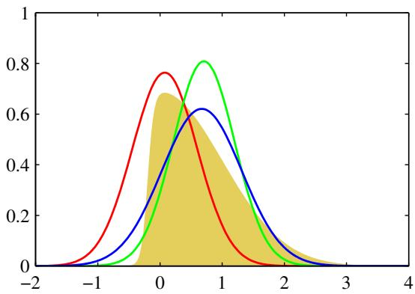
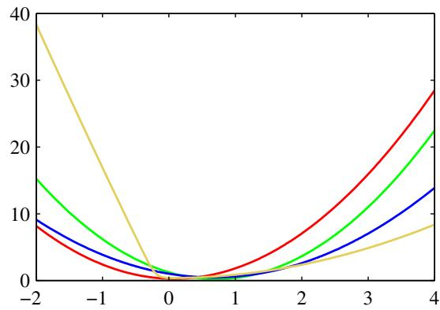
Figure 10.14 Illustration of the expectation propagation approximation using a Gaussian distribution for the example considered earlier in Figures 4.14 and 10.1. The left-hand plot shows the original distribution (yellow) along with the Laplace (red), global variational (green), and EP (blue) approximations, and the right-hand plot shows the corresponding negative logarithms of the distributions. Note that the $EP$ distribution is broader than that variational inference, as a consequence of the different form of KL divergence.
where $Z_{j}$ is the normalization constant given by
$$Z_{j}=∫f_{j}(θ)q^{∖j}(θ)dθ.$$
We now determine a revised factor ${\tilde{f}}_{j}(θ)$ by minimizing the Kullback-Leibler divergence
$$KL\left(\right.\frac{f_{j}(θ)q^{∖j}(θ)}{Z_{j}}∥q^{\text{ new }}(θ)\left.\right).$$
This is easily solved because the approximating distribution $q^{new}(θ)$ is from the exponential family, and so we can appeal to the result (10.187), which tells us that the parameters of $q^{new}(θ)$ are obtained by matching its expected sufficient statistics to the corresponding moments of (10.196). We shall assume that this is a tractable operation. For example, if we choose $q(θ)$ to be a Gaussian distribution $N(θ|μ,Σ)$ , then $μ$ is set equal to the mean of the (unnormalized) distribution $f_{j}(θ)q^{∖j}(θ)$ , and Σ is set to its covariance. More generally, it is straightforward to obtain the required expectations for any member of the exponential family, provided it can be normalized, because the expected statistics can be related to the derivatives of the normalization coefficient, as given by (2.226). The EP approximation is illustrated in Figure 10.14.
From (10.193), we see that the revised factor ${\tilde{f}}_{j}(θ)$ can be found by taking $q^{new}(θ)$ and dividing out the remaining factors so that
$${\tilde{f}}_{j}(θ)=K\frac{q^{\text{ new }}(θ)}{q^{∖j}(θ)}$$
where we have used (10.195). The coefficient K is determined by multiplying both
sides of (10.199) by $q^{∖i}(θ)$ and integrating to give
$$K=∫{\tilde{f}}_{j}(θ)q^{∖j}(θ)dθ$$
where we have used the fact that $q^{new}(θ)$ is normalized. The value of K can therefore be found by matching zeroth-order moments
$$∫{\tilde{f}}_{j}(θ)q^{∖j}(θ)dθ=∫f_{j}(θ)q^{∖j}(θ)dθ.$$
Combining this with (10.197), we then see that $K=Z_{j}$ and so can be found by evaluating the integral in (10.197).
In practice, several passes are made through the set of factors, revising each factor in turn. The posterior distribution $p(θ|D)$ is then approximated using (10.191), and the model evidence $p(D)$ can be approximated by using (10.190) with the factors $f_{i}(θ)$ replaced by their approximations ${\tilde{f}}_{i}(θ)$

Expectation Propagation
We are given a joint distribution over observed data $D$ and stochastic variables θ in the form of a product of factors
p(D,θ)=i​fi(θ)
and we wish to approximate the posterior distribution $p(θ|D)$ by a distribution of the form 1
q(θ)=1Zi​fi(θ).
We also wish to approximate the model evidence $p(D)$
- Initialize all of the approximating factors ${\tilde{f}}_{i}(θ)$
2. Initialize the posterior approximation by setting
q(θ)∝i​fi(θ).
- Until convergence:
- Choose a factor ${\tilde{f}}_{j}(θ)$ to refine.
- Remove ${\tilde{f}}_{j}(θ)$ from the posterior by division
$$q^{∖j}(θ)=\frac{q(θ)}{{\tilde{f}}_{j}(θ)}.$$
- Evaluate the new posterior by setting the sufficient statistics (moments) of $q^{new}(θ)$ equal to those of $q^{\backslash j}(θ)\overline{f_{j}}(θ)$ , including evaluation of the normalization constant
$$Z_{j}=∫q^{∖j}(θ)f_{j}(θ)dθ.$$
- Evaluate and store the new factor
$${\tilde{f}}_{j}(θ)=Z_{j}\frac{q^{new}(θ)}{q^{∖j}(θ)}.$$
- Evaluate the approximation to the model evidence
p(D)≃∫i​fi(θ)dθ.
A special case of EP, known as assumed density filtering (ADF) or moment matching (Maybeck, 1982; Lauritzen, 1992; Boyen and Koller, 1998; Opper and Winther, 1999), is obtained by initializing all of the approximating factors except the first to unity and then making one pass through the factors updating each of them once. Assumed density filtering can be appropriate for on-line learning in which data points are arriving in a sequence and we need to learn from each data point and then discard it before considering the next point. However, in a batch setting we have the opportunity to re-use the data points many times in order to achieve improved accuracy, and it is this idea that is exploited in expectation propagation. Furthermore, if we apply ADF to batch data, the results will have an undesirable dependence on the (arbitrary) order in which the data points are considered, which again EP can overcome.
One disadvantage of expectation propagation is that there is no guarantee that the iterations will converge. However, for approximations $q(θ)$ in the exponential family, if the iterations do converge, the resulting solution will be a stationary point of a particular energy function (Minka, 2001a), although each iteration of EP does not necessarily decrease the value of this energy function. This is in contrast to variational Bayes, which iteratively maximizes a lower bound on the log marginal likelihood, in which each iteration is guaranteed not to decrease the bound. It is possible to optimize the EP cost function directly, in which case it is guaranteed to converge, although the resulting algorithms can be slower and more complex to implement.
Another difference between variational Bayes and EP arises from the form of KL divergence that is minimized by the two algorithms, because the former minimizes $KL(q∥p)$ whereas the latter minimizes $KL(p‖q)$ . As we saw in Figure 10.3, for distributions $p(θ)$ which are multimodal, minimizing $KL(p||q)$ can lead to poor approximations. In particular, if EP is applied to mixtures the results are not sensible because the approximation tries to capture all of the modes of the posterior distribution. Conversely, in logistic-type models, EP often out-performs both local variational methods and the Laplace approximation (Kuss and Rasmussen, 2006).
Figure 10.15
Illustration of the clutter problem for a data space dimensionality of $D=1$ Training data points, denoted by the crosses, are drawn from a mixture of two Gaussians with components shown in red and green. The goal is to infer the mean of the green Gaussian from the observed data.
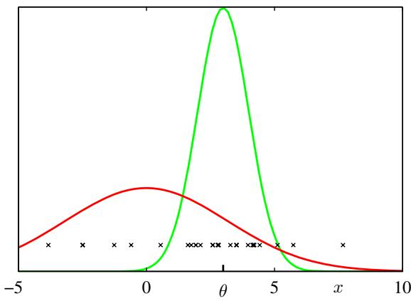

10.7.1 Example: The clutter problem
Following Minka (2001b), we illustrate the EP algorithm using a simple example in which the goal is to infer the mean $θ$ of a multivariate Gaussian distribution over a variable x given a set of observations drawn from that distribution. To make the problem more interesting, the observations are embedded in background clutter, which itself is also Gaussian distributed, as illustrated in Figure 10.15. The distribution of observed values x is therefore a mixture of Gaussians, which we take to be of the form
$$p(x|θ)=(1−w)N(x|θ,I)+wN(x|0,aI)$$
where $w$ is the proportion of background clutter and is assumed to be known. The prior over $θ$ is taken to be Gaussian
$$p(θ)=N(θ|0,bI)$$
and Minka (2001a) chooses the parameter values $a=10,b=100$ and $w=0.5$ The joint distribution of N observations $D=\{x_{1},…,x_{N}\}$ and θ is given by
$$p(D,θ)=p(θ)\prod_{n=1}^{N}{p}(x_{n}|θ)$$
and so the posterior distribution comprises a mixture of $2^{N}$ Gaussians. Thus the computational cost of solving this problem exactly would grow exponentially with the size of the data set, and so an exact solution is intractable for moderately large $N$
To apply EP to the clutter problem, we first identify the factors $f_{0}(θ)=p(θ)$ and $f_{n}(θ)=p(x_{n}|θ)$ . Next we select an approximating distribution from the exponential family, and for this example it is convenient to choose a spherical Gaussian
$$q(θ)=N(θ|m,vI).$$
The factor approximations will therefore take the form of exponential-quadratic functions of the form
$${\tilde{f}}_{n}(θ)=s_{n}N(θ|m_{n},v_{n}I)$$
where $n=1,…,N$ , and we set ${\tilde{f}}_{0}(θ)$ equal to the prior $p(θ)$ . Note that the use of $N(θ|⋅,⋅)$ does not imply that the right-hand side is a well-defined Gaussian density (in fact, as we shall see, the variance parameter $v_{n}$ can be negative) but is simply a convenient shorthand notation. The approximations ${\tilde{f}}_{n}(θ)$ , for $n=1,…,N$ , can be initialized to unity, corresponding to $s_{n}=(2πv_{n})^{D/2},v_{n}→∞$ and $m_{n}=0$ where $D$ is the dimensionality of x and hence of $θ.$ . The initial $q(θ)$ , defined by (10.191), is therefore equal to the prior.
We then iteratively refine the factors by taking one factor $f_{n}(θ)$ at a time and applying (10.205), (10.206), and (10.207). Note that we do not need to revise the term $f_{0}(θ)$ because an EP update will leave this term unchanged. Here we state the results and leave the reader to fill in the details.
First we remove the current estimate ${\dot{f}}_{n}(θ)$ from $q(θ)$ by division using (10.205) to give $q^{\backslash n}(θ)$ , which has mean and inverse variance given by
$$m^{∖n}=m+v^{∖n}v_{n}^{−1}(m−m_{n})$$
$$(v^{∖n})^{−1}=v^{−1}−v_{n}^{−1}.$$
Next we evaluate the normalization constant $Z_{n}$ using (10.206) to give
$$Z_{n}=(1−w)N(x_{n}|m^{∖n},(v^{∖n}+1)I)+wN(x_{n}|0,aI).$$
Similarly, we compute the mean and variance of $q^{new}(θ)$ by finding the mean and variance of $q^{∖n}(θ){\overset{‾}{f}}_{n}(θ)$ to give
$$m=m^{∖n}+ρ_{n}\frac{v^{∖n}}{v^{∖n}+1}(x_{n}−m^{∖n})$$
$$v=v^{∖n}−ρ_{n}\frac{(v^{∖n})^{2}}{v^{∖n}+1}+ρ_{n}(1−ρ_{n})\frac{(v^{∖n})^{2}∥x_{n}−m^{∖n}∥^{2}}{D(v^{∖n}+1)^{2}}$$
where the quantity
$$ρ_{n}=1−\frac{w}{Z_{n}}N(x_{n}|0,aI)$$
has a simple interpretation as the probability of the point ${ \bf x } _ { n }$ not being clutter. Then we use (10.207) to compute the refined factor ${\tilde{f}}_{n}(θ)$ whose parameters are given by
$$v_{n}^{−1}=(v^{new})^{−1}−(v^{∖n})^{−1}$$
$$m_{n}=m^{∖n}+(v_{n}+v^{∖n})(v^{∖n})^{−1}(m^{new}−m^{∖n})$$
$$Z_{n}$$
$$s_{n}=\frac{n}{(2πv_{n})^{D/2}N(m_{n}|m^{∖n},(v_{n}+v^{∖n})I)}.$$
This refinement process is repeated until a suitable termination criterion is satisfied, for instance that the maximum change in parameter values resulting from a complete pass through all factors is less than some threshold. Finally, we use (10.208) to evaluate the approximation to the model evidence, given by
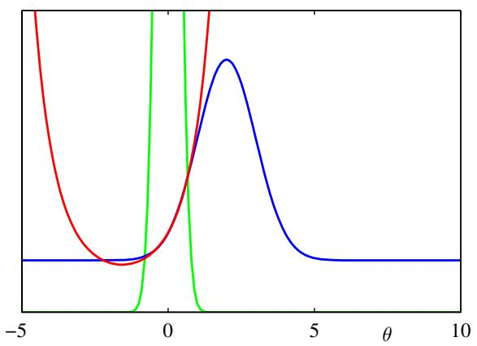
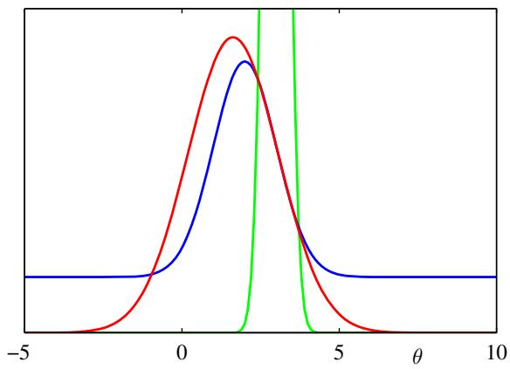
Figure 10.16 Examples of the approximation of specific factors for a one-dimensional version of the clutter problem, showing $f_{n}(θ)$ in blue, ${\tilde{f}}_{n}(θ)$ in red, and $q^{\backslash n}(θ)$ in green. Notice that the current form for $q^{\backslash n}(θ)$ controls the range of θ over which ${\tilde{f}}_{n}(θ)$ will be a good approximation to $f_{n}(θ)$
$$p(D)≃(2πv^{new})^{D/2}exp(B/2)\prod_{n=1}^{N}{\left\{s_{n}(2πv_{n})^{−D/2}\right\}}$$
where
$$B=\frac{(m^{new})^{T}m^{new}}{v}−\sum_{n=1}^{N}{\frac{m_{n}^{T}m_{n}}{v_{n}}}.$$
Examples factor approximations for the clutter problem with a one-dimensional parameter space $θ$ are shown in Figure 10.16. Note that the factor approximations can have infinite or even negative values for the ‘variance’ parameter $v_{n}$ . This simply corresponds to approximations that curve upwards instead of downwards and are not necessarily problematic provided the overall approximate posterior $q(θ)$ has positive variance. Figure 10.17 compares the performance of EP with variational Bayes (mean field theory) and the Laplace approximation on the clutter problem.

10.7.2 Expectation propagation on graphs
So far in our general discussion of EP, we have allowed the factors $f_{i}(θ)$ in the distribution $p(θ)$ to be functions of all of the components of θ, and similarly for the approximating factors $\tilde{f}(θ)$ in the approximating distribution $q(θ)$ . We now consider situations in which the factors depend only on subsets of the variables. Such restrictions can be conveniently expressed using the framework of probabilistic graphical models, as discussed in Chapter 8. Here we use a factor graph representation because this encompasses both directed and undirected graphs.
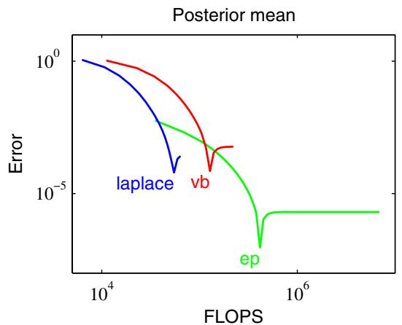
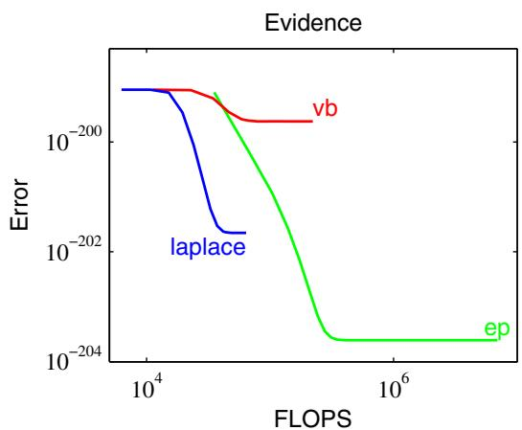
Figure 10.17 Comparison of expectation propagation, variational inference, and the Laplace approximation on the clutter problem. The left-hand plot shows the error in the predicted posterior mean versus the number of floating point operations, and the right-hand plot shows the corresponding results for the model evidence.
We shall focus on the case in which the approximating distribution is fully factorized, and we shall show that in this case expectation propagation reduces to loopy belief propagation (Minka, 2001a). To start with, we show this in the context of a simple example, and then we shall explore the general case.
First of all, recall from (10.17) that if we minimize the Kullback-Leibler divergence KL $(p∥q)$ with respect to a factorized distribution $q,$ then the optimal solution for each factor is simply the corresponding marginal of $p.$
Now consider the factor graph shown on the left in Figure 10.18, which was introduced earlier in the context of the sum-product algorithm. The joint distribution is given by
$$p(x)=f_{a}(x_{1},x_{2})f_{b}(x_{2},x_{3})f_{c}(x_{2},x_{4}).$$
We seek an approximation $q(x)$ that has the same factorization, so that
$$q(x)∝{\tilde{f}}_{a}(x_{1},x_{2}){\tilde{f}}_{b}(x_{2},x_{3}){\tilde{f}}_{c}(x_{2},x_{4}).$$
Note that normalization constants have been omitted, and these can be re-instated at the end by local normalization, as is generally done in belief propagation. Now suppose we restrict attention to approximations in which the factors themselves factorize with respect to the individual variables so that
$$q(x)∝{\tilde{f}}_{a1}(x_{1}){\tilde{f}}_{a2}(x_{2}){\tilde{f}}_{b2}(x_{2}){\tilde{f}}_{b3}(x_{3}){\tilde{f}}_{c2}(x_{2}){\tilde{f}}_{c4}(x_{4})$$
which corresponds to the factor graph shown on the right in Figure 10.18. Because the individual factors are factorized, the overall distribution $q(x)$ is itself fully factorized.
Now we apply the EP algorithm using the fully factorized approximation. Suppose that we have initialized all of the factors and that we choose to refine factor ${\tilde{f}}_{b}(x_{2},x_{3})={\tilde{f}}_{b2}(x_{2}){\tilde{f}}_{b3}(x_{3})$ . We first remove this factor from the approximating distribution to give
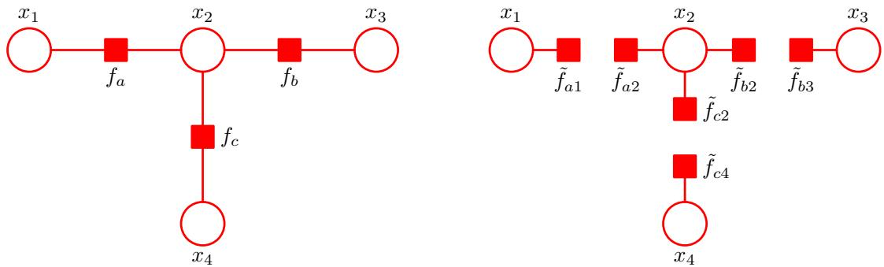
Figure 10.18 On the left is a simple factor graph from Figure 8.51 and reproduced here for convenience. On the right is the corresponding factorized approximation.
$$q^{∖b}(x)={\tilde{f}}_{a1}(x_{1}){\tilde{f}}_{a2}(x_{2}){\tilde{f}}_{c2}(x_{2}){\tilde{f}}_{c4}(x_{4})$$
and we then multiply this by the exact factor $f_{b}(x_{2},x_{3})$ to give
$$\hat{p}(x)=q^{∖b}(x)f_{b}(x_{2},x_{3})={\tilde{f}}_{a1}(x_{1}){\tilde{f}}_{a2}(x_{2}){\tilde{f}}_{c2}(x_{2}){\tilde{f}}_{c4}(x_{4})f_{b}(x_{2},x_{3}).$$
We now find $q^{new}(x)$ by minimizing the Kullback-Leibler divergence $KL(\hat{p}∥q^{new})$ The result, as noted above, is that $q^{new}(z)$ comprises the product of factors, one for each variable $x_{i}$ , in which each factor is given by the corresponding marginal of $\widehat { p } ( { \bf x } )$ . These four marginals are given by
$$\hat{p}(x_{1})∝{\tilde{f}}_{a1}(x_{1})$$
p(x2)∝fa2(x2)fc2(x2)x3​fb(x2,x3)
p(x3)∝x2​fb(x2,x3)fa2(x2)fc2(x2)
$$\hat{p}(x_{4})∝{\tilde{f}}_{c4}(x_{4})$$
and $q^{new}(x)$ is obtained by multiplying these marginals together. We see that the only factors in $q(x)$ that change when we update ${\tilde{f}}_{b}(x_{2},x_{3})$ are those that involve the variables in $f_{b}$ namely $x_{2}$ and $x_{3}$ . To obtain the refined factor ${\tilde{f}}_{b}(x_{2},x_{3})=$ ${\tilde{f}}_{b2}(x_{2}){\tilde{f}}_{b3}(x_{3})$ we simply divide $q^{new}(x)$ by $q^{∖b}(x)$ , which gives
fb2(x2)∝x3​fb(x2,x3)
fb3(x3)∝x2​fb(x2,x3)fa2(x2)fc2(x2).
These are precisely the messages obtained using belief propagation in which messages from variable nodes to factor nodes have been folded into the messages from factor nodes to variable nodes. In particular, ${\tilde{f}}_{b2}(x_{2})$ corresponds to the message $μ_{f_{b}→x_{2}}(x_{2})$ sent by factor node $f_{b}$ to variable node $x_{2}$ and is given by (8.81). Similarly, if we substitute (8.78) into (8.79), we obtain (10.235) in which ${\tilde{f}}_{a2}(x_{2})$ corresponds to $μ_{f_{a}→x_{2}}(x_{2})$ and ${\tilde{f}}_{c2}(x_{2})$ corresponds to $μ_{f_{c}→x_{2}}(x_{2})$ , giving the message ${\tilde{f}}_{b3}(x_{3})$ which corresponds to $μ_{f_{b}→x_{3}}(x_{3})$
This result differs slightly from standard belief propagation in that messages are passed in both directions at the same time. We can easily modify the EP procedure to give the standard form of the sum-product algorithm by updating just one of the factors at a time, for instance if we refine only ${\tilde{f}}_{b3}(x_{3})$ , then ${\tilde{f}}_{b2}(x_{2})$ is unchanged by definition, while the refined version of ${\tilde{f}}_{b3}(x_{3})$ is again given by (10.235). If we are refining only one term at a time, then we can choose the order in which the refinements are done as we wish. In particular, for a tree-structured graph we can follow a two-pass update scheme, corresponding to the standard belief propagation schedule, which will result in exact inference of the variable and factor marginals. The initialization of the approximation factors in this case is unimportant.
Now let us consider a general factor graph corresponding to the distribution
p(θ)=i​fi(θi)
where $θ_{i}$ represents the subset of variables associated with factor $f_{i}$ . We approximate this using a fully factorized distribution of the form
q(θ)∝i​k​fik(θk)
where $θ_{k}$ corresponds to an individual variable node. Suppose that we wish to refine the particular term ${\tilde{f}}_{jl}(θ_{l})$ keeping all other terms fixed. We first remove the term ${\tilde{f}}_{j}(θ_{j})$ from $q(θ)$ to give
q∖j(θ)∝i≠j​k​fik(θk)
and then multiply by the exact factor $f_{j}(θ_{j})$ . To determine the refined term ${\tilde{f}}_{jl}(θ_{l})$ we need only consider the functional dependence on $θ_{l}$ , and so we simply find the corresponding marginal of
$$q^{∖j}(θ)f_{j}\left(θ_{j}\right).$$
Up to a multiplicative constant, this involves taking the marginal of $f_{j}(θ_{j})$ multiplied by any terms from $q^{\backslash j}(θ)$ that are functions of any of the variables in $θ_{j}$ . Terms that correspond to other factors ${\tilde{f}}_{i}(θ_{i})$ for $i≠j$ will cancel between numerator and denominator when we subsequently divide by $q^{\backslash j}(θ)$ . We therefore obtain
fjl(θl)∝θm≠l∈θj​fj(θj)k​m≠l​fkm(θm).
We recognize this as the sum-product rule in the form in which messages from variable nodes to factor nodes have been eliminated, as illustrated by the example shown in Figure 8.50. The quantity ${\tilde{f}}_{jm}(θ_{m})$ corresponds to the message $μ_{f_{j}→θ_{m}}(θ_{m})$ which factor node $j$ sends to variable node $m,$ and the product over k in $(10.240)$ is over all factors that depend on the variables $θ_{m}$ that have variables (other than variable $θ_{l})$ in common with factor $f_{j}(θ_{j})$ . In other words, to compute the outgoing message from a factor node, we take the product of all the incoming messages from other factor nodes, multiply by the local factor, and then marginalize.
Thus, the sum-product algorithm arises as a special case of expectation propagation if we use an approximating distribution that is fully factorized. This suggests that more flexible approximating distributions, corresponding to partially disconnected graphs, could be used to achieve higher accuracy. Another generalization is to group factors $f_{i}(θ_{i})$ together into sets and to refine all the factors in a set together at each iteration. Both of these approaches can lead to improvements in accuracy (Minka, 2001b). In general, the problem of choosing the best combination of grouping and disconnection is an open research issue.
We have seen that variational message passing and expectation propagation optimize two different forms of the Kullback-Leibler divergence. Minka (2005) has shown that a broad range of message passing algorithms can be derived from a common framework involving minimization of members of the alpha family of divergences, given by (10.19). These include variational message passing, loopy belief propagation, and expectation propagation, as well as a range of other algorithms, which we do not have space to discuss here, such as tree-reweighted message passing (Wainwright et al., 2005),fractional beliefpropagation (Wiegerinck and Heskes, 2003), and power EP (Minka, 2004).

Exercises
10.1 () www Verify that the log marginal distribution of the observed data ln $p(X)$ can be decomposed into two terms in the form (10.2) where $L(q)$ is given by (10.3) and $KL(q∥p)$ is given by (10.4).
10.2 () Use the properties $E[z_{1}]=m_{1}$ and $E[z_{2}]=m_{2}$ to solve the simultaneous equations (10.13) and (10.15), and hence show that, provided the original distribution $p(z)$ is nonsingular, the unique solution for the means of the factors in the approximation distribution is given by $E[z_{1}]=μ_{1}$ and $E[z_{2}]=μ_{2}$
10.3 ( ) www Consider a factorized variational distribution $q(Z)$ of the form (10.5). By using the technique of Lagrange multipliers, verify that minimization of the Kullback-Leibler divergence $KL(p‖q)$ with respect to one of the factors $q_{i}(Z_{i})$ keeping all other factors fixed, leads to the solution (10.17).
10.4 ( ) Suppose that $p(x)$ is some fixed distribution and that we wish to approximate it using a Gaussian distribution $q(x)=N(x|μ,Σ)$ . By writing down the form of the KL divergence $KL(p||q)$ for a Gaussian $q(x)$ and then differentiating, show that minimization of $KL(p||q)$ with respect to $μ$ and $Σ$ leads to the result that $μ$ is given by the expectation of x under $p(x)$ and that Σ is given by the covariance.
10.5 ( ) www Consider a model in which the set of all hidden stochastic variables, denoted collectively by $Z,$ comprises some latent variables z together with some model parameters $θ.$ Suppose we use a variational distribution that factorizes between latent variables and parameters so that $q(z,θ)=q_{z}(z)q_{θ}(θ)$ , in which the distribution $q_{θ}(θ)$ is approximated by a point estimate of the form $q_{θ}(θ)=δ(θ−θ_{0})$ where $θ_{0}$ is a vector of free parameters. Show that variational optimization of this factorized distribution is equivalent to an EM algorithm, in which the E step optimizes $q_{z}(z)$ and the M step maximizes the expected complete-data log posterior distribution of θ with respect to $θ_{0}$
10.6 ( ) The alpha family of divergences is defined by (10.19). Show that the Kullback-Leibler divergence $KL(p‖q)$ corresponds to $α1$ . This can be done by writing $p^{ϵ}=exp(ϵlnp)=1+ϵlnp+O(ϵ^{2})$ and then taking $ϵ0$ . Similarly show that $KL(q∥p)$ corresponds to $α−1$
10.7 ( ) Consider the problem of inferring the mean and precision of a univariate Gaussian using a factorized variational approximation, as considered in Section 10.1.3. Show that the factor $q_{μ}(μ)$ is a Gaussian of the form $N(μ|μ_{N},λ_{N}^{−1})$ with mean and precision given by (10.26) and (10.27), respectively. Similarly show that the factor $q_{τ}(τ)$ is a gamma distribution of the form $Gam(τ|a_{N},b_{N})$ with parameters given by (10.29) and (10.30).
10.8 () Consider the variational posterior distribution for the precision of a univariate Gaussian whose parameters are given by (10.29) and (10.30). By using the standard results for the mean and variance of the gamma distribution given by (B.27) and (B.28), show that if we let $N∞$ , this variational posterior distribution has a mean given by the inverse of the maximum likelihood estimator for the variance of the data, and a variance that goes to zero.
10.9 ( ) By making use of the standard result $E[τ]=a_{N}/b_{N}$ for the mean of a gamma distribution, together with (10.26), (10.27), (10.29), and (10.30), derive the result (10.33) for the reciprocal of the expected precision in the factorized variational treatment of a univariate Gaussian.
10.10 () www Derive the decomposition given by (10.34) that is used to find approximate posterior distributions over models using variational inference.
10.11 ( ) www By using a Lagrange multiplier to enforce the normalization constraint on the distribution $q(m)$ , show that the maximum of the lower bound (10.35) is given by (10.36).
10.12 ( ) Starting from the joint distribution (10.41), and applying the general result (10.9), show that the optimal variational distribution $q^{⋆}(Z)$ over the latent variables for the Bayesian mixture of Gaussians is given by (10.48) by verifying the steps given in the text.
10.13 ( ) www Starting from (10.54), derive the result (10.59) for the optimum variational posterior distribution over $μ_{k}$ and $Λ_{Λ_{k}}$ in the Bayesian mixture of Gaussians, and hence verify the expressions for the parameters of this distribution given by (10.60)–(10.63).
10.14 ( ) Using the distribution (10.59), verify the result (10.64).
10.15 () Using the result (B.17), show that the expected value of the mixing coefficients in the variational mixture of Gaussians is given by (10.69).
10.16 ( ) www Verify the results (10.71) and (10.72) for the first two terms in the lower bound for the variational Gaussian mixture model given by (10.70).
10.17 ( ) Verify the results (10.73)–(10.77) for the remaining terms in the lower bound for the variational Gaussian mixture model given by (10.70).
10.18 ( ) In this exercise, we shall derive the variational re-estimation equations for the Gaussian mixture model by direct differentiation of the lower bound. To do this we assume that the variational distribution has the factorization defined by (10.42) and (10.55) with factors given by (10.48), (10.57), and (10.59). Substitute these into (10.70) and hence obtain the lower bound as a function of the parameters of the variational distribution. Then, by maximizing the bound with respect to these parameters, derive the re-estimation equations for the factors in the variational distribution, and show that these are the same as those obtained in Section 10.2.1.
10.19 ( ) Derive the result (10.81) for the predictive distribution in the variational treatment of the Bayesian mixture of Gaussians model.
10.20 ( ) www This exercise explores the variational Bayes solution for the mixture of Gaussians model when the size N of the data set is large and shows that it reduces (as we would expect) to the maximum likelihood solution based on EM derived in Chapter 9. Note that results from Appendix B may be used to help answer this exercise. First show that the posterior distribution $q^{⋆}(Λ_{k})$ of the precisions becomes sharply peaked around the maximum likelihood solution. Do the same for the posterior distribution of the means $q^{⋆}(μ_{k}|Λ_{k})$ . Next consider the posterior distribution $q^{⋆}(π)$ for the mixing coefficients and show that this too becomes sharply peaked around the maximum likelihood solution. Similarly, show that the responsibilities become equal to the corresponding maximum likelihood values for large N, by making use of the following asymptotic result for the digamma function for large x
$$ψ(x)=lnx+O\left(1/x\right).$$
Finally, by making use of (10.80), show that for large N, the predictive distribution becomes a mixture of Gaussians.
10.21 () Show that the number of equivalent parameter settings due to interchange symmetries in a mixture model with K components is K!.
10.22 ( ) We have seen that each mode of the posterior distribution in a Gaussian mixture model is a member of a family of K! equivalent modes. Suppose that the result of running the variational inference algorithm is an approximate posterior distribution $q$ that is localized in the neighbourhood of one of the modes. We can then approximate the full posterior distribution as a mixture of $K!$ such $q$ distributions, once centred on each mode and having equal mixing coefficients. Show that if we assume negligible overlap between the components of the $q$ mixture, the resulting lower bound differs from that for a single component $q$ distribution through the addition of an extra term ln $K!$
10.23 ( ) www Consider a variational Gaussian mixture model in which there is no prior distribution over mixing coefficients $\{π_{k}\}$ . Instead, the mixing coefficients are treated as parameters, whose values are to be found by maximizing the variational lower bound on the log marginal likelihood. Show that maximizing this lower bound with respect to the mixing coefficients, using a Lagrange multiplier to enforce the constraint that the mixing coefficients sum to one, leads to the re-estimation result (10.83). Note that there is no need to consider all of the terms in the lower bound but only the dependence of the bound on the $\{π_{k}\}$
10.24 ( ) www We have seen in Section 10.2 that the singularities arising in the maximum likelihood treatment of Gaussian mixture models do not arise in a Bayesian treatment. Discuss whether such singularities would arise if the Bayesian model were solved using maximum posterior (MAP) estimation.
10.25 ( ) The variational treatment of the Bayesian mixture of Gaussians, discussed in Section 10.2, made use of a factorized approximation (10.5) to the posterior distribution. As we saw in Figure 10.2, the factorized assumption causes the variance of the posterior distribution to be under-estimated for certain directions in parameter space. Discuss qualitatively the effect this will have on the variational approximation to the model evidence, and how this effect will vary with the number of components in the mixture. Hence explain whether the variational Gaussian mixture will tend to under-estimate or over-estimate the optimal number of components.
10.26 ( ) Extend the variational treatment of Bayesian linear regression to include a gamma hyperprior Gam $(β|c_{0},d_{0})$ over $β$ and solve variationally, by assuming a factorized variational distribution of the form $q(w)q(α)q(β)$ . Derive the variational update equations for the three factors in the variational distribution and also obtain an expression for the lower bound and for the predictive distribution.
10.27 ( ) By making use of the formulae given in Appendix B show that the variational lower bound for the linear basis function regression model, defined by (10.107), can be written in the form (10.107) with the various terms defined by (10.108)–(10.112).
10.28 ( ) Rewrite the model for the Bayesian mixture of Gaussians, introduced in Section 10.2, as a conjugate model from the exponential family, as discussed in Section 10.4. Hence use the general results (10.115) and (10.119) to derive the specific results (10.48), (10.57), and (10.59).
10.29 () www Show that the function $f(x)=ln(x)$ is concave for $0<x<∞$ by computing its second derivative. Determine the form of the dual function $g(λ)$ defined by (10.133), and verify that minimization of $λx−g(λ)$ with respect to λ according to (10.132) indeed recovers the function ln(x).
10.30 () By evaluating the second derivative, show that the log logistic function $f(x)=$ $−ln(1+e^{−x})$ is concave. Derive the variational upper bound (10.137) directly by making a second order Taylor expansion of the log logistic function around a point $x=ξ$
10.31 ( ) By finding the second derivative with respect to x, show that the function $f ( x ) = { \dot { - } } \ln ( e ^ { x { \mathord { \left/ { \vphantom { \mathrm { 1 2 } } } \right. \kern - delimiterspace } 2 } } + e ^ { - x / 2 } )$ is a concave function of $x.$ Now consider the second derivatives with respect to the variable $x^{2}$ and hence show that it is a convex function of $x^{2}$ . Plot graphs of $f(x)$ against x and against $x^{2}$ . Derive the lower bound (10.144) on the logistic sigmoid function directly by making a first order Taylor series expansion of the function $f(x)$ in the variable $x^{2}$ centred on the value $ξ^{2}$
10.32 ( ) www Consider the variational treatment of logistic regression with sequential learning in which data points are arriving one at a time and each must be processed and discarded before the next data point arrives. Show that a Gaussian approximation to the posterior distribution can be maintained through the use of the lower bound (10.151), in which the distribution is initialized using the prior, and as each data point is absorbed its corresponding variational parameter $ξ_{n}$ is optimized.
10.33 () By differentiating the quantity $Q(ξ,ξ^{old})$ defined by (10.161) with respect to the variational parameter $ξ_{n}$ show that the update equation for $ξ_{n}$ for the Bayesian logistic regression model is given by (10.163).
10.34 ( ) In this exercise we derive re-estimation equations for the variational parameters $ξ$ in the Bayesian logistic regression model of Section 4.5 by direct maximization of the lower bound given by (10.164). To do this set the derivative of $L(ξ)$ with respect to $ξ_{n}$ equal to zero, making use of the result (3.117) for the derivative of the log of a determinant, together with the expressions (10.157) and (10.158) which define the mean and covariance of the variational posterior distribution $q(w)$
10.35 ( ) Derive the result (10.164) for the lower bound $L(ξ)$ in the variational logistic regression model. This is most easily done by substituting the expressions for the Gaussian prior $q(w)=N(w|m_{0},S_{0})$ , together with the lower bound $h(w,ξ)$ on the likelihood function, into the integral (10.159) which defines $L(ξ)$ . Next gather together the terms which depend on w in the exponential and complete the square to give a Gaussian integral, which can then be evaluated by invoking the standard result for the normalization coefficient of a multivariate Gaussian. Finally take the logarithm to obtain (10.164).
10.36 ( ) Consider the ADF approximation scheme discussed in Section 10.7, and show that inclusion of the factor $f_{j}(θ)$ leads to an update of the model evidence of the form
$$p_{j}(D)≃p_{j−1}(D)Z_{j}$$
where $Z_{j}$ is the normalization constant defined by (10.197). By applying this result recursively, and initializing with $p_{0}(D)=1$ , derive the result
p(D)≃j​Zj.
10.37 () www Consider the expectation propagation algorithm from Section 10.7, and suppose that one of the factors $f_{0}(θ)$ in the definition (10.188) has the same exponential family functional form as the approximating distribution $q(θ)$ . Show that if the factor ${\tilde{f}}_{0}(θ)$ is initialized to be $f_{0}(θ)$ , then an EP update to refine ${\tilde{f}}_{0}(θ)$ leaves ${\tilde{f}}_{0}(θ)$ unchanged. This situation typically arises when one of the factors is the prior $p(θ)$ , and so we see that the prior factor can be incorporated once exactly and does not need to be refined.
10.38 ( ) In this exercise and the next, we shall verify the results (10.214)–(10.224) for the expectation propagation algorithm applied to the clutter problem. Begin by using the division formula (10.205) to derive the expressions (10.214) and (10.215) by completing the square inside the exponential to identify the mean and variance. Also, show that the normalization constant $Z_{n}$ , defined by (10.206), is given for the clutter problem by (10.216). This can be done by making use of the general result (2.115).
10.39 ( ) Show that the mean and variance of $q^{new}(θ)$ for EP applied to the clutter problem are given by (10.217) and (10.218). To do this, first prove the following results for the expectations of $θ$ and $θθ^{T}$ under $q^{new}(θ)$
$$E[θ]=m^{∖n}+v^{∖n}∇_{m^{∖n}}lnZ_{n}$$
$$E[θ^{T}θ]=2(v^{∖n})^{2}∇_{v^{∖n}}lnZ_{n}+2E[θ]^{T}m^{∖n}−∥m^{∖n}∥^{2}$$
and then make use of the result (10.216) for $Z_{n}$ . Next, prove the results (10.220)– (10.222) by using (10.207) and completing the square in the exponential. Finally, use (10.208) to derive the result (10.223).

11

Sampling Methods

For most probabilistic models of practical interest, exact inference is intractable, and so we have to resort to some form of approximation. In Chapter 10, we discussed inference algorithms based on deterministic approximations, which include methods such as variational Bayes and expectation propagation. Here we consider approximate inference methods based on numerical sampling, also known as Monte Carlo techniques.
Although for some applications the posterior distribution over unobserved variables will be of direct interest in itself, for most situations the posterior distribution is required primarily for the purpose of evaluating expectations, for example in order to make predictions. The fundamental problem that we therefore wish to address in this chapter involves finding the expectation of some function f(z) with respect to a probability distribution $p(z)$ . Here, the components of z might comprise discrete or continuous variables or some combination of the two. Thus in the case of continuous
Figure 11.1 Schematic illustration of a function $f(z)$ whose expectation is to be evaluated with respect to a distribution $p(z)$
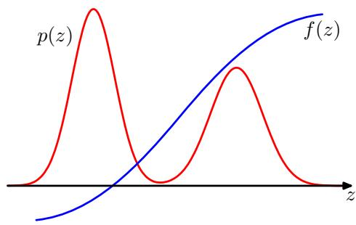
variables, we wish to evaluate the expectation
$$E[f]=∫f(z)p(z)dz$$
where the integral is replaced by summation in the case of discrete variables. This is illustrated schematically for a single continuous variable in Figure 11.1. We shall suppose that such expectations are too complex to be evaluated exactly using analytical techniques.
The general idea behind sampling methods is to obtain a set of samples $z^{(l)}$ (where $l\overset{⋅}{=}1,…,L)$ drawn independently from the distribution $p(z)$ . This allows the expectation (11.1) to be approximated by a finite sum
$$\hat{f}=\frac{1}{L}\sum_{l=1}^{L}{f}(z^{(l)}).$$
As long as the samples $z^{(l)}$ are drawn from the distribution $p(z)$ , then $E[\hat{f}]=E[f]$ and so the estimator $\hat{f}$ has the correct mean. The variance of the estimator is given by
$$var[\hat{f}]=\frac{1}{L}E\left[(f−E[f])^{2}\right]$$
is the variance of the function $f(z)$ under the distribution $p(z)$ . It is worth emphasizing that the accuracy of the estimator therefore does not depend on the dimensionality of $z,$ and that, in principle, high accuracy may be achievable with a relatively small number of samples $z^{(l)}$ . In practice, ten or twenty independent samples may suffice to estimate an expectation to sufficient accuracy.
The problem, however, is that the samples $\{z^{(l)}\}$ might not be independent, and so the effective sample size might be much smaller than the apparent sample size. Also, referring back to Figure 11.1, we note that if $f(z)$ is small in regions where $p(z)$ is large, and vice versa, then the expectation may be dominated by regions of small probability, implying that relatively large sample sizes will be required to achieve sufficient accuracy.
For many models, the joint distribution $p(z)$ is conveniently specified in terms of a graphical model. In the case of a directed graph with no observed variables, it is straightforward to sample from the joint distribution (assuming that it is possible to sample from the conditional distributions at each node) using the following ancestral sampling approach, discussed briefly in Section 8.1.2. The joint distribution is specified by
$$p(z)=\prod_{i=1}^{M}{p}(z_{i}|{pa}_{i})$$
where $z_{i}$ are the set of variables associated with node $i,$ and ${pa}_{i}$ denotes the set of variables associated with the parents of node i. To obtain a sample from the joint distribution, we make one pass through the set of variables in the order $z_{1},…,z_{M}$ sampling from the conditional distributions $p(z_{i}|{pa}_{i})$ . This is always possible because at each step all of the parent values will have been instantiated. After one pass through the graph, we will have obtained a sample from the joint distribution.
Now consider the case of a directed graph in which some of the nodes are instantiated with observed values. We can in principle extend the above procedure, at least in the case of nodes representing discrete variables, to give the following logic sampling approach (Henrion, 1988), which can be seen as a special case of importance sampling discussed in Section 11.1.4. At each step, when a sampled value is obtained for a variable $z_{i}$ whose value is observed, the sampled value is compared to the observed value, and if they agree then the sample value is retained and the algorithm proceeds to the next variable in turn. However, if the sampled value and the observed value disagree, then the whole sample so far is discarded and the algorithm starts again with the first node in the graph. This algorithm samples correctly from the posterior distribution because it corresponds simply to drawing samples from the joint distribution of hidden variables and data variables and then discarding those samples that disagree with the observed data (with the slight saving of not continuing with the sampling from the joint distribution as soon as one contradictory value is observed). However, the overall probability of accepting a sample from the posterior decreases rapidly as the number of observed variables increases and as the number of states that those variables can take increases, and so this approach is rarely used in practice.
In the case of probability distributions defined by an undirected graph, there is no one-pass sampling strategy that will sample even from the prior distribution with no observed variables. Instead, computationally more expensive techniques must be employed, such as Gibbs sampling, which is discussed in Section 11.3.
As well as sampling from conditional distributions, we may also require samples from a marginal distribution. If we already have a strategy for sampling from a joint distribution $p(u,v)$ , then it is straightforward to obtain samples from the marginal distribution $p(u)$ simply by ignoring the values for v in each sample.
There are numerous texts dealing with Monte Carlo methods. Those of particular interest from the statistical inference perspective include Chen et al. (2001), Gamerman (1997), Gilks et al. (1996), Liu (2001), Neal (1996), and Robert and Casella (1999). Also there are review articles by Besag et al. (1995), Brooks (1998), Diaconis and Saloff-Coste (1998), Jerrum and Sinclair (1996), Neal (1993), Tierney (1994), and Andrieu et al. (2003) that provide additional information on sampling
methods for statistical inference.
Diagnostic tests for convergence of Markov chain Monte Carlo algorithms are summarized in Robert and Casella (1999), and some practical guidance on the use of sampling methods in the context of machine learning is given in Bishop and Nabney (2008).

11.1. Basic Sampling Algorithms
In this section, we consider some simple strategies for generating random samples from a given distribution. Because the samples will be generated by a computer algorithm they will in fact be pseudo-random numbers, that is, they will be deterministically calculated, but must nevertheless pass appropriate tests for randomness. Generating such numbers raises several subtleties (Press et $al.$ , 1992) that lie outside the scope of this book. Here we shall assume that an algorithm has been provided that generates pseudo-random numbers distributed uniformly over $(0,1)$ , and indeed most software environments have such a facility built in.

11.1.1 Standard distributions
We first consider how to generate random numbers from simple nonuniform distributions, assuming that we already have available a source of uniformly distributed random numbers. Suppose that z is uniformly distributed over the interval $(0,1)$ and that we transform the values of z using some function $f(⋅)$ so that $y=f(z)$ The distribution of $y$ will be governed by
$$p(y)=p(z)\left|\frac{dz}{dy}\right|$$
where, in this case, $p(z)=1$ . Our goal is to choose the function $f(z)$ such that the resulting values of $y$ have some specific desired distribution $p(y)$ . Integrating (11.5) we obtain
$$z=h(y)≡\int_{−∞}^{y}{p}(\hat{y})d\hat{y}$$
which is the indefinite integral of $p(y)$ . Thus, $y=h^{−1}(z)$ , and so we have to transform the uniformly distributed random numbers using a function which is the inverse of the indefinite integral of the desired distribution. This is illustrated in Figure 11.2.
Consider for example the exponential distribution
$$p(y)=λexp(−λy)$$
where $0≤y<∞$ . In this case the lower limit of the integral in (11.6) is 0, and so $h(y)=1−exp(−λy)$ . Thus, if we transform our uniformly distributed variable $z$ using $y=−λ^{−1}ln(1−z)$ , then $y$ will have an exponential distribution.
Figure 11.2 Geometrical interpretation of the transformation method for generating nonuniformly distributed random numbers. $h(y)$ is the indefinite integral of the desired distribution $p(y)$ If a uniformly distributed random variable z is transformed using $y=h^{−1}(z)$ , then y will be distributed according to $p(y)$
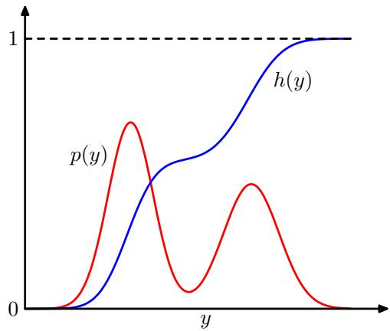
Another example of a distribution to which the transformation method can be applied is given by the Cauchy distribution
$$p(y)=\frac{1}{π}\frac{1}{1+y^{2}}.$$
In this case, the inverse of the indefinite integral can be expressed in terms of the ‘tan’ function.
The generalization to multiple variables is straightforward and involves the Jacobian of the change of variables, so that
$$p(y_{1},…,y_{M})=p(z_{1},…,z_{M})\left|\frac{∂(z_{1},…,z_{M})}{∂(y_{1},…,y_{M})}\right|.$$
As a final example of the transformation method we consider the Box-Muller method for generating samples from a Gaussian distribution. First, suppose we generate pairs of uniformly distributed random numbers $z_{1},z_{2}∈(−1,1)$ , which we can do by transforming a variable distributed uniformly over (0, 1) using $z2z−1$ Next we discard each pair unless it satisfies $z_{1}^{2}+{\dot{z}}_{2}^{2}≤1$ This leads to a uniform distribution of points inside the unit circle with $p(z_{1},z_{2})=1/π$ , as illustrated in Figure 11.3. Then, for each pair $z_{1},z_{2}$ we evaluate the quantities
Figure 11.3 The Box-Muller method for generating Gaussian distributed random numbers starts by generating samples from a uniform distribution inside the unit circle.
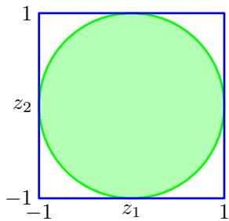
$$y_{1}=z_{1}{\left(\frac{−2lnz_{1}}{r^{2}}\right)}^{1/2}$$
$$y_{2}=z_{2}{\left(\frac{−2lnz_{2}}{r^{2}}\right)}^{1/2}$$
where $r^{2}=z_{1}^{2}+z_{2}^{2}$ . Then the joint distribution of $y_{1}$ and $y_{2}$ is given by
$$\begin{matrix}p(y_{1},y_{2}) & = & p(z_{1},z_{2})\left|\frac{∂(z_{1},z_{2})}{∂(y_{1},y_{2})}\right| \\ & = & \left[\frac{1}{\sqrt{2π}}exp(−y_{1}^{2}/2)\right]\left[\frac{1}{\sqrt{2π}}exp(−y_{2}^{2}/2)\right]\end{matrix}$$
and so $y_{1}$ and $y_{2}$ are independent and each has a Gaussian distribution with zero mean and unit variance.
If $y$ has a Gaussian distribution with zero mean and unit variance, then $σy+μ$ will have a Gaussian distribution with mean $μ$ and variance $σ^{2}$ . To generate vectorvalued variables having a multivariate Gaussian distribution with mean $μ$ and covariance Σ, we can make use of the Cholesky decomposition, which takes the form ${ \pmb \Sigma } = { \bf L L } ^ { \mathrm { T } }$ (Press et al., 1992). Then, if z is a vector valued random variable whose components are independent and Gaussian distributed with zero mean and unit variance, then $y=μ+Lz$ will have mean $μ$ and covariance Σ.
Obviously, the transformation technique depends for its success on the ability to calculate and then invert the indefinite integral of the required distribution. Such operations will only be feasible for a limited number of simple distributions, and so we must turn to alternative approaches in search of a more general strategy. Here we consider two techniques called rejection sampling and importance sampling. Although mainly limited to univariate distributions and thus not directly applicable to complex problems in many dimensions, they do form important components in more general strategies.

11.1.2 Rejection sampling
The rejection sampling framework allows us to sample from relatively complex distributions, subject to certain constraints. We begin by considering univariate distributions and discuss the extension to multiple dimensions subsequently.
Suppose we wish to sample from a distribution $p(z)$ that is not one of the simple, standard distributions considered so far, and that sampling directly from $p(z)$ is difficult. Furthermore suppose, as is often the case, that we are easily able to evaluate $p(z)$ for any given value of $z,$ up to some normalizing constant $Z.$ , so that
$$p(z)=\frac{1}{Z_{p}}\tilde{p}(z)$$
where $\tilde{p}(z)$ can readily be evaluated, but $Z_{p}$ is unknown.
In order to apply rejection sampling, we need some simpler distribution $q(z)$ sometimes called a proposal distribution, from which we can readily draw samples.
Figure 11.4 In the rejection sampling method, samples are drawn from a simple distribution $q(z)$ and rejected if they fall in the grey area between the unnormalized distribution $\tilde{p}(z)$ and the scaled distribution $kq(z)$ . The resulting samples are distributed according to $p(z)$ which is the normalized version of $\tilde{p}(z)$
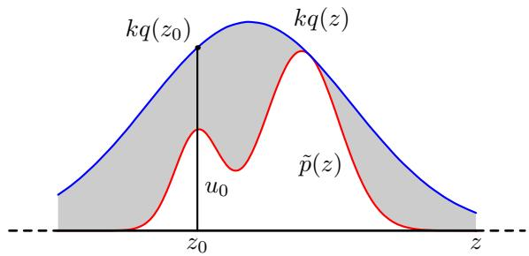
We next introduce a constant k whose value is chosen such that $kq(z)≥\tilde{p}(z)$ for all values of z. The function $kq(z)$ is called the comparison function and is illustrated for a univariate distribution in Figure 11.4. Each step of the rejection sampler involves generating two random numbers. First, we generate a number $z_{0}$ from the distribution $q(z)$ . Next, we generate a number $u_{0}$ from the uniform distribution over $[0,kq(z_{0})]$ . This pair of random numbers has uniform distribution under the curve of the function $kq(z)$ . Finally, if $u_{0}>\tilde{p}(z_{0})$ then the sample is rejected, otherwise $u_{0}$ is retained. Thus the pair is rejected if it lies in the grey shaded region in Figure 11.4. The remaining pairs then have uniform distribution under the curve of $\tilde{p}(z)$ and hence the corresponding z values are distributed according to $p(z)$ , as desired.
The original values of z are generated from the distribution $q(z)$ , and these samples are then accepted with probability $\tilde{p}(z)/kq(z)$ , and so the probability that a sample will be accepted is given by
$$\begin{matrix}p(accept) & = & ∫\{\tilde{p}(z)/kq(z)\}q(z)dz \\ & = & \frac{1}{k}∫\tilde{p}(z)dz.\end{matrix}$$
Thus the fraction of points that are rejected by this method depends on the ratio of the area under the unnormalized distribution $\tilde{p}(z)$ to the area under the curve $kq(z)$ We therefore see that the constant k should be as small as possible subject to the limitation that $kq(z)$ must be nowhere less than $\tilde{p}(z)$
As an illustration of the use of rejection sampling, consider the task of sampling from the gamma distribution
$$Gam(z|a,b)=\frac{b^{a}z^{a−1}exp(−bz)}{Γ(a)}$$
which, for $a > 1$ , has a bell-shaped form, as shown in Figure 11.5. A suitable proposal distribution is therefore the Cauchy (11.8) because this too is bell-shaped and because we can use the transformation method, discussed earlier, to sample from it. We need to generalize the Cauchy slightly to ensure that it nowhere has a smaller value than the gamma distribution. This can be achieved by transforming a uniform random variable y using $z=btany+c,$ which gives random numbers distributed according to.
Plot showing the gamma distribution given by (11.15) as the green curve, with a scaled Cauchy proposal distribution shown by the red curve. Samples from the gamma distribution can be obtained by sampling from the Cauchy and then applying the rejection sampling criterion.
Exercise 11.9
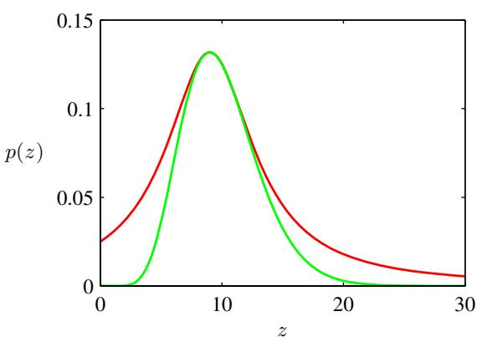
$$q(z)=\frac{k}{1+(z−c)^{2}/b^{2}}.$$
The minimum reject rate is obtained by setting $c=a−1,b^{2}=2a−1$ and choosing the constant k to be as small as possible while still satisfying the requirement $kq(z)≥\tilde{p}(z)$ . The resulting comparison function is also illustrated in Figure 11.5.

11.1.3 Adaptive rejection sampling
In many instances where we might wish to apply rejection sampling, it proves difficult to determine a suitable analytic form for the envelope distribution $q(z)$ . An alternative approach is to construct the envelope function on the fly based on measured values of the distribution $p(z)$ (Gilks and Wild, 1992). Construction of an envelope function is particularly straightforward for cases in which $p(z)$ is log concave, in other words when ln $p(z)$ has derivatives that are nonincreasing functions of z. The construction of a suitable envelope function is illustrated graphically in Figure 11.6.
The function ln $p(z)$ and its gradient are evaluated at some initial set of grid points, and the intersections of the resulting tangent lines are used to construct the envelope function. Next a sample value is drawn from the envelope distribution. This is straightforward because the log of the envelope distribution is a succession of linear functions, and hence the envelope distribution itself comprises a piecewise exponential distribution of the form
In the case of distributions that are log concave, an envelope function for use in rejection sampling can be constructed using the tangent lines computed at a set of grid points. If a sample point is rejected, it is added to the set of grid points and used to refine the envelope distribution.
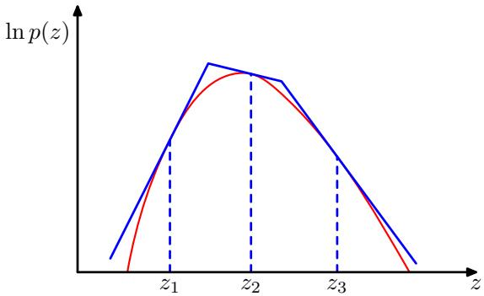
Figure 11.7 Illustrative example of rejection sampling involving sampling from a Gaussian distribution $p(z)$ shown by the green curve, by using rejection sampling from a proposal distribution $\overset{⋅}{q}(z)$ that is also Gaussian and whose scaled version $kq(z)$ is shown by the red curve.
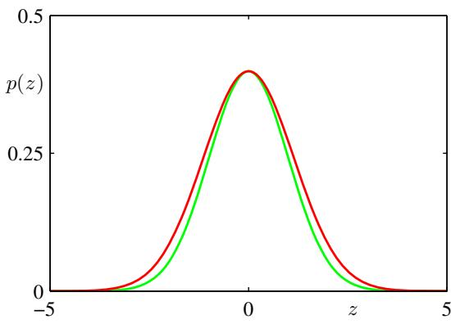
$$q(z)=k_{i}λ_{i}exp\left\{−λ_{i}(z−z_{i−1})\right\} z_{i−1}<z≤z_{i}.$$
Once a sample has been drawn, the usual rejection criterion can be applied. If the sample is accepted, then it will be a draw from the desired distribution. If, however, the sample is rejected, then it is incorporated into the set of grid points, a new tangent line is computed, and the envelope function is thereby refined. As the number of grid points increases, so the envelope function becomes a better approximation of the desired distribution $p(z)$ and the probability of rejection decreases.
A variant of the algorithm exists that avoids the evaluation of derivatives (Gilks, 1992). The adaptive rejection sampling framework can also be extended to distributions that are not log concave, simply by following each rejection sampling step with a Metropolis-Hastings step (to be discussed in Section 11.2.2), giving rise to adaptive rejection Metropolis sampling (Gilks et al., 1995).
Clearly for rejection sampling to be of practical value, we require that the comparison function be close to the required distribution so that the rate of rejection is kept to a minimum. Now let us examine what happens when we try to use rejection sampling in spaces of high dimensionality. Consider, for the sake of illustration, a somewhat artificial problem in which we wish to sample from a zero-mean multivariate Gaussian distribution with covariance $σ_{p}^{2}I$ , where I is the unit matrix, by rejection sampling from a proposal distribution that is itself a zero-mean Gaussian distribution having covariance ${\overset{‾}{σ}}_{q}^{2}I$ . Obviously, we must have $σ_{q}^{2}≥σ_{p}^{2}$ in order that there exists a k such that $kq(z)\overset{▿}{≥}p(z)$ . In D-dimensions the optimum value of k is given by $k=(σ_{q}/σ_{p})^{D}$ , as illustrated for $D=1$ in Figure 11.7. The acceptance rate will be the ratio of volumes under $p(z)$ and $kq(z)$ , which, because both distributions are normalized, is just $1/k$ . Thus the acceptance rate diminishes exponentially with dimensionality. Even if $σ_{q}$ exceeds $σ_{p}$ by just one percent, for $D=1,000$ the acceptance ratio will be approximately $1/20,000$ In this illustrative example the comparison function is close to the required distribution. For more practical examples, where the desired distribution may be multimodal and sharply peaked, it will be extremely difficult to find a good proposal distribution and comparison function.
Figure 11.8 Importance sampling addresses the problem of evaluating the expectation of a function $f(z)$ with respect to a distribution $p(z)$ from which it is difficult to draw samples directly. Instead, samples $\{z^{(l)}\}$ are drawn from a simpler distribution $q(z)$ , and the corresponding terms in the summation are weighted by the ratios $p(z^{(l)})/q(z^{(l)})$ .
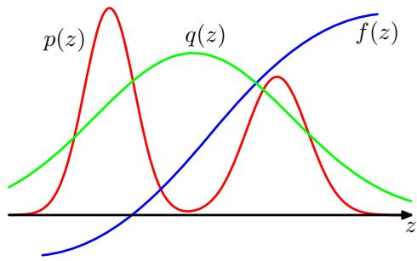
Furthermore, the exponential decrease of acceptance rate with dimensionality is a generic feature of rejection sampling. Although rejection can be a useful technique in one or two dimensions it is unsuited to problems of high dimensionality. It can, however, play a role as a subroutine in more sophisticated algorithms for sampling in high dimensional spaces.

11.1.4 Importance sampling
One of the principal reasons for wishing to sample from complicated probability distributions is to be able to evaluate expectations of the form (11.1). The technique of importance sampling provides a framework for approximating expectations directly but does not itself provide a mechanism for drawing samples from distribution $p(z)$
The finite sum approximation to the expectation, given by (11.2), depends on being able to draw samples from the distribution $p(z)$ . Suppose, however, that it is impractical to sample directly from $p(z)$ but that we can evaluate $p(z)$ easily for any given value of $z.$ One simplistic strategy for evaluating expectations would be to discretize z-space into a uniform grid and to evaluate the integrand as a sum of the form
$$E[f]≃\sum_{l=1}^{L}{p}(z^{(l)})f(z^{(l)}).$$
An obvious problem with this approach is that the number of terms in the summation grows exponentially with the dimensionality of $z.$ . Furthermore, as we have already noted, the kinds of probability distributions of interest will often have much of their mass confined to relatively small regions of z space and so uniform sampling will be very inefficient because in high-dimensional problems, only a very small proportion of the samples will make a significant contribution to the sum. We would really like to choose the sample points to fall in regions where $p(z)$ is large, or ideally where the product $p(z)f(z)$ is large.
As in the case of rejection sampling, importance sampling is based on the use of a proposal distribution $q(z)$ from which it is easy to draw samples, as illustrated in Figure 11.8. We can then express the expectation in the form of a finite sum over
samples $\{z^{(l)}\}$ drawn from $q(z)$
$$\begin{matrix}E[f] & = & ∫f(z)p(z)dz \\ & = & ∫f(z)\frac{p(z)}{q(z)}q(z)dz \\ & ≃ & \frac{1}{L}\sum_{l=1}^{L}{\frac{p(z^{(l)})}{q(z^{(l)})}}f(z^{(l)}).\end{matrix}$$
The quantities $r_{l}=p(z^{(l)})/q(z^{(l)})$ are known as importance weights, and they correct the bias introduced by sampling from the wrong distribution. Note that, unlike rejection sampling, all of the samples generated are retained.
It will often be the case that the distribution $p(z)$ can only be evaluated up to a normalization constant, so that $p(z)=\tilde{p}(z)/Z_{p}$ where $\tilde{p}(z)$ can be evaluated easily, whereas $Z_{p}$ is unknown. Similarly, we may wish to use an importance sampling distribution $q(z)=\tilde{q}(z)/Z_{q}$ , which has the same property. We then have
$$\begin{matrix}E[f] & = & ∫f(z)p(z)dz \\ & = & \frac{Z_{q}}{Z_{p}}∫f(z)\frac{\tilde{p}(z)}{\tilde{q}(z)}q(z)dz \\ & ≃ & \frac{Z_{q}}{Z_{p}}\frac{1}{L}\sum_{l=1}^{L}{{\tilde{r}}_{l}}f(z^{(l)}).\end{matrix}$$
where ${\tilde{r}}_{l}=\tilde{p}(z^{(l)})/\tilde{q}(z^{(l)})$ . We can use the same sample set to evaluate the ratio $Z_{p}/Z_{q}$ with the result
$$\begin{matrix}\frac{Z_{p}}{Z_{q}} & = & \frac{1}{Z_{q}}∫\tilde{p}(z)dz=∫\frac{\tilde{p}(z)}{\tilde{q}(z)}q(z)dz \\ & ≃ & \frac{1}{L}\sum_{l=1}^{L}{\tilde{r_{l}}}\end{matrix}$$
and hence
$$E[f]≃\sum_{l=1}^{L}{w_{l}}f(z^{(l)})$$
where we have defined
wl=rlm​rm=p(z(l))/q(z(l))m​p(z(m))/q(z(m)).
As with rejection sampling, the success of the importance sampling approach depends crucially on how well the sampling distribution $q(z)$ matches the desired distribution $p(z)$ . If, as is often the case, $p(z)f(z)$ is strongly varying and has a sig nificant proportion of its mass concentrated over relatively small regions of z space, then the set of importance weights $\{r_{l}\}$ may be dominated by a few weights having large values, with the remaining weights being relatively insignificant. Thus the effective sample size can be much smaller than the apparent sample size $L.$ . The problem is even more severe if none of the samples falls in the regions where $p(z)f(z)$ is large. In that case, the apparent variances of $r_{l}$ and $r_{l}f(z^{(\overline{l})})$ may be small even though the estimate of the expectation may be severely wrong. Hence a major drawback of the importance sampling method is the potential to produce results that are arbitrarily in error and with no diagnostic indication. This also highlights a key requirement for the sampling distribution $q(z)$ , namely that it should not be small or zero in regions where $p(z)$ may be significant.
For distributions defined in terms of a graphical model, we can apply the importance sampling technique in various ways. For discrete variables, a simple approach is called uniform sampling. The joint distribution for a directed graph is defined by (11.4). Each sample from the joint distribution is obtained by first setting those variables $z_{i}$ that are in the evidence set equal to their observed values. Each of the remaining variables is then sampled independently from a uniform distribution over the space of possible instantiations. To determine the corresponding weight associated with a sample $z^{(l)}$ , we note that the sampling distribution $\tilde{q}(z)$ is uniform over the possible choices for $z,$ and that $\tilde{p}(z|x)=\tilde{p}(z)$ , where x denotes the subset of variables that are observed, and the equality follows from the fact that every sample z that is generated is necessarily consistent with the evidence. Thus the weights $r_{l}$ are simply proportional to $p(z)$ . Note that the variables can be sampled in any order. This approach can yield poor results if the posterior distribution is far from uniform, as is often the case in practice.
An improvement on this approach is called likelihood weighted sampling (Fung and Chang, 1990; Shachter and Peot, 1990) and is based on ancestral sampling of the variables. For each variable in turn, if that variable is in the evidence set, then it is just set to its instantiated value. If it is not in the evidence set, then it is sampled from the conditional distribution $p(z_{i}|{pa}_{i})$ in which the conditioning variables are set to their currently sampled values. The weighting associated with the resulting sample z is then given by
r(z)=zi∉e​p(zi|pai)p(zi|pai)zi∈e​p(zi|pai)1=zi∈e​p(zi|pai).
This method can be further extended using self-importance sampling (Shachter and Peot, 1990) in which the importance sampling distribution is continually updated to reflect the current estimated posterior distribution.

11.1.5 Sampling-importance-resampling
The rejection sampling method discussed in Section 11.1.2 depends in part for its success on the determination of a suitable value for the constant k. For many pairs of distributions $p(z)$ and $q(z)$ , it will be impractical to determine a suitable value for k in that any value that is sufficiently large to guarantee a bound on the desired distribution will lead to impractically small acceptance rates.
As in the case of rejection sampling, the sampling-importance-resampling (SIR) approach also makes use of a sampling distribution $q(z)$ but avoids having to determine the constant k. There are two stages to the scheme. In the first stage, $L$ samples $z^{(1)},…,z^{(L)}$ are drawn from $q(z)$ . Then in the second stage, weights $w_{1},…,w_{L}$ are constructed using (11.23). Finally, a second set of $L$ samples is drawn from the discrete distribution $(z^{(1)},…,z^{(L)})$ with probabilities given by the weights $(w_{1},…,w_{L})$
The resulting L samples are only approximately distributed according to $p(z)$ but the distribution becomes correct in the limit $L∞$ . To see this, consider the univariate case, and note that the cumulative distribution of the resampled values is given by
p(z≤a)=l:z(l)≤a​wl=l​I(z(l)≤a)p(z(l))/q(z(l))l​p(z(l))/q(z(l))
where $I(.)$ is the indicator function (which equals 1 if its argument is true and 0 otherwise). Taking the limit $L∞$ , and assuming suitable regularity of the distributions, we can replace the sums by integrals weighted according to the original sampling distribution $q(z)$
$$\begin{matrix}p(z≤a) & = & \frac{∫I(z≤a)\{\tilde{p}(z)/q(z)\}q(z)dz}{∫\{\tilde{p}(z)/q(z)\}q(z)dz} \\ & = & \frac{∫I(z≤a)\tilde{p}(z)dz}{∫\tilde{p}(z)dz} \\ & = & ∫I(z≤a)p(z)dz\end{matrix}$$
which is the cumulative distribution function of $p(z)$ . Again, we see that the normalization of $p(z)$ is not required.
For a finite value of $L,$ and a given initial sample set, the resampled values will only approximately be drawn from the desired distribution. As with rejection sampling, the approximation improves as the sampling distribution $q(z)$ gets closer to the desired distribution $p(z)$ . When $q(z)=p(z)$ , the initial samples $(z^{(1)},…,z^{(L)})$ have the desired distribution, and the weights $w_{n}=1/L$ so that the resampled values also have the desired distribution.
If moments with respect to the distribution $p(z)$ are required, then they can be
evaluated directly using the original samples together with the weights, because
$$\begin{matrix}E[f(z)] & = & ∫f(z)p(z)dz \\ & = & \frac{∫f(z)[\tilde{p}(z)/q(z)]q(z)dz}{∫[\tilde{p}(z)/q(z)]q(z)dz} \\ & ≃ & \sum_{l=1}^{L}{w_{l}}f(z_{l}).\end{matrix}$$

11.1.6 Sampling and the EM algorithm
In addition to providing a mechanism for direct implementation of the Bayesian framework, Monte Carlo methods can also play a role in the frequentist paradigm, for example to find maximum likelihood solutions. In particular, sampling methods can be used to approximate the E step of the EM algorithm for models in which the E step cannot be performed analytically. Consider a model with hidden variables Z, visible (observed) variables $X,$ , and parameters $θ.$ . The function that is optimized with respect to $θ$ in the M step is the expected complete-data log likelihood, given by
$$Q(θ,θ^{old})=∫p(Z|X,θ^{old})lnp(Z,X|θ)dZ.$$
We can use sampling methods to approximate this integral by a finite sum over samples $\{Z^{(l)}\}$ , which are drawn from the current estimate for the posterior distribution $p ( { \bf Z } | { \bf X } , \boldsymbol { \theta } ^ { \mathrm { o l d } } )$ , so that
$$Q(θ,θ^{old})≃\frac{1}{L}\sum_{l=1}^{L}{ln}p(Z^{(l)},X|θ).$$
The $Q$ function is then optimized in the usual way in the M step. This procedure is called the Monte Carlo EM algorithm.
It is straightforward to extend this to the problem of finding the mode of the posterior distribution over $θ$ (the MAP estimate) when a prior distribution $p(θ)$ has been defined, simply by adding ln $p(θ)$ to the function $Q(θ,θ^{old})$ before performing the M step.
A particular instance of the Monte Carlo EM algorithm, called stochastic EM, arises if we consider a finite mixture model, and draw just one sample at each E step. Here the latent variable Z characterizes which of the K components of the mixture is responsible for generating each data point. In the E step, a sample of Z is taken from the posterior distribution $p ( { \bf Z } | { \bf X } , \boldsymbol { \theta } ^ { \mathrm { { \bar { o l d } } } } )$ where X is the data set. This effectively makes a hard assignment of each data point to one of the components in the mixture. In the M step, this sampled approximation to the posterior distribution is used to update the model parameters in the usual way.
Now suppose we move from a maximum likelihood approach to a full Bayesian treatment in which we wish to sample from the posterior distribution over the parameter vector θ. In principle, we would like to draw samples from the joint posterior $p(θ,Z|X)$ , but we shall suppose that this is computationally difficult. Suppose further that it is relatively straightforward to sample from the complete-data parameter posterior $p(θ|Z,X)$ . This inspires the data augmentation algorithm, which alternates between two steps known as the I-step (imputation step, analogous to an E step) and the P-step (posterior step, analogous to an M step).

IP Algorithm
I-step. We wish to sample from $p(Z|X)$ but we cannot do this directly. We therefore note the relation
$$p(Z|X)=∫p(Z|θ,X)p(θ|X)dθ$$
and hence for $l=1,…,L$ we first draw a sample $θ^{(l)}$ from the current estimate for $p(θ|X)$ , and then use this to draw a sample $Z^{(l)}$ from $p(Z|θ^{(l)},X)$ . P-step. Given the relation
$$p(θ|X)=∫p(θ|Z,X)p(Z|X)dZ$$
we use the samples $\{Z^{(l)}\}$ obtained from the I-step to compute a revised estimate of the posterior distribution over θ given by
$$p(θ|X)≃\frac{1}{L}\sum_{l=1}^{L}{p}(θ|Z^{(l)},X).$$
By assumption, it will be feasible to sample from this approximation in the I-step.
Note that we are making a (somewhat artificial) distinction between parameters θ and hidden variables Z. From now on, we blur this distinction and focus simply on the problem of drawing samples from a given posterior distribution.

11.2. Markov Chain Monte Carlo
In the previous section, we discussed the rejection sampling and importance sampling strategies for evaluating expectations of functions, and we saw that they suffer from severe limitations particularly in spaces of high dimensionality. We therefore turn in this section to a very general and powerful framework called Markov chain Monte Carlo (MCMC), which allows sampling from a large class of distributions, and which scales well with the dimensionality of the sample space. Markov chain Monte Carlo methods have their origins in physics (Metropolis and Ulam, 1949), and it was only towards the end of the 1980s that they started to have a significant impact in the field of statistics.
As with rejection and importance sampling, we again sample from a proposal distribution. This time, however, we maintain a record of the current state ${\overset{‾}{z}}^{(τ)}$ , and the proposal distribution $q(z|z^{(τ)})$ ) depends on this current state, and so the sequence of samples ${ \bf z } ^ { ( 1 ) } , { \bf z } ^ { ( 2 ) } , . . .$ . forms a Markov chain. Again, if we write $p(z)=\tilde{p}(\overset{‾}{z})/Z_{p}$ we will assume that $\tilde{p}(z)$ can readily be evaluated for any given value of $z,$ , although the value of $Z_{p}$ may be unknown. The proposal distribution itself is chosen to be sufficiently simple that it is straightforward to draw samples from it directly. At each cycle of the algorithm, we generate a candidate sample $z^{⋆}$ from the proposal distribution and then accept the sample according to an appropriate criterion.
In the basic Metropolis algorithm (Metropolis et al., 1953), we assume that the proposal distribution is symmetric, that is $q(z_{A}|z_{B})=q(z_{B}|z_{A})$ for all values of $z_{A}$ and $z_{B}$ . The candidate sample is then accepted with probability
$$A(z^{⋆},z^{(τ)})=min\left(1,\frac{\tilde{p}(z^{⋆})}{\tilde{p}(z^{(τ)})}\right).$$
This can be achieved by choosing a random number u with uniform distribution over the unit interval $(0,1)$ and then accepting the sample if $A(z^{⋆},z^{(τ)})>u$ . Note that if the step from $z^{(τ)}$ to $z^{⋆}$ causes an increase in the value of $p(z)$ , then the candidate point is certain to be kept.
If the candidate sample is accepted, then $z^{(τ+1)}=z^{⋆}$ , otherwise the candidate point $z^{⋆}$ is discarded, $z^{(\hat{τ}+1)}$ is set to $z^{(τ)}$ and another candidate sample is drawn from the distribution $q(z|z^{(τ+1)})$ . This is in contrast to rejection sampling, where rejected samples are simply discarded. In the Metropolis algorithm when a candidate point is rejected, the previous sample is included instead in the final list of samples, leading to multiple copies of samples. Of course, in a practical implementation, only a single copy of each retained sample would be kept, along with an integer weighting factor recording how many times that state appears. As we shall see, as long as $q ( { \bf z } _ { A } | { \bf z } _ { B } )$ is positive for any values of $z_{A}$ and $z_{B}$ (this is a sufficient but not necessary condition), the distribution of $z^{(τ)}$ tends to $p(z)$ as $τ→∞$ . It should be emphasized, however, that the sequence ${ \bf z } ^ { ( 1 ) } , { \bf z } ^ { ( 2 ) } , . . .$ . is not a set of independent samples from $p(z)$ because successive samples are highly correlated. If we wish to obtain independent samples, then we can discard most of the sequence and just retain every ${\hat{M}}^{th}$ sample. For M sufficiently large, the retained samples will for all practical purposes be independent. Figure 11.9 shows a simple illustrative example of sampling from a two-dimensional Gaussian distribution using the Metropolis algorithm in which the proposal distribution is an isotropic Gaussian.
Further insight into the nature of Markov chain Monte Carlo algorithms can be gleaned by looking at the properties of a specific example, namely a simple random
A simple illustration using Metropolis algorithm to sample from a Gaussian distribution whose one standard-deviation contour is shown by the ellipse. The proposal distribution is an isotropic Gaussian distribution whose standard deviation is 0.2. Steps that are accepted are shown as green lines, and rejected steps are shown in red. A total of 150 candidate samples are generated, of which 43 are rejected.
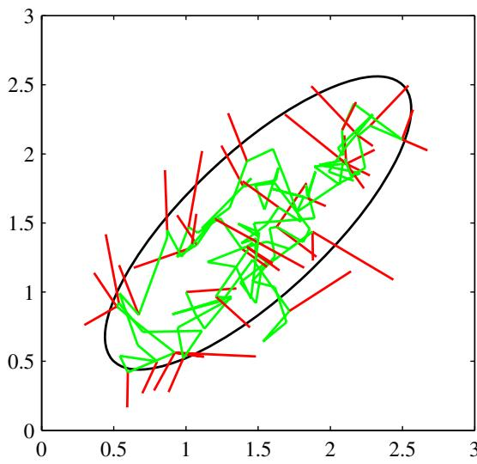
walk. Consider a state space z consisting of the integers, with probabilities
$$p(z^{(τ+1)}=z^{(τ)})=0.5$$
$$p(z^{(τ+1)}=z^{(τ)}+1)=0.25$$
$$p(z^{(τ+1)}=z^{(τ)}−1)=0.25$$
Exercise 11.10
where $z^{(τ)}$ denotes the state at step τ. If the initial state is $z^{(1)}=0$ , then by symmetry the expected state at time $τ$ will also be zero $E[z^{(τ)}]=0$ , and similarly it is easily seen that E $\overset{‾}{ι}[(z^{(τ)})^{2}]=τ/2$ . Thus after τ steps, the random walk has only travelled a distance that on average is proportional to the square root of $τ$ . This square root dependence is typical of random walk behaviour and shows that random walks are very inefficient in exploring the state space. As we shall see, a central goal in designing Markov chain Monte Carlo methods is to avoid random walk behaviour.

11.2.1 Markov chains
Before discussing Markov chain Monte Carlo methods in more detail, it is useful to study some general properties of Markov chains in more detail. In particular, we ask under what circumstances will a Markov chain converge to the desired distribution. A first-order Markov chain is defined to be a series of random variables $z^{(1)},…,z^{(M)}$ such that the following conditional independence property holds for $m∈\{1,…,M−1\}$
$$p(z^{(m+1)}|z^{(1)},…,z^{(m)})=p(z^{(m+1)}|z^{(m)}).$$
This of course can be represented as a directed graph in the form of a chain, an example of which is shown in Figure 8.38. We can then specify the Markov chain by giving the probability distribution for the initial variable $p(z^{(0)})$ ) together with the conditional probabilities for subsequent variables in the form of transition probabilities $T_{m}(z^{(\hat{m})},z^{(m+1)})≡p(z^{(m+1)}|z^{(m)})$ . A Markov chain is called homogeneous if the transition probabilities are the same for all m.
The marginal probability for a particular variable can be expressed in terms of the marginal probability for the previous variable in the chain in the form
p(z(m+1))=z(m)​p(z(m+1)|z(m))p(z(m)).
A distribution is said to be invariant, or stationary, with respect to a Markov chain if each step in the chain leaves that distribution invariant. Thus, for a homogeneous Markov chain with transition probabilities $T(z^{′},z)$ , the distribution $p^{⋆}(z)$ is invariant if
p⋆(z)=z′​T(z′,z)p⋆(z′).
Note that a given Markov chain may have more than one invariant distribution. For instance, if the transition probabilities are given by the identity transformation, then any distribution will be invariant.
A sufficient (but not necessary) condition for ensuring that the required distribution $p(z)$ is invariant is to choose the transition probabilities to satisfy the property of detailed balance, defined by
$$p^{⋆}(z)T(z,z^{′})=p^{⋆}(z^{′})T(z^{′},z)$$
for the particular distribution $p^{⋆}(z)$ . It is easily seen that a transition probability that satisfies detailed balance with respect to a particular distribution will leave that distribution invariant, because
z′​p⋆(z′)T(z′,z)=z′​p⋆(z)T(z,z′)=p⋆(z)z′​p(z′|z)=p⋆(z).
A Markov chain that respects detailed balance is said to be reversible.
Our goal is to use Markov chains to sample from a given distribution. We can achieve this if we set up a Markov chain such that the desired distribution is invariant. However, we must also require that for $m→∞$ , the distribution $p(z^{(m)})$ ) converges to the required invariant distribution $p^{⋆}(z)$ , irrespective of the choice of initial distribution ${ \bf \bar { \rho } } _ { p } ( { \bf z } ^ { ( 0 ) } )$ . This property is called ergodicity, and the invariant distribution is then called the equilibrium distribution. Clearly, an ergodic Markov chain can have only one equilibrium distribution. It can be shown that a homogeneous Markov chain will be ergodic, subject only to weak restrictions on the invariant distribution and the transition probabilities (Neal, 1993).
In practice we often construct the transition probabilities from a set of ‘base transitions $B_{1},…,B_{K}$ . This can be achieved through a mixture distribution of the form
$$T(z^{′},z)=\sum_{k=1}^{K}{α_{k}}B_{k}(z^{′},z)$$
for some set of mixing coefficients $α_{1},…,α_{K}$ satisfying $α_{k}≥0$ and k​αk=1 Alternatively, the base transitions may be combined through successive application, so that
T(z′,z)=z1​…zn−1​B1(z′,z1)…BK−1(zK−2,zK−1)BK(zK−1,z).
If a distribution is invariant with respect to each of the base transitions, then obviously it will also be invariant with respect to either of the $T(z^{′},z)$ given by (11.42) or (11.43). For the case of the mixture (11.42), if each of the base transitions satisfies detailed balance, then the mixture transition $T$ will also satisfy detailed balance. This does not hold for the transition probability constructed using (11.43), although by symmetrizing the order of application of the base transitions, in the form $B_{1},B_{2},…,B_{K},B_{K},…,B_{2},B_{1}$ , detailed balance can be restored. A common example of the use of composite transition probabilities is where each base transition changes only a subset of the variables.

11.2.2 The Metropolis-Hastings algorithm
Earlier we introduced the basic Metropolis algorithm, without actually demonstrating that it samples from the required distribution. Before giving a proof, we first discuss a generalization, known as the Metropolis-Hastings algorithm (Hastings, 1970), to the case where the proposal distribution is no longer a symmetric function of its arguments. In particular at step τ of the algorithm, in which the current state is $z^{(τ)}$ , we draw a sample $z^{⋆}$ from the distribution $q_{k}(z|z^{(τ)})$ and then accept it with probability $A _ { k } ( { \bf z } ^ { \star } , { \bf z } _ { \tau } )$ where
$$A_{k}(z^{⋆},z^{(τ)})=min\left(1,\frac{\tilde{p}(z^{⋆})q_{k}(z^{(τ)}|z^{⋆})}{\tilde{p}(z^{(τ)})q_{k}(z^{⋆}|z^{(τ)})}\right).$$
Here k labels the members of the set of possible transitions being considered. Again, the evaluation of the acceptance criterion does not require knowledge of the normalizing constant $Z_{p}$ in the probability distribution $p(z)\overset{‾}{ρ}=\tilde{p}(z)/Z_{p}$ . For a symmetric proposal distribution the Metropolis-Hastings criterion (11.44) reduces to the standard Metropolis criterion given by (11.33).
We can show that $p(z)$ is an invariant distribution of the Markov chain defined by the Metropolis-Hastings algorithm by showing that detailed balance, defined by (11.40), is satisfied. Using (11.44) we have
$$\begin{matrix}p(z)q_{k}(z|z^{′})A_{k}(z^{′},z) & = & min(p(z)q_{k}(z|z^{′}),p(z^{′})q_{k}(z^{′}|z)) \\ & = & min(p(z^{′})q_{k}(z^{′}|z),p(z)q_{k}(z|z^{′})) \\ & = & p(z^{′})q_{k}(z^{′}|z)A_{k}(z,z^{′})\end{matrix}$$
as required.
The specific choice of proposal distribution can have a marked effect on the performance of the algorithm. For continuous state spaces, a common choice is a Gaussian centred on the current state, leading to an important trade-off in determining the variance parameter of this distribution. If the variance is small, then the
Schematic illustration of the use of an isotropic Gaussian proposal distribution (blue circle) to sample from a correlated multivariate Gaussian distribution (red ellipse) having very different standard deviations in different directions, using the Metropolis-Hastings algorithm. In order to keep the rejection rate low, the scale $ρ$ of the proposal distribution should be on the order of the smallest standard deviation $σ_{min}$ , which leads to random walk behaviour in which the number of steps separating states that are approximately independent is of order $(σ_{max}/σ_{min})^{2}$ where $σ_{max}$ is the largest standard deviation.
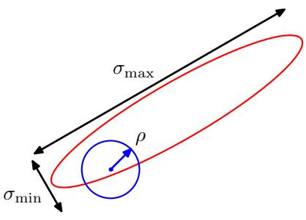
proportion of accepted transitions will be high, but progress through the state space takes the form of a slow random walk leading to long correlation times. However, if the variance parameter is large, then the rejection rate will be high because, in the kind of complex problems we are considering, many of the proposed steps will be to states for which the probability $p(z)$ is low. Consider a multivariate distribution $p(z)$ having strong correlations between the components of $z,$ as illustrated in Figure 11.10. The scale $ρ$ of the proposal distribution should be as large as possible without incurring high rejection rates. This suggests that $ρ$ should be of the same order as the smallest length scale $σ_{min}$ . The system then explores the distribution along the more extended direction by means of a random walk, and so the number of steps to arrive at a state that is more or less independent of the original state is of order $(σ_{max}/σ_{min})^{2}$ . In fact in two dimensions, the increase in rejection rate as $ρ$ increases is offset by the larger steps sizes of those transitions that are accepted, and more generally for a multivariate Gaussian the number of steps required to obtain independent samples scales like $(σ_{max}/σ_{2})^{2}$ where $σ_{2}$ is the second-smallest standard deviation (Neal, 1993). These details aside, it remains the case that if the length scales over which the distributions vary are very different in different directions, then the Metropolis Hastings algorithm can have very slow convergence.

11.3. Gibbs Sampling
Gibbs sampling (Geman and Geman, 1984) is a simple and widely applicable Markov chain Monte Carlo algorithm and can be seen as a special case of the Metropolis-Hastings algorithm.
Consider the distribution $p(z)=p(z_{1},…,z_{M})$ from which we wish to sample, and suppose that we have chosen some initial state for the Markov chain. Each step of the Gibbs sampling procedure involves replacing the value of one of the variables by a value drawn from the distribution of that variable conditioned on the values of the remaining variables. Thus we replace $z_{i}$ by a value drawn from the distribution $p(z_{i}|z_{∖i})$ , where $z_{i}$ denotes the $i^{th}$ component of $z,$ and $z_{∖i}$ denotes $z_{1},…,z_{M}$ but with $z_{i}$ omitted. This procedure is repeated either by cycling through the variables in some particular order or by choosing the variable to be updated at each step at random from some distribution.
For example, suppose we have a distribution $p(z_{1},z_{2},z_{3})$ over three variables, and at step $τ$ of the algorithm we have selected values $z_{1}^{(τ)},{\dot{z}}_{2}^{(τ)}$ and $z_{3}^{(τ)}$ . We first replace $z_{1}^{(τ)}$ by a new value $z_{1}^{(τ+1)}$ obtained by sampling from the conditional distribution
$$p(z_{1}|z_{2}^{(τ)},z_{3}^{(τ)}).$$
Next we replace $z_{2}^{(τ)}$ by a value $z_{2}^{(τ+1)}$ obtained by sampling from the conditiona distribution
$$p(z_{2}|z_{1}^{(τ+1)},z_{3}^{(τ)})$$
so that the new value for $z_{1}$ is used straight away in subsequent sampling steps. Then we update $z_{3}$ with a sample $z_{3}^{(τ+1)}$ drawn from
$$p(z_{3}|z_{1}^{(τ+1)},z_{2}^{(τ+1)})$$
and so on, cycling through the three variables in turn.

Gibbs Sampling
- Initialize $\{z_{i}:i=1,…,M\}$ 2. For $τ=1,…,T$ :
- Sample $z_{1}^{(τ+1)}∼p(z_{1}|z_{2}^{(τ)},z_{3}^{(τ)},…,z_{M}^{(τ)})$ .
- Sample $z_{2}^{(τ+1)}∼p(z_{2}|z_{1}^{(τ+1)},z_{3}^{(τ)},…,z_{M}^{(τ)})$ . $⋮$ - Sample $z_{j}^{(τ+1)}∼p(z_{j}|z_{1}^{(τ+1)},…,z_{j−1}^{(τ+1)},z_{j+1}^{(τ)},…,z_{M}^{(τ)})$ . $⋮$ - Sample $z_{M}^{(τ+1)}∼p(z_{M}|z_{1}^{(τ+1)},z_{2}^{(τ+1)},…,z_{M−1}^{(τ+1)})$ .
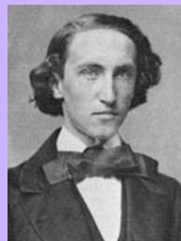

Josiah Willard Gibbs 1839–1903
Gibbs spent almost his entire life living in a house built by his father in New Haven, Connecticut. In 1863, Gibbs was granted the first PhD in engineering in the United States, and in 1871 he was appointed to
States at Yale, a post for which he received no salary because at the time he had no publications. He developed the field of vector analysis and made contributions to crystallography and planetary orbits. His most famous work, entitled On the Equilibrium of Het-, laid the foundations for the science of physical chemistry.
the first chair of mathematical physics in the United
To show that this procedure samples from the required distribution, we first of all note that the distribution $p(z)$ is an invariant of each of the Gibbs sampling steps individually and hence of the whole Markov chain. This follows from the fact that when we sample from $p(z_{i}|\{z_{∖i})$ , the marginal distribution $p(z_{∖i})$ is clearly invariant because the value of $z_{∖i}$ is unchanged. Also, each step by definition samples from the correct conditional distribution $p(z_{i}|z_{∖i})$ . Because these conditional and marginal distributions together specify the joint distribution, we see that the joint distribution is itself invariant.
The second requirement to be satisfied in order that the Gibbs sampling procedure samples from the correct distribution is that it be ergodic. A sufficient condition for ergodicity is that none of the conditional distributions be anywhere zero. If this is the case, then any point in z space can be reached from any other point in a finite number of steps involving one update of each of the component variables. If this requirement is not satisfied, so that some of the conditional distributions have zeros, then ergodicity, if it applies, must be proven explicitly.
The distribution of initial states must also be specified in order to complete the algorithm, although samples drawn after many iterations will effectively become independent of this distribution. Of course, successive samples from the Markov chain will be highly correlated, and so to obtain samples that are nearly independent it will be necessary to subsample the sequence.
We can obtain the Gibbs sampling procedure as a particular instance of the Metropolis-Hastings algorithm as follows. Consider a Metropolis-Hastings sampling step involving the variable $z_{k}$ in which the remaining variables $z_{∖k}$ remain fixed, and for which the transition probability from z to $z^{⋆}$ is given by $q_{k}({\dot{z}}^{⋆}|z)=p(z_{k}^{⋆}|z_{∖k})$ We note that $z_{backslashk}^{⋆}=z_{∖k}$ because these components are unchanged by the sampling step. Also, $p(z)=p(z_{k}|z_{∖k})p(z_{∖k})$ . Thus the factor that determines the acceptance probability in the Metropolis-Hastings (11.44) is given by
$$A(z^{⋆},z)=\frac{p(z^{⋆})q_{k}(z|z^{⋆})}{p(z)q_{k}(z^{⋆}|z)}=\frac{p(z_{k}^{⋆}|z_{∖k}^{⋆})p(z_{∖k}^{⋆})p(z_{k}|z_{∖k}^{⋆})}{p(z_{k}|z_{∖k})p(z_{∖k})p(z_{k}^{⋆}|z_{∖k})}=1$$
where we have used $z_{ k}^{⋆}=z_{∖k}$ . Thus the Metropolis-Hastings steps are always accepted.
As with the Metropolis algorithm, we can gain some insight into the behaviour of Gibbs sampling by investigating its application to a Gaussian distribution. Consider a correlated Gaussian in two variables, as illustrated in Figure 11.11, having conditional distributions of width l and marginal distributions of width L. The typical step size is governed by the conditional distributions and will be of order l. Because the state evolves according to a random walk, the number of steps needed to obtain independent samples from the distribution will be of order $(L/\overset{‾}{l)^{2}}$ . Of course if the Gaussian distribution were uncorrelated, then the Gibbs sampling procedure would be optimally efficient. For this simple problem, we could rotate the coordinate system in order to decorrelate the variables. However, in practical applications it will generally be infeasible to find such transformations.
One approach to reducing random walk behaviour in Gibbs sampling is called over-relaxation (Adler, 1981). In its original form, this applies to problems for which
Figure 11.11
Illustration of Gibbs sampling by alternate updates of two variables whose distribution is a correlated Gaussian. The step size is governed by the standard deviation of the conditional distribution (green curve), and is $O(l)$ , leading to slow progress in the direction of elongation of the joint distribution (red ellipse). The number of steps needed to obtain an independent sample from the distribution is $\dot { \cal O } ( ( L / l ) ^ { 2 } )$ ).
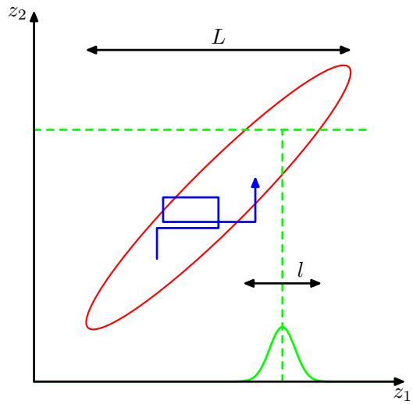
the conditional distributions are Gaussian, which represents a more general class of distributions than the multivariate Gaussian because, for example, the non-Gaussian distribution $p(z,y)∝exp(−z^{2}y^{2})$ has Gaussian conditional distributions. At each step of the Gibbs sampling algorithm, the conditional distribution for a particular component $z_{i}$ has some mean $μ_{i}$ and some variance $σ_{i}^{2}$ . In the over-relaxation framework, the value of $z_{i}$ is replaced with
$$z_{i}^{′}=μ_{i}+α(z_{i}−μ_{i})+σ_{i}(1−α_{i}^{2})^{1/2}ν$$
where ν is a Gaussian random variable with zero mean and unit variance, and α is a parameter such that $−1<α<1$ . For $α=0$ , the method is equivalent to standard Gibbs sampling, and for $α<0$ the step is biased to the opposite side of the mean. This step leaves the desired distribution invariant because if $z_{i}$ has mean $μ_{i}$ and variance $σ_{i}^{\overset{‾}{2}}$ , then so too does $z_{i}^{′}.$ . The effect of over-relaxation is to encourage directed motion through state space when the variables are highly correlated. The framework of ordered over-relaxation (Neal, 1999) generalizes this approach to non-Gaussian distributions.
The practical applicability of Gibbs sampling depends on the ease with which samples can be drawn from the conditional distributions $p(z_{k}|z_{∖k})$ . In the case of probability distributions specified using graphical models, the conditional distributions for individual nodes depend only on the variables in the corresponding Markov blankets, as illustrated in Figure 11.12. For directed graphs, a wide choice of conditional distributions for the individual nodes conditioned on their parents will lead to conditional distributions for Gibbs sampling that are log concave. The adaptive rejection sampling methods discussed in Section 11.1.3 therefore provide a framework for Monte Carlo sampling from directed graphs with broad applicability.
If the graph is constructed using distributions from the exponential family, and if the parent-child relationships preserve conjugacy, then the full conditional distributions arising in Gibbs sampling will have the same functional form as the original conditional distributions (conditioned on the parents) defining each node, and so standard sampling techniques can be employed. In general, the full conditional distributions will be of a complex form that does not permit the use of standard sampling algorithms. However, if these conditionals are log concave, then sampling can be done efficiently using adaptive rejection sampling (assuming the corresponding variable is a scalar).
Figure 11.12 The Gibbs sampling method requires samples to be drawn from the conditional distribution of a variable conditioned on the remaining variables. For graphical models, this conditional distribution is a function only of the states of the nodes in the Markov blanket. For an undirected graph this comprises the set of neighbours, as shown on the left, while for a directed graph the Markov blanket comprises the parents, the children, and the co-parents, as shown on the right.
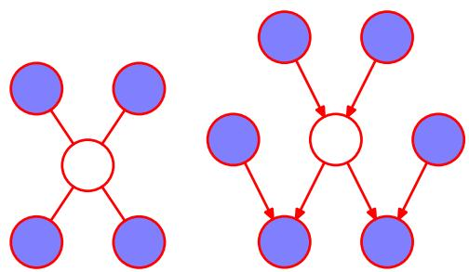
If, at each stage of the Gibbs sampling algorithm, instead of drawing a sample from the corresponding conditional distribution, we make a point estimate of the variable given by the maximum of the conditional distribution, then we obtain the iterated conditional modes (ICM) algorithm discussed in Section 8.3.3. Thus ICM can be seen as a greedy approximation to Gibbs sampling.
Because the basic Gibbs sampling technique considers one variable at a time, there are strong dependencies between successive samples. At the opposite extreme, if we could draw samples directly from the joint distribution (an operation that we are supposing is intractable), then successive samples would be independent. We can hope to improve on the simple Gibbs sampler by adopting an intermediate strategy in which we sample successively from groups of variables rather than individual variables. This is achieved in the blocking Gibbs sampling algorithm by choosing blocks of variables, not necessarily disjoint, and then sampling jointly from the variables in each block in turn, conditioned on the remaining variables (Jensen et al., 1995).

11.4. Slice Sampling
We have seen that one of the difficulties with the Metropolis algorithm is the sensitivity to step size. If this is too small, the result is slow decorrelation due to random walk behaviour, whereas if it is too large the result is inefficiency due to a high rejection rate. The technique of slice sampling (Neal, 2003) provides an adaptive step size that is automatically adjusted to match the characteristics of the distribution. Again it requires that we are able to evaluate the unnormalized distribution $\tilde{p}(z)$
Consider first the univariate case. Slice sampling involves augmenting z with an additional variable u and then drawing samples from the joint (z, u) space. We shall see another example of this approach when we discuss hybrid Monte Carlo in Section 11.5. The goal is to sample uniformly from the area under the distribution
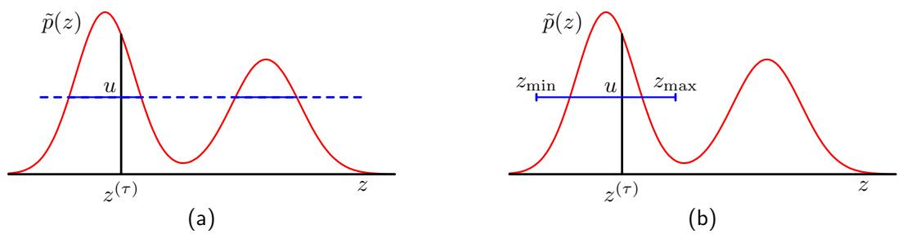
Figure 11.13 Illustration of slice sampling. (a) For a given value $z^{(τ)}$ , a value of u is chosen uniformly in the region $0≤u≤\tilde{p}(z^{(τ)})$ , which then defines a ‘slice’ through the distribution, shown by the solid horizontal lines. (b) Because it is infeasible to sample directly from a slice, a new sample of z is drawn from a region zmin $≤z≤z_{max}$ , which contains the previous value ${\dot{z}}^{(τ)}$
given by
$$\hat{p}(z,u)=\left\{\begin{matrix}1/Z_{p} & \text{ if }0≤u≤\tilde{p}(z) \\ 0 & \text{ otherwise }\end{matrix}\right.$$
where $Z_{p}=∫\tilde{p}(z)$ dz. The marginal distribution over $z$ is given by
$$∫\hat{p}(z,u)du=\int_{0}^{\tilde{p}(z)}{\frac{1}{Z_{p}}}du=\frac{\tilde{p}(z)}{Z_{p}}=p(z)$$
and so we can sample from $p(z)$ by sampling from $\hat{p}(z,u)$ and then ignoring the u values. This can be achieved by alternately sampling z and u. Given the value of $z$ we evaluate $\tilde{p}(z)$ and then sample u uniformly in the range $0≤u≤\tilde{p}(z)$ , which is straightforward. Then we fix u and sample z uniformly from the ‘slice’ through the distribution defined by $\{z:\tilde{p}(z)>u\}$ . This is illustrated in Figure 11.13(a).
In practice, it can be difficult to sample directly from a slice through the distribution and so instead we define a sampling scheme that leaves the uniform distribution under $\hat{p}(z,u)$ invariant, which can be achieved by ensuring that detailed balance is satisfied. Suppose the current value of z is denoted $z^{(τ)}$ and that we have obtained a corresponding sample $u.$ . The next value of z is obtained by considering a region $z_{min}≤z≤z_{max}$ that contains $z^{(τ)}$ . It is in the choice of this region that the adaptation to the characteristic length scales of the distribution takes place. We want the region to encompass as much of the slice as possible so as to allow large moves in z space while having as little as possible of this region lying outside the slice, because this makes the sampling less efficient.
One approach to the choice of region involves starting with a region containing $z^{(τ)}$ having some width w and then testing each of the end points to see if they lie within the slice. If either end point does not, then the region is extended in that direction by increments of value w until the end point lies outside the region. A candidate value $z^{′}$ is then chosen uniformly from this region, and if it lies within the slice, then it forms $z^{(τ+1)}$ . If it lies outside the slice, then the region is shrunk such that $z^{′}$ forms an end point and such that the region still contains ${\overset{‾}{z}}^{(τ)}$ . Then another candidate point is drawn uniformly from this reduced region and so on, until a value of z is found that lies within the slice.
Slice sampling can be applied to multivariate distributions by repeatedly sampling each variable in turn, in the manner of Gibbs sampling. This requires that we are able to compute, for each component $z_{i},$ a function that is proportional to $p(z_{i}|z_{∖i})$

11.5. The Hybrid Monte Carlo Algorithm
As we have already noted, one of the major limitations of the Metropolis algorithm is that it can exhibit random walk behaviour whereby the distance traversed through the state space grows only as the square root of the number of steps. The problem cannot be resolved simply by taking bigger steps as this leads to a high rejection rate.
In this section, we introduce a more sophisticated class of transitions based on an analogy with physical systems and that has the property of being able to make large changes to the system state while keeping the rejection probability small. It is applicable to distributions over continuous variables for which we can readily evaluate the gradient of the log probability with respect to the state variables. We will discuss the dynamical systems framework in Section 11.5.1, and then in Section 11.5.2 we explain how this may be combined with the Metropolis algorithm to yield the powerful hybrid Monte Carlo algorithm. A background in physics is not required as this section is self-contained and the key results are all derived from first principles.

11.5.1 Dynamical systems
The dynamical approach to stochastic sampling has its origins in algorithms for simulating the behaviour of physical systems evolving under Hamiltonian dynamics. In a Markov chain Monte Carlo simulation, the goal is to sample from a given probability distribution $p(z)$ . The framework of Hamiltonian dynamics is exploited by casting the probabilistic simulation in the form of a Hamiltonian system. In order to remain in keeping with the literature in this area, we make use of the relevant dynamical systems terminology where appropriate, which will be defined as we go along.
The dynamics that we consider corresponds to the evolution of the state variable $z=\{z_{i}\}$ under continuous time, which we denote by τ. Classical dynamics is described by Newton’s second law of motion in which the acceleration of an object is proportional to the applied force, corresponding to a second-order differential equation over time. We can decompose a second-order equation into two coupled firstorder equations by introducing intermediate momentum variables $r,$ corresponding to the rate of change of the state variables z, having components
$$r_{i}=\frac{dz_{i}}{dτ}$$
where the $z_{i}$ can be regarded as position variables in this dynamics perspective. Thus for each position variable there is a corresponding momentum variable, and the joint space of position and momentum variables is called phase space.
Without loss of generality, we can write the probability distribution $p(z)$ in the form 1
$$p(z)=\frac{1}{Z_{p}}exp(−E(z))$$
where $E(z)$ is interpreted as the potential energy of the system when in state z. The system acceleration is the rate of change of momentum and is given by the applied force, which itself is the negative gradient of the potential energy
$$\frac{dr_{i}}{dτ}=−\frac{∂E(z)}{∂z_{i}}.$$
It is convenient to reformulate this dynamical system using the Hamiltonian framework. To do this, we first define the kinetic energy by
K(r)=12∥r∥2=12i​ri2.
The total energy of the system is then the sum of its potential and kinetic energies
$$H(z,r)=E(z)+K(r)$$
where H is the Hamiltonian function. Using (11.53), (11.55), (11.56), and (11.57), we can now express the dynamics of the system in terms of the Hamiltonian equations given by
Exercise 11.15
$$\frac{dz_{i}}{dτ}=\frac{∂H}{∂r_{i}}$$
$$\frac{dr_{i}}{dτ}=−\frac{∂H}{∂z_{i}}.$$
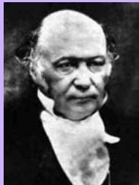

William Hamilton 1805–1865
William Rowan Hamilton was an Irish mathematician and physicist, and child prodigy, who was appointed Professor of Astronomy at Trinity College, Dublin, in 1827, before he had even graduated. One of Hamilton’s most important contributions was a new formulation of dynamics, which played a significant role in the later development of quantum mechanics.
His other great achievement was the development of , which generalize the concept of complex numbers by introducing three distinct square roots of minus one, which satisfy $i^{2}=j^{2}=k^{2}\overset{⋅}{=}ijk=−1.$ It is said that these equations occurred to him while walking along the Royal Canal in Dublin with his wife, on 16 October 1843, and he promptly carved the equations into the side of Broome bridge. Although there is no longer any evidence of the carving, there is now a stone plaque on the bridge commemorating the discovery and displaying the quaternion equations.

