

International School

CMU-SE 451

**Architecture Design**

**Version 2.0**

**Date: 02/04/2021**

**Book Management**

**Submitted by**

|  |  |
| --- | --- |
| **Bùi Lê Huy** | **0612** |
| **Lê Đức Huy** | **8264** |
| **Hồ Minh Khánh** | **2397** |
| **Võ Đức Minh** | **6188** |
| **Lê Thị Thảo** | **2457** |

**Approved by Nguyen Manh Duc**

**Proposal Review Panel Representative:**

Name Signature Date

**Capstone Project 2- Mentor:**

Name Signature Date

**PROJECT INFORMATION**

|  |  |  |  |
| --- | --- | --- | --- |
| **Project acronym** | Book Management | | |
| **Project Title** | Book Management System helps work related to it faster and more convenient | | |
| **Start Date** | 05 Nov 2023 | **End Date** | 24 Dec 2023 |
| **Lead Institution** | International School, Duy Tan University | | |
| **Project Mentor** | Duc, Nguyen Manh, Ph.D | | |
| **Scrum master**  **/ Project Leader & contact details** | Thao, Le Thi | | |
| **Partner Organization** |  | | |
| **Project Web URL** |  | | |
| **Team members** | Name | Email | Tel |
| 1 | Huy, Bui Le |  |  |
| 2 | Huy, Le Duc |  |  |
| 3 | Khanh, Ho Minh |  |  |
| 4 | Minh, Vo Duc |  |  |
| 5 | Thao, Le Thi |  |  |

**REVISION HISTORY**

|  |  |  |  |  |
| --- | --- | --- | --- | --- |
| **Version** | **Date** | **Comments** | **Author** | **Approval** |
| 1.0 | 05/11/2023 | Create Architecture Document | All members |  |
| 1.1 | 15/11/2023 | Update 3 | All members |  |
| 2.0 | 23/1/2020 | Update workflow for chatbot | All members |  |
| 2.0 | 01/05/2021 | Update with new requirements(3) | All member |  |

**TABLE OF CONTENTS**

**PROJECT INFORMATION** 2

1. Architecture driver 4

1.1 Business constraints 4

1.2 Technical constraints 4

1.4 Quality attributes 6

1.4.2.1 Security 8

1.4.2.2 Performance 8

1.4.2.3 Usability 10

1.4.2.4 Correctness 11

1.4.2.5 Modifiability 12

2. Architecture overview 13

2.1 System context 13

2.2 Component and connector 14

# 1. Architecture driver

## 1.1 Business constraints

* Sources: 5 people.
* Project was started on: 12/11/2023.
* Project will be ended on: 10/01/2024.
* Project will be finished in 59 days (177 hours).
* Cost: $2503.

## 1.2 Technical constraints

Technical to develop:

* Programming Language: JavaScript.
* Frameworks / Libraries: ReactNative, ReactJS, NodeJS, Bootstrap 4.
* Database Management System: MongoDB.

Environment:

* Web browsers: Google Chrome, FireFox, Opera.
* Operation systems: Microsoft Windows 10, Ubuntu.

**1.3 Functional Requirement**

|  |  |  |  |  |  |  |
| --- | --- | --- | --- | --- | --- | --- |
| Id | Heading | As a | I want to | So that | Acceptance Criteria | Priority |
| 1 | Register | User | Register | I can register a new account to log into the system. | Account must be >8 characters, <16 alphanumeric characters, no special characters | 5 |
| 2 | Login | User | Login | I can log in to my account to access the main home page when I have previously registered | Account has been successfully registered | 5 |
| 3 | Forgot password | User | Password retrieval | I can regenerate a new password after forgetting the previously registered password | - Use valid Email  - Use a valid phone number | 5 |
| 4 | Search and view information of book | User | Search and view information of book | I can search and find information about books to know the place of publication, author, category , …. | Enter the correct or approximate book title | 5 |
| 5 | Borrowing and Returning Books | User | Borrowing and Returning Books | You can borrow books from the library as well as return them when you have finished reading them | Get the right library books | 5 |
| 6 | Personal Account Management | User | Personal Account Management | I can view personal information and edit information if necessary as well as view book borrowing history and related notifications. | Must have an account after registering and logging into the system successfully | 4 |
| 7 | Making Penalty Payments | User | Making Penalty Payments | I can pay penalty fees if I borrow a book past its due date and don't return it | There must be money in the card or bank wallet | 3 |
| 8 | Receive Notifications and Reminders | User | Receive Notifications and Reminders | I can receive notifications when I have successfully borrowed a book or when it is almost time to return the book | Must have an account after registering and logging into the system successfully | 4 |
| 9 | Book Information Management | Admin | Book Information Management | Add, edit, delete and update books from the database. | Permission granted | 5 |
| 10 | User management | Admin | User management | View a list of users and their details, and activate or delete user accounts | Permission granted | 4 |
| 11 | Managing Borrowing and Returning Books | Admin | Managing Borrowing and Returning Books | I can view the list of borrowed and returned books and make notes about late or lost books. | Permission granted | 4 |
| 12 | System Integration and Maintenance | Admin | System Integration and Maintenance | Perform system maintenance and upgrades. |  | 4 |

## 1.4 Quality attributes

**1.4.1 Utility table**

There are following quality attributes that drive the design of architecture. Each quality attribute scenario is ranked with importance (I) defined by the Product Owner, and the estimated level difficulty (D). Both values are based on a scale of High (H) - Medium (M) - Low (L).

**1.4.2 Quality attributes**

#### 1.4.2.1 Security

|  |  |
| --- | --- |
| Scenario: Login authentication | |
| Type | Security |
| Stimulus | User |
| Source of stimulus | Customers |
| Environment | In runtime |
| Artifact stimulated | Application |
| Response | System |
| Response measure | Login authentication request |

|  |  |
| --- | --- |
| Scenario: Account information encryption | |
| Type | Security |
| Stimulus | User |
| Source of stimulus | Customers |
| Environment | In runtime |
| Artifact stimulated | System |
| Response | System |
| Response measure | Account information encryption |

#### 1.4.2.2 Performance

|  |  |
| --- | --- |
| Scenario: Search for books | |
| Type | Performance |
| Stimulus | User |
| Source of stimulus | Customers |
| Environment | In runtime |
| Artifact stimulated | Application |
| Response | Application |
| Response measure | Display search results |

|  |  |
| --- | --- |
| Scenario: Add new book | |
| Type | Performance |
| Stimulus | User |
| Source of stimulus | Customers |
| Environment | In runtime |
| Artifact stimulated | Application |
| Response | Application |
| Response measure | Add book to the system |

|  |  |
| --- | --- |
| Scenario: Borrow book | |
| Type | Performance |
| Stimulus | User |
| Source of stimulus | Customers |
| Environment | In runtime |
| Artifact stimulated | Application |
| Response | Application |
| Response measure | Confirm book borrowing |

#### 1.4.2.3 Usability

|  |  |
| --- | --- |
| Scenario: Login and access the system | |
| Type | Usability |
| Stimulus | User |
| Source of stimulus | Customers |
| Environment | In runtime |
| Artifact stimulated | Application |
| Response | Application |
| Response measure | Allow login and access the system |

|  |  |
| --- | --- |
| Scenario: View book information and borrow book | |
| Type | Usability |
| Stimulus | User |
| Source of stimulus | Customer |
| Environment | In runtime |
| Artifact stimulated | Application |
| Response | Application |
| Response measure | View book information and borrow book |

#### 1.4.2.4 Correctness

|  |  |
| --- | --- |
| Scenario: Add book to the system | |
| Type | Correctness |
| Stimulus | Users |
| Source of stimulus | Customers |
| Environment | In runtime |
| Artifact stimulated | The System |
| Response | The System |
| Response measure | Add book to the database |

|  |  |
| --- | --- |
| Quality attributes: Confirm book borrowing | |
| Type | Correctness |
| Stimulus | User |
| Source of stimulus | Customers |
| Environment | Runtime |
| Artifact stimulated | The System |
| Response | System |
| Response measure | Confirm book borrowing information |

#### 1.4.2.5 Modifiability

|  |  |
| --- | --- |
| Scenario: Add new feature | |
| Type | Modifiability |
| Stimulus | Product manager |
| Source of stimulus | A product manager |
| Environment | The next version |
| Artifact stimulated | The system |
| Response | system |
| Response measure | Allow extension |

# 2. Architecture overview

This section shows the diagrams which bounds our target system and describes the architecture and interaction between components

## 2.1 System context

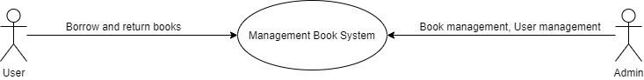

**Figure 1: System Context Overview**

**User:**

- Users can register an account, log in, and retrieve the account password when they forget

the password to access the system.

- Users can search and view information about books.

- Users can modify user information.

- Users can pay fees through the system

- Users can receive notifications or reminders related to library books as well as related

events

**Admin:**

- Admin can add, edit, delete and update books and information.

- Admin can view and manage user information.

- Admin can view books that are being loaned as well as books that are about to expire and

have expired.

- Admin can conduct maintenance and update additional features for the system.

## 2.2 C4 Model

## - Context (2.1)

- Container

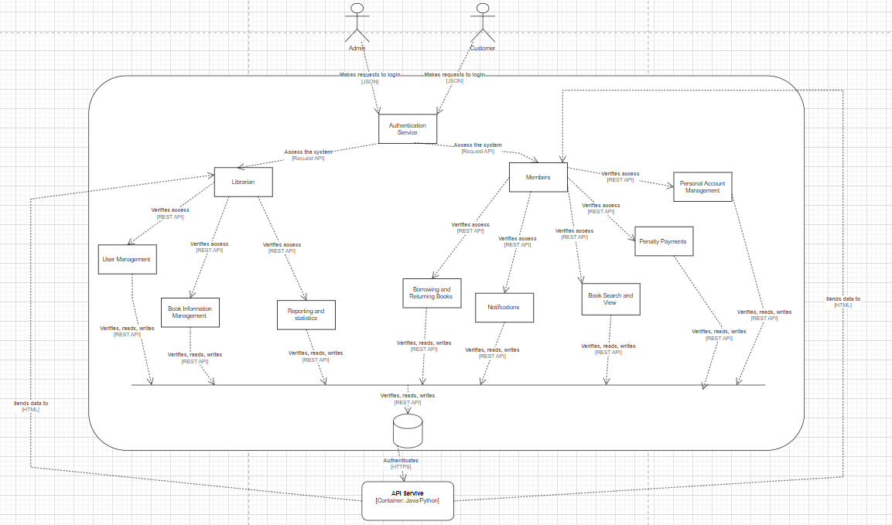

- Component

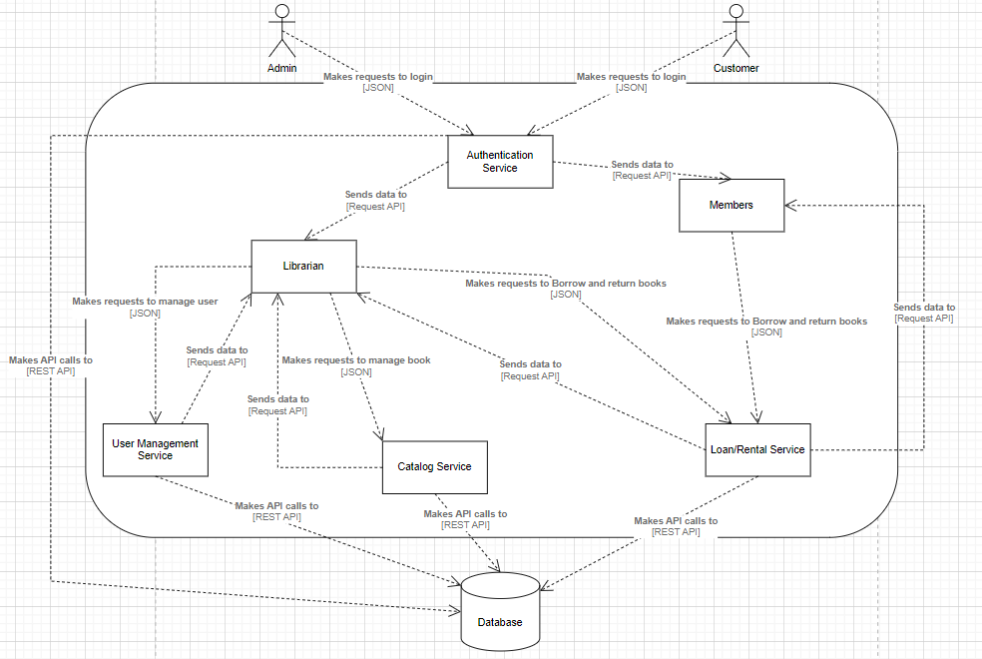

- Class

