

**INTERNATIONAL SCHOOL**

**CAPSTONE PROJECT 1**

**CMU-SE 450**

**USER INTERFACE DESIGN DOCUMENT**

Version: 1.0

**Online learning monitoring and tracking system**

**Mentor: Nguyen Dang Quang Huy**

***Team Member*:**

Khanh, Ho Minh

Trinh, Nguyen Duy

Dat, Pham Tan

Sy, Nguyen Van

**Approved by Huy Nguyen Dang Quang**

**UserInterface Review Panel Representative:**

Name Signature Date

**Capstone Project 1- Mentor:**

Name Signature Date

Da Nang, 09/2023

**PROJECT INFORMATION**

|  |  |
| --- | --- |
| **Project Acronym** | OLMT System |
| **Project Title** | Online learning monitoring and tracking system | | | |
| **Start Date** | September 10, 2023 | **End Date** | December 10, 2023 | |
| **Lead Institution** | International School, Duy Tan University | | | |
| **Team Member** | **Name** | **Email** | | **Phone** |
| 26211222152 | Trinh, Nguyen Duy | duytrinh2k2@gmail.com | | 0988465934 |
| 26211932993 | Dat, Pham Tan | phamtandat260918@gmail.com | | 0818971807 |
| 25211216743 | Sy, Nguyen Van | vansy01682937260@gmail.com | | 0377445085 |
| 26211222397 | Khanh, Ho Minh | hokhanhzxz@gmail.com | | 0763085584 |

**PROJECT PLAN DOCUMENT**

|  |  |  |  |
| --- | --- | --- | --- |
| **Document Title** | User Interface Document | | |
| **Author(s)** | C1SE.23 Team | | |
| **Date** | 10/09/2023 | **File name:** | C1SE.23_ OLMTSystem _UserInterface_v1.0 |
| **URL** |  | | |
| **Access** | Project and CMU Program | | |

**SIGNATURE**

**Document Approvals:** The following signatures are required for approval of this document.

|  |  |  |  |
| --- | --- | --- | --- |
| **Mentor** | Huy, Nguyen Dang Quang | **Signature:** |  |
| **Date:** |  |
| **Scrum master** | Khanh, Ho Minh | **Signature:** |  |
| **Date:** |  |
| **Team member(s)** | Trinh, Nguyen Duy | **Signature:** |  |
| **Date:** |  |
| Dat, Pham Tan | **Signature:** |  |
| **Date:** |  |
| Sy, Nguyen Van | **Signature:** |  |
| **Date:** |  |

**DOCUMENT HISTORY**

|  |  |  |  |
| --- | --- | --- | --- |
| **Version** | **Person** | **Date** | **Description** |
| 1.0 | Nguyen Duy Trinh | 10/09/2023 | First creation |
|  |  |  |  |
|  |  |  |  |
|  |  |  |  |

TABLE OF CONTENTS

I. INTRODUCTION 8

**1. PURPOSE 8**

**2. SCOPE 8**

**3. SCOPE 8**

II. LIST OF USER INTERFACE 9

**1. BUSINESS FUNCTION DIAGRAM: 9**

**2. WEB APP: 10**

III. DESCRIBE USER INTERFACE 12

**1. LOGIN PAGE 12**

**2. REGISTER PAGE 13**

**3. HOMEPAGE ADMIN FUNCTION 14**

**4. HOMEPAGE INSTRUCT FUNCTION 15**

**5. HOMEPAGE STUDENT FUNCTION 16**

**6. VIEW PERSONAL INFORMATION 17**

## 

**TABLES**

**Table 1: Describe LOGIN PAGE 10**

**Table 2: Describe REGISTER PAGE 11**

**Table 3: Describe HOMEPAGE ADMIN FUNCTION 13**

**Table 4: Describe HOMEPAGE INSTRUCT FUNCTION 14**

**Table 5: Describe HOMEPAGE STUDENT FUNCTION 15**

**Table 6: Describe VIEW PERSONAL INFORMATION 16**

# INTRODUCTION

## PURPOSE

* Document the design of user interface of functions of the Online learning monitoring and tracking system
* Be the primary document driving the implementation of the user interfaces.
* Introduce interface design for the reader. Including the background, content information display, command buttons.

## SCOPE

* This document helps to better understand the interface of the System, detailed specification components and function of the System.
* With this document, the development team can understand the structure and composition to create a consistent and complete system.
* Overview of the stages and modules of the software and create a complete interface.

## SCOPE

This document is intended for the following audiences:

* Technical reviewers including:
* Scrum Master
* Product owner
* Implementers, including:
  + Developers.
  + Testers.

# LIST OF USER INTERFACE

## BUSINESS FUNCTION DIAGRAM:

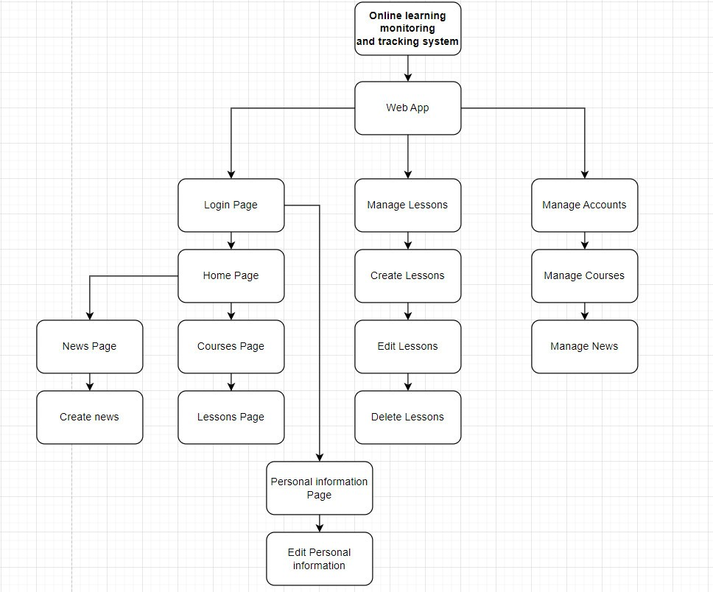

*Figure 1: Business Function diagram*

## WEB APP:

|  |  |  |
| --- | --- | --- |
| **User Interface ID** | **UI Name** | **Description** |
| UI-01 | Login/Logout function | Login will be used as the function to allow user to log into the system, it needs to be put in moderation. |
| UI-02 | Register function | This page is for student, instructor to register an account |
| UI-03 | Homepage admin function | This page is for admins to manage accounts |
| UI-04 | Homepage instruct function | This page is for instructor to see home page |
| UI-05 | Homepage student function | This page is for student to see home page |
| UI-06 | View personal information | This page is for student, instructor to see personal information |
| UI-07 | Edit personal information | This page is for student, instructor to edit personal information |
| UI-08 | News page function | This page is for the admin to add new page |
| UI-09 | Course page function | This page is for admins to add course page function |
| UI-10 | Manage Accounts function | This page is for admins to manage Accounts |
| UI-11 | Manage Courses function | This page is for admin to Manage Courses |
| UI-12 | Manage News function | This page is for admin to Manage News |
| UI-13 | Route page function | This page is for admin to manage Route page |
| UI-14 | Lessons page function | This page is for student to see Lessons |
| UI-15 | Face Recognition function | This page is for admin to manage Face Recognition |
| UI-16 | Manage Lessons function | This page is for instructor to Manage Lessons |
| UI-17 | Block copy/paste function | This page is for admin to Block copy/paste |
| UI-18 | Monitoring action on the website function | This page is for Monitoring actions on the website |
| UI-19 | Monitoring on webcam function | This page is for Monitoring on webcam |
| UI-20 | Warning function | This page is for give a warning |

*Table 1: List of Interface*

# DESCRIBE USER INTERFACE

## LOGIN PAGE

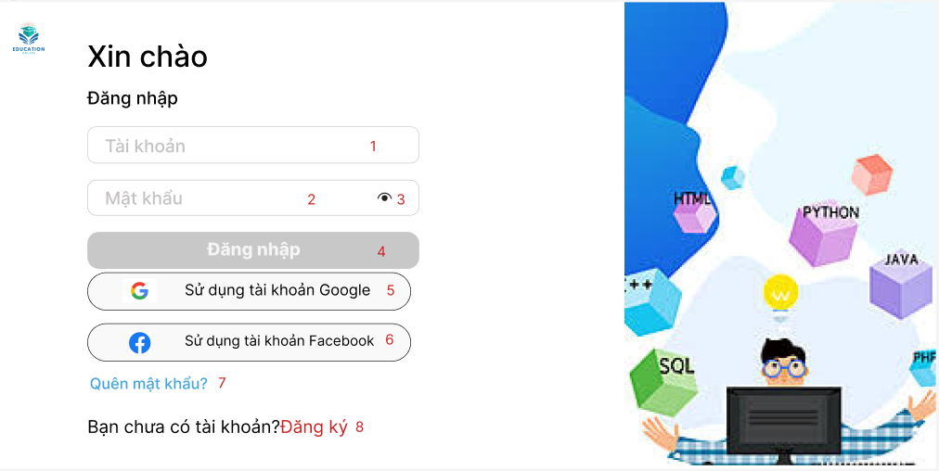

|  |  |  |  |
| --- | --- | --- | --- |
| **ID** | **Condition** | **Control Type** | **Target** |
| 1 | Press | Input Text | Enter your username |
| 2 | Press | Input Text | Enter password |
| 3 | Press | Button | Click to display the password |
| 4 | Press | Button | Click to login to the site |
| 5 | Press | Button | Click to log in to the website using Google |
| 6 | Press | Button | Click to log in to the website using Facebook |
| 7 | Press | Button | Click to go to the forgot my password page |
| 8 | Press | Button | Click to login to the site |

## Table : Describe LOGIN PAGE

1. **REGISTER PAGE**

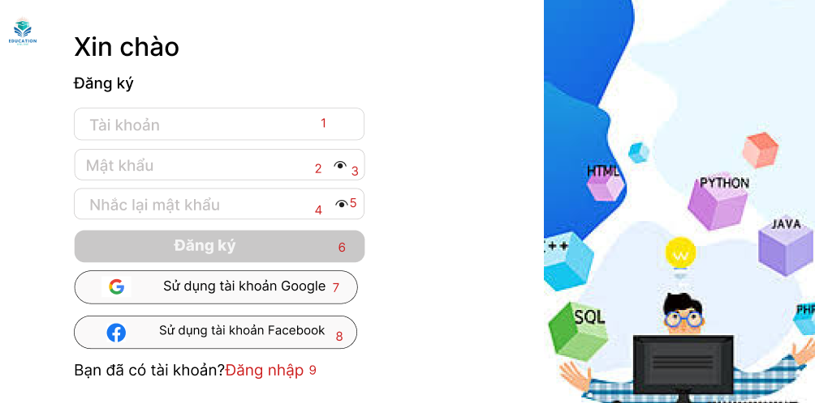

|  |  |  |  |
| --- | --- | --- | --- |
| **ID** | **Condition** | **Control Type** | **Target** |
| 1 | Press | Input Text | Enter your username |
| 2 | Press | Input Text | Enter password |
| 3 | Press | Button | Click to display the password |
| 4 | Press | Input Text | Enter the password |
| 5 | Press | Button | Click to display the password |
| 6 | Press | Button | Click to register to the site |
| 7 | Press | Button | Click to register in to the website using Google |
| 8 | Press | Button | Click to register in to the website using Facebook |
| 9 | Press | Button | Click to register to the site |

**Table 2: Describe REGISTER PAGE**

1. **HOMEPAGE ADMIN FUNCTION**

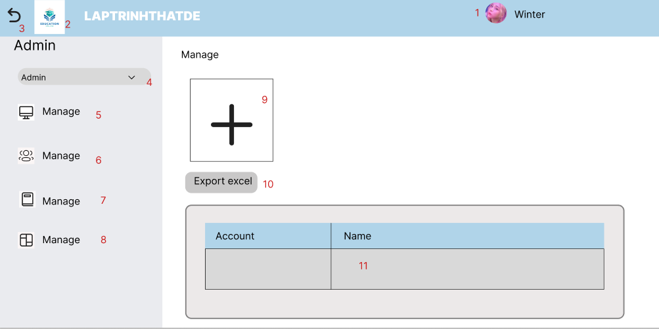

|  |  |  |  |
| --- | --- | --- | --- |
| **ID** | **Condition** | **Control Type** | **Target** |
| 1 | Press | Button | Click to view the admin home page |
| 2 | Press | Button | Click to return to the home page |
| 3 | Press | Button | Click to go back |
| 4 | Press | Button | Click to select items |
| 5 | Press | Button | Click to enter the management section |
| 6 | Press | Button | Click to go to Account section |
| 7 | Press | Button | Click to go to class management |
| 8 | Press | Button | Click to go to the class division section |
| 9 | Press | Button | Click to add account |
| 10 | Press | Button | Click to export to excel |
| 11 | Press | Button | Click to display accounts |

**Table 3: Describe HOMEPAGE ADMIN FUNCTION**

1. **HOMEPAGE INSTRUCT FUNCTION**

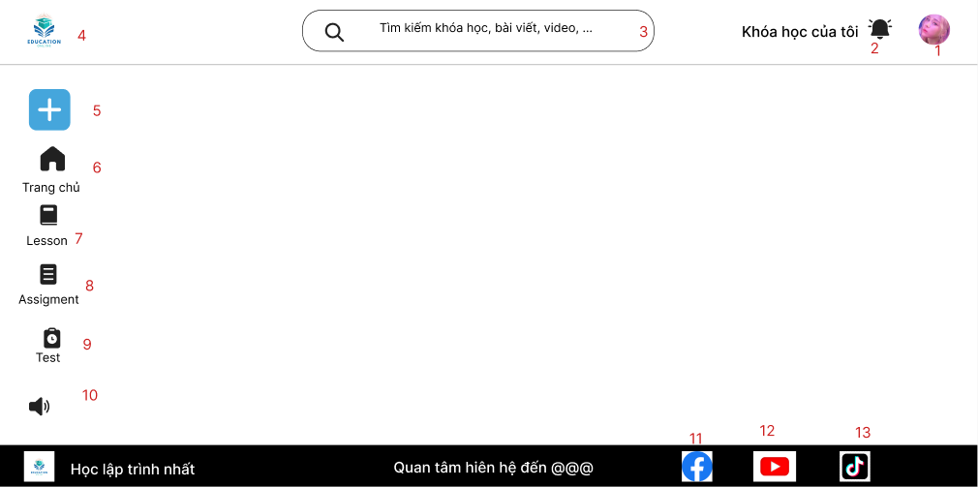

|  |  |  |  |
| --- | --- | --- | --- |
| **ID** | **Condition** | **Control Type** | **Target** |
| 1 | Press | Button | Click to go to the information page |
| 2 | Press | Button | Click to view the announcement |
| 3 | Press | Button | Click to search |
| 4 | Press | Button | Click to return to the home page |
| 5 | Press | Button | Click to register for class |
| 6 | Press | Button | Click to go to the home page |
| 7 | Press | Button | Click to go to the lesson page |
| 8 | Press | Button | Click to go to the assignment page |
| 9 | Press | Button | Click to go to the test page |
| 10 | Press | Button | Click to view news |
| 11 | Press | Button | Click to go to the facebook page |
| 12 | Press | Button | Click to go to the youtube page |
| 13 | Press | Button | Click to go to the tiktok page |

**Table 4: Describe HOMEPAGE INSTRUCT FUNCTION**

## HOMEPAGE STUDENT FUNCTION

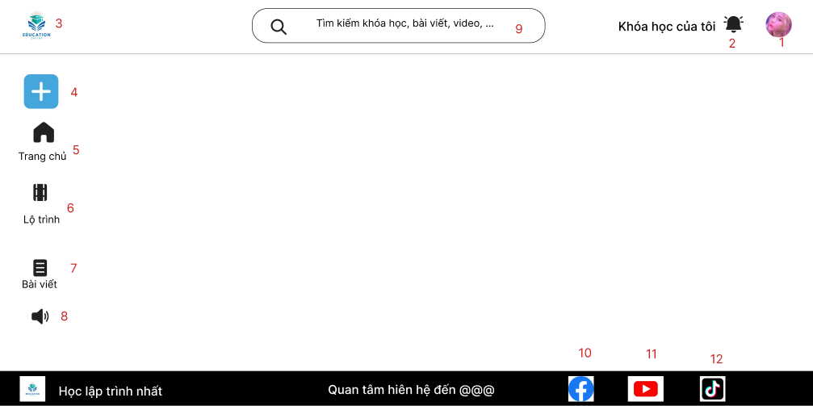

|  |  |  |  |
| --- | --- | --- | --- |
| **ID** | **Condition** | **Control Type** | **Target** |
| 1 | Press | Button | Click to go to the information page |
| 2 | Press | Button | Click to view the announcement |
| 3 | Press | Button | Click to search |
| 4 | Press | Button | Click to return to the home page |
| 5 | Press | Button | Click to register for class |
| 6 | Press | Button | Click to go to the home page |
| 7 | Press | Button | Click to go to the Lộ trình page |
| 8 | Press | Button | Click to go to the Bài viết page |
| 9 | Press | Button | Click to view news |
| 10 | Press | Button | Click to go to the facebook page |
| 11 | Press | Button | Click to go to the youtube page |
| 12 | Press | Button | Click to go to the tiktok page |

## Table : Describe HOMEPAGE STUDENT FUNCTION

1. **VIEW PERSONAL INFORMATION**

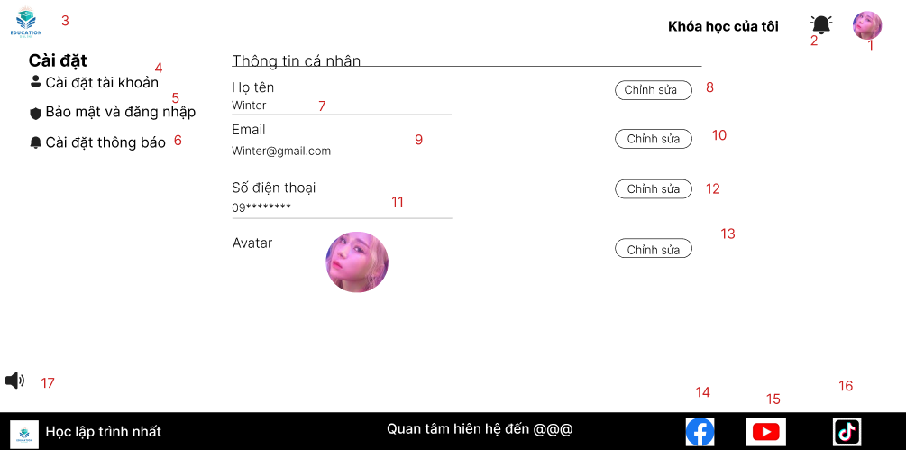

|  |  |  |  |
| --- | --- | --- | --- |
| **ID** | **Condition** | **Control Type** | **Target** |
| 1 | Press | Button | Click to go to the information page |
| 2 | Press | Button | Click to view the announcement |
| 3 | Press | Button | Click to return to the home page |
| 4 | Press | Button | Click to go to the account settings page |
| 5 | Press | Button | Click to go to the security page and log in |
| 6 | Press | Button | Click to enter the settings and notifications page |
| 7 | Press | Input Text | Enter full name |
| 8 | Press | Button | Click to edit full name |
| 9 | Press | Input Text | Enter Email |
| 10 | Press | Button | Click to edit Email |
| 11 | Press | Input Text | Enter phone number |
| 12 | Press | Button | Click to edit Phone number |
| 13 | Press | Button | Click to edit Avatar |
| 14 | Press | Button | Click to go to the facebook page |
| 15 | Press | Button | Click to go to the youtube page |
| 16 | Press | Button | Click to go to the tiktok page |

**Table 6: Describe VIEW PERSONAL INFORMATION**