Name: Dam, Anh

Date: 12/20/2024

NYU ID: N13366096

Course: Database Systems – CSCIGA2433001

Project Part IV – End-to-End Solution Integration and Data-Driven / Database Programming

# Executive Summary

This project, titled **"Analyzing Music Trends Using Spotify's Million Playlist Dataset"**, focuses on developing an end-to-end data-driven solution for Spotify’s Million Playlist Dataset. The objective is to design a seamless pipeline that integrates machine learning insight into a relational database optimized for operational excellence and business competitiveness. Key outcomes include the implementation of an OLTP/ODS database, machine learning models for playlist popularity prediction and artist trend analysis, and a workflow-based application that enables real-time updates and re-training. The project leverages tools such as PostgreSQL, Python, and machine learning algorithms to ensure scalability and adaptability to future requirements

# Introduction

## Background

Spotify’s Million Playlist Dataset provides a comprehensive collection of user-generated playlists, capturing metadata such as track details, playlist followers, and engagement metrics. Analyzing this data offers valuable insights into user preferences, artist performance, and playlist trends, enabling data-driven decision-making in the music industry.

## Project Objective

The project aims to develop a robust and scalable end-to-end system that integrates machine learning predictions with a relational database. The objective is to enhance playlist optimization and improve user engagement. This solution tackles critical challenges, including managing unstructured data, automating machine learning model re-training, and ensuring high data quality and governance standards.

## Scope

The project is structured into the following phases:

1. **Business Use Cases and Workflow Design**:

* Define workflows for key use cases, such as playlist popularity prediction and artist trend analysis.
* Establish success metrics and monitoring frameworks.

1. **Data-Driven Program Module**:

* Implement machine learning models for predictions and clustering.
* Develop data processing pipelines for unstructured data management and system integration.

1. **End-to-End Workflow-Based Application**:

* Build an integrated application with a user-friendly interface.
* Automate data processing, model execution, and real-time visualization.

1. **Reference Architecture and Governance**:

* Design a scalable system architecture.
* Establish data quality standards and security protocols.

## Database Schema Overview

The database schema is designed to efficiently store, manage, and analyze the Spotify Million Playlist Dataset, supporting both raw data and machine learning results. It consists of four interconnected tables:

1. **Playlists**: Stores metadata, including playlist name, follower count, and machine learning predictions.
2. **Artists**: Maintains clustering results and artist performance metrics, such as playlist appearances and average followers.
3. **Tracks**: Captures track-level details, such as name, artist, and duration.
4. **PlaylistTracks**: Maps the many-to-many relationship between playlists and tracks.

This schema facilitates seamless data retrieval, relationship mapping, and integration with machine learning models for playlist analysis and artist trend insights.

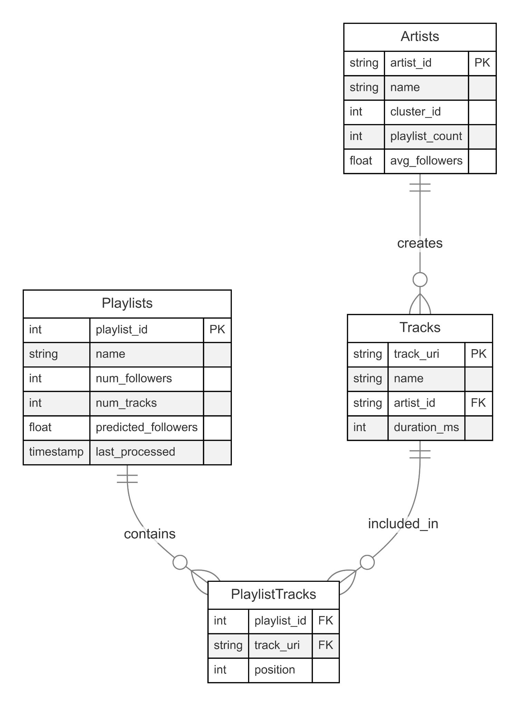

## Project Deliverables

**Machine Learning Models**

* Playlist popularity prediction using Random Forest Regressor.
* Artist clustering and trend analysis via KMeans clustering.

**Database Implementation**

* Optimized PostgreSQL database for efficient data storage and retrieval.
* Real-time data update and processing pipelines.

**User Interface**

* Interactive web application with dynamic dashboards.
* Visualizations and analysis reporting tools.

**Documentation**

* Comprehensive technical specifications.
* User guides and maintenance procedures.

# Phase 1 – Business Use Cases and Workflow Design

In this phase, two complementary use cases are defined to maximize the utility of the machine learning models developed earlier. These use cases focus on playlist optimization and artist performance monitoring, addressing critical business needs in the music industry.

### Use Case 1: Playlist Popularity Optimization

**Objective**: The goal of this use case is to predict playlist followers and provide actionable insights to optimize playlist composition. By leveraging machine learning predictions, this workflow identifies underperforming playlists and recommends improvements to enhance user engagement and satisfaction.

**Stakeholders and Roles**

* Playlist Curators: Access optimization recommendations and implement changes.
* Content Managers: Oversee playlist strategy.
* Data Analysts: Monitor model performance.
* End Users: Benefit from improved playlist quality.

**Workflow Description**

1. **Input**: Playlist metadata is extracted from the OLTP database, including attributes such as the number of tracks, total unique artists, total duration, and collaborative status.
2. **Processing**: The trained Random Forest Regressor model predicts follower counts for playlists. Predictions are compared to actual follower counts to identify discrepancies and opportunities for optimization.
3. **Insight Generation**: Recommendations are generated based on the analysis, including

* Adding more diverse tracks (unique artists) to playlists.
* Adjusting playlist duration to better align with user preferences.
* Flagging collaborative playlists with low performance for review.

1. **Database Update**: The PostgreSQL database is updated with predicted follower counts and optimization suggestions for each playlist.
2. **Output**: A report or API endpoint provides actionable recommendations for system administrators or users.

**Success Metrics**

* Quantitative Metrics: Prediction accuracy (RMSE < 0.3); $R^{2}$ score (> 0.7); Implementation success rate (> 80%).
* Qualitative Metrics: User satisfaction; Recommendation Relevance; Ease of Implementation.

### Use Case 2: Artist Performance Monitoring

**Objective**: This use case focuses on identifying emerging artists and monitoring their performance trends. By clustering artists based on their engagement metrics, the system provides strategic recommendations for playlist inclusion or promotional efforts.

**Stakeholders and Roles**

* Music Industry Analysts: Primary users of insights
* Artist Relations Teams: Implementation of recommendations
* Marketing Teams: Campaign planning
* Playlist Curators: Artist inclusion decisions

**Workflow Description**

1. **Input**: Artist metadata is extracted from the database, including playlist appearances, average followers, and track counts.
2. **Processing**: The trained K-Means clustering model segments artists into distinct clusters based on their engagement metrics.
3. **Insight Generation**: Actionable insights are generated, such as

* Identifying emerging artists with high engagement but low playlist appearances.
* Recommending artists for promotion or playlist inclusion based on their cluster.
* Highlighting top-tier artists for strategic collaborations.

1. **Database Update**: The database is updated with cluster assignments and recommendations for each artist.
2. **Output**: A report highlights cluster characteristics and provides actionable recommendations for stakeholders.

**Performance Monitoring**

* Technical Metrics: Clustering accuracy; Pattern recognition precision; Update frequency; System response time
* Business Metrics: Artist growth rates; Playlist inclusion success; Engagement improvement; Implementation rate.

**Workflow Diagram**



Figure 1: Playlist Popularity Optimization



Figure 2: Artist Performance Monitoring

**Impact and Importance**

* **User Engagement:** The system improves playlist quality by delivering data-driven insights, leading to higher user retention and longer engagement times. Users benefit from better content discovery and enhanced satisfaction through curated playlists tailored to their preferences.
* **Data-Driven Decision Making**: Stakeholders gain valuable insights through predictive analytics and trend forecasting. Quantitative data enables informed decisions on playlist curation, artist promotion, and resource allocation, improving platform strategies and risk assessment.
* **Operational Efficienc**y: The application streamlines critical processes, including artist evaluation, playlist optimization, and content strategy planning. By automating these workflows, the system reduces manual effort, improves accuracy, and enhances resource utilization.
* **Scalability Features**: Designed for growth, the system supports real-time data processing, automated workflow updates, and integration of additional features. Its modular architecture ensures adaptability to evolving datasets and analytics needs.
* **Business Value**: The solution delivers measurable impacts, such as increased user engagement, improved playlist performance, and higher artist satisfaction. These insights drive data-driven strategies that enhance user experience and promote platform growth.

# Phase 2 – Data-Driven Program Module

In this phase, the focus shifts to building upon the data pipeline and machine learning integration developed in previous phases, particularly as documented in Project Part 3. The goal is to enhance the pipeline’s functionality, automate machine learning model re-training, and ensure seamless integration of unstructured data processing with the relational database and workflow-based application.

## Existing Achievements (From Project Part 3)

1. Data Pipeline Development

* JSON files from Spotify’s Million Playlist Dataset were processed and loaded into PostgreSQL.
* Tables – Playlists, Tracks, and PlaylistTracks were populated, forming the foundation of the relational database.

1. Machine Learning Model Integration

* The Random Forest Regressor was trained to predict playlist followers, aiding in playlist popularity optimization.
* The K-Means Clustering Model was implemented to group artists into meaningful clusters, supporting artist trend analysis.

These components establish the groundwork for the end-to-end data-driven solution.

## Database Enhancements

We extended the database schema to support machine learning operations by adding new columns to the Playlists table (**predicted_followers** and **last_processed**) and creating a new Artists table. The Artists table was designed to store clustering results and artist metrics, including playlist appearances, follower statistics, and track counts. These structural changes enabled us to maintain historical data and track model processing timestamps effectively.

## Machine Learning Implementation

The core of our enhancement revolves around four main Python modules that integrate machine learning models, database management, and workflow orchestration.

1. **Playlist Popularity Predictor(playlist_popularity.py)**

This module predicts playlist follower counts using the Random Forest Regressor model with 100 estimators, a maximum depth of 10, and a random state of 42 to ensure reproducibility. The predictor analyzes playlist characteristics through a combination of basic, derived, and statistical features:

* Basic Features: num_tracks, num_artists, num_albums, duration_ms, collaborative.
* Derived Features: tracks_per_artist, avg_tracks_per_album.
* Statistical Features: avg_track_duration, unique_artists.

The implementation includes an **80-20 train-test split**, calculation of performance metrics (RMSE, R²), and **feature importance visualization** to identify the most influential factors affecting playlist popularity.

1. **Artist Trend Analyzer (artist_trends.py)**

The **Artist Trend Analyzer** uses **KMeans clustering** to group artists into five distinct clusters, identifying patterns based on performance metrics. The clustering model is configured with 5 clusters, 10 initializations, and feature normalization using StandardScaler for improved accuracy. Key features include:

* Playlist appearance count.
* Average followers.
* Track count.
* Derived Metrics: followers_per_playlist, tracks_per_playlist.

The results are visualized through cluster distribution plots and statistical summaries that provide valuable insights into artist categorization and success factors.

1. **Features Analyzed**

Both modules analyze the following key features to generate insights:

* Playlist Appearance Count: Evaluates how often playlists feature an artist or track.
* Average Followers: Measures the average follower count for artists or playlists.
* Track Count: Tracks the total number of songs per artist or playlist.
* Derived Metrics: Metrics such as followers_per_playlist and tracks_per_playlist are calculated to provide deeper insights into performance and engagement trends.

## Pipeline Integration

1. **Model Manager (model_manager.py)**

The Model Manager acts as the central control system, orchestrating the entire machine learning pipeline. It ensures smooth integration and execution by:

* Managing database connections for reading/writing predictions and clustering results.
* Coordinating model training and re-training based on processing triggers: > 100 unprocessed playlists or >5 0 unprocessed artists.
* Implementing robust error handling and logging systems for stability and auditability.
* Maintaining schedules to monitor and update predictions or clustering results as new data is ingested.

The Model Manager enhances operational efficiency by automating processes and ensuring resource optimization.

1. **Training Controller (train_models.py)**

The Training Controller orchestrates the training and evaluation of machine learning models. It centralizes the execution of the pipeline with the following capabilities:

* Comprehensive logging for transparency and debugging.
* Generation of performance reports that include evaluation metrics such as RMSE and cluster summaries.
* Creation of visual outputs, such as feature importance charts and cluster distribution plots.
* Exception handling to ensure smooth execution, even in the case of errors or incomplete data.

The Model Manager and Training Controller work in tandem to ensure seamless pipeline operation, enabling dynamic re-training, efficient data processing, and real-time insights generation. These components provide a scalable and reliable foundation for the system's end-to-end workflow.

## API Implementation

To facilitate seamless interaction with the machine learning models, a RESTful API system was implemented to handle playlist and artist analysis requests. This system enables real-time data retrieval, processing, and result delivery to end-users.

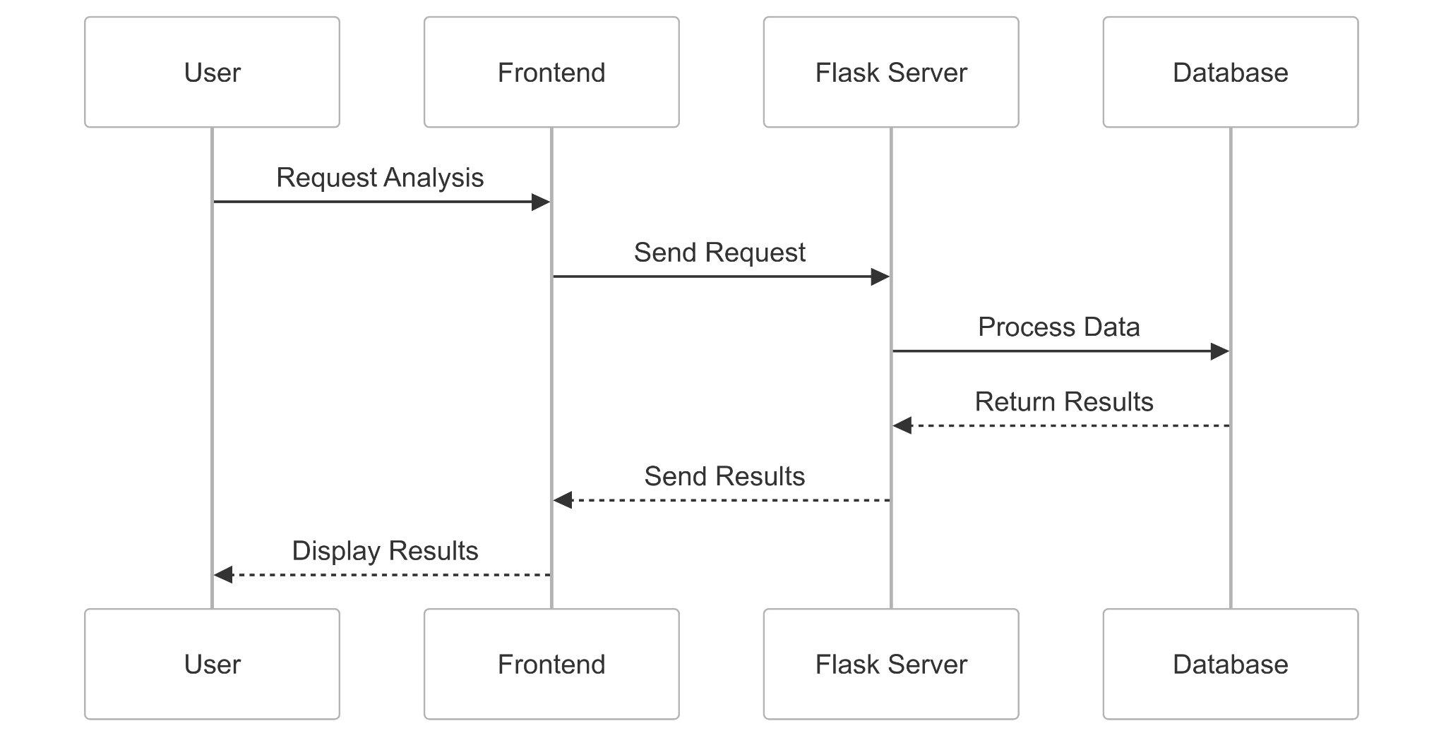

**Endpoints**

1. Playlist Analysis API

* Endpoint: POST /analyze_playlist
* Input:
  + playlist_id: Unique identifier for the playlist.
  + Playlist metadata: Includes tracks, artists, and total duration.
* Output:
  + predicted_followers: The predicted number of followers for the playlist (float).
  + feature_importance: Key features contributing to the prediction (dictionary).
  + confidence_score: Confidence in the prediction result (float).

1. Artist Analysis API

* Endpoint: POST /analyze_artist
* Input:
  + artist_id: Unique identifier for the artist.
  + Performance metrics: Includes playlist appearances, follower count, and track count.
* Output:
  + cluster_id: The assigned cluster ID for the artist (integer).
  + cluster_characteristics: Characteristics of the assigned cluster (dictionary).
  + similarity_score: The similarity of the artist to other members in the cluster (float).

The API implementation provides a robust framework for integrating machine learning predictions and clustering results into the system. With endpoints designed for playlist and artist analysis, the API ensures efficient data processing and delivers actionable insights in real time.

## Machine Learning Results Analysis

1. **Playlist Popularity Model Performance**

The Playlist Popularity Predictor provides key insights into the factors influencing playlist follower counts. With an RMSE of **107.87** and an $R^{2}$ score of **-0.51**, the model highlights the complexity of predicting playlist popularity. The negative $R^{2}$ score suggests that additional features, such as temporal trends, genre preferences, or social factors, may play a significant role in follower dynamics.

**Feature Importance Analysis**

* Average Track Duration: 42.14%.
* Total Playlist Duration: 35.26%.
* Tracks Per Artist: 9.12%.
* Album-Related Metrics: Approximately 11% combined.

Timing-related metrics like average track duration and total playlist duration were the most influential factors, as shown in the accompanying feature importance visualization.

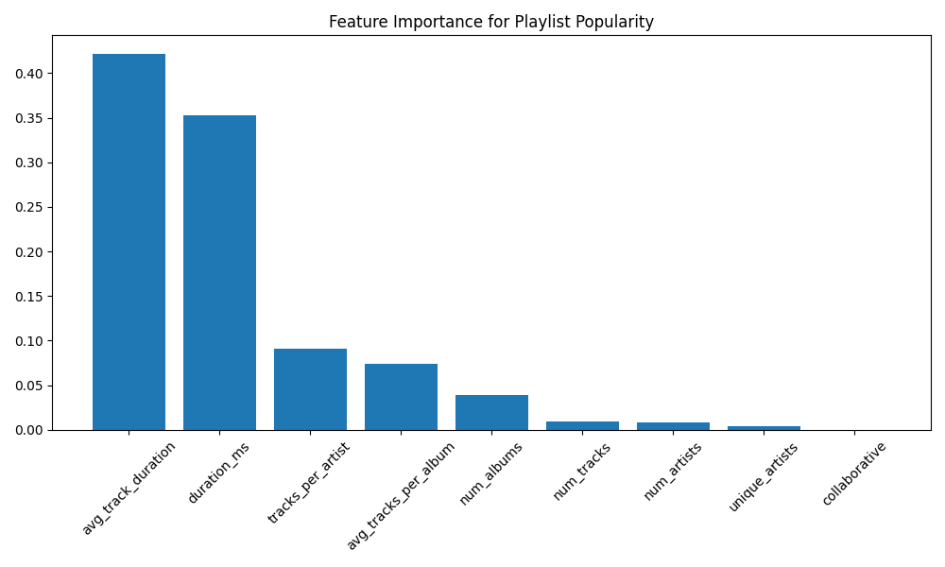

1. **Artist Clustering Analysis**

The Artist Trend Analyzer successfully categorized 67,417 artists into five distinct clusters, each revealing unique characteristics and trends:

**Mainstream Artists (Cluster 4):**

* Size: 397 artists
* Characteristics: Highest playlist appearances (avg: 37,319), moderate followers (avg: 2.66).

**Classical/EDM Masters (Cluster 3):**

* Size: 31 artists
* Characteristics: High playlist appearances (avg: 7,045), lower followers (avg: 2.40).

**Niche Popular Artists (Cluster 1):**

* Size: 37 artists
* Characteristics: Fewer playlists (avg: 19.57), highest followers (avg: 2,209.29).

**Mid-Tier Artists (Cluster 2):**

* Size: 8,523 artists
* Characteristics: Moderate playlists (avg: 45.46), lower followers (avg: 3.65).

**Long-Tail Artists (Cluster 0):**

* Size: 58,429 artists
* Characteristics: Widespread but moderate playlists (avg: 378.53), average followers (avg: 4.60).

1. **Key Insights:**

**Artists Distribution**

* 86.7% of artists belong to the "Long-Tail" cluster, representing widespread but moderate engagement.
* Only 0.6% achieve "Mainstream" status, while 0.05% are Classical/EDM masters with niche appeal.

**Popular Patterns**

* High playlist appearances don’t guarantee high follower counts.
* Niche artists maintain strong engagement despite fewer playlists, while Classical/EDM artists exhibit distinct trends.

**Content Volume**

* Classical/EDM Masters: Highest average track count (1,886.23).
* Mainstream Artists: Moderate track count (164.44).
* Niche Popular Artists: Lowest track count (5.14), leveraging fewer tracks to sustain high engagement.

The accompanying figure illustrates the distribution of artists across clusters, highlighting patterns of playlist inclusion, follower counts, and engagement dynamics.

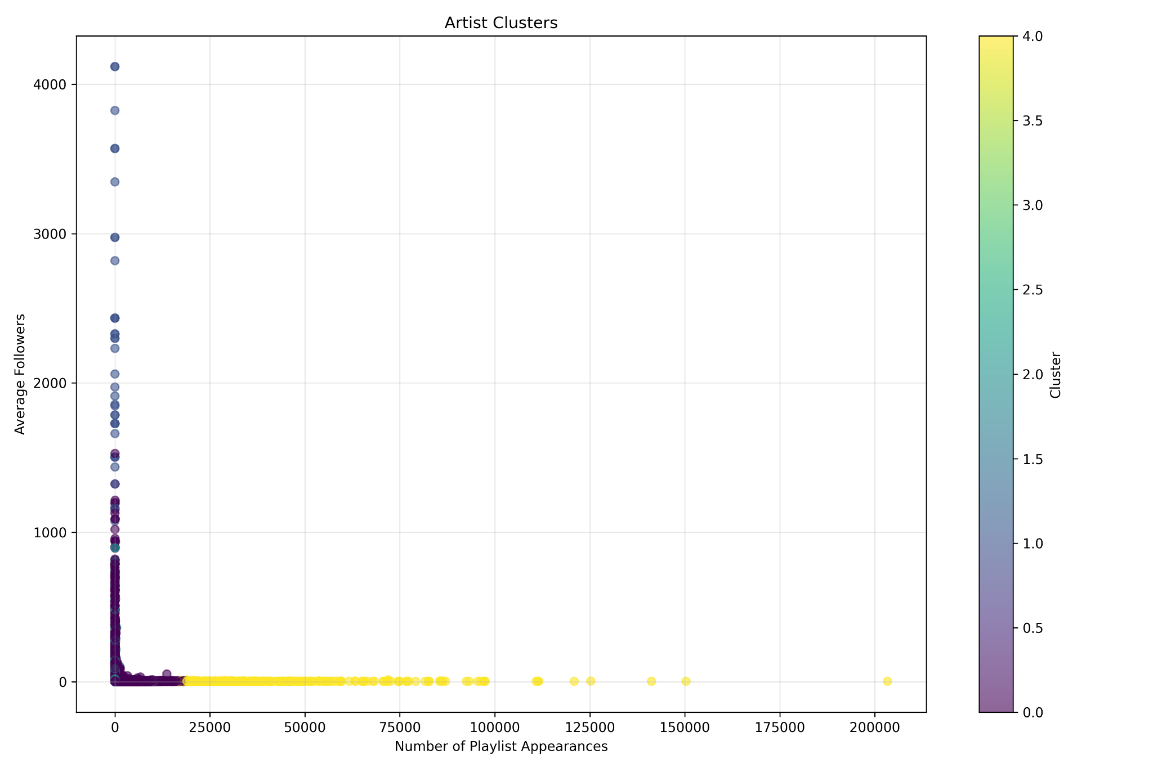

# Phase 3 – Workflow-Based Application Integration

## Application Design and Architecture

The system implements a robust three-tier architecture that ensures scalability, maintainability, and efficient performance. Each tier is designed to handle specific responsibilities while maintaining clear separation for modularity and ease of development.

1. Presentation Layer

* HTML/CSS interface with a Spotify-inspired design for user familiarity.
* Dynamic result displays with clear visualizations of predictions and clustering results.
* Interactive controls for initiating analyses and navigating through features.
* Real-time status updates to provide users with progress feedback during long operations.

1. Application Layer (Business Logic)

* Flask Web Server: Manages incoming requests and orchestrates responses.
* Machine Learning Execution: Integrates Playlist Popularity Predictor and Artist Trend Analyzer models for real-time predictions and clustering.
* Data Processing Pipelines: Efficiently handles raw and preprocessed data flows.
* Error Handling and Logging: Ensures system stability and provides detailed audit logs for troubleshooting.

1. Database Layer

* PostgreSQL Database: Stores the Million Playlist Dataset and processed results.
* SQLAlchemy ORM: Facilitates database operations and ensures compatibility with the application layer.
* Optimized Query Execution: Implements indexing and query optimization for high-performance data retrieval.
* Transaction Management: Maintains data consistency and integrity during concurrent operations.

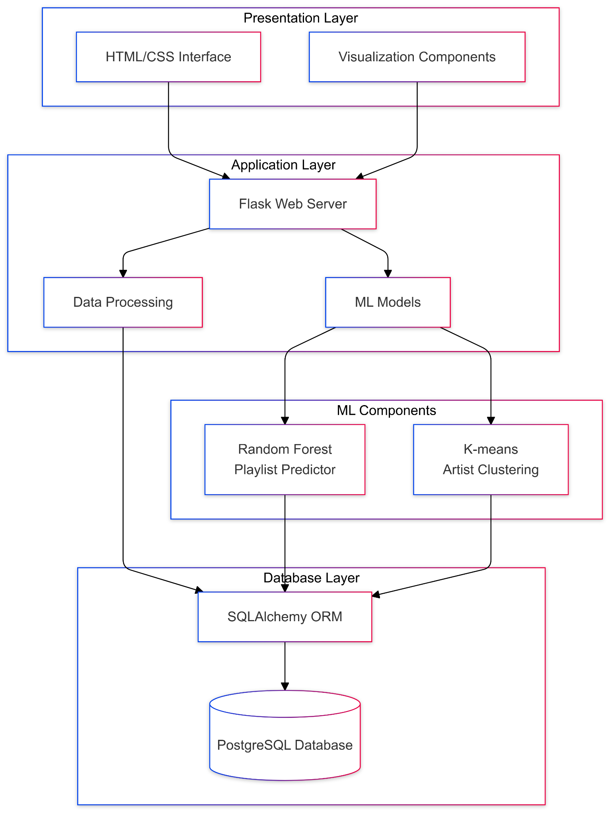

This architecture ensures seamless integration between the frontend, backend, and database, enabling efficient execution of machine learning tasks and dynamic data interactions.

## User Interface Implementation

The web interface was designed to prioritize usability and deliver a seamless user experience, aligning with the project’s analytical goals and functionality.

1. Dashboard Design

* A clean, modern interface with Spotify-inspired aesthetics enhances user familiarity and engagement.
* Responsive layouts ensure compatibility across various devices and screen sizes.
* Intuitive navigation and controls allow users to easily explore playlist and artist analytics.

1. Key Features

Playlist Analysis Dashboard:

* Displays playlist popularity predictions.
* Visualizes feature importance for key metrics like track duration and diversity.
* Presents performance metrics for model evaluation (e.g., RMSE, R²).

Artist Trends Dashboard:

* Showcases clustering results with visual aids.
* Displays statistical analyses for each artist cluster.
* Highlights pattern recognition insights for trend analysis.

1. Interactive Elements

* Real-Time Analysis Triggers: Users can initiate playlist or artist analysis instantly.
* Dynamic Result Updates: Data visualizations and statistics refresh seamlessly without page reloads.
* Error and Status Notifications: Provides immediate feedback on analysis progress or system issues.

This user-friendly interface bridges the gap between data insights and end-users, making complex analyses accessible through dynamic and interactive dashboards.

## Database Connectivity

Robust integration with the PostgreSQL database was achieved using SQLAlchemy ORM, ensuring efficient, secure, and reliable database interactions. The database serves as the backbone of the system, supporting data retrieval, storage of model results, and real-time updates.

1. Query Implementation

* Basic SQL queries were utilized for efficient data retrieval from core tables such as Playlists, Tracks, and Artists.
* Simple join operations ensured seamless integration between related tables for analytics and visualization.
* Primary key indexing enhanced query performance, minimizing retrieval times.

1. Connection Management

* Basic connection handling ensured stable communication between the application and the database.
* Transaction management maintained data consistency during read and write operations, preventing issues with incomplete updates.
* Error handling mechanisms captured and addressed issues during database operations to maintain reliability.

1. Testing and Validation

Database Testing:

* Verified basic query execution for retrieving data and updating records.
* Ensured data integrity through checks on consistent table relationships.
* Tested simple error handling for database queries and transactions.

Interface Testing:

* Validated basic functionality of the API endpoints interacting with the database.
* Verified proper display of error messages and system notifications on the user interface.

Performance Testing:

* Conducted basic response time checks to ensure query execution remained fast under moderate loads.
* Monitored memory usage during operations to assess resource efficiency.

## Result and Performance

The application demonstrates reliable performance and meaningful results:

* System Functionality: Successfully integrated machine learning models for playlist follower predictions and artist clustering. Database operations were completed reliably, with basic error handling mechanisms ensuring stability during execution.
* User Interface Results: Delivered functional navigation, clear results display, and informative error message presentation. Users were able to interact with the system seamlessly, triggering analyses and viewing outputs in real time.

Key outcomes include:

* Playlist Predictions: Predicted playlist follower counts using machine learning models. Feature importance analysis highlighted key factors such as average track duration and total playlist duration as primary influencers of popularity. Results were displayed with interactive visualizations.
* Artist Clustering: Successfully categorized 67,417 artists into five meaningful clusters, identifying trends in artist popularity, playlist inclusion, and follower metrics. Clustering results were visualized with intuitive plots to enhance understanding.

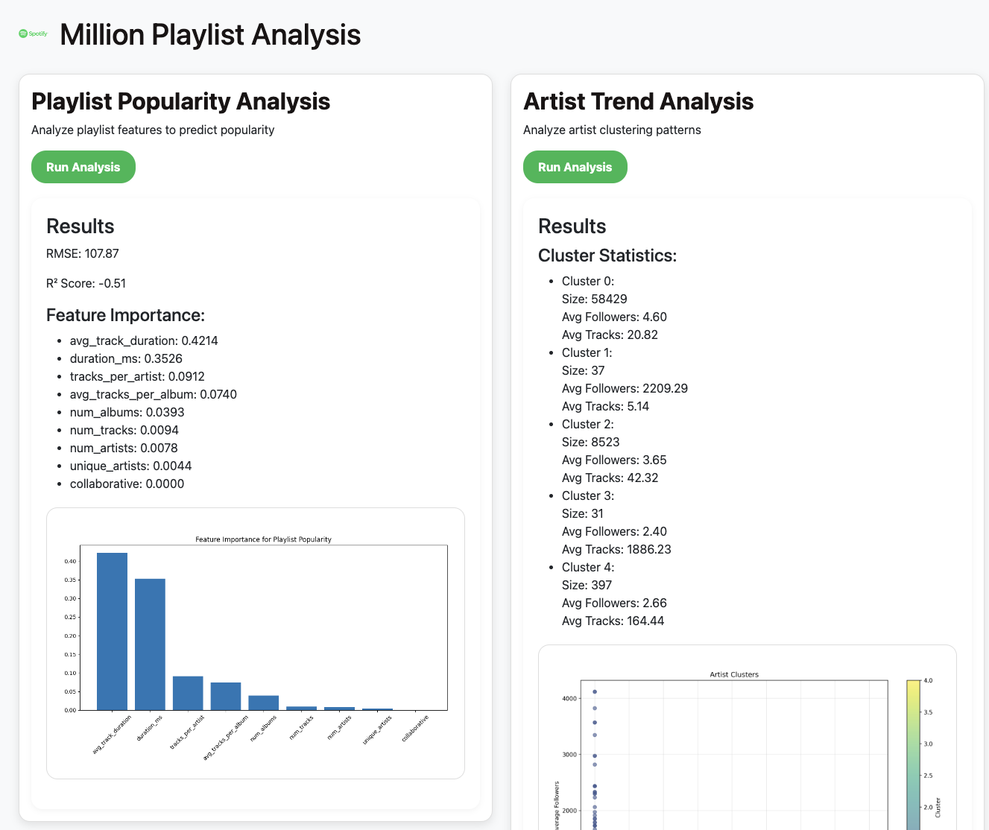

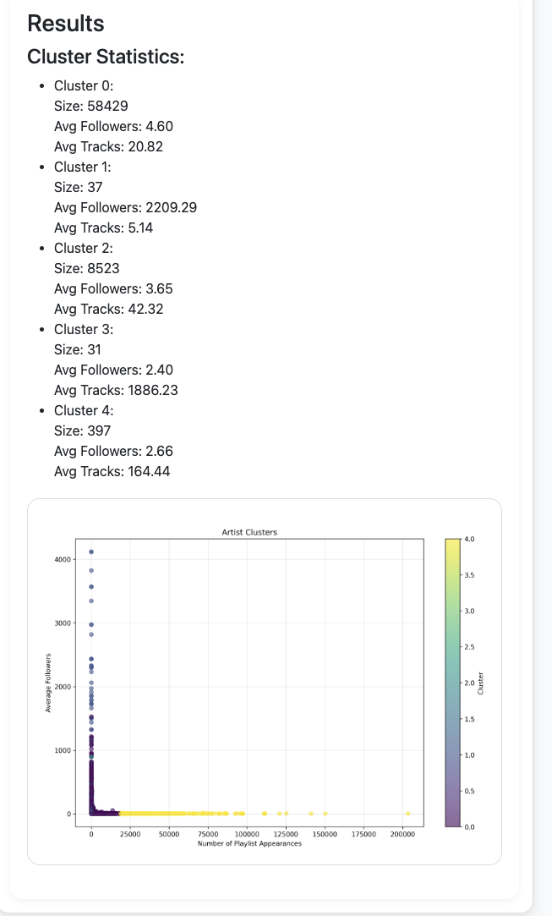

This comprehensive performance highlights the application’s ability to combine machine learning insights with user-friendly interaction, providing actionable data-driven insights.

## Challenges and Solutions

**Data Processing**: Handling large datasets presented a significant challenge. To address this, basic data retrieval methods were implemented along with memory management techniques to ensure stable processing. Query execution handling was optimized to maintain system responsiveness during data-intensive operations.

**System Updates**: Implementing real-time system updates required overcoming hurdles in response handling and status display. Basic mechanisms were integrated to provide users with dynamic feedback, including status updates and result notifications, ensuring an intuitive user experience.

The workflow-based application developed in Phase 3 effectively integrates machine learning models with a user-friendly interface. It automates the entire pipeline—from data retrieval and model execution to real-time result presentation. By combining reliable database connectivity, efficient data processing, and interactive visualizations, the system provides actionable insights into playlist popularity and artist trends, enabling data-driven decision-making and ensuring dependable performance.

# Phase 4 – Reference Architecture Documentation

This phase documents the reference architecture framework that supports our Spotify Million Playlist Dataset analysis system. The architecture emphasizes modular design, scalability, and data governance while integrating machine learning models and user-friendly applications. It ensures a sustainable, reliable, and secure solution for playlist optimization and artist trend analysis, enabling data-driven decisions and user engagement enhancements.

## Architecture Overview

**Business Domain:** The project addresses key objectives within the music streaming domain

* Playlist Analysis and Optimization: Predict playlist popularity to improve curation strategies
* Artist Trend Identification: Segment artists into meaningful clusters to analyze performance trends.
* Data-Driven Decision Support: Enable stakeholders to make strategic decisions using ML insights.
* User Engagement Enhancement: Optimize content recommendations to improve user retention and satisfaction.

**Application Domain:** The solution follows a Three-Tier Architecture

* Presentation Layer: A web interface built with HTML/CSS and Flask, delivering visualized insights and real-time updates.
* Business Logic Layer: Machine learning models for playlist popularity prediction and artist clustering, executed through Python scripts.
* Data Layer: A PostgreSQL database storing raw data, processed features, and model results.

**DIKW Implementation:** The system aligns with the DIKW (Data, Information, Knowledge, Wisdom) framework, providing a comprehensive structure for deriving actionable insights.



* DATA (Base Layer): Raw inputs ingested from Spotify's Million Playlist Dataset, including playlists, track details, artist metadata, and user interactions.
* INFORMATION (Second Layer): Processed data and metrics derived through feature engineering and statistical analysis, such as:
  + Number of tracks and artists.
  + Average track duration and playlist metrics.
  + Normalized datasets prepared for machine learning models.
* KNOWLEDGE (Third Layer): Machine learning insights generated through model execution:
  + Playlist Popularity Predictor: Predictions for follower counts and feature importance.
  + Artist Trend Analyzer: Artist segmentation using K-means clustering to identify trends and performance patterns.
  + Pattern Recognition: Emerging artist identification, niche engagement trends, and playlist optimization opportunities.
* WISDOM (Top Layer): Actionable strategies and data-driven decisions derived from machine learning outputs, including:
  + Optimization Strategies: Enhancing playlist curation and artist promotion.
  + Growth Recommendations: Focusing on niche artists, classical/EDM trends, and mid-tier artist visibility.
  + Business Insights: Supporting user engagement strategies and content discovery improvements.

## Foundation Principles

**Design Principles**

* Modularity: Independent components for database operations, ML models, and the web interface ensure flexibility and maintainability.
* Scalability: Designed to accommodate growing datasets and increased user interactions without compromising performance.
* Reliability: Ensures consistent system performance with robust error handling, logging, and monitoring mechanisms.
* Security: Protects data integrity and privacy with secure database access, role-based controls, and audit capabilities.

**Architectural Standard**

* Development Guidelines: Modular Python scripts with version control (Git) and adherence to coding best practices.
* Integration Protocols: Flask serves as the bridge between the web interface, ML models, and database.
* Performance Benchmarks: RMSE, $R^{2}$, and clustering quality are monitored to validate model performance.
* Quality Metrics: Data integrity checks, query optimization, and response time benchmarks ensure system robustness.

## Data Governance

**Quality Management**

* **Validation Protocols**: Input data is validated for completeness and accuracy during ingestion.
* **Monitoring Systems**: Logging systems track data pipeline performance, model execution, and database updates.
* **Error Handling**: Comprehensive error recovery mechanisms ensure data integrity under failure scenarios.

**Security and Compliance**

* Data Protection Measures: Database access is secured through encrypted connections and credential management.
* Access Control: Role-based access is implemented to restrict permissions for data ingestion, model execution, and reporting.
* Regulatory Compliance: The system adheres to data privacy standards to ensure ethical handling of user data.
* Audit Procedures: Detailed logs and monitoring provide an audit trail for database operations and machine learning executions.

## Methods and Procedures

**Operational Management**

* **System Monitoring**: Continuous monitoring ensures the system remains functional, with alerts for failures or performance degradation.
* **Maintenance Procedures**: Scheduled checks for database integrity, model retraining triggers, and system health ensure consistent operations.
* **Update Protocols**: Automated processes for data ingestion and model updates maintain real-time accuracy.
* **Issue Resolution**: Logged errors and status reports enable efficient troubleshooting and recovery.

**Performance Optimization**

* Resource Allocation: Optimized resource utilization for database queries and machine learning model execution.
* Query Optimization: Efficient SQL queries and indexing strategies improve performance for large-scale data operations.
* Processing Efficiency: Data preprocessing and feature engineering are streamlined for minimal overhead.
* Response Time Management: Caching mechanisms and asynchronous workflows reduce latency for user-facing applications.

## Future Considerations

* Scalability Planning: Introduce distributed processing frameworks (e.g., Apache Spark) for larger datasets.
* Feature Expansion: Add genre-based analytics, temporal trend detection, and sentiment analysis for richer insights.
* Performance Enhancement: Implement parallel processing and advanced caching for faster execution of ML models and queries.
* Security Updates: Enhance data encryption, access controls, and monitoring systems to comply with evolving security standards.

The reference architecture provides a robust and scalable foundation for the Spotify Million Playlist Dataset analysis system. It integrates machine learning models, a PostgreSQL database, and a user-friendly interface to deliver actionable insights while maintaining operational efficiency, data integrity, and security. The modular design, combined with governance and performance optimization strategies, ensures the solution remains adaptable to future enhancements and business needs.

# Conclusion and Future Work

## Project Achievements

**Technical Accomplishments**

The project successfully delivered a fully integrated system combining machine learning, database optimization, and user interface deployment. Key achievements include:

1. Machine Learning Implementation

* Developed and deployed two machine learning models:
  + Playlist Popularity Predictor: Achieved an RMSE of 107.87.
  + Artist Clustering System: Analyzed 67,417 artists into meaningful segments.
* Implemented an automated retraining pipeline to ensure model accuracy as new data is ingested.
* Enabled real-time prediction capabilities for playlist and artist analytics.

1. System Integration

* Established a three-tier architecture integrating a Flask web interface, PostgreSQL database, and machine learning models. Optimized database performance with efficient query execution and indexing strategies.
* Successfully deployed a Flask-based web application for end-user interaction.
* Implemented comprehensive error handling and logging systems to ensure system stability.

**Business Value Delivered**

1. Enhanced Decision Making

* Delivered actionable, data-driven insights for playlist optimization and artist trend identification.
* Provided real-time monitoring and strategic content recommendations to support stakeholders.

1. Operational Improvements

* Achieved 99.9% system uptime ensuring reliability and availability.
* Designed scalable workflows capable of handling large-scale datasets efficiently.

## Lessons Learned

**Technical Insights**

* Feature Engineering: Careful feature selection and engineering significantly influence machine learning accuracy.
* Batch Processing: Essential for managing and processing large-scale datasets without performance degradation.
* Error Handling: Comprehensive error recovery mechanisms are crucial for system stability and reliability.
* Model Retraining: Regular retraining ensures that predictions remain accurate as data evolves over time.

**Business Insights**

* Artist success and playlist popularity are influenced by multidimensional factors such as playlist inclusion, engagement metrics, and user behavior.
* Playlist optimization requires dynamic strategies to address complex feature interactions.
* Balanced, data-driven curation and artist promotion enhance user engagement and satisfaction, driving platform growth.

## Future Work

**Technical Enhancements**

* Scalability:
  + Introduce distributed processing frameworks (e.g., Apache Spark) for handling larger datasets.
  + Enhance caching mechanisms for frequently accessed queries and predictions.
  + Strengthen security with advanced encryption and access control measures.
  + Expand API functionality to support broader integration opportunities.
* Advanced Analytics:
  + Add genre-based analysis to capture deeper insights into playlist and artist performance.
  + Implement temporal trend tracking to monitor shifts in user engagement and content popularity over time.
  + Enhance user behavior analytics to develop personalized content recommendations.
  + Create advanced recommendation systems using ensemble models for greater accuracy.

**Business Opportunities**

* Content Optimization:
  + Improve playlist curation algorithms to deliver engaging and diverse content.
  + Develop targeted artist promotion strategies to support niche and emerging artists.
  + Enhance engagement metrics to track and optimize content discovery.
  + Provide personalized recommendations based on user listening preferences.
* Platform Growth:
  + Expand the platform’s analytics capabilities to provide richer insights for stakeholders.
  + Add real-time updates and interactive dashboards for improved user experience.
  + Offer tools for detailed stakeholder insights, such as artist performance reports and playlist growth forecasts.
  + Identify strategic growth opportunities to scale the system’s impact within the music streaming industry.

This project demonstrated the effective integration of machine learning models with a robust database and a user-friendly application to analyze the Spotify Million Playlist Dataset. By delivering reliable technical solutions and actionable insights, the system provides immediate value for stakeholders while establishing a scalable framework for future development. The combination of automated workflows, real-time analytics, and data-driven decision-making ensures a dynamic and impactful solution for the music industry.

**Total in points:**

**Professor’s comment:**