**SDS 313: Homework 1**

*By: Anh Doan (atd2354)*

1. Question 1:

* **Bond Approval Overview**:

Out of a total of 8,848 bonds, 7,210 have been approved, while 1,638 have been defeated

* **Approval by Government types:**

1. Independent School District (ISD) – Leadedwith 3,482 approved bonds, the highest among the four types
2. Water District (WD) – Followed with 2,174 approved bonds
3. Cities – a moderate number with 1,547 approved bonds
4. Counties – Fell behind with 207 approved bonds

* **Approval rates by Government types:**

1. Water District (WD) – Achieved the highest rate at 94.5%
2. Cities – Ranked second with an approval rate of 87,5%
3. Counties – Slightly lower at 82.8%
4. ISD - Had the lowest approval rate at 72.4%
5. Question 2:

* The bond with the most voter turnout was Harris County
* Bond analysis:
  + Name: Harris County
  + Type: County
  + Election Date: November 8, 2022
  + Amount: $900,000,000
  + Purpose: Other (Road facilities)
  + Votes For: 711,352
  + Votes Against: 319,062
  + Voter Turnout: 1,030,414
  + Result: Carried

1. Question 3:

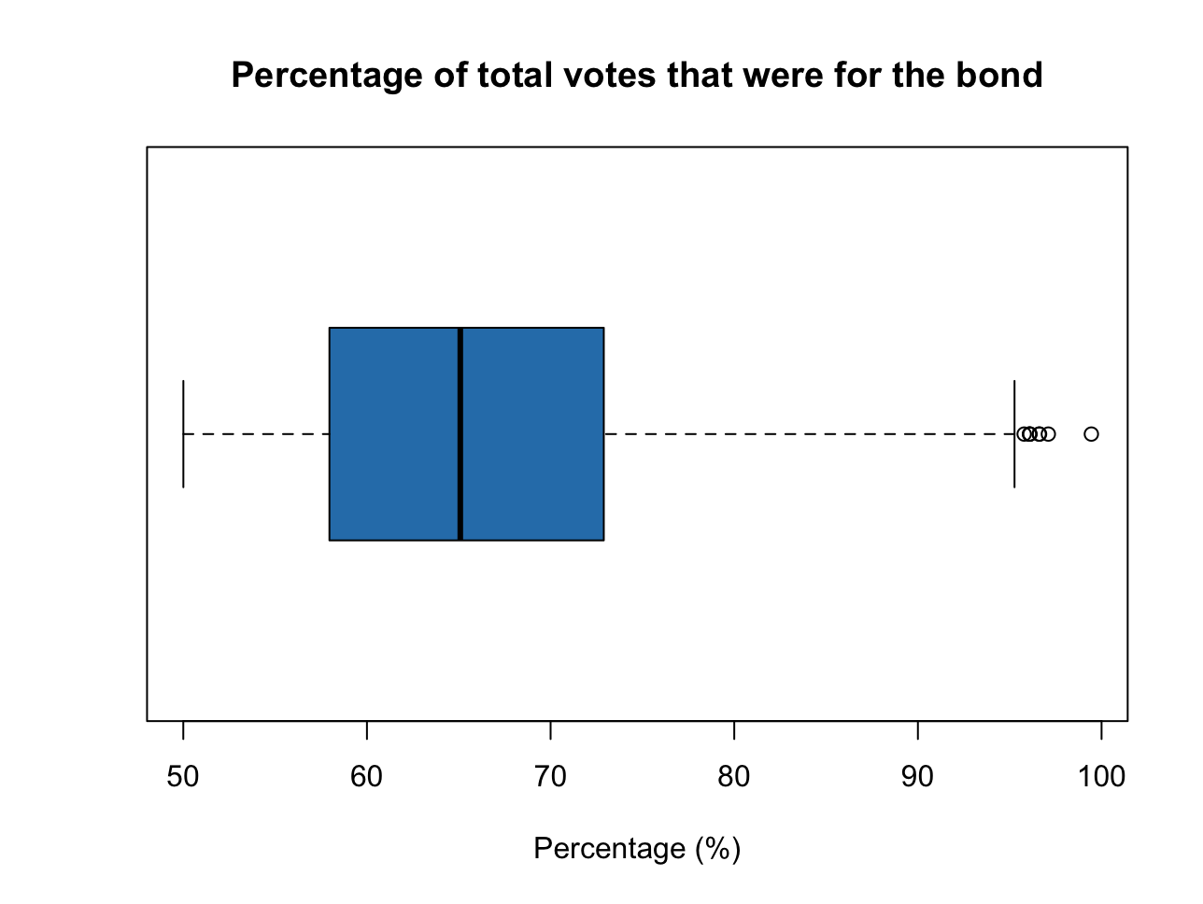

* Min: 50.04% (Granbury ISD)
* Max: 99.44% (Clyde CISD)
* Median: 65.08%
* Inner-quartile range (Q1-Q3): 14.94%

1. Question 4:

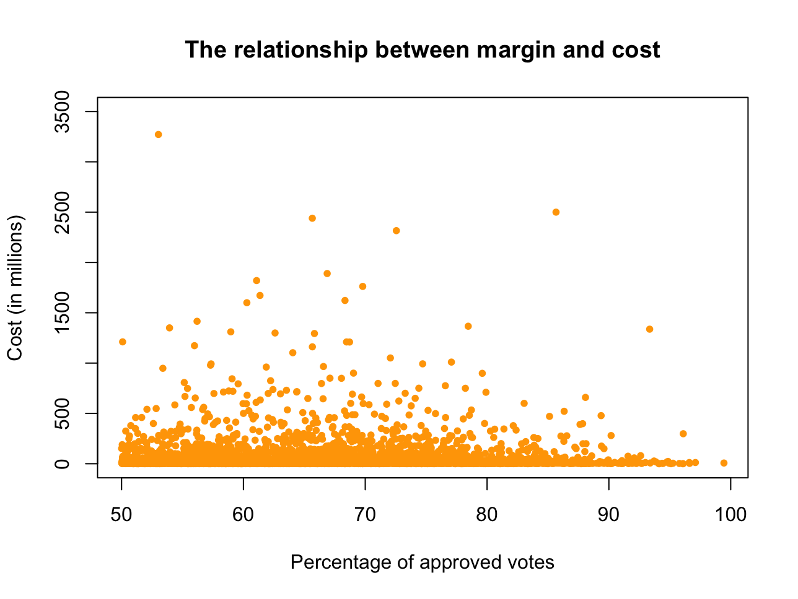

* The correlation between margin a bond was approved and cost: 0.000559 => cost does not play an important role in improving the margin a bond was approved