OOP Capstone Project - Tetris Game
Group 4

- Member assignment
Group members | Student ID | Work assigned | Source cited
Đoàn Đức Anh | 202417091 | - Classes:  - Cell  - Board  - Tetromino  - StraightShape  - SquareShape  - IShape  - SShape  - ZShape  - TShape  - JShape  - Main
Bùi Đức Sơn | 202417193 | - Classes:  - MenuPanel  - HelpPanel  - SoundController  - GamePanel (modify)  - bgmToggleButton  - DifficultyPanel (modify)  - difficultyComboBox  - paintComponent  - Design:  - GeneralClassDiagram  - UseCaseDiagram  - ModelClassDiagram  - ViewClassDiagram  - ControllerClassDiagram | - Java sound
Phạm Lê Công | 202417102 | - Classes:  - MainFrame  - GamePanel (modify)  - drawNextPieces  - drawScore  - GameEngine (modify)  - spawnNewPiece  - createNextPiece  - addPiecetoQueue  - getNewPiece  - getUpcomingPieces
Phạm Đức Gia Bảo | 202417101 | - Classes:  - GamePanel  - DifficultyPanel  - Constants  - GameEngine (modify)  - scoreMultiplier  - calculateScore  - setDifficultyDelay  - MainFrame (modify)  - MainFrame (constructor)  - HelpPanel (modify)  - HelpPanel (constructor) | - Swing official documentation
Nguyễn Văn Tùng Cương | 202417103 | - Classes:  - GameEngine  - GamePanel (modify)  - setEngineAndRouting  - setupKeyBindings  - paintComponent  - drawSingleBlock  - drawNextPieces  - drawGrid  - drawLockedBlocks  - drawActivePiece  - drawShadowPiece  - drawScore  - setActivePiece  - refreshBoard

- Project description
  - Detailed description
This capstone project involved the design and development of a custom, simplified Tetris game. The primary objective was to apply Object-Oriented Programming principles to create a maintainable and structured game system from scratch, explicitly avoiding the use of pre-built game libraries. To achieve this, the software architecture followed the Model-View-Controller (MVC) pattern to effectively separate the core data, graphical interfaces, and logic handlers. The model includes the game board, grid cells, and various Tetromino shapes, while the controller manages the core game engine and audio, and the view handles graphical panels and main application frame.
The core gameplay mechanics focus on manipulating falling blocks (Tetrominoes) to form complete horizontal lines that are subsequently cleared from the board. While the original specification only required 3 most basic shapes (straight, square, and L-shape), in the final implementation, there are several other tetromino types as well, such as the T-shape, Z-shape, and the S-shape. The game engine can successfully handle row clearing, score calculation, and triggers game-over state when the board is filled and no new Tetromino can enter.
The graphical user interface (GUI) was developed to feature a functional main menu and an active game screen. The main menu allows users to start a new game, access a help panel detailing the project’s purposes as well as game rules and controls, and safely quit the application via a confirmation prompt. During active gameplay, there are event handlers that capture keyboard inputs in real time to control falling blocks. Specifically, hitting the left and right arrow can adjust a block’s horizontal movement, the up arrow changes the block’s rotation, the down arrow for a soft drop, and the spacebar for an immediate hard drop. The active game screen continuously updates the block’s display accordingly and includes a dedicated back button that allows the player to return to the main menu any time.
To ensure smooth gameplay without graphical freezing, the project utilized a multi-threaded system approach. The architecture effectively separated the background game logic, which manages the falling Tetrominoes at a fixed time interval, from the continuous loop responsible for updating and repainting the GUI. Furthermore, the system successfully integrates additional extension features to enhance the user experience. For example, an additional difficulty panel that allows the user to change the game difficulty (selecting different modes will change how the game engine works too), a sound controller that manages background music and clear-line sound effect, and the upcoming pieces being displayed on the side of the main gameplay.

  - Use case diagram and explanation
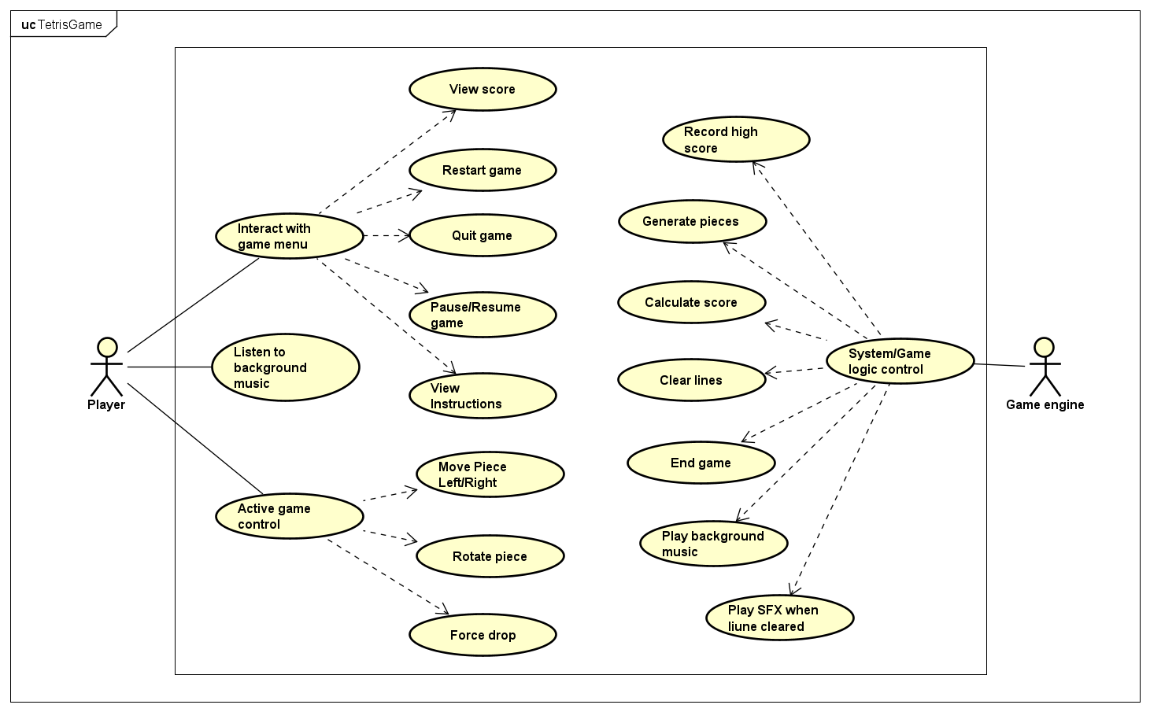
Figure 1: The use case diagram

The Use case diagram for the Tetris game illustrates the interactions between two primary actors: the Player and the Game Engine.
The Player serves as the primary actor who directly engages with the game's interface and mechanics. From the main interface, the player can interact with the game menu to view their score, restart a session, pause or resume active gameplay, read the instructions, or quit the application entirely. During an active session, the player assumes direct control over the falling pieces, utilizing input commands to move the pieces left or right, rotate them to fit the board, or force them to drop instantly to the bottom. Additionally, the player passively interacts with the application by listening to the continuous background music provided by the system.
The Game Engine operates as the secondary actor, representing the backend system responsible for autonomous operations, game physics, and state management. Its primary role involves executing system and game logic controls, which include generating new falling pieces, clearing completed lines from the board, and dynamically calculating the player's score based on their performance. The engine also handles data management by recording high scores and oversees the overall game state, determining exactly when to trigger the end-game sequence. Furthermore, the engine is responsible for audio management, independently streaming the background music and executing a specific sound effect whenever a line is successfully cleared.

- Design
  - General class diagram
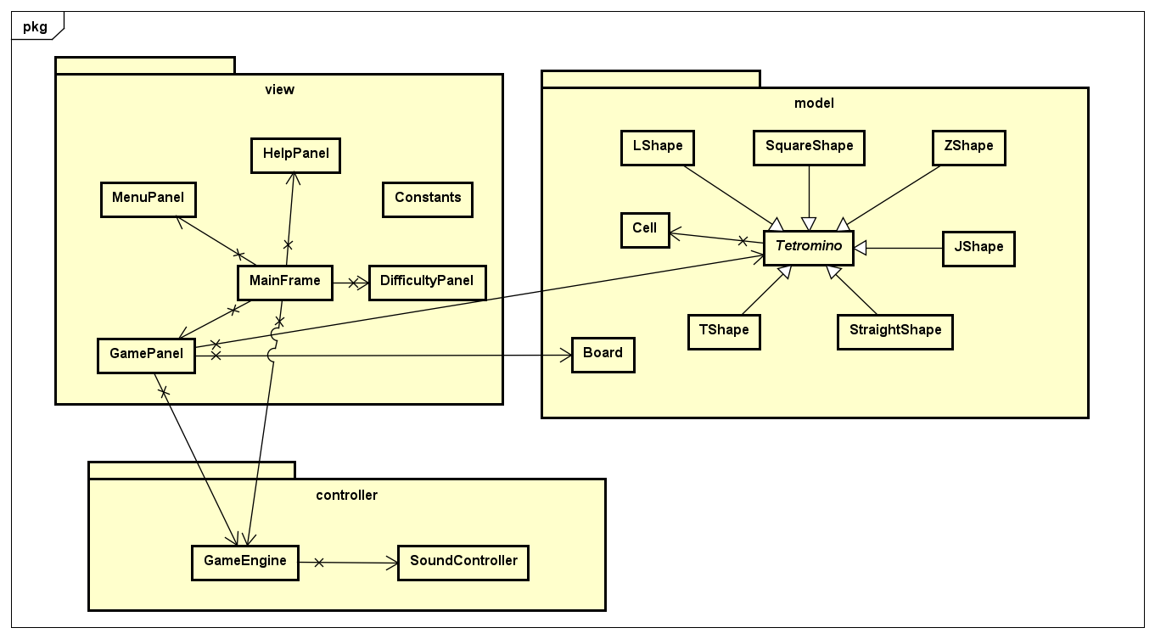
Figure 2: The general class diagram
The system is divided into 3 main packages: model, view, and controller. Within this architecture, MainFrame acts as the primary structural container, maintaining a composition relationship over its structural view panels, which include MenuPanel, GamePanel, HelpPanel, and DifficultyPanel. While bidirectional relationships exist between specific sub-panels and the container, explicit X markings on association paths dictate strict unidirectional navigation limits to prevent structural coupling. Finally, polymorphic inheritance links specialized components to JFrame and JPanel base classes, while binding structural shape blocks directly to the base Tetromino abstract type.
  - View package class diagram
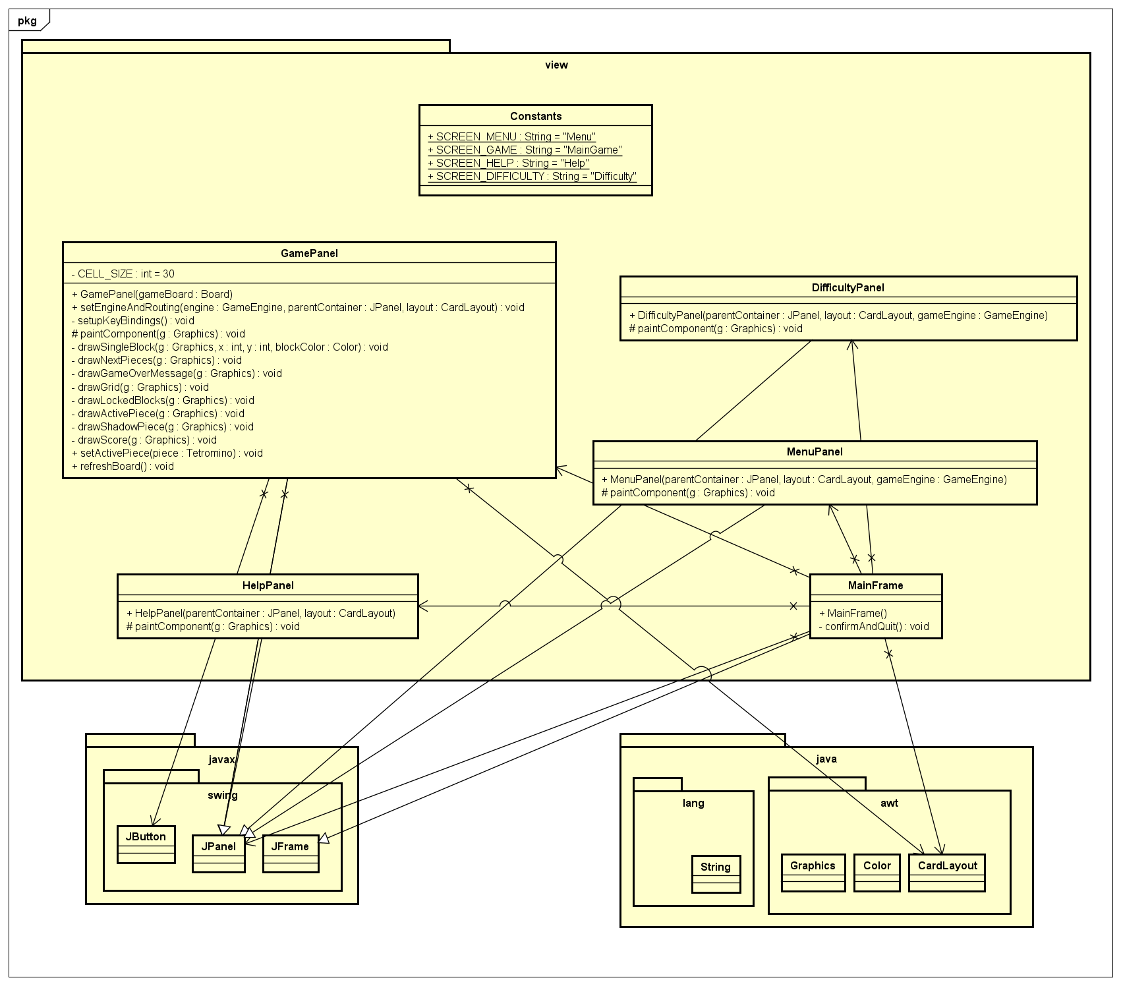
Figure 3: The view package class diagram

The class diagram within the view package defines the user interface structure of the game application, which is built on the Java Swing and Java AWT libraries. The primary class responsible is MainFrame, which extends JFrame and acts as the main window controlling the entire display flow. MainFrame utilizes Java AWT's CardLayout mechanism to manage and dynamically switch between different interface screens, including MenuPanel, GamePanel, DifficultyPanel, and HelpPanel. These component screens all extend the JPanel class and depend on the Constants class to identify the interface transition flow using string constants such as SCREEN_MENU or SCREEN_GAME. In terms of method execution, the GamePanel class plays the most critical role in handling the game's graphics. This class overrides the paintComponent method to execute the entire screen rendering process through a sequence of specialized internal methods, including drawGrid(), drawActivePiece(), drawLockedBlocks(), and drawGameOverMessage(). These methods interact directly with the Graphics object and data from the Board or Tetromino to display the game state in real time. Additionally, the confirmAndQuit() method in MainFrame is designed to handle application closure events safely, ensuring synchronicity and a consistent user experience across all component screens.

  - Controller package class diagram
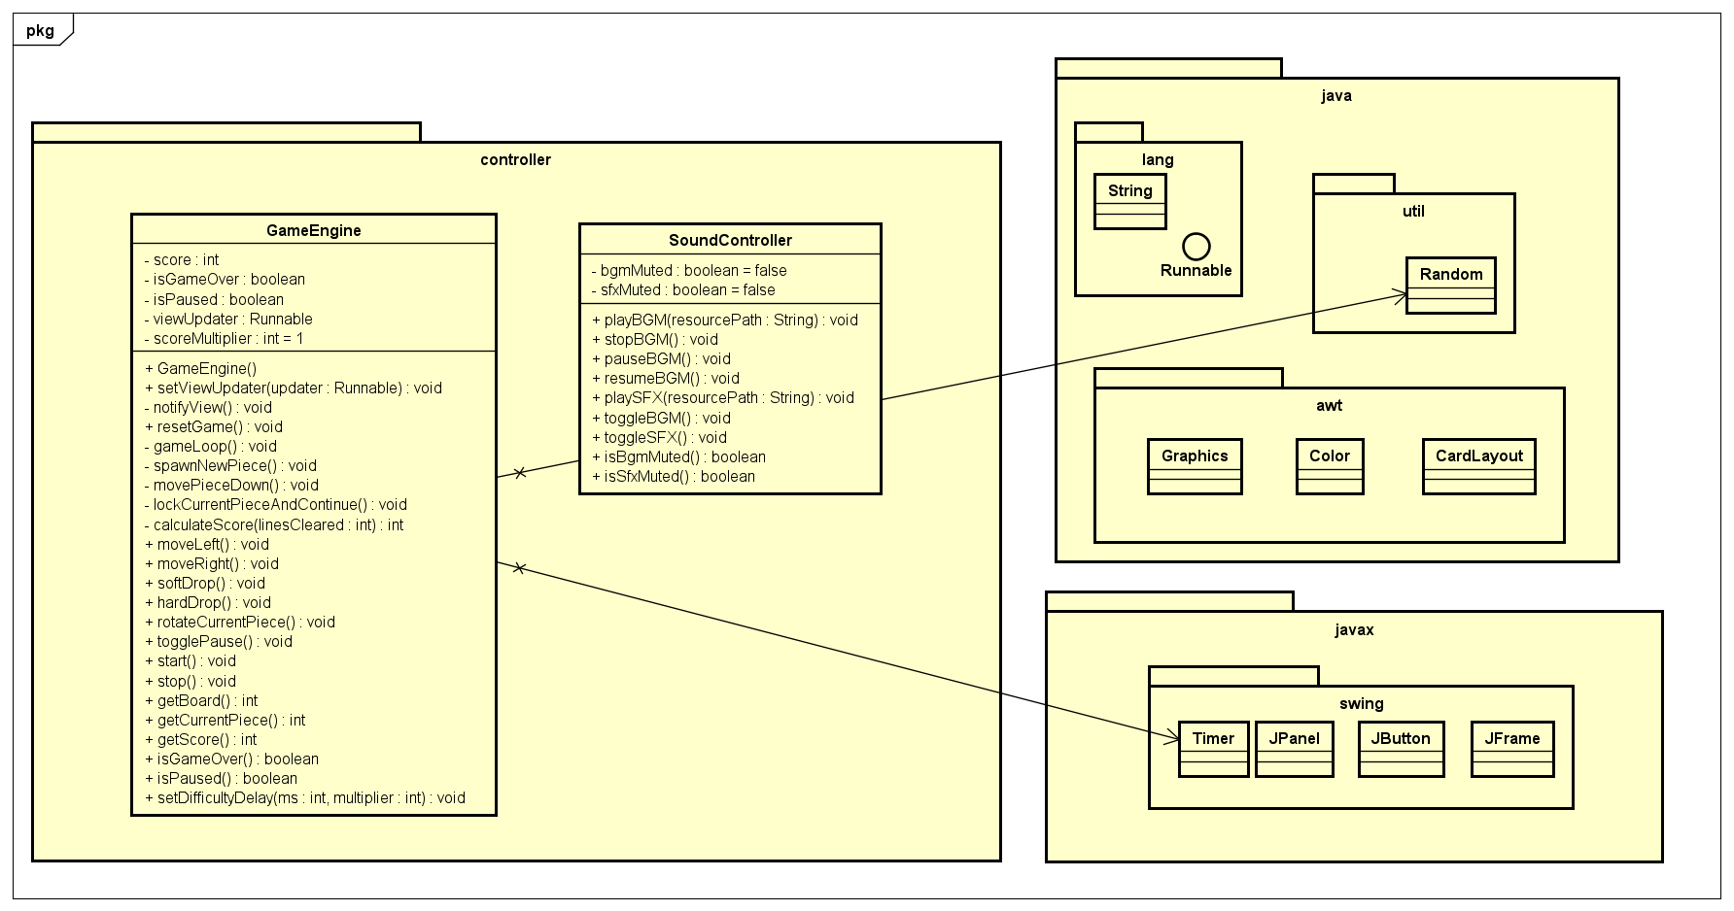
Figure 4: The controller package class diagram

The class diagram for the controller package defines the core game logic and audio management of the system, primarily driven by the GameEngine and SoundController classes. GameEngine acts as the central controller of the gameplay loop, managing essential state attributes such as score, isGameOver, and isPaused. It relies on external Java components, utilizing java.util.Random for generating randomized game pieces, javax.swing.Timer for driving game ticks, and a java.lang.Runnable object named viewUpdater to invoke notifyView() and refresh the User Interface. Furthermore, GameEngine maintains a direct association with SoundController, allowing it to trigger contextual audio events during gameplay. The SoundController class encapsulates the audio subsystem, managing toggle states for background music (bgmMuted) and sound effects (sfxMuted) while providing public methods like playBGM() and playSFX() to play audio files from specified resource paths. Regarding method implementations, the GameEngine encapsulates complex state transitions through several critical routines. The gameLoop() method serves as the center of the game, continuously updating the state. Movement and positioning are handled by methods such as movePieceDown(), moveLeft(), moveRight(), softDrop(), and rotateCurrentPiece(), which validate and update coordinates. When a piece can no longer move, lockCurrentPieceAndContinue() is invoked to secure its position on the board, followed by calculateScore(linesCleared: int) to compute and update the player's current score based on the scoreMultiplier. Additionally, methods like togglePause(), start(), and stop() provide robust control over the execution state of the game loop, ensuring smooth and predictable application control.

  - Model package class diagram
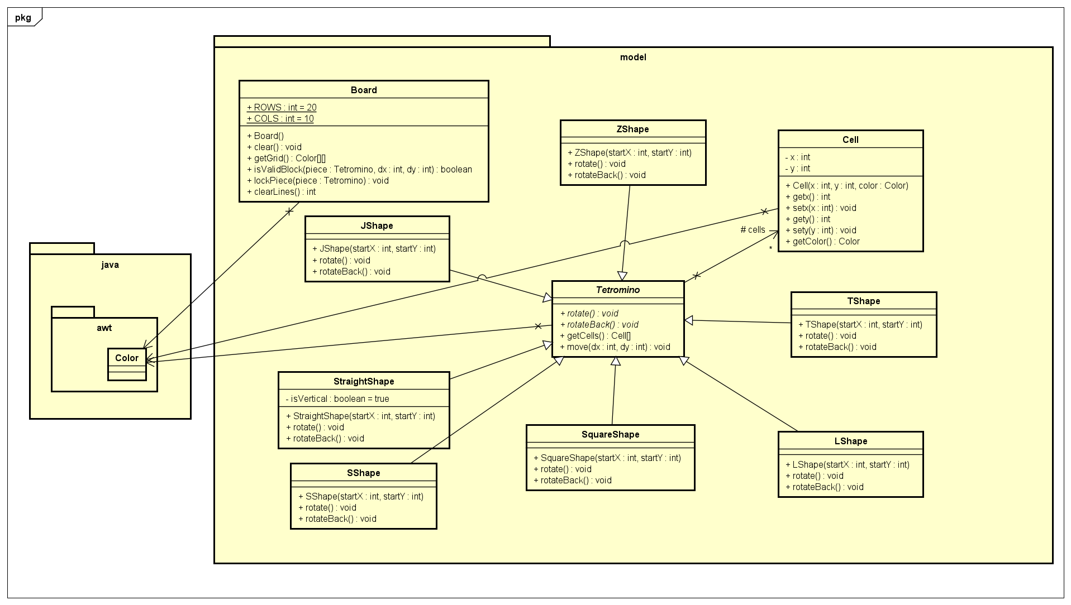
Figure 5: The model package class diagram

The class diagram for the model package encapsulates the core data structures and state representation of the Tetris game, structured around a grid-based board and piece management. The Board class defines the playing field with fixed dimensions of 20 rows (ROWS) and 10 columns (COLS), maintaining a 2D grid matrix representation via the java.awt.Color package. The game pieces are managed through an object-oriented hierarchy centered on the Tetromino class, which holds a composite relationship with the Cell class, which serves as the atomic primitive, tracking individual grid positions using x and y coordinate attributes along with their specific Color. To implement the diverse set of Tetris blocks, seven distinct subclasses—ZShape, JShape, TShape, LShape, SquareShape, SShape, and StraightShape—inherit directly from the base Tetromino class. In terms of method implementations, the Board class manages spatial validation and grid modification. It exposes isValidBlock(piece: Tetromino, dx: int, dy: int) to perform collision detection, lockPiece(piece: Tetromino) to permanently bind a fallen piece to the grid, and clearLines() to scan, clear completed rows, and collapse the grid down. Movement mechanics are delegated to the Tetromino class, which offers the move(dx: int, dy: int) method to alter position coordinates uniformly. To handle spatial orientation, the abstract or base Tetromino defines rotate() and rotateBack() routines. Each specialized shape subclass overrides these two rotation methods to execute shape-specific coordinate transformations, ensuring proper geometric behavior and wall-kick restorations when rotations are cancelled.

