**FPT ACADEMY INTERNATIONAL**



## FPT – APTECH COMPUTER EDUCATION

SMARTSTORE

|  |  |  |  |
| --- | --- | --- | --- |
| **Center Name** | | FPT – Aptech – HCM2  Address: 590 Cach Mang Thang Tam, District 3, Ho Chi Minh City | |
| **Instructor** |  | Ms. Le Mong Thuy |  |
| **Class** |  | T1.2010.E0 |  |
| **Group** |  | 2 |  |
| **Group members** | | **Name** | **Student ID** |
|  |  | Hoàng Anh Đức | Student1283038 |
|  |  | Nguyễn Đình Gia Bình | Student1283037 |
|  |  | Nguyễn Trực Nhân | Student1283035 |
| **Duration** | Start date | 25th December 2020 |  |
| End date | 25th January 2021 |  |

**This is to certify that**

**Mr.:**

Hoàng Anh Đức

Nguyễn Đình Gia Bình

Nguyễn Trực Nhân

**has successfully designed & developed**

eProject: SmartStore website

**Submitted by:**

Hoang Anh Duc

**Date of issue:**

**Authorized Signature:**



**TABLE OF CONTENTS**

FPT – APTECH COMPUTER EDUCATION 1

ACKNOWLEGMENT 4

SYNOSIS 4

PROBLEM DEFINITION 4

CUSTOMER'S REQUIREMENTS SPECIFICATIONS (CRS) 5

Business/Project Objective: 5

Hardware/ Software Requirements: 6

SCOPE OF THE WORK (IN BRIEF) 7

Architecture and design of the system 8

Diagram of the website 9

TASK SHEET REVIEW 1 10

SITE MAP 11

MOCK OF THE WEBSITE 12

**1.** **Homepage** 12

**2.** **Shop** 13

**3.** **About us** 16

**4.** **Contact us** 17

**5.** **Search** 18

**6.** **Compare** 19

TASK SHEET REVIEW 2 22

WEBSITE DESCRIPTION 19

**1.** **Homepage** 19

**2.** **Shop** 20

**3.** **About us** 21

**4.** **Contact us** 22

**5.** **Comparison** 23

**6.** **Search** 23

TASK SHEET REVIEW 3 28

**Acknowledgement**

On behalf of all the members of group 2, I would like to thank you all for the hard works, supports to make this eProject complete successfully. Especially, Ms. Le Mong Thuy, our teacher, she helped us a lot from the day that we started to study at FPT Aptech. With this eProject, she had guided us with her enthusiasm and rigorous, because of her guiding, we would be able to finish this project. Besides, I want to thank all the team member of group 2, each of the team member had been working continuously in 1 month in order to complete this project. All in all, we would like to say thank you to our family for always supporting us, creating the best conditions for us to focus on the project, and putting faith in the dreams we pursue.

**Synosis**

We need to create a website that meets all the requirement of our customer, Smartstore. Smartstore is an interior store that provides wardrobe and space saver products. They have a big collection about closets and categories as well. The main purpose of this website is to reach to the customers, who have interest in tidy habits that they can live with their wanted. Come to Smartstore, customer can also be a member that has a lot of discount and special offer

# PROBLEM DEFINITION

“Smartstore” is an interior company that sells wardrobe and other home storage products specially space savers. They supply variety of products suiting every requirement and various sizes and qualities for homes and even companies.

They have large wardrobe collection from a lot producer from over the world. Beside the wardrobe, Smartstore also sells small boxes to able to contain items to save space and categories to fit with costumers.

They also have a membership facility where in you can enroll yourself against any purchase of Rs. 200 and for subsequent purchases you can avail of points and other offers.

Looking at the growing competition, they have decided to find an easy source to reach to the customer and the solution they thought of is of building a web site which will host all the information about their shop.

# CUSTOMER'S REQUIREMENTS SPECIFICATIONS (CRS)

**Client: Smartstore**

### Business/Project Objective:

Smart store is an interior company in the city. They are not only supplying different kind of wardrobe, but also space savers products. They want to build a website to easy reach and support their customers.

We are supposed to create a website for them with the below mentioned requirement specifications.

The website is to be developed for the Windows Platform using HTML5, JavaScript, Bootstrap, jQuery and Geolocation. The site should work well in all leading browsers including Chrome, IE, Firefox etc.

**Input to the system:**

* + - * Searching products based on price-range, quality, color, size, rating….
      * Register members on website.

**Output from the system:**

* A menu that will categorize all the functions of the site.
* Display the list of available products wise.
* Various types of wardrobe can be hinged door, free-standing, sliding door, walk-in or customized
* Perform the search based on a particular name, brand..
* Display the various offers by the shop.
* Display the details (price, like, style, brand, etc.) of product .
* Display the available promotion and upcoming sales.
* Display the price list of the various items available in the shop i.e.
* Site should be able to provide brief introduction/history about the shop under About Us page.
* The location of the shop under Contact-Us page.
* Besides the above requirements, the site should have look and feel as per the industry standards.

### Hardware/ Software Requirements:

* **For developer**

**Hardware**

* + Intel Pentium 4 processor or higher
  + 1 Gigabytes of RAM or higher

**Software**

* + Windows 7 OS or higher
  + Adobe Dreamweaver
  + Web browsers such as IE, Chrome or Firefox are supporting HTML5, CSS3 and Javascript.
* **For web users**

**Hardware**

* + Intel Pentium 4 processor or higher
  + 512 Megabytes of RAM or higher

**Software**

* + Windows XP OS or higher
  + Web browsers such as IE, Chrome or Firefox are supporting HTML5, CSS3 and Javascript.

# SCOPE OF THE WORK (IN BRIEF)

After a long and detailed discussion, our group has decided to create a website contain the following webpages:

1. ***Homepage***: Display information about best-selling products, an introduction about Smartstore.
2. ***Shop***: Display all available wardrobe and other home storage products based on brands.
3. ***About Us***: Display the information of the company, clients’ review and about us.
4. ***Contact***: Display the address of the company, allow customers to request any information they want to Smartstore.
5. ***Comparison***: compare the different between Items
6. ***Search***: search for product through keyword, name,…

# Architecture and design of the system

Webpage request



Requested Page

**RENDERING**

**ENGINE**

**CSS CODE**

**HTML CODE**

**WEB SERVER**

**WEB BROWSER**

**CLIENT**

**SERVER**

# Diagram of the website

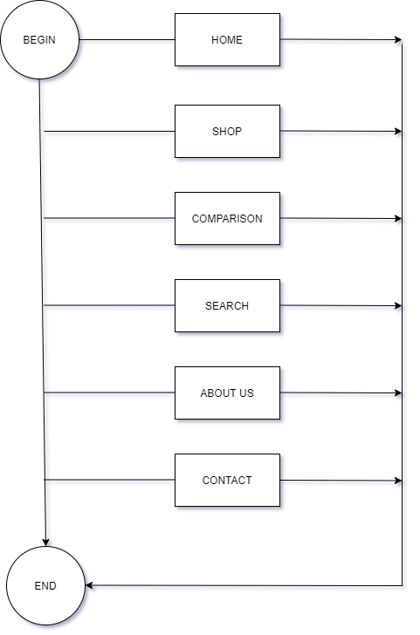



# TASK SHEET REVIEW 1

|  |  |  |  |  |  |  |  |
| --- | --- | --- | --- | --- | --- | --- | --- |
| **Project Ref. No.:**  **eP/Advertisement Portal Management**  **System/01** | | **Project Title:** | **Activity Plan Prepared By:** | **Date of Preparation of Activity Plan:** | | | |
| **Sr.**  **No.** | **Task** | **Actual**  **Start Date** | **Actual Days** | **Team**  **Mate Names** | **Status** |
| 1 | Problem Statement | SMART STORE | Duc | 25-Dec-20 | 1 | Nhan | Completed |
| 2 | Analysis of Rhythm House requirements about the website | 25-Dec-20 | 1 | Nhan | Completed |
| 3 | The scope of the work (in brief) | 25-Dec-20 | 1 | Duc | Completed |
| 4 | Architecture and design of the system | 25-Dec-20 | 1 | Binh | Completed |
| 5 | Diagram of the website | 25-Dec-20 | 1 | Binh | Completed |
| 6 | Task Sheet | 25-Dec-20 | 1 | Duc | Completed |

|  |  |
| --- | --- |
| **Date:** | |
| Signature of Instructor:  **Ms. Le Mong Thuy** | Signature of Team Leader:    **Hoang Anh Duc** |

# SITE MAP

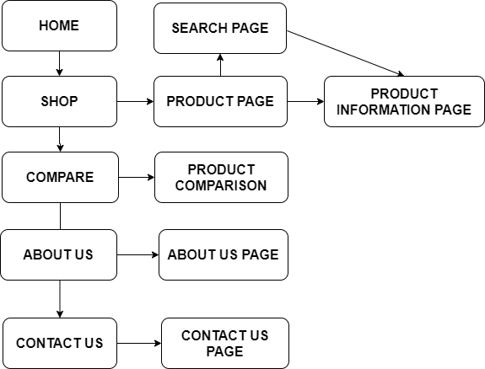

# MOCK OF THE WEBSITE

1. **Homepage**

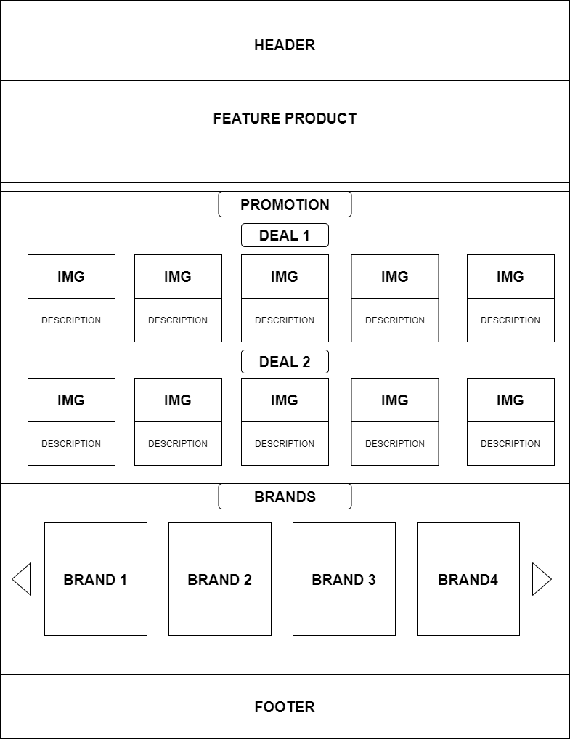

1. **Shop**

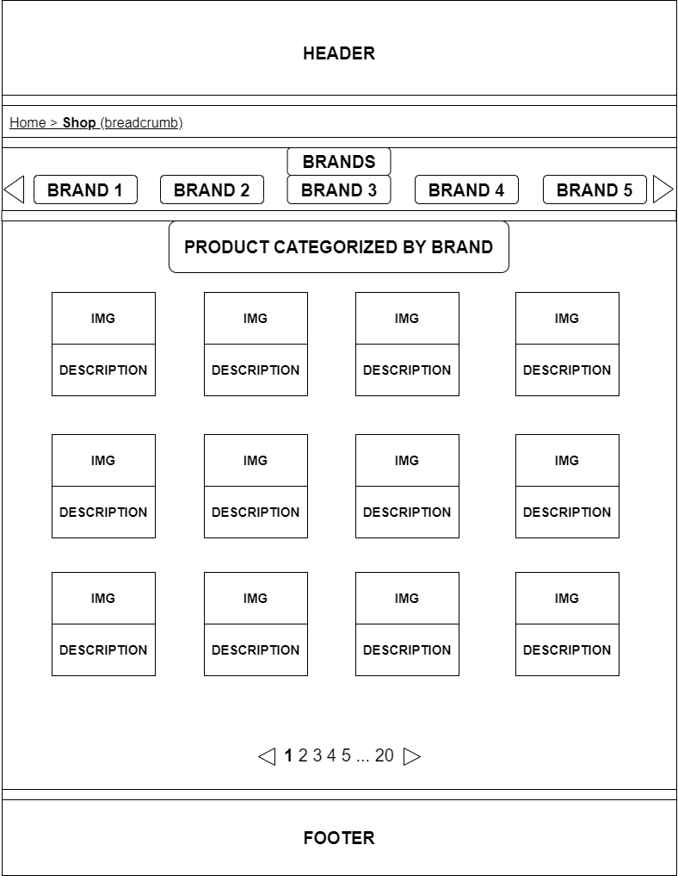

1. 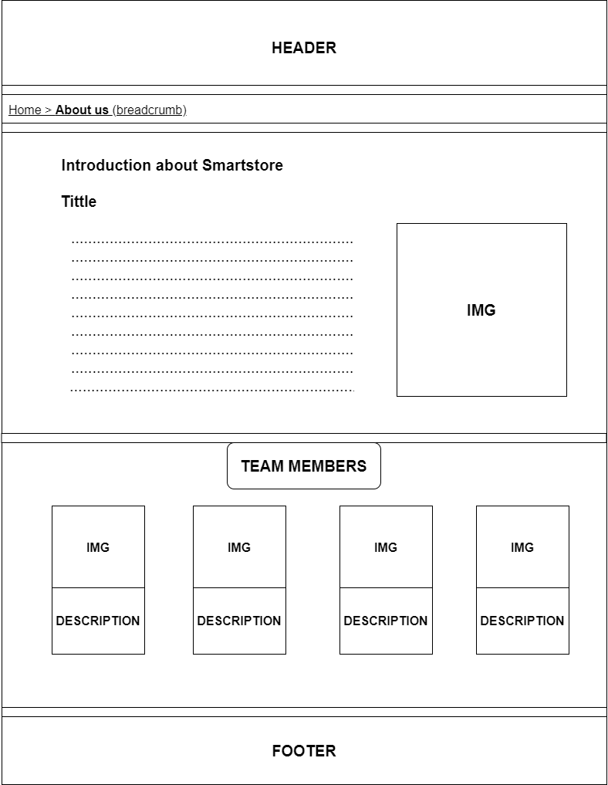**About us**
2. 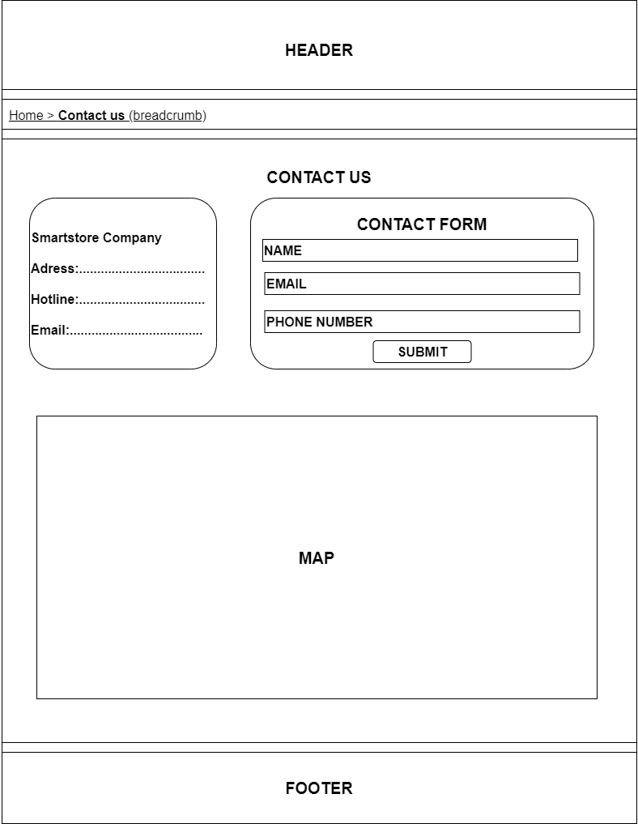**Contact us**
3. 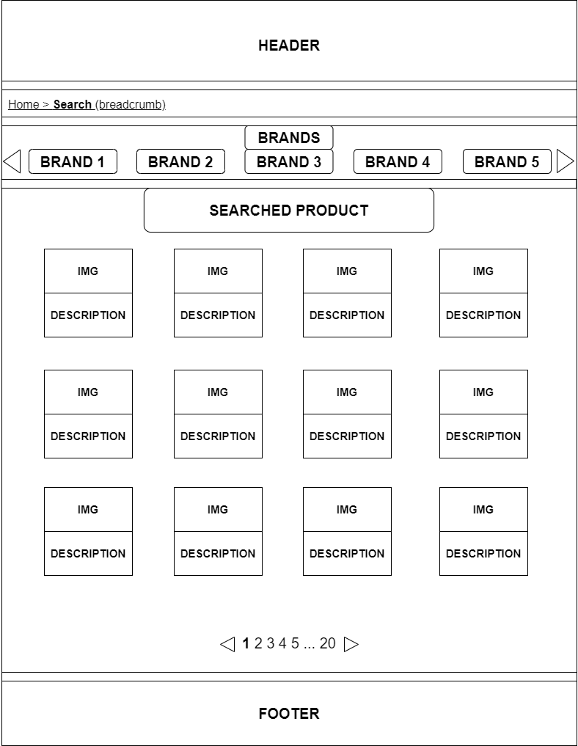**Search**
4. 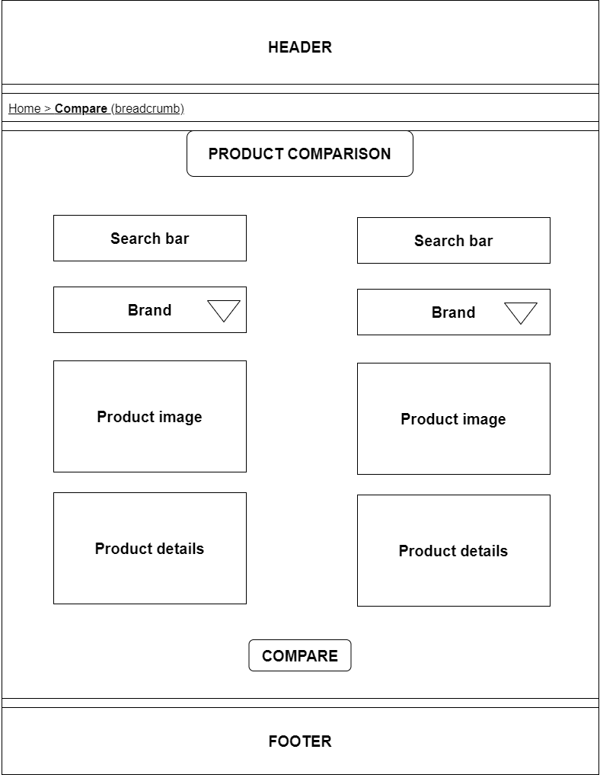**Compare**

# TASK SHEET REVIEW 2

|  |  |  |  |  |  |  |  |
| --- | --- | --- | --- | --- | --- | --- | --- |
| **Project Ref. No.:**  **eP/Advertisement**  **Portal Management System/01** | | **Project Title:** | **Activity Plan Prepared By:** | **Date of Preparation of Activity Plan:** | | | |
| **Sr.**  **No.** | **Task** | **Actual Start Date** | **Actual Days** | **Team Mate Names** | **Status** |
| 1 | Site map | Smart Store | Duc | 25-Dec-20 | 1 | Duc | Completed |
| 2 | Mock of the website | 25-Dec-20 | 2 | Nhan | Completed |
| 3 | Task sheet | 25-Dec-20 | 2 | Binh | Completed |

|  |  |
| --- | --- |
| **Date:** | |
| Signature of Instructor:  **Ms. Le Mong Thuy** | Signature of Team Leader:  **Hoang Anh Duc** |

# WEBSITE DESCRIPTION

1. **Home Page**
2. Description

Home page displays following information:

* Feature product such as different kind of wardrobe.
* Promotions.
* Featuring brands.

1. Screen shot

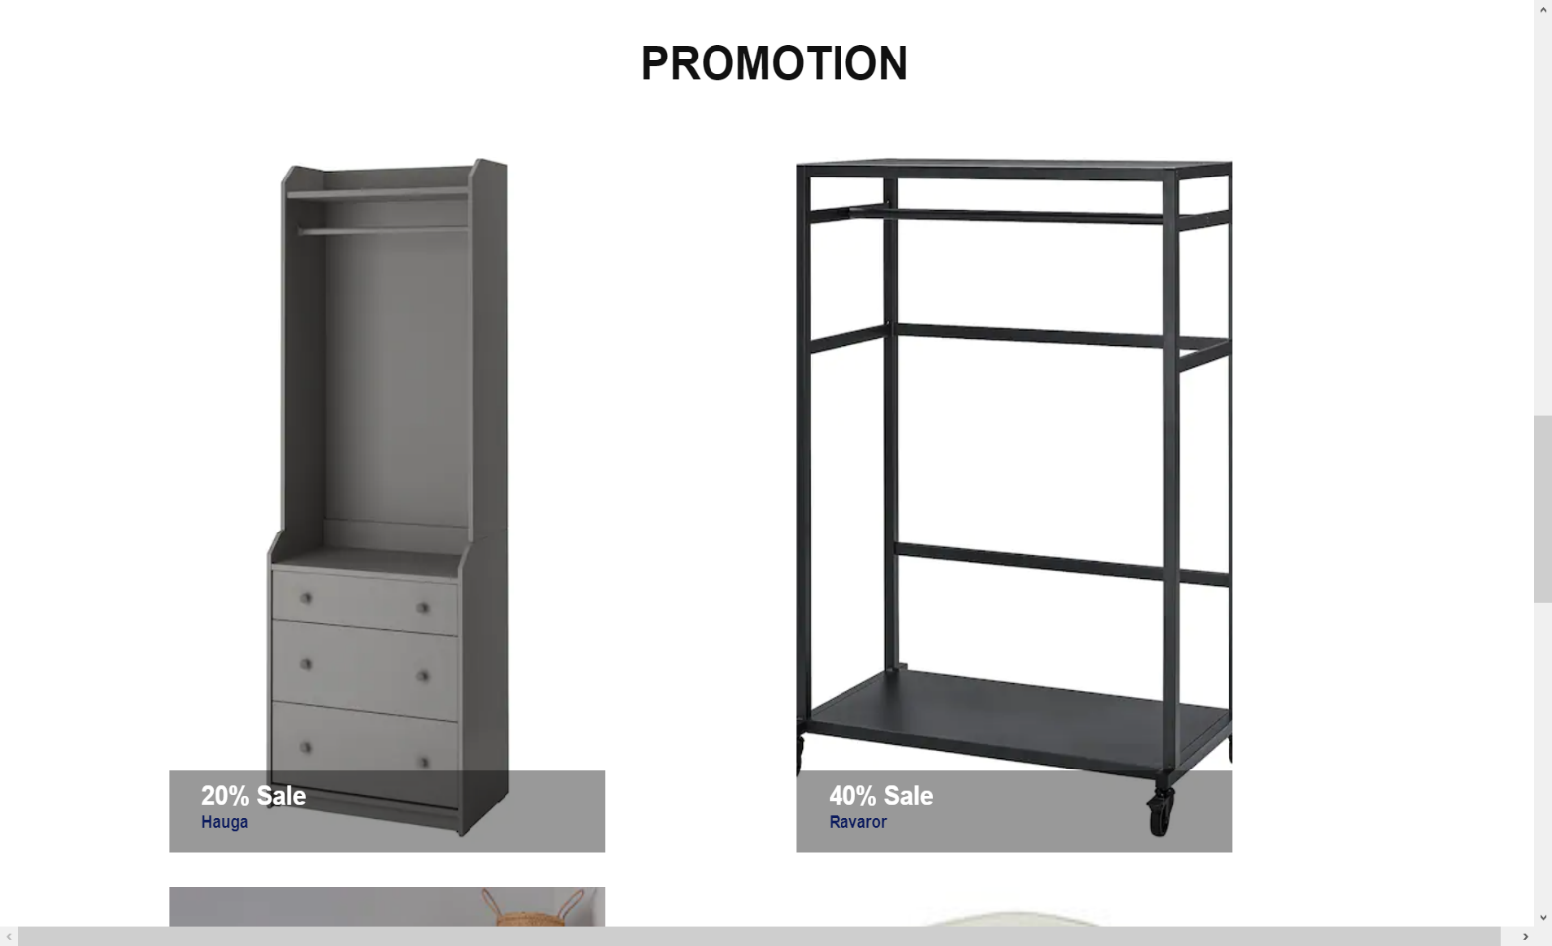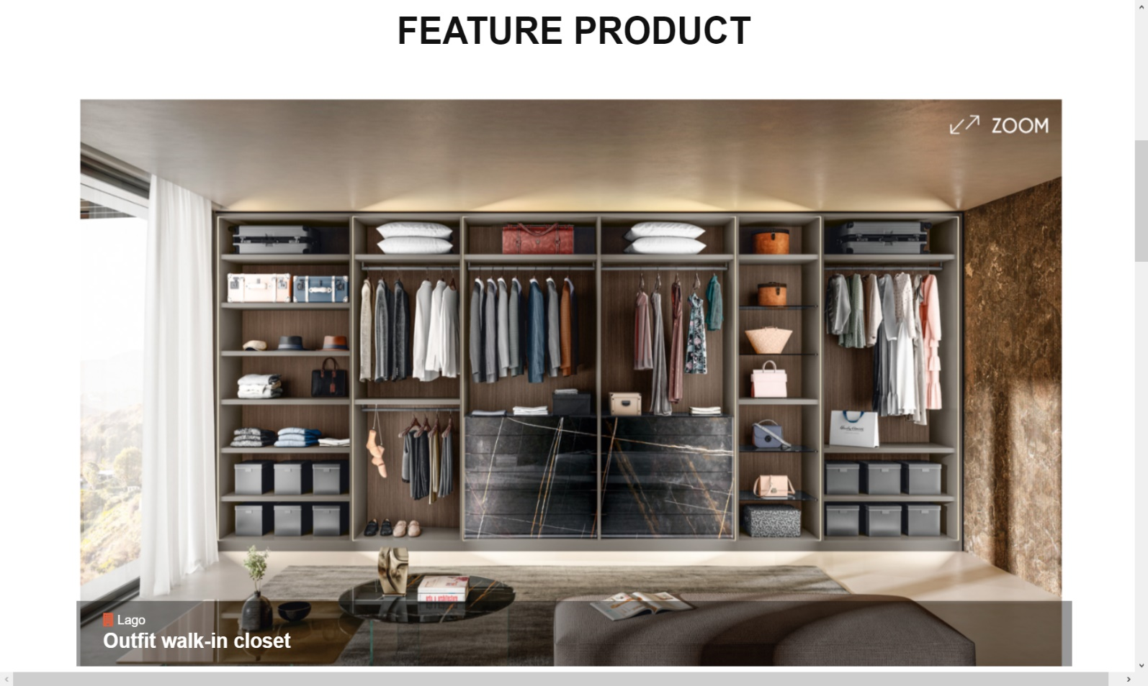

1. **Shop**
2. Description

This shop page displays following information:

* All product that being sold at Smart Store from many brands, when click on 1 specific item, it will show the detail of that item

1. Screen shot

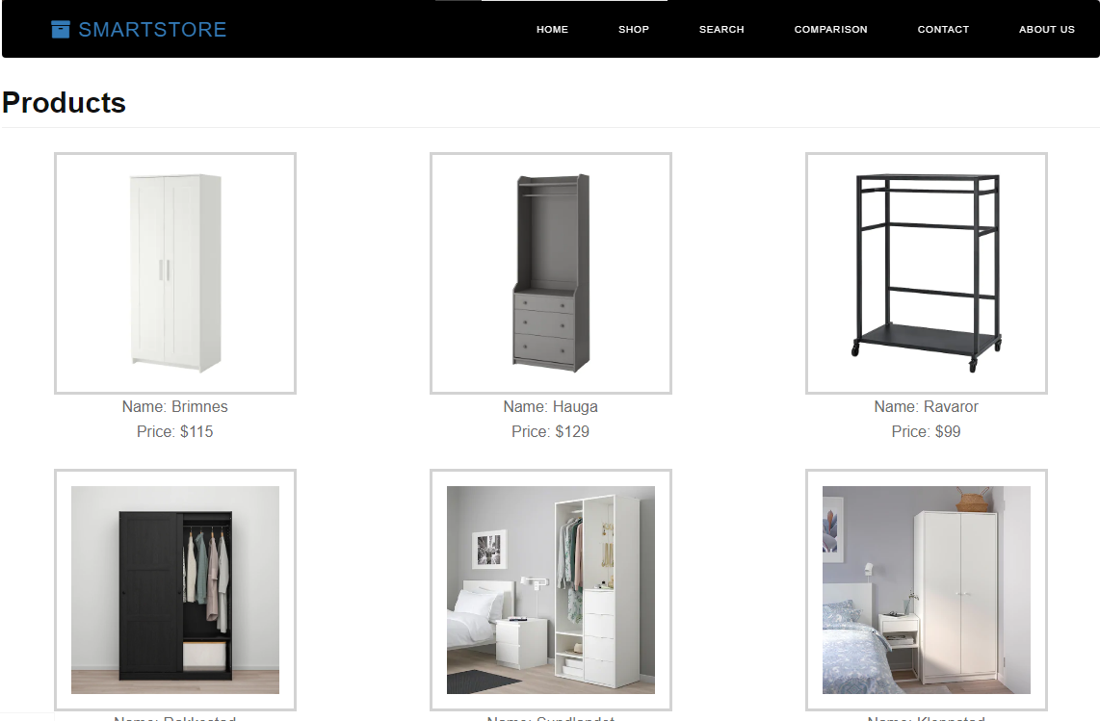

**Detail product:**

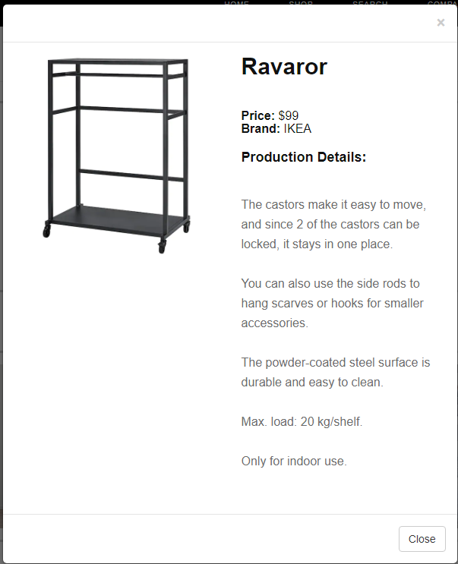

1. **About us**
2. Description

This page displays information about the history of Rhythm House, our service that we provide and our team member.

1. 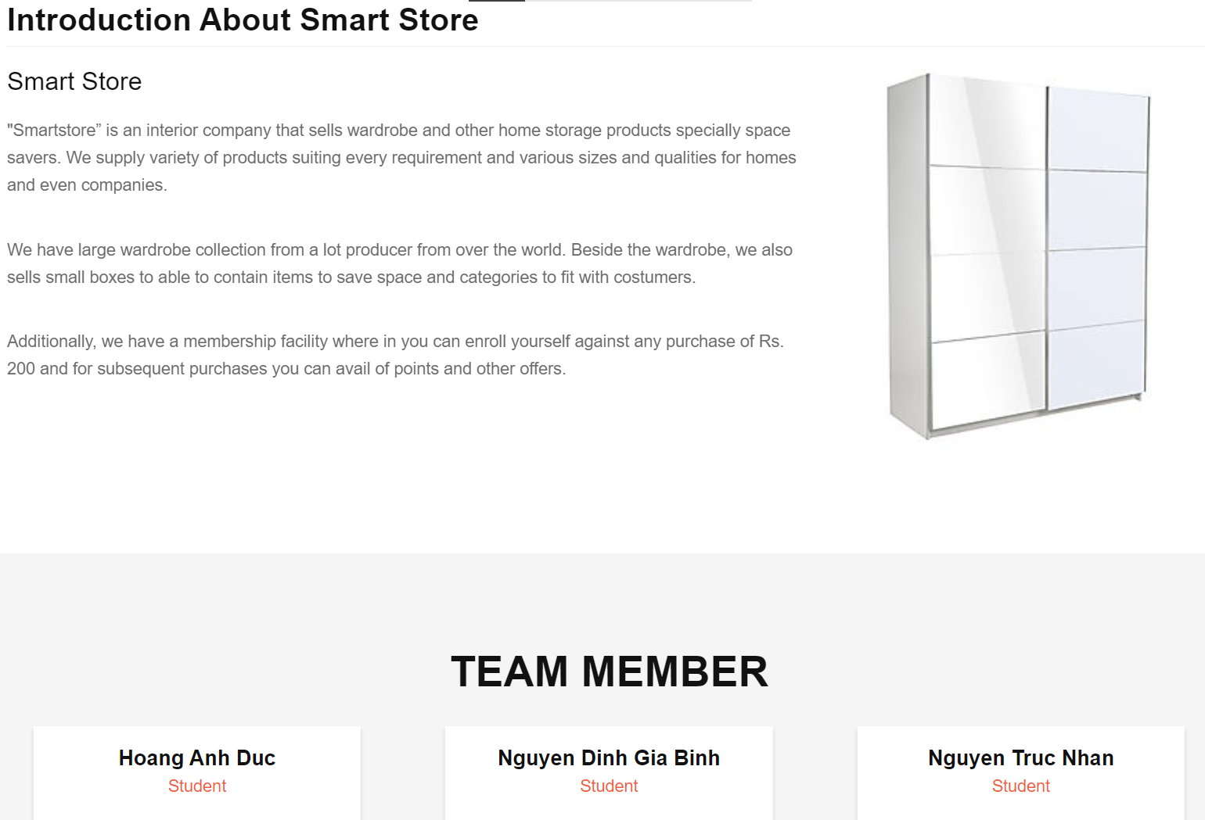Screen shot
2. **Contact us**
3. Description

This page displays contact information: location, telephone number, email and a quick contact form for customer.

1. Screen shot

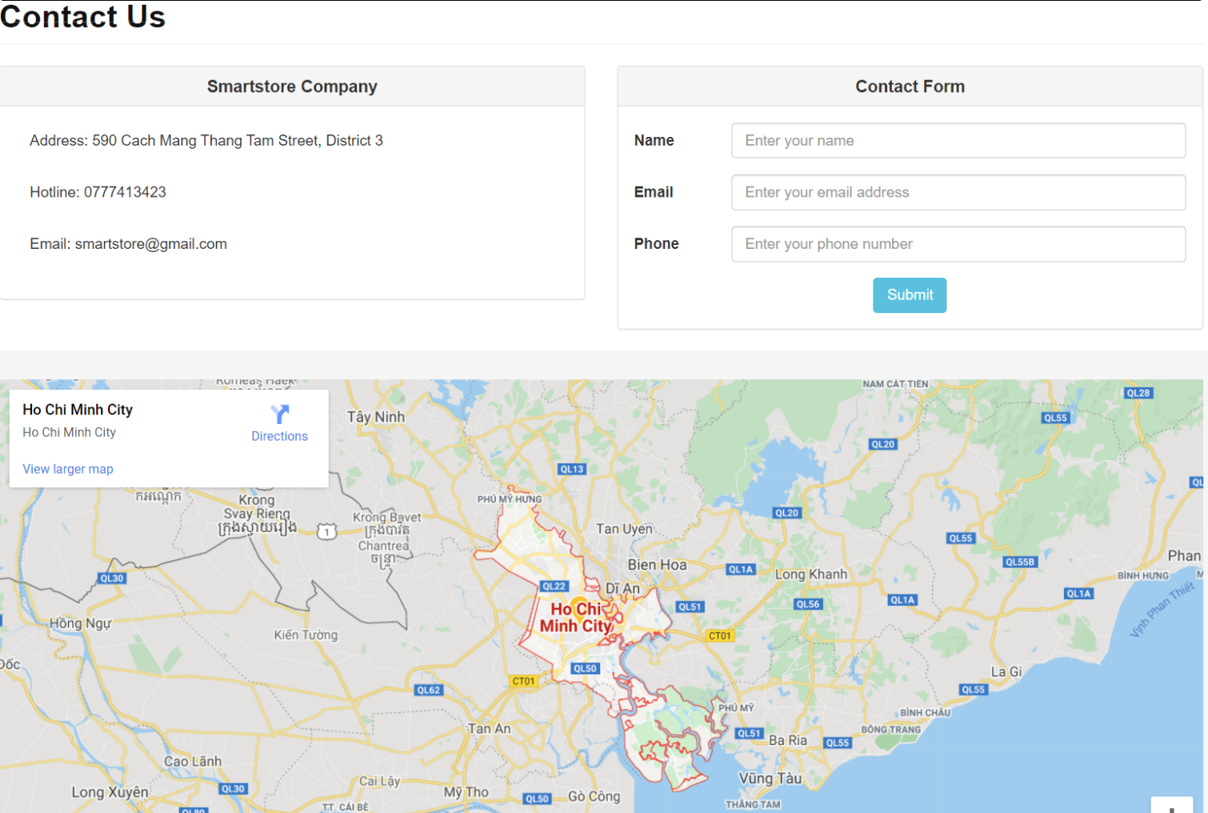

1. **Comparison**
2. Description

This webpage compare two different products from the website.

1. 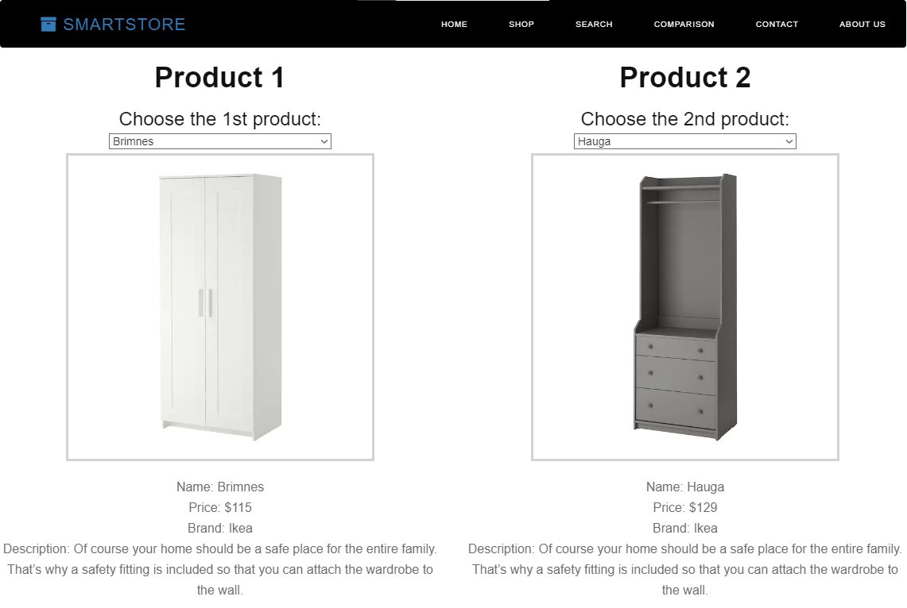Screen shot
2. **Search**
3. Description

This webpage displays all the products with the menu filter and search window by the side.

1. Screen shot

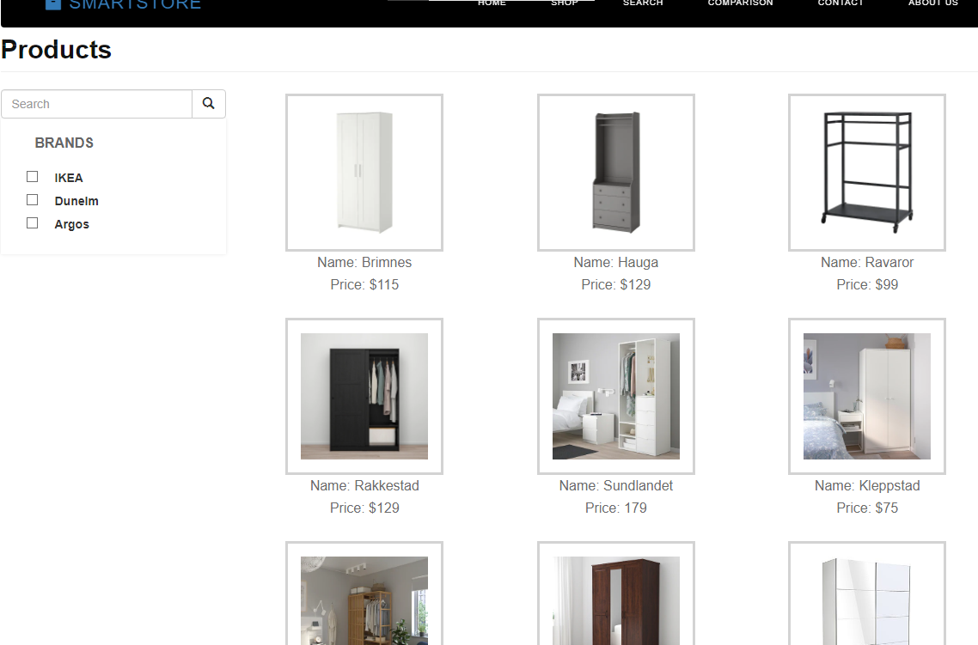

**RESPONSIVE**

The page has responsive feature for small screen device such as smart phone, tablet, etc.

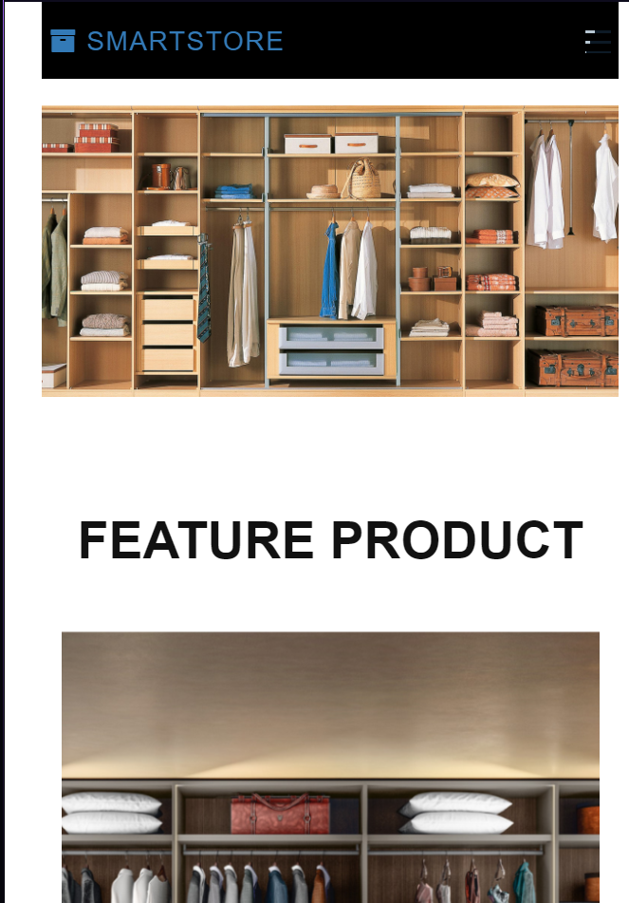

**JAVASCRIPT DESCRIPTION**

1. **Slider javascript**
2. Description

This script used owl package (carousel) to display the products on the website.

1. Screen shot

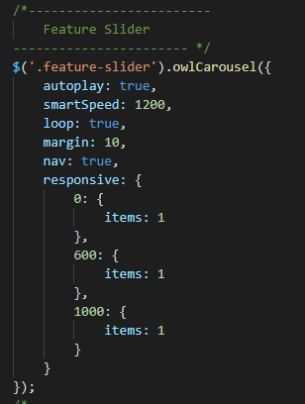

1. **Filter javascript**
2. Description

This script used for filtering items in the search page based on categories.

1. Screen shot

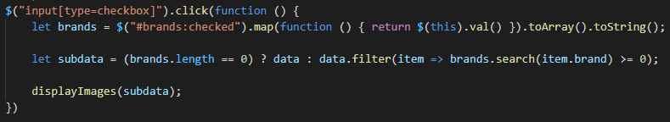

1. **Search javascript**
2. Description

This script used for searching items in the search page.

1. Screen shot

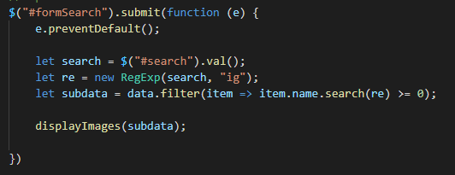

1. **Product javascript**
2. **Description**

This script used for pushing product from data file to the shop page and search page.

1. **Screen shot**

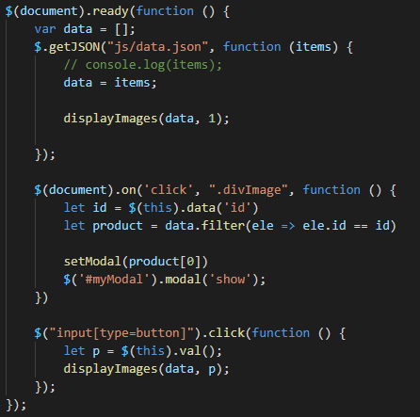

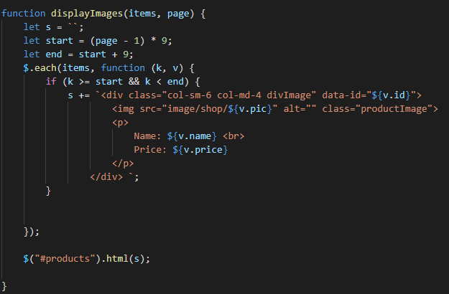

1. **Modal javascript**
2. **Description**

This javascript used for displaying modal after clicking on the image of the product.

1. **Screen shot**

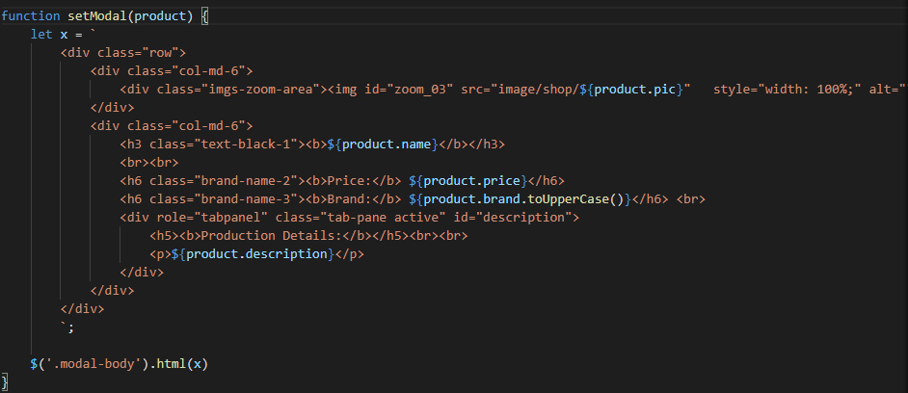

# TASK SHEET REVIEW 3

|  |  |  |  |  |  |  |  |
| --- | --- | --- | --- | --- | --- | --- | --- |
| ***Project Ref. No.:***  ***eP/Advertisement Portal Management System/01*** | | ***Project Title:*** | ***Activity Plan Prepared By:*** | ***Date of Preparation of Activity Plan:*** | | | |
| ***Sr.***  ***No.*** | ***Task*** | ***Actual Start***  ***Date*** | ***Actual Days*** | ***Team Mate***  ***Names*** | ***Status*** |
| *1* | *Home page* | *Smart*  *Store* | *Duc* | 02-Jan-21 | *1* | *Duc* | *Completed* |
| *2* | *Shop* | 03-Jan-21 | *2* | *Duc* | *Completed* |
| *3* | *About us* | 03-Jan-21 | *1* | *Nhan* | *Completed* |
| *4* | *Contact us* | 04-Jan-21 | *1* | *Binh* | *Completed* |
| *5* | *Compare* | 05-Jan-21 | *1* | *Duc* | *Completed* |
| *6* | *Search* | 06-Jan-21 | *1* | *Duc* | *Completed* |
| *7* | *Javascript* |  |  | 04-Jan-21 | *1* | *Duc* | *Completed* |
| *8* | *User Guide* |  |  | 05-Jan-21 | *1* | *Nhan* | *Pending* |

|  |  |
| --- | --- |
| **Date:** | |
| Signature of Instructor:  **Ms. Le Mong Thuy** | Signature of Team Leader:  **Hoang Anh Duc** |