Travel again - yochan06
I snapped a photo while passing through a location during my trip. Since the car never stopped, the photo is all I have. I've forgotten where it was—can you identify the location?
Flag format: NHNC{latitude,longitude} Truncate both the latitude and longitude to 4 decimal places (do not round). Example: NHNC{25.0339,121.5645}
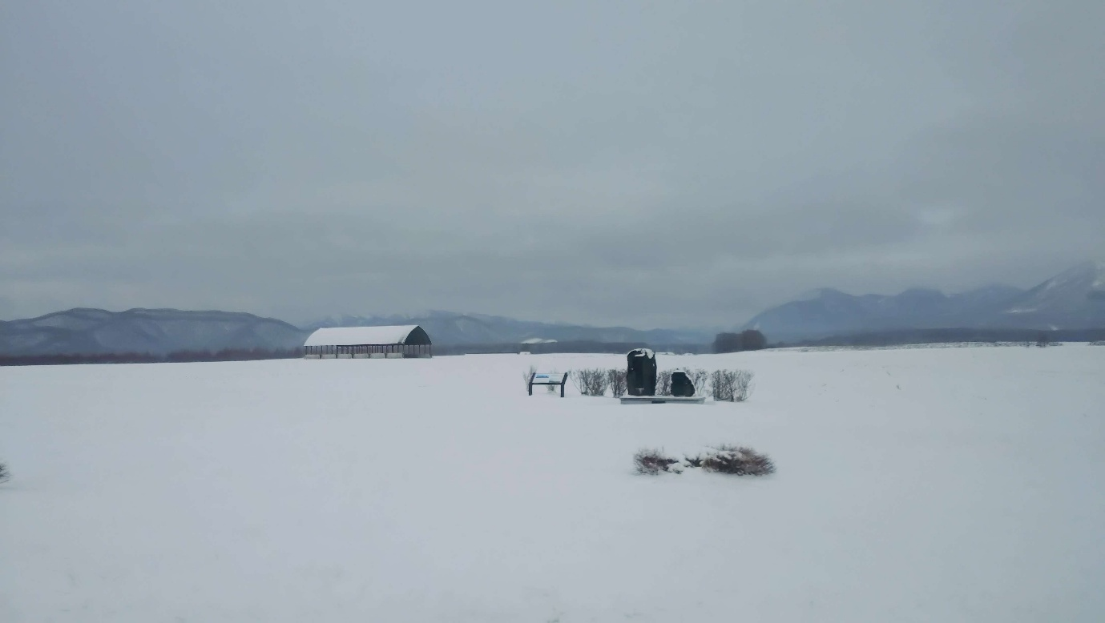
At first, I use google lens to figure out what is that building, rocks and instruction. But no matter I tried, I still can’t find the concise location. Luckily, google and gemini knows this place is inside Hokkaido
Then I tried to find those mountains, by using gemini. After I found, I looked around on google map, but the city is too big to find =))))
After that, I had changed my mind, I decided to look for the road plan the author had gone through base on the information I stalked =)))). But it didn’t help much.
Finally, I tried the low-tech ways=))), searching for it on google image. Surprisingly, I found it after searching in english, vietnamese, taiwanese and japanese!
