Swinburne University of Technology

COS30045 – Data Visualization

Assignment 1 - Data Visualization Analysis

Student name: Nguyen Anh Duc

Student ID: 103488489

Lecturer: Ms. Nguyen Thuy Linh

Tutor: Mr. Vu Ngoc Binh

Introduction

The purpose of this report is to critically evaluate three visualizations based on OECD Health Statistics data, using established principles of data visualization design. The analysis will assess how effectively each visualization communicates key information and adheres to good design practices, considering both the human perception and cognition aspects of data interpretation. This critique will be supported by guidelines from notable theorists such as Edward Tufte’s design principles and the Gestalt principles of visual perception. In each case, the visualizations will be evaluated based on the appropriateness of their chart types, the effectiveness of their encoding, color schemes, and the clarity of the information they present. Recommendations for improvements will be provided based on the critiques to ensure the visualizations are optimized for conveying the intended message clearly and efficiently.

Data Visualization Analysis
- The first visualization

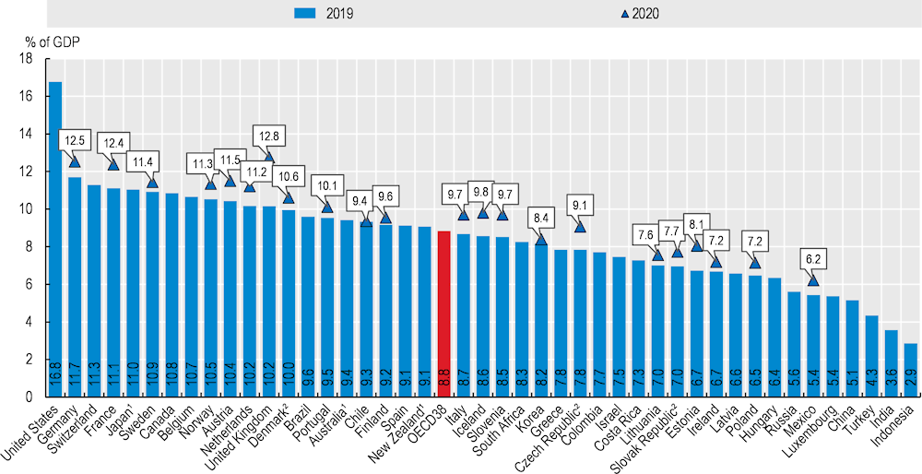
Figure 1. Health expenditure as a share of GDP (2019 and 2020) (OECD, 2021)
1. OECD estimates for 2019.
2. OECD estimates for 2020.

Context and Purpose
The above visualization compares the percentage of gross domestic product (GDP) that various OECD countries allocate to health expenditures. It provides a snapshot of how much each country invests in healthcare relative to the size of its economy, with comparisons between the years 2019 and 2020. The purpose is to highlight variations in health expenditure across countries and illustrate how spending may have changed during the onset of the COVID-19 pandemic in 2020.

Critique Based on Data Visualization Principles

1. Clarity and Precision
Tufte’s principle of maximizing the data-ink ratio (1983) encourages reducing non-essential visual elements to enhance clarity and ensure that the focus is on the data itself. This visualization largely adheres to this principle as it minimizes extraneous design elements. The focus is on the vertical bars representing the percentage of GDP, making the data the central point. The use of bars in two shades (blue for 2019 and gray for 2020) effectively communicates changes in spending.
However, the chart contains redundant gridlines, which might detract from focusing solely on the bars. Reducing the gridline density or using lighter lines would improve the data-ink ratio, ensuring that more ink is used for representing the data rather than background design features.

2. Chart Type Appropriateness
The bar chart used in this visualization is appropriate for comparing values across different countries. It follows the Gestalt principle of proximity (Ware C., 2012), which states that objects close to each other are perceived as related. The bars are grouped together in a linear sequence that allows for easy comparison between countries. Moreover, the dual-year comparison (2019 and 2020) uses distinct but harmonized visual encoding (color) to maintain clarity. However, the crowded x-axis labels (country names) are hard to read due to their orientation. This reduces the legibility of the chart. One potential improvement is to change it to a horizontal bar chart for clearer reading of labels.

3. Annotations and Focus (Highlighting Key Data)
The chart provides helpful annotations (the numeric value of percentages above each bar) for easy interpretation of the exact figures. This follows Tufte’s principle of adding data directly onto the chart, which minimizes the need for users to refer to a separate legend or table. However, there are missed opportunities in highlighting critical data points. For example, the United States has the highest health expenditure, yet the visualization does not draw special attention to this significant outlier, which could have been achieved through a different color or bold text annotation. This would follow the Gestalt principle of figure-ground (Ware C., 2012), which suggests that important data should stand out from the background.

4. Color Encoding and Accessibility
The use of blue and gray colors is clear in differentiating the two years, but the color scheme could be improved to enhance both aesthetic appeal and accessibility. Blue is a good choice, as it is a commonly used and neutral color that does not distract from the data. However, the contrast between the two shades of gray for 2019 and 2020 is not significant enough, especially for viewers with color vision deficiency. According to data visualization guidelines (Evergreen, 2016), it’s important to ensure that color choices are accessible to all users, including those with color blindness. A potential improvement is to use more distinct colors with higher contrast.

5. Scaling and Proportion
The y-axis, which represents the percentage of GDP, is well-scaled, ensuring that small differences in health expenditure between countries remain visible. This avoids the common pitfall of truncating the y-axis, which can mislead the viewer. However, the chart could improve by highlighting the OECD average with a reference line or marker. Including such a benchmark would offer context, making it easier for viewers to assess how each country compares to the average. This would align with Tufte’s principle of showing data variation (1997) without distorting or oversimplifying the results.

Suggestions for Improvement
- Highlight Key Outliers: Use additional colors or design elements to highlight significant outliers like the United States, drawing attention to critical findings without overwhelming the viewer.
- Adjust Colors for Accessibility: Choose a color palette with greater contrast between 2019 and 2020 bars or introduce pattern variations to ensure accessibility for color-blind viewers.

- The second visualization

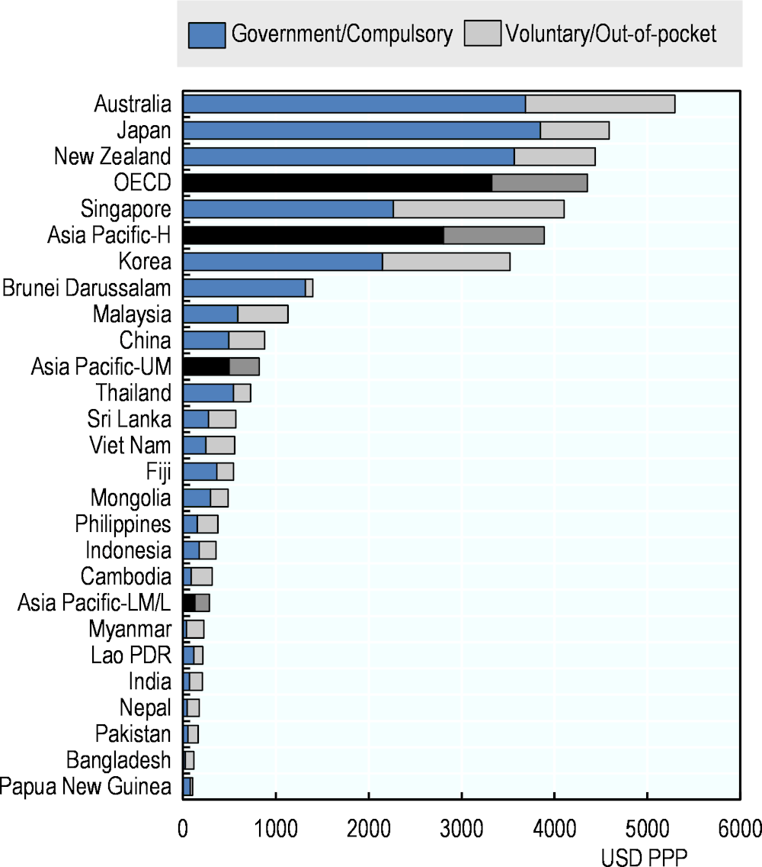
Figure 2. Asia Pacific countries Health expenditure per capita, 2019 (OECD, 2022)

Context and Purpose
The provided visualization compares government/compulsory healthcare spending with voluntary or out-of-pocket expenditures across various countries and regions in the Asia-Pacific region, as well as OECD averages. This chart provides insight into the composition of health expenditure, distinguishing between government-funded healthcare and private or out-of-pocket expenses. The data is expressed in USD PPP (Purchasing Power Parity), enabling meaningful comparisons by accounting for living expense differences between countries. It also helps in evaluating disparities in healthcare access, which are critical for decision-making, especially in countries with a high burden of out-of-pocket health expenses.

Critique Based on Data Visualization Principles
1. Chart Type Appropriateness
The stacked bar chart is an effective choice for this visualization because it allows for a clear comparison of both the total health expenditure per capita and the breakdown between government and voluntary spending. This approach enables the viewer to assess not only how much each country spends on healthcare overall, but also the composition of that spending, which is essential for understanding the financial burden on citizens.
However, while the stacked bar chart is effective for conveying two components of the data, it can make it difficult to compare the voluntary/out-of-pocket spending alone across countries. This is because the second component (gray bars) does not share a common baseline. A grouped bar chart or a separate comparison chart could be introduced as an improvement to allow for easier comparison between components.
2. Clarity and Simplicity
According to Tufte’s principle (1983), we should maximize the data-ink ratio, and the principle is generally well-applied in this visualization. The focus is on the data itself, with minimal extraneous elements. The choice of a clean, minimalist design ensures that the viewer can focus on the bars, which represent the core information. However, to enhance the data-ink ratio further, the legend could be placed directly on the bars in the form of small labels or annotations, thereby integrating the information with the chart itself.
3. Proximity and Grouping
The Gestalt principle of proximity (Ware C., 2012) suggests that elements close to each other are considered as related. In this visualization, the proximity of the stacked bars to each other effectively groups countries by their spending levels. Countries with similar total health expenditures are naturally grouped together (e.g., Australia, Japan, and New Zealand), allowing for easy comparison across regions.
However, the chart could better utilize categorical grouping for regions. For instance, the chart could group OECD countries separately from other Asia-Pacific regions, which would make the differences in spending trends more explicit. Adding separators or distinct labels between these categories could help viewers quickly identify which countries belong to which groups.
4. Color Encoding and Accessibility
The color scheme of blue and gray is functional but lacks visual impact. Both colors are relatively neutral and do not guide the viewer’s attention to specific data points. Furthermore, the use of gray for voluntary spending may not be ideal for individuals with color vision deficiencies, who might struggle to distinguish between these shades.
To improve accessibility, the contrast between colors could be enhanced by using a darker shade or introducing patterns (e.g., diagonal lines for voluntary spending). This would ensure that the data is easily interpretable by a wider audience, including those with color blindness.
5. Axes, Scaling, and Annotations
The x-axis, representing the USD PPP, is well-scaled and offers sufficient granularity for distinguishing differences in expenditure between countries. However, the y-axis (country names) becomes cluttered toward the bottom due to the large number of countries included. Although the current arrangement is readable, it would benefit from a slight increase in spacing between country labels or the use of hover-over tooltips in a digital format.
The chart also lacks annotations to highlight important data points, such as countries with the highest (Australia, Japan) and lowest (Papua New Guinea) total health expenditures. Adding annotations would help guide the viewer's attention to key findings, such as the significant disparity in healthcare spending between OECD countries and lower-middle-income countries in the Asia-Pacific region.

Suggestions for Improvement
- Introduce Categorical Grouping: Group countries by regions (OECD vs. Asia-Pacific) or income levels to make trends more apparent and enhance comparison across similar contexts.
- Enhance Color Contrast: Use more distinct colors or add patterns to differentiate between government and voluntary health spending. This would improve accessibility for viewers with color vision deficiencies and make the chart more visually engaging.

- The third visualization

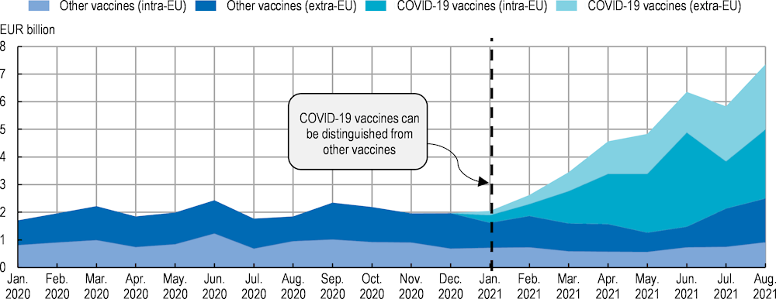
Figure 3. Exports of vaccines (COVID‑19 and non-COVID‑19) from the EU, 2020-21 (OECD,2022)

Context and Purpose
The chart depicts the monthly export trends of vaccines (both COVID-19 and non-COVID-19) from the European Union (EU) over time. It is a stacked area graph showing how vaccine exports shifted during the pandemic, with a key moment marked by the introduction of a separate nomenclature for COVID-19 vaccines in January 2021. The visualization distinguishes between intra-EU and extra-EU vaccine exports, giving viewers a comprehensive understanding of the dynamics of vaccine distribution within and outside the EU.

Critique Based on Data Visualization Principles
1. Chart Type Appropriateness
The stacked area chart is an appropriate choice for illustrating the growth of multiple vaccine export categories over time. It allows viewers to clearly see how exports evolved in response to the pandemic. It is easily seen that COVID-19 vaccines (intra-EU and extra-EU) began to dominate the EU’s vaccine exports from early 2021 onward.
However, it becomes harder to distinguish changes in the layers lower down in the stack, particularly the “other vaccines (intra-EU)” section, which remains relatively small throughout the time series. This makes it difficult for viewers to track trends in non-COVID-19 vaccine exports. A solution might be to separate out the layers or use a small multiples approach as suggested by Tufte (1997), where each vaccine type is plotted in its own chart, allowing for clearer comparisons.
2. Clarity and Simplification
Tufte’s principle of maximizing the data-ink ratio (Tufte E. R., 1983) is partially applied in this visualization. The graph avoids unnecessary decorative elements and focuses on the data itself. The use of distinct colors to differentiate between vaccine types (blue for non-COVID vaccines and teal for COVID-19 vaccines) is helpful and contributes to clarity. Furthermore, the vertical line marking January 2021 is effective in indicating an important milestone (the introduction of separate nomenclature), but the accompanying note might be more impactful if placed within the chart area itself to better integrate the information with the data.
3. Color and Accessibility
The color scheme chosen for this visualization is logical and enhances the comparison between the different categories of vaccines. However, the palette does not offer sufficient contrast between the “other vaccines (extra-EU)” and “COVID-19 vaccines (extra-EU)” layers, which may be difficult to distinguish for viewers with color vision deficiencies. According to accessibility guidelines (Evergreen, 2016), more distinctive colors or patterns (such as adding textures to the layers) should be considered to enhance accessibility.
4. Continuity and Annotation
The Gestalt principle of figure-ground (Ware C., 2012) is well-applied here. The use of a vertical dashed line to indicate a critical change successfully draws the viewer’s attention to the point where COVID-19 vaccines became distinguishable in the data. However, the annotation “COVID-19 vaccines can be distinguished from other vaccines” could be more integrated into the graph. Instead of a floating text box, the annotation could be directly tied to the data point where this shift occurs, increasing the immediacy and relevance of the note.
5. Axis Scaling and Labeling
The y-axis, representing the value of vaccine exports in EUR billions, is well-scaled and provides sufficient detail to distinguish between export values. However, the x-axis, which represents time, could be enhanced by using quarterly labels instead of monthly ones. This would make the timeline less cluttered while still capturing the critical turning points in the data (e.g., January 2021). Additionally, using a shaded background to mark different years could help distinguish the two phases of the pandemic (2020 vs. 2021), thereby enhancing temporal comparison.

Suggestions for Improvement
- Simplify Gridlines: Reduce the visibility of gridlines and tick marks to enhance the focus on the data itself. Tufte’s data-ink ratio principle can be applied here to reduce unnecessary visual noise.

Conclusion

In this report, three visualizations using OECD Health Statistics were critically analyzed based on established data visualization principles, including Tufte’s design guidelines and Gestalt principles. The first visualization on health expenditure as a share of GDP was evaluated for its clarity and use of color, with improvements suggested to enhance accessibility and readability. The second visualization on per capita health expenditure was critiqued for its stacked bar chart approach, with suggestions for clearer comparisons through better color contrast and grouping of countries. The final visualization on vaccine exports from the EU was analyzed for its effective use of a stacked area chart, though enhancements were recommended to improve annotation integration, color differentiation and gridline prominence. Overall, these critiques highlighted the importance of clear, accessible, and well-annotated visualizations to convey complex health data effectively to a wide audience.

Reference

OECD (2021), Health at a Glance 2021: OECD Indicators, OECD Publishing, Paris, https://doi.org/10.1787/ae3016b9-en.

Ware, C. (2012). Information visualization: Perception for design (3rd ed.). Morgan Kaufmann.

Tufte, E. R. (1983). The visual display of quantitative information. Cheshire, CT: Graphics Press.

Evergreen, S. D. H. (2016). Effective data visualization: The right chart for the right data. SAGE Publications.

Tufte, E. R. (1997). Visual explanations: Images and quantities, evidence and narrative. Cheshire, CT: Graphics Press.

OECD/WHO (2022), Health at a Glance: Asia/Pacific 2022: Measuring Progress Towards Universal Health Coverage, OECD Publishing, Paris, https://doi.org/10.1787/c7467f62-en.

OECD (2024), Securing Medical Supply Chains in a Post-Pandemic World, OECD Health Policy Studies, OECD Publishing, Paris, https://doi.org/10.1787/119c59d9-en.

