**Predicting Binance Stock Prediction with Recurrent Neural Network: A Data Driven Approach**

Nguyen Diem Thanh  
University of Adelaide  
a1876954

**ABSTRACT**

This research delves into the domain of stock market prediction, with a specific focus on Binance stocks—a prominent player in the cryptocurrency exchange arena. Utilizing the capabilities of Recurrent Neural Networks (RNN), the study concentrates on three key coin pairs, namely BTCUSDT, MATICBUSDT, and ETHUSDT, deemed as potential influencers of future market dynamics. While predicting stock market indices poses considerable challenges, the allure lies in the substantial profitability it offers to investors. Machine Learning models have emerged as indispensable tools for precise stock market predictions and effective investment management. This study involves the compilation of historical market data for Binance coin pairs, preprocessing the data to extract pertinent features, and implementing an RNN architecture tailored for time-series prediction. The proposed model is designed to incorporate sequential dependencies within the stock price data, enabling it to capture intricate patterns and trends that could impact future price movements. Training the RNN involves utilizing a comprehensive dataset spanning a significant time, coupled with the fine-tuning of hyperparameters. The model's performance is subsequently assessed using metrics such as Mean Squared Error (MSE), providing a quantitative measure of its predictive accuracy. This research aims to deliver valuable insights into the nuanced world of cryptocurrency trading, investment decisions.

1. **INTRODUCTION**

In the realm of the financial cryptography market, the ability to develop profitable solutions in the marks of its rapid evolution and inherent volatility has become a central point of attraction for investors seeking both opportunities and challenges. Binance stock, as one of the leading cryptocurrency exchanges globally, stands at the forefront of this dynamic landscape. In the quest to navigate the complexity of this market, the ability to accurately predict stock prices becomes paramount. This paper embarks on an exploration of leveraging advanced machine learning techniques, specifically Recurrent Neural Networks, to forecast Binance stock prices. Conventional approaches frequently prove inadequate in comprehensively grasping the nuanced patterns and interdependencies inherent in the time-series data of cryptocurrency markets. Take, for instance, the fluctuation in a cryptocurrency stock price index, influenced by multifaceted factors like economic activity shifts, geopolitical events, or obstacles faced by the associated companies. A manual analysis of stock prices often falls short of encompassing all potential scenarios. The swift progression of technology has thankfully ushered in a myriad of techniques applied to stock analysis, facilitating timely and informed decision-making, potentially influencing trading strategies, risk management within the

broader financial ecosystem. The outcome of this study promises to illuminate the effectiveness of cuttiing-edge artificial intelligence technique in deciphering the complexities of cryptocurrency markets. Through this exploration, not only to the growing body of knowledge in financial technology but also to empower stakeholders within tools that enhance their ability to navigate the ever-evolving landscape of cryptocurrency trading. In this paper, the methodology involves data acquisition through scraping Binance stock data using Binance APIs. The objective is to compile a comprehensive historical dataset spanning the last two years. This approach ensures a rich and extensive source of information for analysis and modeling, proving insights into the market trends and patterns that have unfolded over the specified timeframe. By leveraging Binance APIs, the study ensures access to real-time and accurate data, laying a robust foundation for the subsequent analysis of stock price movements and the development of predictive models.

1. **RECURRENT NEURAL NETWORK**

Recurrent Neural Networks (RNNs) are a category of artificial intelligence specifically crafted for the processing and analysis of sequential data. This type of data includes handwriting, genomes, as well as text or numerical time series commonly generated in industrial environments such as stock markets or sensor outputs [1,2]. In comparision between two Feedforward Neural Networks and Recurrent Neural Networks (RNNs) share similarities but distinguish themselves by having connections that loop backward. RNNs operate sequentially, executing the same task in each round while producing outputs that depend on the preceding computations as described in Figure.1 **Ảnh có chứa văn bản, ảnh chụp màn hình, biểu đồ, hàng
**

***Figure 1****. FeedForward and Recurrent Neural Network Comparision.*

The input layer, denotes as x, receives, and processes the input of neural network before forwarding it to middle layer. Within the middle layer, labeled as h, mutiple hidden layers exist, each equipped with its unique activation functions, weights, and biases [3].

If there is no memory within the neural network, meaning that the various parameters of distinct hidden layers are unaffected by the preceding layer, one can opt a recurrent neural network. [3].

***Figure 2***. *RNN architecture working structure*.

At every time interval $t$, the activation $a^{t}$ and the output $y^{t}$ are represented in the following manner. The coefficients $W_{ax}, W_{aa},W_{ya},b_{a} and b_{y}$ are shared across time intervals, and $g_{1} and g_{2}$ denote the activation functions. The RNN model prediction involves the activation and weight propagation from the preceding hidden layer to the current one [3].

There are some types of RNNs architecture:

1. **one-to-one** ($T_{x}=T_{y}=1)$: RNNs involves only one pair. Traditional neural networks commonly employ a one-to-one configuration.
2. **one-to-many** ($T_{x}=1, T_{y}>1$): A single input can generate multiple outputs. This architecture finds applications in fields such as music production.
3. **many-to-one** ($T_{x}>1, T_{y}=1$): A single output is produced by aggregating inputs from various time steps. Applications include sentiment analysis, emotion identification, where the classification is influenced by a sequence of words.
4. **many-to-many** ($T_{x}>1, T_{y}>1$): This configuration offers numerous possibilities, such as having two inputs generate three outputs. Utilized in machine translation systems.

In the RNN architecture, there is the capability to process inputs of variable lengths, ensuring that the model size does not increase proportionally with the input size. The computation takes historical information into account, enabling the model to capture sequential dependencies. Additionally, weights are shared across time intervals, enhancing the model's ability to generalize patterns over the entire sequence. In contrast, the computation tends to be slow, and accessing information from a distance past becomes challenging. Furthermore, the model cannot factor in any furture input when determining the current state.

1. **BIDIRECTIONAL RECURRENT NEURAL NETWORKS (BRNNs)**

In contrast to conventional RNNs, which focus solely on past information in a sequence, Bidirectional Recurrent Neural Networks (Bi-RNNs) consider both past and future information. This characteristic enhances their effectiveness in capturing contextual dependencies within the data sequence.

In the architecture of a Bidirectional Recurrent Neural Network (Bi-RNN), the hidden layer is partitioned into two components:

1. Processing the input sequence in a forward direction
2. Processing the input in a backward direction.

Utilizing dual processing, the network can gather contextual insights from both preceding and succeeding elements in the sequence. Bidirectional RNNs find application in tasks where a comprehensive understanding of context from both directions is essential. In the context of financial currency index analysis, where precision and minimizing error rates are crucial, bidirectional RNNs prove valuable for enhancing output accuracy.

***Figure 3.*** *Bidirectional RNN Architecture Dual Form*

In a formal context, at each time step $t$, given a minibatch input $X_{t} ∈R^{n*d}$ and using the hidden layer activation function denoted as $θ$. the Bidirectional Recurrent Neural Networks (B-RNNs) yield forward and backward hidden states for this time step, represented as ${\overline{H}}_{t}∈R^{n* h} and {\overset{⃖}{H}}_{t}∈R^{n*h}$**,** respectively. Here, $h$ signifies the number of hidden units [4]. Represented by the following formula (1) (2):

$${\overset{⃑}{H}}_{t}= θ\left(X_{t}W_{xh}^{\left(f\right)}+{\overset{⃑}{H}}_{t-1 }W_{hh}^{\left(f\right)}+b_{h}^{\left(f\right)}\right)(1)$$

$$\overset{⃖}{H_{t}}= θ\left(X_{t}W_{xh}^{\left(b\right)}+{\overset{⃐}{H}}_{t+1}W_{hh}^{\left(b\right)}+b_{h}^{\left(b\right)}\right) (2)$$

Afterward, merge both the forward and backward hidden states $({\overset{⃑}{H}}_{t} and \overset{⃖}{H_{t}})$ to form the hidden state $\left(H_{t}\right)$, which is then provided as input to the output layer. In deep bidirectional RNNs with multiple hidden layers, this data is passed on as input to the following bidirectional layer. Ultimately, the output layer calculates the output $(Y_{t})$, with the number of outputs denoted by ($n_{output}) [4].$

$$O_{t}= θ\left({\overset{⃑}{H}}_{t}⋂\overset{⃖}{H_{t}}\right)W_{ho}+b_{o}$$

Combining two matrices along axis 0 involves stacking them on top of each other, essentially performing concatenation along the vertical axis.

1. **LONG SHORT-TERM MEMORY**

The Long Short-Term Memory (LSTM) represents an advancement over traditional Recurrent Neural Networks (RNNs), specifically addressing the challenge of the vanishing gradient problem. It possesses the capability to effectively learn long-term dependencies. Unlike conventional RNNs, where the vanishing gradient problem can hinder the learning of distant dependencies, LSTMs excel at retaining information for extended periods, making this ability a default characteristic.

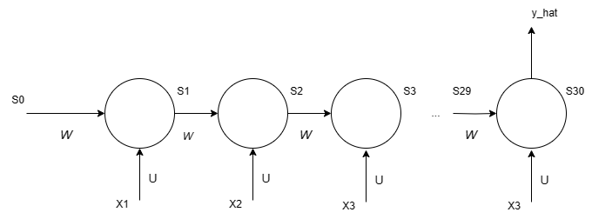

***Figure 4.1:*** *RNN architecture*

In Figure 4.1, the derivative of L with respect W at state i: $\frac{∂L}{∂W}=\frac{∂L}{∂\hat{y}}*\frac{∂\hat{y}}{∂s_{30}}*\frac{∂s_{30}}{∂s_{i}}*\frac{∂s^{'}i}{∂W}$. With $\prod_{j=i}^{29}{\frac{∂s_{j+1}}{∂s_{j}}}$. Assuming that activation is $tanh$, $s_{t}=tanh⁡(U*x_{t}+W*s_{t-1})$

$$\frac{∂s_{t}}{∂s_{t-1} }=\left(1-s_{t}^{2}\right)*W→\frac{∂s_{30}}{∂s_{i}}=W^{30-i}*\prod_{j=i}^{29}{\left(1-s_{j}^{2}\right)}$$

$s_{j}<1, W<1→$ So, at far distant the value of derivative at $s_{30}$: $\frac{∂s_{30}}{∂s_{i}}≈0$.

The traditional RNN approach encounters the vanishing gradient problem, where updates from distant time frames, especially at the initial state, are not effectively propagated. This limitation results in the RNN method struggling to learn from past information due to the issue of the gradient vanishing over time.   
In technical terms, RNNs primarily transmit information from one layer to the next. However, in practice, this information tends to persist only through a limited number of states before encountering the vanishing gradient issue. In simpler terms, RNNs effectively learn from nearby states, with their ability to capture information diminishing as it extends further.   
Indeed, Long Short-Term Memory (LSTM) networks come into play to address challenges that conventional RNNs struggle with. LSTMs are designed to overcome limitations such as the vanishing gradient problem, enabling them to capture and retain long-term dependencies more effectively than traditional RNNs.

***Figure 4.2:*** LSTM architecture

$Output:c_{t}:cell state, h_{t}:hidden state$**: ${Input: c}_{t-1}, h_{t-1}:previous output$ $$x_{t}:input state at t$$**

$f_{t},i_{t},o_{t}$ correspond to the forget gate, input gate, and output gate.

- $f_{t}= σ(U_{f}*x_{t}+W_{f}*h_{t-1}+b_{f})$

- $i_{t}= σ(U_{i}*x_{t}+W_{i}*h_{t-1}+b_{i})$

- $o_{t}= σ\left(U_{o}*x_{t}+W_{o}*h_{t-1}+b_{o}\right)$

As can be seen, $0<f_{t},i_{t},o_{t}<1;b_{f},b_{i},b_{o}$: bias. $c_{t}$ The forget gate determines the extent to which the cell state should be discarded, and the input gate decides how much information from the input and the previous hidden layer should be incorporated into the cell state. This mechanism that helps the LSTM network effectively manage and update its internal cell state for both short-term and long-term memory.

1. **DATASET**

Ensuring the reliability and accuracy of data is imperative. This research acquires data through scraping tools designed to gather pairs of coin datasets, covering a period from the current date back to two years ago. Opted to use the Excel data extraction package to retrieve OHLCV (Open, High, Low, Close, Volume) historical crypto currency data, along with historical adjusted ratio for dividened or stock split, with the historical components of Binance index. This study incorporates three pair types, namely BTCUSDT, MATICUSD, and ETHUSDT as illustrated in Figure. 5.

***Figure 5.1:*** BTCUSDT currency exchange from 2021 to present.

***Figure 5.2:*** MATICBUSDcurrency exchange from 2021 to present.

***Figure 5.3:*** ETHUSDTcurrency exchange from 2021 to present.

The dataset has been constructed by scraping Binance APIs, specifically retrieving historical dataset in the OHLCV (Open, High, Low, Close, Volume) format, specifically there are 7 values are used in this study to predict the price:

* **Open Time**: The moment the trading period (candle) initiates, indicated by a timestamp.
* **Open Price**: The initial value of the asset as the trading period begins.
* **High Price**: The utmost value attained by the asset during the trading duration.
* **Low Price**: The minimum value reached by the asset during the trading period.
* **Close Price**: The conclusive value of the asset at the termination of the trading period.
* **Volume**: The overall quantity of the asset transacted within the specified timeframe.
* **Number of Trades**: The overall count of individual transactions completed within the specified timeframe.

The training process and concentrated efforts revolve around the assessment of three distinct types of well-known cryptocurrencies, aiming to compare and evaluate their performance using the Mean Squared Error (MSE) technique. The dataset has been partitioned into two segments: 90% for training and 10% for testing. Additionally, specific parameters have been set, including a sequence length of 100, a batch size of 64, and iterations for each 50 epochs, with the learning rate fixed at 0.001.

1. **Experiments and Results**

In this research, both Bidirectional Recurrent Neural Networks (Bi-RNNs) and Long Short-Term Memory (LSTM) are employed for three datasets: BTCUSDT, MATICUSD, and ETHUSDT. The subsequent section will delve into an analysis of these models, discussing their performance and exploring potential avenues for future improvements.

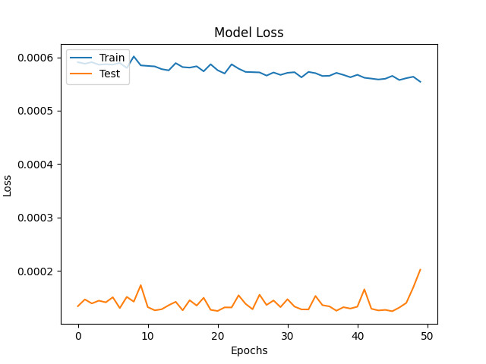

***Figure 6.1:*** BTCUSDT Currency Model Loss

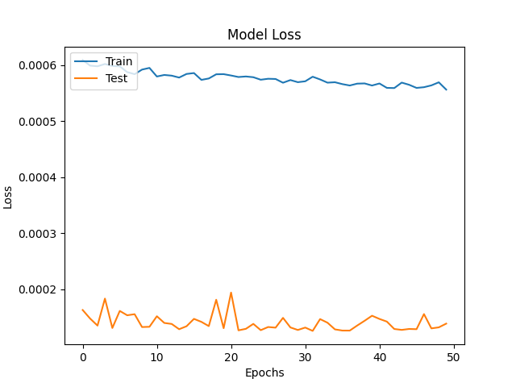

***Figure 6.2:*** MATICBUSD Currency Model Loss

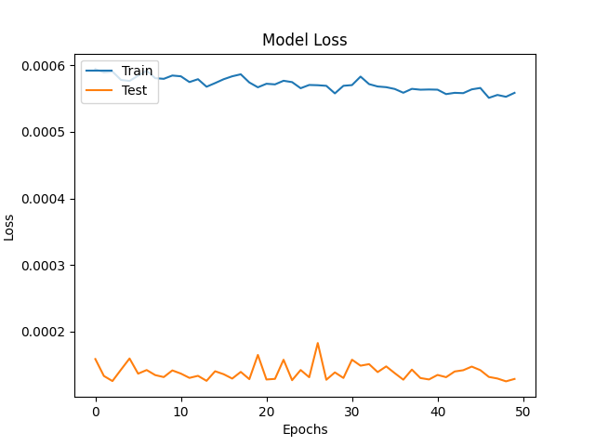

***Figure 6.3:*** ETHUSDT Currency Model Loss

Across the three dataset types, the loss curve exhibited a marginal variation, accompanied by a consistently low validation score.

***Figure 6.4:*** BTCUSDT Price Prediction

***Figure 6.5:*** MATICBUSD Price Prediction

***Figure 6.6:*** ETHUSDT Price Prediction

The experimentation focused on price prediction, combining the examination of actual prices for each type of coin. The resulting line from the model closely aligns with the actual prices, indicating a notable accuracy in predicting price movements.

1. **Conclusion**

This study combines Bidirectional Recurrent Neural Network (Bi-RNN) and Long Short-Term Memory (LSTM) to achieve high model accuracy and a low loss curve, surpassing the limitations encountered by traditional RNN models. As traditional RNNs process information sequentially and lack parallelization capabilities, the integration of these advanced models effectively addresses this limitation, paving the way for enhanced performance in sequential data processing tasks.

In conclusion, this study undertook a comprehensive exploration of price predictions for three types of cryptocurrencies BTCUSDT, MATICUSDT, and ETHUSDT. By utilizing a combination of Bidirectional Recurrent Neural Network (Bi-RNN) and Long Short-Term Memory (LSTM) models, as evidenced by the close alignment between the predicted and actual prices. Unlike traditional RNN models, the integration of Bi-RNN and LSTM addressed sequential processing limitations, contributing to more effective information processing. This research marks a significant step forward in leveraging advanced neural network architectures for cryptocurrency price prediction, laying the foundation for furture advancements and applications in the dynamic realm of financial technology.

**References**

[1] Junyoung Chung et al. “Gated Feedback Recurrent Neural Networks”. In: Proceedings of the 32Nd International Conference on International Conference on Machine Learning - Volume 37. ICML’15. Lille, France: JMLR.org, 2015, pp. 2067–2075.  
[2] Mike Schuster and Kuldip K. Paliwal. “Bidirectional recurrent neural networks”. In: IEEE Trans. Signal Processing 45 (1997), pp. 2673–2681.  
[3] Kalita, D. (2022, March 11). A Brief Overview of Recurrent Neural Networks (RNN). Analytics Vidhya. https://www.analyticsvidhya.com/blog/2022/03/a-brief-overview-of-recurrent-neural-networks-rnn/   
[4] Praveen, Bishwas, and Vineetha Menon. “A Bidirectional Deep-Learning-Based Spectral Attention Mechanism for Hyperspectral Data Classification.” Remote Sensing, vol. 14, no. 1, 4 Jan. 2022, p. 217, https://doi.org/10.3390/rs14010217. Accessed 25 Jan. 2022.