**LOGIN WITH SOCIAL NETWORKS**

1. FACEBOOK:
2. **Step 1:**

Open Android Studio and create a project Empty Activity and set name “LoginWithSocialNetworks”

The package name of the project is: ***com.example.loginwithsocialnetworks***

1. **Step 2:**

Open this link: <https://developers.facebook.com/docs/facebook-login/android/>

Click on “Create a New App” button

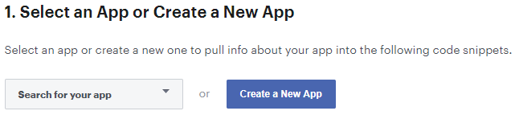

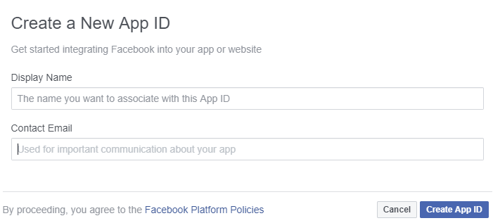

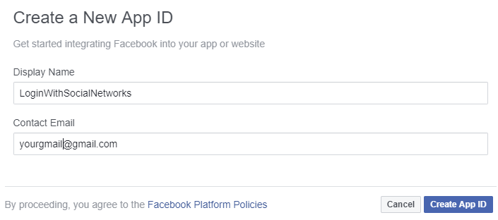

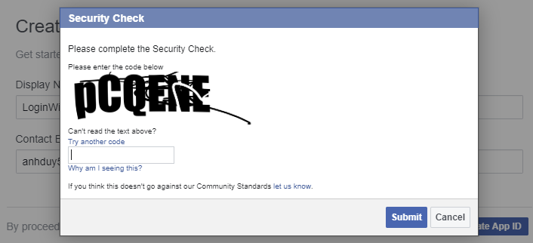

After submit, you refresh this page and you will see your new app at here

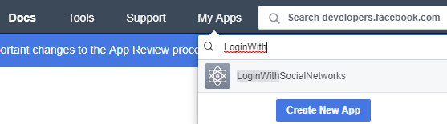

1. **Step 3:** Open your Facebook App by click on app name

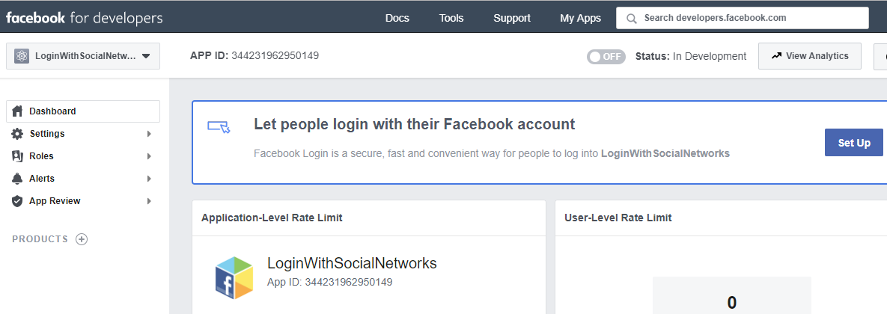

Click on “Set Up” button.

Or Click on “Quickstart”

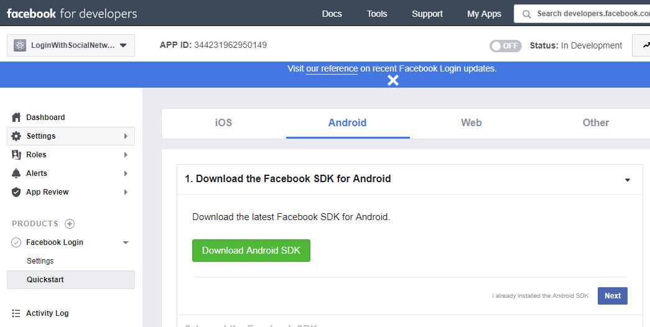

Skip “Download the facebook SDK”, click Next

1. **Step 4:** Integrate the Facebook SDK

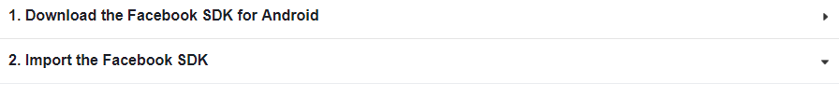

Add jCenter() to build.gradle (Project)

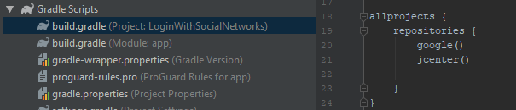

In build.gradle (Module: app) -> implementation 'com.facebook.android:facebook-login:[5,6)'

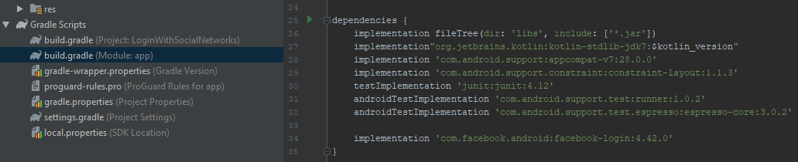

1. **Step 5:** Input Package Name and Default Activity Class Name

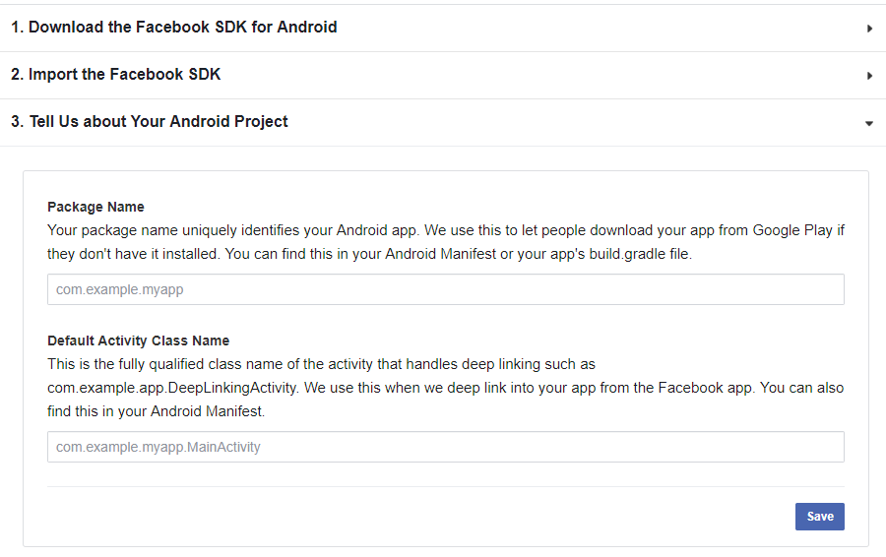

Package Name, we can get from AndroidManifest.xml.

Default Activity class name: We haven’t implemented deep link yet, so we can use default activity

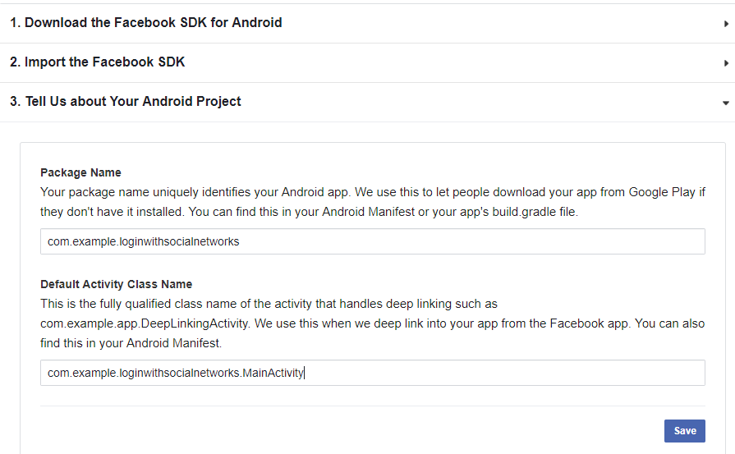

Click “Save”: You will see an alert dialog -> select “Use this package name”

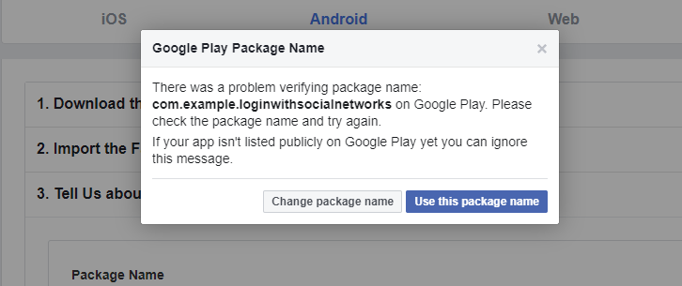

Click “Continue”

1. **Step 6:** Generating Debug Key Hash and Release Key Hash

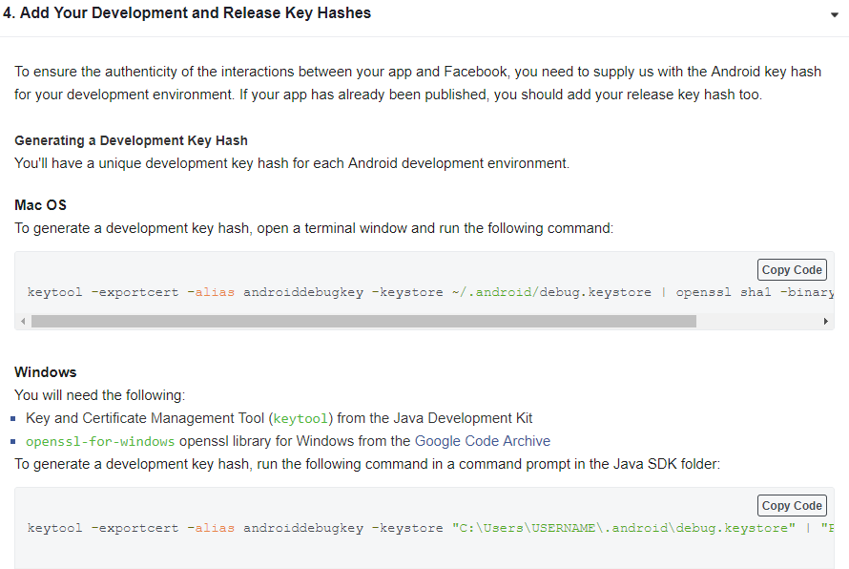

* Download openssl-for-windows: <https://code.google.com/archive/p/openssl-for-windows/downloads>

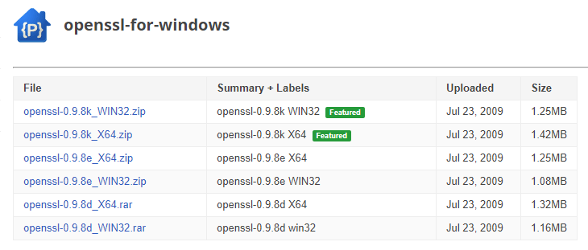

After downloading, I copy it to desktop and unzip

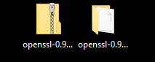

* To generate a development key hash, run the following command in a command prompt in the Java SDK folder:

keytool -exportcert -alias androiddebugkey -keystore "C:\Users\USERNAME\.android\debug.keystore" | "PATH_TO_OPENSSL_LIBRARY\bin\openssl" sha1 -binary | "PATH_TO_OPENSSL_LIBRARY\bin\openssl" base64

Open Command Prompt:

cd C:\Program Files\Java\jdk1.8.0_112

keytool -exportcert -alias androiddebugkey -keystore "C:\Users\paduy\.android\debug.keystore" | "C:\Users\paduy\Desktop\openssl-0.9.8k_X64\bin\openssl" sha1 -binary | "C:\Users\paduy\Desktop\openssl-0.9.8k_X64\bin\openssl" base64

Password: android

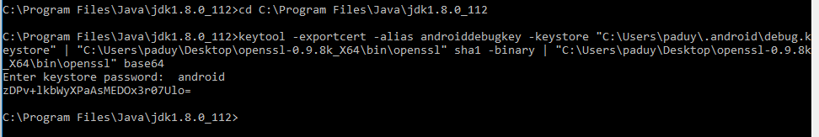

Copy Debug Key Hash and paste Key Hashes box

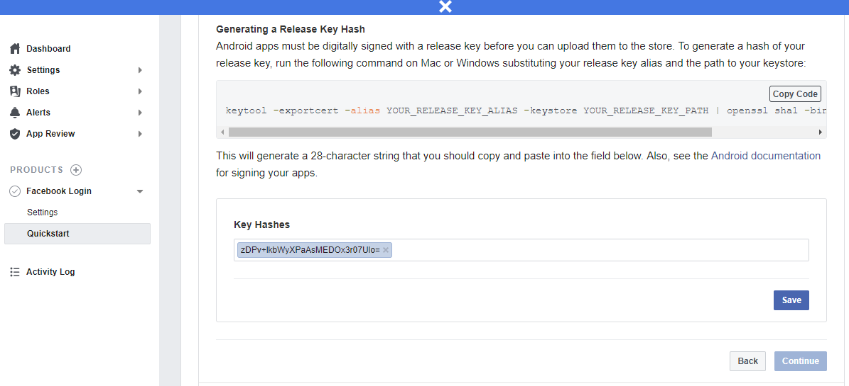

Click “Save”, “Continue”

1. **Step 7:** Enable Single Sign On for Your App

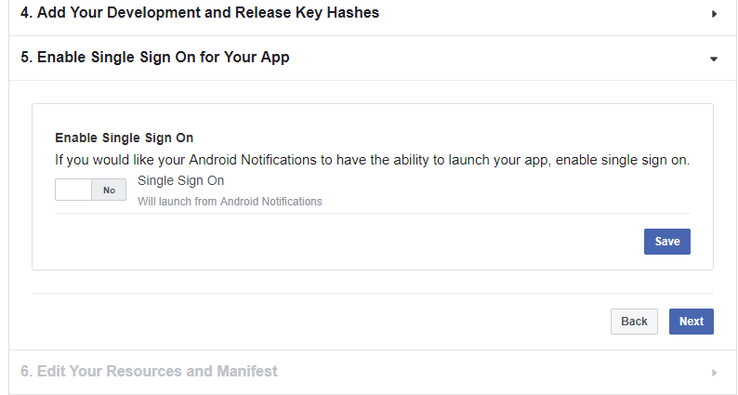

Switch to “Yes”, Click “Save” “Next”

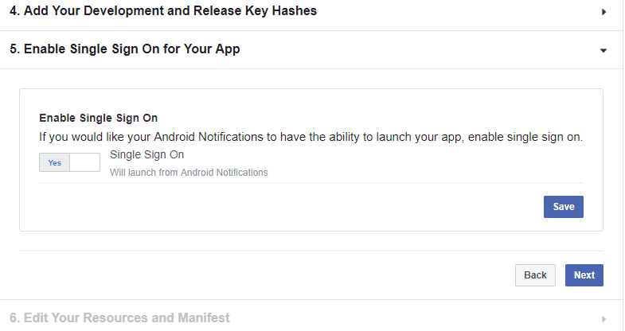

1. **Step 8:** Edit Your Resources and Manifest

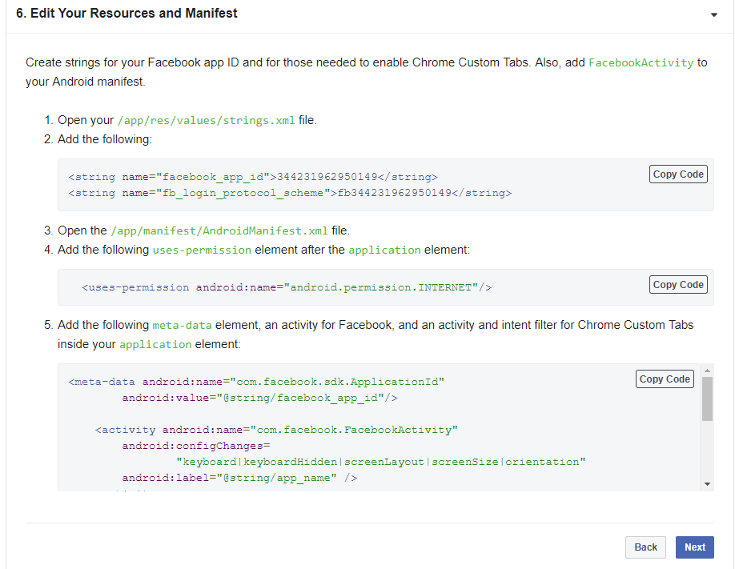

Manifest after updating

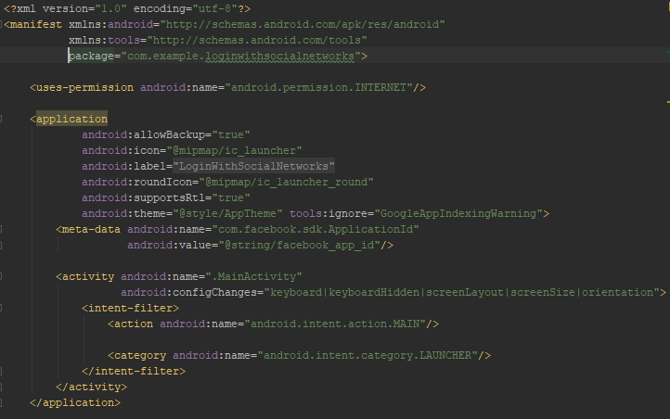

Click “Next”

**Skip 2 steps: Log App Events and Add the Facebook Login Button**

1. **Step 9:** Register a Callback

Create a login button in activity_main.xml and following guide of Register a Callback. There is code after updating:

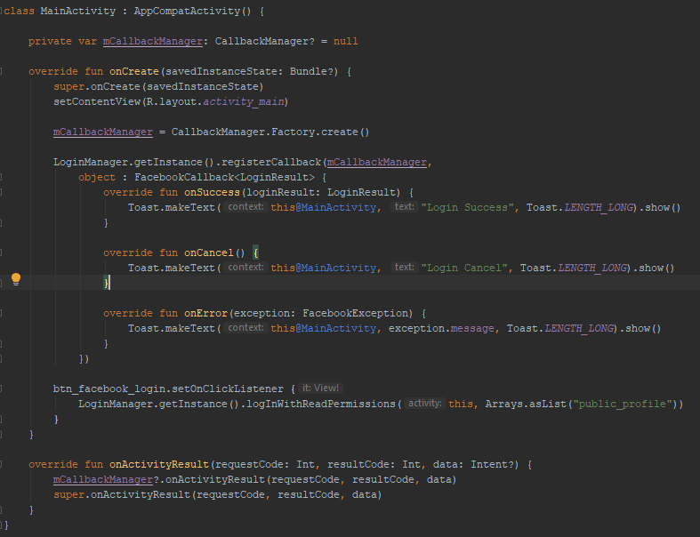

Completed code.

1. **Step 10:** Check login status

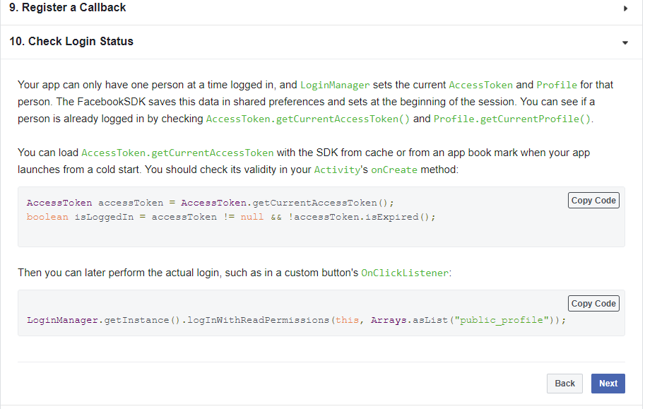

1. GOOGLE

Following this link: <https://developers.google.com/identity/sign-in/android/start>

1. TWITTER
2. INSTAGRAM
3. Register Your Application: <https://www.instagram.com/developer/>

After registering your application, click on Manage Clients to register a new Client

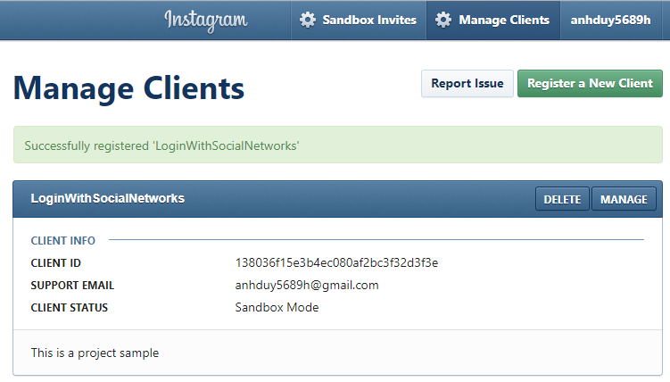

Click “MANAGE”

1. Update Redirect URIs = <http://localhost> , Uncheck “Disable implicit OAuth”

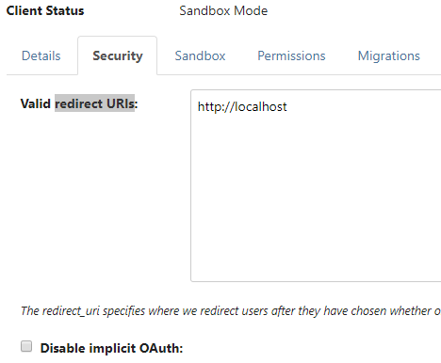

1. Read Authentication

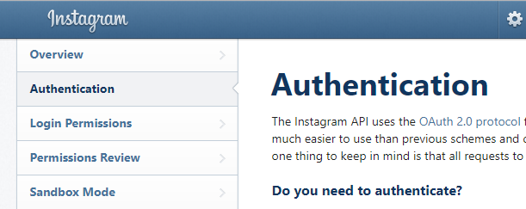

For test: Choose Client-Side (Implicit) Authentication

<https://www.instagram.com/oauth/authorize/?client_id=138036f15e3b4ec080af2bc3f32d3f3e&redirect_uri=http://localhost&scope=public_content&response_type=token>

1. aa