**APP CHATBOT**

* **Đảo chiều xu hướng chắc chắn sẽ có quay lại test vùng lần nữa**

# 20/4

## Phá giả

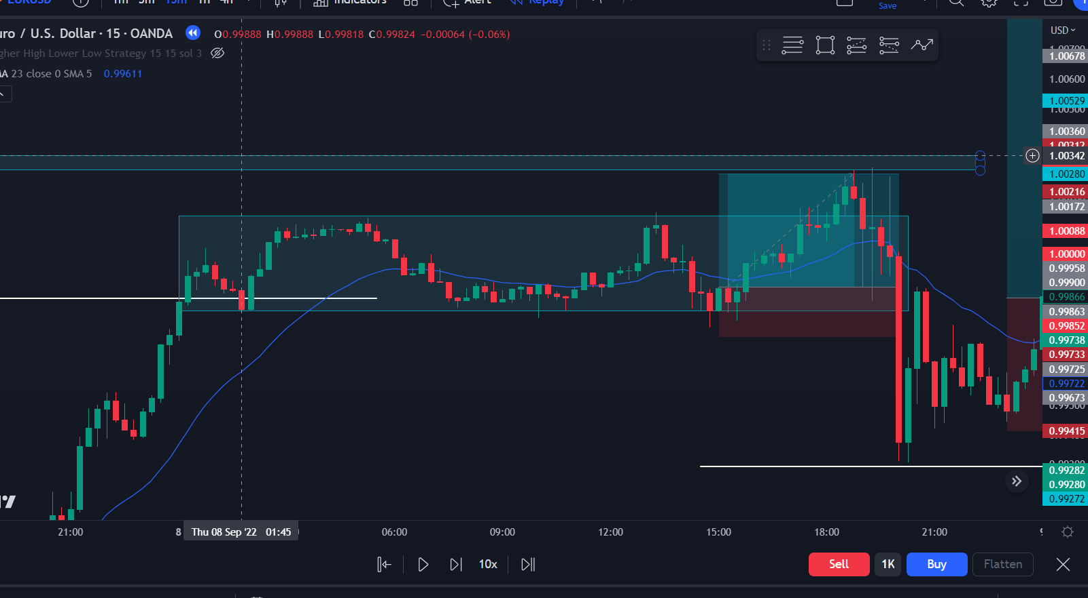

Id:1 | Time:15h | Tp:2.5 | classify: Phá giả 2 lần

Dk:

- Thuận xu hướng tăng

- Giá sideway tại vùng BULL vừa phá, lần 2 phá xuống thất bại, tạo nến có râu dài (phá giả)

- Tạo engufing tại đáy phá giả không được lần 2 => vào tại điểm này |

Alert: none

## Break

## Retest

## Phá giả

## Retest + break

## Break

## Break

## Break

## Retest

## Break

## Retest + break

## Break

