**Parameter Selection and Data Collection**

To value this product, we need to know the initial index value, threshold index value, determination dates, maturity, interest rate from now to maturity, dividend yield of SP 500, volatility of SP 500. Next, we will talk about how we collect these data.

**Initial index value and threshold index value:** they can be found on the product website. The values are 2704.1 and 1757.665.

**Determination dates and maturity:** to simplify the calculation, we assume the time spans from the pricing date to the first determination date, the second determination date and the maturity are 1, 2 and 3, which are really close to the real time spans.

**Interest rate:** via SWDF function on Bloomberg, we find the three-year discount factor on Jan 31 2019 is 0.927011418 (mid), with which we can get the compounded continuously interest rate is 0.025263132.

**Dividend yield:** through Bloomberg Dividend Forecasts function, we can find the projected dividend yield is 2.12% and we choose it for our calculation.

**Volatility:** there are four European options, the implied volatilities of which have influence on the product value: one-year option with strike price at 2704.1, two-year option with strike price at 2704.1, three-year option with strike price at 2704.1 and three-year option with strike price at 1757.665. We collected the implied volatilities of these options through Volatility Matrix on Bloomberg:

|  |  |  |
| --- | --- | --- |
|  | buy | short |
| one-year 2704.1 option | 16.39% | 16.04% |
| two-year 2704.1 option | 17.65% | 17.05% |
| three-year 2704.1 option | 18.38% | 16.97% |
| three-year 1757.665 option | 25.56% | 23.33% |

**Table 1**

We decide to use the mean of these eight volatilities for our calculation, which is 0.18921.

**Tree Construction and Valuation Procedure**

We choose CRR binomial tree to conduct calculation. In this model, we have $u=e^{σ\sqrt{dt}}$, $d=1/u$, $q=\frac{e^{\left(r-div\right)dt}-d}{u-d}$. First, we use the parameters we collected to get the SP 500 index value matrix for the number of steps N. To get the value of the product, we conduct the following calculation:

$$V_{N,i}=1300, if S_{N,i}≥2704.1$$

$$V_{N,i}=1000, if 1757.665≤S_{N,i}<2704.1$$

$$V_{N,i}=1000*S_{N,i}/2704.1, if S_{N,i}<1757.665$$

$$V_{j,i}=e^{-r*dt}\left(q*V_{j+1,i+1}+\left(1-q\right)*V_{j+1,i}\right), if j≠N and j≠a or b$$

$$V_{j,i}=e^{-r*dt}\left(q*V_{j+1,i+1}+\left(1-q\right)*V_{j+1,i}\right), if j≠N, j=a, and S_{j,i}<2704.1$$

$$V_{j,i}=1100*exp⁡(r\left(a*dt-1-\frac{3}{365}\right)), if j≠N, j=a, and S_{j,i}≥2704.1$$

$$V_{j,i}=e^{-r*dt}\left(q*V_{j+1,i+1}+\left(1-q\right)*V_{j+1,i}\right), if j≠N, j=b, and S_{j,i}<2704.1$$

$$V_{j,i}=1200*exp⁡(r\left(b*dt-2-\frac{3}{365}\right)), if j≠N, j=b, and S_{j,i}≥2704.1$$

$$where a is the rounded down integer of\frac{1}{dt}, b is the rounded down integer of\frac{2}{dt}$$

With formulas above, we use Python to calculate the value of the product for time steps ranging from 51 to 10001 in steps of 50. The reason we choose odd numbers as the numbers of steps is that when the position of the nodes relative to the initial value is in the middle, the tree gives the most accurate value, and when the number is the steps is odd, the position is in the middle. We can see the graph of N(x-axis) against value(y-axis) as follows:

**Graph 1**

From the graph, we can see that as N increases, the value converges to 994.2(keeping two digits), which is also the result when N is 10001. Hence, we think the value of the product is 994.62.

**Discussion of Results and Sensitivity Analysis**

On the product website, we can see the estimated value on the pricing date is 997.4. Our result is really near it, but difference still exists.

We think the difference is mainly because some parameters are not accurate enough. Among all the parameters we need, we are confident that we have the right data for the initial index value, threshold index value, determination dates, maturity, and interest rate. However, the dividend yield and volatility are just based on estimations of Bloomberg and our assumption. If the real-world values for these two parameters are not the same as our estimations, errors will happen.

Next, we will search the real-world ranges of yield and volatility, conduct sensitivity analysis and discuss how the value will change if dividend yield and volatility change.

To get the range of dividend yield, we collected the historical dividend yields of SP 500 from 2008 to 2018 from Multpl [1]. We find that during the nearest 10 years, the dividend yield of SP 500 ranges from 0.018 to 0.032 and we assume this is the reasonable range of the dividend yield.

From Table 1, we can know the implied volatilities of the four options whose volatilities have influence on the calculation of product value. The maximum of these implied volatilities is 26%, and the minimum is 16%. So we assume the reasonable range for the volatility is from 16% to 26%.

We choose 10001 as the number of steps and analyze how the price will change if dividend yield and volatility change in their reasonable ranges. The 3D graph shows the valuation of the product price:

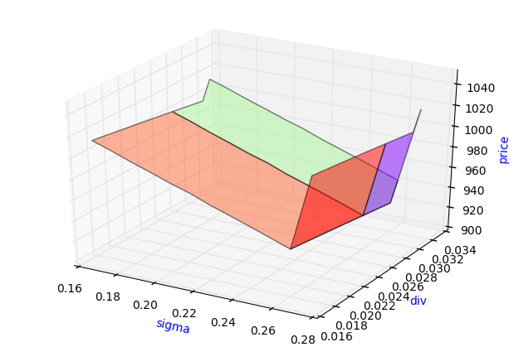

**Graph 2**

From the graph, we can see if dividend yield or volatility deviates from our estimations in the first part, the price will also deviate from our result. In our estimated ranges of dividend yield and volatility, the price of the product can be as high as 1016.75, which happens when the dividend yield is 0.033 and volatility is 27%, and can be as low as 926.025, which happens when the dividend yield is 0.032 and volatility is 26%.

[1] http://www.multpl.com/s-p-500-dividend-yield/table