**FRM Project Report**

**Portfolio Construction**

Our portfolio involves writing Dow Jones Index straddles and buying straddles on the component stocks. Between vega-neutral and theta–neutral dispersion trade, we choose vega–neutral dispersion trade, as a bet that individual stock volatility profiles will diverge from the index average. We hope that gains in the long single-stock volatility leg are only partially offset by the short index volatility.

We choose to construct our portfolio on December 29 2017. The tenor of all options is 3 months. We will show our calculation of numbers of each component straddles, Greeks, Value at Risk, and expected shortfall in the following. Finally, we will discuss our results and other risks that are not captured by our system.

**Calculation of numbers of each component straddles**

Our portfolio involves writing one at-the–money DJI straddle (The DJI index options are based 1/100th of the current value of DJI and also have a multiplier of 100) and buying several at-the-money stock straddles on December 29 2017. To ensure the vega of our portfolio is zero, we have:

|  |  |  |
| --- | --- | --- |
|  | $$k\sum_{i=1}^{30}{w_{i}*{vega of stock straddle }_{i}}=vega of DJI straddle$$ | (1) |

where $w_{i}$ is the weight of ${stock}_{i}$ on Dow Jones Index.

To get the value of k, we first collect the close price data of DJI and all component stocks from January 3 2017 to December 29 2017 (totally 251 trading days). Then we use Garch(1,1) Model to calculate the alphas, betas, long-run volatilities and volatilities on the first trading day (January 3 2017). With these coefficients, we can get the all volatilities from January 3 2017 to December 29 2017.

After that, we also collect the weights and dividend yields of all the index components on December 29 2017 from Bloomberg. We also get that on December 29 2017, the continuously compounded interest is 0.0169.

|  |  |  |
| --- | --- | --- |
| Stock | Dividend Yield | Weight on DJI |
| UTX | 2.2330% | 3.5534% |
| MCD | 2.3880% | 4.7943% |
| DIS | 0.0000% | 2.9946% |
| JNJ | 2.4470% | 3.8918% |
| GS | 1.1940% | 7.0962% |
| JPM | 2.1350% | 2.9788% |
| VZ | 4.5700% | 1.4743% |
| HD | 2.1230% | 5.2793% |
| GE | 2.9140% | 0.4861% |
| PG | 3.0650% | 2.5593% |
| KO | 3.4660% | 1.2780% |
| CSCO | 3.0940% | 1.0668% |
| CAT | 2.0160% | 4.3893% |
| MMM | 2.1440% | 6.5561% |
| BA | 2.3610% | 8.2146% |
| INTC | 2.4050% | 1.2858% |
| AAPL | 1.5130% | 4.7138% |
| AXP | 1.4340% | 2.7662% |
| XOM | 3.7620% | 2.3298% |
| V | 0.6930% | 3.1760% |
| IBM | 3.9980% | 4.2735% |
| PFE | 3.8380% | 1.0089% |
| NKE | 1.2970% | 1.7423% |
| TRV | 2.1580% | 3.7782% |
| MRK | 3.4780% | 1.5674% |
| WMT | 2.1400% | 2.7506% |
| CVX | 3.5880% | 3.4871% |
| UNH | 1.3800% | 6.1408% |
| DWDP | 3.2300% | 1.9838% |
| MSFT | 1.9970% | 2.3827% |
| DJI | 2.2120% |  |

Table 1: dividend yields of DJI and index components and weights of stocks

Now with closing prices, which are also strike prices, time to maturity, interest rate, dividend yields and volatilities, we can use GBSGreeks Function of R to calculate the vegas of all straddles. From the equation (1), we can get the value of *k* is 156.4817. Then, we get the numbers of each component straddles.

Using GBSOption Function of R, we calculate the prices of the component options and DJI options. With these option price information, we get our portfolio value is 840.79.

|  |  |
| --- | --- |
| Stock | Number of Straddles (= ${k*w}_{i}$) |
| UTX | 5.560441 |
| MCD | 7.502257 |
| DIS | 4.686078 |
| JNJ | 6.090027 |
| GS | 11.10432 |
| JPM | 4.661233 |
| VZ | 2.30708 |
| HD | 8.261113 |
| GE | 0.7606 |
| PG | 4.004808 |
| KO | 1.999789 |
| CSCO | 1.669397 |
| CAT | 6.868497 |
| MMM | 10.25916 |
| BA | 12.85435 |
| INTC | 2.011993 |
| AAPL | 7.376291 |
| AXP | 4.328661 |
| XOM | 3.645648 |
| V | 4.969832 |
| IBM | 6.687173 |
| PFE | 1.578734 |
| NKE | 2.72639 |
| TRV | 5.91219 |
| MRK | 2.452661 |
| WMT | 4.304253 |
| CVX | 5.456703 |
| UNH | 9.60927 |
| DWDP | 3.104292 |
| MSFT | 3.728463 |

Table 2: dividend yields of DJI and index components and weights of stocks

**Calculation of Greeks**

Since we choose vega–neutral dispersion trade, the vega of our portfolio is zero. For each at-the-money straddle, we also know that the deltas of them are all zero, so the delta of our portfolio is zero.

With closing prices, which are also strike prices, time to maturity, interest rate, dividend yields and volatilities, we can use GBSGreeks Function of R to calculate the gammas, thetas, and rhos of all straddles. Adding them together separately, we can get the gamma, theta and rho of our portfolio.

|  |  |
| --- | --- |
| Greek | Value |
| Vega | 0 |
| Delta | 0 |
| Gamma | 5.959891 |
| Theta | -1665.809 |
| Rho | 11.38158 |

Table 3: Greeks of our portfolio

**Calculation of VaR and Expected Shortfall**

We use Monte Carlo Simulation to calculate the Value at Risk and expected shortfall of our portfolio. So far, we have get the volatilities of all the index components on December 29 2017. With our estimates of alphas, betas and long-run volatilities from Garch(1,1) Model, we can get the volatilities of stocks on the next trading day. To simulate the prices of stocks on the next trading day, we need to know the correlation between all stock pairs.

We apply DCC(1,1) Model to calculate the correlations. With MLE method, we can get the alpha and beta of the DCC model after standardizing each return by its dynamic standard deviation. Next, we compute the correlation matrix from January 3 2017 to December 29 2017 and also the correlation matrix on the next trading day after December 29 2017.

Now, with the standard deviations of stocks and correlation matrix on the next trading day after December 29 2017, we can get the covariance matrix, based on which we can generate possible returns for the next day. After that, we can get the possible closing prices of each stock on the next day. For each simulation path, dividing the sum of component prices by Dow Divisor can give us the possible values of Dow Jones Index on the next trading day.

We choose 10,000 as the number of simulations. After getting the values of stock prices and DJI on each path, we use GBSOption Function of R to compute the straddle prices on the next day and then our possible portfolio values. Finally, we get our one-day VaR and expected shortfall.

|  |  |
| --- | --- |
| $${VaR}_{95\%}$$ | 6.50602 |
| $${VaR}_{99\%}$$ | 16.28958 |
| $${ES}_{95\%}$$ | 12.49754 |
| $${ES}_{99\%}$$ | 22.39201 |

Table 4: VaR and ES of our portfolio

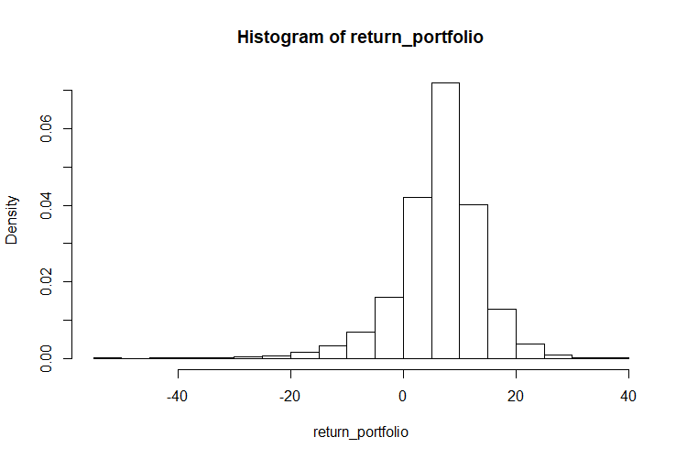

Graph 1: Distribution of one-day return

**Discussion of Results and Other Risks**

According to the Greeks we get above, the instantaneous change in stock prices and DJI value will have no effect on the portfolio value, since the delta is zero. Also, the effect of instantaneous change in volatilities is also zero. Since gamma is positive, changes in prices will lead positive delta and change in prices will be more favorable than indicated by delta. Meanwhile, because theta is negative, our portfolio value has a decreasing tendency as time passes. Our portfolio value also has a positive correlation with riskless interest rate.

From our results from last part, we can see that one-day ${VaR}_{95\%}$, ${VaR}_{99\%}$, ${ES}_{95\%}$ and ${ES}_{99\%}$ are relatively small compared with the initial value of our portfolio. From the return distribution graph, we can also see that it is more probable that the one-day return is positive. This means that our portfolio is more likely to be profitable. This also means that only in very rare cases, our portfolio will lose more than 50% of the initial value or even more.

There are still risks that are not captured by our model. First, the index components can change sometimes. If a stock with high volatility is eliminated from Dow Jones Index, and the new component stock drives DJI volatility up, it is possible that the value of DJI will deviate a lot from the initial value. In this case, the gains in the long single-stock volatility leg may be less than the loss from the short position in DJI straddle. Our method does not account for this risk.

Second, as the prices of components change, the weights of these stocks change. In this way, our portfolio is not vega-neutral anymore. Our method does not take the effects of weights on the portfolio value into consideration. If the weights change a lot, our portfolio may suffer large loss.