**Parameter Selection and Data Selection**

To value this product, we need to know interest rate from pricing date to maturity, dividend yields of SP 500 and Russell 2000, volatilities of SP 500 and Russell 2000 and the correlation between SP 500 and Russell 2000. Next we will talk about how we collect or estimate these data.

**Interest rate:** via SWDF function on Bloomberg, we find the five-year and six-year discount factors on April 4 2018, with which we can get the five-year and six-year continuously compounded rates. By interpolating, we can get the continuously compounded rate from pricing date to maturity is 0.027.

**Dividend yields:** through WSJ website, we can find the dividend yield of SP 500 on the pricing date is 1.92%, and the dividend yield of Russell 2000 is 1.3%. We choose them for our calculation.

**Volatilities:** via Option Value Matrix Function of Bloomberg, we collect the implied volatilities of 65-month options of SP 500 and Russell 2000 with the moneyness of 95%, 100% and 121%. Finally, we choose the 121% in the money call option implied volatilities, which are relatively small since we know that in the long run, volatilities of stock market are relatively small and the period from the pricing date to maturity is relatively long. The implied volatility of SP 500 is 17%, while the implied volatility of Russell 2000 is 20.64%.

**Correlation:** through Yahoo Finance, we download the historical daily prices of these two indexes from 1/01/2000 to 4/04/2018 (the pricing date). After computing the daily log returns of SP 500 and Russell 2000, we calculate the correlation based on the nearly eighteen-year historical information. Our result is 0.906796. We use is to conduct calculation.

**Model Selection and Valuation Procedure**

We use Monte Carlo Simulation to value this product. There are totally 1362 trading days from the pricing date to the end of averaging date. We choose dt equal to one trading day, namely dt=1/252. Under risk neutral measurement, we can have:

$$dSPX=\left(r-{div}_{SPX}\right)SPXdt+σ_{SPX}dW_{1}$$

$$dRussell=\left(r-{div}_{RU}\right)Russelldt+σ_{RU}dW_{2}$$

With the built-in function in Python, we can draw correlated random values for $dW_{1}$ and $dW_{2}$ and ensure that their mean is zero and variance is dt. Then we simulate the values of SP 500 and Russell 2000 from April 4 2018 to September 6 2023.

For each simulation path, we calculate both the means of the index values during the averaging dates. We denote them as ${SP}_{T}$ and ${RU}_{T}$. After that, we calculate the expected payoff of the product. The formulas are as follows:

If (${SP}_{T}≥1.21{SP}_{0}$) and (${RU}_{T}≥1.21{RU}_{0}$), then $payoff=min⁡(2116.4,1000+1000*(min\left(\frac{{SP}_{T}}{{SP}_{0}},\frac{{RU}_{T}}{{RU}_{0}}\right)-1.21)*3.34+415$;

If (${SP}_{T}≥{SP}_{0}$) and (${RU}_{T}≥{RU}_{0}$) and (min($\frac{{SP}_{T}}{{SP}_{0}},\frac{{RU}_{T}}{{RU}_{0}}$)<1.21), then $payoff=1000+1000*(min\left(\frac{{SP}_{T}}{{SP}_{0}},\frac{{RU}_{T}}{{RU}_{0}}\right)-1)*1.5+100$;

If (${SP}_{T}≥0.95{SP}_{0}$) and (${RU}_{T}≥0.95{RU}_{0}$) and (min($\frac{{SP}_{T}}{{SP}_{0}},\frac{{RU}_{T}}{{RU}_{0}}$)<1), then $payoff=1000+1000*(min\left(\frac{{SP}_{T}}{{SP}_{0}},\frac{{RU}_{T}}{{RU}_{0}}\right)-0.95)*2$;

Otherwise, $payoff=1000*(min\left(\frac{{SP}_{T}}{{SP}_{0}},\frac{{RU}_{T}}{{RU}_{0}}\right))+50$.

After simulating 10,000 times, we calculate the arithmetic mean of all the payoffs. Finally, we discount the mean to the pricing date. Our result is 970.22.

**Discussion of Results and Sensitivity Analysis**

From the product website, we can see that the estimated value of the notes on the pricing date is $972.30 per $1,000 principle amount note. Our result is really near it, but is a little lower.

We think the difference between our result and Morgan Stanley’s estimated value is from two sources. First, since the payoff of this structured product at maturity is non-linear, there is non-linearity problem in our model. But we do not know how to deal with it with Monte Carlo Simulation. Second, our estimates of some parameters are not accurate enough, so errors exist.

Among all the parameters we use, we are confident that we have the right data for the interest rate. However, the dividend yield and volatility are just based on estimations of Bloomberg and our assumption. Meanwhile, the correlation is just based on historical information, and we are not sure whether the correlation will be the same for the period from the pricing date to the maturity. If the real-world values for these five parameters are not the same as our estimations, errors will happen. Since the dividend yields always have a small effect on the product price, whereas the value is very sensitive to the volatilities and correlation we input, we will next conduct sensitivity analysis and discuss how the value will change if the volatilities and correlation change.

First, we keep the correlation constant and discuss how the value changes as the volatilities of these two indexes change. From the volatility matrix on Bloomberg, we can see that the implied volatilities are ranging from 15% to 25%. We choose 10000 as the number of simulations and analyze how the price will change if volatilities change in their reasonable ranges. The 3D graph shows the valuation of the product price:

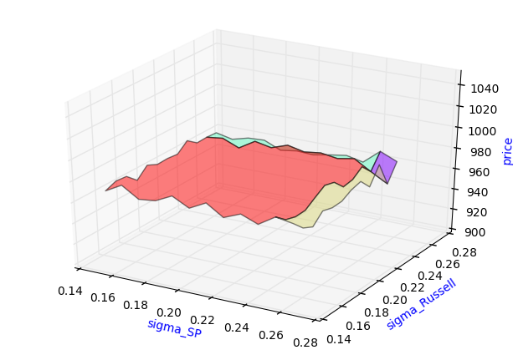

**Graph 1**

From the graph, we can see if the volatilities deviate from our estimations in the first part, the price will also deviate from our result. In our estimated reasonable ranges of volatilities, the price of the product can be as high as 983.095, which happens when the volatility of SP 500 is 18% and volatility of Russell 2000 is 17%, and can be as low as 955.67, which happens when the volatility of SP 500 is 26% and volatility of Russell 2000 is 25%.

Next, we keep the volatilities constant and discuss how the value changes as the correlation of these two indexes change. From the historical log returns, we can see that the correlation is ranging from 0.85 to 0.95. We choose 10000 as the number of simulations and analyze how the price will change if the correlation changes in the reasonable range. The below graph shows the valuation of the product price as the correlation changes:

**Graph 2**

From the graph, we can see that when we keep the volatilities constant if the correlation deviates from our estimation in the first part, the price will also deviate from our result. In our estimated reasonable range of correlation, the price of the product can be as high as 979.5884, which happens when the correlation is 89%, and can be as low as 966.13, which happens when the correlation is 94%.