

**ECE-111 Advanced Digital Design Projects**

* **Objective of Homework-2:** Learn how to create parameterized modules, how to instantiate a module in another module, how to connect primary ports of two modules using explicit name based binding approach. Learn functional behavior of SystemVerilog arithmetic and logical operators and understand hardware generated for each of the operator post synthesis. Observe change in value of signals in sensitivity list of always block how it impacts the behavior of the circuit.

**Homework-2a**

* Design synthesizable SystemVerilog Model of 4-bit ALU (Arithmetic Logic Unit) which can perform following mentioned functions:

|  |  |  |
| --- | --- | --- |
| **Operation Select** | **Function** | **Function Definition** |
| 4'b0000 | operand1 + operand2 | Addition |
| 4'b0001 | operand1 - operand2 | Subtraction |
| 4'b0010 | operand1 * operand2 | Multiplication |
| 4'b0011 | operand1 % operand2 | Division |
| 4'b0100 | operand1 / operand2 | Modulo |
| 4'b0101 | operand1 & operand2 | Bitwise AND |
| 4'b0110 | operand1 | operand2 | Bitwise OR |
| 4'b0111 | operand1 ^ operand2 | Bitwise XOR |
| 4'b1000 | operand1 && operand2 | Logical AND |
| 4'b1001 | operand1 || operand2 | Logical OR |
| 4'b1010 | operand1 << 1 | Left Shift by 1 |
| 4'b1011 | operand1 >> 1 | Right Shift by 1 |
| 4'b1100 | operand1 == operand2 | Logical Equality |
| 4'b1101 | operand1 != operand2 | Logical Inequality |
| 4'b1110 | operand1 < operand2 | Less Than Comparison |
| 4'b1111 | operand1 > operand2 | Greater Than Comparison |

**Block Diagram of alu_top block**

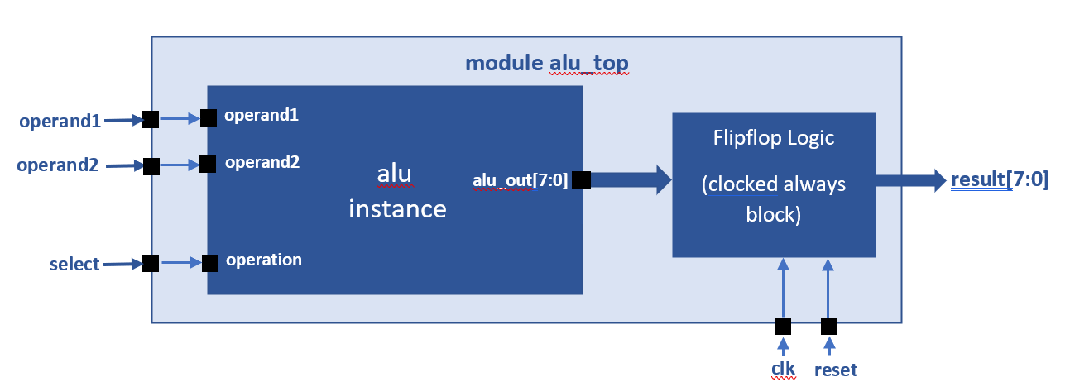

* Create module with name "alu"
  + Declare 4-bit logic type input primary ports: operand1, operand2, operation
  + Declare 8-bit logic type output primary alu_out
  + Declare parameter "N" with default value set as 4. N is used when declaring width of operand1 and operand2 primary ports
  + Use always block with operation, operand1, operand2 in its sensitivity list
  + Within always procedural block, use "case" statement to select between alu operations
  + Ensure default case expression is provided with addition operation
* Create another module alu_top
  + Declare 4-bit logic type input primary ports: operand1, operand2, select
  + Declare 8-bit logic type output primary result
  + Instantiate alu module inside module alu_top
  + In instance of alu, connect primary ports of alu_top with alu primary ports using explicit name based binding approach
  + Add positive edge triggered flipfop at the output of alu

**Note:** flipflop logic is already implemented in alu_top template code provided in lab folder

* Perform synthesis of alu_top and alu module
  + Review resource usage report, RTL Netlist and Post Mapping Schematics
* Perform simulation of alut_top using alu_top_testbench provided in lab folder
  + Review all 16 ALU operation results in waveform
  + Observe functional behavior of all ALU operations. Especially review the difference between logical and bitwise and / or operations

**Homework Submission:**

**Submit report (PDF file) which should include:**

* SystemVerilog code snapshot of module alu_top and alu
* Provide snapshot of FPGA resource usage generated post synthesis
* Provide snapshot of schematic generated from RTL netlist viewer
* Provide snapshot of simulation waveform and explain simulation result

**Note:** Lab2.zip folder has following mentioned files:

* alu_top.sv template code
* alu.sv template code
* alu_top_testbench.sv with full testbench implementation

**Reference Simulation Snapshot**

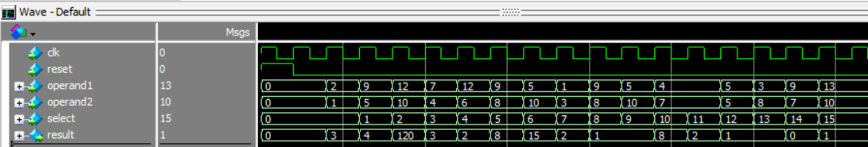

**Homework-2b**

**Develop synthesizable SystemVerilog code for 4-bit up down binary counter. Refer to below mentioned block diagram of up_down_counter when developing SystemVerilog code.**

**module up_down_counter**

**count[3:0]**

**up_count_value[3:0]ount**

mux_2x1

instance

**clk**

up_counter

instance

**in0[3:0]**

**clk**

**clear**

**out[3:0]**

**count_value[3:0]**

**clear**

**clk**

down_counter

instance

**sel**

**down_count_value[3:0]]ount**

**count [3:0]**

**in1[3:0]**

**clear**

**select**

* In up_down_counter there are two separate counters. These are :
  + 4-bit up counter which counts values from 0 to 15 in increment by 1 each clk cycle
  + 4-bit down counter which counts values from 15 to 0 in decrement by 1 each clk cycle
* Output of both up and down counters are connected to inputs of a 2-to-1 Multiplexer
  + When "select" input port of up_down_counter module is driven to '0' then output of multiplexer should reflect up_counter count values (i.e. 0 to 15 count values)
  + When "select" input port of up_down_counter module is driven to '1' then output of multiplexer should generate down_counter count values (i.e. 15 to 0 values)
* Review code for up_counter module in up_counter.sv file and using it as a reference update down_counter module in down_counter.sv file with required modification
* Review mux_2to1.sv file and make update width of it primary ports in0, in1 and out to 4 bits
* Instantiate up_counter, down_counter and mux_2x1 modules inside up_down_counter module and connect the ports of modules using explicit name based binding approach
  + Output count port from up_counter and down_counter should be connected to mux_2x1 in0 and ini1 ports using wires up_count_value and down_count_value
  + Output out port of mux should be connected to primary port result of up_down_counter
  + Primary input port select of up_down_counter should be connected to sel port of mux_2x1
  + Primary input port clk and clear should be connected to clk and clear ports of up_counter and down_counter
* Synthesize up_down_counter top level module along with sub-modules up-counter, down_counter, mux_2to1
* Review synthesis results (resource usage and RTL netlist/schematic)
* Run simulation using up_down_counter testbench code provided in Lab2 folder
* Review up down counter input output signals in simulation waveform

**Homework Submission**

**Submit report (PDF file) which should include:**

* up_down_counter, up_counter, down_counter, mux_2x1 SystemVerilog code
* Provide snapshot of FPGA resource usage generated post synthesis
* Provide snapshot of schematic generated from RTL netlist viewer
* Provide snapshot of simulation waveform and explain simulation result

**Note:** Lab2.zip folder has following mentioned files:

* up_down_counter.sv template code
* down_coutner.sv with partial code
* up_counter.sv with full implementation
* mux2to1.sv with full implementation
* up_down_counter_testbench.sv with full testbench implementation

**Reference Simulation Snapshot**

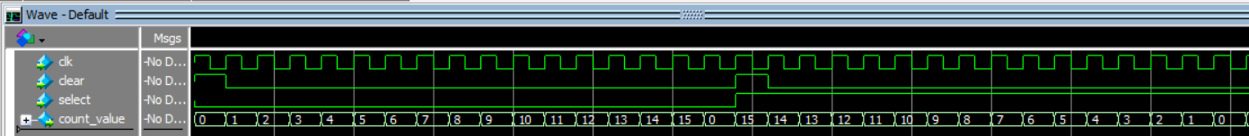

**When select ==1, down counter counting from 15 to 0**

**When select == 0, up counter counting from 0 to 15**