ECE 111 Winter 2022  
HW7  
Hao Le A15547504

**UART Receiver**

Code

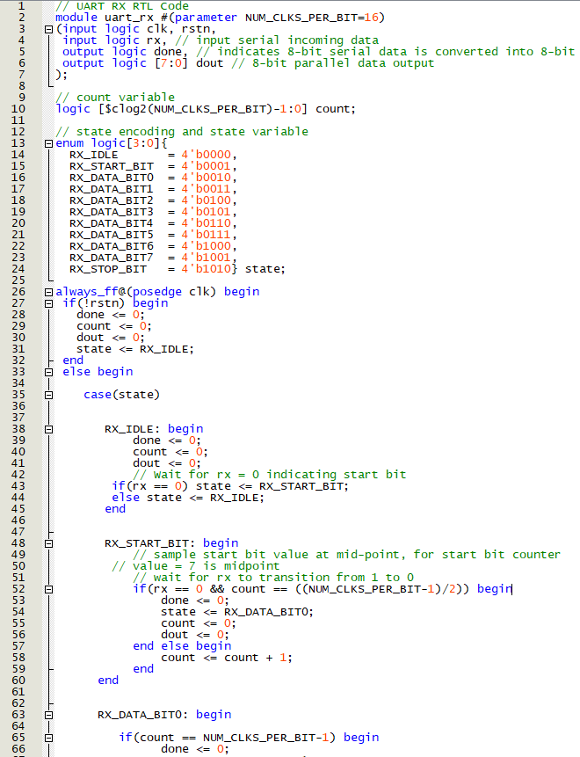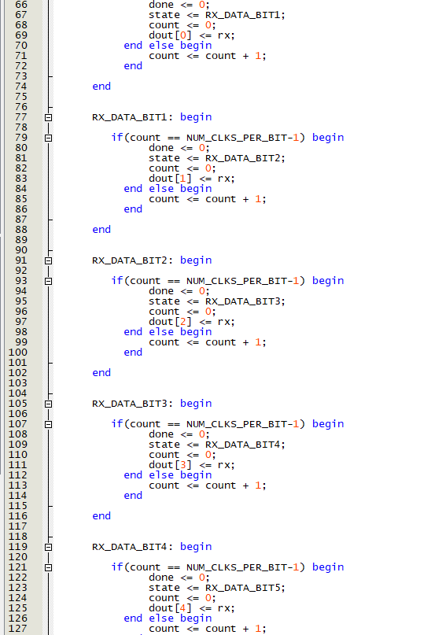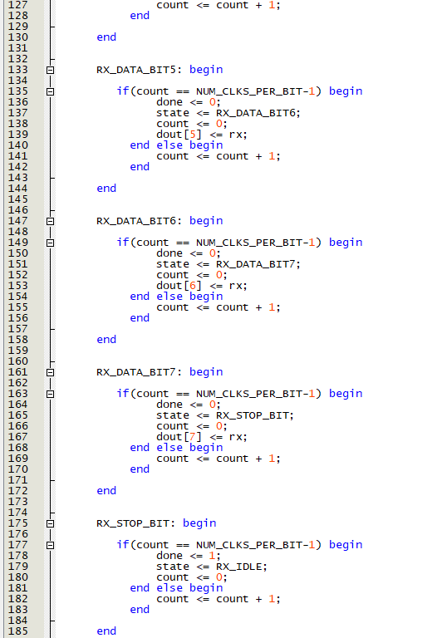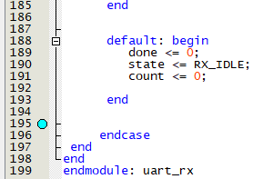

RTL netlist

Resource usage

State diagram

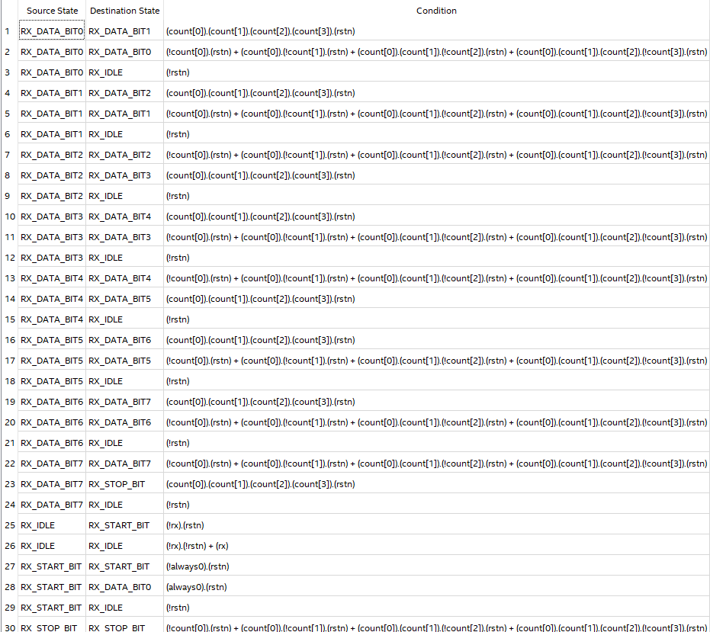

Testbench simulation waveform

* When rx first goes low, this indicates a start bit, and we can observe the state variable going to that state
* Then, for 16 clock cycles from the halfway point of that start bit, we can observe the dout register getting values changed from LSB to MSB
* Moreover, the state also changes at the halfway point of every bit, indicating that the incoming bits are being sampled at the right times
* Once the eight bit has been sampled, the state changes to the stop state, where the stop bit is sampled as a high – subsequently the done bit is raised high as a pulse, dout represents the received byte, then the receiver goes back to idle state
* The receiver DUT passes all the tests
* Described above are signs that the receiver is behaving correctly

**UART TX-RX Communication System**

Code

RTL netlist

Resource usage

Testbench simulation waveform

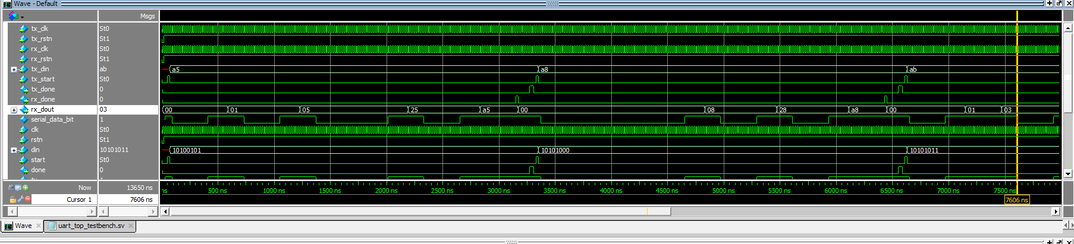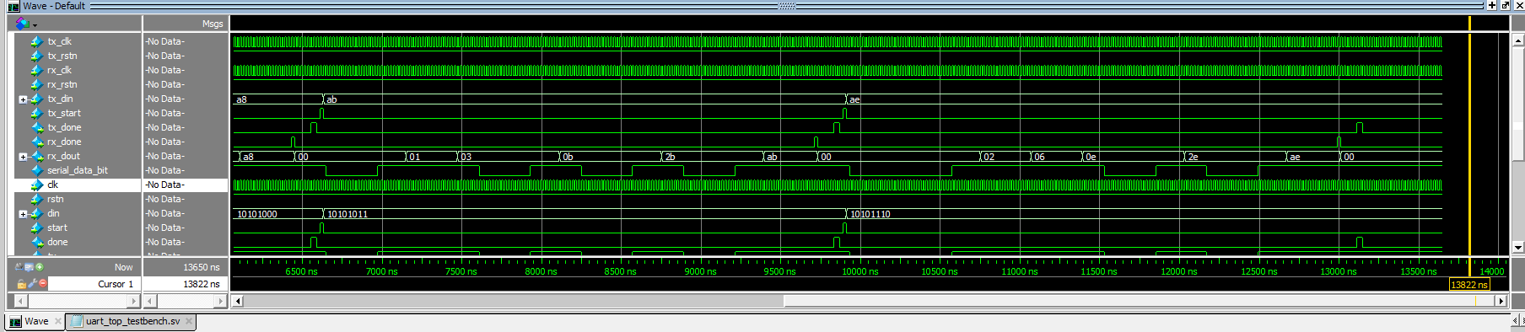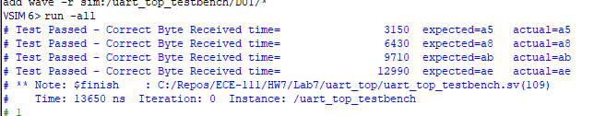

* Shown above is the detailed waveform of both tx and rx UART modules working together, where the tx module transmits 4 different bytes loaded in through tx_din, and the rx deserializes the byte and outputs that to rx_dot
* For example, the first byte to be transmitted is A5 in hexadecimal. After tx_start goes high, this signals tx to start serializing what is in tx_din which is A5
* After the starting of tx, we also see rx_dout start to change, indicating that rx has received that start bit, so it starts reading
* We can also observe the wire connecting the modules taking on the serialized data, on wire serial_data_bit
* Once rx has received all eight bits, it pulls rx_done high to indicate so. Similarly, tx also pulls tx_done high
* The end data is output to rx_dout. It matches with what was initially fed into tx_din
* Described above is the correct behavior between the two modules, for all four test cases

**UART Control System**

RX Control code

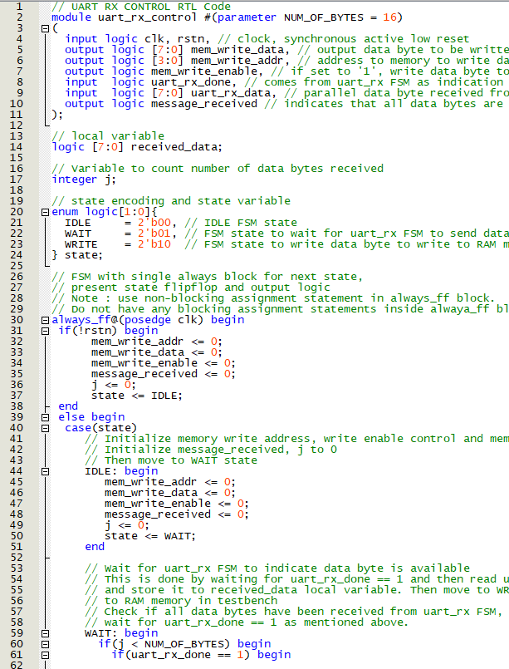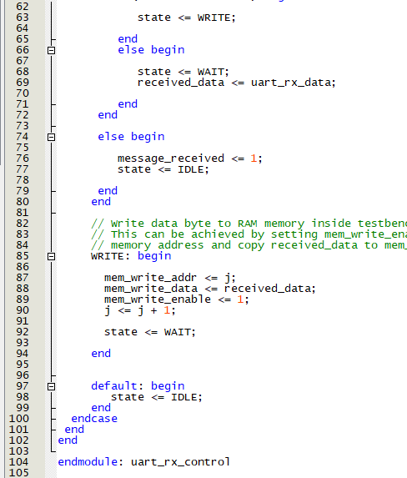

RX Control state diagram

TX Control code

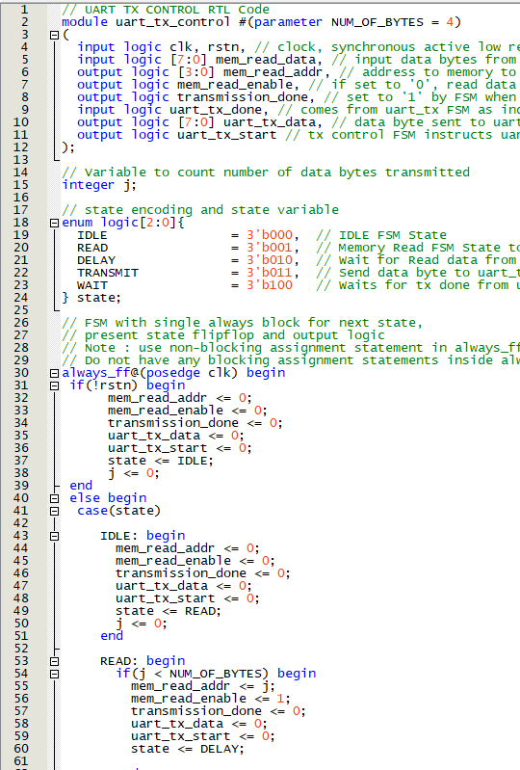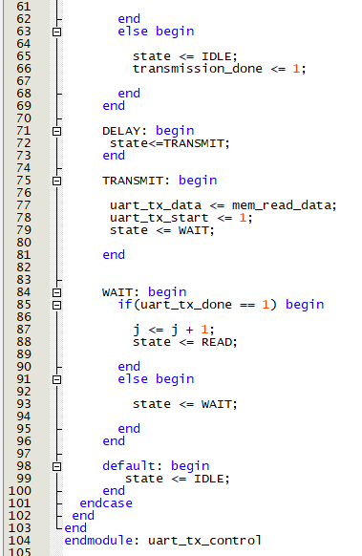

TX Control state diagram

UART Control System code

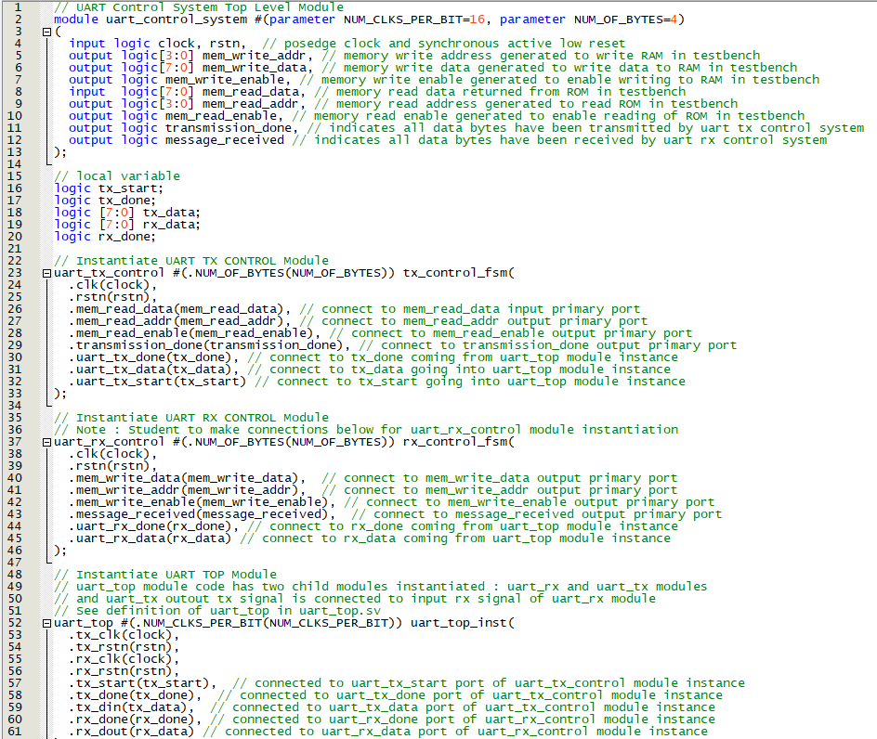

RTL netlist

Resource usage

Testbench simulation waveform

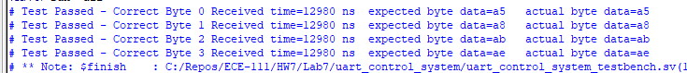

* The data being read from memory by the tx controller is matched with the data written to memory by the rx controller – we can observe this by seeing mem_read_data being matched by mem_write_data after rx_done signal goes high to indicate all 8 bits have been received by the UART top module
* When all four bytes have been transferred, message_received goes high indicating that all 4 bytes have been written to memory
* Described above is the correct behavior for the UART control system