LAB 2
Exercise 1: Deploy webpage on Github
Link webpage on Github: https://anhhuynh1707.github.io/
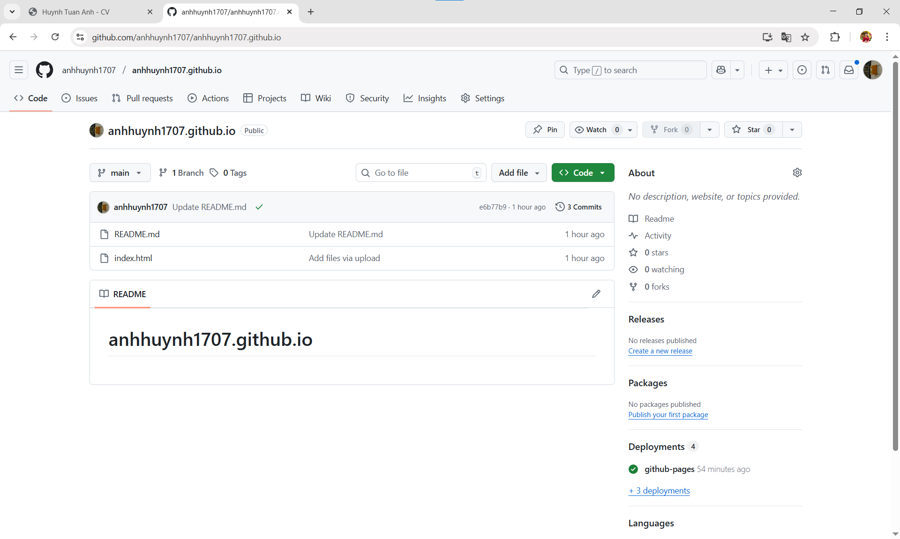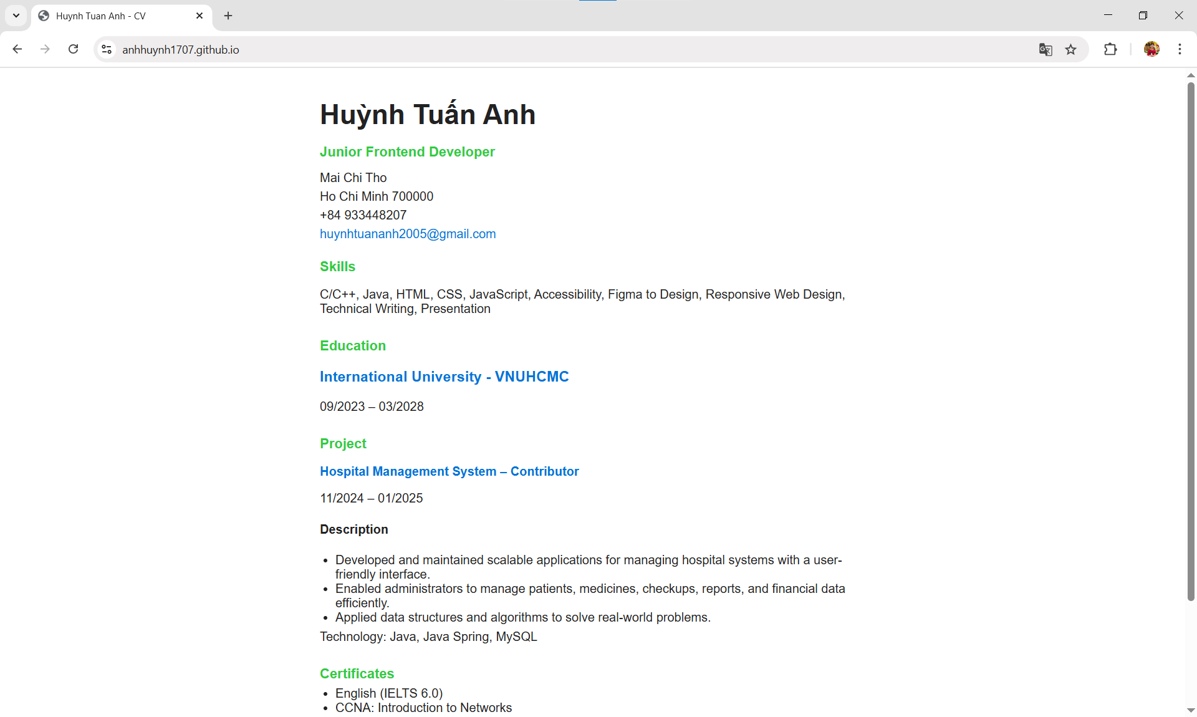
Exercise 2: Form on webpage
Source code:
<!DOCTYPE html>
<html lang="en">
<head>
<meta charset="UTF-8">
<meta name="viewport" content="width=device-width, initial-scale=1">
<title>Survey Form</title>
<!-- Bootstrap CSS -->
<link href="https://cdn.jsdelivr.net/npm/bootstrap@5.3.3/dist/css/bootstrap.min.css" rel="stylesheet">

<style>
body {
margin: 40px;
font-family: Arial, sans-serif;
display: flex;
justify-content: center;
}
main {
max-width: 650px;
}
header img {
width: 100px;
display: block;
margin-bottom: 10px;
}
h2,
legend {
font-weight: bold;
color: #007B7F;
}
label.form-label,
label.col-form-label {
font-weight: bold;
}
.form-check-label {
font-weight: normal;
}
.btn-submit {
margin-top: 15px;
}
</style>
</head>
<body>
<main>
<header>
<img src="favicon.png" alt="Logo">
<h2>Survey</h2>
<p>If you have a moment, we'd appreciate it if you would fill out this survey.</p>
</header>
<section>
<h4 class="fw-bold" style="color:#007B7F;">Your information:</h4>
<form>
<fieldset class="mb-3 d-flex align-items-center">
<label for="fname" class="col-form-label me-3" style="width: 150px;">First Name</label>
<input type="text" id="fname" class="form-control" required>
</fieldset>

<fieldset class="mb-3 d-flex align-items-center">
<label for="lname" class="col-form-label me-3" style="width: 150px;">Last Name</label>
<input type="text" id="lname" class="form-control" required>
</fieldset>

<fieldset class="mb-3 d-flex align-items-center">
<label for="email" class="col-form-label me-3" style="width: 150px;">Email</label>
<input type="email" id="email" class="form-control" required>
</fieldset>

<fieldset class="mb-3 d-flex align-items-center">
<label for="dob" class="col-form-label me-3" style="width: 150px;">Date of Birth</label>
<input type="date" id="dob" class="form-control" required>
</fieldset>
<fieldset class="mb-4">
<legend class="fw-bold h4" style="color:#007B7F;">How did you hear about us?</legend>

<section class="d-flex flex-wrap gap-4">
<label class="form-check">
<input class="form-check-input" type="radio" name="source" id="search" checked>
Search engine
</label>

<label class="form-check">
<input class="form-check-input" type="radio" name="source" id="word">
Word of mouth
</label>

<label class="form-check">
<input class="form-check-input" type="radio" name="source" id="social">
Social Media
</label>

<label class="form-check">
<input class="form-check-input" type="radio" name="source" id="other">
Other
</label>
</section>
</fieldset>
<fieldset class="mb-4">
<legend class="fw-bold h4" style="color:#007B7F;">
Would you like to receive announcements about new CDs and special offers?
</legend>

<section>
<label class="form-check">
<input class="form-check-input" type="checkbox" id="offers">
YES, I'd like that.
</label>

<label class="form-check mt-2">
<input class="form-check-input" type="checkbox" id="emails">
YES, please send me email announcements.
</label>
</section>
</fieldset>
<fieldset class="mb-3 d-flex align-items-center">
<label for="contactMethod" class="form-check-label me-3" style="width: 180px;">
Please contact me by:
</label>

<select class="form-select" id="contactMethod" style="max-width: 200px;">
<option>Email or postal mail</option>
<option>Email only</option>
<option>Postal mail only</option>
</select>
</fieldset>
<button type="submit" class="btn btn-primary btn-submit">Submit</button>
</form>
</section>
</main>
<script src="https://cdn.jsdelivr.net/npm/bootstrap@5.3.3/dist/js/bootstrap.bundle.min.js"></script>
</body>
</html>
Result:
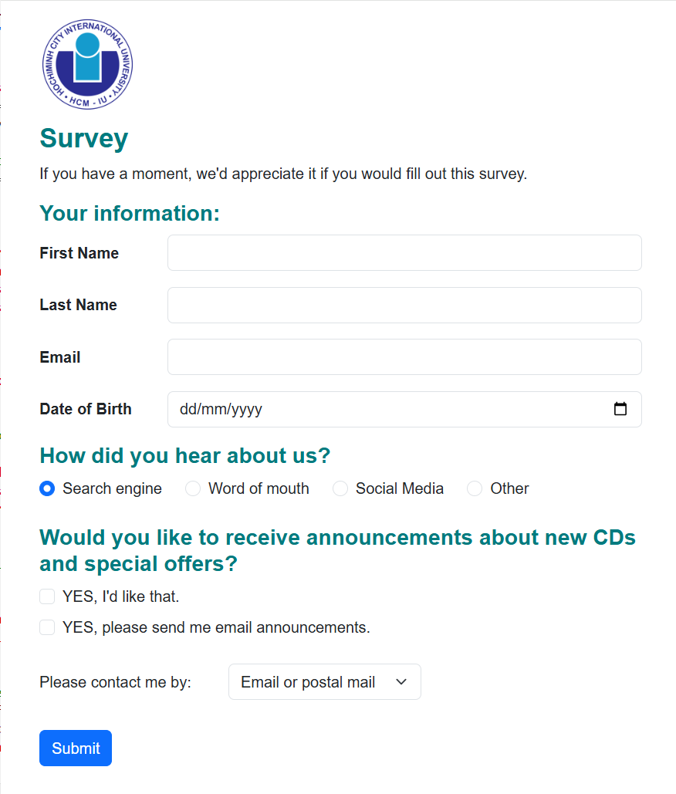
Exercise 3:
Source code:
<!DOCTYPE html>
<html lang="en">
<head>
<meta charset="UTF-8">
<meta name="viewport" content="width=device-width, initial-scale=1.0">
<title>Lab 2 - Ex2</title>
<style>
body {
background-color: #f4b978;
margin: 0;
font-family: Arial, sans-serif;
}
.page {
padding: 40px 0;
}
.container {
width: 90%;
max-width: 960px;
margin: 0 auto;
background-color: white;
border: 1px solid #000;
display: flex; /* Flexbox layout */
flex-direction: column; /*Flexbox layout */
min-height: 95vh;
box-shadow: 0 0 10px rgba(0, 0, 0, 0.1);
box-sizing: border-box;
}
.header,
.footer {
background-color: #fff;
padding: 20px;
text-align: center;
font-weight: bold;
border: 1px solid #ddd;
}
.content {
display: flex; /* Flexbox layout */
flex: 1;
border-top: 1px solid #ddd;
border-bottom: 1px solid #ddd;
flex-wrap: wrap; /* allows sidebars to stack on small screens */
}
.sidebar {
background-color: #fff;
padding: 20px;
border-right: 1px solid #ddd;
width: 150px;
box-sizing: border-box;
font-weight: bold;
}
.sidebar-b {
border-left: 1px solid #ddd;
border-right: none;
}
.main {
flex: 1; /*Flexbox layout */
background-color: #fff;
padding: 20px;
box-sizing: border-box;
font-weight: bold;
}
</style>
</head>
<body>
<div class="container">
<header class="header">Header</header>
<div class="content">
<aside class="sidebar sidebar-a">Sidebar A</aside>
<main class="main">Main content</main>
<aside class="sidebar sidebar-b">Sidebar B</aside>
</div>
<footer class="footer">Footer</footer>
</div>
</body>
</html>
Result:
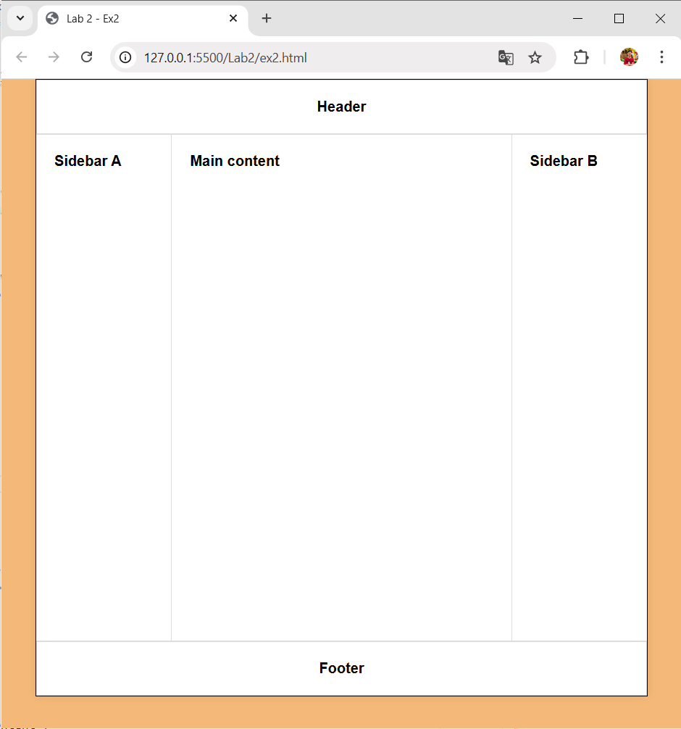
Explain: In the .container in style tag, we apply Flexbox layout called display: flex. Flexbox arranges the header, content, and footer vertically. The .content section in style tag uses Flexbox to place Sidebar A, Main Content, and Sidebar B horizontally. The flex-wrap: wrap allows stack on smaller screens.
Exercise 4:
Source code:
<!DOCTYPE html>
<html lang="en">
<head>
<meta charset="UTF-8">
<meta name="viewport" content="width=device-width, initial-scale=1.0">
<title>San Joaquin Valley Town Hall</title>
<style>
body {
background-color: #f4b978;
margin: 0;
font-family: Arial, Helvetica, sans-serif;
}
.page {
width: 960px;
margin: 20px auto;
background-color: white;
border: 1px solid #ccc;
box-shadow: 0 0 10px rgba(0, 0, 0, 0.1);
padding: 20px;
box-sizing: border-box;
}
.header {
display: flex;
/* Flexbox for layout */
align-items: center;
border-bottom: 2px solid #f4b978;
padding-bottom: 10px;
}
.logo {
width: 80px;
height: 80px;
margin-right: 15px;
}
.title h1 {
color: #d4841c;
margin: 0;
}
.title p {
margin: 0;
font-style: italic;
font-weight: bold;
line-height: 0.8em;
}
.content {
display: flex;
/* Flexbox for layout */
gap: 20px;
margin-top: 20px;
}
.main {
flex: 2;
}
.main h2 {
color: #000;
font-size: 1.5em;
}
.main ul {
list-style-type: disc;
padding-left: 20px;
line-height: 1.0;
}
.main ul li {
margin-bottom: 5px;
}
.main a {
color: #7b3f00;
text-decoration: none;
}
.main a:hover {
text-decoration: underline;
}
.main h3 {
margin-top: 25px;
color: #000;
}
.sidebar {
flex: 1;
/* Sidebar takes less space */
background-color: #fff4e1;
border: 1px solid #e0c190;
padding: 15px;
box-sizing: border-box;
}
.sidebar h3 {
background-color: #fff4e1;
margin-top: 0;
font-weight: bold;
font-size: 1.5em;
line-height: 0.8em;
}
.sidebar h4 {
color: #a62b00;
margin-bottom: 5px;
}
.footer {
text-align: right;
border-top: 1px solid #ccc;
margin-top: 20px;
padding-top: 10px;
font-size: 0.9em;
}
@media (max-width: 768px) {
.header {
flex-direction: column;
align-items: flex-start;
}
.logo {
margin-bottom: 10px;
}
.content {
flex-direction: column;
}
.sidebar {
order: 2;
}

.main {
order: 1;
}
.page {
width: 95%;
padding: 15px;
}
.main h2,
.sidebar h3 {
font-size: 1.3em;
}
}
</style>
</head>
<body>
<div class="page">
<header class="header">
<img src="favicon.png" alt="Town Hall Logo" class="logo">
<div class="title">
<h1>San Joaquin Valley Town Hall</h1>
<p><em>Bringing cutting-edge speakers to the valley</em></p>
</div>
</header>
<div class="content">
<section class="main">
<h2>This season's guest speakers</h2>
<ul>
<li>October: <a href="#">David Brancaccio</a></li>
<li>November: <a href="#">Andrew Ross Sorkin</a></li>
<li>January: <a href="#">Amy Chua</a></li>
<li>February: <a href="#">Scott Sampson</a></li>
<li>March: <a href="#">Carlos Eire</a></li>
<li>April: <a href="#">Ronan Tynan</a></li>
</ul>
<h3>Looking for a unique gift?</h3>
<p>
Town Hall has the answer. For only $100, you can get a book of tickets for all of the remaining
speakers. And the bargain includes a second book of tickets for a companion.
</p>
<p>
Or, for $50, you can give yourself the gift of our speakers, and still get an extra ticket for a
companion, but for just one of the events.
</p>
<p>See you at the next show!</p>
<p><strong><em>Contact us by phone</em></strong> at (559) 555-1212 for ticket information.</p>
</section>
<aside class="sidebar">
<h3>Lecture notes</h3>
<h4>Event change for November</h4>
<p>
SJV Town Hall is pleased to announce the addition of award-winning author Andrew Ross Sorkin. The
appearance of previously scheduled speaker, Greg Mortenson, has been postponed.
</p>

<h4>Lecture day, time, and location</h4>
<p>
All one-hour lectures are on the second Wednesday of the month beginning at 10:30 a.m. at William
Saroyan Theatre, 700 M Street, Fresno, CA.
</p>
</aside>
</div>
<footer class="footer">
<p>&copy; Copyright 2022 San Joaquin Valley Town Hall.</p>
</footer>
</div>
</body>
</html>
Result:
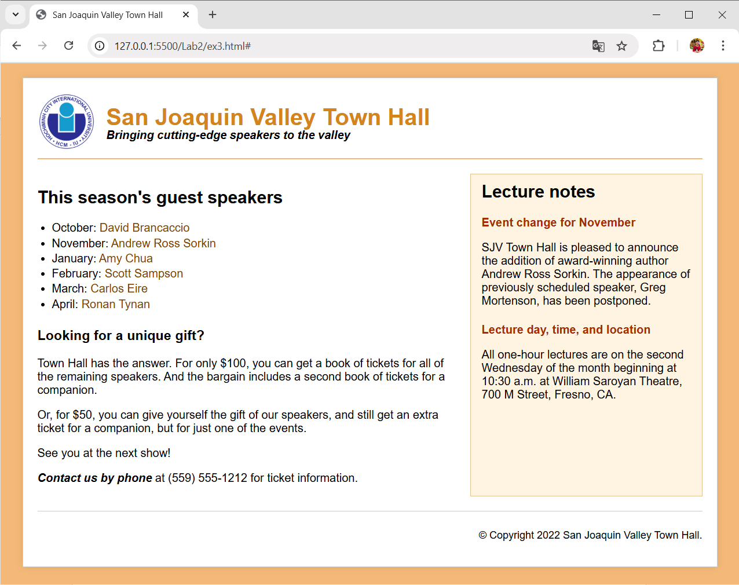
Explain: This HTML and CSS code builds a professional, responsive webpage for the San Joaquin Valley Town Hall using Flexbox for layout control. The .page container centers the content, adds a white background, borders, and a drop shadow for a clean framed look. The header section uses Flexbox to position the logo beside the site title and tagline, keeping them vertically aligned. The content area also uses Flexbox to create a two-column layout, with the main section taking up twice as much space as the sidebar (flex: 2 and flex: 1). The sidebar is visually distinct with a light background and border. The footer aligns text to the right, and a responsive media query ensures the design adjusts on smaller screens by stacking elements vertically and resizing text for readability. Overall, the code demonstrates effective use of Flexbox for alignment, spacing, and responsive webpage design within a clean, structured layout.

