Report Lab 5

Exercise 1:
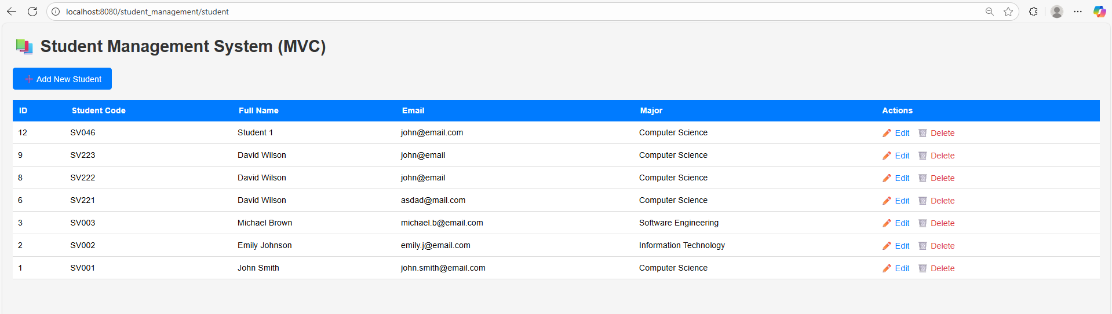
Flow explanation:
- Browser → GET /student
- The browser sends a GET request to the servlet mapped at /student.
- StudentController receives the request through the doGet() method.
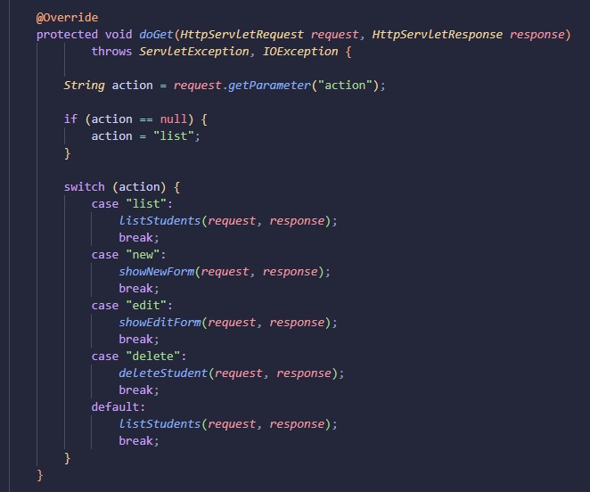
- The controller checks the URL parameter action; since it is null, it defaults to "list".
- The controller calls listStudents(request, response), the controller calls studentDAO.getAllStudents() to fetch all student records.
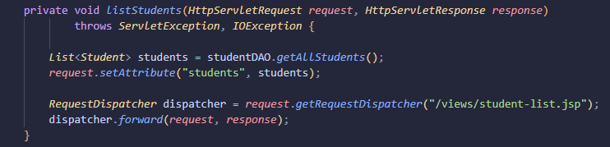

- The StudentDAO connects to the MySQL database, runs SELECT * FROM students, and returns a List<Student> object.
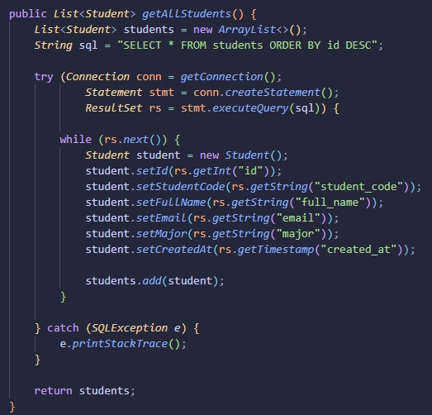
- The controller adds this list to the request object using request.setAttribute("students", students).
- It then forwards the request to /views/student-list.jsp using a RequestDispatcher.
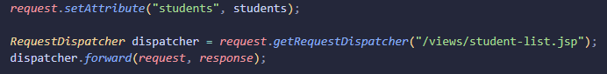
- The JSP uses JSTL (<c:forEach>) to loop through ${students} - the attribute students which was set in the controller now can be used to loop. and display each row in an HTML table,
- The rendered HTML page with the list of students is sent back as the response to the browser.

Exercise 2:
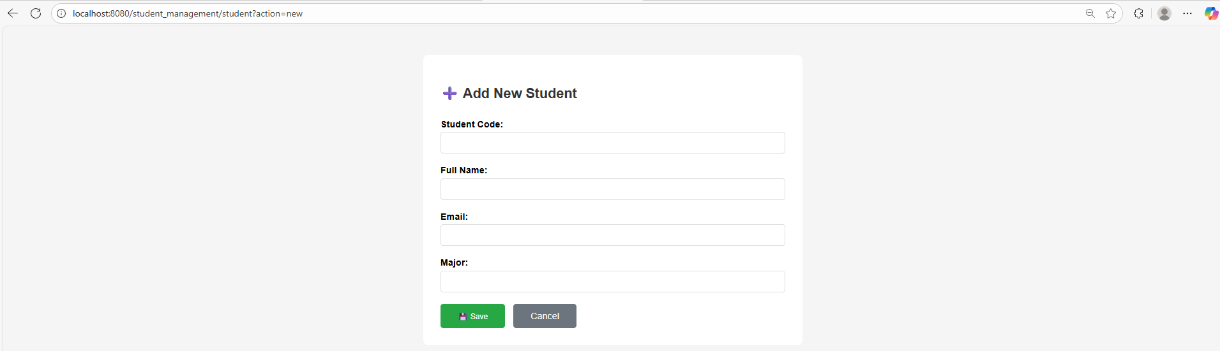
Case failed: (duplicative id)
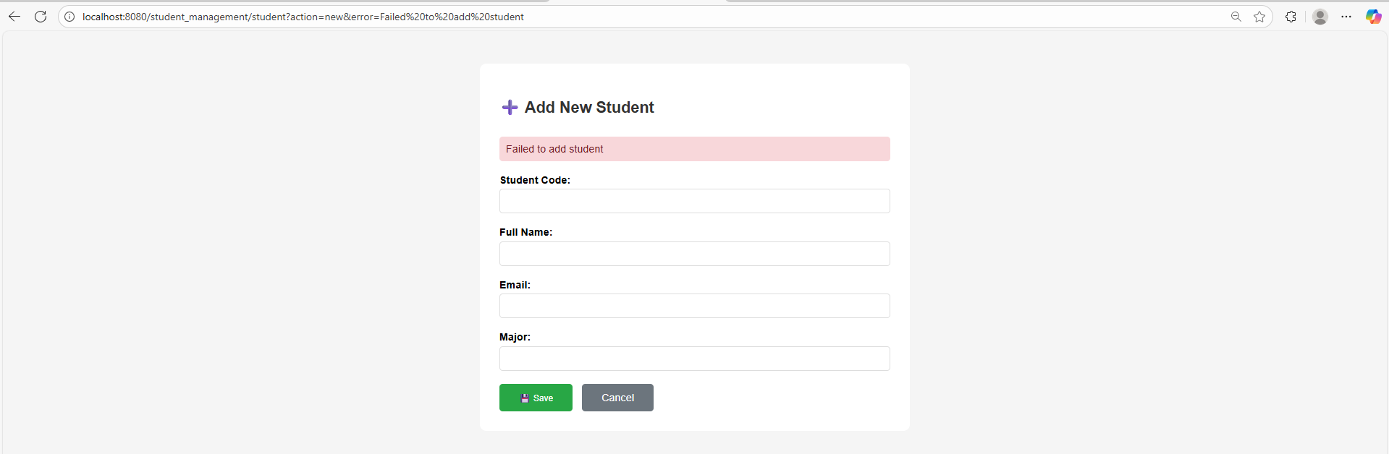
Case success:
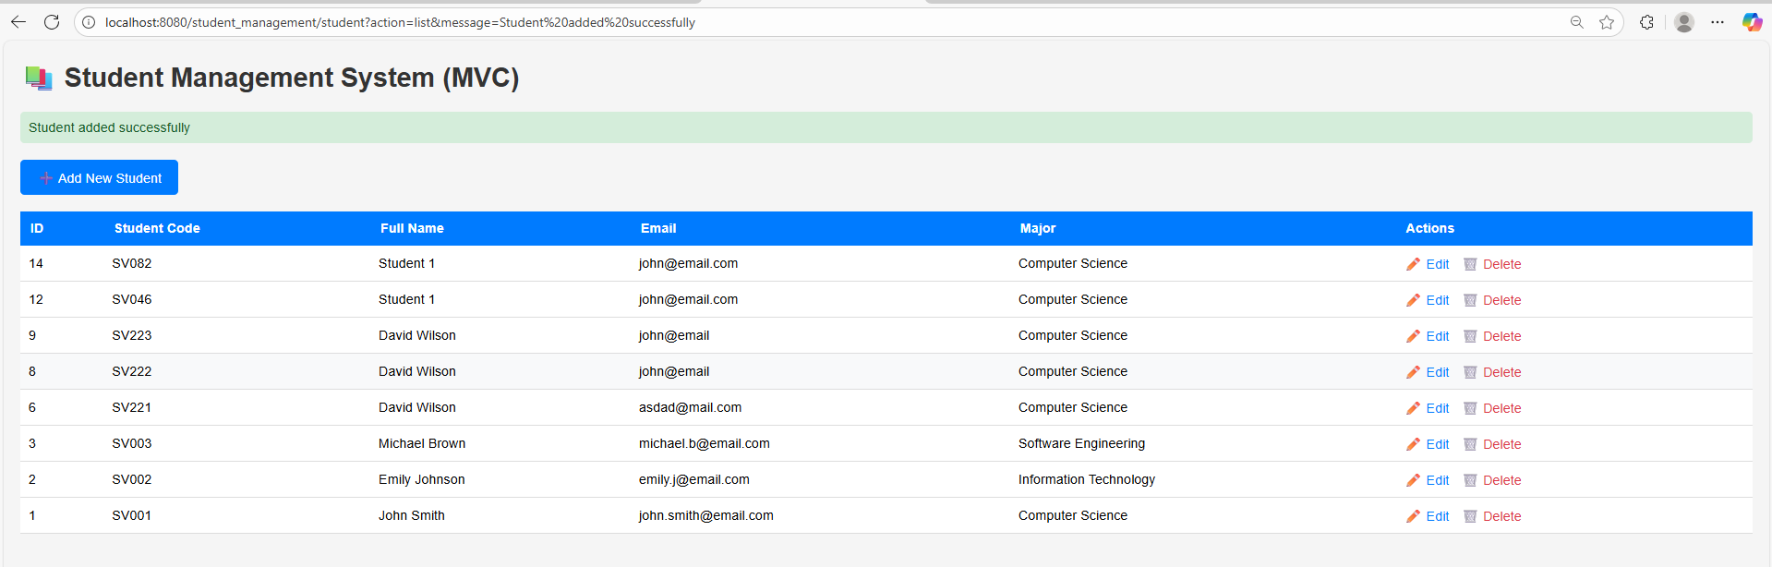

Flow explanation:
- Browser → Clicks “Add New Student”
The link student?action=new sends a GET request to /student?action=new.
- StudentController.doGet() receives the request and detects the action "new".
- The controller calls showNewForm(request, response), directing the user to /views/student-form.jsp.
- The user fills in the form fields and clicks Save, sending a POST request to /student with all the form data and action=insert.
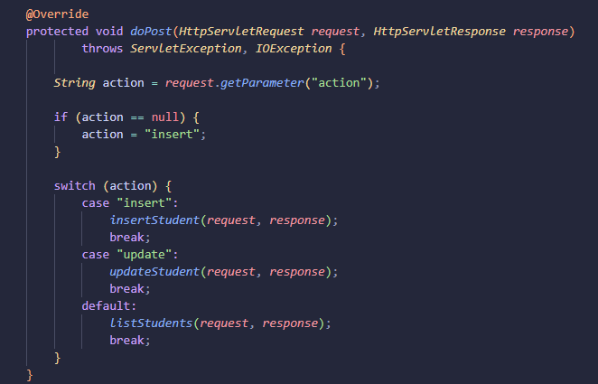
- The controller’s doPost() reads the action parameter ("insert") and calls insertStudent(request, response).
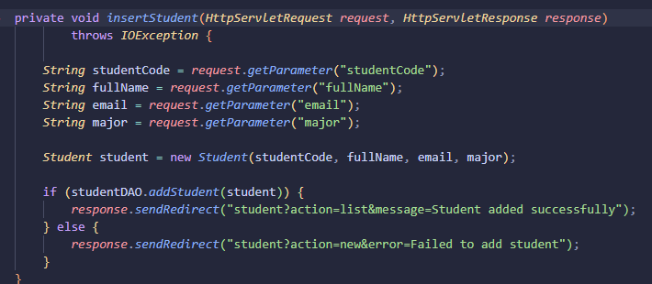
- Inside insertStudent(), form data (studentCode, fullName, email, major) are read and used to create a new Student object.
- The controller calls studentDAO.addStudent(student), which connects to MySQL and executes an INSERT SQL command.
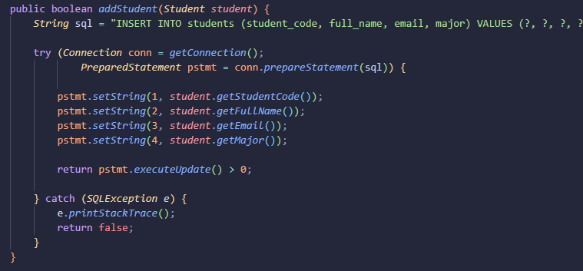
- If insertion succeeds, the controller redirects the browser to student?action=list&message=Student added successfully, otherwise, redirects to student?action=new&error=Failed to add student
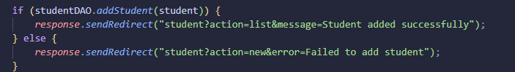
- The browser sends a new GET request and updated student list with a success message.

Exercise 3:
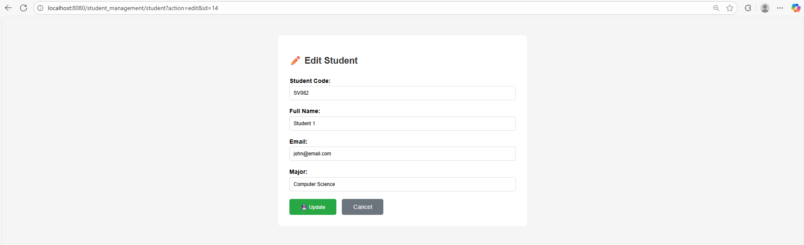
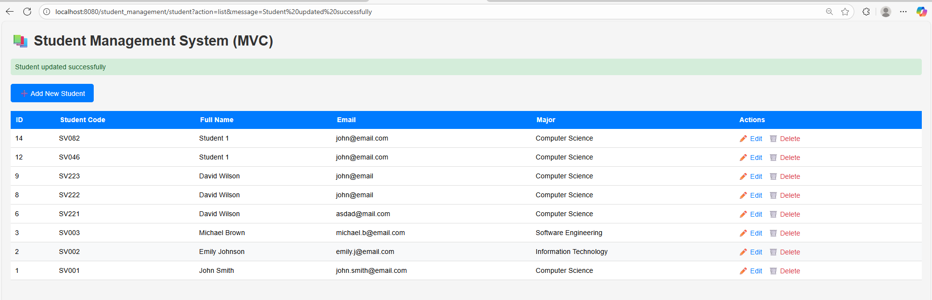
Flow explanation:
- Browser → Clicks “Edit” link
- StudentController.doGet() receives the request and detects the action "edit".
- The controller calls showEditForm(request, response).
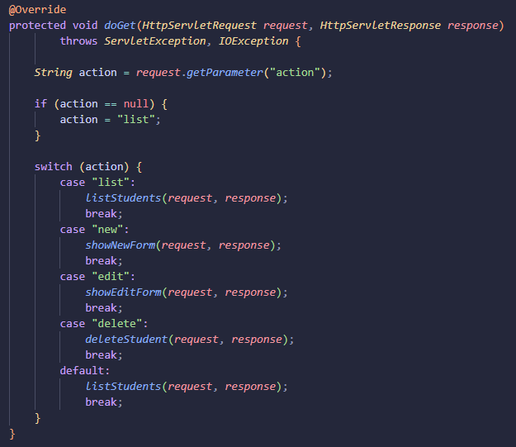
- Inside showEditForm(), it retrieves the student ID from the URL (request.getParameter("id")), then calls studentDAO.getStudentById(id).
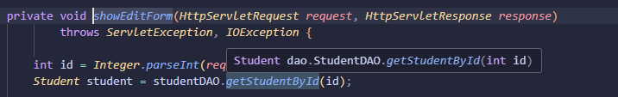
- The DAO connects to the database and run the command
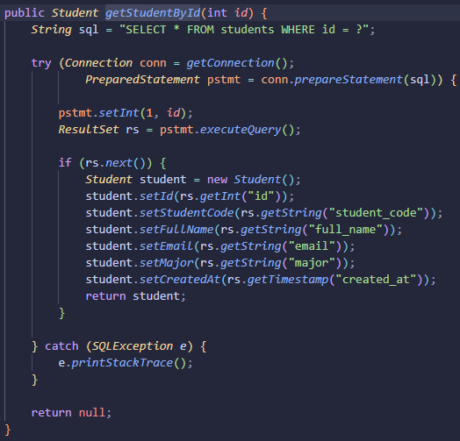
- The controller stores this object in the request using request.setAttribute("student", student) and forwards the request to /views/student-form.jsp
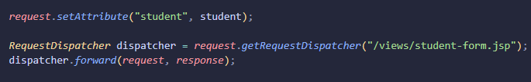
In student-form.jsp, ${student} is not null, so the form fields are automatically prefilled with existing data and the hidden input becomes <input type="hidden" name="action" value="update">.
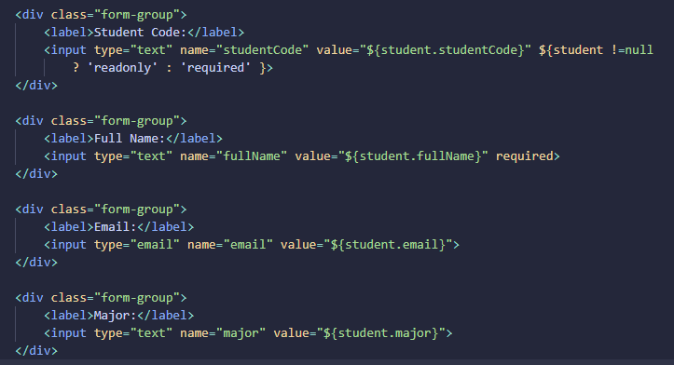
- When the user updates the information and clicks Update, the browser sends a POST request to /student with form data and action=update.
- The controller’s doPost() handles it, calls updateStudent(request, response), and the DAO runs an UPDATE SQL command to modify the record.
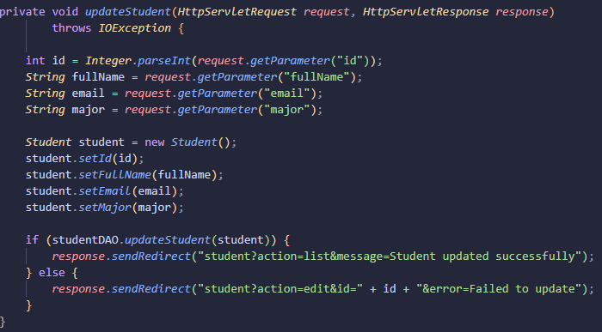
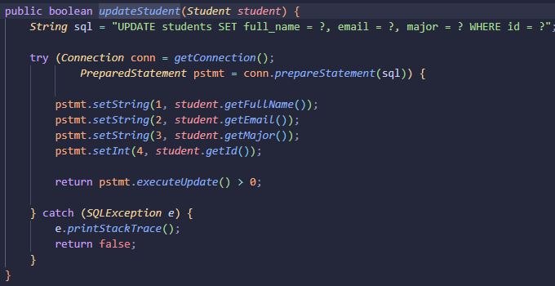
- After successful update, the controller redirects to student?action=list&message=Student updated successfully.
- 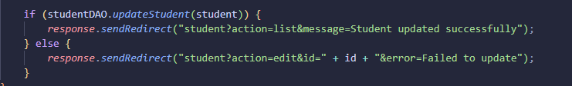
- Finally, the browser sends a new GET request to list students, showing the updated record and success message.

Exercise 4:
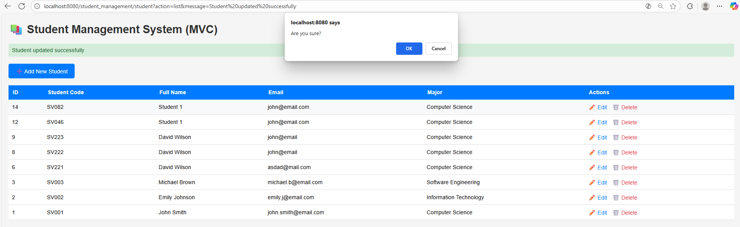
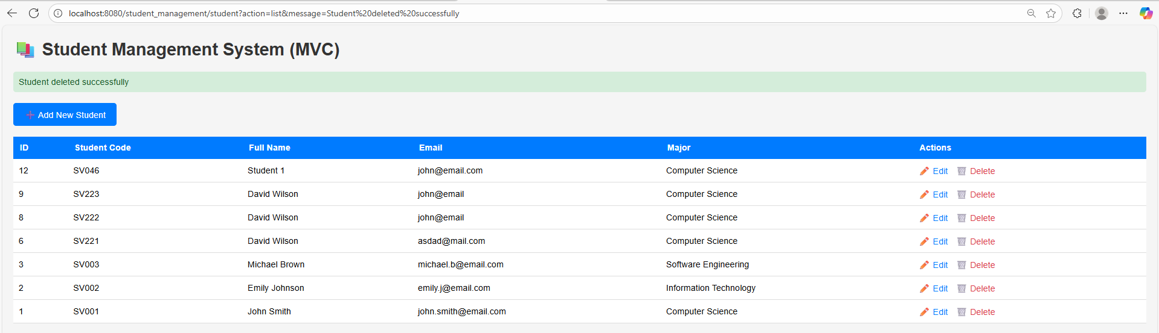
Flow explanation:
- Browser → Clicks “🗑️ Delete” link
In student-list.jsp, the delete link student?action=delete&id=${student.id}
- StudentController.doGet() receives the request, detects the action "delete", and calls deleteStudent(request, response)..
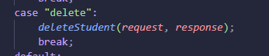
- Inside deleteStudent(), it retrieves the student ID from the request parameter:
int id = Integer.parseInt(request.getParameter("id"));
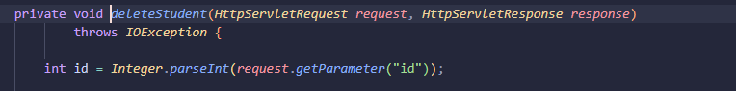
- The controller calls studentDAO.deleteStudent(id) to remove the record from the database.
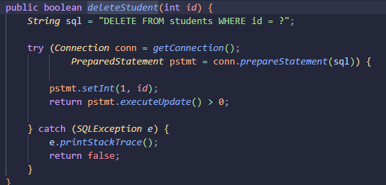

- The database deletes the record if the ID exists, returning true to the controller.
- If the deletion succeeds, the controller redirects to student?action=list&message=Student deleted successfully; otherwise, it redirects with an error message.
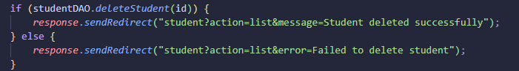
- The browser then makes a new GET request to /student?action=list.
- The controller calls listStudents(), reloads the updated student list from the database, and forwards to student-list.jsp.
- Finally, the JSP displays the refreshed table without the deleted student and shows a success message to confirm the deletion.

Exercise 5:
Test searchStudents(“john”):
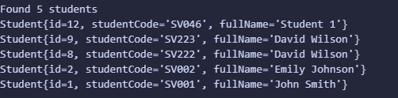
Flow explanation:
- Browser → User enters a keyword and clicks “Search”
In student-list.jsp, form send request “GET /student?action=search&keyword=keyword”
- StudentController.doGet() receives the request
- Inside searchStudent(), controller read the keyword and send to studentDAO
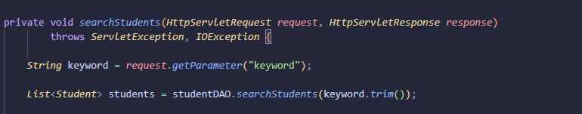
- DAO executes database search and retrieves data, send back to controller
- Controller receives the search results and save to requestAttribute, and forward to student-list.jsp
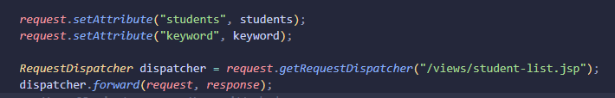
- Browser receives the rendered JSP page and displays search results.

Exercise 6:
Result: 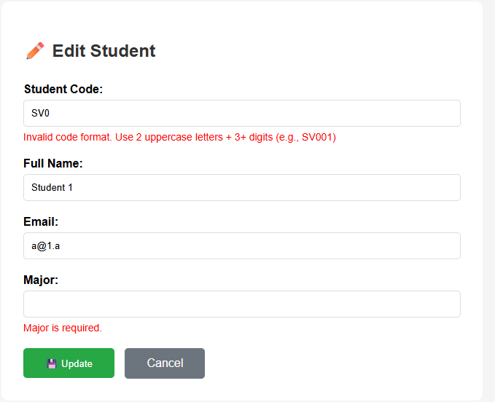

Exercise 7:
Result:
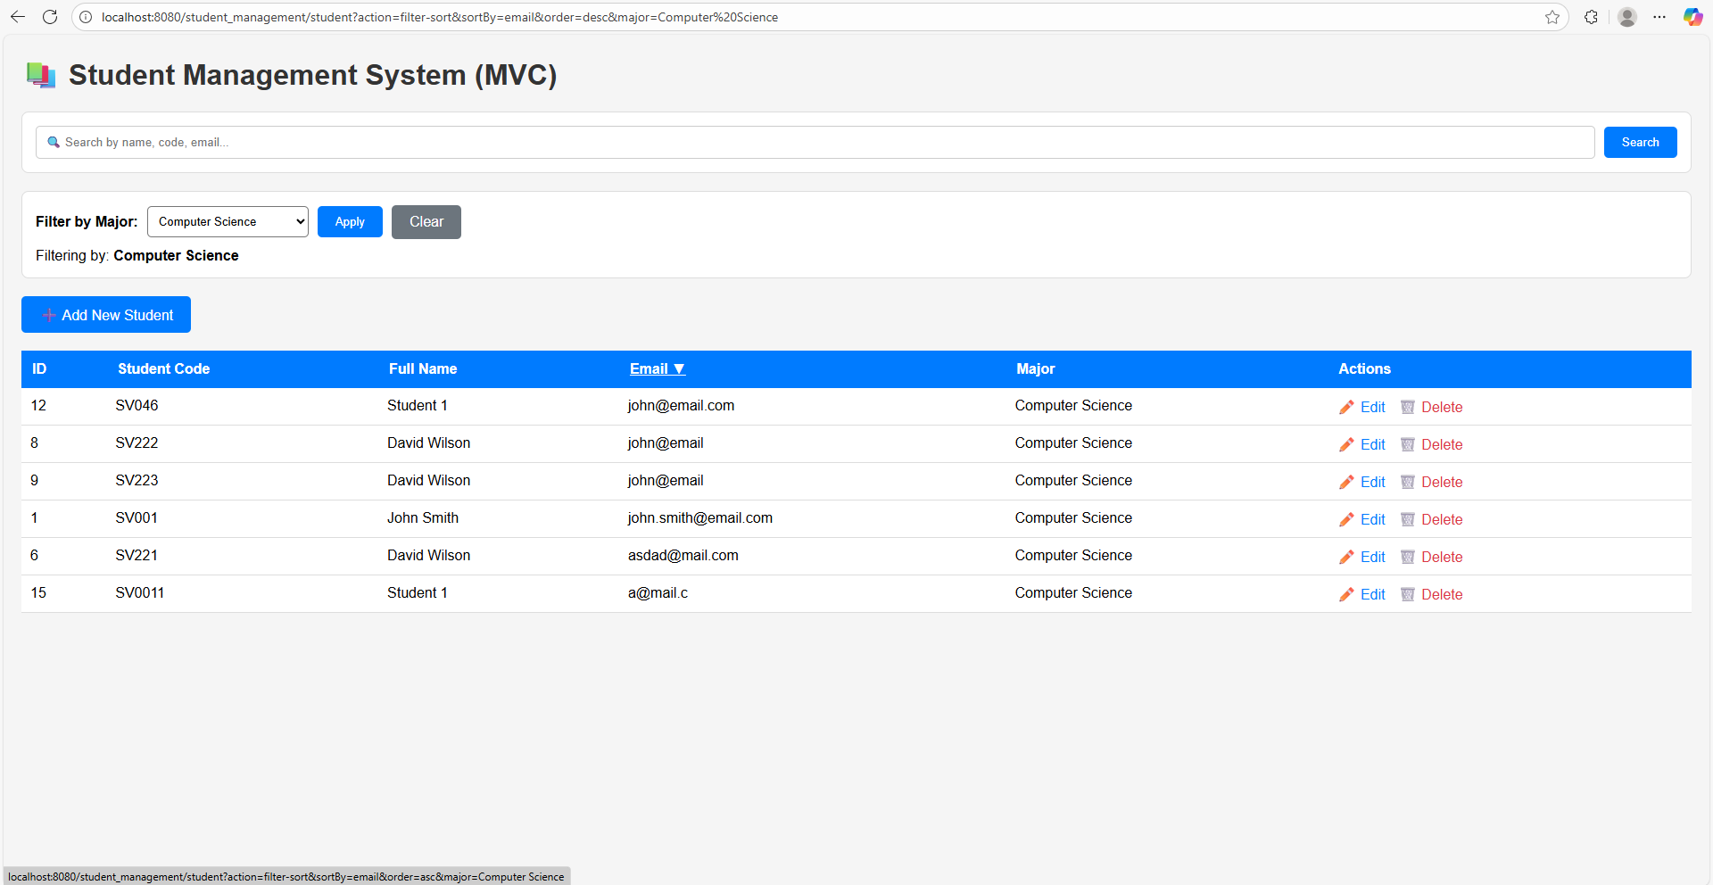
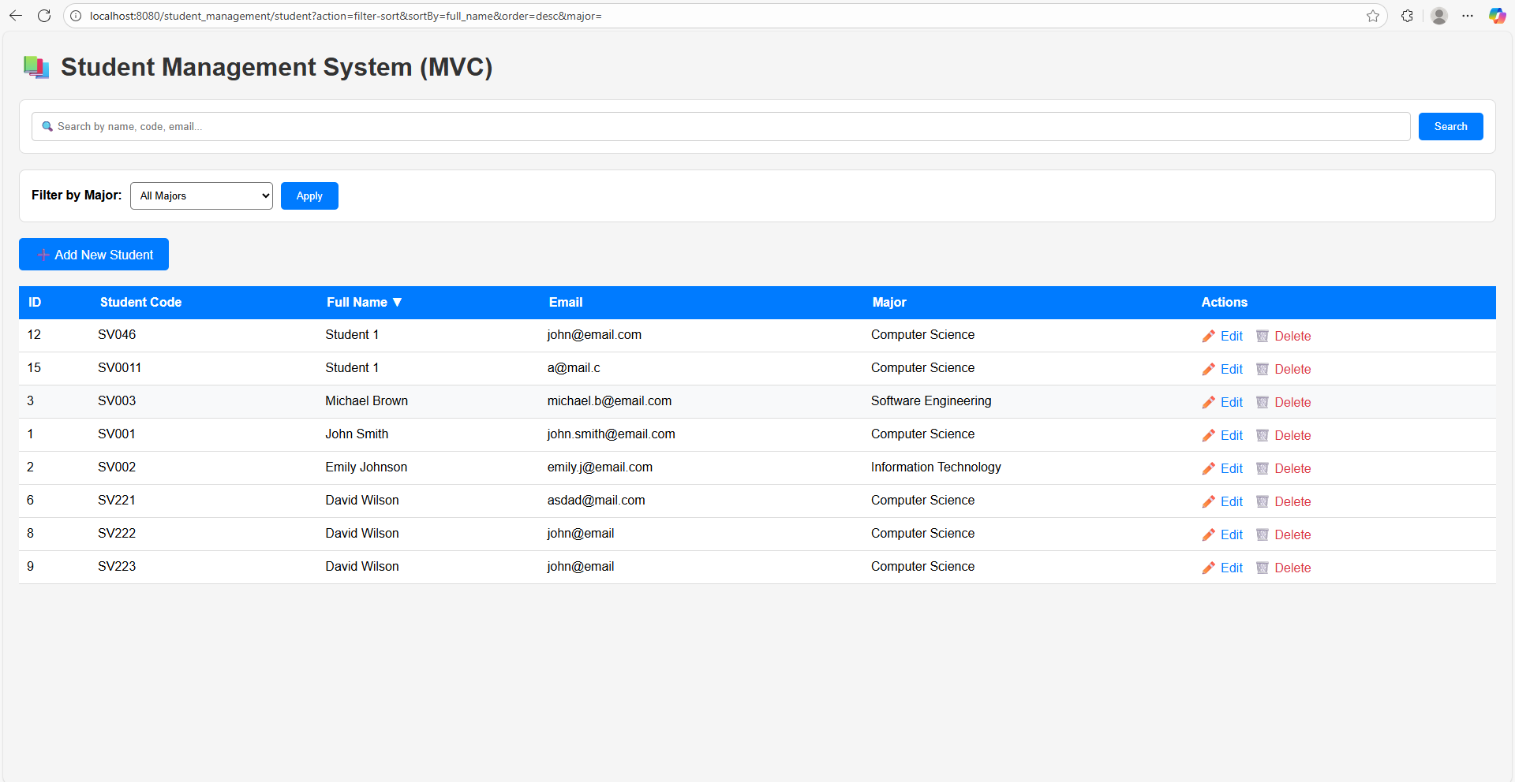
Flow explaination:
- Browser → User clicks a sortable column header OR applies a filter.
- StudentController.doGet() get the action=”filter-sort” form URL and call the method filterAndSortStudents(request, response)
- Controller read parameters and send to studentDAO.getStudentsFiltered(major, sortBy, order)
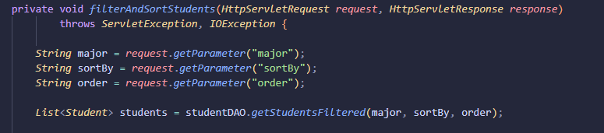
- studentDAO execute the command and return the sorted & filtered data
- Controller setAttribute and forward to /views/student-list.jsp.
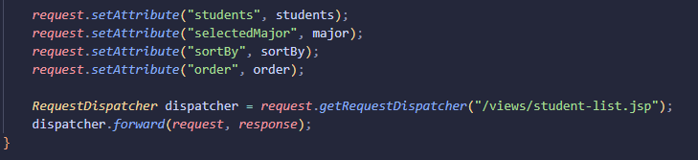
- JSP show the data, and when the user click to the header, the flow comeback to step 1.

