LAB4

Dashboard:
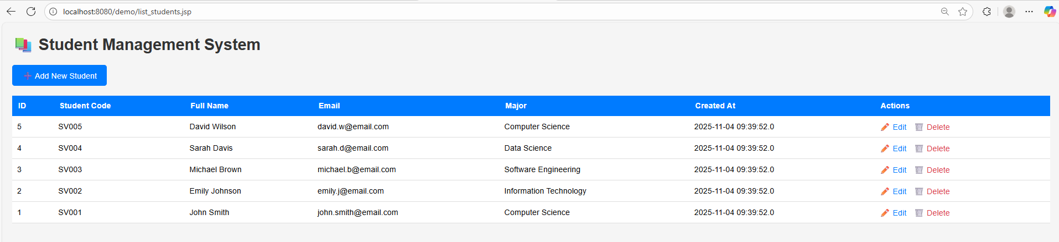

Edit student:
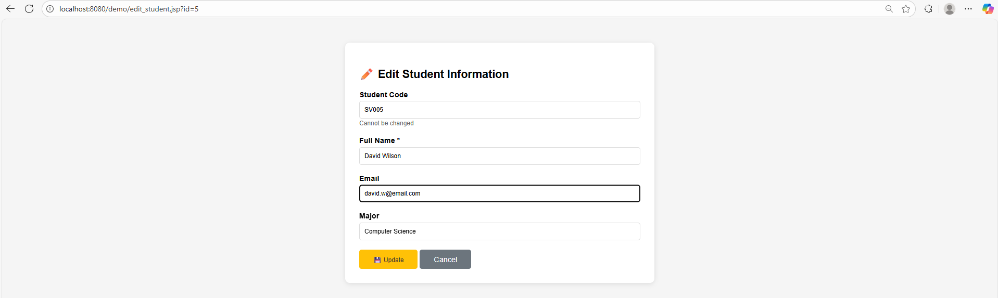

Delete student:
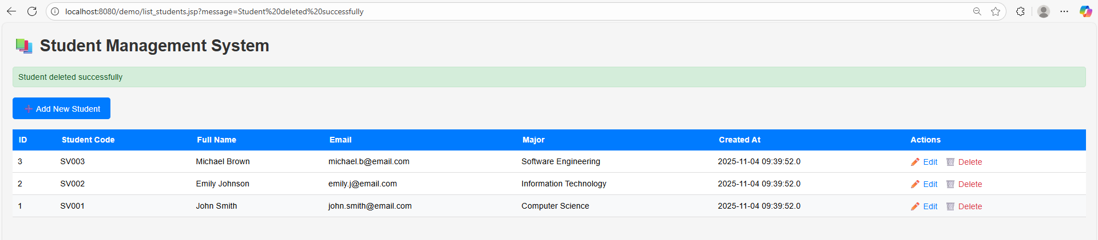

Add student:
