Report Lab 7

Exercise 5: Advanced search
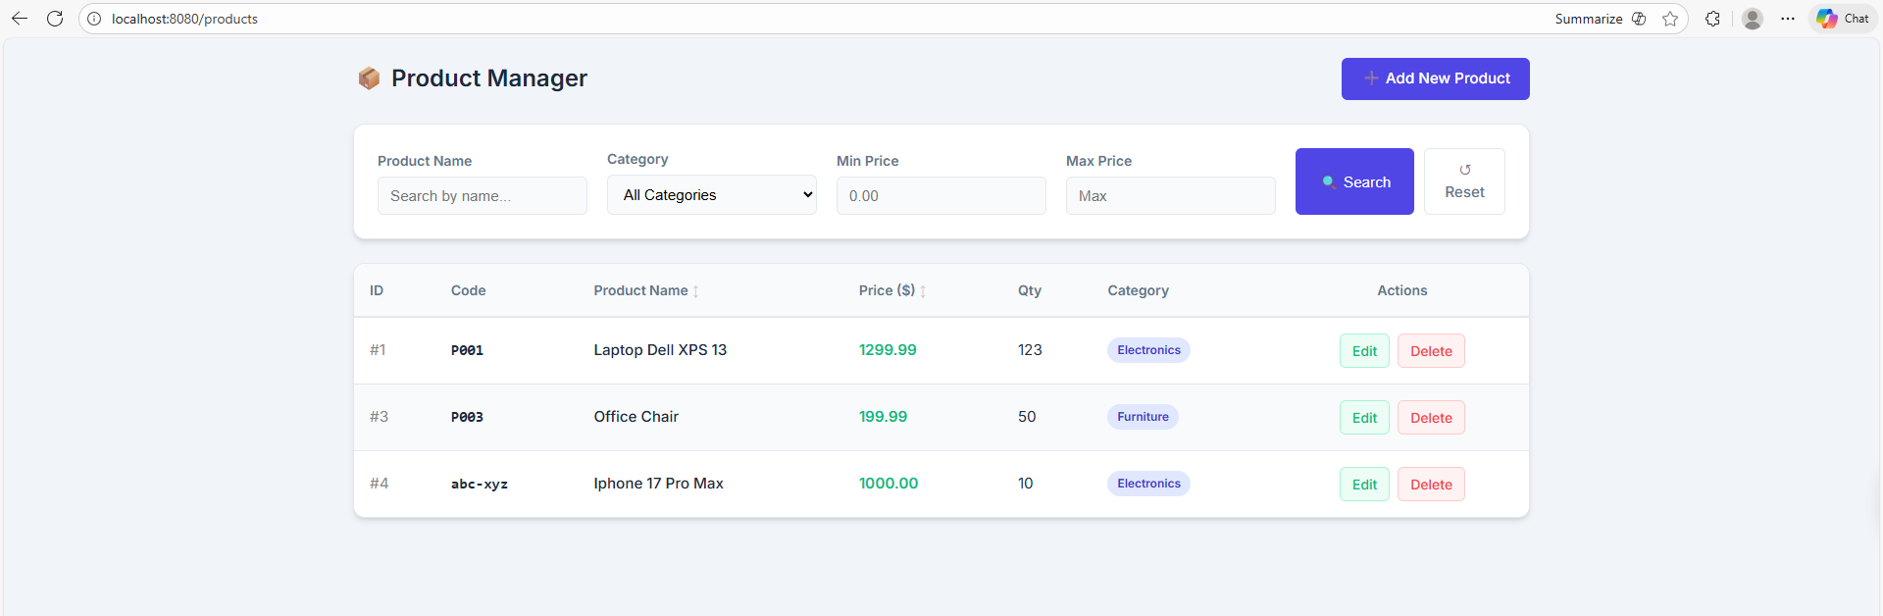
Search by name:
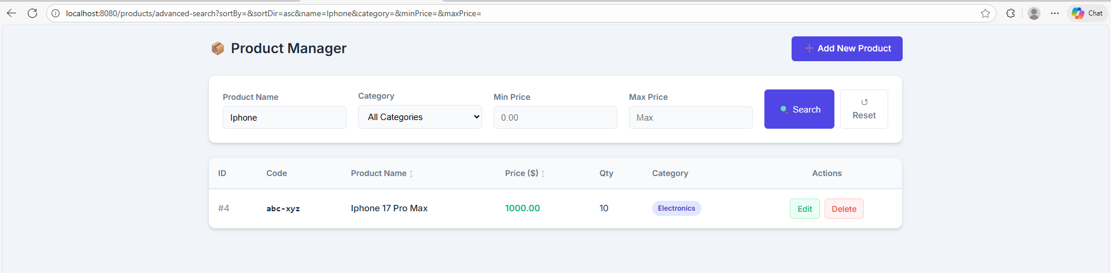

Search by category
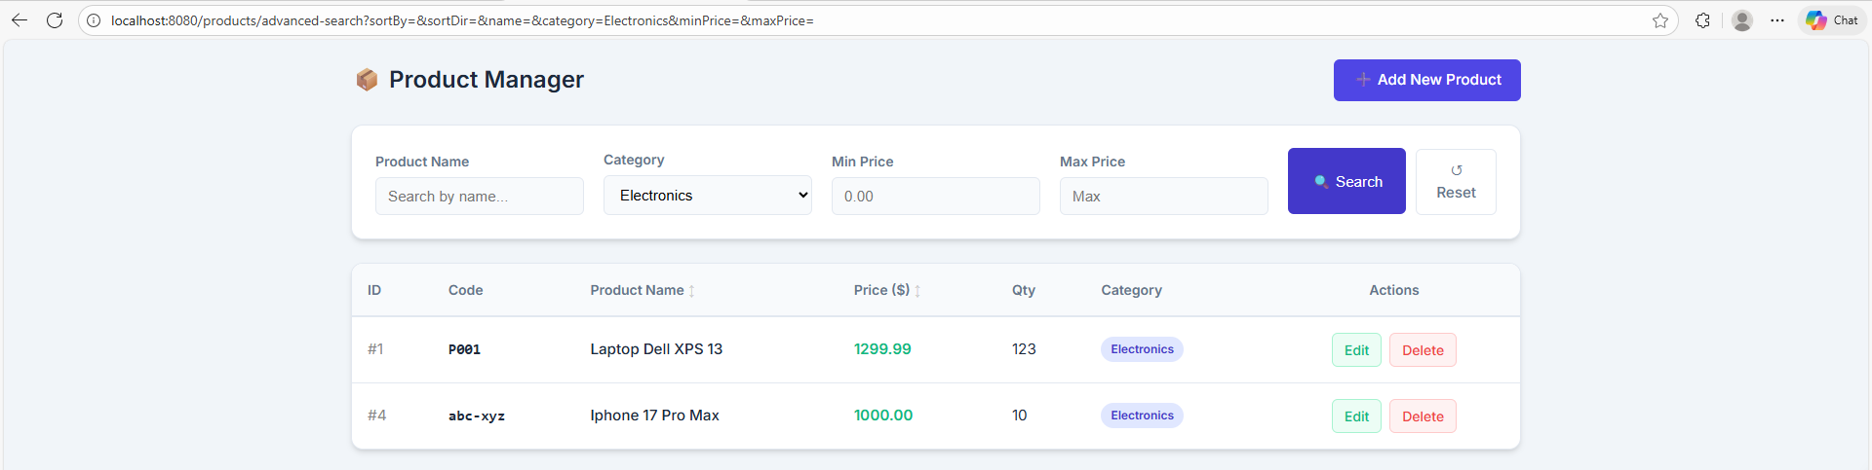

Search by min price and max price in category electronics
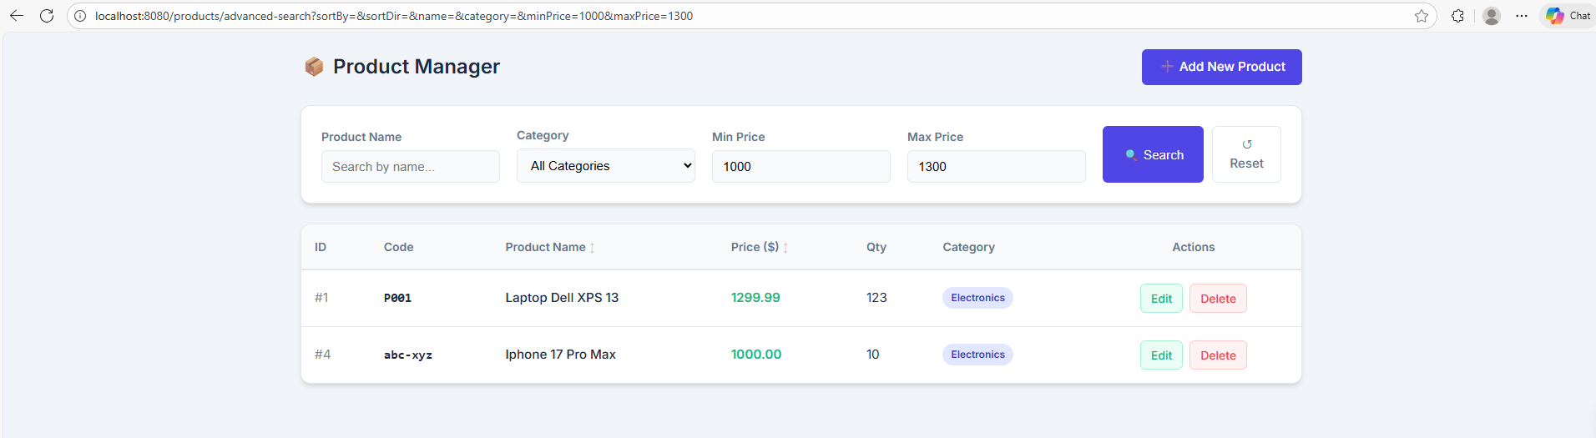
- Pagination
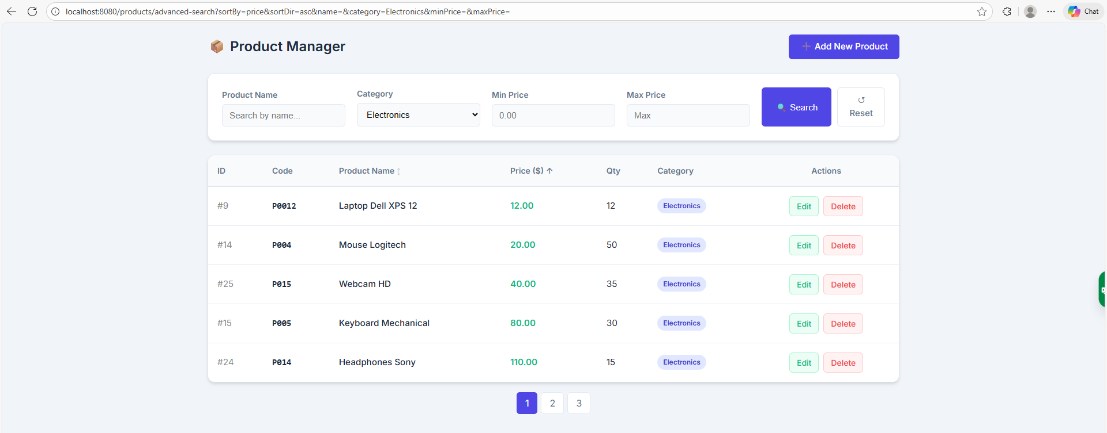

- Handle no products found
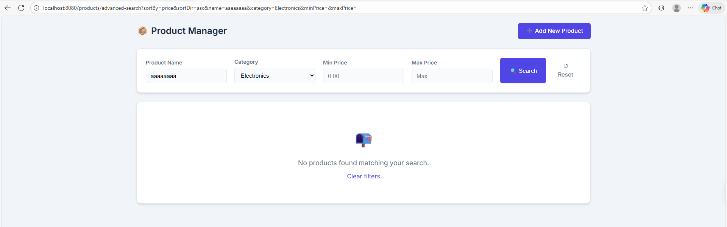

Data flow
- When use input the ‘advanced search’ form and press the search submit button
- Browser url will request /products/advanced-search?name={}&category={}&minPrice={}&maxPrice={}
- It will navigate to the controller method and get all of parameters. Some are default.
- Validate the params and call service layer
- The service class will call the repository layer.
- The repository layer using jpa to translates to native SQL and executes it.
- DB return a page of product which sent back to service layer and back to controller layer where it is added to Spring model and direct to product-list.html where it is populated through the attribute products.

Validation
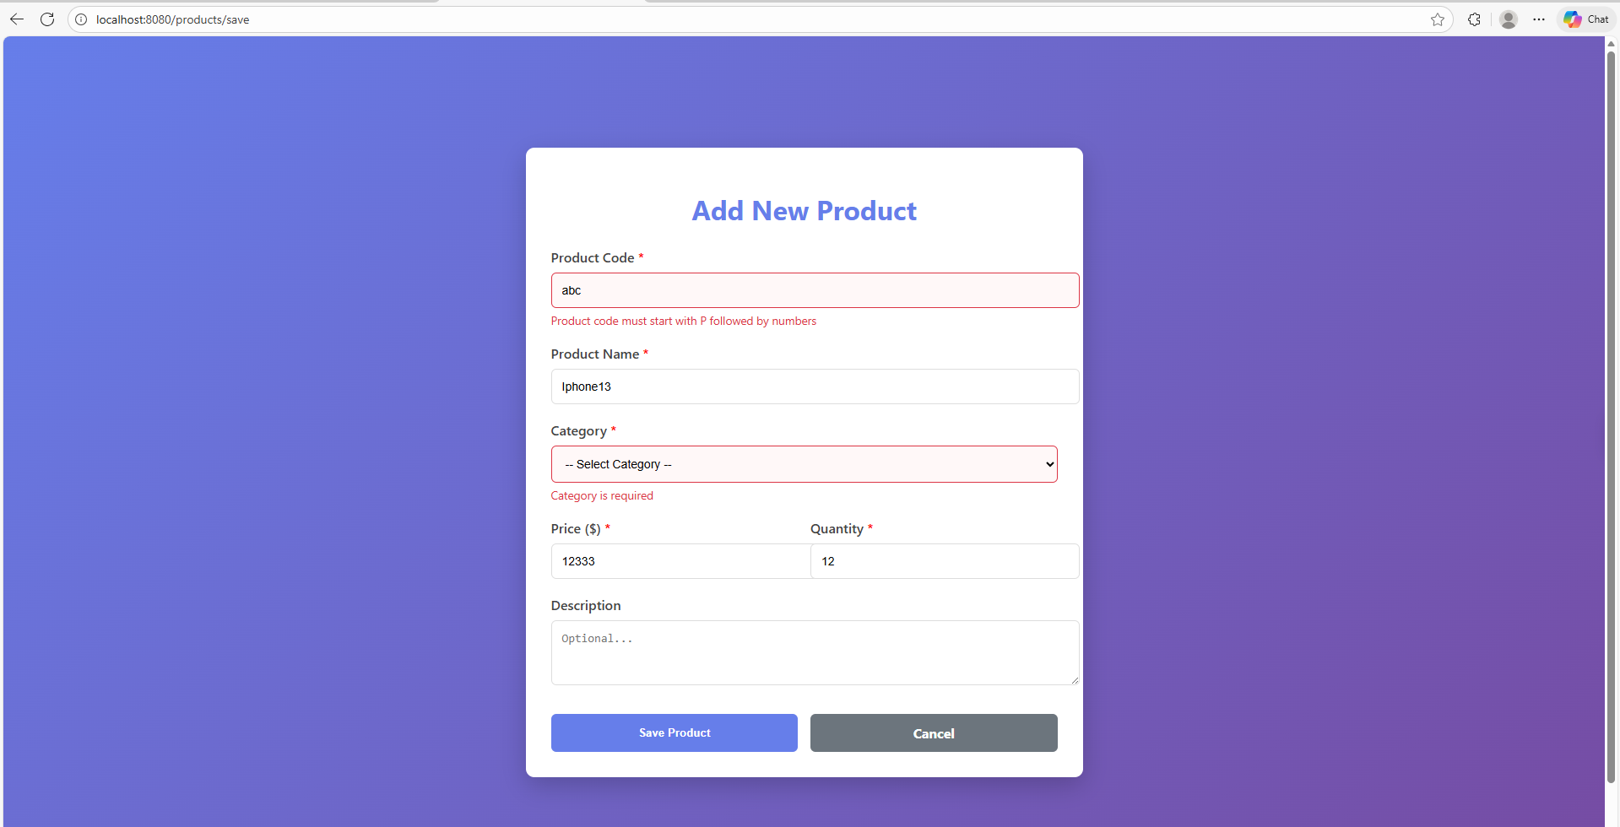

Data flow:
- User fills out the form and press submit button -> browser send POST request /products/save
- @Valid in parameter in controller method to validate the data sent, any violations found are added BindingResult result
- The controller check if result has error, if it has -> return to product-form
- If it has error, thymeleaf detects those errors and render using the message defined in Product entity

- Sort by filtering electronics and sorting by price.
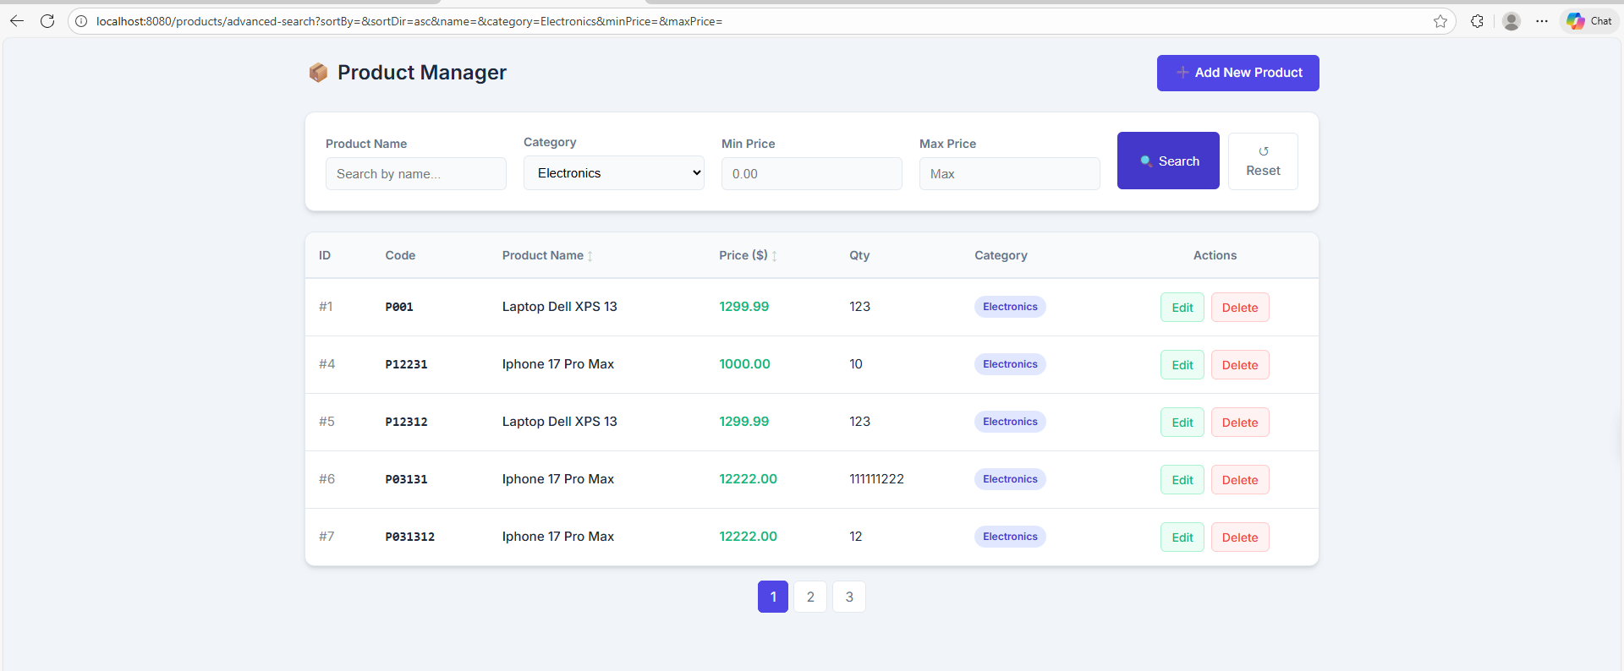
Data flow:
- User can optionally filtering by category and press on column header for sorting -> browser will send request to /products?category=Electronics&sortBy=name&sortDir=asc
- It will go to the controller method, and get all of these parameters
- filtering logic executes first, if a category is present, the service fetches products only for that category.
- the sorting logic executes, if a sortBy field is present, the service is called to retrieve and sort the entire list, and reapply filtering.
- Added List<Product> to model through attributes products for view.

Dashboard

