LAB REPORT – Authentication & Session Management
Student name: Nguyễn Viết Anh Khoa
Course: Web Application Development
Lab: 6
System Overview
The Student Management System supports two roles:
Admin:
- Access dashboard
- Add/Edit/Delete students
- View student list

User:
- View student list only
- Cannot access dashboard
- Cannot modify student data

Database Setup
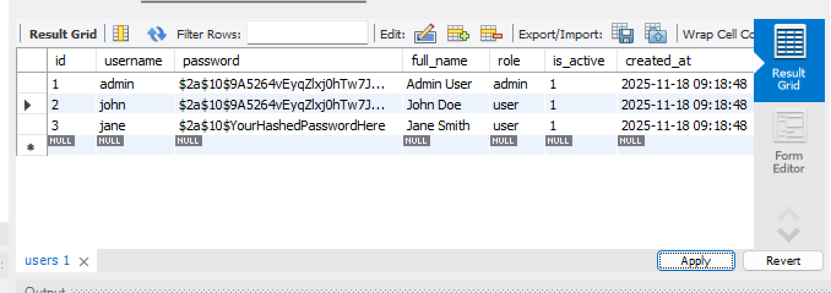

UserDAO – Authentication
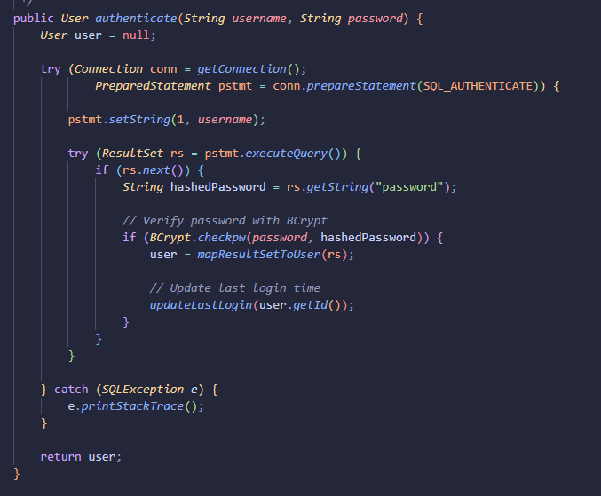

LoginController

GET /login
- Show login page
- If already logged in → redirect to dashboard

POST /login
- Validate input
- Call UserDAO.authenticate()
- If valid → create session
- Store:

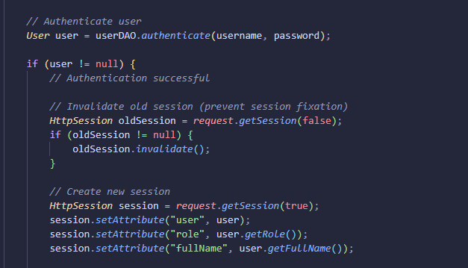

Redirect:
- admin → dashboard
- user → student list
If invalid → return to login.jsp with error message

DashboardController

User:
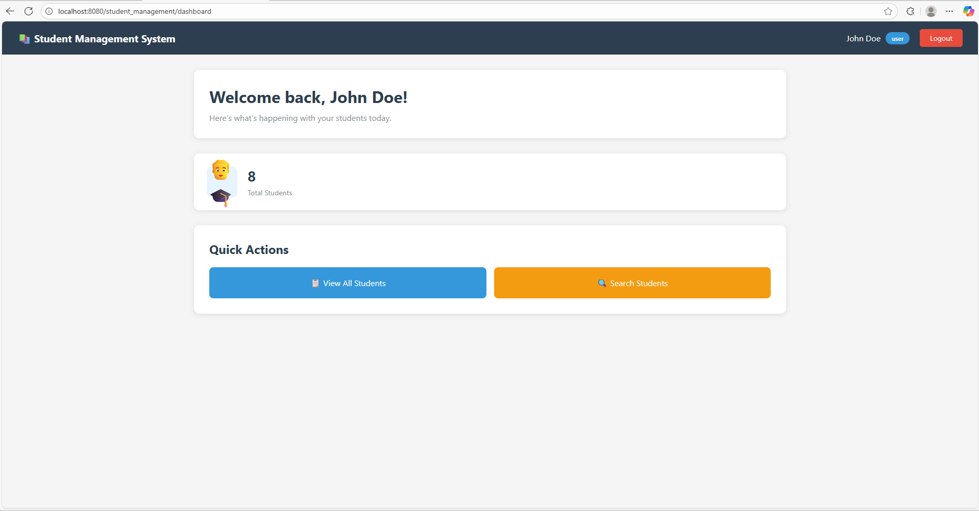

Admin:
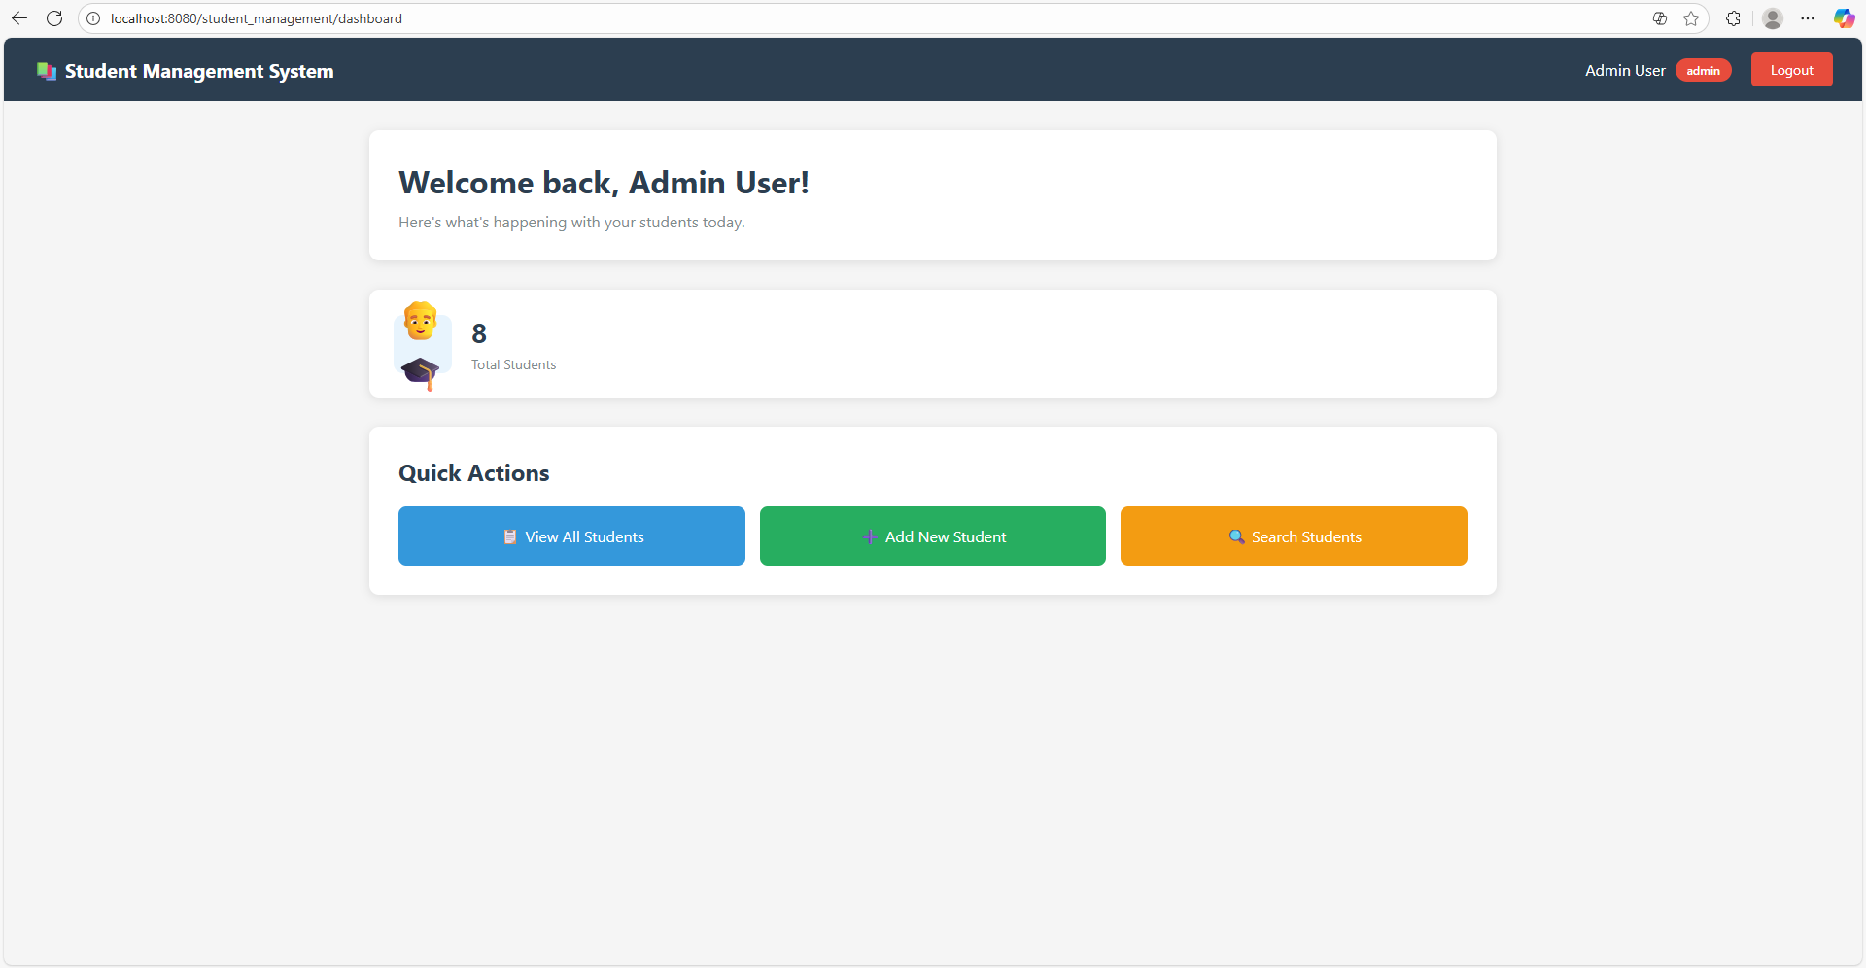

Example: show Edit/Delete only for admins:
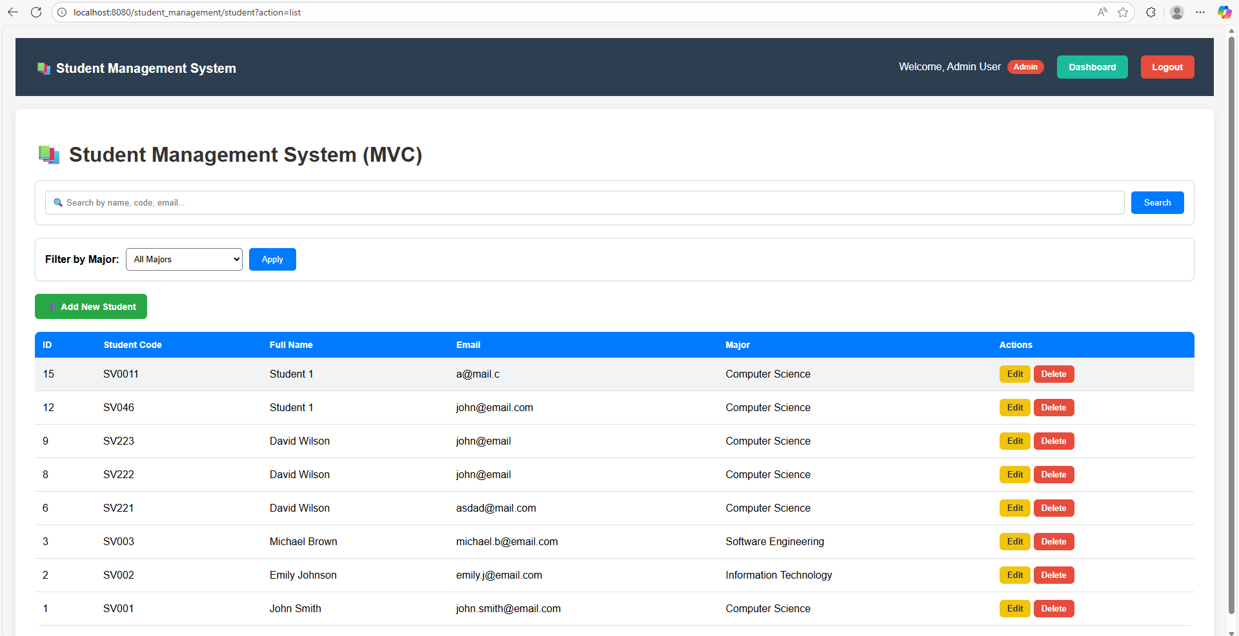

Workflow

- Authentication Workflow

- User enters username/password in login.jsp
- POST → /login
- LoginController:
  - validate input
  - call UserDAO.authenticate()
  - if correct → create session
  - if incorrect → return to login.jsp
- Redirect user based on role

login.jsp → LoginController → UserDAO → Session Created → Redirect

- Authorization Workflow

Admin
- Can access dashboard
- Can add/edit/delete students
User
- Cannot access dashboard
- Cannot modify student data

Change password
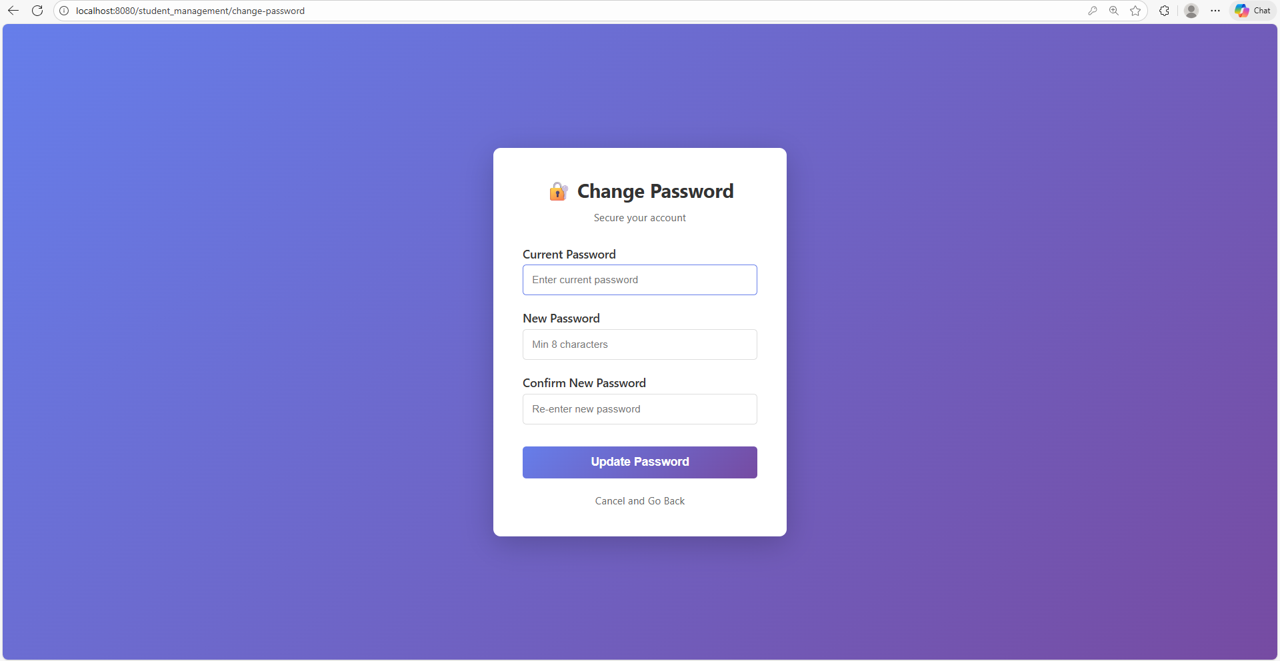

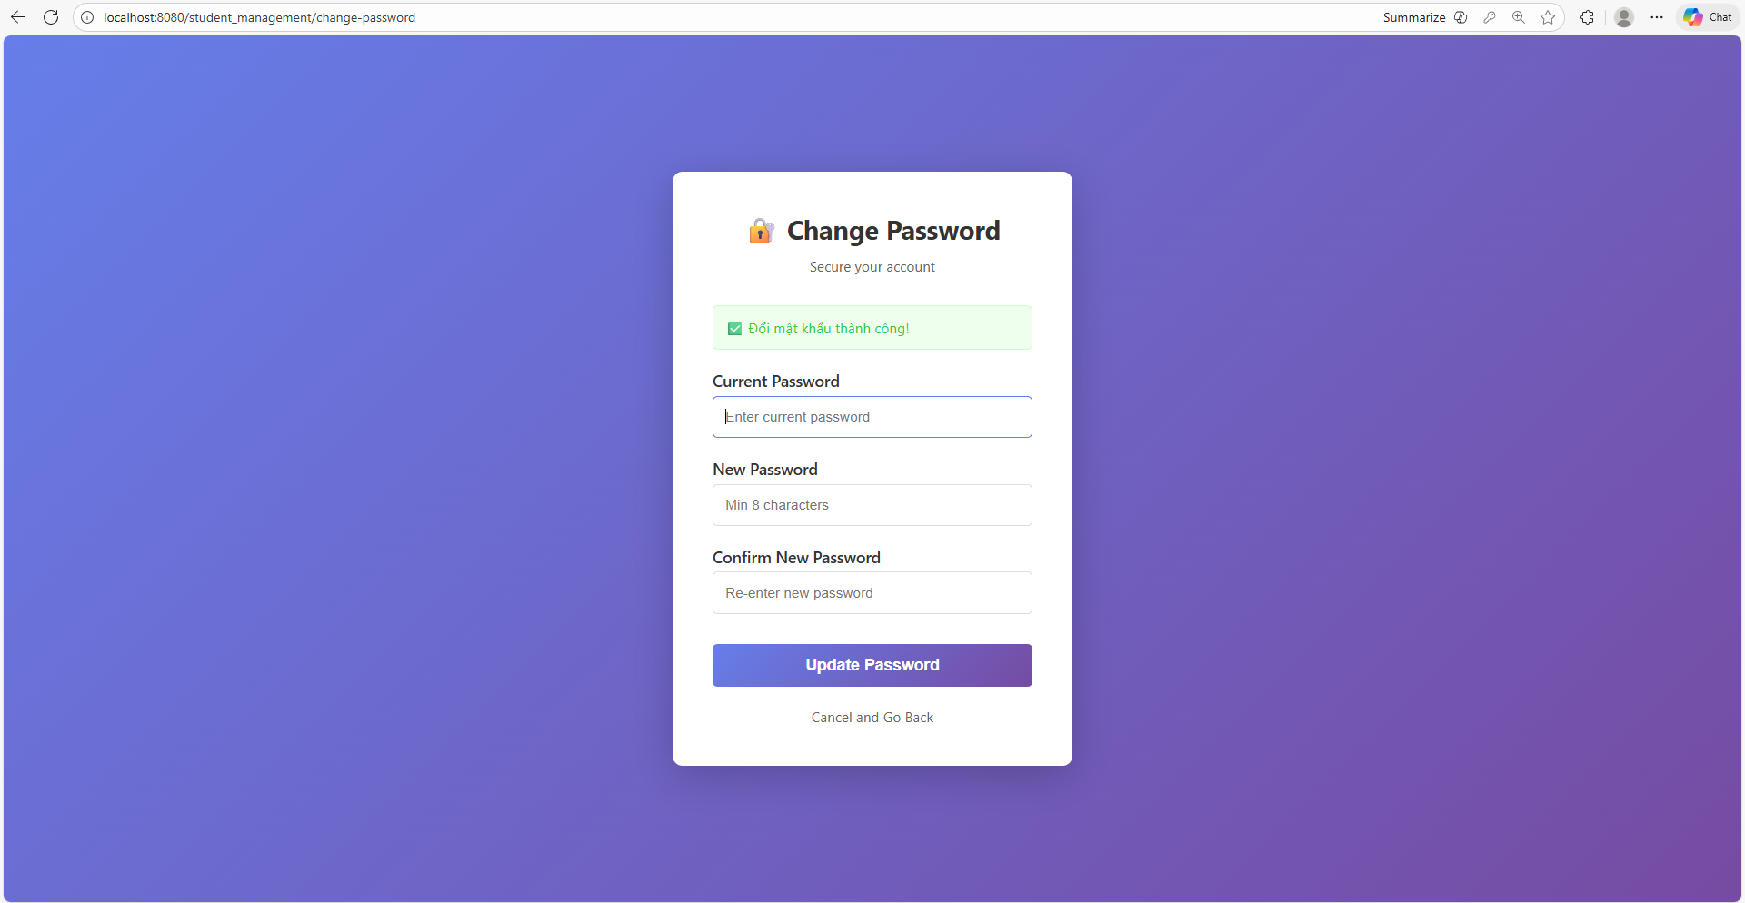

Workflow:
  - User click change password at dashboard
  - ChangePasswordController.java check if already login, it forward to /views/change-password.jsp
  - User input new password, and form send post back to /change-password
  - ChangePasswordController.java check and validate password, then update by using UserDAO.java
  - After success or failure, the controller sends the result back to /views/change-password/jsp

DEMO

Admin:

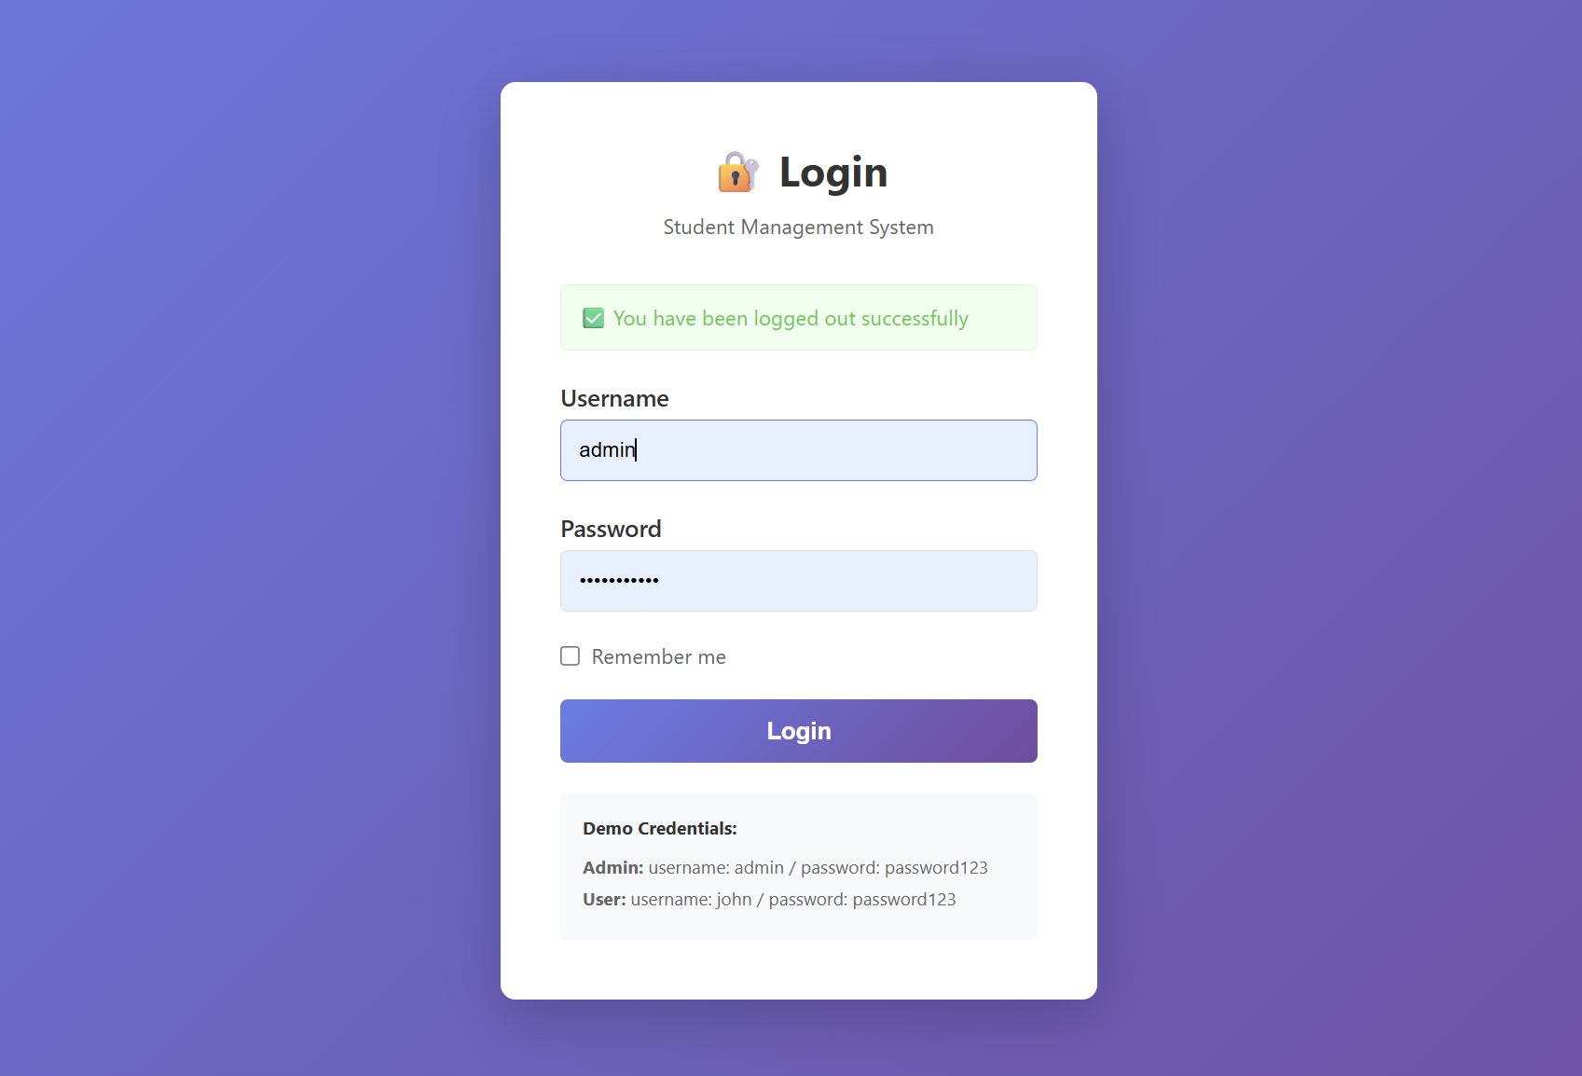

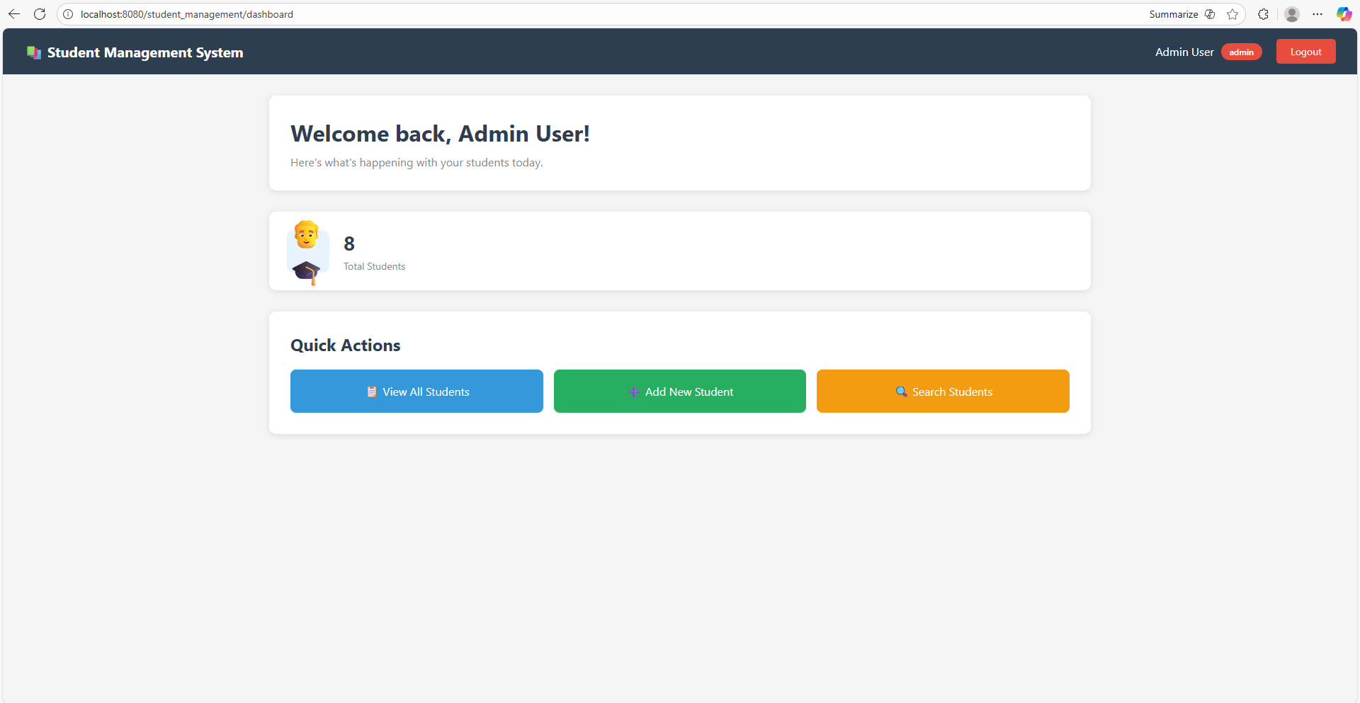

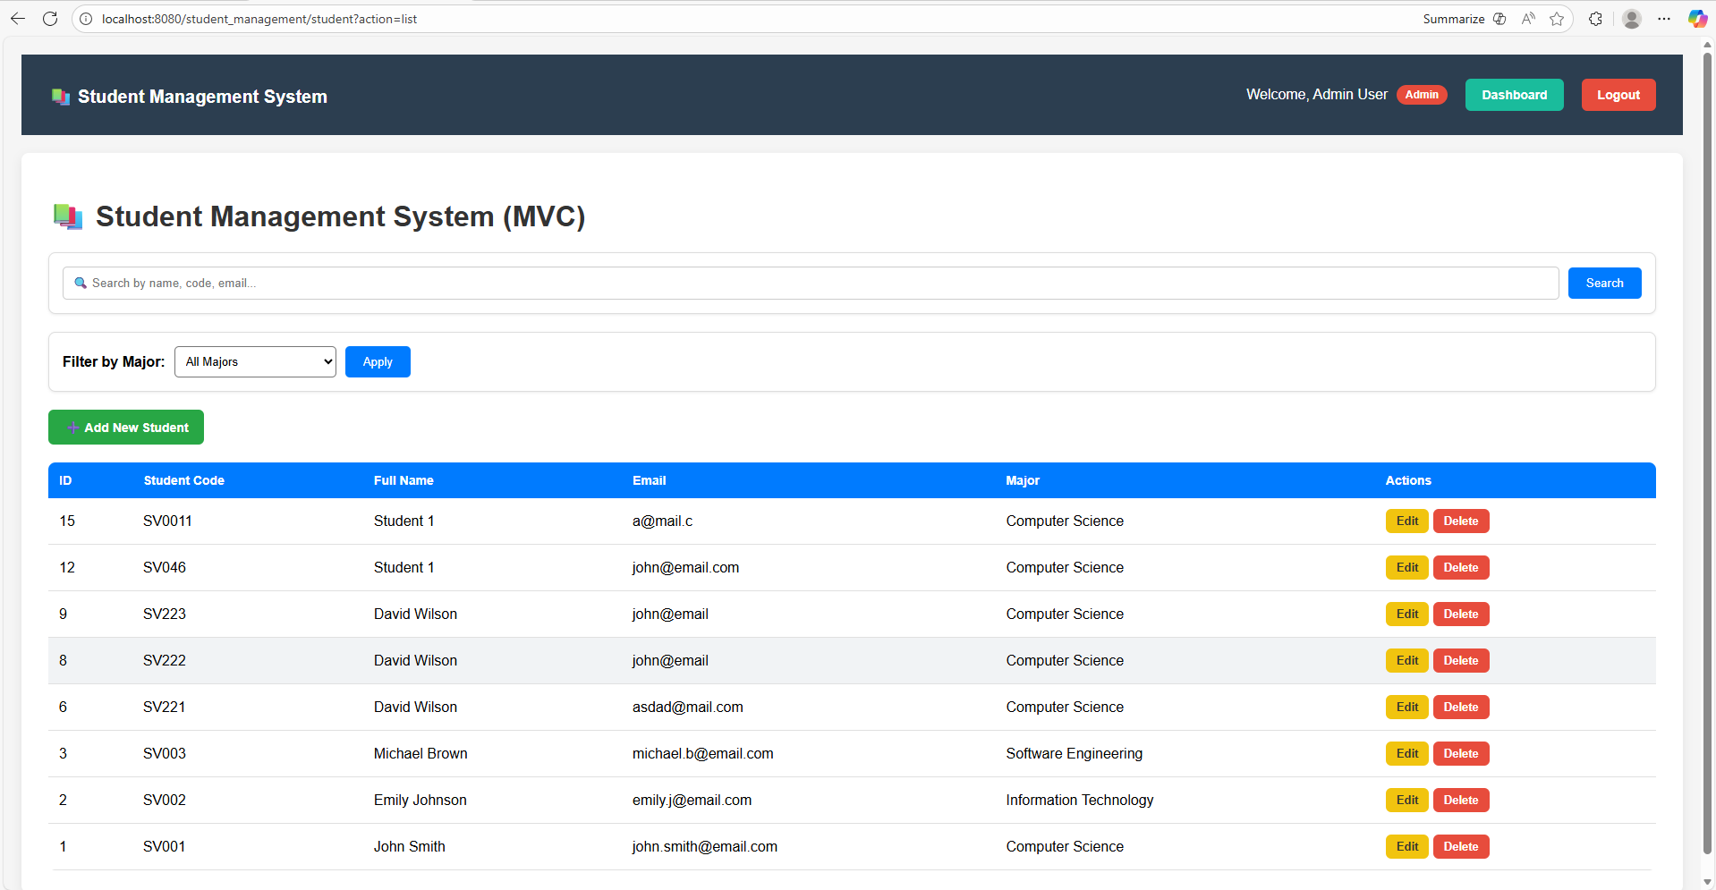

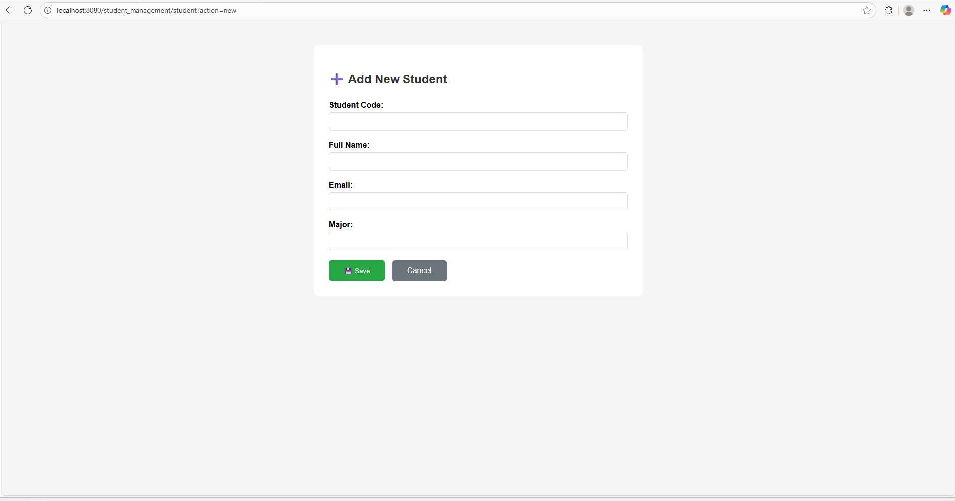

User:
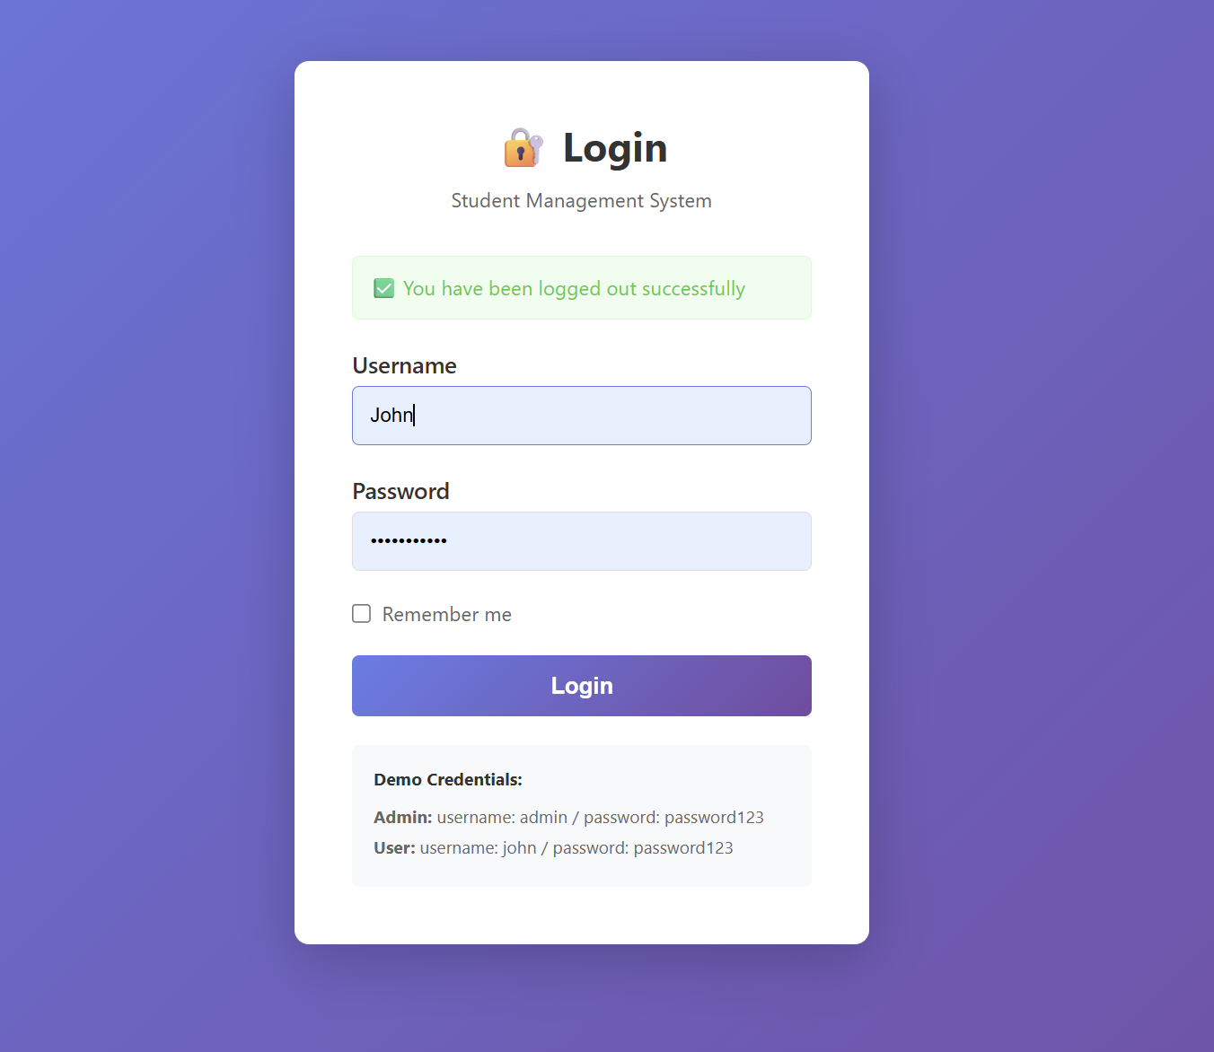

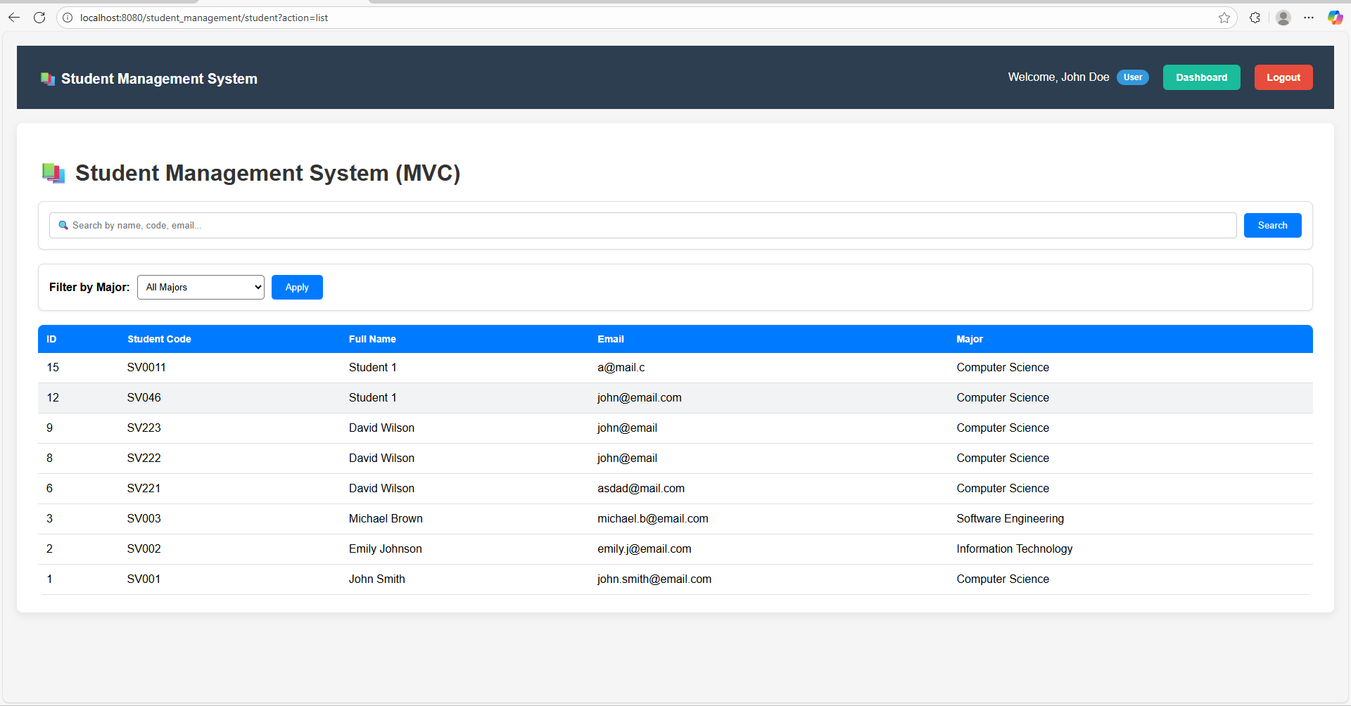

Case: User try to direct /student_management/student?action=new
