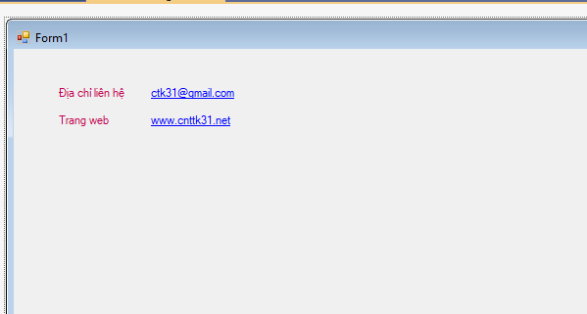**TRANG 35**

using System;

using System.Collections.Generic;

using System.ComponentModel;

using System.Data;

using System.Drawing;

using System.Linq;

using System.Text;

using System.Threading.Tasks;

using System.Windows.Forms;

using System.Diagnostics;

namespace C1

{

public partial class Form1 : Form

{

public Form1()

{

InitializeComponent();

}

private void Form1_Load(object sender, EventArgs e)

{

string strURL = "mailto:ctk31@gmail.com";

this.linkLabel1.Links.Add(0, strURL.Length, strURL);

strURL = "http://www.cnttk31.net";

this.linkLabel2.Links.Add(0, strURL.Length, strURL);

}

private void linkLabel1_LinkClicked_1(object sender, LinkLabelLinkClickedEventArgs e)

{

string strURL = Convert.ToString(e.Link.LinkData);

if (strURL.StartsWith("mailto:"))

Process.Start(strURL + "?subject=hello");

}

private void linkLabel2_LinkClicked(object sender, LinkLabelLinkClickedEventArgs e)

{

string strURL = Convert.ToString(e.Link.LinkData);

if (strURL.StartsWith("http://www."))

Process.Start(strURL); //Process.Start("IExplore", strURL)

}

}

}

**TRANG 42**

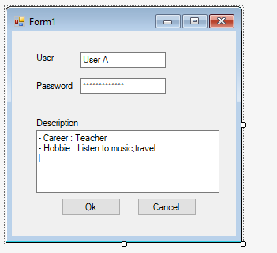

**TRANG 48**

private void Form1_Load(object sender, EventArgs e)

{

string [] datas = { "Tiếng Anh", "Tiếng Pháp", "Tiếng Nhật" };

this.comboBox1.DataSource = datas;

}

private void comboBox1_SelectedIndexChanged(object sender, EventArgs e)

{

MessageBox.Show(this.comboBox1.SelectedItem.ToString());

}

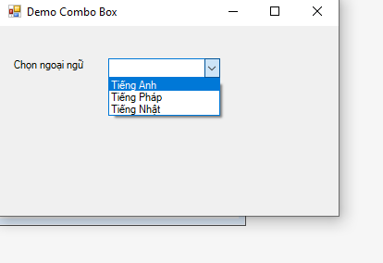

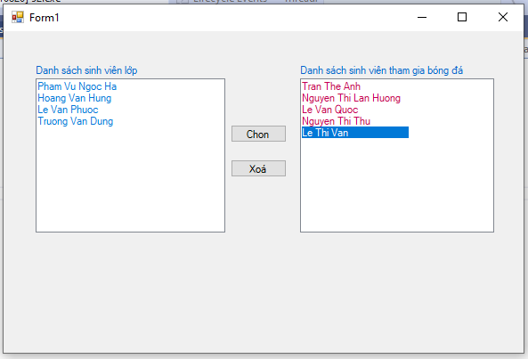

**TRANG 52**

private void button1_Click(object sender, EventArgs e)

{

int itemsselect = lbDanhsach.SelectedItems.Count - 1;

for (int i = itemsselect; i >= 0; i--)

{

lbDanhsachchon.Items.Add(lbDanhsach.SelectedItems[i]);

lbDanhsach.Items.Remove(lbDanhsach.SelectedItems[i]);

// lstDanhsach.Items.RemoveAt(lstDanhsach.SelectedIndices[i]);

}

}

private void button2_Click(object sender, EventArgs e)

{

int i = lbDanhsachchon.SelectedItems.Count - 1;

while (i >= 0)

{

lbDanhsachchon.Items.RemoveAt(lbDanhsachchon.SelectedIndices[i]);

i--;

}

**TRANG 56**

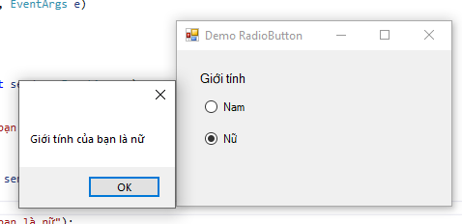

private void rbNam_CheckedChanged(object sender, EventArgs e)

{

if (this.rbNam.Checked)

MessageBox.Show("Giới tính của bạn là: "+ rbNam.Text) ;

}

private void rbNu_CheckedChanged(object sender, EventArgs e)

{

if (this.rbNu.Checked)

MessageBox.Show("Giới tính của bạn là:"+ rbNu.Text);

}

**TRANG 57**

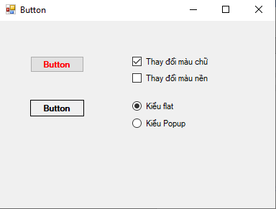

private void ckbMauChu_CheckedChanged(object sender, EventArgs e)

{

if (this.ckbMauChu.Checked)

this.btnButton.ForeColor = Color.Red;

else

this.btnButton.ForeColor = Color.Black;

}

private void ckbMauNen_CheckedChanged(object sender, EventArgs e)

{

if (this.ckbMauNen.Checked)

this.btnButton.BackColor = Color.LightCyan;

else

this.btnButton.BackColor = this.btnButtonFlat.BackColor;

}

private void rdFlat_CheckedChanged(object sender, EventArgs e)

{

if (this.rdFlat.Checked)

this.btnButtonFlat.FlatStyle = FlatStyle.Flat;

else

this.btnButtonFlat.FlatStyle = FlatStyle.Popup;

}

T **TRANG 60**

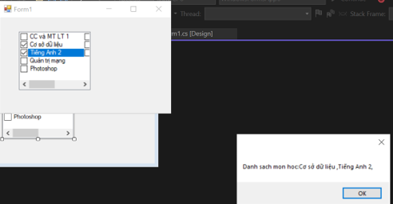

private void checkedListBox1_SelectedIndexChanged(object sender, EventArgs e)

{

string s = "";

for (int i = 0; i < clbMonHoc.Items.Count; i++)

if (this.clbMonHoc.GetItemChecked(i) == true)

s += this.clbMonHoc.Items[i].ToString() + ",";

MessageBox.Show("Danh sach mon hoc:" + s);

}

private void clbMonHoc_SelectedIndexChanged(object sender, EventArgs e)

{

CheckedListBox.CheckedIndexCollection items;

items = this.clbMonHoc.CheckedItems;

string s = "";

foreach (object ob in items)

{

s += ob.ToString() + ",";

}

MessageBox.Show("Danh sach mon hoc: " + s);

}