UNIVERSITY OF INFORMATION TECHNOLOGY

FACULTY OF COMPUTER NETWORK AND COMMUNICATION

**REPORT**

Subject: Basic Network Programming

Semester II (2021 – 2022)

**Report Lab 4**

Student: Võ Anh Kiệt

Student ID Number: 20520605

Class: NT106.M21.ANTN

University of Information Technology

Lecturer: Đỗ Thị Hương Lan

**Hồ Chí Minh City, April 2022**

Report Lab 4

**Student Information**

Full Name: Võ Anh Kiệt

Student ID Number: 20520605

Class: ANTN2020

**Device Information**

CPU: Intel core i5 – 8250U @ 1.60 GHz

Ram: 16 GB DDR3L

SSD M2 SATA: 500GB

HDD: 1000GB

Display chip name: UHD 620

**Task 1**

Function to get the html

Get the html and show in the richTextBox

Deploy the task 1

**Task 2**

Get the html and the header

Show the header in gridView

Deploy the task 2

**Task 3**

Download the html to the file local and show in the deploy

Deploy the task 3

**Task 4**

Show the web get form the link

Using task 2 to get the header and value header

Download data and image from web

Parse the code and deploy from webget

Design the button

Deploy

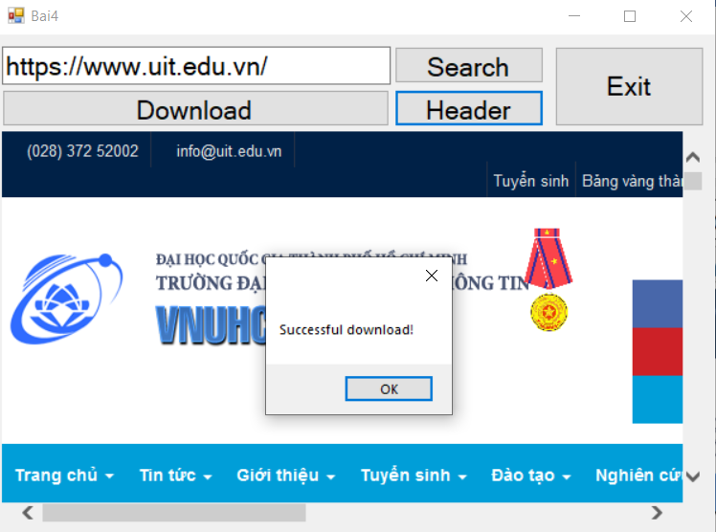

Hide the server header for the local host (set up in iis)

