UNIVERSITY OF INFORMATION TECHNOLOGY

FACULTY OF COMPUTER NETWORK AND COMMUNICATION

**REPORT**

Subject: Cryptography

Semester II (2021 – 2022)

**Report Lab 5 – 6**

Student: Võ Anh Kiệt

Student ID Number: 20520605

Class: NT219.M21.ANTN

University of Information Technology

Lecturer: Nguyễn Ngọc Tự

**Hồ Chí Minh City, May 2022**

Report Lab 5 – 6

**Student Information**

Full Name: Võ Anh Kiệt

Student ID Number: 20520605

Class: ANTN2020

**Device Information**

CPU: Intel core i5 – 8250U @ 1.60 GHz

Ram: 16 GB DDR3L

SSD M2 SATA: 500GB

HDD: 1000GB

Display chip name: UHD 620

**Lab 5: Hash function**

Testcase1: Võ Anh Kiệt - 20520605 - ANTN2020

TimeCounter: mili second

Window

|  |  |  |  |  |  |  |
| --- | --- | --- | --- | --- | --- | --- |
| Hash function | 1KB | 100KB | 1MB | 10MB | 100MB | 1GB |
| SHA224 | 0.0011 |  |  |  |  |  |
| SHA256 | 0.0010 |  |  |  |  |  |
| SHA384 | 0.0013 |  |  |  |  |  |
| SHA512 | 0.0021 |  |  |  |  |  |
| SHA3-224 | 0.0020 |  |  |  |  |  |
| SHA3-256 | 0.0021 |  |  |  |  |  |
| SHA3-384 | 0.0015 |  |  |  |  |  |
| SHA3-512 | 0.0016 |  |  |  |  |  |
| SHAKE128  (Digest size: 64 bytes) | 0.0024 |  |  |  |  |  |
| SHAKE256  (Digest size: 64 bytes) | 0.0016 |  |  |  |  |  |

Linux

|  |  |  |  |  |  |  |
| --- | --- | --- | --- | --- | --- | --- |
| Hash function | 1KB | 100KB | 1MB | 10MB | 100MB | 1GB |
| SHA224 | 0.0011023 |  |  |  |  |  |
| SHA256 | 0.0010611 |  |  |  |  |  |
| SHA384 | 0.0011874 |  |  |  |  |  |
| SHA512 | 0.0012427 |  |  |  |  |  |
| SHA3-224 | 0.0014128 |  |  |  |  |  |
| SHA3-256 | 0.0014235 |  |  |  |  |  |
| SHA3-384 | 0.0015383 |  |  |  |  |  |
| SHA3-512 | 0.0018721 |  |  |  |  |  |
| SHAKE128  (Digest size: 64 bytes) | 0.0014478 |  |  |  |  |  |
| SHAKE256  (Digest size: 64 bytes) | 0.0013604 |  |  |  |  |  |

**PKI and digital certificate**

Create cert

Check cert

**Lab 6.1: MD5 collision attacks**

Task 1: Two collision messages have the same prefix string (Generate 2 different files with the same MD5 hash)

Prefix.txt:

Solution: Use md5_fastcoll

Step 1: Run md5_fastcoll to create 2 different files with the same prefix and the same MD5 hash digest.

Step 2: Compare the two out files.



Step 3: Use md5sum and compare hash.



That is collision!

Full step:

Task 2: Understanding MD5's property

Solution 1: use md5collgen

Solution 2: use hashclash (md5_fastcoll)

Task 3: Two different C++ programs but have the same MD5 (Generating two executable files with the same MD5 hash)

Solution: md5_fastcoll

Step 1: implement the program

Step 2: Build the *.o file with the gcc



Step 3: Check the *.o file with bless and spot the location of a continuous block of A's, the byte offset is 1040 (4160). Slipt the *.o into 3 parts: prefix, suffix, and the var. The var is required that MD5(prefix || variant1 || suffix) = MD5(prefix || variant2 || suffix).

The prefix is chosen to be a multiple of 64. The offset is 4224.



The suffix is kept with 10FF because of ending byte offset as 10FF in files



Step 4: Using the md5_fastcoll to get the same hash transfer to file1 and file2

Step 5: Create 2 binaries transfer to code1 and code2



Step 6: Check the binary



Step 7: Use md5sum and compare hash



That is collision!

Full step:

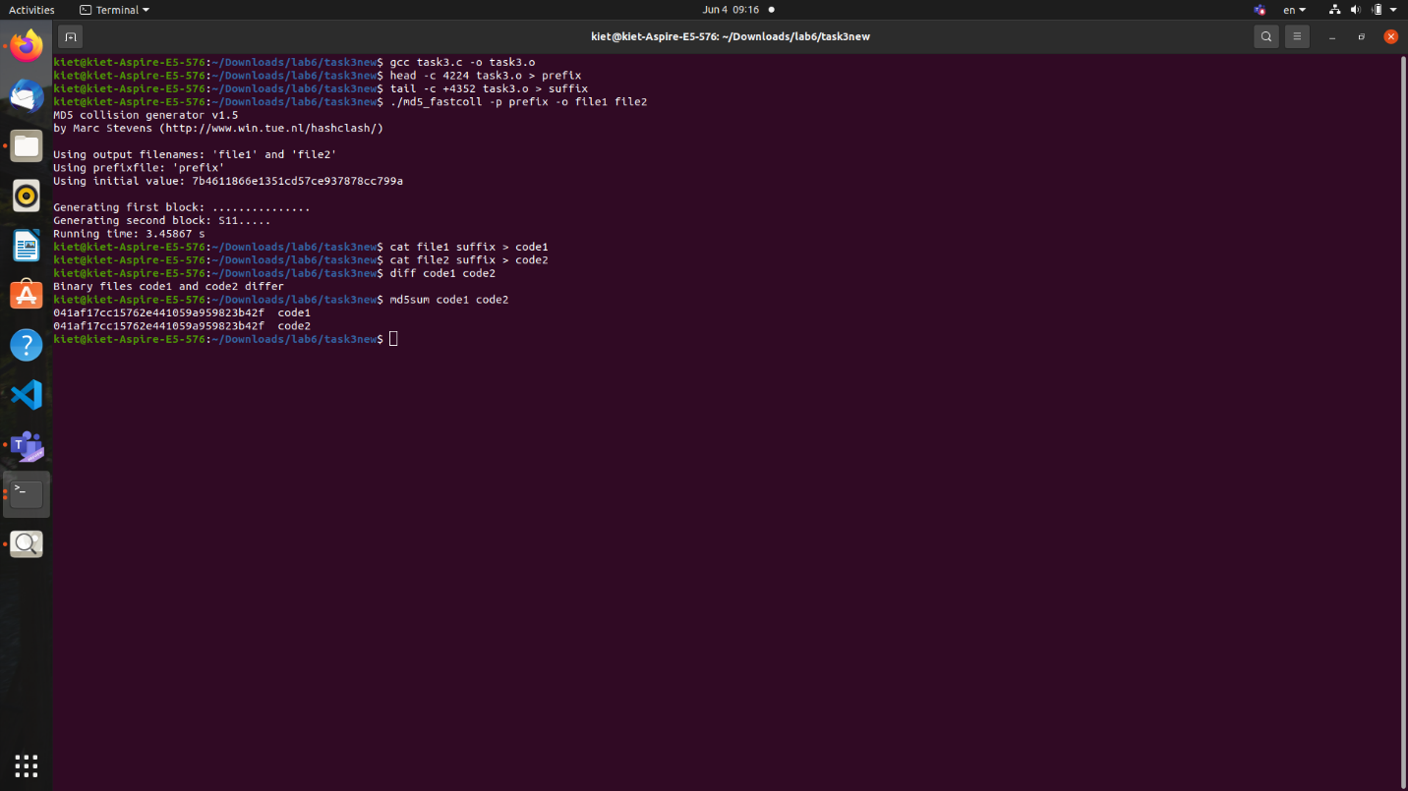

**Lab 6.2: Length extension attacks on MAC in form**

