VIETNAM GENERAL CONFEDERATION OF LABOR
TON DUC THANG UNIVERSITY
FACULTY OF INFORMATION TECHNOLOGY



VO ANH KIET - 523H0048

GRADUATION THESIS

DEVELOPMENT OF A REAL-TIME COLLABORATIVE WORKSPACE PLATFORM WITH INTEGRATED MULTIPOINT VIDEO CONFERENCING

HO CHI MINH CITY, YEAR 2026
VIETNAM GENERAL CONFEDERATION OF LABOR
TON DUC THANG UNIVERSITY
FACULTY OF INFORMATION TECHNOLOGY

VO ANH KIET - 523H0048

GRADUATION THESIS

DEVELOPMENT OF A REAL-TIME COLLABORATIVE WORKSPACE PLATFORM WITH INTEGRATED MULTIPOINT VIDEO CONFERENCING

Advised by
Vu Dinh Hong

HO CHI MINH CITY, YEAR 2026
ACKNOWLEDGEMENT

I would like to express my sincere gratitude to Mr. Vu Dinh Hong, my instructor and mentor, for his guidance throughout this graduation thesis. His valuable suggestions, his patience and his constructive feedback on the design, the experiments and this report greatly contributed to the completion of the project.
I also thank the lecturers of the Faculty of Information Technology, Ton Duc Thang University, for the knowledge they shared during my studies, and my family and friends, who supported me and helped test the application. Despite my efforts, the thesis certainly still has shortcomings, and I look forward to receiving comments from the lecturers.

Ho Chi Minh City, October 2026
Author
(Signature and full name)
Vo Anh Kiet

DECLARATION OF AUTHORSHIP
I hereby declare that this graduation thesis is my own work, carried out under the guidance of Mr. Vu Dinh Hong. The research content and the results presented in it are original and have not been published in any form before. The measurements in the tables and figures used for analysis and evaluation were collected by me from the experiments described in Chapter 5, and the sources are stated clearly in the report.
The thesis also uses ideas, specifications and data from other authors and organisations; all of them are cited and listed in the references.
If any fraud is found, I take full responsibility for the content of my thesis. Ton Duc Thang University is not involved in any copyright violation that I may have caused in the course of this work.
Ho Chi Minh City, October 2026
Author
(Signature and full name)

Vo Anh Kiet

ABSTRACT
Remote teams, online classes and online communities usually split their work across several tools: a chat application for day-to-day discussion, a separate service for video meetings and another one for task tracking. Every switch between these tools breaks the context of the conversation. This thesis designs, implements and evaluates nexo, a browser-based collaborative workspace that combines channel-based real-time messaging, presence, multipoint video conferencing and lightweight task management in a single application organised as Workspace → Channel.
The system consists of a React/TypeScript single-page client, a Node.js application server that carries REST, Socket.IO messaging and WebRTC signalling, a mediasoup Selective Forwarding Unit (SFU) with a pool of C++ media workers, and a PostgreSQL database that also synchronises events and presence between application processes. Messages are delivered with an idempotent protocol (client-generated message identifiers, a durable client outbox and a database uniqueness constraint), so that lost acknowledgements and reconnections neither lose nor duplicate messages. The conferencing client uses three-layer VP8 simulcast and a dynamic video grid that only requests the layers it can actually display.
The system was evaluated with automated tests, a WebSocket load test and a media laboratory that runs every participant as a separate headless Chromium instance. With 200 concurrent sockets the 95th-percentile message delivery latency stayed below 50 ms with no lost or duplicated messages. Against a full-mesh peer-to-peer implementation used as the baseline on the same hardware, the SFU kept the per-client uplink almost constant as the room grew, while the mesh client's uplink and CPU grew linearly and the mesh session collapsed at six participants. All experiments ran on a single machine over the loopback network; multi-network, TURN and production-scale measurements remain future work.
Keywords: real-time collaboration, WebSocket, Socket.IO, WebRTC, SFU, mediasoup, simulcast, QoS.

TABLE OF CONTENTS
CHAPTER 1. INTRODUCTION AND OVERVIEW 1
1.1 Reasons for choosing the topic 1
1.2 Problem statement 1
1.3 Objectives 2
1.4 Scope 2
1.4.1 Target users 2
1.4.2 In scope 3
1.4.3 Out of scope 3
1.5 Methodology 3
1.6 Technologies used 4
1.7 Report structure 4
CHAPTER 2. THEORETICAL BACKGROUND 6
2.1 Real-time web communication 6
2.1.1 From request–response to WebSocket 6
2.1.2 Socket.IO 7
2.1.3 Presence synchronisation 7
2.2 WebRTC 8
2.2.1 Session negotiation with SDP 8
2.2.2 NAT traversal: ICE, STUN and TURN 8
2.2.3 Security: DTLS-SRTP 9
2.2.4 RTP, RTCP and QoS metrics 10
2.2.5 Congestion control, simulcast and codecs 10
2.3 Multipoint conferencing architectures 11
2.3.1 Mesh 11
2.3.2 MCU 11
2.3.3 SFU 12
2.3.4 Quantitative comparison 12
2.4 The mediasoup SFU 13
2.5 Role-based access control 13
2.6 Chapter summary 14
CHAPTER 3. SYSTEM BLOCK DIAGRAM AND DESIGN 15
3.1 Requirements analysis 15
3.1.1 Actors 15
3.1.2 Functional requirements 15
3.1.3 Non-functional requirements 16
3.1.4 Main use cases 17
3.2 System block diagram 17
3.2.1 Overview 17
3.2.2 Control plane and data plane 19
3.3 Block analysis 19
3.3.1 Client block 19
3.3.2 Application and signalling server block 20
3.3.3 SFU media block 20
3.3.4 Data block 21
3.3.5 Network traversal block 21
3.4 Database design 21
3.5 Access control design 23
3.6 Real-time protocol design 24
3.6.1 Event catalogue 24
3.6.2 Message delivery flow 24
3.6.3 Joining a video channel 25
3.7 Horizontal scaling design 26
3.8 User interface design 27
3.9 Chapter summary 27
CHAPTER 4. SYSTEM IMPLEMENTATION 28
4.1 Source code organisation 28
4.2 Real-time core 29
4.2.1 Authentication and per-event authorisation 29
4.2.2 Exactly-once message storage 30
4.2.3 Presence and typing 32
4.2.4 Multi-process event distribution 33
4.3 Conferencing core 34
4.3.1 Worker pool and room placement 34
4.3.2 Producer and consumer lifecycle 34
4.3.3 Meeting sessions and moderation 35
4.3.4 NAT traversal and ICE recovery 35
4.4 Conferencing client and dynamic video grid 36
4.4.1 Capture and publishing 36
4.4.2 QoS collection 37
4.4.3 Dynamic grid and demand-driven layers 37
4.5 User interface 39
4.6 Deployment 43
4.7 Chapter summary 44
CHAPTER 5. EXPERIMENTS AND EVALUATION 45
5.1 Experimental setup 45
5.1.1 Test bed and scale 45
5.1.2 Metrics 46
5.1.3 Baseline system 47
5.2 Functional and reliability testing 47
5.3 Messaging latency under load 49
5.3.1 Scenario 49
5.3.2 Results 49
5.4 Mesh versus SFU 51
5.4.1 Experiment design 51
5.4.2 Measurement pitfalls 52
5.4.3 Results: bandwidth 53
5.4.4 Results: CPU 56
5.4.5 Results: delay and quality 57
5.4.6 Effect of simulcast and layer selection 59
5.4.7 Discussion 60
5.5 Comparison with existing systems 61
5.6 Requirement verification 62
5.7 Limitations of the measurements 63
5.8 Chapter summary 64
CHAPTER 6. CONCLUSION AND FUTURE WORK 65
6.1 Achieved results against the objectives 65
6.2 Contributions 66
6.3 Limitations 67
6.4 Future work 67
REFERENCES 69

LIST OF ABBREVIATIONS
Abbreviation | Meaning
ACK | Acknowledgement
API | Application Programming Interface
CDP | Chrome DevTools Protocol
CPU | Central Processing Unit
DTLS | Datagram Transport Layer Security
FPS | Frames per second
GCC | Google Congestion Control
ICE | Interactive Connectivity Establishment
JWT | JSON Web Token
MCU | Multipoint Control Unit
NACK | Negative Acknowledgement
NAT | Network Address Translation
P2P | Peer-to-peer
PLI | Picture Loss Indication
QoS | Quality of Service
RBAC | Role-Based Access Control
REST | Representational State Transfer
RTCP | RTP Control Protocol
RTP | Real-time Transport Protocol
RTT | Round-trip time
SDP | Session Description Protocol
SFU | Selective Forwarding Unit
SPA | Single-Page Application
SRTP | Secure Real-time Transport Protocol
SSRC | Synchronisation Source identifier
STUN | Session Traversal Utilities for NAT
TTL | Time to live
TURN | Traversal Using Relays around NAT
UDP / TCP | User Datagram Protocol / Transmission Control Protocol
VP8 | Video codec defined in RFC 6386
WebRTC | Web Real-Time Communication

LIST OF FIGURES
Figure 2.1. ICE candidate types and connectivity paths between a browser and the SFU 9
Figure 2.2. Mesh, MCU and SFU topologies for a room with four participants 11
Figure 3.1. Main use cases of the system 17
Figure 3.2. System block diagram 18
Figure 3.3. Core entities of the database 22
Figure 3.4. Sequence diagram of reliable message delivery 25
Figure 3.5. Sequence diagram of joining a video channel 26
Figure 3.6. Horizontal scaling: shared messaging, room affinity for media 27
Figure 4.1. Per-event authorisation pipeline of the Socket.IO gateway 29
Figure 4.2. Flowchart of idempotent message sending on the server 31
Figure 4.3. Presence heartbeat executed by each API process every 15 seconds 33
Figure 4.4. State diagram of ICE recovery on the client 36
Figure 4.5. Demand-driven video grid: from tile layout to SFU requests 38
Figure 4.6. Home page with assigned tasks, upcoming meetings and notifications 40
Figure 4.7. Workspace view with the channel list and a text channel 40
Figure 4.8. Video channel with the moderation panel and layout switch 41
Figure 4.9. Workspace administration page 42
Figure 4.10. Chat (left) and meeting (right) views on a 375-pixel-wide phone screen 43
Figure 4.11. Production deployment with Docker Compose 44
Figure 5.1. Test bed of the media experiments 46
Figure 5.2. Receipt latency percentiles at 50, 100 and 200 sockets 50
Figure 5.3. Uplink per client against the number of participants 54
Figure 5.4. Downlink per client against the number of participants 55
Figure 5.5. Browser CPU per client against the number of participants 56
Figure 5.6. Round-trip time against the number of participants (logarithmic scale) 57
Figure 5.7. Received frame rate against the number of participants 58
Figure 5.8. Downlink per client for the three SFU configurations at N = 6 and N = 10 (single encoding was measured up to N = 8) 60

LIST OF TABLES
Table 1.1. Technologies used in the system 4
Table 2.1. Techniques for server-to-client push 6
Table 2.2. Cost of the conferencing architectures for N participants 12
Table 2.3. Main concepts of mediasoup 13
Table 3.1. Actors of the system 15
Table 3.2. Functional requirements 16
Table 3.3. Non-functional requirements 16
Table 3.4. Separation of control, media and data traffic 19
Table 3.5. Database tables grouped by domain 21
Table 3.6. Workspace-level permissions 23
Table 3.7. Meeting-level permissions 23
Table 3.8. Socket.IO event catalogue 24
Table 4.1. Structure of the source code 28
Table 4.2. Implementation of presence and typing 33
Table 5.1. Test environment 45
Table 5.2. Automated test suites 47
Table 5.3. Message latency in milliseconds (two runs per level) 49
Table 5.4. Resources during the messaging load test (maximum observed) 51
Table 5.5. Configuration of the compared architectures 51
Table 5.6. Results of the mesh baseline (mean ± SD over runs) 53
Table 5.7. Results of the SFU with simulcast (mean ± SD over runs) 53
Table 5.8. Server-side cost of the SFU (mean over runs) 57
Table 5.9. SFU variants: simulcast with the default policy, single encoding, and layer 0 forced (mean over runs) 59
Table 5.10. Qualitative comparison with existing platforms 61
Table 5.11. Verification of the non-functional requirements 62
Table 6.1. Objectives of Chapter 1 and the level achieved 65

INTRODUCTION AND OVERVIEW

Reasons for choosing the topic
Remote work, online learning and online communities have become everyday activities. A typical team, however, still uses several platforms side by side: one application for daily chat, another for video meetings and a third one for assigning tasks. Each switch between tools breaks the flow of work. The context of a discussion does not follow the team into the meeting, "who is available right now" is not visible next to the channel where the discussion happens, and the history of a project ends up scattered across services.
Platforms such as Discord and Slack have shown that organising communication as workspaces (servers) containing channels solves the organisational part of the problem well [1], [2]. A department or a class becomes a workspace, each topic or activity becomes a channel, and users can move between text channels and voice/video channels without leaving the application. Building such a platform, however, requires solving two technically demanding problems at the same time: low-latency, reliable delivery of messages and presence to many concurrent connections, and multipoint audio/video conferencing inside the browser that does not overload the participants' devices as the room grows. These two problems are the core of real-time web engineering and make the topic suitable for a graduation thesis that combines software design with quantitative evaluation.

Problem statement
The thesis addresses three concrete problems:
- Fragmented communication tools. Messaging and video calls live in separate applications, so the working context is split.
- Limits of full-mesh peer-to-peer conferencing. When every participant connects directly to every other participant, each browser has to encode and upload a separate stream for each peer. Uplink bandwidth and CPU usage grow linearly with the number of participants, and the browser becomes overloaded as soon as several people turn on their cameras.
- Instant state synchronisation. Presence, typing indicators and new messages must reach exactly the right users of the right channel with low latency. The system must also tolerate users with several open tabs, sudden network loss, and a server that runs as several processes.

Objectives
The thesis sets four objectives, which are revisited in Chapter 6:
- O1 – Integrated workspace. Build an "all-in-one" web platform organised as Workspace → Channel that lets users move freely between workspaces and between text and voice/video channels.
- O2 – Real-time messaging and presence. Provide channel-based real-time messaging that neither loses nor duplicates messages under retries and reconnections, together with synchronised presence (online, offline, typing).
- O3 – Multipoint video conferencing. Provide in-browser multipoint video conferencing without plug-ins, based on an SFU so that a client's uplink and CPU do not grow with the number of participants, together with meeting moderation.
- O4 – Quantitative evaluation. Measure transmission quality (delay, jitter, packet loss), the load behaviour of the WebSocket core, and compare the SFU with a mesh baseline under identical conditions.

Scope

Target users
Distributed project teams, educational organisations that use e-learning, and online communities.

In scope
- A single-page web application for modern browsers (Chromium, Firefox, Safari).
- A two-level hierarchy of workspaces and channels, with role-based access control at workspace level (owner/admin/member) and at meeting level (host/co-host/member).
- Text channels: messages, threaded replies, mentions, reactions, pins, bookmarks, attachments and search.
- Voice/video channels: join and leave, microphone/camera control, screen sharing, a dynamic video grid and moderation (waiting room, lock, admit, remove, mute, raise hand, end).
- Quality monitoring: collecting and exporting RTT, jitter, packet loss and bitrate of a call.
The system also contains a few supporting features: a Kanban task board, Google sign-in and a personal profile. They are described in the implementation chapter but are not the focus of the evaluation.

Out of scope
Native mobile applications, call recording, end-to-end encryption through the SFU, and multi-region deployment are outside the scope of this thesis.

Methodology
The work followed four steps:
- Literature study of the WebSocket protocol, the WebRTC protocol suite (SDP, ICE/STUN/TURN, DTLS-SRTP, RTP/RTCP) and the Mesh, MCU and SFU conferencing architectures.
- Analysis and design: functional and non-functional requirements, a system block diagram with three main blocks (client, application/signalling server, SFU media server), the database and the access-control model.
- Implementation: a Node.js + Socket.IO + PostgreSQL server, a mediasoup SFU with a worker pool, and a React/TypeScript single-page client with a dynamic video grid.
- Experiments and evaluation: automated tests, a WebSocket load test with 50/100/200 connections, and a media laboratory in which each participant is a real headless Chromium browser with a synthetic camera. The laboratory measures uplink, downlink, CPU, RTT, jitter and packet loss for a mesh baseline and for the SFU.

Technologies used
Table 1.1 lists the main technologies of each layer. The client is built with React [3], the server with Node.js and Socket.IO [4], and the media server with mediasoup [5].
Table 1.1. Technologies used in the system
Layer | Technologies
User interface | React 19, TypeScript 5, Vite 6, mediasoup-client 3, socket.io-client 4
Application server | Node.js 22, TypeScript, Socket.IO 4, JWT (jose), scrypt password hashing
Media server | mediasoup 3 (C++ workers), VP8 simulcast, Opus
Data | PostgreSQL 17 (data, Socket.IO adapter, presence with TTL); file storage in the database or S3
Infrastructure | Docker Compose, Nginx (HTTPS, reverse proxy), coturn (STUN/TURN)
Testing | node:test, Socket.IO load scripts, media laboratory (Chromium + Chrome DevTools Protocol)

Report structure
The rest of the report is organised as follows:
- Chapter 2 summarises the theory needed for the project: real-time web communication, WebRTC and multipoint conferencing architectures.
- Chapter 3 presents the requirements, the system block diagram and the analysis of each block, the database, access control and the real-time protocols.
- Chapter 4 describes the implementation through algorithm diagrams and the key parts of the source code.
- Chapter 5 presents the experiments and evaluates the system against a mesh baseline and against the requirements.
- Chapter 6 concludes the thesis, reviews the objectives of this chapter and proposes future work.

THEORETICAL BACKGROUND
This chapter summarises only the theory that the project relies on: real-time communication on the web for messaging and presence, WebRTC for media, and the three architectures for multipoint conferencing. The comparison at the end of the chapter motivates the architecture of Chapter 3 and the experiments of Chapter 5.

Real-time web communication

From request–response to WebSocket
HTTP is a request–response protocol: the server only answers when the browser asks. To show a new message or a "typing" indicator as soon as it happens, older techniques simulate server push, each with its own limitation (Table 2.1).
Table 2.1. Techniques for server-to-client push
Technique | How it works | Limitation
Short polling | The client asks periodically, e.g. every 2 s | Delay up to one polling period; many empty requests
Long polling | The server holds the request until data is available | One new HTTP round trip and full headers per event
Server-Sent Events | One-way HTTP stream from server to client | No client-to-server channel on the same connection
WebSocket | One long-lived, full-duplex TCP connection | Connection state, reconnection and scaling must be managed

WebSocket [6] starts with an HTTP/1.1 Upgrade handshake. The client sends a random Sec-WebSocket-Key; the server proves that it understands the protocol by returning the base64-encoded SHA-1 hash of that key concatenated with a fixed GUID, with status 101 Switching Protocols. After the handshake the TCP connection carries WebSocket frames instead of HTTP. Each frame has a 2–14 byte header (FIN bit, opcode, mask bit and payload length); client-to-server frames are masked with a 32-bit key to protect intermediary caches, and ping/pong control frames detect dead connections. Because headers are sent only once, WebSocket is well suited to chat, typing and presence, which all need low-latency, two-way traffic. The system therefore uses WebSocket for every real-time interaction.

Socket.IO
Socket.IO [4] is a library on top of WebSocket that adds the features an application needs:
- Named events with acknowledgements. The server can return a result to exactly the request that emitted an event, through a callback passed to socket.emit(). The system uses acknowledgements for every write operation (sending a message, WebRTC signalling), so the client knows whether the operation succeeded.
- Rooms. The server groups sockets into rooms, for example per user (user:<id>) or per meeting (meeting:<id>), and emits events to a room. This is the mechanism used to deliver messages to the right audience.
- Middleware. Every connection must present an access token, and middleware can inspect every event before it reaches its handler.
- Automatic reconnection and adapters. When several server processes run, an adapter forwards io.to(room).emit(...) calls to the other processes, so a client connected to process A still receives events produced on process B.

Presence synchronisation
Presence answers the question "who is online" over a constantly changing set of connections. Three difficulties must be handled: a user may have several connections (tabs, devices), so the user is offline only when the last connection closes; connections can die without notice (network loss, a killed server process), so each presence record needs a time-to-live (TTL) renewed by a heartbeat; and presence changes should only be sent to the users who share a workspace with that user, so the number of messages is proportional to the number of related users rather than to the whole system. Typing indicators are short-lived: the client sends typing: true when the user starts typing and false after a few seconds of inactivity; the server only forwards them.

WebRTC
WebRTC [7] is a set of browser APIs and IETF protocols for sending audio, video and data between endpoints without plug-ins. The main APIs are getUserMedia()/getDisplayMedia() for capturing camera, microphone and screen, RTCPeerConnection for establishing a session, RTCRtpSender/RTCRtpReceiver for configuring encodings, and getStats() for standardised statistics [8], which are the source of the QoS measurements in Chapter 5. WebRTC deliberately does not define signalling: the application must exchange session descriptions itself. In this system signalling travels over Socket.IO.

Session negotiation with SDP
A WebRTC session is described in SDP [9] and negotiated with the offer/answer model [10] as specified by JSEP [11]. The description lists one media section per track, the codecs and their payload types (a=rtpmap), the ICE credentials and candidates, the DTLS certificate fingerprint, and options such as a=group:BUNDLE (all tracks share one transport), a=rtcp-mux (RTP and RTCP share one port) and a=simulcast (several encodings of one track). With the mediasoup SFU the browser does not negotiate with another browser: the mediasoup-client library builds the local SDP from parameters that the server sends through signalling (ICE parameters, candidates, DTLS parameters and RTP parameters), and the server never parses SDP text.

NAT traversal: ICE, STUN and TURN
Most devices are behind NAT and have no public address. ICE [12] solves this in three steps (Figure 2.1). First, each endpoint gathers candidates: host addresses of its own interfaces, server-reflexive addresses learned by asking a STUN server [13], and relay addresses allocated on a TURN server [14]. Second, the endpoints pair their candidates and run connectivity checks (STUN Binding requests) on each pair in priority order; host candidates have the highest priority and relay candidates the lowest, so ICE always prefers a direct path. Third, the controlling endpoint nominates one successful pair, and media flows on it. TURN relays all media and consumes server bandwidth, so it is only used when a direct path is impossible (symmetric NAT, UDP blocked).
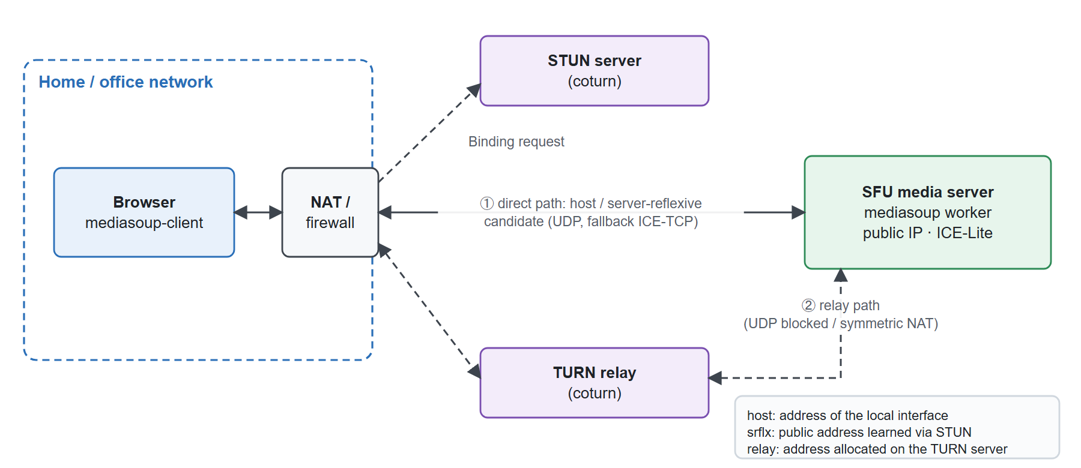
Figure 2.1. ICE candidate types and connectivity paths between a browser and the SFU
A media server with a fixed public address, such as mediasoup, runs ICE-Lite: it only announces its own host candidates and answers checks, while the browser controls the process. The server listens on both UDP and TCP, so media can still flow over ICE-TCP when UDP is blocked. To avoid distributing a permanent TURN password, the system uses time-limited TURN credentials [15]: the username is <expiry timestamp>:<userId> and the password is base64(HMAC-SHA1(secret, username)), which the TURN server (coturn) verifies with the same shared secret.

Security: DTLS-SRTP
WebRTC mandates encryption. After ICE has found a path, the endpoints run a DTLS handshake (TLS over UDP) and compare the peer's certificate with the fingerprint received through signalling; since signalling runs over secure WebSocket, the fingerprint cannot be forged. Keys derived from DTLS [16] are then used by SRTP [17] to encrypt and authenticate every RTP and RTCP packet. With an SFU this protection is hop-by-hop (client ↔ SFU): the SFU decrypts packets to read RTP headers and re-encrypts them for each receiver.

RTP, RTCP and QoS metrics
RTP [18] carries media. Its 12-byte fixed header contains a payload type, a 16-bit sequence number (to detect loss and reordering), a 32-bit timestamp in codec clock units and a 32-bit SSRC that identifies the stream. RTCP is the companion control channel: Sender and Receiver Reports carry packet counts, cumulative loss, the highest sequence number and the interarrival jitter; feedback messages carry NACK (retransmission requests), PLI (requests for a new key frame) and transport-wide congestion control feedback. The QoS metrics used in this thesis are:
- Jitter, the variation of packet transit time. With D(i−1,i) = (Rᵢ − Rᵢ₋₁) − (Sᵢ − Sᵢ₋₁), where R is the arrival time and S the RTP timestamp, the smoothed estimate is Jᵢ = Jᵢ₋₁ + (|D(i−1,i)| − Jᵢ₋₁)/16.
- Round-trip time (RTT), measured from RTCP reports or, in the browser, from STUN checks on the selected ICE candidate pair.
- Packet loss ratio in a measurement window: Δlost / (Δreceived + Δlost).
- Jitter-buffer delay, the average time a frame waits in the receive buffer before decoding, which is the main component of the end-to-end delay perceived by the user.

Congestion control, simulcast and codecs
Network capacity is not constant, so the sender estimates it continuously. Chrome uses Google Congestion Control (GCC) [19], which treats growing queuing delay as a sign of imminent congestion and reduces the bitrate, resolution or frame rate; the browser reports the reason in qualityLimitationReason (bandwidth or cpu). To serve receivers with different capacities, the sender can use simulcast: it encodes the same video several times at different resolutions, each with its own RTP stream, and the SFU forwards the version that suits each receiver at the cost of extra encoders and uplink on the sender. The system uses VP8 [20] simulcast with three layers q/h/f (quarter, half and full resolution, at most 150/400/1200 kbps) and Opus [21] for audio.

Multipoint conferencing architectures
Consider a room with N participants, each sending one video stream of bitrate b. Figure 2.2 shows the three classical architectures.
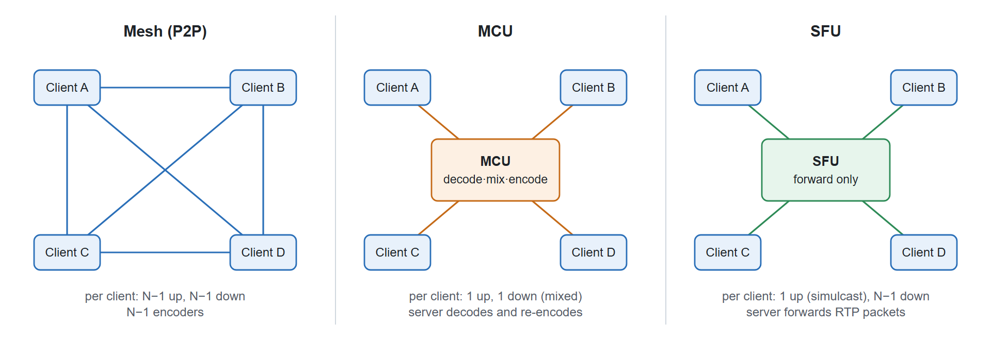
Figure 2.2. Mesh, MCU and SFU topologies for a room with four participants

Mesh
Every pair of participants has its own peer connection, N(N−1)/2 connections in total. Each client encodes its video N−1 times (one encoder per connection, because each connection runs its own congestion control), uploads N−1 streams and decodes N−1 streams. No media server is needed and the delay is minimal, but the uplink and CPU of every client grow linearly with N. Because the uplink is usually the weakest part of home and mobile networks, mesh is practical only for very small rooms.

MCU
Each client sends one stream to a Multipoint Control Unit, which decodes all streams, mixes them into one composite picture and sound, and re-encodes the result for each participant. Clients send and receive only one stream, but the server spends a large amount of CPU on decoding, mixing and encoding, adds processing delay, imposes a fixed layout and reduces quality through transcoding.

SFU
Each client sends one stream (or one simulcast group) to a Selective Forwarding Unit. The SFU does not decode media: it reads RTP headers and forwards each packet only to the receivers that need it, while handling RTCP feedback for each receiver. The client's uplink is independent of N, the server's CPU cost is low because it works at packet level, and each receiver can get a different quality layer. The client's downlink still grows with N−1, which can be reduced by selecting lower layers or pausing streams that are not displayed [22].

Quantitative comparison
Table 2.2 compares the per-client and server costs of the architectures.
Table 2.2. Cost of the conferencing architectures for N participants
Quantity (per client) | Mesh | MCU | SFU | SFU + simulcast
Video encoders | N−1 | 1 | 1 | 3 (constant)
Uplink | (N−1)·b | b | b | b_q + b_h + b_f
Downlink | (N−1)·b | b_mix | (N−1)·b | sum of selected layers
Decoded streams | N−1 | 1 | N−1 | N−1 or number of visible tiles
Server CPU | none | very high | low | low
Added delay | none | decode + mix + encode | one forwarding hop | one forwarding hop

For N = 6 and b = 1.2 Mbps, a mesh client would have to upload 5 × 1.2 = 6 Mbps with five encoders, whereas an SFU client with simulcast uploads at most 0.15 + 0.4 + 1.2 ≈ 1.75 Mbps with three encoders, independently of N. Previous studies of open-source SFUs [23] report the same qualitative behaviour. The project therefore chooses an SFU: client uplink and CPU stay constant as N grows, the server does not decode media, and simulcast combined with demand-driven layer selection also keeps the downlink under control. Chapter 5 verifies this choice experimentally against a mesh implementation on the same hardware.

The mediasoup SFU
mediasoup [5] is an SFU library for Node.js whose media core is written in C++ and runs in separate worker processes, while the control API is written in JavaScript/TypeScript. Its main concepts are listed in Table 2.3.
Table 2.3. Main concepts of mediasoup
Concept | Role
Worker | A C++ process that uses one CPU core; the application creates a pool of workers
Router | A media "room" with a common set of codecs; forwards packets from producers to consumers
WebRtcTransport | An ICE-Lite/DTLS/SRTP endpoint for one client (usually one for sending and one for receiving)
Producer | A track sent by a client (microphone, camera or screen)
Consumer | A track sent by the SFU to one client; can be paused, resumed and switched between simulcast layers

The minimal signalling flow is: obtain the router's RTP capabilities, create two transports, connect them with the client's DTLS parameters, produce local tracks, and consume remote tracks. Consumers are created paused and resumed only when the client is ready, so the first key frame is not lost. mediasoup also sends probing packets on a dedicated stream (SSRC 1234) to discover spare bandwidth before switching a consumer to a higher layer; these packets must be excluded from client-side quality metrics (Section 5.4.2).

Role-based access control
Role-based access control (RBAC) [24] assigns permissions to roles rather than to individual users. The system uses two levels of roles. At workspace level, the single owner has full control and can transfer ownership, admins manage members, channels and invitations, and members use the channels they are allowed to see; private channels add an explicit list of channel members. At meeting level, the host and co-hosts moderate the room (waiting room, lock, admit, remove, mute) and only the host can appoint co-hosts or end the meeting. Every socket event that writes data and every media signalling call is checked against the current role before it reaches its handler.

Chapter summary
WebSocket and Socket.IO provide a two-way channel with acknowledgements, rooms and horizontal scaling through adapters, which is the basis for chat, typing, presence and signalling. WebRTC captures, encrypts and transports media and exposes standard statistics; ICE/STUN/TURN handle NAT traversal and RTP/RTCP carry media and quality feedback. Among the three conferencing architectures, the SFU gives the best balance between client load, server load and delay, and with simulcast it can control both uplink and downlink. These conclusions drive the design in Chapter 3.

SYSTEM BLOCK DIAGRAM AND DESIGN
This chapter starts from the requirements, presents the block diagram of the whole system, and then analyses each block: what it contains, what it is responsible for and how it works with the other blocks. The last sections describe the database, the access-control model and the real-time protocols that connect the blocks.

Requirements analysis

Actors
Table 3.1 lists the actors of the system. Workspace roles and meeting roles are independent: the same person can be a member of a workspace and the host of a meeting in one of its channels.
Table 3.1. Actors of the system
Actor | Description
Guest | Not signed in; can view the landing page, register, sign in and open an invitation link
Member | Belongs to one or more workspaces; sends messages and joins voice/video channels
Admin | A member who manages channels, members and invitations of a workspace
Owner | The creator of a workspace; full control, changes roles, transfers ownership, archives
Host / co-host | Roles inside one meeting session; moderate the room

Functional requirements
Table 3.2 lists the functional requirements, grouped by feature. F1–F7 are the user-facing functions; F8 supports the evaluation in Chapter 5.
Table 3.2. Functional requirements
ID | Group | Requirement
F1 | Account | Register with e-mail OTP verification, sign in with password or Google, refresh sessions, reset password
F2 | Workspace | Create workspaces; invite members by link or e-mail; owner/admin/member roles; archive and restore
F3 | Channel | Text, voice and video channels; private channels with a member list; channel ordering
F4 | Messaging | Send, edit and delete messages; threaded replies, mentions, reactions, pins, bookmarks, attachments, search
F5 | Presence | Online/offline status, typing indicators and unread counters in real time
F6 | Conferencing | Join and leave a video channel; microphone and camera control; screen sharing; dynamic video grid
F7 | Moderation | Waiting room, room lock, admit, remove, mute others, raise hand, end the meeting
F8 | Measurement | Display and export call QoS (RTT, jitter, packet loss, bitrate)

Non-functional requirements
Table 3.3 states the non-functional requirements and how each of them is verified in Chapter 5.
Table 3.3. Non-functional requirements
Group | Requirement | Verification
Latency | Messages reach receivers in < 100 ms (95th percentile) on a local network | Load test with 50/100/200 connections (Section 5.3)
Media scalability | Client uplink and CPU do not grow with the number of participants | Mesh/SFU experiment (Section 5.4)
Media quality | Packet loss ≈ 0, jitter < 30 ms, RTT < 150 ms on a good network | getStats() measurements (Section 5.4)
Reliability | No lost or duplicated messages after lost acknowledgements or reconnection; automatic ICE recovery | Integration tests (Section 5.2)
Security | Hashed passwords, short-lived tokens, per-event authorisation, DTLS-SRTP | Permission tests (Section 5.2)
Horizontal scaling | Several API processes; meetings placed on workers/nodes | Two-process integration test (Section 5.2)

Main use cases
Figure 3.1 shows the main use cases grouped by actor. Members work inside workspaces and channels; owners and admins manage the workspace; hosts and co-hosts moderate a meeting.
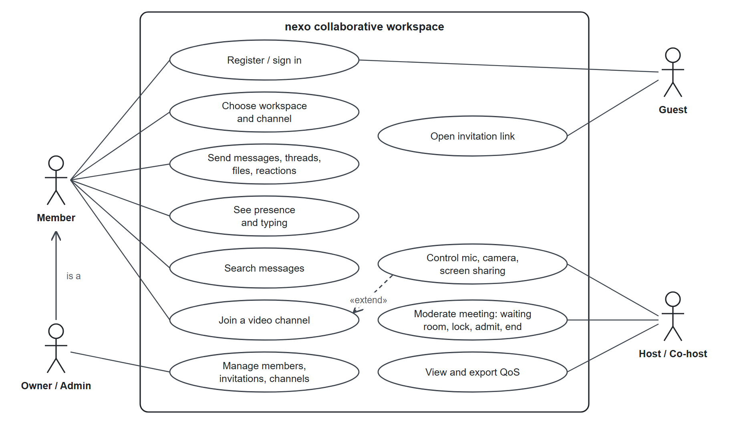
Figure 3.1. Main use cases of the system

System block diagram

Overview
Figure 3.2 is the block diagram of the system. It consists of three main blocks (the client, the application and signalling server, and the SFU media server) and two supporting blocks (the data block and the network traversal block).
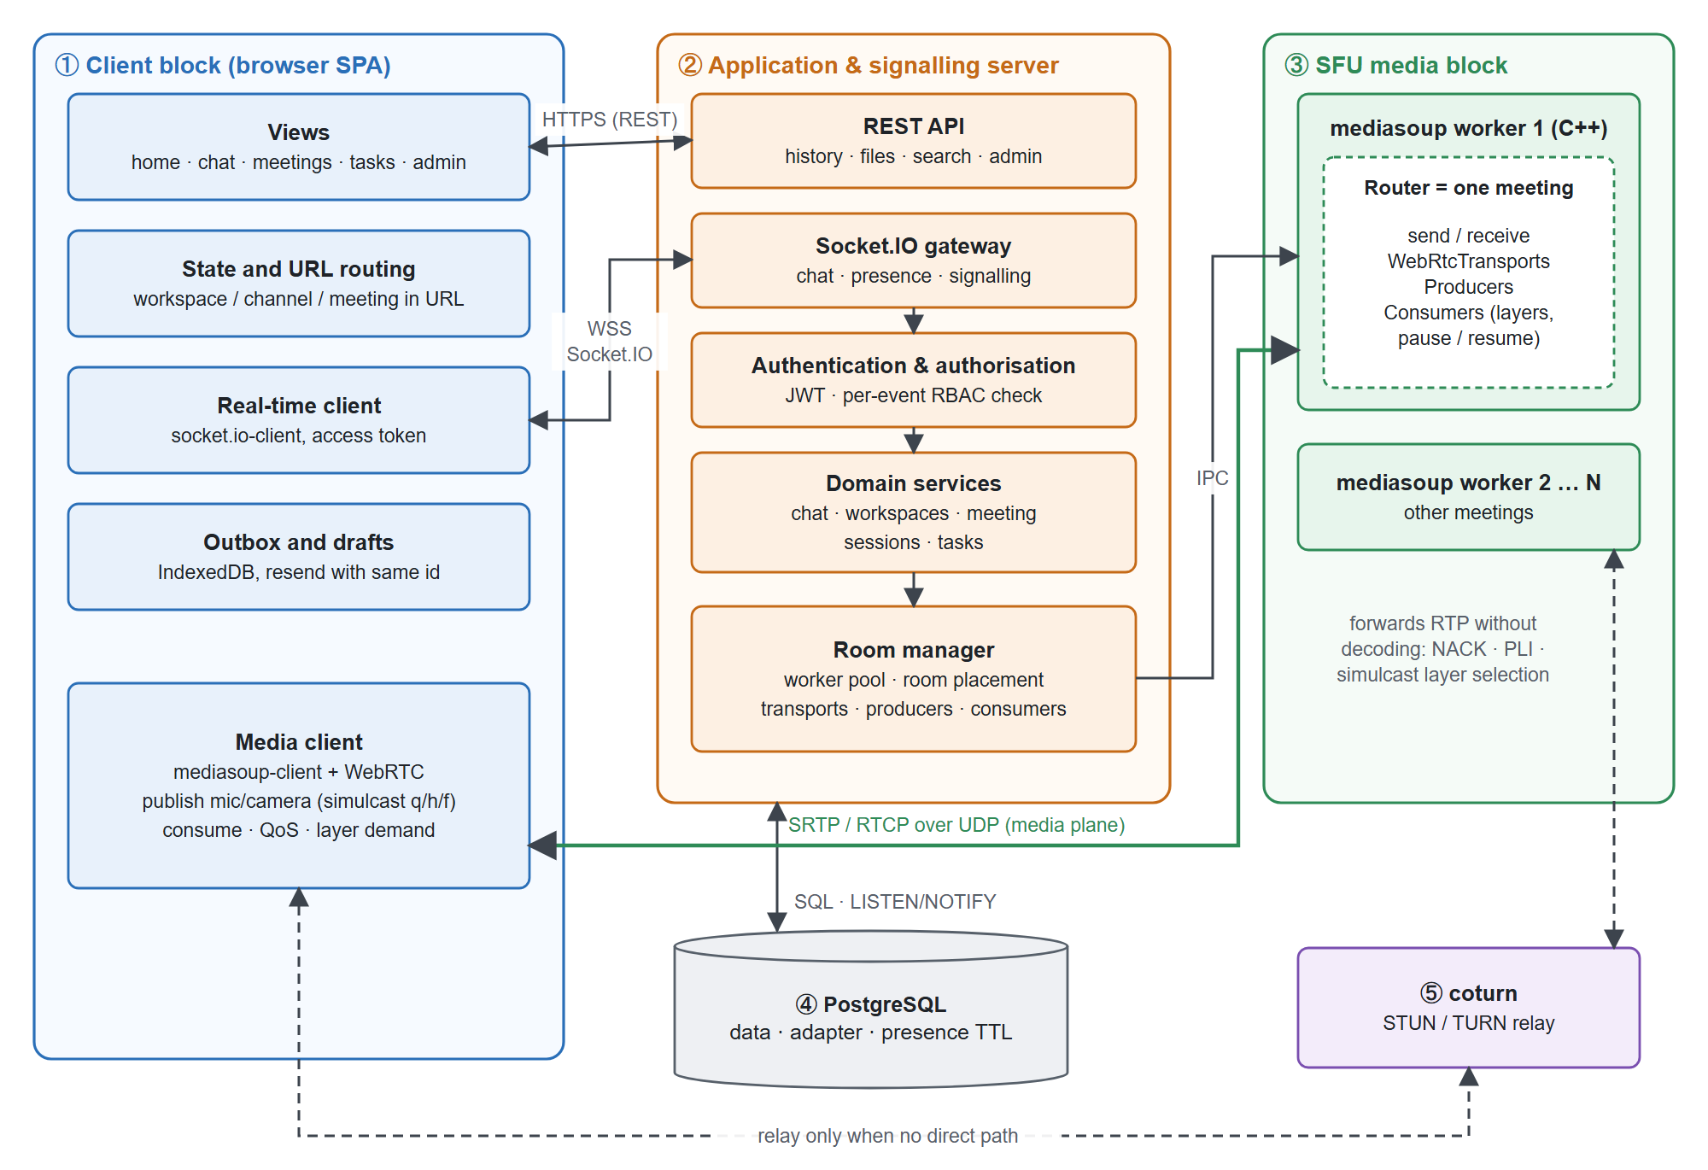
Figure 3.2. System block diagram
- The client block is a React single-page application running in the browser. It opens one Socket.IO connection for messaging and presence, uses REST for data that is loaded on demand, and opens two WebRTC transports (send and receive) when the user joins a video channel.
- The application and signalling server block is a Node.js process that exposes the REST API and the Socket.IO gateway. Every request and every event goes through authentication and authorisation before it reaches the chat, meeting or task services. The room manager in this block controls the media workers.
- The SFU media block is a pool of mediasoup C++ workers. Each meeting is a router placed on one worker; media flows directly between the browser and the worker.
- The data block is PostgreSQL. Besides business data, it stores presence with a TTL and forwards Socket.IO events between application processes.
- The network traversal block is a coturn STUN/TURN server used when a direct UDP path between a browser and the SFU is impossible.

Control plane and data plane
The most important design decision is to separate the control plane from the media plane (Table 3.4). Messages, presence and signalling are small and go through the Node.js process; audio and video packets are large and never touch Node.js but go directly between the browser and a C++ worker. As a result the Node.js process only handles small messages, and Chapter 5 shows that its CPU usage stays at about 1% of one core or less while the workers forward media for ten participants.
Table 3.4. Separation of control, media and data traffic
Traffic | Protocol | Path
Control (messages, presence, signalling) | Secure WebSocket (Socket.IO) | Browser ↔ Node.js API
Media | SRTP/SRTCP over UDP (fallback ICE-TCP, TURN) | Browser ↔ mediasoup worker
Persistent data | SQL | Node.js API ↔ PostgreSQL

Block analysis

Client block
The client block has five components:
- Views for the home page, workspaces, channels, chat, meetings, tasks, notifications, profile and administration. The layout has a navigation rail, a channel list and a content area; on phones the columns collapse into drawers.
- Application state and routing. The current workspace, channel and meeting are encoded in the URL, so reloading the page, using back/forward or sharing a link always restores the right context.
- Real-time client. A single socket.io-client connection authenticated with a short-lived access token. It receives messages, presence and meeting events and sends signalling requests with acknowledgements.
- Durable outbox and drafts. Unconfirmed messages and drafts are stored in IndexedDB, so they survive a reload and can be resent with the same identifier.
- Media client. mediasoup-client builds the WebRTC transports from server parameters, publishes the microphone, camera (as three simulcast layers) and screen, consumes remote tracks, collects QoS statistics and decides which layer each visible tile needs.

Application and signalling server block
The server block runs on Node.js and contains:
- Authentication: registration with e-mail OTP, password sign-in with salted scrypt hashes [25], Google sign-in, short-lived JWT access tokens [26] (15 minutes) and rotating refresh tokens stored in an HttpOnly cookie.
- REST API for data loaded on demand: workspaces, channel history, files, search, notifications, tasks and administration.
- Socket.IO gateway with two middleware layers: token verification on connection, and per-event rate limiting and authorisation before each handler.
- Domain services: chat (messages, threads, mentions, notifications), workspaces and invitations, meeting sessions and moderation, tasks.
- Room manager, which owns the pool of mediasoup workers, places each meeting on a worker and creates transports, producers and consumers on behalf of clients.

SFU media block
The SFU block is a pool of mediasoup workers (two by default, at most eight). Each meeting is a router on exactly one worker, chosen as the worker with the fewest rooms. A router holds one send transport and one receive transport per participant, the producers that participants publish and the consumers that deliver remote tracks. The worker forwards RTP packets without decoding them, selects the simulcast layer for each consumer, retransmits lost packets on NACK and requests key frames when a consumer starts or changes layer. If a worker dies, only the meetings on that worker are closed; their participants are asked to rejoin and a replacement worker is created.

Data block
PostgreSQL stores all business data (Section 3.4). It also plays two infrastructure roles. First, the Socket.IO PostgreSQL adapter uses LISTEN/NOTIFY [27] to forward emitted events between API processes. Second, the socket_presence table stores one row per live socket with an expiry time renewed by a heartbeat, so presence is consistent across processes and stale rows of a crashed process expire automatically.

Network traversal block
The coturn server provides STUN and TURN. The API generates time-limited TURN credentials for each transport, so a client can fall back to a relay when UDP is blocked or the NAT is symmetric. The SFU itself announces a public (or LAN) address and accepts both UDP and TCP.

Database design
The PostgreSQL database contains 36 tables and views created by 20 versioned migrations. Table 3.5 groups the tables by domain, and Figure 3.3 shows the core entities of messaging and conferencing.
Table 3.5. Database tables grouped by domain
Domain | Main tables | Notes
Identity | users, refresh_sessions, email_otps, password_resets | Salted password hashes; refresh tokens and OTP codes stored only as hashes
Organisation | workspaces, memberships, channels, channel_memberships, workspace_invitations, audit_events | Exactly one owner (unique index and constraint trigger); invitation tokens stored as SHA-256
Communication | messages, message_attachments, message_reactions, message_mentions, message_pins, message_bookmarks, thread_reads, notifications | Unique client message identifier per author prevents duplicates
Conferencing | meeting_sessions, meeting_attendees, meeting_connections, meeting_schedules | At most one active session per channel (partial unique index)
Operations | socket_presence, api_instances, request_rate_limits, schema_migrations | Presence TTL, process leases, rate limits
Extension | tasks and related tables | Kanban board (not the focus of the thesis)

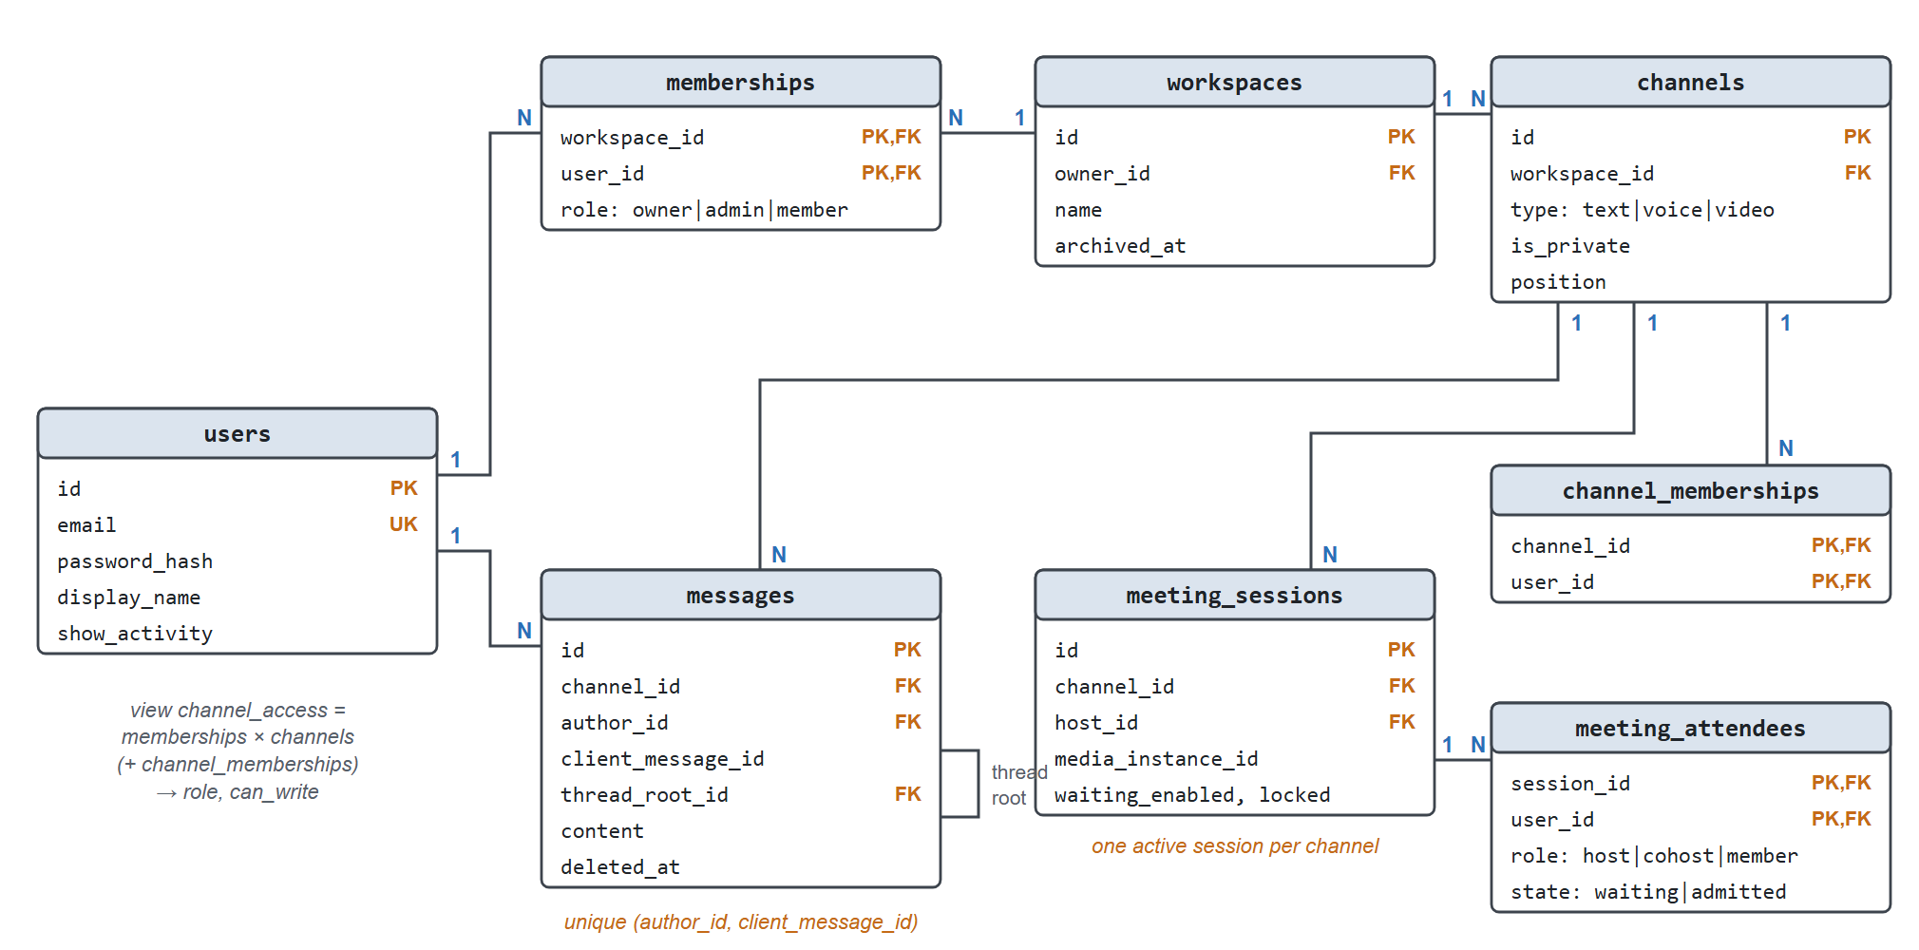
Figure 3.3. Core entities of the database
A database view, channel_access, joins memberships with channels (and with channel_memberships for private channels) and returns, for each user and channel, the role and whether the user can write (the workspace and channel are not archived). Every read or write permission check (REST, socket, search, file download and media) uses this single view, so the access policy is defined in exactly one place.

Access control design
Table 3.6 and Table 3.7 define the permissions of the two role levels introduced in Section 2.5.
Table 3.6. Workspace-level permissions
Operation | Owner | Admin | Member | Note
Read and send in public channels | ✓ | ✓ | ✓ | Workspace and channel not archived
Read and send in private channels | ✓* | ✓* | ✓* | Requires channel membership, even for the owne
Create, edit and reorder channels | ✓ | ✓ | –
Invite and revoke invitations | ✓ | ✓ | – | Seven-day tokens, stored only as hashes
Change roles, transfer ownership, archive | ✓ | – | – | Transaction with a workspace lock
Join video channels | ✓ | ✓ | ✓ | Per-session limits on users, tabs and sources

Table 3.7. Meeting-level permissions
Operation | Host | Co-host | Member
Enable the waiting room, lock the room | ✓ | ✓ | –
Admit, remove, mute others | ✓ | ✓ | –
Appoint co-hosts, end the session | ✓ | – | –
Raise hand, control own devices | ✓ | ✓ | ✓

When a user loses access, the server emits access_revoked, disconnects all sockets of that user on every process and closes the user's media resources. The client then reconnects and reloads data with the new permissions.

Real-time protocol design

Event catalogue
The Socket.IO event contract is defined once as TypeScript types in a shared package and is used by both the client and the server, so a renamed event or a changed payload is a compile-time error on both sides. Table 3.8 summarises the events.
Table 3.8. Socket.IO event catalogue
Group | Client → server (with acknowledgement) | Server → client
Channels | join_channel, leave_channel, mark_channel_read | channel_read
Messages | send_message, edit_message, delete_message, react_message | new_message, message_changed
Presence | typing | user_typing, user_presence, online_users
Meetings | join_meeting, leave_meeting, meeting_state, meeting_action | meeting_state_changed, meeting_closed, meeting_mute
SFU signalling | create_webrtc_transport, connect_webrtc_transport, produce, consume, resume_consumer, pause_consumer, consumer_layer, close_producer, restart_ice | new_producer, producer_closed, peer_left

Message delivery flow
The goal of the message protocol is that a message is never lost and never stored twice, even when acknowledgements are lost or the connection drops. Figure 3.4 shows the flow. The client assigns a clientMessageId and keeps the message in its outbox until it receives the acknowledgement. The server checks the current permission, takes a lock on (author, clientMessageId) and either inserts the message and broadcasts it, or, if the same identifier was already stored with the same content, returns the stored message without broadcasting it again. If the acknowledgement is lost, the client resends with the same identifier; after a reconnection it fetches the messages it missed through REST with an after cursor.
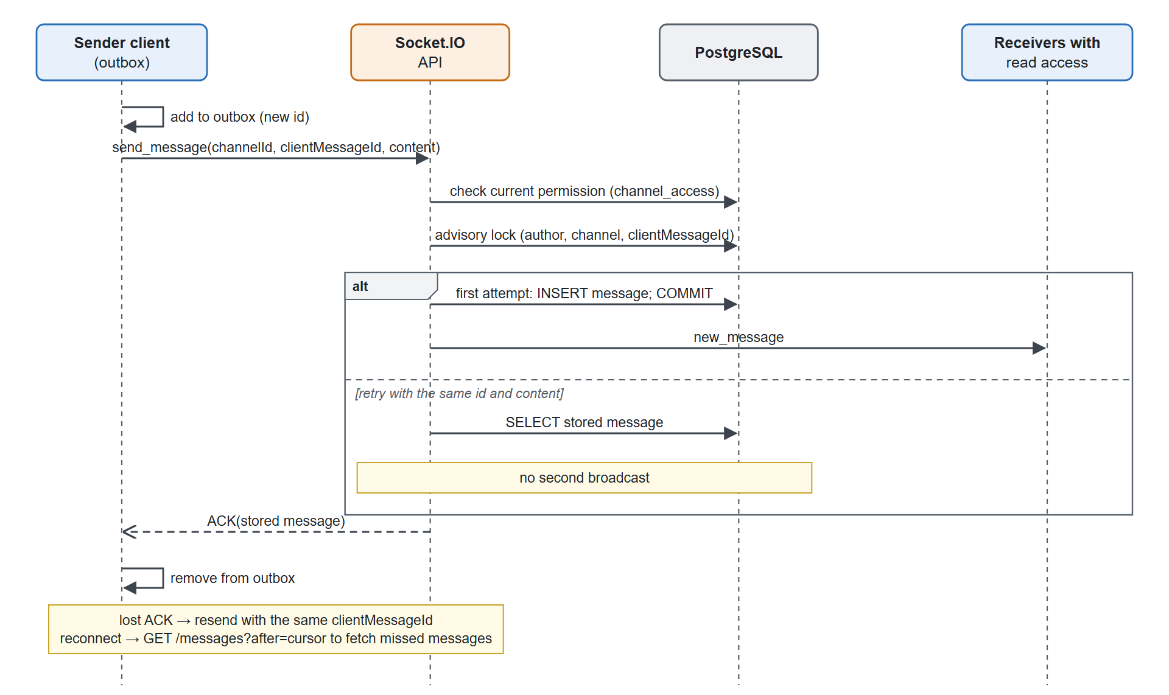
Figure 3.4. Sequence diagram of reliable message delivery

Joining a video channel
Figure 3.5 shows how a client joins a video channel. The server checks permissions, session limits and the waiting room, places the meeting on a worker, and returns the router's RTP capabilities. The client loads its mediasoup device, creates a send and a receive transport, publishes its tracks (the camera as three simulcast layers) and consumes the producers of the other participants. Consumers start paused and are resumed when the client is ready. Afterwards the client continuously tells the SFU which layer it needs for each tile, or pauses tiles that are not visible.
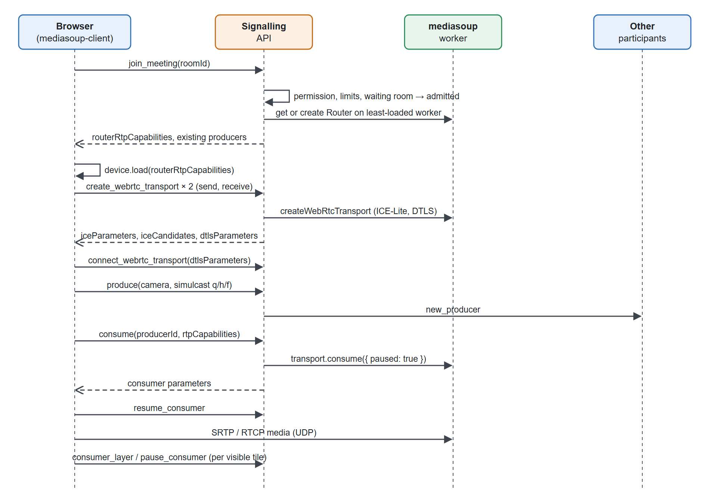
Figure 3.5. Sequence diagram of joining a video channel

Horizontal scaling design
Messaging and media scale differently, as illustrated in Figure 3.6. For messaging and presence, several API processes share PostgreSQL; the PostgreSQL adapter forwards emitted events between processes and the socket_presence table with a TTL and heartbeat gives a consistent view of who is online. Each process also renews a lease in api_instances, so the others can detect a dead process and clean up its meetings. Media cannot be shared in this way, because transports and routers live inside one worker process. A meeting therefore lives on one node and worker (room affinity): the session row records the media instance that owns the meeting, and clients ask the API for the media location before they open their media socket.
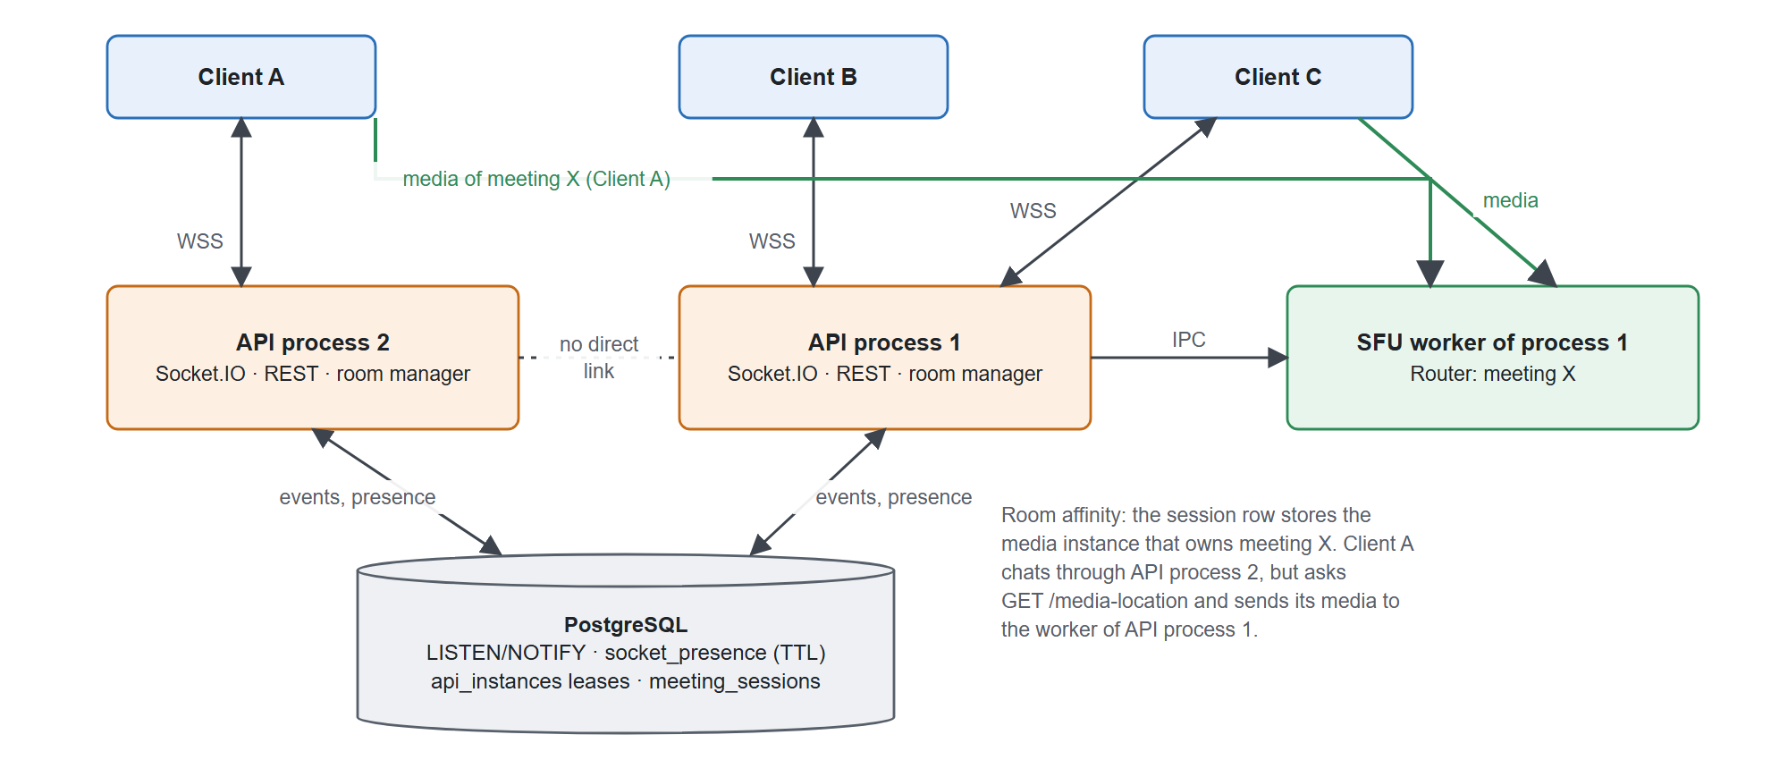
Figure 3.6. Horizontal scaling: shared messaging, room affinity for media

User interface design
The interface follows a three-column layout: a navigation rail (home, groups, meetings, tasks, notifications, settings), a list of workspaces and channels, and a content area for chat or a meeting, with an optional information panel. The video grid computes the column count that gives the largest 16:9 tiles, paginates tiles (4, 6 or 9 per page depending on the width) and offers a focus mode with one large tile. Tiles outside the current page are not rendered and their video is paused at the SFU. The connection state is always visible: the channel header shows the number of online members or "reconnecting", and messages that could not be sent are shown with retry and discard actions. Screenshots of the implemented interface are presented in Section 4.5.

Chapter summary
The system is organised as three main blocks (client, application/signalling server and SFU) and two supporting blocks (PostgreSQL and coturn). The control plane and the media plane are separated so that Node.js only handles small messages. A single database view defines access to channels, the message protocol combines client identifiers, an outbox and a uniqueness constraint to avoid loss and duplication, and meetings are pinned to one worker while messaging is shared between processes. Chapter 4 explains how these blocks are implemented.

SYSTEM IMPLEMENTATION
This chapter describes how the blocks of Chapter 3 are implemented. Following the guidelines of the faculty, it does not reproduce the source code; it presents the algorithms as diagrams and quotes only the short pieces of code that carry the key ideas. The listings are shortened, and comments in English were added for the report.

Source code organisation
The project is an npm-workspaces monorepo written entirely in TypeScript (Table 4.1). Each feature (authentication, workspaces, chat, meetings, tasks, files, profiles) has its own routes and services on the server and its own pages, components and API client on the browser side. The Socket.IO contract (ClientToServerEvents, ServerToClientEvents) lives in the shared package, so the compiler checks both sides of every event.
Table 4.1. Structure of the source code
Folder | Content
apps/web | React single-page client: application providers and layout, features/<module>, shared UI
services/api | Node.js server: modules/<domain>, infrastructure (database, real-time, e-mail), 20 SQL migrations
packages/shared | Data types and the Socket.IO event contract shared by client and server
experiments | Mesh/SFU media laboratory and packet-capture analyser (Chapter 5)
scripts | WebSocket benchmark, backup/restore verification, test fixtures
infra | Docker Compose files for development and production, Nginx configuration

The code base contains about 17,500 lines of TypeScript/TSX and 13,000 lines of CSS in the client, about 7,000 lines of TypeScript in the server and 470 lines in the shared package.

Real-time core

Authentication and per-event authorisation
The Socket.IO server shares the HTTP server with the REST API and applies two middleware layers. When a socket connects, the access token from the handshake is verified and the user is loaded; connections without a valid token are rejected. Then, before every event, a second middleware applies the checks shown in Figure 4.1: a burst limit per socket, re-verification of the token, a rate limit of 120 write operations per minute per user, a check of the current channel permission in the database (not the rooms the socket joined earlier) and, for media signalling, a check that the socket is inside that meeting and has been admitted. A user in the waiting room or one who was removed therefore cannot create transports, produce or consume media.
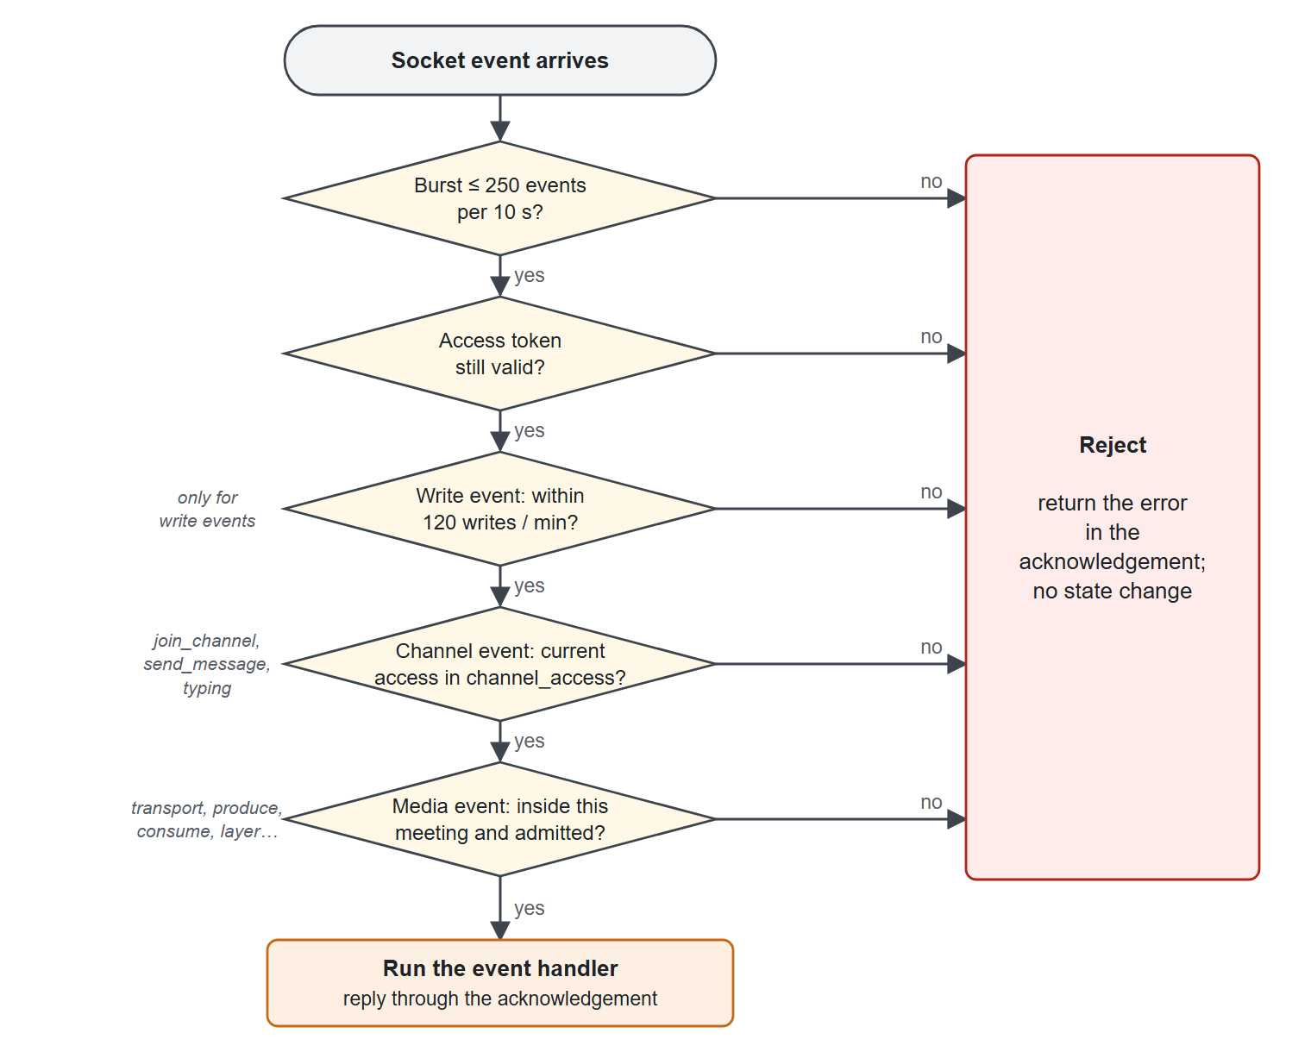
Figure 4.1. Per-event authorisation pipeline of the Socket.IO gateway
Listing 4.1 shows the core of this middleware. The event name selects which checks apply.
Listing 4.1. Per-event authorisation middleware (services/api/src/infrastructure/realtime/socket.ts, shortened)
socket.use(async ([event, data, ack], next) => {
try {
if (++burstCount > 250) throw new Error("Too many operations");
await verifyAccessToken(token); // token may have expired
if (WRITE_EVENTS.includes(event))
await limitActor(user.id, "realtime-write", 120, 60);
if (["join_channel", "send_message", "typing"].includes(event))
// current rights read from the database, not from joined rooms
await requireChannelAccess(user.id, data?.channelId);
if (MEDIA_EVENTS.includes(event)) {
await requireChannelAccess(user.id, data?.roomId, true);
if (event !== "join_meeting" && activeMeetingRoomId !== data.roomId)
throw new Error("You have not joined this room");
if (event !== "join_meeting")
// not in the waiting room, not removed
await requireAdmitted(user.id, data.roomId, socket.id);
}
next();
} catch (error) { reply(ack, error); }
});
Revocation takes effect immediately: the server emits access_revoked to the room user:<id> and disconnects all sockets of that user.

Exactly-once message storage
Figure 4.2 is the flowchart of send_message. The server validates the content (at most 4,000 characters) and the attachment, opens a transaction, locks the workspace and channel rows in share mode and re-checks the write permission inside the transaction, so a concurrent removal cannot slip in between the check and the insert. It then takes a transaction-scoped advisory lock on (author, channel, clientMessageId) and looks for an existing message with the same identifier. Three outcomes are possible: no message exists, so the message is inserted, mentions and notifications are created and new_message is emitted after commit; the same identifier exists with the same content fingerprint, which means the client is retrying after a lost acknowledgement, so the stored message is returned without a new broadcast; or the identifier exists with different content, which is reported as a conflict.
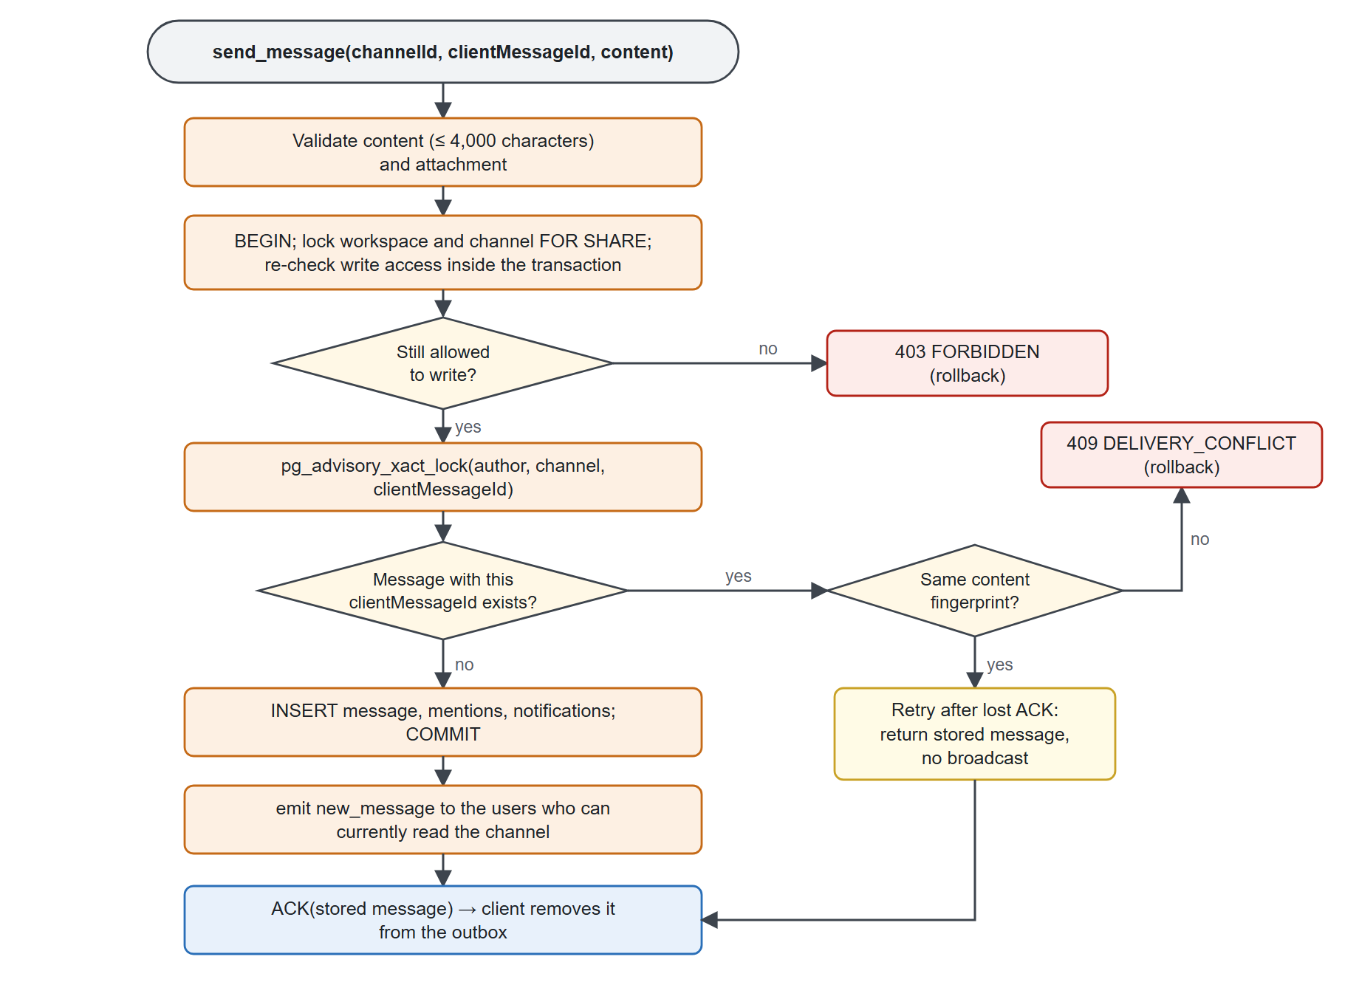
Figure 4.2. Flowchart of idempotent message sending on the server
Listing 4.2 shows the deduplication step inside the transaction. The content fingerprint (payloadHash) is a SHA-256 hash of the content, the reply target, the attachment, the thread root and the mentioned users, computed before the transaction starts.
Listing 4.2. Deduplication inside the send-message transaction (services/api/src/modules/workspaces/service.ts, shortened)
const result = await withTransaction(async (client) => {
// Hold the current membership until the insert commits
const access = await client.query(`SELECT m.user_id FROM memberships m ...
AND EXISTS (SELECT 1 FROM channel_access a WHERE ... AND a.can_write)
FOR SHARE OF m`, [channelId, userId]);
if (!access.rowCount) throw new HttpError(403, "FORBIDDEN", "...");
if (options.clientMessageId) {
await client.query(`SELECT pg_advisory_xact_lock(hashtextextended($1, 0))`,
[`${userId}:${channelId}:${options.clientMessageId}`]);
const previous = await client.query(
`SELECT ..., client_payload_hash AS "payloadHash" FROM messages
WHERE channel_id=$1 AND author_id=$2 AND client_message_id=$3`,
[channelId, userId, options.clientMessageId]);
if (previous.rowCount) {
if (previous.rows[0].payloadHash !== payloadHash)
throw new HttpError(409, "DELIVERY_CONFLICT", "...");
// retry after a lost ACK: return the stored message, no broadcast
deduplicated = true;
return previous;
}
}
return client.query(
`INSERT INTO messages (..., client_message_id, client_payload_hash) ...`);
});
New messages are emitted to the user:<id> rooms of the users who can currently read the channel, determined with the channel_access view, rather than to a workspace-wide room; content of a private channel therefore never reaches a member who is not in that channel. On the client, unconfirmed messages are kept in an IndexedDB outbox that survives a reload and are resent with the same clientMessageId. After a reconnection the client calls GET /api/channels/:id/messages?after=<cursor> to fetch the messages it missed and merges them by identifier. Together with the unique constraint on (author, clientMessageId), this gives at-least-once delivery on the network and exactly-once storage in the database.

Presence and typing
Presence is implemented with an in-memory connection counter per user and a socket_presence table that makes presence consistent across processes (Table 4.2). Figure 4.3 shows the heartbeat that runs every 15 seconds on each API process.
Table 4.2. Implementation of presence and typing
Component | Implementation
Connection counting | A map from user to number of sockets; online when the count goes from 0 to 1, offline when it goes from 1 to 0
Cross-process state | socket_presence(socket_id, user_id, instance_id, expires_at) with a 45-second TTL
Heartbeat | Every 15 s: renew the TTL of live sockets, delete expired rows, clean up meetings of dead processes, send online_users to each socket
Broadcast scope | user_presence only to workspaces the user belongs to; respects the user's "show activity" setting
Typing | typing {channelId, isTyping} → permission check → user_typing to the other members of the channel; not stored

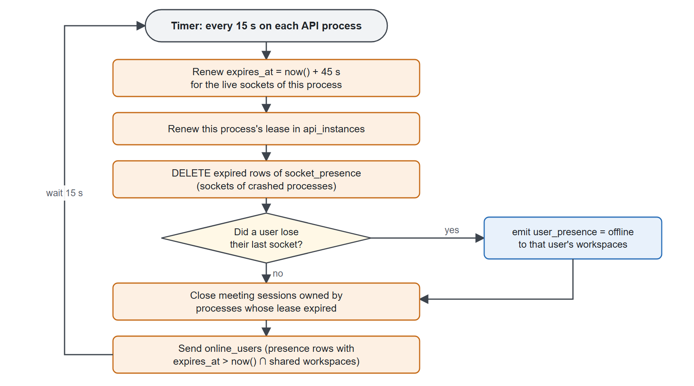
Figure 4.3. Presence heartbeat executed by each API process every 15 seconds
Because the online list is computed from rows whose expires_at is in the future, a user connected to process A is visible to a user connected to process B, and when a process is killed its rows expire within at most 45 seconds and its users become offline.

Multi-process event distribution
With SOCKET_ADAPTER=postgres, Socket.IO uses the PostgreSQL adapter: a call to io.to(room).emit(...) is published through LISTEN/NOTIFY and the other processes re-emit it to their local sockets. Each process holds a lease row in api_instances that it renews every 15 seconds and that expires after 45 seconds. The integration test distributed.test.js starts two real API processes and verifies that messages, task updates and notifications cross processes.

Conferencing core

Worker pool and room placement
The room manager keeps a pool of mediasoup workers (MEDIASOUP_WORKERS, two by default, at most eight). When a meeting starts, the room manager places its router on the worker that currently hosts the fewest rooms (Listing 4.3). If a worker dies, its rooms are closed, their participants receive media_failure and are asked to rejoin, rooms on other workers are not affected, and the next join creates a replacement worker; the test worker-recovery.test.js kills a real worker to verify this behaviour.
Listing 4.3. Choosing the least-loaded worker (services/api/src/modules/meetings/media/room-manager.ts)
const worker = [...this.workers].sort(
(a, b) =>
(this.allocations.get(a.pid) ?? 0) - (this.allocations.get(b.pid) ?? 0),
)[0];
if (!worker) throw new Error("Media worker unavailable");
this.allocations.set(worker.pid, (this.allocations.get(worker.pid) ?? 0) + 1);
return worker;
Routers use Opus 48 kHz stereo and VP8 with a start bitrate of 1 Mbps. Each WebRTC transport enables UDP and TCP, prefers UDP and announces MEDIASOUP_ANNOUNCED_IP, which must be the public address in production and the LAN address (not 127.0.0.1) in development, for the reason explained in Section 5.4.2.

Producer and consumer lifecycle
- produce checks the limit of sources per participant (by default three: microphone, camera and screen), accepts only those three kinds and emits new_producer to the other participants.
- consume checks router.canConsume, creates the consumer paused and resumes it only after the client sends resume_consumer, once the track is attached, so the first key frame is not lost.
- consumer_layer sets the preferred spatial layer of a simulcast consumer, and pause_consumer stops forwarding a stream that is not displayed. When the consumer is resumed, mediasoup requests a new key frame automatically.
- Closing a producer or a transport closes the dependent consumers, and peer_left tells the clients to remove the tile.

Meeting sessions and moderation
Meeting state is stored in PostgreSQL so that every process sees the same session. Each channel has at most one active session (enforced by a partial unique index), and the first person who joins becomes the host. Joining locks the session row, checks the limits on users and on tabs per user, and checks the lock and waiting-room flags; the result is admitted or waiting. A waiting participant has a socket but no SFU peer. The meeting_action event implements waiting room and lock (host and co-host), admit, remove and mute (host and co-host, never against the host), appoint co-host, transfer and end (host only), and raise hand (everyone). The session row also records the media instance that owns the meeting, and GET /api/channels/:id/media-location returns the SFU endpoint of that instance.

NAT traversal and ICE recovery
With every transport the server returns the list of ICE servers. If TURN is configured, it generates a time-limited credential as described in Section 2.2.2 (Listing 4.4).
Listing 4.4. Time-limited TURN credential (services/api/src/modules/meetings/media/ice.ts)
// valid for one hour
const username = `${Math.floor(Date.now() / 1000) + 3600}:${userId}`;
return [{
urls, // from TURN_URLS
username,
credential: createHmac("sha1", process.env.TURN_SHARED_SECRET)
.update(username)
.digest("base64"),
}];
On the client, every transport is watched for connection-state changes (Figure 4.4). If the transport stays disconnected for 5 seconds, or becomes failed, the client asks the server for new ICE parameters and calls transport.restartIce(), at most twice. If the transport is still not connected 10 seconds after a restart, the user is told to rejoin.
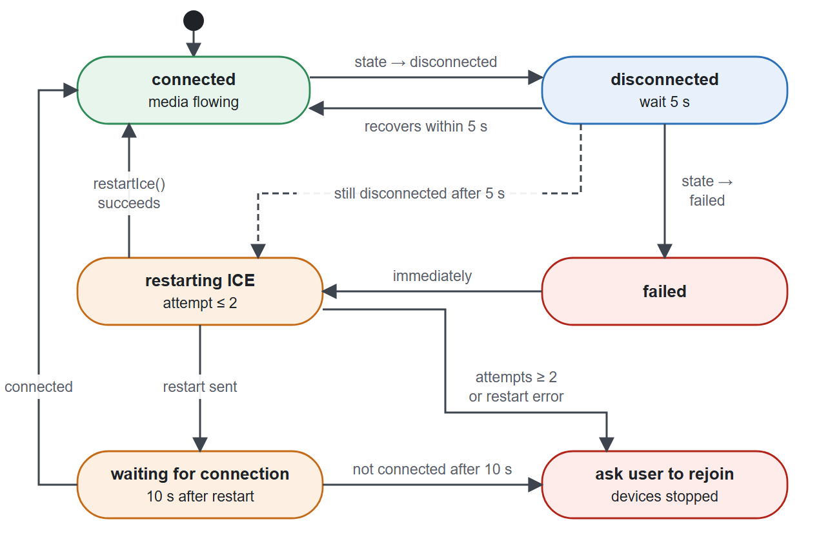
Figure 4.4. State diagram of ICE recovery on the client

Conferencing client and dynamic video grid

Capture and publishing
The lobby lets users preview the camera and microphone, choose devices and a capture quality (640×360, 960×540 or 1280×720) before joining. Only sources that are switched on are published; all four microphone/camera combinations were tested to make sure that a disabled source is never sent. The camera is published with three simulcast encodings q (quarter resolution, 150 kbps), h (half, 400 kbps) and f (full, 1,200 kbps). Screen sharing uses getDisplayMedia() and is published as a separate, non-simulcast source that closes automatically when the user stops sharing from the browser bar. Muting uses track.enabled together with producer.pause(), so unmuting is immediate and does not renegotiate the transport.

QoS collection
A QoS collector reads getStats() from both transports every 2.5 seconds. RTT is taken from the selected candidate pair; jitter is the maximum over the inbound RTP streams; bitrates are computed from the change in bytes over the change in time; and packet loss is computed per window from the change in received and lost packet counters (Listing 4.5). The interface keeps the latest 300 samples (about 12.5 minutes) and can export them as CSV or JSON.
Listing 4.5. Windowed packet-loss computation (apps/web/src/features/meetings/webrtc/qos.ts, shortened)
if (old && sample.timestamp > old.timestamp &&
counter.received >= old.received && counter.lost >= old.lost) {
deltaPackets += counter.received - old.received; // counters may be reset:
deltaLost += Math.max(0, counter.lost - old.lost); // such windows are skipped
hasLoss = true;
}
...
packetLoss: hasLoss && deltaPackets + deltaLost > 0
? (100 * deltaLost) / (deltaPackets + deltaLost)
: null, // no data is not "0% loss"

Dynamic grid and demand-driven layers
The aim of the grid is that the browser only decodes and draws what the user actually sees, at the resolution it needs. Figure 4.5 summarises the algorithm.
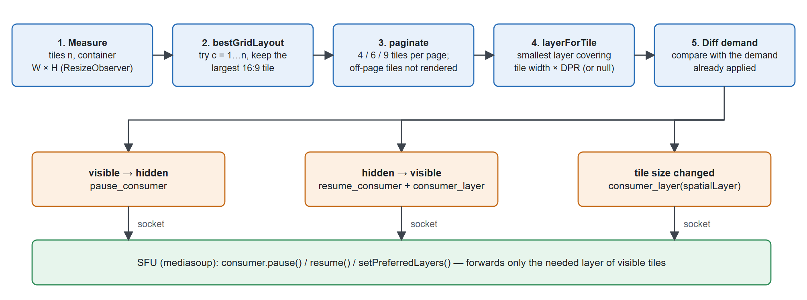
Figure 4.5. Demand-driven video grid: from tile layout to SFU requests
- Best layout. For n tiles in a container of width W and height H, the algorithm tries every column count c from 1 to n, computes the number of rows r = ⌈n/c⌉ and the tile width w = min((W − gap·(c−1))/c, (H − gap·(r−1))/r · 16/9), and keeps the c that maximises w (Listing 4.6).
- Pagination. A page holds 4, 6 or 9 tiles depending on the width. Tiles outside the current page are not rendered, but the audio of those participants keeps playing through separate audio elements.
- Layer per tile. The smallest simulcast layer whose width still covers the tile in device pixels is selected: with a 960-pixel source, tiles up to 264 px use layer 0, up to 528 px layer 1, otherwise layer 2 (Listing 4.7).
- Pushing demand to the SFU. For each participant the page computes the demand: null if the tile is not visible, otherwise a layer. The meeting provider compares it with the demand already applied to each consumer and sends only the differences: pause_consumer when a tile disappears, resume_consumer followed by consumer_layer when it reappears, and consumer_layer when its size changes. When the meeting page is not open (the user went to chat while staying in the call), the demand is removed and a default policy based on the number of cameras is used (more than six → layer 0, more than two → layer 1, otherwise layer 2).
Listing 4.6. Choosing the column count that gives the largest 16:9 tile (apps/web/src/features/meetings/grid-layout.ts)
for (let columns = 1; columns <= tiles; columns++) {
const rows = Math.ceil(tiles / columns);
const byWidth = (width - gap * (columns - 1)) / columns;
const byHeight = ((height - gap * (rows - 1)) / rows) * aspect;
const tileWidth = Math.max(0, Math.min(byWidth, byHeight));
if (tileWidth > best.tileWidth)
best = { columns, rows, tileWidth, tileHeight: tileWidth / aspect };
}
Listing 4.7. Selecting the simulcast layer for a tile (apps/web/src/features/meetings/grid-layout.ts)
export function layerForTile(
cssWidth: number, devicePixelRatio = 1, sourceWidth = 960) {
if (cssWidth <= 0) return null; // not rendered: pause the consumer
const needed = cssWidth * devicePixelRatio;
if (needed <= (sourceWidth / 4) * 1.1) return 0; // q layer
if (needed <= (sourceWidth / 2) * 1.1) return 1; // h layer
return 2; // f layer
}
As a result, the downlink of a client is proportional to the number and the size of the visible tiles rather than to the total number of participants in the room. Section 5.4.6 measures the effect of layer selection.

User interface
The client was implemented as a responsive single-page application with a Vietnamese interface. Figure 4.6 shows the home page, which prioritises the user's work: assigned tasks, upcoming meetings and notifications, with shortcuts to create a workspace or open a meeting.

Figure 4.6. Home page with assigned tasks, upcoming meetings and notifications
Figure 4.7 shows a workspace with its channel list and an open text channel. The header shows the number of members and how many are online, the tabs switch between the overview, tasks, chat, meetings and files of the workspace, and the composer supports emoji, attachments and voice messages.
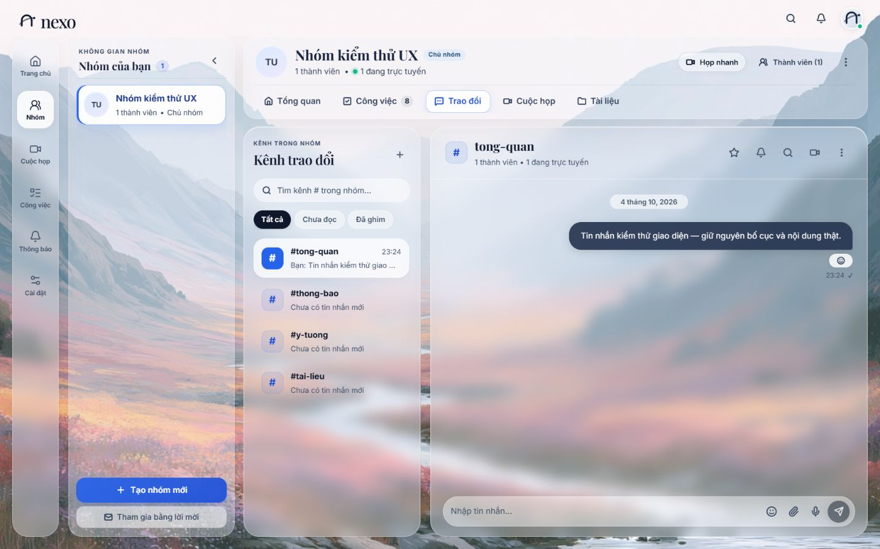
Figure 4.7. Workspace view with the channel list and a text channel
Figure 4.8 shows a video channel. The moderation panel offers the host the waiting room, room lock, "end for everyone" and raise hand, and the grid can be switched between grid and focus layouts.
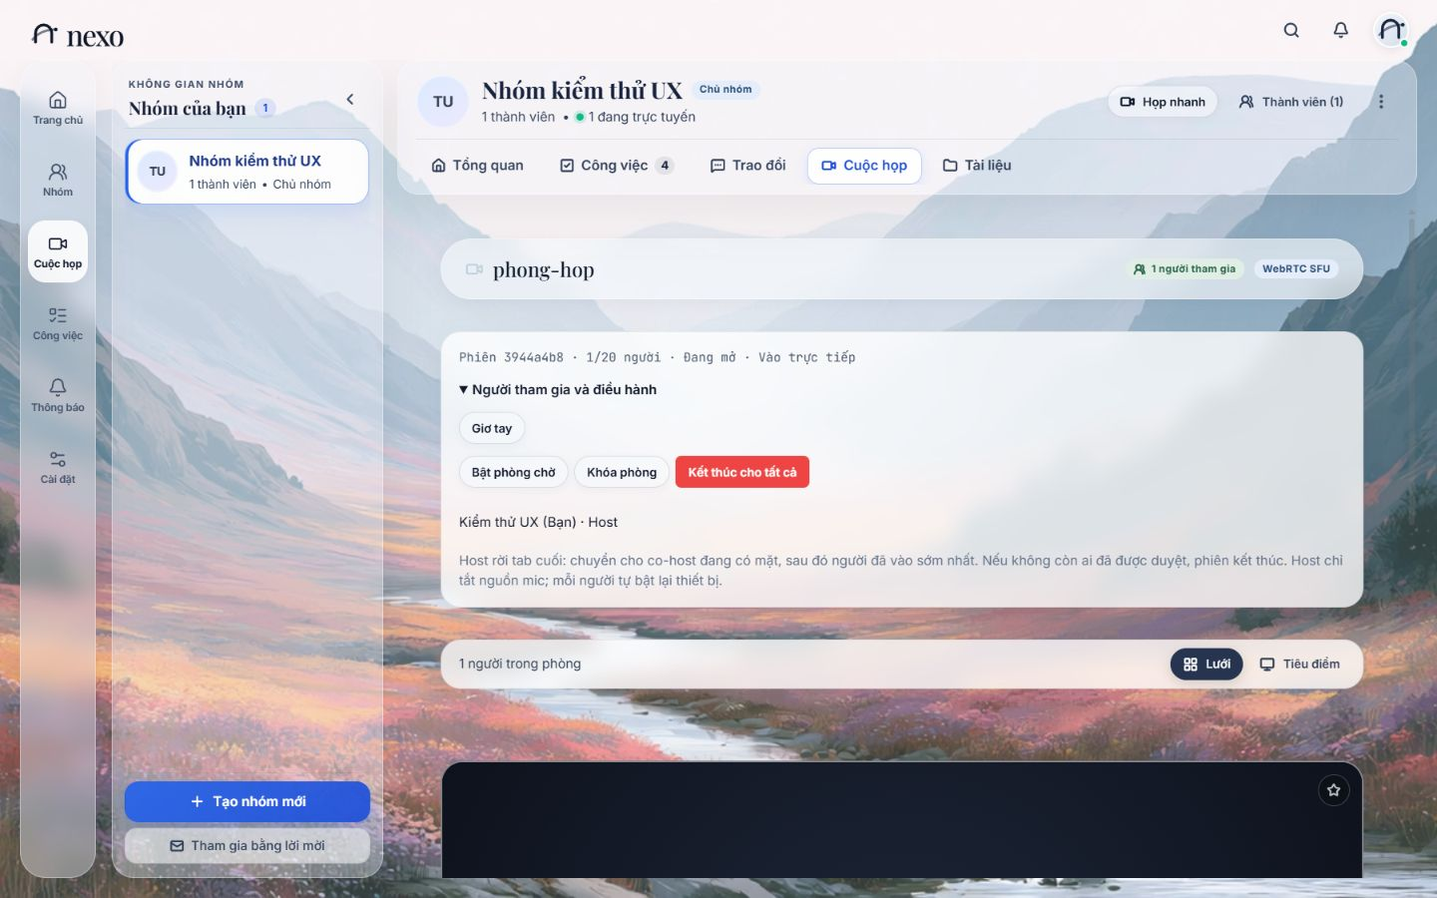
Figure 4.8. Video channel with the moderation panel and layout switch
Figure 4.9 shows the administration page, where owners and admins edit the workspace, manage members, invitations and channels, archive the workspace and read the audit log.
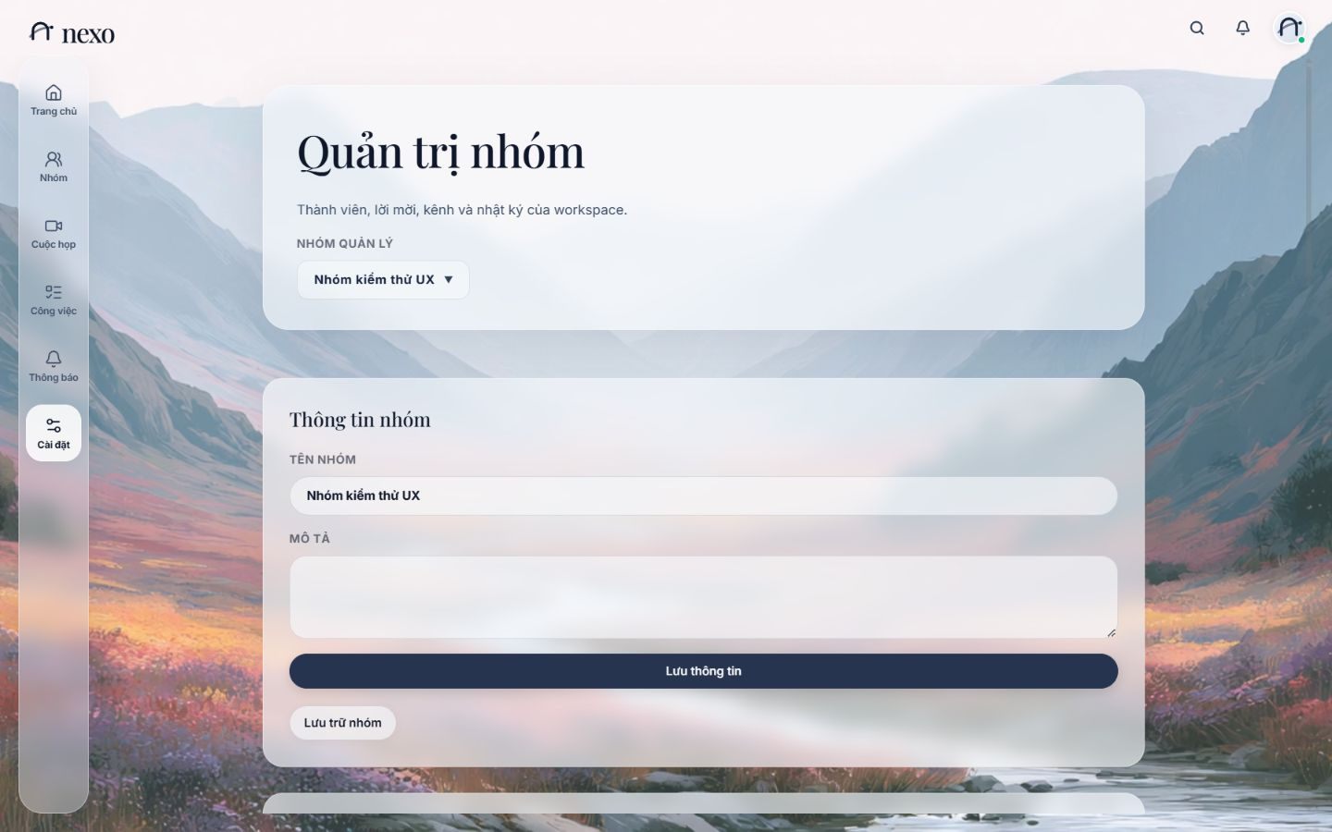
Figure 4.9. Workspace administration page
The layout adapts to tablets and phones; Figure 4.10 shows the chat and meeting views at a width of 375 pixels.
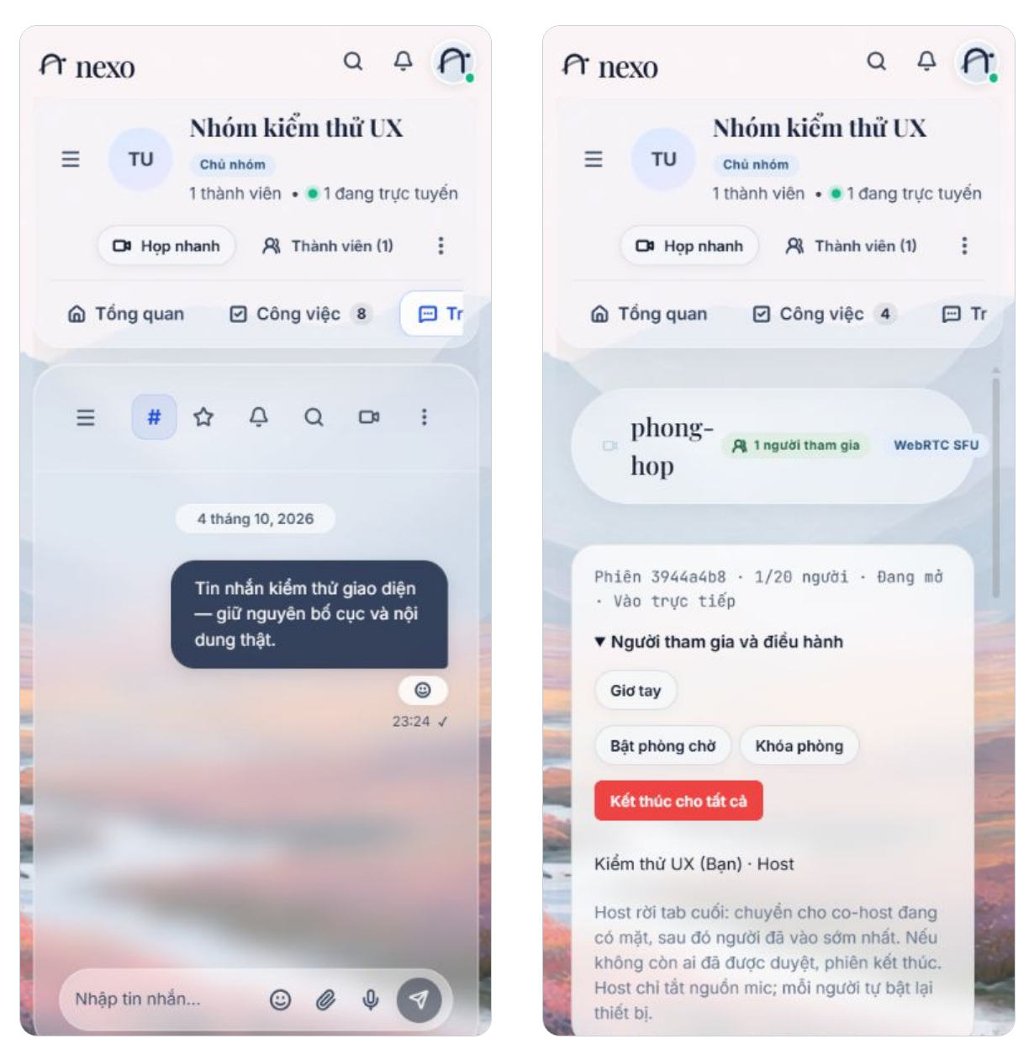
Figure 4.10. Chat (left) and meeting (right) views on a 375-pixel-wide phone screen

Deployment
The production deployment, shown in Figure 4.11, uses Docker Compose with three services: postgres; api, which runs Node.js and mediasoup and publishes the media port range 40000–40099 over UDP and TCP directly; and web, an Nginx server that serves the client, terminates TLS and proxies /api and /socket.io to the API. A separate coturn server provides STUN/TURN with the same shared secret as the API. The /ready health check succeeds only when PostgreSQL is reachable and all migrations have been applied. The environment variables for multi-process operation (SOCKET_ADAPTER=postgres, API_INSTANCE_ID, SFU_PUBLIC_URL) are available, but a multi-node deployment on real infrastructure has not been validated (Section 5.7).
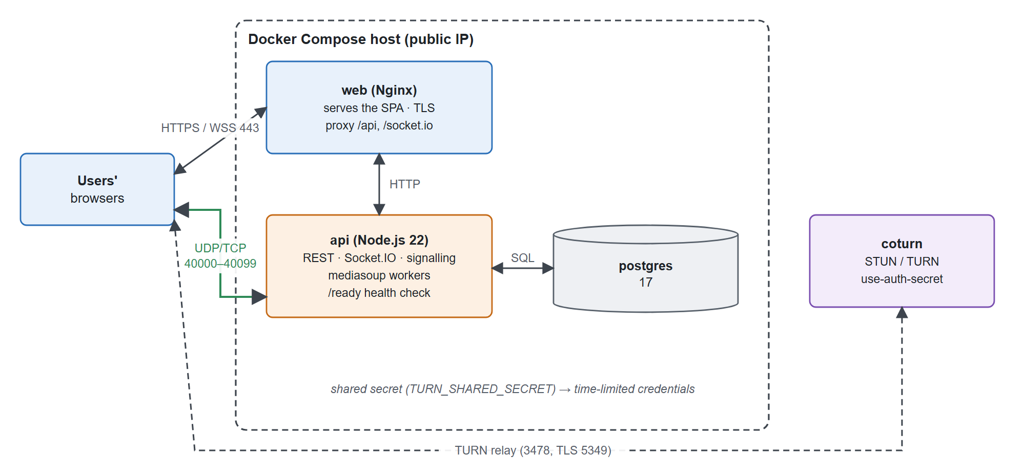
Figure 4.11. Production deployment with Docker Compose

Chapter summary
The server authorises every Socket.IO event against the current state of the database, stores each message exactly once through an advisory lock and a uniqueness constraint, and keeps presence consistent across processes with a TTL table. The conferencing core places each meeting on the least-loaded mediasoup worker, starts consumers paused, recovers ICE automatically and issues time-limited TURN credentials. The client publishes simulcast video and requests from the SFU only the layers that its visible tiles need. Chapter 5 evaluates these mechanisms.

EXPERIMENTS AND EVALUATION
This chapter evaluates the system against the requirements of Section 3.1.3. It first describes the test bed, the metrics and the baseline system (Section 5.1), then reports functional and reliability tests (Section 5.2), the latency of the messaging core under load (Section 5.3) and the main experiment, which compares the SFU of the system with a full-mesh baseline (Section 5.4). Section 5.5 compares the system with existing platforms, Section 5.6 checks the requirements and Section 5.7 discusses the limitations of the measurements. All numbers come from raw data stored in the repository under docs/evidence/; values that were derived from the raw data (for example totals or ratios) are marked as computed.

Experimental setup

Test bed and scale
All experiments were run on one development machine (Table 5.1). Figure 5.1 shows how the media experiments are organised: a harness written in Node.js starts every participant as a separate headless Chrome process with a synthetic camera and microphone, joins it to a room, and samples its WebRTC statistics and CPU usage through the Chrome DevTools Protocol. Up to ten browsers ran at the same time for the media experiments, and up to 200 Socket.IO clients for the messaging experiment.
Table 5.1. Test environment
Component | Value
Hardware | AMD Ryzen 7 6800HS, 8 cores / 16 threads, 23.3 GiB RAM
Operating system | Windows 11 (x64)
Software | Node.js 22.19, PostgreSQL 17.11 (Docker), Google Chrome (headless), mediasoup 3
Media source | Chromium synthetic camera, 960×540 requested at 30 fps (delivers 20 fps), VP8 and Opus
Network | All browsers, the API and the SFU on the same host; media sent to the host's LAN address over UDP
Scale | Media: 2–10 browsers per room. Messaging: 50, 100 and 200 sockets on two API processes

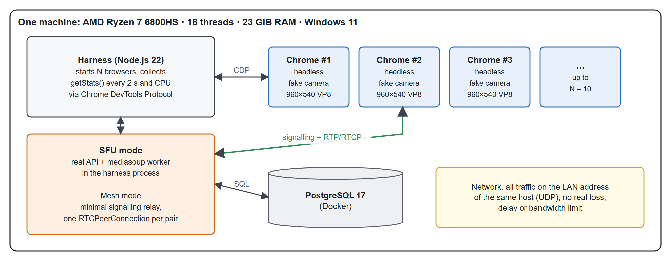
Figure 5.1. Test bed of the media experiments
Running everything on one host has a consequence that is used throughout this chapter: the network path adds no real delay, loss or bandwidth limit, so RTT, jitter and loss reflect processing load, not network quality, and when the total CPU demand approaches the capacity of the machine every metric degrades because of contention. Section 5.7 discusses this limitation.

Metrics
The media metrics are read from getStats() every 2 seconds and follow the definitions of Section 2.2.4 and Section 4.4.2:
- Uplink and downlink (kbps): change in bytes (payload and RTP headers) over the change in time.
- Client CPU (%): total CPU time of all processes of one browser instance; 100% equals one core.
- RTT (ms) of the selected ICE candidate pair; audio and video jitter (ms); packet loss (%) per window.
- Received frame rate, jitter-buffer delay, freeze count and the number of active encoders (outgoing video streams above 1 kbps).
- Server CPU: CPU of the mediasoup worker and of the Node.js process.
Each level of N is measured for 60 seconds after a 30-second warm-up that lets the bandwidth estimator settle, which gives 30 samples per client. The media levels were repeated three times; tables report the mean over runs and, where several runs exist, the sample standard deviation across runs (± SD). Message latency is reported as nearest-rank percentiles p50, p95 and p99 over all samples.

Baseline system
The guidelines of the faculty ask for an established reference system to compare against. For the media core, the reference is a full-mesh peer-to-peer implementation, the architecture that a small WebRTC application uses when it has no media server (Section 2.3.1). Implementing the baseline inside the same laboratory makes the comparison fair: both architectures use the same browser, the same synthetic source, the same codec, the same machine and the same measurement code, and differ only in the topology. The mesh client opens one RTCPeerConnection per pair of participants through a minimal signalling relay and sends one encoding with at most 1,200 kbps per connection; the SFU client is the production MediasoupClientService of nexo with three simulcast layers and the default layer policy. Section 5.5 additionally compares nexo qualitatively with existing products.

Functional and reliability testing
Table 5.2 summarises the automated tests. The integration suites run against a real PostgreSQL database and real mediasoup workers.
Table 5.2. Automated test suites
Suite | Scope | Result
Frontend unit tests (npm test, web) | URL identity, grid layout, QoS computation, media operations, raised hand, call-drop messages, interaction states | 39 / 39 passed
API unit tests (npm test, api) | Authentication, health, Google avatar, contracts; DB/SFU suites skipped in the default run | 17 passed, 8 skipped by design
Integration tests with PostgreSQL and mediasoup (npm run test:sfu) | Governance and permissions, conversations, tasks, meeting sessions, storage, two API processes, worker recovery | 9 / 9 passed, 0 skipped
Static checks | typecheck, lint, build of all workspaces | No errors

The tests verify the reliability properties required in Section 3.1.3:
- Message idempotency. Six concurrent requests with the same clientMessageId create exactly one row; dropping the acknowledgement and resending produces exactly one new_message broadcast; pagination with the after cursor never returns a message twice.
- Revocation. After access to a private channel is revoked, both retries and backfill after reconnection are rejected.
- Administration. Permissions are checked across REST, socket, search, file download, schedules and media; invitations with a wrong e-mail, expired, revoked or accepted concurrently are handled; ownership transfer works and the database refuses to delete the only owner.
- Search. Vietnamese text, the characters % and _, and opening a message outside the latest 100 messages are tested; a query plan on 10,000 messages confirmed that the existing timeline index is sufficient at this scale.
- Meetings. Waiting room, lock, removal, end and the limits on users and tabs are tested, and all four microphone/camera combinations are checked to make sure a disabled source is never published.
- Fault tolerance. With two workers, killing one worker does not affect participants on the other worker, and the next join creates a replacement worker.
- Two API processes. With the PostgreSQL adapter, messages, tasks and notifications cross processes, and revocation takes effect on both.
- Migrations and recovery. The 20 migrations are checksummed; two runners started at the same time on one database do not conflict; a backup restored into a fresh database preserves the schema and Unicode data.
These tests establish the correctness of control traffic and permissions; they do not measure RTP quality, which is the subject of Section 5.4.

Messaging latency under load

Scenario
Two API processes shared PostgreSQL through the PostgreSQL adapter (pool of eight connections per process); four workspaces with two text channels each were created. Each level (50, 100 and 200 sockets) ran for 30 seconds and was repeated twice, with 4 messages per second in total sent by four concurrent senders. In every run the acknowledgement was dropped on purpose six times and the message was resent with the same identifier, and two messages were sent while one client was offline to exercise backfill. Most sockets are receivers, so the scenario models a busy channel rather than 200 users all typing at the same time.

Results
Table 5.3 and Figure 5.2 show the latencies. ACK is the time from emitting a message to the successful acknowledgement; receipt is the time from emitting a message to the moment each receiver gets new_message, weighted by the number of receivers.
Table 5.3. Message latency in milliseconds (two runs per level)
Sockets | ACK p50 / p95 / p99 | Receipt p50 / p95 / p99 | Unique messages / receipts | Errors / duplicates
50 | 24.99 / 39.88 / 53.79 | 25.01 / 32.23 / 47.02 | 244 / 3,052 | 0 / 0
100 | 23.69 / 46.09 / 56.81 | 23.78 / 34.87 / 48.07 | 244 / 6,096 | 0 / 0
200 | 25.23 / 48.58 / 140.26 | 25.38 / 45.93 / 137.86 | 244 / 12,196 | 0 / 0

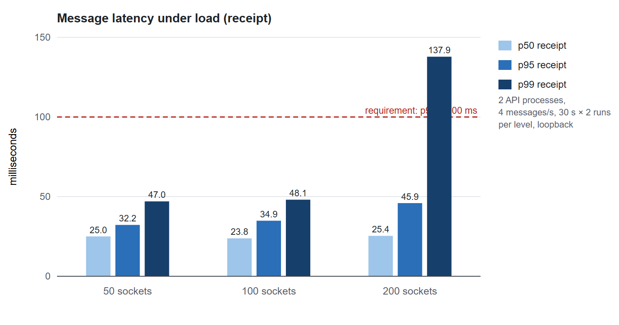
Figure 5.2. Receipt latency percentiles at 50, 100 and 200 sockets
In total 732 messages produced 21,344 receipts, and the number of stored rows equalled the number of unique messages in every run: no message was lost or duplicated, although 36 sends were retried after a lost acknowledgement and six clients reconnected. Each reconnection recovered the two missed messages through REST in 21.5–54.9 ms. The median latency stayed almost constant (23.7–25.4 ms) while the number of sockets grew fourfold; the 95th percentile grew from 32 to 46 ms, and only the 99th percentile at 200 sockets rose to about 140 ms.
Table 5.4 shows the resources used. Each API process used less than 6% of one core and less than 120 MiB of memory. The number of requests waiting for a database connection grew with the number of sockets (13, 31 and 120) but appeared only during the initial burst of connections and disappeared in later samples. The burst of connections and the presence updates that accompany it are therefore the first point to optimise before increasing the load, rather than simply enlarging the pool.
Table 5.4. Resources during the messaging load test (maximum observed)
Sockets | RSS per API (MiB) | CPU per API (% of one core) | Max waiting pool requests | PostgreSQL CPU / memory
50 | 98.8 | 5.60 | 13 | 5.1–5.2% / 107–112 MiB
100 | 95.7 | 3.75 | 31 | 5.0–6.0% / 111–113 MiB
200 | 115.2 | 4.66 | 120 | 4.8–5.6% / 112–113 MiB

Mesh versus SFU
This is the main experiment of the thesis. It checks the architectural choice of Section 2.3.4: as the number of participants N grows, which architecture keeps the quality of the call at an acceptable cost?

Experiment design
Table 5.5 summarises the configuration of the two architectures. Both are measured with the same procedure: the harness creates fresh test users and a test workspace for each level, starts N browsers, waits 30 seconds, measures for 60 seconds and removes the fixtures. Each architecture was measured three times at every level; the mesh runs stop at N = 8 because the machine was already saturated at N = 6, while the SFU runs go up to N = 10. Two additional SFU configurations isolate the effect of simulcast: a single encoding instead of three layers, and all consumers forced to the lowest layer.
Table 5.5. Configuration of the compared architectures
Item | Mesh baseline | SFU (nexo)
Topology | One RTCPeerConnection per pair, minimal signalling relay | Real API and mediasoup worker; production client code
Video encoding | One encoding, at most 1,200 kbps per connection | Simulcast q/h/f = 150/400/1,200 kbps
Receive layer | – | Default policy: more than 6 cameras → layer 0, more than 2 → layer 1, otherwise layer 2
Source | 960×540 synthetic camera, 20 fps, VP8; Opus audio | Same
Rendering of received video | Off (decoded, not drawn) | Off
Levels of N | 2, 4, 6, 8 | 2, 4, 6, 8, 10
Repetitions | 3 runs × 60 s per level (30 s warm-up) | 3 runs × 60 s per level (30 s warm-up)

Received video is decoded but not drawn. In headless mode the browser draws video in software, which costs about one core per client and would hide the transport and codec costs that are being compared; the drawing cost is the same for both architectures for the same number of tiles, and on a real device it is done by the GPU.

Measurement pitfalls
Two effects would have biased the comparison if they had not been found and removed.
Loopback announcement. When the SFU announced 127.0.0.1, the browser did not gather a loopback candidate, the UDP connectivity check failed and ICE fell back to mediasoup's passive TCP candidate. RTP over TCP suffers from head-of-line blocking, which produced frequent NACKs and high jitter without any real loss. The harness therefore announces the LAN address of the machine, and all SFU results below use UDP (the selected candidate pair is recorded with every sample). The development configuration of the application must use the LAN address for the same reason.
Probation packets. mediasoup sends padding on a dedicated stream (SSRC 1234) to probe for spare bandwidth before raising a consumer's layer. This stream shows artificial "loss" and jitter of about 200 ms, while the real media streams have zero loss and near-zero jitter; the consumer statistics on the SFU also report zero loss and zero NACK. Its bytes are counted in the downlink, because they do cross the network, but it is excluded from the quality metrics. Without this correction the SFU would have appeared worse than the mesh.

Results: bandwidth
Table 5.6 and Table 5.7 give the results of the two architectures, and Figures 5.3 to 5.7 plot the main metrics against N with error bars of one standard deviation across runs.
Table 5.6. Results of the mesh baseline (mean ± SD over runs)
N | Uplink (kbps) | Downlink (kbps) | CPU (%) | Encoders | RTT (ms) | Video jitter (ms) | Loss (%) | FPS
2 | 526  ± 1 | 526  ± 1 | 26.0  ± 2.0 | 1.0  ± 0.0 | 0.87  ± 0.10 | 0.00  ± 0.00 | 0.00  ± 0.00 | 19.9  ± 0.1
4 | 1,582  ± 1 | 1,582  ± 1 | 81.1  ± 4.1 | 3.0  ± 0.0 | 0.88  ± 0.03 | 1.09  ± 0.66 | 0.00  ± 0.00 | 20.0  ± 0.1
6 | 1,525  ± 1,828 | 658  ± 599 | 202.1  ± 3.1 | 1.8  ± 0.0 | 3,457  ± 850.4 | 383.7  ± 56.99 | 0.23  ± 0.25 | 10.1  ± 3.8
8 | 2,279  ± 1,047 | 1,845  ± 807 | 154.0  ± 6.1 | 1.9  ± 0.3 | 5,432  ± 4,275 | 633.4  ± 291.5 | 0.01  ± 0.01 | 14.7  ± 0.1

Table 5.7. Results of the SFU with simulcast (mean ± SD over runs)
N | Uplink (kbps) | Downlink (kbps) | CPU (%) | Encoders | RTT (ms) | Video jitter (ms) | Loss (%) | FPS
2 | 1,020  ± 5 | 481  ± 108 | 25.8  ± 3.7 | 3.0  ± 0.0 | 0.19  ± 0.10 | 0.33  ± 0.08 | 0.00  ± 0.00 | 17.2  ± 2.3
4 | 999  ± 13 | 938  ± 12 | 33.8  ± 1.2 | 3.0  ± 0.0 | 0.29  ± 0.10 | 0.31  ± 0.20 | 0.00  ± 0.00 | 20.0  ± 0.0
6 | 989  ± 3 | 1,561  ± 9 | 41.7  ± 0.9 | 3.0  ± 0.0 | 0.47  ± 0.11 | 0.75  ± 0.19 | 0.00  ± 0.00 | 20.0  ± 0.0
8 | 992  ± 6 | 1,218  ± 19 | 40.9  ± 0.2 | 3.0  ± 0.0 | 0.53  ± 0.03 | 0.82  ± 0.07 | 0.00  ± 0.00 | 20.0  ± 0.0
10 | 992  ± 2 | 1,542  ± 2 | 47.1  ± 1.8 | 3.0  ± 0.0 | 1.00  ± 0.11 | 1.83  ± 0.41 | 0.00  ± 0.00 | 20.0  ± 0.0

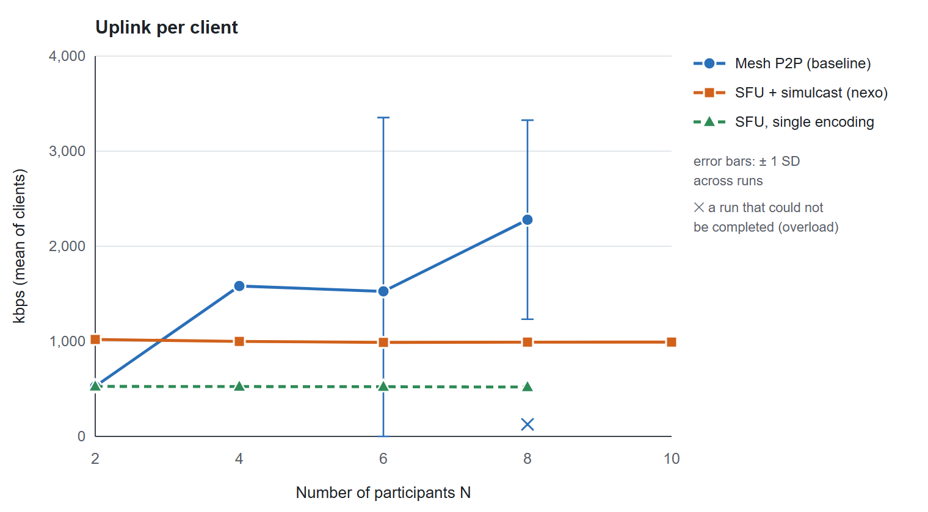
Figure 5.3. Uplink per client against the number of participants
Figure 5.3 shows the main result. The mesh uplink grows with the number of connections: each connection carries about 526 kbps, so a client uploads 526 ± 1 kbps at N = 2 and 1,582 ± 1 kbps at N = 4 with three encoders, exactly the (N−1)·b of Table 2.2. The SFU uplink is flat: 1,020 ± 5 kbps at N = 2 and 992 ± 2 kbps at N = 10, always with three encoders (the simulcast layers). At N = 2 the SFU client uploads more than the mesh client because it sends three layers instead of one; this fixed cost of simulcast is the price paid for flatness. From the mesh data, two connections at N = 3 would need about 1,053 kbps (computed by linear extrapolation, not measured), so the break-even point is around N = 3, and from N = 4 the SFU uploads 37% less than the mesh (computed).
The mesh values at N = 6 and 8 do not reflect the theoretical demand (five and seven streams, about 2,636 and 3,691 kbps, computed): the number of encoders that were actually sending dropped to 1.8 and 1.9 on average because connections stalled, and the variation between runs is very large. This is an overload state, not a steady state.
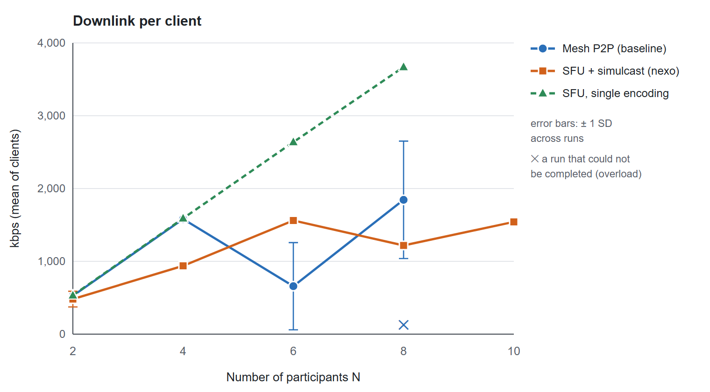
Figure 5.4. Downlink per client against the number of participants
Figure 5.4 shows the downlink. In the mesh, every received stream costs about 526 kbps and the total grows with N−1. In the SFU, the downlink follows the layer policy rather than N: one stream on layer 2 costs 481 kbps at N = 2; at N = 4 and 6 the consumers move to layer 1 and each stream costs about 312 kbps (computed); above six cameras they move to layer 0, so the downlink at N = 8 (1,218 kbps for seven streams) is lower than at N = 6, and at N = 10 nine streams cost 1,542 kbps. The downlink of an SFU client therefore stays bounded even as the room grows, which is the purpose of simulcast and of the layer policy.

Results: CPU
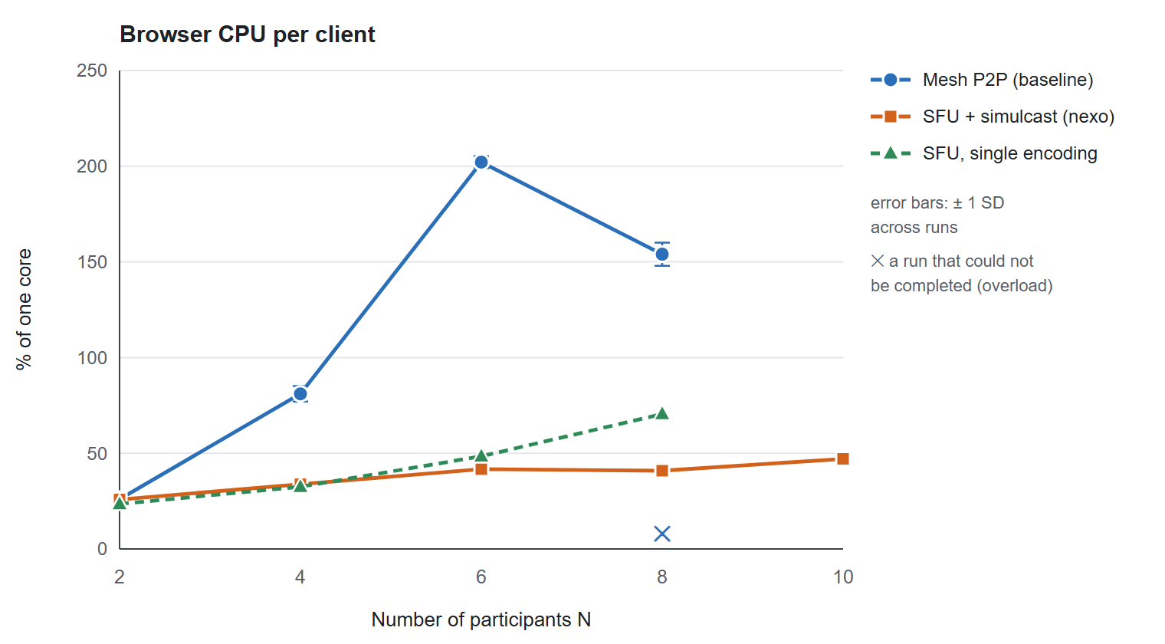
Figure 5.5. Browser CPU per client against the number of participants
Figure 5.5 compares the CPU of one browser. In the mesh, CPU grows from 26.0 ± 2.0% to 81.1 ± 4.1% of one core when N goes from 2 to 4, about 3.1 times (computed), in line with the number of encoders and decoders per client growing from one to three. At N = 6 a mesh browser used 202.1% on average, i.e. more than two cores, far beyond what a typical user device can spend on a call. In the SFU, CPU grows slowly from 25.8 ± 3.7% at N = 2 to 47.1 ± 1.8% at N = 10, because the number of encoders is fixed and only the decoders grow; at N = 4 the SFU client uses 58% less CPU than the mesh client (computed).
Table 5.8 shows the cost moved to the server. The mediasoup worker used 2.7% of one core at N = 2 and 38.9% at N = 10; it grows faster than linearly because the number of forwarded streams grows with N(N−1). The Node.js process, which carries signalling and the API, stayed between 0.1% and 1.0% of one core with 86–109 MiB of memory, which confirms the separation of control and media planes of Section 3.2.2: Node.js never touches media packets.
Table 5.8. Server-side cost of the SFU (mean over runs)
N | mediasoup worker CPU (% of one core) | Node.js CPU (% of one core) | Node.js RSS (MiB) | Downlink sum of all clients (Mbps, computed)
2 | 2.7 ± 0.5 | 0.1 ± 0.1 | 86 ± 0 | 1.0
4 | 10.3 ± 1.3 | 0.2 ± 0.1 | 92 ± 0 | 3.8
6 | 19.7 ± 0.9 | 0.2 ± 0.1 | 98 ± 0 | 9.4
8 | 26.6 ± 0.8 | 0.3 ± 0.1 | 102 ± 1 | 9.7
10 | 38.9 ± 2.8 | 1.0 ± 0.5 | 109 ± 0 | 15.4

Summing the CPU of all browsers gives the total load of the experiment (computed as N × mean client CPU): the mesh used about 324% of one core in total at N = 4, 1,213% at N = 6 and 1,232% at N = 8, whereas the SFU used 135% at N = 4 and 471% at N = 10, plus 38.9% for its worker. The mesh at N = 6 and 8 used most of the 16 hardware threads of the machine; part of its collapse is therefore caused by the test machine itself, a point discussed in Section 5.7.

Results: delay and quality
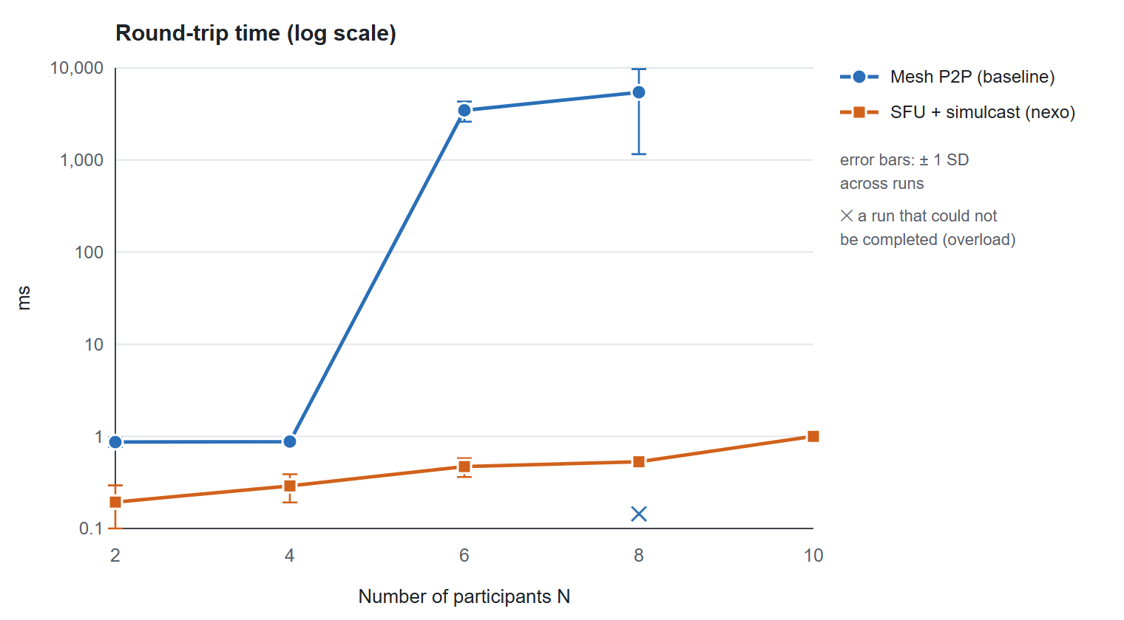
Figure 5.6. Round-trip time against the number of participants (logarithmic scale)
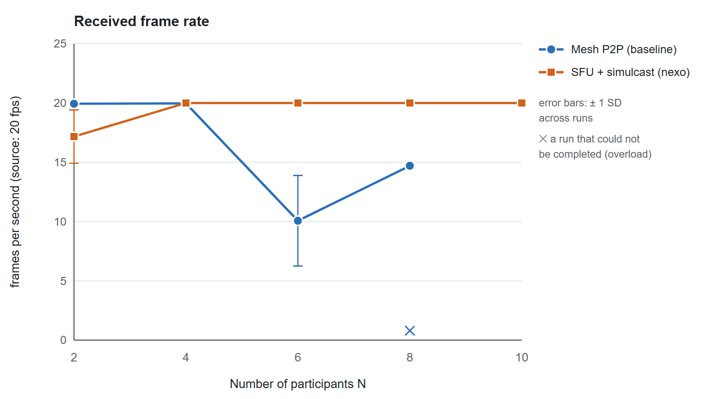
Figure 5.7. Received frame rate against the number of participants
Figure 5.6 and Figure 5.7 show the delay and the frame rate. With the SFU, RTT stayed between 0.19 and 1.00 ms, video jitter at most 1.83 ms, audio jitter at most 1.06 ms, packet loss 0.00% and NACK rate zero at every level, and from N = 4 upwards the received frame rate stayed at 20.0 fps, the rate of the source. N = 2 is the exception, with an average of 17.2 ± 2.3 fps: in every run at least one of the two receivers spent part of the window (7 to 20 of its 30 samples) below 18 fps, down to 5 fps, and the downlink was correspondingly lower and more variable. This is most likely the bandwidth estimate still rising towards the full-resolution layer, which the policy selects when there is only one remote camera and which needs the largest bitrate; it did not occur at any larger N, where lower layers are used. Holding a single-camera room on layer 1 until the estimate is sufficient would remove this effect. No video freeze occurred during the measurement windows of the SFU runs; the few freezes counted while the room was filling up correspond to layer switches when the room grew beyond six cameras.
The mesh reached similar quality at N = 2 and 4 (RTT about 1 ms, no loss, 20 fps) but collapsed at N = 6: RTT rose to 3,457 ± 850.4 ms, the jitter buffer held 4,077 ± 3,833 ms of media, the received frame rate fell to 10.1 ± 3.8 fps, audio jitter reached 90.92 ms, each client saw 31 video freezes per minute, and the browser reported its sending quality as limited by bandwidth or CPU during 27% of the samples. At N = 8 one of the three runs could not even be completed because the browsers stopped responding to the harness, and the completed runs show RTTs of several seconds. The first frame appeared after 5,181 ms at N = 2 and 10,648 ms at N = 8 in the mesh, against 6,228–12,719 ms in the SFU; with the SFU this time includes the sequential join of all participants through the API.

Effect of simulcast and layer selection
Table 5.9 and Figure 5.8 isolate the contribution of simulcast and of the layer policy. With a single encoding, the SFU client uploads only 526 kbps at N = 2, the same as a mesh client, but every receiver gets the full-resolution stream, so the downlink grows linearly to 3,669 kbps at N = 8, 3.0 times the downlink of the simulcast configuration at the same N (computed), and the client CPU rises to 70.5% because every stream is decoded at full resolution. Simulcast therefore trades a fixed uplink cost for a bounded downlink and decoding cost. Forcing all consumers onto layer 0 lowers the downlink at N = 6 from 1,561 kbps (layer 1 under the default policy) to 857 kbps, 45% less (computed); at N = 10 the default policy already selects layer 0, so both configurations give about the same downlink (1,542 and 1,578 kbps). The demand-driven grid of Section 4.4.3 refines this policy per tile in the real interface, pausing tiles that are off-page and requesting larger layers only for large tiles.
Table 5.9. SFU variants: simulcast with the default policy, single encoding, and layer 0 forced (mean over runs)
Configuration | N | Uplink (kbps) | Downlink (kbps) | CPU (%) | FPS
Simulcast, default policy | 2 | 1,020 | 481 | 25.8 | 17.2
Simulcast, default policy | 6 | 989 | 1,561 | 41.7 | 20.0
Simulcast, default policy | 8 | 992 | 1,218 | 40.9 | 20.0
Simulcast, default policy | 10 | 992 | 1,542 | 47.1 | 20.0
Single encoding | 2 | 526 | 533 | 23.5 | 20.0
Single encoding | 4 | 524 | 1,590 | 32.5 | 20.0
Single encoding | 6 | 523 | 2,638 | 48.4 | 20.0
Single encoding | 8 | 519 | 3,669 | 70.5 | 20.0
Simulcast, layer 0 forced | 6 | 999 | 857 | 32.0 | 20.0
Simulcast, layer 0 forced | 10 | 985 | 1,578 | 48.5 | 20.0

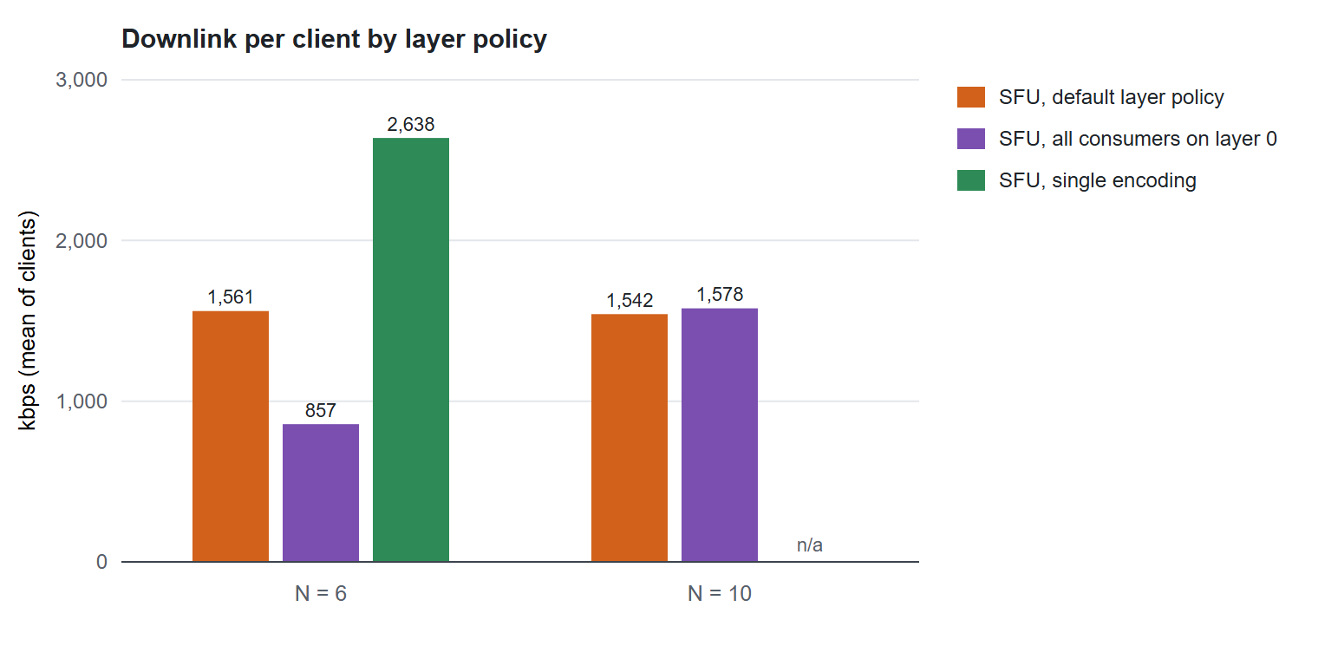
Figure 5.8. Downlink per client for the three SFU configurations at N = 6 and N = 10 (single encoding was measured up to N = 8)

Discussion
- The mesh collapses between N = 4 and N = 6, while the SFU shows no sign of degradation up to N = 10. This matches Table 2.2: the mesh costs grow linearly with N−1 in uplink, downlink and CPU, while the SFU keeps the uplink constant and lets the downlink be controlled by the layer policy.
- The SFU is not cheaper at every N. At N = 2, simulcast costs more uplink than a mesh connection. A single encoding, or peer-to-peer media for two-person calls, would be the better choice there; automatic switching is not implemented.
- The measured SFU uplink (about 1.0 Mbps) is lower than the 1.75 Mbps of the example in Section 2.3.4. That figure is the sum of the maximum bitrates of the three layers. With the simple synthetic content at 960×540 and 20 fps the encoder does not use the full budget; real cameras would push the uplink closer to the ceiling. The result that matters is that the uplink does not depend on N.
- The cost moves to the server. The SFU's outgoing bandwidth is the sum of the downlinks of all clients (about 15.4 Mbps at N = 10, computed), and the worker's CPU grows faster than linearly with N. An SFU server must be provisioned for this bandwidth, a cost that a mesh does not have.

Comparison with existing systems
Besides the measured mesh baseline, Table 5.10 places nexo among well-known platforms. Persistent channels with integrated voice and video are the model of Discord and Slack [2], [1]; dedicated meeting products such as Jitsi Meet [28] focus on the meeting itself. Like Jitsi Videobridge and Discord's media servers, nexo uses a selective forwarding unit, which is the architecture that open-source SFU studies [23] and the results above identify as the scalable choice for multi-party calls. Jitsi's Last N [22] forwards only the most recently active speakers; nexo instead derives the forwarded streams and their layers from the tiles that are actually visible, a complementary policy that could be combined with speaker activity in future work.
Table 5.10. Qualitative comparison with existing platforms
Feature | nexo | Discord | Slack | Jitsi Meet
Workspaces with persistent text channels | ✓ | ✓ | ✓ | –
Video calls inside the workspace | ✓ (video channels) | ✓ (voice/video channels) | ✓ (huddles) | – (separate meetings)
Media architecture | SFU (mediasoup) | SFU (own servers) | Proprietary | SFU (Jitsi Videobridge)
Self-hosted, source available | ✓ | – | – | ✓
Waiting room and host moderation | ✓ | Partial | Partial | ✓
Task board linked to messages | ✓ | – | Via integrations | –

The comparison is qualitative: the commercial platforms run on global infrastructure that cannot be reproduced on one machine, so no performance comparison with them is claimed.

Requirement verification
Table 5.11 checks the non-functional requirements of Table 3.3 against the measurements.
Table 5.11. Verification of the non-functional requirements
Requirement | Measured result | Assessment
Messages delivered in < 100 ms (p95) on a local network | Receipt p95 32.2 / 34.9 / 45.9 ms at 50 / 100 / 200 sockets; ACK p95 at most 48.6 ms; p99 at 200 sockets about 140 ms | Met for p95 on one host; the p99 tail at 200 sockets exceeds 100 ms
Client uplink and CPU do not grow with N (SFU) | Uplink 1,020 → 992 kbps for N = 2 → 10; CPU 25.8% → 47.1% | Met for uplink; CPU grows slowly with the number of decoded streams, far below the linear growth of the mesh
Loss ≈ 0, jitter < 30 ms, RTT < 150 ms on a good network | SFU: loss 0%, video jitter ≤ 1.83 ms, audio jitter ≤ 1.06 ms, RTT ≤ 1.00 ms up to N = 10 | Met on the loopback path; not yet measured on real networks
No loss or duplication after lost ACKs or reconnection; ICE recovery | 0 lost, 0 duplicated in 732 messages with 36 retries and 6 reconnections; ICE restart implemented and tested at signalling level | Met in the tested scenarios
Hashed passwords, short-lived tokens, per-event authorisation, DTLS-SRTP | Cross-permission tests pass; DTLS-SRTP is mandatory in WebRTC | Met for authorisation; no packet capture yet to show DTLS-SRTP on the wire
Several API processes; meetings placed on workers | Two API processes and a killed worker in integration tests | Met for several processes and workers on one host; multi-node SFU not validated

Limitations of the measurements
The following limitations define what may be concluded from this chapter.
- One machine. All browsers, the API, PostgreSQL and the SFU shared 16 hardware threads. When the total CPU demand approached the capacity of the machine, every metric degraded because of contention. The mesh at N = 6 and 8 was in this state, so part of its collapse comes from the test machine; on real devices each participant has its own CPU, and the breaking point of a mesh is set by the uplink or the CPU of the weakest device, which may lie at a different N. The robust conclusions are the trends (linear growth for the mesh, flat uplink for the SFU), not the exact breaking point.
- Loopback network. There is no real loss, delay or bandwidth limit, so RTT, jitter and loss reflect processing load rather than network quality. Multi-network tests, TURN and controlled impairment were not performed.
- Synthetic media and no rendering. The synthetic camera produces simple content and therefore lower bitrates than a real camera, and the cost of drawing video was excluded. Real CPU usage would be higher by about the same amount for both architectures.
- Three runs per level. Standard deviations are based on three runs per level (two for the mesh at N = 8, where one run could not be completed), which is enough to show trends but not to give tight confidence intervals.
- No packet capture. The packet-capture analyser and procedure exist in the repository, but no capture was made, so there is no packet-level evidence for STUN, DTLS and RTP/RTCP.
- Moderate messaging load. The messaging test used 4 messages per second; soak tests, saturation tests, long network outages and mobile networks were not simulated.
- Infrastructure not validated. Remote CI, production backups, cloud S3 and e-mail, public HTTPS and a real TURN server were outside the tested environment, so the system is not claimed to be production-ready.

Chapter summary
The automated tests confirmed the correctness of message idempotency, permissions, administration, worker fault tolerance, multi-process operation, migrations and recovery. The messaging core kept the 95th-percentile receipt latency below 46 ms with 200 sockets and lost or duplicated no message. In the main experiment, the SFU kept the client uplink at about 1 Mbps and the client CPU low from N = 2 to N = 10 with no packet loss and a stable 20 fps from N = 4 upwards, whereas the mesh baseline grew linearly and collapsed at N = 6 on the same machine. These results were obtained on one host over the loopback network; extending them to real networks is the main item of future work.

CONCLUSION AND FUTURE WORK

Achieved results against the objectives
Chapter 1 set four objectives. Table 6.1 restates each of them, summarises what was achieved and how it was verified, and states the level reached.
Table 6.1. Objectives of Chapter 1 and the level achieved
Objective | Result | Evidence | Level
O1 – Integrated workspace | A web application organised as Workspace → Channel with text, voice and video channels, private channels, invitations, roles, administration and audit, plus task board, notifications, search and profiles | Chapters 3–4; browser acceptance tests; Figures 4.6–4.10 | Achieved
O2 – Real-time messaging and presence | Idempotent delivery (client identifier, IndexedDB outbox, advisory lock and unique constraint), backfill after reconnection, presence with TTL across processes, typing indicators | Section 5.2; Section 5.3: 0 lost and 0 duplicated messages, p95 receipt latency ≤ 46 ms at 200 sockets | Achieved on a single machine; not yet measured on a wide-area network
O3 – Multipoint video conferencing | mediasoup SFU with a worker pool, three-layer simulcast, demand-driven layers and pausing, ICE recovery, time-limited TURN credentials, waiting room and moderation | Section 5.4: SFU uplink 989–1,020 kbps from N = 2 to N = 10 with no packet loss (20 fps from N = 4); the mesh baseline collapsed at N = 6 | Achieved in the laboratory; multi-network and TURN tests remain
O4 – Quantitative evaluation | Media laboratory with real browsers, repeated runs and raw data; load test of the messaging core; comparison with a mesh baseline | Chapter 5, raw data in docs/evidence/ | Achieved for a single host; packet-level capture and multi-host runs remain

The central technical claim of the thesis, that an SFU keeps the cost of each participant independent of the size of the room while a mesh does not, was confirmed experimentally on the same hardware. From N = 2 to N = 10 the uplink of an SFU client stayed between 989 and 1,020 kbps and its CPU below 47% of one core, while the CPU of a mesh client grew 3.1 times from N = 2 to N = 4 and the mesh session collapsed at N = 6.

Contributions
The main contributions of the project are:
- A working, self-hostable collaboration platform that integrates persistent channel messaging and multipoint conferencing in one browser application, with a shared permission model enforced on every REST request and every socket event.
- A message delivery protocol that combines client-generated identifiers, a durable outbox, a transaction-scoped advisory lock and a uniqueness constraint to obtain exactly-once storage on top of at-least-once delivery, verified under lost acknowledgements, concurrent retries and reconnections.
- A demand-driven video grid that derives the simulcast layer of every consumer from the size of its tile and pauses consumers that are not displayed, so that the downlink follows what the user sees rather than the size of the room.
- A reproducible media laboratory that runs every participant as a real browser, compares the SFU with a mesh baseline under identical conditions, repeats each level and keeps all raw samples, together with documented measurement pitfalls (loopback announcement and probation packets) that would otherwise bias the results.

Limitations
- All media and messaging measurements were taken on one machine over the loopback path of its LAN address. They show trends and relative costs reliably, but they do not measure behaviour under real network delay, loss or bandwidth limits.
- No packet capture was made, so DTLS-SRTP and RTCP behaviour is supported by the specifications and by getStats() but not by packet-level evidence.
- The synthetic camera produces simple content; real cameras would produce higher bitrates, and the rendering cost of video was excluded from the CPU measurements.
- Multi-node deployment of the SFU, TURN on a public server, production e-mail delivery, cloud storage, remote continuous integration and production backups have been implemented or configured but not validated on real infrastructure. The system is therefore not claimed to be production-ready.
- There are no native mobile applications, no recording and no end-to-end encryption through the SFU.

Future work
- Multi-network evaluation. Repeat the media experiments with clients on several machines and networks, including a client that must use TURN, and with controlled impairment (loss, delay, bandwidth limits) at a router; capture packets with Wireshark to analyse STUN, DTLS, RTP and RTCP (SR/RR, NACK, PLI) and to cross-check getStats().
- Adaptive topology for small rooms. Use a single encoding or peer-to-peer media for two-person calls, where simulcast costs more uplink than it saves, and switch to the SFU when a third participant joins.
- Active-speaker selection. Combine the demand-driven grid with audio-level based selection of the forwarded streams (in the spirit of Last N [22]) for large rooms.
- Scaling the media plane. Pipe routers between workers and nodes so that a very large meeting can span several workers, and validate the multi-node deployment with load balancing on real servers.
- Product features. Direct messages, recording, end-to-end encryption with insertable streams, and native or progressive mobile applications.
In conclusion, the thesis delivered an integrated real-time workspace with in-browser multipoint conferencing and showed, with reproducible measurements, that its SFU-based media architecture scales where the peer-to-peer baseline does not. The remaining work is mainly to extend the evaluation from one machine to real networks and real infrastructure.

REFERENCES
[1] Slack Technologies, "What is a channel?," Slack Help Center. [Online]. Available: https://slack.com/help/articles/360017938993-What-is-a-channel (accessed Oct. 2026).
[2] J. Vass, "How Discord handles two and half million concurrent voice users using WebRTC," Discord Engineering Blog, Sep. 2018. [Online]. Available: https://discord.com/blog/how-discord-handles-two-and-half-million-concurrent-voice-users-using-webrtc
[3] Meta Open Source, "React documentation." [Online]. Available: https://react.dev (accessed Oct. 2026).
[4] Socket.IO, "Socket.IO v4 documentation." [Online]. Available: https://socket.io/docs/v4/ (accessed Oct. 2026).
[5] I. Baz Castillo and J. L. Millán, "mediasoup v3 documentation." [Online]. Available: https://mediasoup.org/documentation/v3/ (accessed Oct. 2026).
[6] I. Fette and A. Melnikov, "The WebSocket Protocol," IETF RFC 6455, Dec. 2011.
[7] C. Jennings, F. Castelli, H. Boström and J.-I. Bruaroey, "WebRTC: Real-Time Communication in Browsers," W3C Recommendation. [Online]. Available: https://www.w3.org/TR/webrtc/
[8] H. Boström, V. Singh and J.-I. Bruaroey, "Identifiers for WebRTC's Statistics API," W3C Candidate Recommendation. [Online]. Available: https://www.w3.org/TR/webrtc-stats/
[9] A. Begen, P. Kyzivat, C. Perkins and M. Handley, "SDP: Session Description Protocol," IETF RFC 8866, Jan. 2021.
[10] J. Rosenberg and H. Schulzrinne, "An Offer/Answer Model with the Session Description Protocol (SDP)," IETF RFC 3264, Jun. 2002.
[11] J. Uberti, C. Jennings and E. Rescorla, "JavaScript Session Establishment Protocol (JSEP)," IETF RFC 8829, Jan. 2021.
[12] A. Keranen, C. Holmberg and J. Rosenberg, "Interactive Connectivity Establishment (ICE): A Protocol for Network Address Translator (NAT) Traversal," IETF RFC 8445, Jul. 2018.
[13] M. Petit-Huguenin, G. Salgueiro, J. Rosenberg, D. Wing, R. Mahy and P. Matthews, "Session Traversal Utilities for NAT (STUN)," IETF RFC 8489, Feb. 2020.
[14] T. Reddy, A. Johnston, P. Matthews and J. Rosenberg, "Traversal Using Relays around NAT (TURN): Relay Extensions to Session Traversal Utilities for NAT (STUN)," IETF RFC 8656, Feb. 2020.
[15] J. Uberti, "A REST API for Access to TURN Services," IETF Internet-Draft draft-uberti-behave-turn-rest-00, Mar. 2013.
[16] D. McGrew and E. Rescorla, "Datagram Transport Layer Security (DTLS) Extension to Establish Keys for the Secure Real-time Transport Protocol (SRTP)," IETF RFC 5764, May 2010.
[17] M. Baugher, D. McGrew, M. Naslund, E. Carrara and K. Norrman, "The Secure Real-time Transport Protocol (SRTP)," IETF RFC 3711, Mar. 2004.
[18] H. Schulzrinne, S. Casner, R. Frederick and V. Jacobson, "RTP: A Transport Protocol for Real-Time Applications," IETF RFC 3550, Jul. 2003.
[19] S. Holmer, H. Lundin, G. Carlucci, L. De Cicco and S. Mascolo, "A Google Congestion Control Algorithm for Real-Time Communication," IETF Internet-Draft draft-ietf-rmcat-gcc-02, Jul. 2016.
[20] J. Bankoski, J. Koleszar, L. Quillio, J. Salonen, P. Wilkins and Y. Xu, "VP8 Data Format and Decoding Guide," IETF RFC 6386, Nov. 2011.
[21] J.-M. Valin, K. Vos and T. Terriberry, "Definition of the Opus Audio Codec," IETF RFC 6716, Sep. 2012.
[22] B. Grozev, L. Marinov, V. Singh and E. Ivov, "Last N: Relevance-based selectivity for forwarding video in multimedia conferences," in Proc. 25th ACM Workshop on Network and Operating Systems Support for Digital Audio and Video (NOSSDAV), Portland, OR, USA, 2015.
[23] E. André, N. Le Breton, A. Lemesle, L. Roux and A. Gouaillard, "Comparative study of WebRTC open source SFUs for video conferencing," in Proc. Principles, Systems and Applications of IP Telecommunications (IPTComm), Chicago, IL, USA, 2018.
[24] R. S. Sandhu, E. J. Coyne, H. L. Feinstein and C. E. Youman, "Role-based access control models," IEEE Computer, vol. 29, no. 2, pp. 38–47, Feb. 1996.
[25] C. Percival and S. Josefsson, "The scrypt Password-Based Key Derivation Function," IETF RFC 7914, Aug. 2016.
[26] M. Jones, J. Bradley and N. Sakimura, "JSON Web Token (JWT)," IETF RFC 7519, May 2015.
[27] PostgreSQL Global Development Group, "PostgreSQL 17 documentation: NOTIFY, LISTEN and advisory locks." [Online]. Available: https://www.postgresql.org/docs/17/ (accessed Oct. 2026).
[28] Jitsi, "Jitsi Meet handbook: architecture of Jitsi Meet and Jitsi Videobridge." [Online]. Available: https://jitsi.github.io/handbook/ (accessed Oct. 2026).

