**Name: ___________________________ Date: ________________**

**ED REVIEW TEST 2**

**First Discoveries - Unit 3-4**

(15 minutes)

**LISTENING**

**Task 1: Listen and choose the best answer for the questions. You will listen TWO times.**

1. What does the baby do at 9:00?
   1. She wakes up. B. She sleeps. C. She has her milk.
2. Where is the milk?
   1. In the fridge B. On the dining table C. No information
3. What time does the baby have lunch?
   1. Shortly after her mom goes to work.
   2. At half past twelve
   3. At half past two

**Task 2: Listen and write T (true) or F (false) next to each sentence. You will listen TWO times.**

1. Martha and Dan are at a café. T
2. Their food and drink is €12.60. T
3. The café closes at 5.45. F
4. Dan is cold. F
5. Martha sometimes eats chocolate cake. F
6. Martha likes cheese. T

**READING**

**Task 1**

**Match the notes with the households.**

|  |  |  |  |  |
| --- | --- | --- | --- | --- |
| |  | | --- | | **Taken Ben to the vet.**  **Dinner’s in the oven.** |   **A.** | |  | | --- | | Out of milk. Can you get some on way back from  work? Love you.  P |   **B.** | **C.**  Sue,  Hands off my food! |

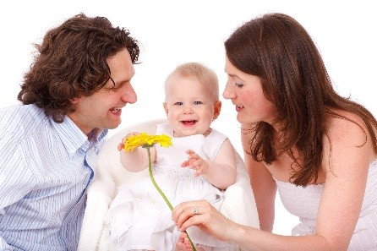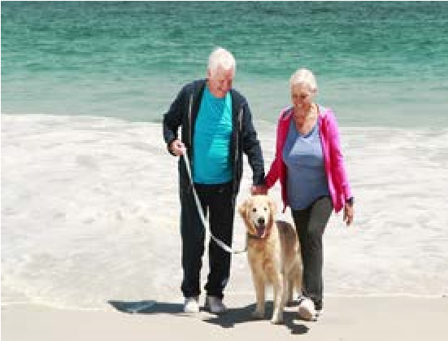

**1 B 2 A 3 C**

|  |  |  |  |  |  |
| --- | --- | --- | --- | --- | --- |
| |  | | --- | | 1. Phil is a computer consultant and Sue works in a shop. They have a ten-month-old boy, Ben. | | |  |  |  | | --- | --- | --- | | 2. Sue and Tim have been married for 15 years. They have a do called Ben. Sue is a bank manager and  Tim is a teacher. |  | 3. Peter is a student who lives in a shared house. | |

**Task 2: Read the emails from a student in Singapore and put a tick (****) in the suitable box.**

Which email is…… A B

a. to Dereck’s friend? B

* 1. to a teacher at Derek’s school? A
  2. thanking for something? A B
  3. formal? A
  4. informal? B

**For one question, more than one box may be ticked.**

**A.**

|  |
| --- |
| **ToSubject**: Mario Bonetti : Thank you (mbonetti@hotmail.com)    Dear Mr. Bonetti,  Thank you very much for allowing me to interview you for our student magazine yesterday.  I enjpy talking to you, and I am sure our students will be interested in reading about your teaching career.  Sincerely, Derek Wong |

**B.**

**To**: Gina Marnadi (gmarnaidi@pacific.net.sg)

**Subject**: Thanks

Gina,

Working hard at the moment – how about you? Thanks for looking at

my report – great help! ☺

See you,

Derek