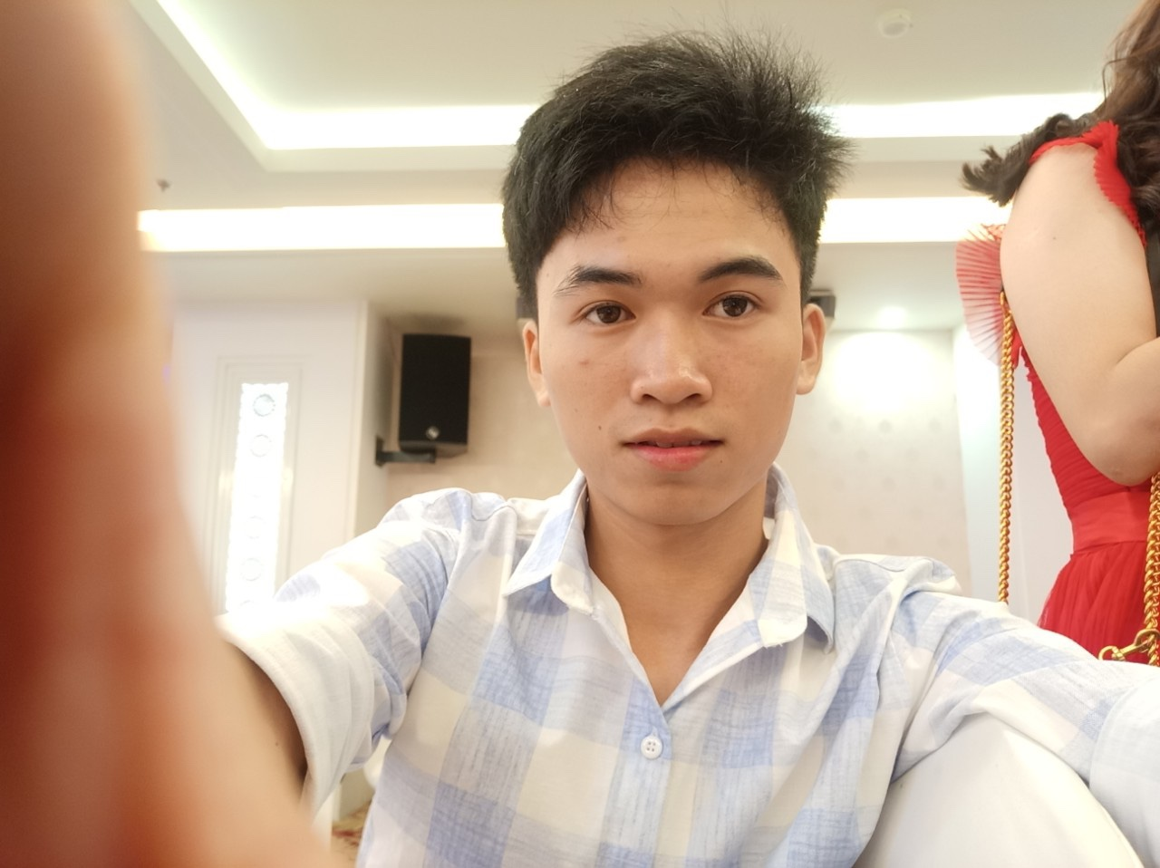

**JOINT STOCK COMPANY SPHACY | 07/2022 – 07/2023**

Backend developer

Tasks:

* + - * Work directly with the CEO to build a pharmacy management software system GDP and GPP.
      * Directly design and manage the database.
      * Handle API and unit tests.
      * Integrated national pharmacy system.
      * Integrated Viettel e-invoice.
      * Troubleshooting from the users.
      * Contribute ideas to build features.
      * Make plans for database migration and deploy products between environments.

**IPI TECHNOLOGY SOLUTIONS COMPANY | 11/2020 – 07/2022**

Backend developer

Tasks:

* + - * Build a microservice system with more than 15 services on spring boot framework.
      * Design pattern, structure modules
      * Have experience working with JPA, hibernate, spring-security, apache-shiro, hazelcast, redis, redis-queue...
      * Work with muti-database system, replication master-slave.
      * Work with elasticsearch system.
      * Processing integration with partner via API and FTP.
      * Handle API for business logic.
      * Control database migration and deploy production.
      * Contribute ideas to build features for the system.

**FREELANCE PROJECT- DRIVER BOOKING APPLICATION - BUTL | 02/2023 – 07/2023**

Leader Backend developer

Tasks:

* + - * Work with spring boot websocket, muti-thread, session
      * Ability to work under pressure and work independently.
      * Assign tasks and ensure work progress.
      * Join the discussion and comment on the feature.
      * Control database migration and deploy production.

**WORK EXPERIENCE**

**DIPLOMAS Y HOBBIES**

**Formaciones :** Diplomados, Congresos, xxxxxxxxxx xxxxxx xxxxxxxxx xxxxxxxxxxxxxxxxx

**Hobbies:** xxxxxxxxxxxxxxxxxxxxxxxxxxxxxx

**LÊ**

**TUẤN ANH**

**ABOUT ME**

BACKEND DEVELOPER

Careful, meticulous is a backend developer with extensive experience solving problems clearly and accurately. With 5 years of experience working with Java, I have confidence in understanding the characteristics and elegance of this language. Along with an open mind to learn and not being afraid to change I am seeking a position as a backend developer to continue career growth and self-improvement.



2017-2020 | HCM

**Mobile developer**

FPT Polytechnic College

**LANGUAGES**

Vietnamese: Native

English: Intermediate

**EDUCATION**

* Java, Javascript, Php
* Spring boot, Laravel, Nestjs
* Mysql, Postgresql, MongoDb
* Git, Docker, CI/CD, Vps

**CONTACT**

+84 326 256 172

anhle99.work@gmail.com

Hồ Chí Minh, Việt Nam

**SKILLS**

©AZURIUS - My-resume-templates.com