Game start

Mode select screen

User selects 1 of 8 Modes

Gameplay screen

Song done?

Feedback screen

Get user feedback

Score updating

Data tracking

YES

NO

|  |  |
| --- | --- |
| **Accuracy Value** | **Timing**  < -300ms = INACTIVE |
| INACTIVE | < -300ms  -300ms = ALMOST |
| ALMOST | -300ms  -210ms = GOOD |
| GOOD | -210ms  -150ms = GREAT |
| GREAT | -150ms  -90ms = PERFECT |
| PERFECT | -90ms  -30ms = MARVELOUS |
| MARVELOUS | -30ms  40ms = PERFECT |
| PERFECT | 40ms  120ms = GREAT  200ms = GOOD |
| GREAT | 120ms |
| GOOD | 200ms  280ms = ALMOST |
| ALMOST | 280ms  > 400ms = MISS |
| MISS | 400ms |

|  |  |  |  |  |  |
| --- | --- | --- | --- | --- | --- |
| **Rhythm Game** | **Layout** | **Notes** | **Hitbox** | **Movement** | **Style** |
| **Dance Dance Revolution** | 4/6 columns | 4/6 arrows | Box at top | Notes scroll up | Falling Notes |
| **In The Groove** | 4 columns | 4 arrows | Box at bottom | Notes scroll up | Falling Notes |
| **Pump It Up NX** | 5 columns | 4 arrows + middle stomp | Box at bottom | Notes scroll up | Falling Notes |
| **Dance Maniax** | 4 columns | 4 motion sensors | Bar at top | Notes scroll up | Falling Notes |
| **Beatmania IIDX** | 6/8 columns | 5/7 bars + 1 scratch | Bar at bottom | Notes fall down | Falling Notes |
| **Pop ‘N Music** | 9 columns | 9 buttons | Bar at bottom | Notes fall down | Falling Notes |
| **DJMax** | 4/5/6/8 columns | 4/5/6/8 bars | Bar at bottom | Notes fall down | Falling Notes |
| **GuitarFreaks** | 3 columns | 3 tabs | Bar at bottom | Notes fall down | Falling Notes |
| **Drummania** | 6 columns | 5 drum + 1 foot pedal | Bar at bottom | Notes fall down | Falling Notes |
| **Keyboardmania** | 24 columns | 24 keys | Bar at bottom | Notes fall down | Falling Notes |
| **Guitar Hero** | 5 columns | 5 tabs | Bar at bottom | Notes approach from distance | Spreading Notes |
| **DJ Hero** | 3 columns | 3 buttons on scratch | Bar at bottom | Notes approach from distance | Spreading Notes |
| **Rockband** | 5 columns | 5 tabs or 4 drum + 1 foot pedal | Bar at bottom | Notes approach from distance | Spreading Notes |
| **Taiko no Tatsujin** | 1 row | 2 drum parts | Box on side | Notes stream to single point | Streaming Notes |
| **The iDOLM@STER** | 1 row | 6 buttons | Box on side | Notes stream to single point | Streaming Notes |
| **Hatsune Miku: Project DIVA** | Fullscreen | 8 buttons | Sequence of hitboxes | Notes focus to corresponding hitbox | Focusing Notes |
| **Gitaroo Man Lives!** | Fullscreen | 4 buttons | Box in centre | Notes focus to single point | Focusing Notes |
| **DJMax Technika** | 3/4 rows | 3/4 buttons | Moving bar | Hitbox slides across rows | Sliding Hitbox |
| **Parappa The Rapper** | 1 row | 4 buttons | Cursor | Cursor slides across row | Sliding Cursor |
| **Audition Online** | 1 row | 4 arrows | Cursor | Cursor slides across row | Sliding Cursor |
| **Osu! Tatakae! Ouendan** | Fullscreen | Anywhere buttons | Shrinking rings | Rings shrink around buttons | Appearing |
| **jubeat** | Grid | 16 buttons | Collapsing box | Box solid fills grid | Grid |

|  |  |  |  |
| --- | --- | --- | --- |
| Moving Notes, Fixed Hitboxes | | Moving Hitbox, Fixed Notes | |
| **Diagram** | **Description** | **Diagram** | **Description** |
|  | **Mode #1:**  **Falling Notes**  **Moving notes** fall toward **fixed hitboxes** from **top to bottom** |  | **Mode #5:**  **Sliding Hitbox**  **Moving hitbox** fall toward **fixed notes** appearing from **top to bottom** |
|  | **Mode #2:**  **Spreading Notes**  **Moving notes** slide toward **fixed hitboxes** from **centre to corners** |  | **Mode #6: Expanding Hitbox**  **Expanding hitbox** grow toward **fixed notes** from **centre to corners** |
|  | **Mode #3:**  **Focusing Notes**  **Moving notes** slide toward **fixed hitboxes** from **corners to centre** |  | **Mode #7:**  **Collapsing Hitbox**  **Collapsing hitbox** shink toward **fixed notes** from **corners to centre** |
|  | **Mode #4:**  **Grid**  **Expanding notes** grow in **fixed hitboxes** at **grid points** |  | **Mode #8:**  **Appearing**  **Collapsing hitboxes** shrink around **fixed notes** appearing at **grid points** |

|  |  |  |  |  |  |  |  |  |  |
| --- | --- | --- | --- | --- | --- | --- | --- | --- | --- |
| **Rating** | **Tablets** |  |  | **Phones** |  |  | **All** |  |  |
| **Category** | **Count** | **Sum** | **Average** | **Count** | **Sum** | **Average** | **Count** | **Sum** | **Average** |
| **#1: Falling Notes** |  |  |  |  |  |  |  |  |  |
| Unique | 47 | 114 | 2.43 | 113 | 427 | 3.78 | 160 | 541 | 3.38 |
| Overall | 49 | 114 | 2.33 | 112 | 448 | 4.00 | 161 | 562 | 3.49 |
| Intuitive | 45 | 188 | 4.18 | 112 | 457 | 4.08 | 157 | 645 | 4.11 |
| Fun | 51 | 192 | 3.76 | 117 | 486 | 4.15 | 168 | 678 | 4.04 |
| Challenge | 42 | 155 | 3.69 | 106 | 399 | 3.76 | 148 | 554 | 3.74 |
| **#2: Spreading Notes** |  |  |  |  |  |  |  |  |  |
| Unique | 33 | 131 | 3.97 | 45 | 182 | 4.04 | 78 | 313 | 4.01 |
| Overall | 39 | 156 | 4.00 | 48 | 181 | 3.77 | 87 | 337 | 3.87 |
| Intuitive | 32 | 126 | 3.94 | 44 | 175 | 3.98 | 76 | 301 | 3.96 |
| Fun | 36 | 135 | 3.75 | 49 | 189 | 3.86 | 85 | 324 | 3.81 |
| Challenge | 31 | 119 | 3.84 | 43 | 173 | 4.02 | 74 | 292 | 3.95 |
| **#3: Focusing Notes** |  |  |  |  |  |  |  |  |  |
| Unique | 34 | 129 | 3.79 | 35 | 129 | 3.69 | 69 | 258 | 3.74 |
| Overall | 37 | 131 | 3.54 | 38 | 129 | 3.39 | 75 | 260 | 3.47 |
| Intuitive | 33 | 124 | 3.76 | 35 | 122 | 3.49 | 68 | 246 | 3.62 |
| Fun | 36 | 123 | 3.42 | 37 | 129 | 3.49 | 73 | 252 | 3.45 |
| Challenge | 33 | 125 | 3.79 | 33 | 128 | 3.88 | 66 | 253 | 3.83 |
| **#4: Grid** |  |  |  |  |  |  |  |  |  |
| Unique | 48 | 185 | 3.85 | 75 | 299 | 3.99 | 123 | 484 | 3.93 |
| Overall | 47 | 187 | 3.98 | 85 | 353 | 4.15 | 132 | 540 | 4.09 |
| Intuitive | 48 | 183 | 3.81 | 70 | 269 | 3.84 | 118 | 452 | 3.83 |
| Fun | 50 | 207 | 4.14 | 79 | 325 | 4.11 | 129 | 532 | 4.12 |
| Challenge | 45 | 192 | 4.27 | 70 | 290 | 4.14 | 115 | 482 | 4.19 |
| **#5: Sliding Hitbox** |  |  |  |  |  |  |  |  |  |
| Unique | 29 | 119 | 4.10 | 31 | 128 | 4.13 | 60 | 247 | 4.12 |
| Overall | 30 | 114 | 3.80 | 33 | 136 | 4.12 | 63 | 250 | 3.97 |
| Intuitive | 28 | 98 | 3.50 | 32 | 115 | 3.59 | 60 | 213 | 3.55 |
| Fun | 29 | 118 | 4.07 | 33 | 131 | 3.97 | 62 | 249 | 4.02 |
| Challenge | 28 | 123 | 4.39 | 32 | 134 | 4.19 | 60 | 257 | 4.28 |
| **#6: Expanding Hitbox** |  |  |  |  |  |  |  |  |  |
| Unique | 26 | 118 | 4.54 | 28 | 107 | 3.82 | 54 | 225 | 4.17 |
| Overall | 27 | 92 | 3.41 | 27 | 108 | 4.00 | 54 | 200 | 3.70 |
| Intuitive | 25 | 71 | 2.84 | 22 | 73 | 3.32 | 47 | 144 | 3.06 |
| Fun | 25 | 84 | 3.36 | 24 | 96 | 4.00 | 49 | 180 | 3.67 |
| Challenge | 25 | 114 | 4.56 | 22 | 90 | 4.09 | 47 | 204 | 4.34 |
| **#7: Collapsing Hitbox** |  |  |  |  |  |  |  |  |  |
| Unique | 22 | 92 | 4.18 | 28 | 108 | 3.86 | 50 | 200 | 4.00 |
| Overall | 22 | 71 | 3.23 | 27 | 94 | 3.48 | 49 | 165 | 3.37 |
| Intuitive | 23 | 61 | 2.65 | 26 | 96 | 3.69 | 49 | 157 | 3.20 |
| Fun | 23 | 70 | 3.04 | 27 | 91 | 3.37 | 50 | 161 | 3.22 |
| Challenge | 23 | 98 | 4.26 | 26 | 116 | 4.46 | 49 | 214 | 4.37 |
| **#8: Appearing** |  |  |  |  |  |  |  |  |  |
| Unique | 43 | 173 | 4.02 | 44 | 148 | 3.36 | 87 | 321 | 3.69 |
| Overall | 40 | 168 | 4.20 | 45 | 174 | 3.87 | 85 | 342 | 4.02 |
| Intuitive | 40 | 165 | 4.13 | 43 | 156 | 3.63 | 83 | 321 | 3.87 |
| Fun | 42 | 182 | 4.33 | 44 | 165 | 3.75 | 86 | 347 | 4.03 |
| Challenge | 40 | 157 | 3.93 | 41 | 160 | 3.90 | 81 | 317 | 3.91 |

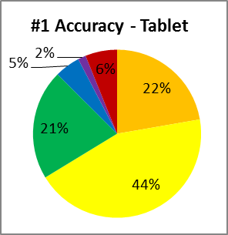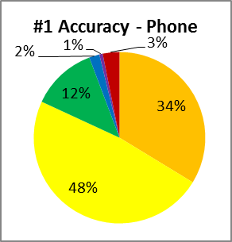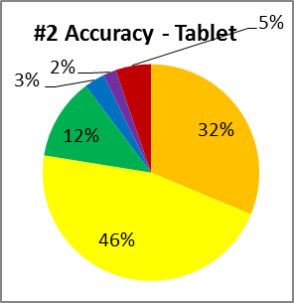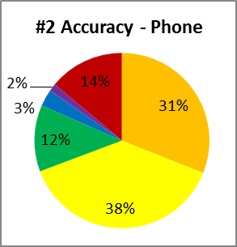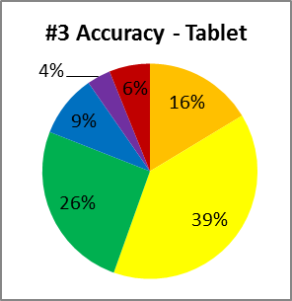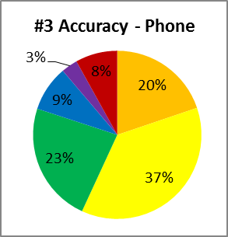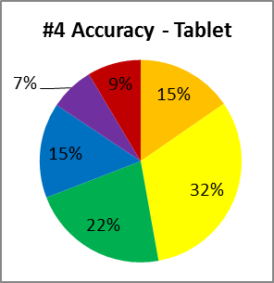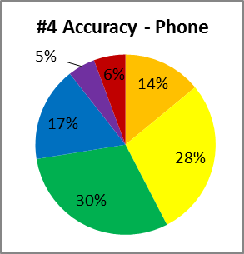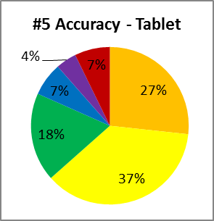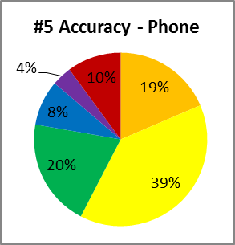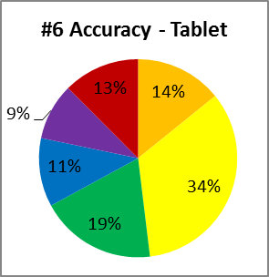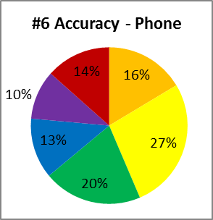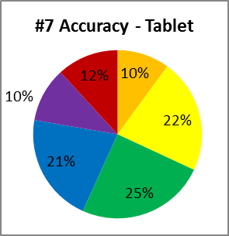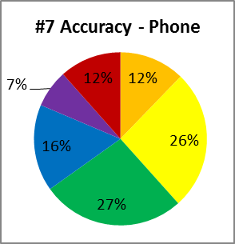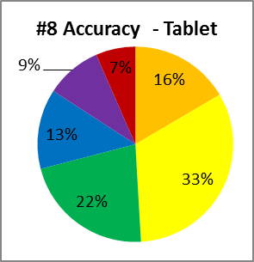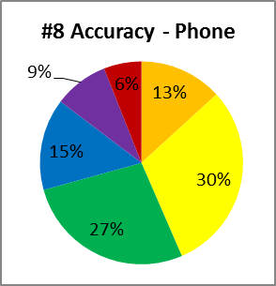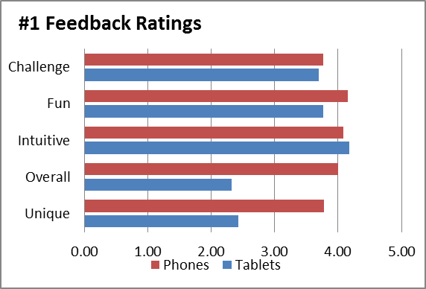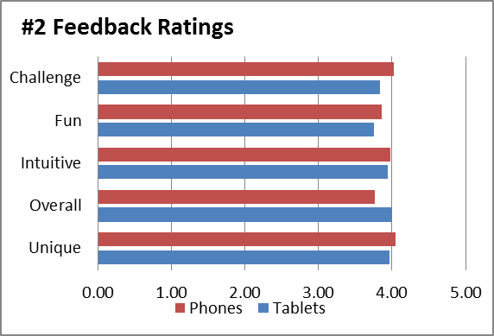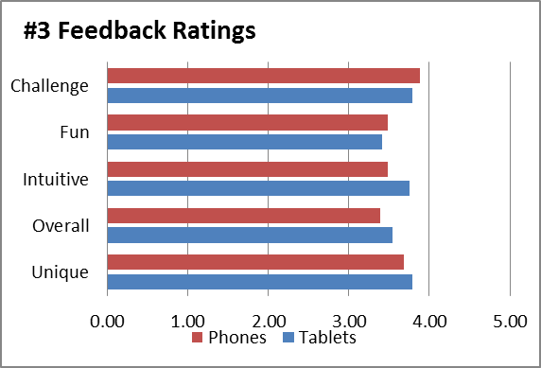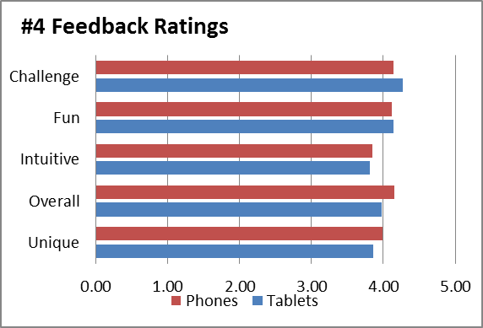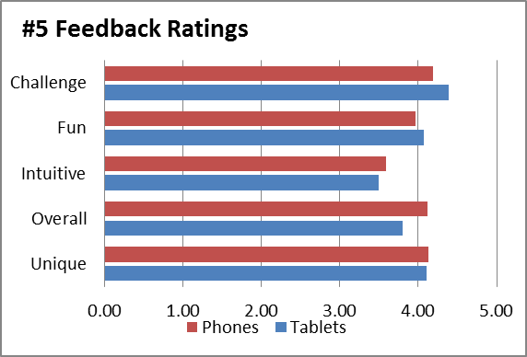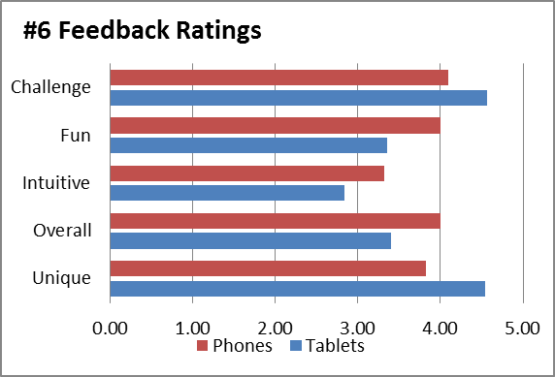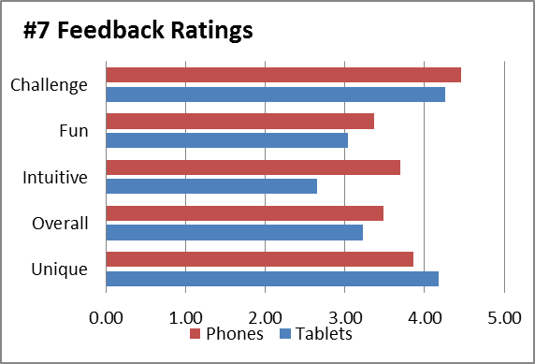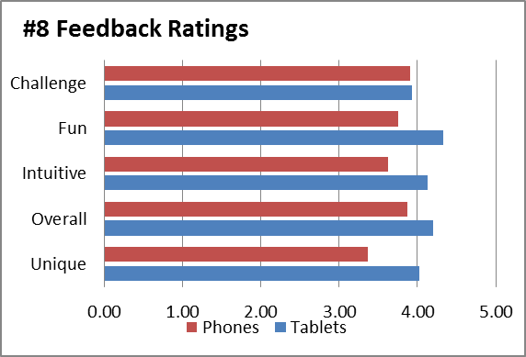

|  |  |  |  |  |  |  |  |  |  |
| --- | --- | --- | --- | --- | --- | --- | --- | --- | --- |
| **Accuracy** | **Tablets** |  |  | **Phones** |  |  | **All** |  |  |
| **Category** | **Count** | **Sum** | **Average** | **Count** | **Sum** | **Average** | **Count** | **Sum** | **Average** |
| **#1: Falling Notes** |  |  |  |  |  |  |  |  |  |
| MARVELOUS | 45 | 2043 | 45.40 | 140 | 9612 | 68.66 | 185 | 11655 | 63.00 |
| PERFECT | 45 | 4038 | 89.73 | 140 | 13735 | 98.11 | 185 | 17773 | 96.07 |
| GREAT | 45 | 1943 | 43.18 | 140 | 3526 | 25.19 | 185 | 5469 | 29.56 |
| GOOD | 45 | 448 | 9.96 | 144 | 571 | 3.97 | 189 | 1019 | 5.39 |
| ALMOST | 46 | 143 | 3.11 | 144 | 185 | 1.28 | 190 | 328 | 1.73 |
| MISS | 46 | 574 | 12.48 | 145 | 932 | 6.43 | 191 | 1506 | 7.88 |
| **#2: Spreading Notes** |  |  |  |  |  |  |  |  |  |
| MARVELOUS | 33 | 2093 | 63.42 | 47 | 2989 | 63.60 | 80 | 5082 | 63.53 |
| PERFECT | 33 | 3093 | 93.73 | 46 | 3607 | 78.41 | 79 | 6700 | 84.81 |
| GREAT | 34 | 839 | 24.68 | 48 | 1209 | 25.19 | 82 | 2048 | 24.98 |
| GOOD | 34 | 211 | 6.21 | 48 | 304 | 6.33 | 82 | 515 | 6.28 |
| ALMOST | 34 | 133 | 3.91 | 48 | 141 | 2.94 | 82 | 274 | 3.34 |
| MISS | 34 | 364 | 10.71 | 48 | 1368 | 28.50 | 82 | 1732 | 21.12 |
| **#3: Focusing Notes** |  |  |  |  |  |  |  |  |  |
| MARVELOUS | 29 | 969 | 33.41 | 42 | 1696 | 40.38 | 71 | 2665 | 37.54 |
| PERFECT | 29 | 2315 | 79.83 | 42 | 3176 | 75.62 | 71 | 5491 | 77.34 |
| GREAT | 29 | 1510 | 52.07 | 42 | 1983 | 47.21 | 71 | 3493 | 49.20 |
| GOOD | 29 | 556 | 19.17 | 42 | 751 | 17.88 | 71 | 1307 | 18.41 |
| ALMOST | 29 | 210 | 7.24 | 43 | 275 | 6.40 | 72 | 485 | 6.74 |
| MISS | 30 | 375 | 12.50 | 43 | 707 | 16.44 | 73 | 1082 | 14.82 |
| **#4: Grid** |  |  |  |  |  |  |  |  |  |
| MARVELOUS | 45 | 1418 | 31.51 | 118 | 3397 | 28.79 | 163 | 4815 | 29.54 |
| PERFECT | 45 | 2925 | 65.00 | 118 | 6864 | 58.17 | 163 | 9789 | 60.06 |
| GREAT | 45 | 2025 | 45.00 | 120 | 7396 | 61.63 | 165 | 9421 | 57.10 |
| GOOD | 45 | 1399 | 31.09 | 124 | 4312 | 34.77 | 169 | 5711 | 33.79 |
| ALMOST | 45 | 652 | 14.49 | 124 | 1246 | 10.05 | 169 | 1898 | 11.23 |
| MISS | 50 | 877 | 17.54 | 124 | 1448 | 11.68 | 174 | 2325 | 13.36 |
| **#5: Sliding Hitbox** |  |  |  |  |  |  |  |  |  |
| MARVELOUS | 28 | 1522 | 54.36 | 41 | 1560 | 38.05 | 69 | 3082 | 44.67 |
| PERFECT | 28 | 2093 | 74.75 | 40 | 3199 | 79.98 | 68 | 5292 | 77.82 |
| GREAT | 28 | 1037 | 37.04 | 40 | 1651 | 41.28 | 68 | 2688 | 39.53 |
| GOOD | 28 | 391 | 13.96 | 40 | 691 | 17.28 | 68 | 1082 | 15.91 |
| ALMOST | 28 | 242 | 8.64 | 41 | 313 | 7.63 | 69 | 555 | 8.04 |
| MISS | 29 | 427 | 14.72 | 41 | 847 | 20.66 | 70 | 1274 | 18.20 |
| **#6: Expanding Hitbox** |  |  |  |  |  |  |  |  |  |
| MARVELOUS | 23 | 665 | 28.91 | 31 | 1026 | 33.10 | 54 | 1691 | 31.31 |
| PERFECT | 23 | 1591 | 69.17 | 32 | 1758 | 54.94 | 55 | 3349 | 60.89 |
| GREAT | 23 | 891 | 38.74 | 33 | 1357 | 41.12 | 56 | 2248 | 40.14 |
| GOOD | 23 | 526 | 22.87 | 33 | 832 | 25.21 | 56 | 1358 | 24.25 |
| ALMOST | 23 | 434 | 18.87 | 35 | 718 | 20.51 | 58 | 1152 | 19.86 |
| MISS | 23 | 585 | 25.43 | 34 | 921 | 27.09 | 57 | 1506 | 26.42 |
| **#7: Collapsing Hitbox** |  |  |  |  |  |  |  |  |  |
| MARVELOUS | 21 | 423 | 20.14 | 30 | 749 | 24.97 | 51 | 1172 | 22.98 |
| PERFECT | 21 | 923 | 43.95 | 32 | 1707 | 53.34 | 53 | 2630 | 49.62 |
| GREAT | 21 | 1045 | 49.76 | 32 | 1749 | 54.66 | 53 | 2794 | 52.72 |
| GOOD | 22 | 925 | 42.05 | 32 | 1060 | 33.13 | 54 | 1985 | 36.76 |
| ALMOST | 22 | 463 | 21.05 | 33 | 475 | 14.39 | 55 | 938 | 17.05 |
| MISS | 22 | 521 | 23.68 | 34 | 803 | 23.62 | 56 | 1324 | 23.64 |
| **#8: Appearing** |  |  |  |  |  |  |  |  |  |
| MARVELOUS | 37 | 1248 | 33.73 | 48 | 1304 | 27.17 | 85 | 2552 | 30.02 |
| PERFECT | 37 | 2457 | 66.41 | 48 | 2987 | 62.23 | 85 | 5444 | 64.05 |
| GREAT | 37 | 1650 | 44.59 | 50 | 2795 | 55.90 | 87 | 4445 | 51.09 |
| GOOD | 37 | 999 | 27.00 | 50 | 1504 | 30.08 | 87 | 2503 | 28.77 |
| ALMOST | 37 | 700 | 18.92 | 50 | 892 | 17.84 | 87 | 1592 | 18.30 |
| MISS | 37 | 494 | 13.35 | 51 | 629 | 12.33 | 88 | 1123 | 12.76 |

|  |  |  |  |  |  |  |  |  |  |
| --- | --- | --- | --- | --- | --- | --- | --- | --- | --- |
| **Completion Rate** | **Tablets** |  |  | **Phones** |  |  | **All** |  |  |
| **Design** | **Started** | **Completed** | **Percent** | **Started** | **Completed** | **Percent** | **Started** | **Completed** | **Percent** |
| **#1: Falling Notes** | 71 | 44 | 61.97 | 206 | 140 | 67.96 | 277 | 184 | 66.43 |
| **#2: Spreading Notes** | 44 | 32 | 72.73 | 84 | 44 | 52.38 | 128 | 76 | 59.38 |
| **#3: Focusing Notes** | 46 | 29 | 63.04 | 55 | 39 | 70.91 | 101 | 68 | 67.33 |
| **#4: Grid** | 57 | 43 | 75.44 | 150 | 117 | 78.00 | 207 | 160 | 77.29 |
| **#5: Sliding Hitbox** | 38 | 28 | 73.68 | 71 | 40 | 56.34 | 109 | 68 | 62.39 |
| **#6: Expanding Hitbox** | 34 | 22 | 64.71 | 48 | 30 | 62.50 | 82 | 52 | 63.41 |
| **#7: Collapsing Hitbox** | 31 | 21 | 67.74 | 54 | 31 | 57.41 | 85 | 52 | 61.18 |
| **#8: Appearing** | 43 | 36 | 83.72 | 76 | 46 | 60.53 | 119 | 82 | 68.91 |

|  |  |  |  |  |  |  |  |  |  |
| --- | --- | --- | --- | --- | --- | --- | --- | --- | --- |
| **Feedback Rate** | **Tablets** |  |  | **Phones** |  |  | **All** |  |  |
| **Design** | **Completed** | **Feedback** | **Percent** | **Completed** | **Feedback** | **Percent** | **Completed** | **Feedback** | **Percent** |
| **#1: Falling Notes** | 44 | 45 | 102.27 | 140 | 114 | 81.43 | 184 | 159 | 86.41 |
| **#2: Spreading Notes** | 32 | 30 | 93.75 | 44 | 43 | 97.73 | 76 | 73 | 96.05 |
| **#3: Focusing Notes** | 29 | 32 | 110.34 | 39 | 34 | 87.18 | 68 | 66 | 97.06 |
| **#4: Grid** | 43 | 45 | 104.65 | 117 | 71 | 60.68 | 160 | 116 | 72.50 |
| **#5: Sliding Hitbox** | 28 | 26 | 92.86 | 40 | 31 | 77.50 | 68 | 57 | 83.82 |
| **#6: Expanding Hitbox** | 22 | 24 | 109.09 | 30 | 23 | 76.67 | 52 | 47 | 90.38 |
| **#7: Collapsing Hitbox** | 21 | 21 | 100.00 | 31 | 27 | 87.10 | 52 | 48 | 92.31 |
| **#8: Appearing** | 36 | 38 | 105.56 | 46 | 42 | 91.30 | 82 | 80 | 97.56 |

|  |  |  |  |  |  |  |  |  |  |
| --- | --- | --- | --- | --- | --- | --- | --- | --- | --- |
| **Combo Max** | **Tablets** |  |  | **Phones** |  |  | **All** |  |  |
| **Design** | **Count** | **Sum** | **Average** | **Count** | **Sum** | **Average** | **Count** | **Sum** | **Average** |
| **#1: Falling Notes** | 47 | 3981 | 84.70 | 153 | 17052 | 111.45 | 200 | 21033 | 105.17 |
| **#2: Spreading Notes** | 34 | 3127 | 91.97 | 48 | 2467 | 51.40 | 82 | 5594 | 68.22 |
| **#3: Focusing Notes** | 31 | 1516 | 48.90 | 43 | 2031 | 47.23 | 74 | 3547 | 47.93 |
| **#4: Grid** | 52 | 2075 | 39.90 | 131 | 4605 | 35.15 | 183 | 6680 | 36.50 |
| **#5: Sliding Hitbox** | 29 | 2189 | 75.48 | 42 | 1758 | 41.86 | 71 | 3947 | 55.59 |
| **#6: Expanding Hitbox** | 23 | 864 | 37.57 | 35 | 1060 | 30.29 | 58 | 1924 | 33.17 |
| **#7: Collapsing Hitbox** | 22 | 468 | 21.27 | 35 | 937 | 26.77 | 57 | 1405 | 24.65 |
| **#8: Appearing** | 37 | 1651 | 44.62 | 54 | 1965 | 36.39 | 91 | 3616 | 39.74 |

|  |  |  |  |  |  |  |  |  |  |
| --- | --- | --- | --- | --- | --- | --- | --- | --- | --- |
| **Percent Score** | **Tablets** |  |  | **Phones** |  |  | **All** |  |  |
| **Design** | **Count** | **Sum** | **Average** | **Count** | **Sum** | **Average** | **Count** | **Sum** | **Average** |
| **#1: Falling Notes** | 44 | 3235 | 73.52 | 142 | 11511 | 81.06 | 186 | 14746 | 79.28 |
| **#2: Spreading Notes** | 32 | 2472 | 77.25 | 46 | 3263 | 70.93 | 78 | 5735 | 73.53 |
| **#3: Focusing Notes** | 29 | 1951 | 67.28 | 39 | 2625 | 67.31 | 68 | 4576 | 67.29 |
| **#4: Grid** | 44 | 2677 | 60.84 | 117 | 7249 | 61.96 | 161 | 9926 | 61.65 |
| **#5: Sliding Hitbox** | 28 | 2038 | 72.79 | 41 | 2861 | 69.78 | 69 | 4899 | 71.00 |
| **#6: Expanding Hitbox** | 22 | 1331 | 60.50 | 31 | 1853 | 59.77 | 53 | 3184 | 60.08 |
| **#7: Collapsing Hitbox** | 21 | 1238 | 58.95 | 31 | 1931 | 62.29 | 52 | 3169 | 60.94 |
| **#8: Appearing** | 36 | 2438 | 67.72 | 46 | 3113 | 67.67 | 82 | 5551 | 67.70 |

|  |  |  |
| --- | --- | --- |
| Mode | Timing Accuracy | Game Enjoyability |
| #1: Falling Notes | Great | Poor |
| #2: Spreading Notes | Great | Great |
| #3: Focusing Notes | Good | Poor |
| #4: Grid | Poor | Great |
| #5: Sliding Hitbox | Good | Good |
| #6: Expanding Hitbox | Bad | Bad |
| #7: Collapsing Hitbox | Bad | Bad |
| #8: Appearing | Poor | Great |