**My first model**

Database mobel documentation

Created with Vertabelo.com

1. Model details 3

2. Tables 4

2.1. Table Check_in 4

2.2. Table user 4

2.3. Table Check_out 4

3. References 5

3.1. Reference Check-out_user 5

3.2. Reference Check-in_user 5

# 1. Model details

**Model name:**My first model

**Version:**2.3

**Database engine:**mysql

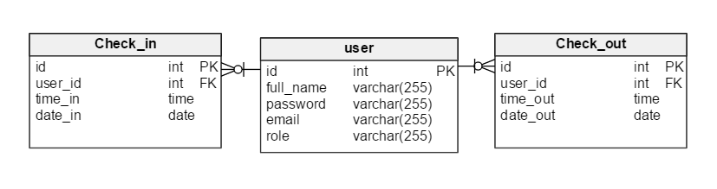

# 2. Tables

## 2.1. Table Check_in

2.1.1. Columns

|  |  |  |  |
| --- | --- | --- | --- |
| **Column name** | **Type** | **Properties** | **Description** |
| id | int |  |  |
| user_id | int |  |  |
| time_in | time |  |  |
| date_in | date |  |  |

## 2.2. Table user

2.2.1. Columns

|  |  |  |  |
| --- | --- | --- | --- |
| **Column name** | **Type** | **Properties** | **Description** |
| id | int |  |  |
| full_name | varchar(255) |  |  |
| password | varchar(255) |  |  |
| email | varchar(255) |  |  |
| role | varchar(255) |  |  |

## 2.3. Table Check_out

2.3.1. Columns

|  |  |  |  |
| --- | --- | --- | --- |
| **Column name** | **Type** | **Properties** | **Description** |
| id | int |  |  |
| user_id | int |  |  |
| time_out | time |  |  |
| date_out | date |  |  |

# 3. References

## 3.1. Reference Check-out_user

|  |  |  |
| --- | --- | --- |
| **user** | **0..\*** | **Check_out** |
| id | <-> | user_id |

## 3.2. Reference Check-in_user

|  |  |  |
| --- | --- | --- |
| **user** | **0..\*** | **Check_in** |
| role | <-> | user_id |

# 4. Wireflame

## 4.1. Login screen

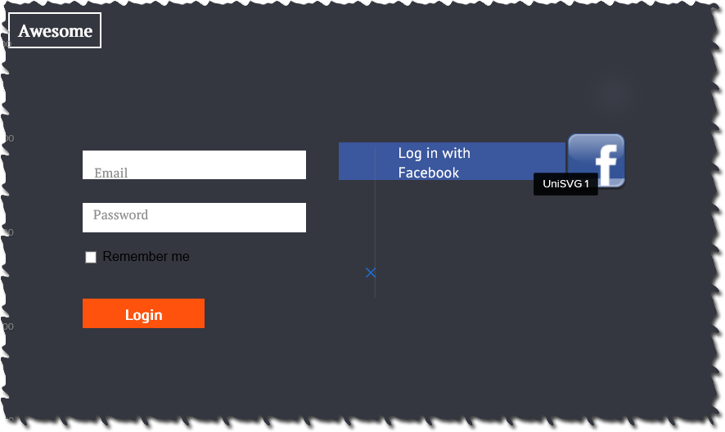

## 4.2 Staff page

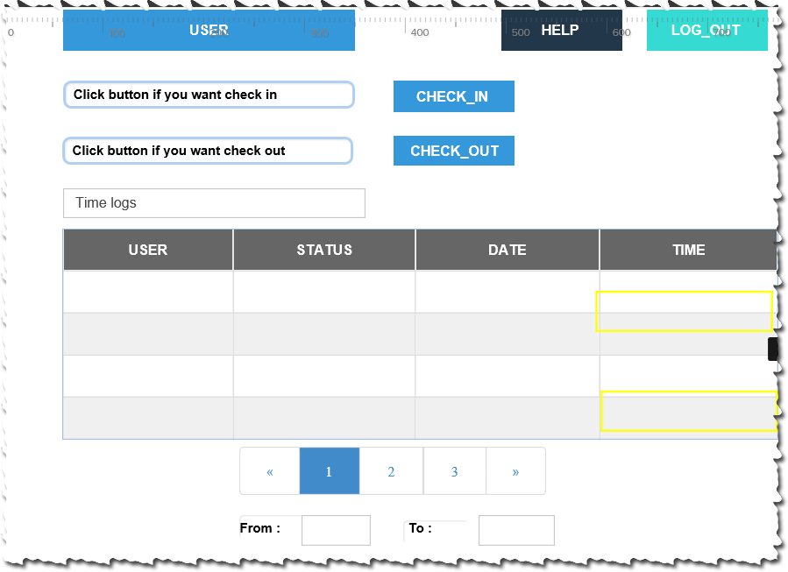

## 4.3 Admin page

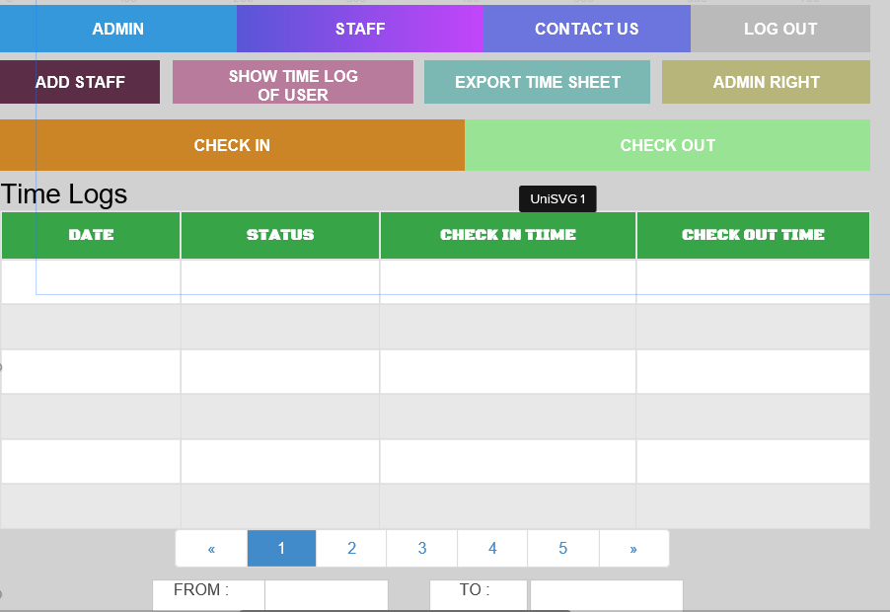

## 4.4 Add staff form

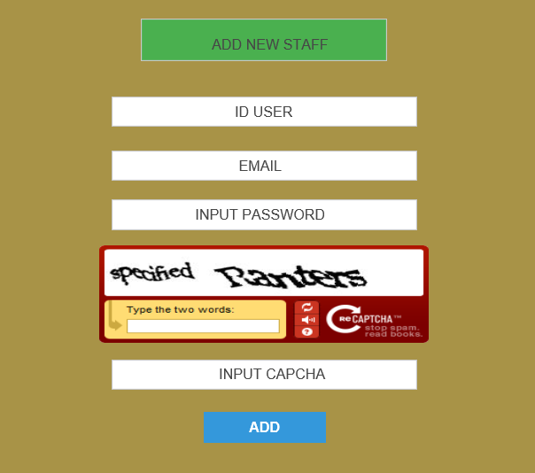

# 5. WBS

