# Feature List

## Task 3: Advanced Features

1. Save/Load Game
2. Game Modes
   * Endless Mode
   * Companion Mode
   * Enable/Disable Balloons
3. More Dots and Companions
   * Butterfly Dot
   * Aristotle Companion
4. Extra GUI Features

## Task 4: Post-graduate Features

1. Action Bar
   * Activate Companion
   * Erase Dot
2. More Dots and Companions
   * Swirl Dot
   * Beam Dot
   * Eskimo Companion
   * Buffalo Companion
   * Captain Companion

# Task 3 Description

## Save/Load Game

* The game can be saved by clicking the **Save Game** command in **File** menu.
* All the informations such as **score**, **moves**, **companion** are saved as well as the current **game mode** status and **special actions** were used.

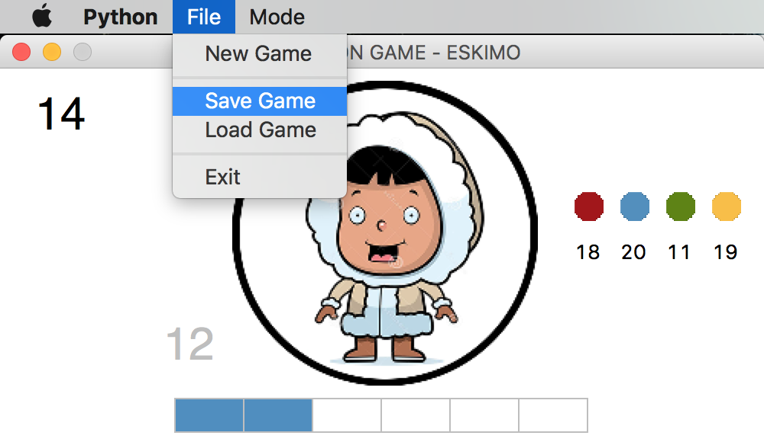­

* Only one game can be saved at a time, the previous save game will be overwritten.
* Confirmation messages will be displayed before the game is saved or loaded.

## Game Modes

* The Playercan switch the game mode between **Endless** and **Companion**.
* In the **Companion Mode**, player can also select a companion to play with.

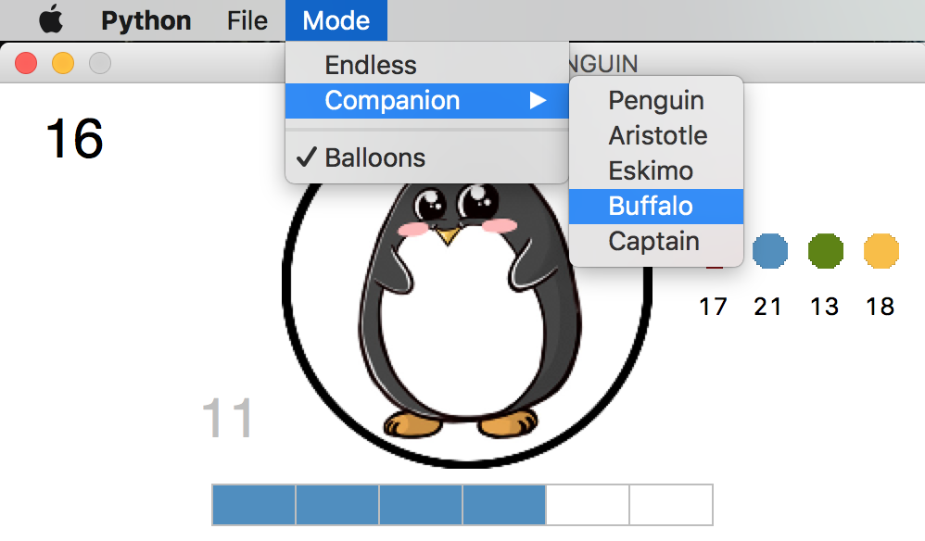

* The **Balloons** can be enabled or disabled via a checkbox on the menu

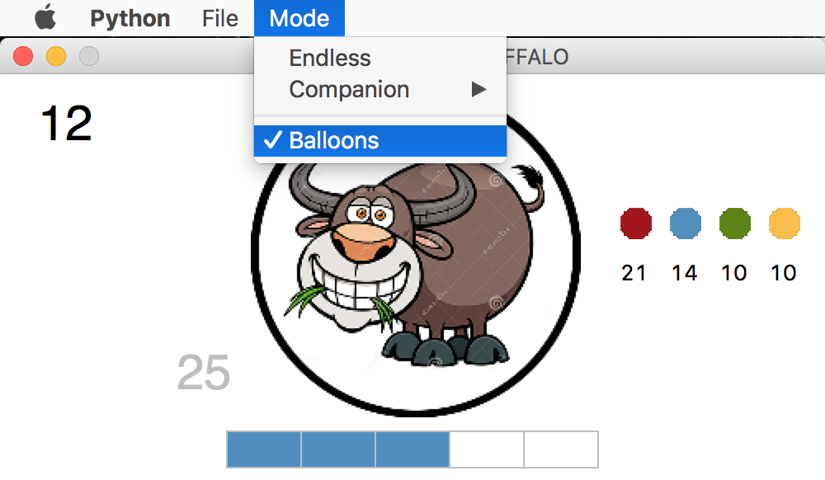

## More Dots and Companions

* **Butterfly Dot** and **Aristotle Companion** are added

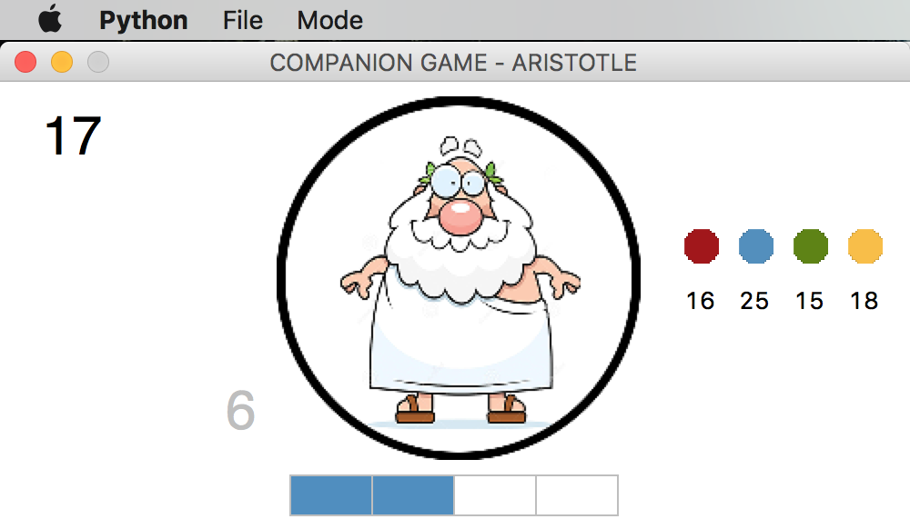

## Extra GUI Feature

* + The window will be centered and the size will be fixed when the game starts
  + The title shows the current game mode and the companion’s name

# Game Screenshots

|  |  |
| --- | --- |
|  |  |