INFS7202 – Web Information Systems

Project Proposal

**Restaurant Order   
Management System**

Student Name: **Vu Anh LE**Student Number: **44907635**

# 1. Description

The Restaurant Order Management System (ROMS) is a web-based system which eases the process of ordering meals for customers with features including dish searching, ingredient filtering, order placing, customer reviewing, meal recommendation and payment. The system also provides periodical and on-demand reports for the managers.

# 2. Use Cases

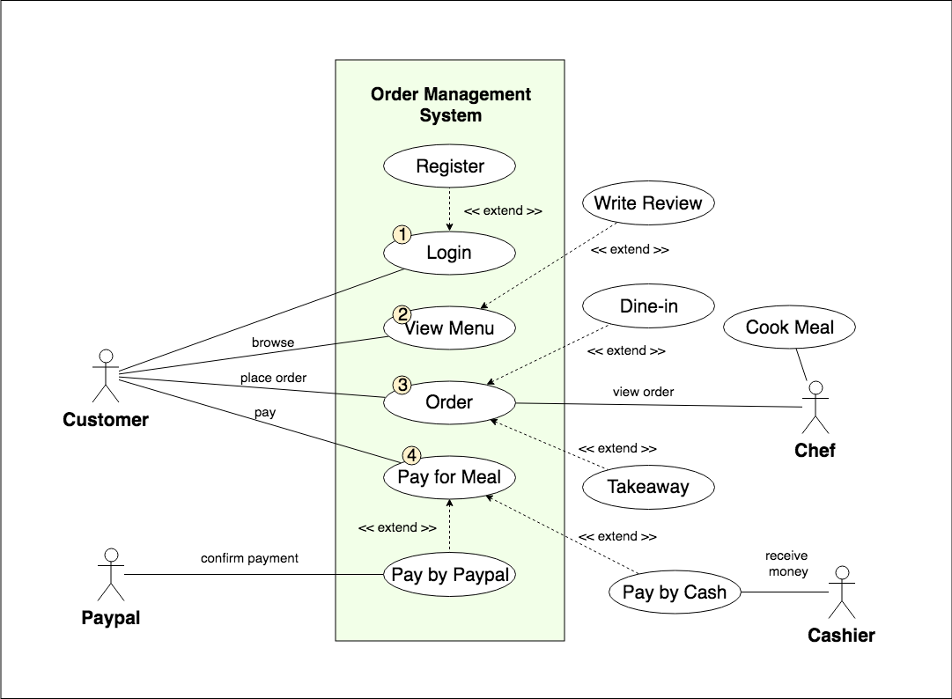

# **Login:** Customer login to the website by using their phone number and their password, if they don’t have an account, they can easily register for one through a very simple process by providing only their name and their phone number. The system will send an OTP via SMS to verify their phone number. Customer can fulfill or edit their profile detail later via their profile page.

# **View Menu:** By browsing the web interface of the system, the customer can have a look at all the dishes in the menu which are categorized into different categories such as Appetizers, Main meals, Dessert, Vegetarian, etc. Moreover, they can search for a dish and view its detail such as ingredients, price, rating as well as some pictures of the dish. Customer can also write a review or rate from 1 star to 5 stars for that dish

# **Place Order:** Customer can place a “Takeaway” order by adding dishes into their virtual bag which is like a shopping cart. Adding dishes can be done easily by “drag and drop”, customer can choose when (pick-up time) and where (could be the nearest restaurant) to pick up their meal. “Dine-in” customers can go to the restaurant and use the provided iPad or Android tablet to place an order via a dedicated web interface.

# **Payment:** Customers can pay for their meals by PayPal, they will be navigated to PayPal system to finalize the payment. Otherwise, they can pay by cash at the counter.

# 3. Communication Topology

# **View Menu:** When the customer opens the menu page, the Application Server will query the database for the name, description, recipe, category, price, review and rating of the meals and then send them to Browser to display on the screen. That information also will be stored on Browser for the next processes.

# **Login:** The customer needs to provide a phone number and their password to log in. When the customer clicks the Login button, the browser sends this information to the Application Server. The Application Server creates a query to get the customer’s record from the database. After comparing the provided password with the stored password, the Application Server will send the login result, back to the Browers. If the login was successful, the result will consist of session id, expired time.

# **Place Order:** When the Customer clicks the Place Order button, all the information such as the list of the meal, quantity, notes, desired pick-up time, desired pick-up place will be sent to the Application Server. The Application Server will verify the information, calculate the total amount, and store this information into the database then return a confirmation message to Browser.

# **Payment:** Customer can choose to pay by PayPal or by cash. If the customer uses PayPal, a window will pop up and show the customer the total amount they have to pay and ask the customer to log in to the PayPal system. After customer review and authorize the payment, PayPal will send transaction information to Application Server and then the Application Server will send the payment result to Browser.

# 4. Takeaway Order Screen Mock-up

